JMS performance benchmark toolkit

Content

1. Architecture 1

2. a 2

3. a 2

4. a 2

1. Architecture

The JMS Performance Benchmark kit is a messaging benchmark that measures the performance of Java Message Service products such as Oracle's Weblogic Server JMS. It is based on a **request-response model** where messaging flow is controlled via the number of responses sent per request using configurable parameters. This ensures a steady state with measurable performance and avoids overflow conditions that tend to rise without this windowing model where the queue size and message latency can continuously increase.

A **Requester Agent** and **Responder Agent** generate JMS message producers (configurable) and JMS message consumers (configurable) respectively as **separate JVM threads** and these can be split into multiple JVM processes (configurable).

The JMS micro-benchmark multi-user tests have been performed in the following environment.

* A **single Weblogic server**, using Work Manager, hosting **9 distributed destination** members with **200 Producers** and **200 asynchronous consumers** load balanced uniformly.
* A medium payload size of **8192 bytes** was chosen and **a flow control** window/response interval of **110 messages** along with a message pipeline of **101 messages** was used.
* Messaging throughput on the consumer side (i.e. the number of messages **consumed per second** by all the queue receivers) is used as the performance measure.

Topology:

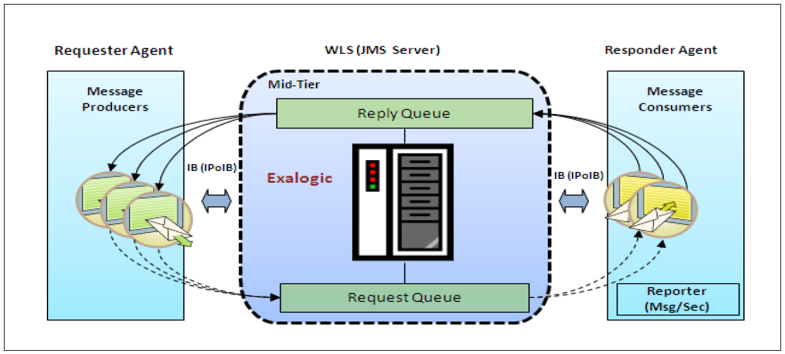

Sample Result:

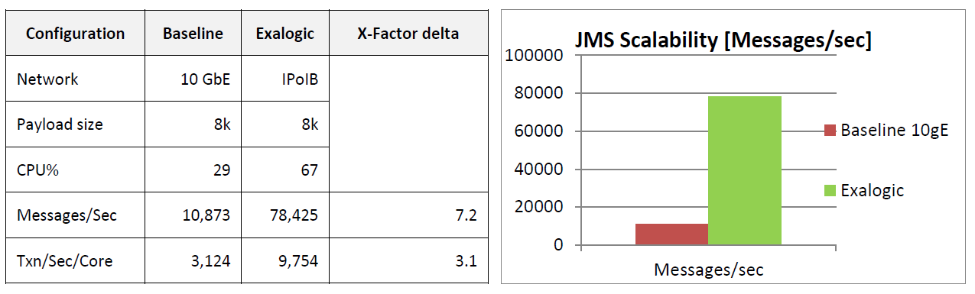

1. a
2. a
3. a