**Problem one: Trains**

This document describes how I implement the solution to solve this problem.

1. Here are three models, ‘Node’ represents town, ‘Edge’ represents the ‘one-way’ route from one town to another, ‘Graph’ is just a set of nodes, Node and Edge build the relationships by the attributes inside them, so you can start from a specific town, be able to find all the ways coming to the town or leaving from it.

**Node**:

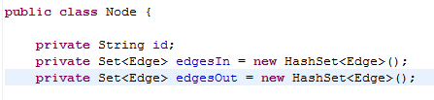

**Edge**:

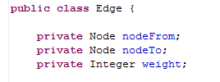

**Graph**:

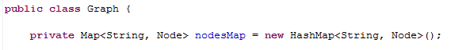

1. ServiceProviderImpl is provided as an implementation of interface ServiceProvider, which is used to init the Graph and provide various interfaces to client code to answer questions.

It has a template method named ’ execute’, which is used to visit nodes of graph recursively,

This recrusive method is used because starting from a specific node, we can get a tree structure, interface ‘Stragety’ is passed into ‘execute’ to determine under what condition to give up the current node and go back to a higher level. ‘Stragety’ has three implementation in this project to solve the ten questions.

**execute method:**

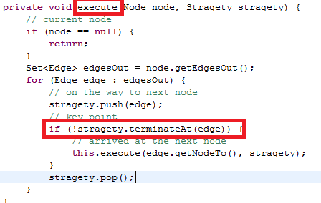

**Stragety Implementations:**

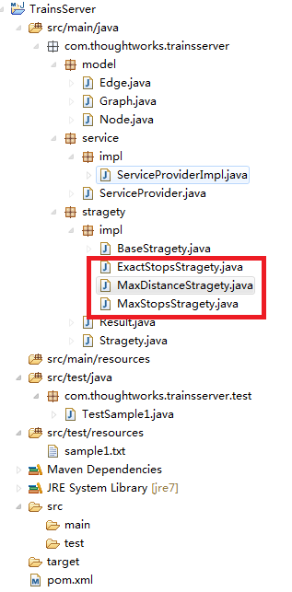

1. The last thing is it uses JUnit to test, TestSample1 reads test input from sample1.txt, run the test on TestSample1, we can get below output:

