Assignment 2

Name: Kyle Colangelo

Deliverables – Copy and paste the code required to answer the following questions along with a screenshot of the executed code.

1. Create a list and assign values to it by prompting the user to enter their favorite games until they enter “Game Over!”. Hint: Remember that you can declare an empty list with mylist = [] and that you should use a while loop here to prompt/add values

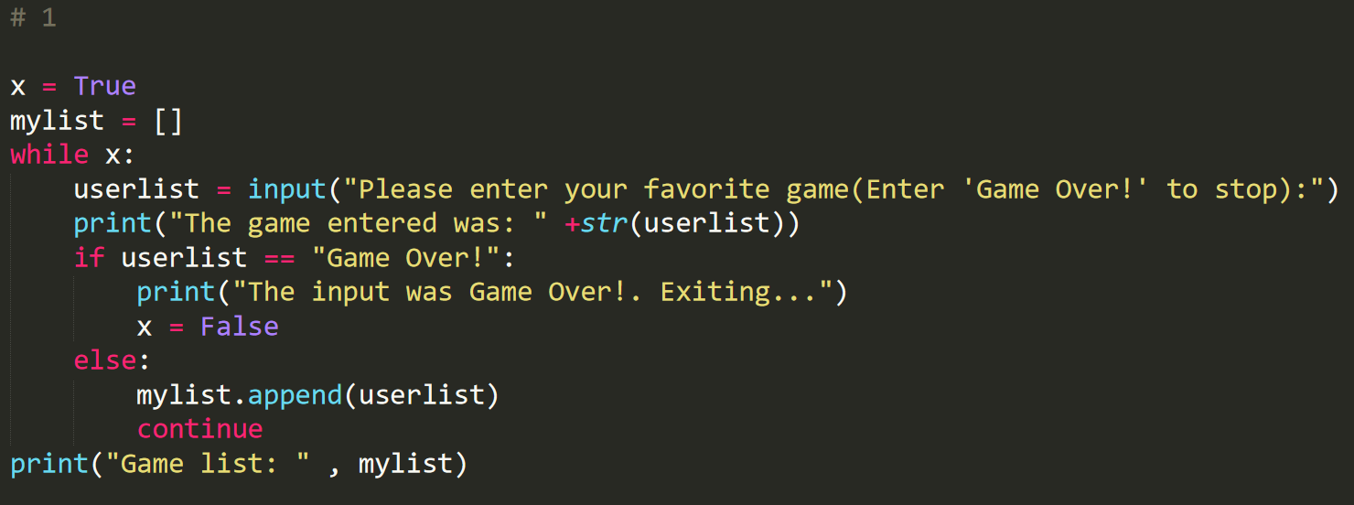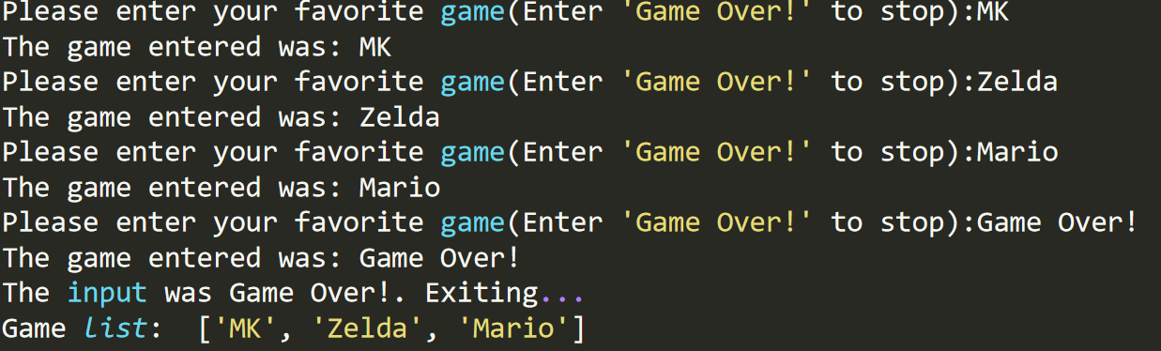

1. Print out the list to the user using a For Loop.

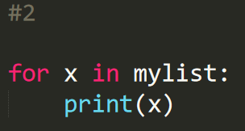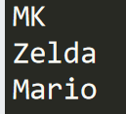

1. Create a new list and assign values to it by prompting the user to enter their favorite bands until they enter “The show is over?!”. Hint: Code is about reusability.

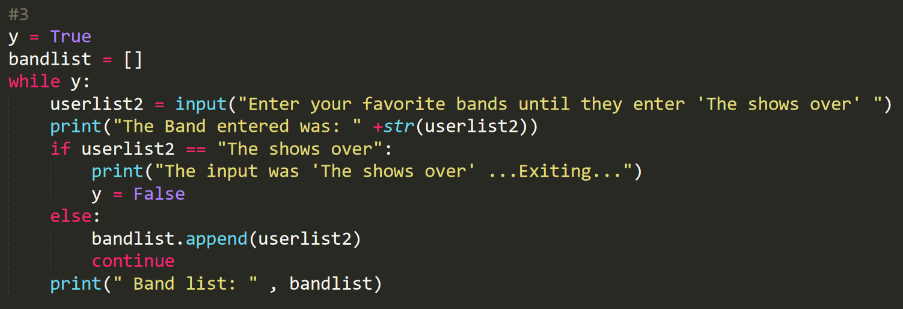

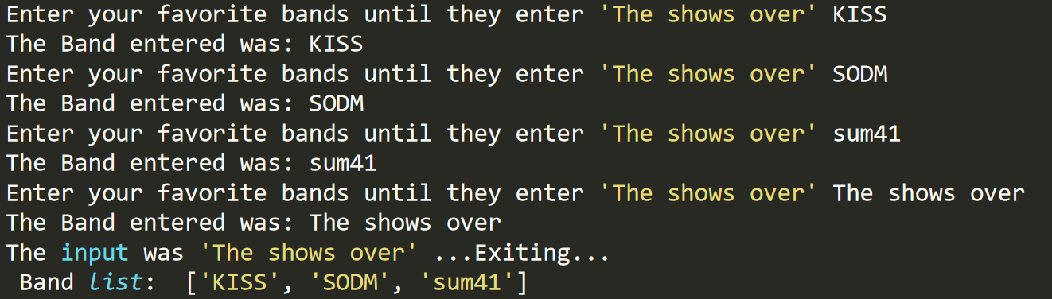

1. Create a tuple that includes a game and a band that you think would make a good combination.

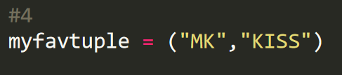

1. Use a nested for loop to check if any combination of game/band that the user entered matches your tuple. If both a game and band they entered matches your tuple values, then print out an appropriate message. If only a game matches, then print out a message. If only a band matches, then print out a message.

Example: The user entered Hades as a game and The Deftones as a band at some point in their lists. That exists in my tuple, so I print out “That is the perfect combination!”. If they only had one in their appropriate lists, then I print out “That is my favorite band!” or “That is a great game!”.

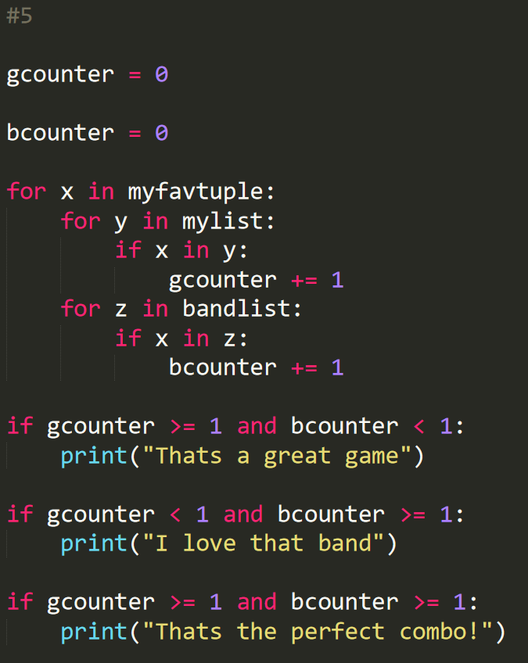



1. Create a new Set with your favorite games (or bands).



1. Print out your values with the message: “My favorites games (or bands depending on what you choose) are:”

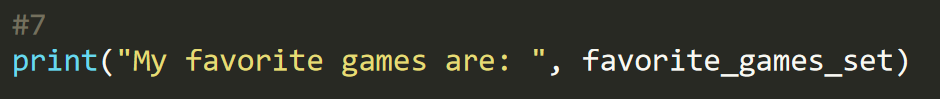

1. Add the appropriate values from the list the user entered to the topic for the Set you chose before (game/band).

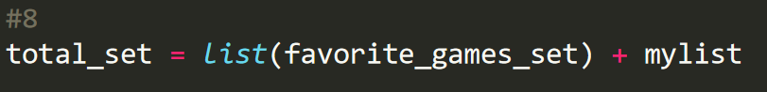

1. Print out a message stating “Our best bands/games in no particular order would be:” with the final values in the Set

