**Assignment 7 - R WordCloud and Rattle**

**Deliverables -**

* A .doc file with the following:
  1. Names of the datasets you chose

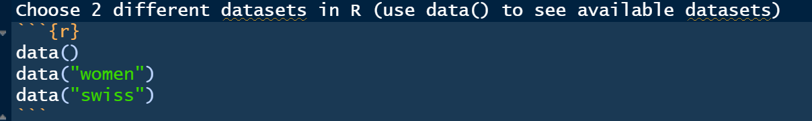

* 1. File name and Screenshot of the speech document you choose.

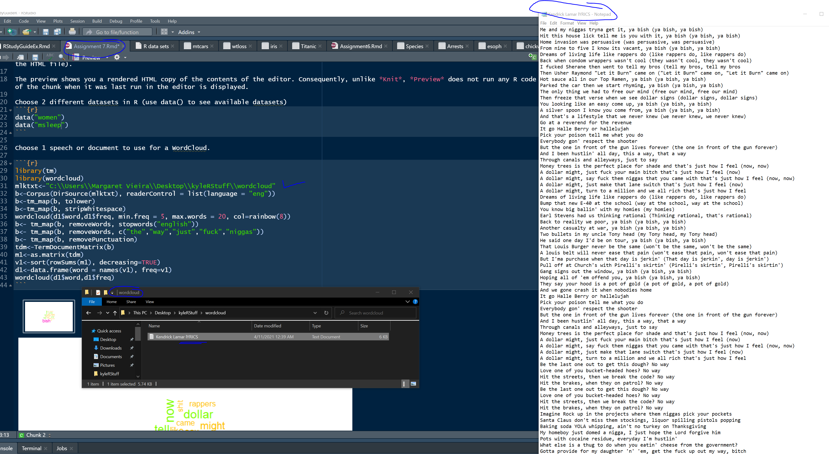

* 1. Screenshots of the summary output

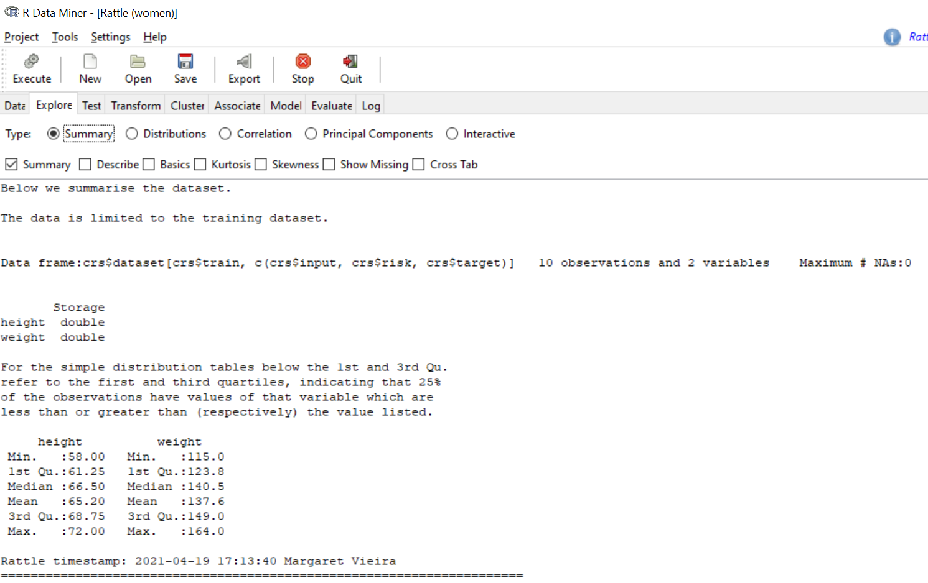

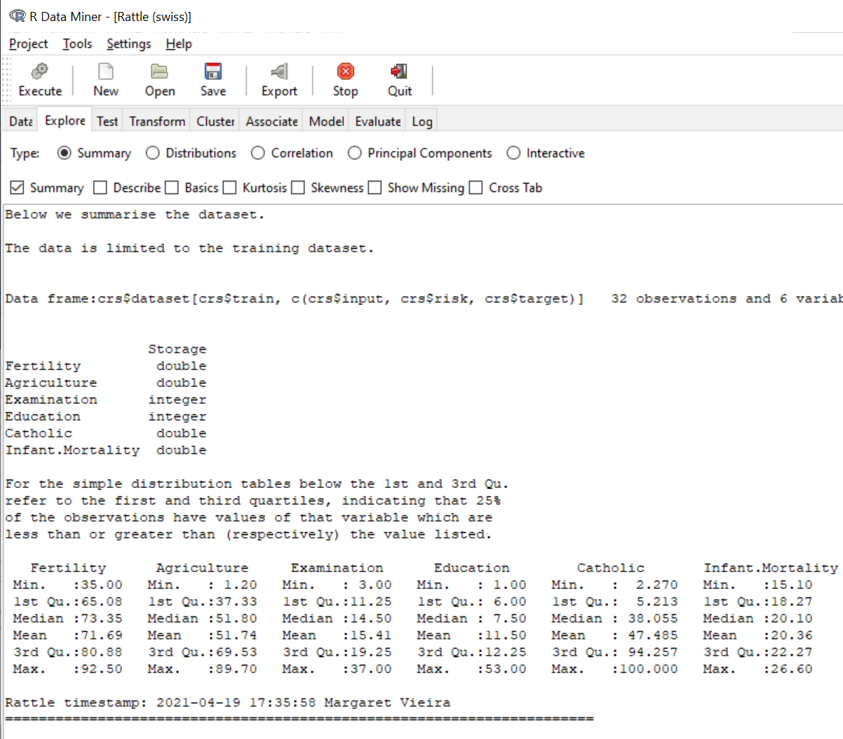

* 1. Screenshots of the correlation output

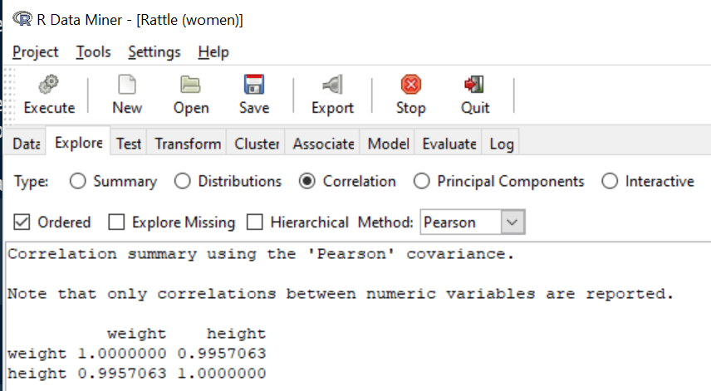

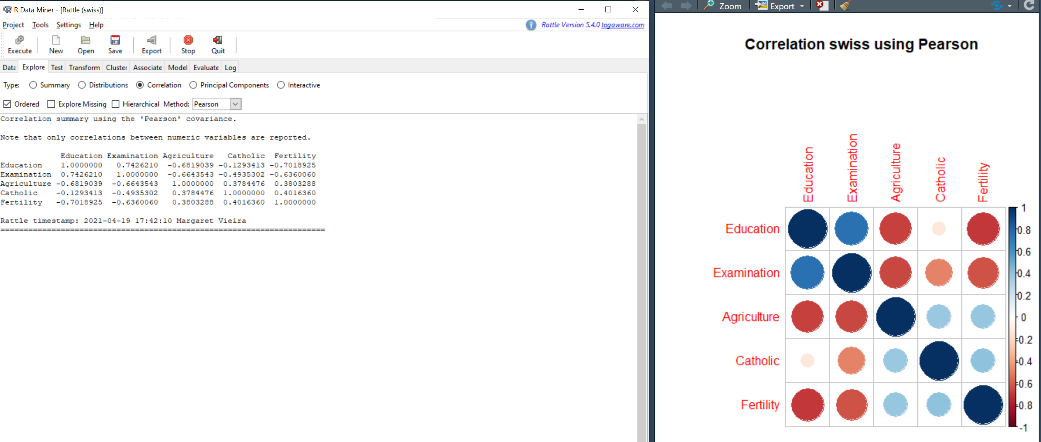

* 1. Screenshots of the tree for each dataset

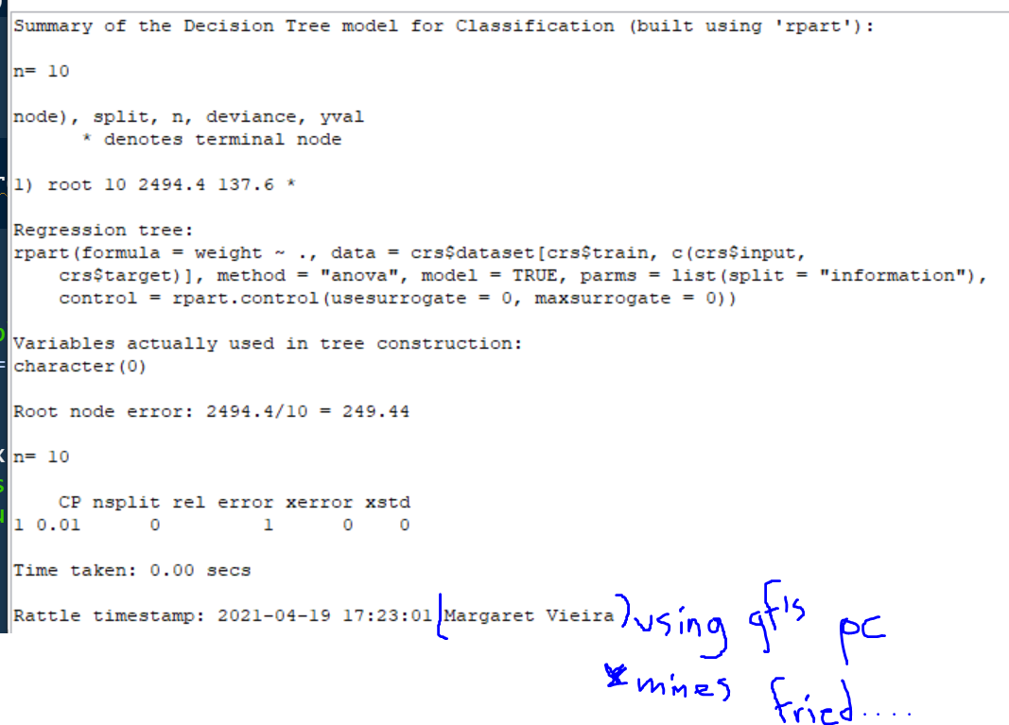

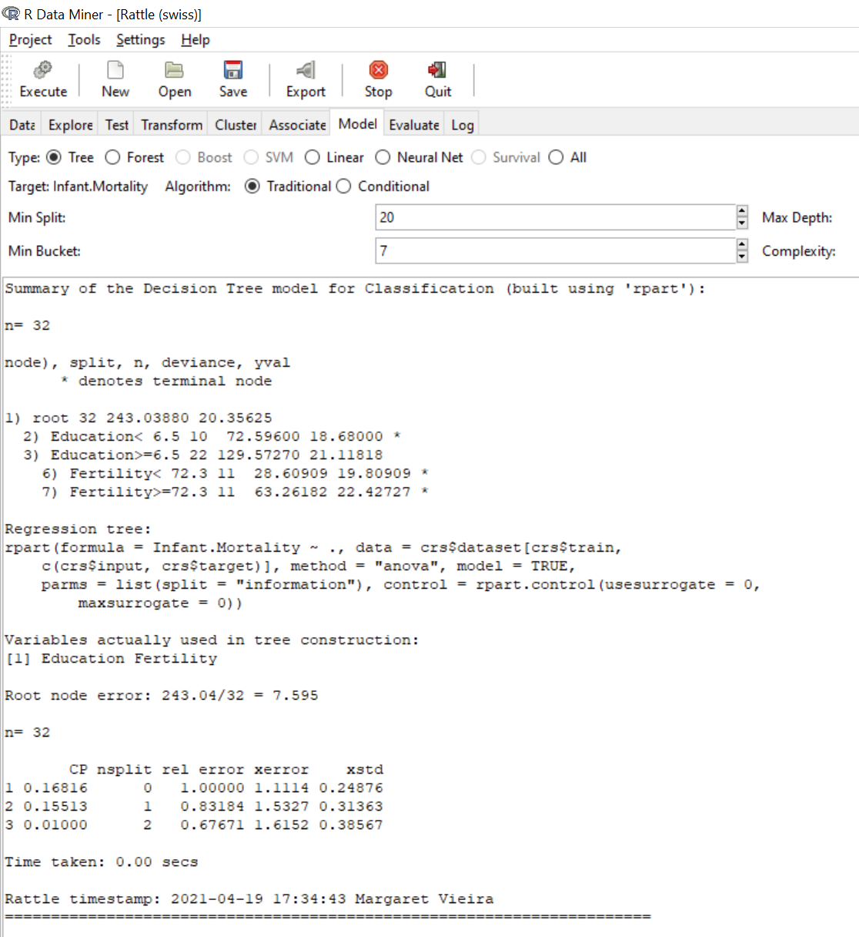

* 1. Screenshot of the WordCloud.
* 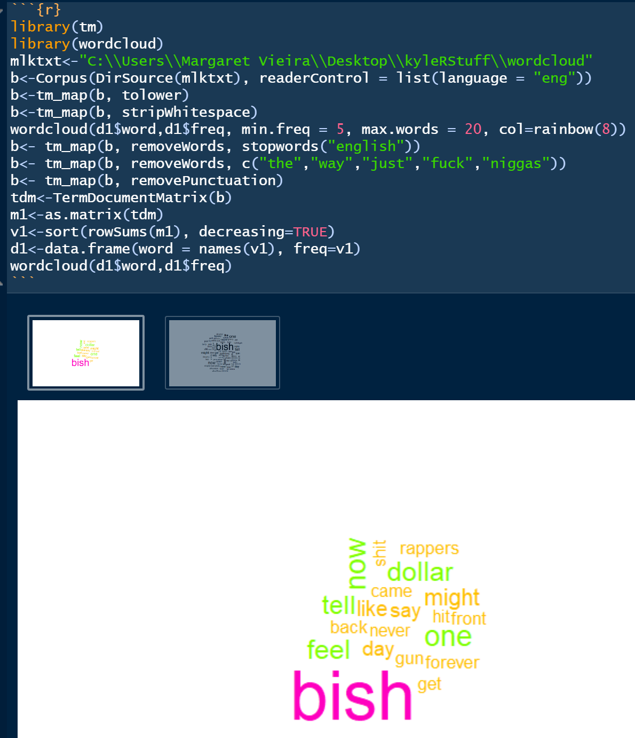
* A copy of the speech/document you used for the WordCloud.

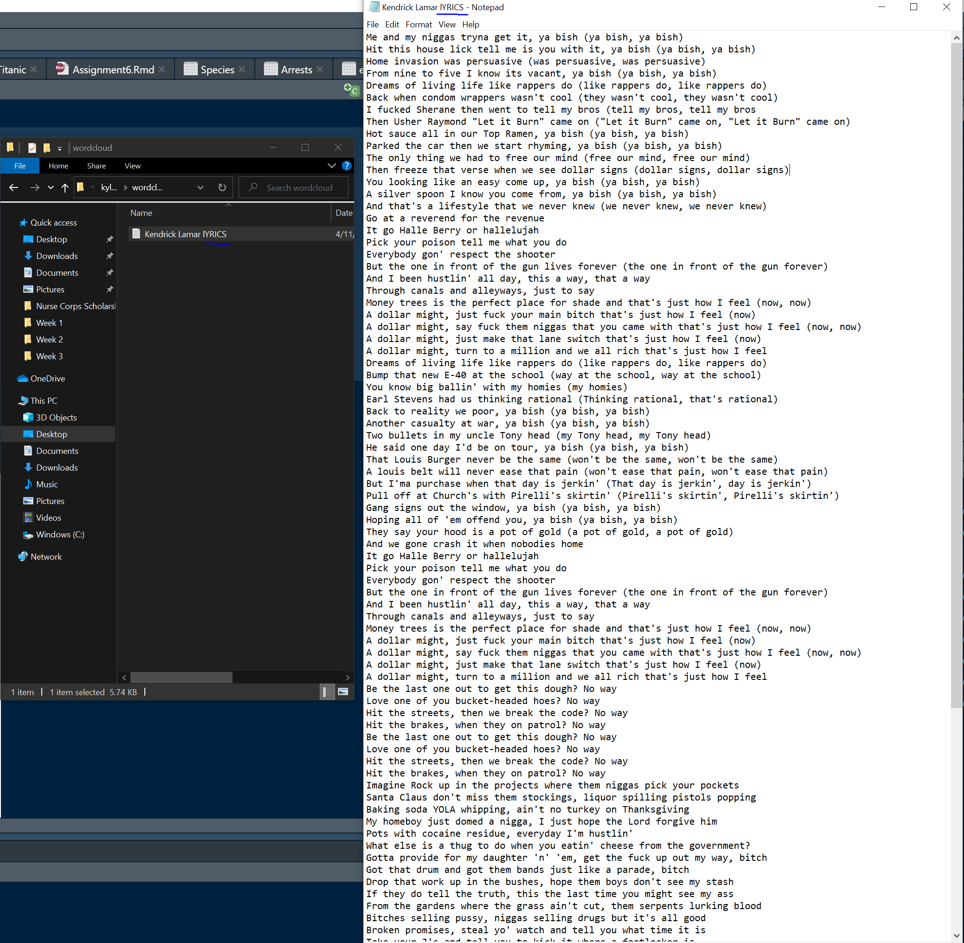

* A copy of the HTML file generated by your R notebook.