**Kyle Colangelo**

**ISM4212**

**Assignment 9**

1. Produce a list of all the customer names in which the first letter of the first and last names is in uppercase and the rest are in lower case.

SELECT INITCAP (Firstname), INITCAP (Lastname) FROM customers;

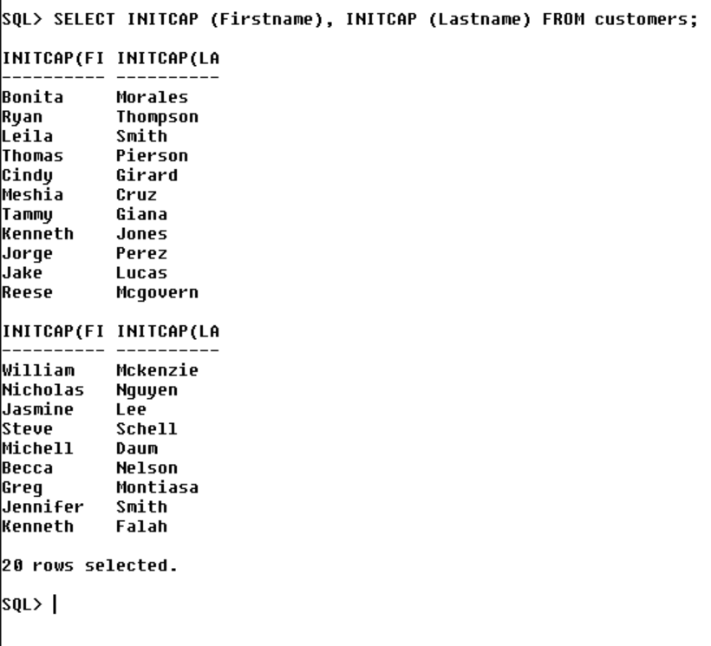

1. Create a list of all customer numbers along with text indicating whether the customer has been referred by another customer. Display the text “NOT REFERRED” if the customer wasn’t referred by another customer or “REFERRED” if they were. Hint: CASE statement.

SELECT Firstname, Lastname, NVL2(referrred, ‘REFERRED’, ‘NOT REFERRED’) FROM customers;

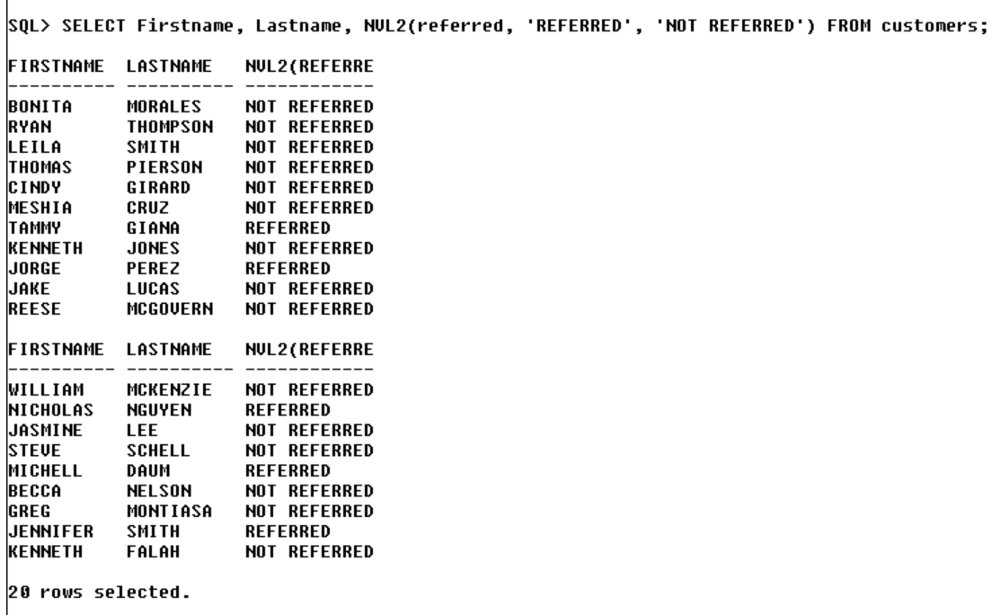

1. Create a list of all the book titles and costs. Precede each book’s cost with asterisks so that the width of the displayed cost field is 12.

SELECT title, LPAD(cost, 12, '*') FROM books;

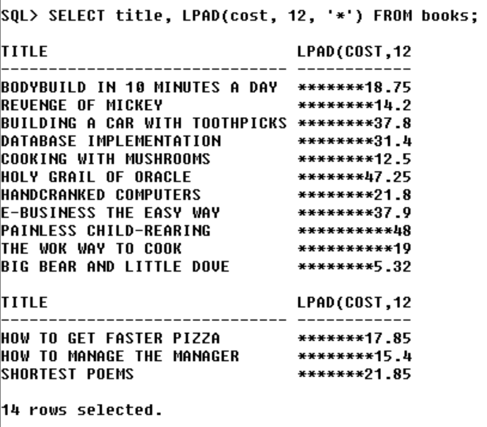

4.)        Determine how many books are in the "Cooking" category.

SELECT COUNT(*) FROM books WHERE category = 'COOKING';

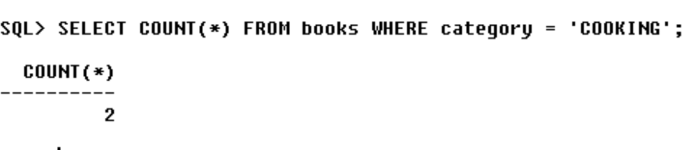

5.)        Display the number of books with a retail price of more than $30.00.

SELECT COUNT(*) FROM books WHERE retail > 30;

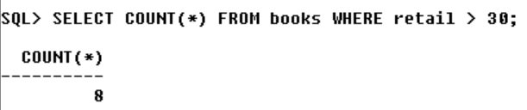

6.)        Display the most recent publication date of all the books sold.

SELECT MAX(pubdate) FROM books;

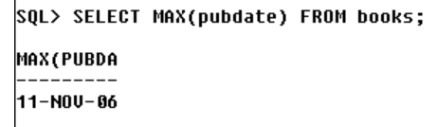

7.)        List the retail price of the least expensive book in the "Computer" category.

SELECT MIN(Retail) FROM books WHERE category = 'COMPUTER';

