**课后扩展题目1:** 统计最近一分钟出现字符“b”的次数。

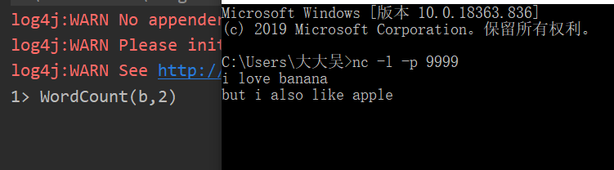

关键代码：

val stream = text.flatMap(line => line.split(""))

.filter(line => line.contains(target))

.map(c => WordCount(c, 1))

.keyBy(0)

.timeWindow(Time.seconds(60))

.sum(1)

.print()

代码参见 Q1.scala

**课后扩展题目2:** 统计到达数为前五的城市

目前，未能排序，只能每隔 30 秒将输入的数据统计一次，得出每个城市作为目的地的数量。

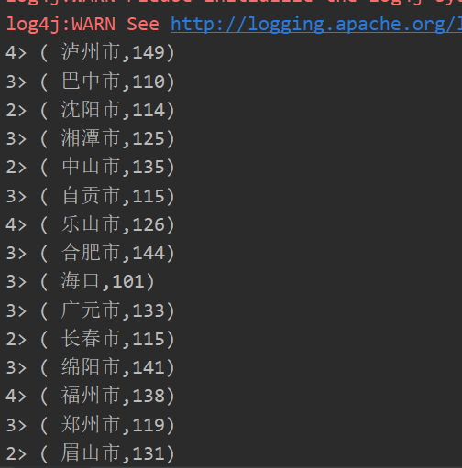

关键代码：

inputKafkaStream.map(line => {

var new_line = line.replace("\"", "")

(new_line.substring(new_line.lastIndexOf(":") + 1, new_line.length() - 1), 1)

})

.keyBy(0)

.timeWindow(Time.seconds(30))

.sum(1)

.print()

代码见 Q2.scala

**课后扩展题目3:** 将Mysql的表读取成一条条数据，并表的数据提交到kafka消息中。

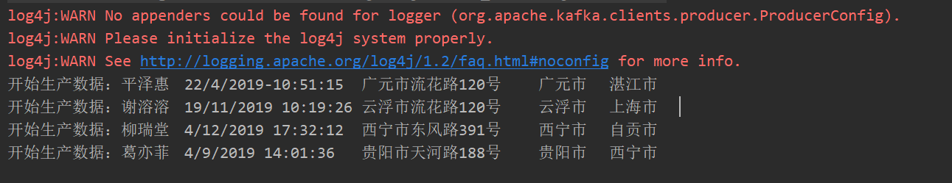

关键代码：

def readFileFromSql(): String = {

import java.sql.DriverManager

val url = "jdbc:mysql://bigdata28.depts.bingosoft.net:23307/user12_db"

val properties = new Properties()

properties.setProperty("driverClassName", "com.mysql.cj.jdbc.Driver")

properties.setProperty("user", "user12")

properties.setProperty("password", "pass@bingo12")

val connection = DriverManager.getConnection(url, properties)

val statement = connection.createStatement()

val sql = "select * from buy_record"

val resultSet = statement.executeQuery(sql)

var content = new StringBuilder()

val columnCount = resultSet.getMetaData.getColumnCount

while(resultSet.next){

for(i <- 1 to columnCount){

content.append(resultSet.getString(i)+"\t")

}

content.append("\n")

}

content.toString()

}

代码参见 Q3.scala