MPI Program
Kyle Angelo Alelis, Rey D. Balangue II, Sherwin Dan P. Morelos, Mapua University

Abstract—This electronic document is a “live” template and already defines the components of your paper [title, text, heads, etc.] in its style sheet. *CRITICAL: Do Not Use Symbols, Special Characters, Footnotes, or Math in Paper Title or Abstract. (Abstract)
Keywords—component, formatting, style, styling, insert (key words)

Introduction

Parallel computing is now a part of everyone’s life as personal computers, smart phones, and other technologies are using this. It is a type of computation in which many calculations or the execution of processes are carried out simultaneously. Large problems can be often divided into smaller ones, which can be solved at the same time. MPI or Message Passing Interface uses this Parallel computing to apply it to programs. MPI is a standardized and portable message-passing to function on a wide variety of parallel computing architectures. The standard defines the syntax and semantics of a core of library routines useful to a wide range of users writing portable message programs in C, C++, and Fortran.

Problem Statement
By considering the MPI program, can MPI program prove that parallel-computing is faster than the usual one processor usage. By running a program with multiple processors and comparing it to a single processor.

Objectives
- To create a program using C++ without MPI to compare it with the MPI
- To use MPI programming in C++ to create a program
- To create the program that can input large number of files to have better performance in the processors.

Limitations of the Study
The study is coded in C++ including MPI programs and its pre-defined functions, and it will only be applicable to C++. The Algorithm that was used was ____ sorting algorithm, to sort the large input of data and process the data through the use of the Regular program, and the MPI coded program to compare the speed of process.

REVIEW OF RELATED LITERATURE

- Message Passing Interface (MPI)

The Message Passing Interface (MPI) is a standardized and portable message-passing standard designed by group of researchers on a wide variety of parallel computing architectures. MPI is also a communication protocol for programming for programming parallel computers.MPI’s goals are high performance, scalability, and portability.

III. Flowcharts

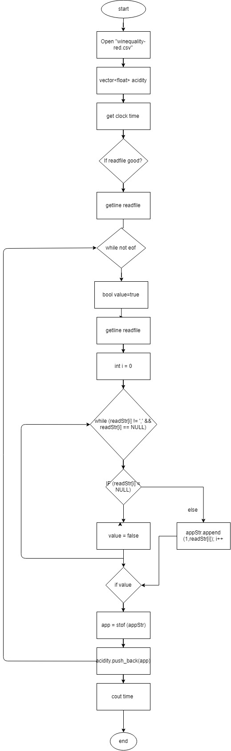
EnumSortSerial-main
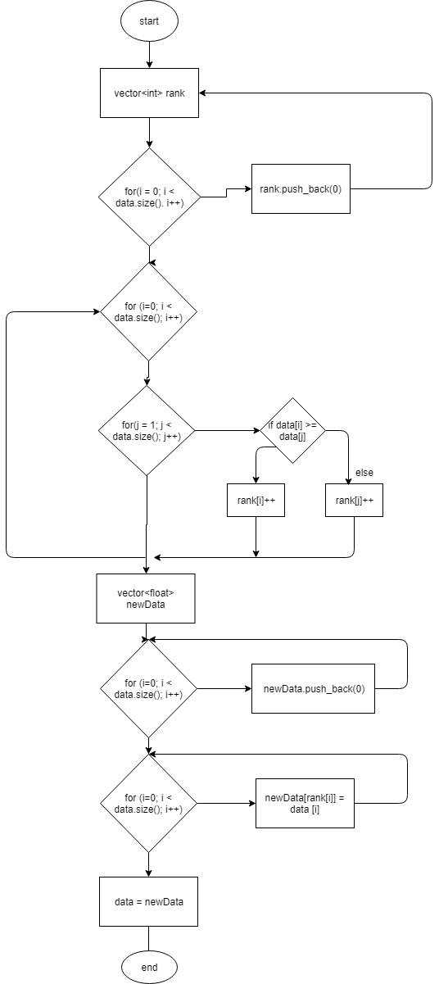
EnumSortSerial-void

