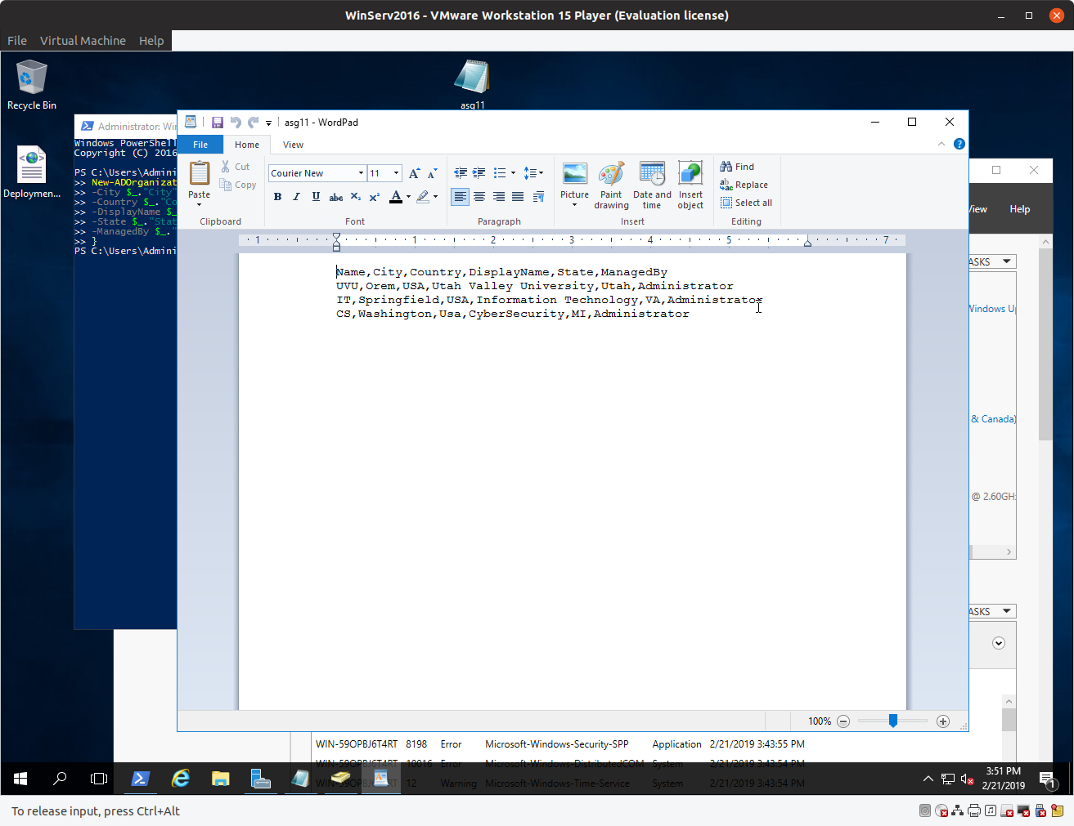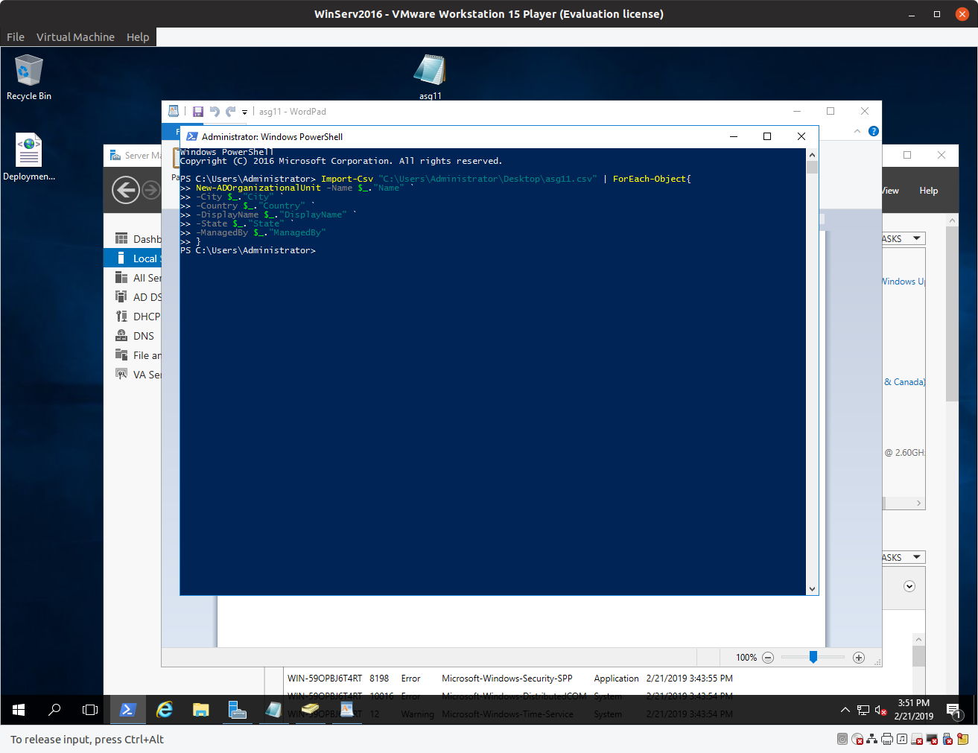

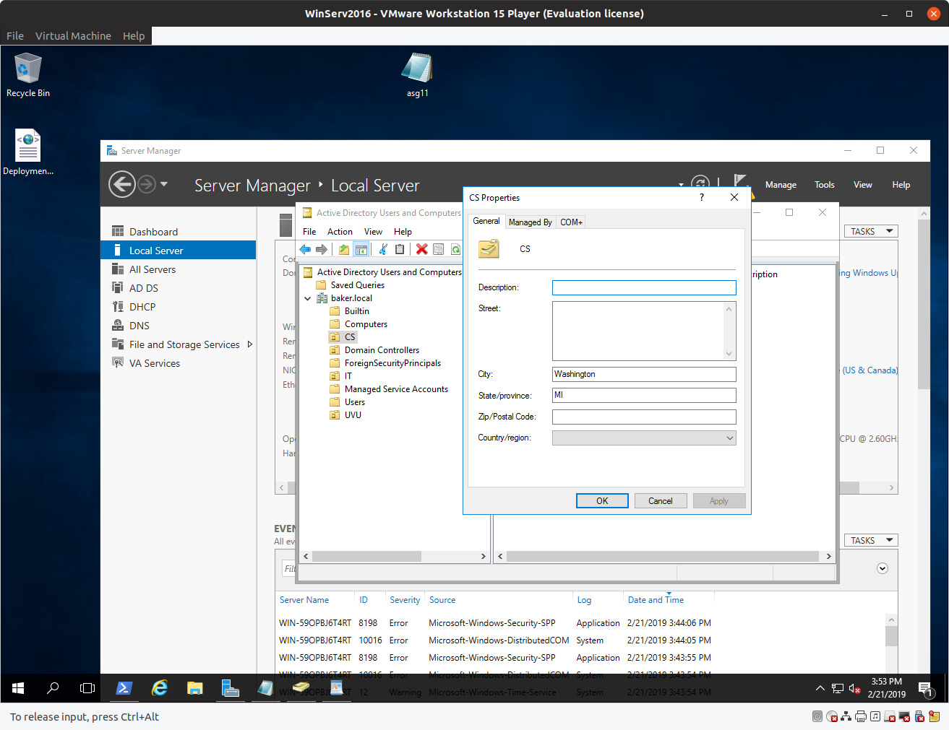

First image: Shows .csv file on server

Second image: Shows script and that it was run successfully

Third Image: Shows the OUs, with the CS OU selected to show the properties.