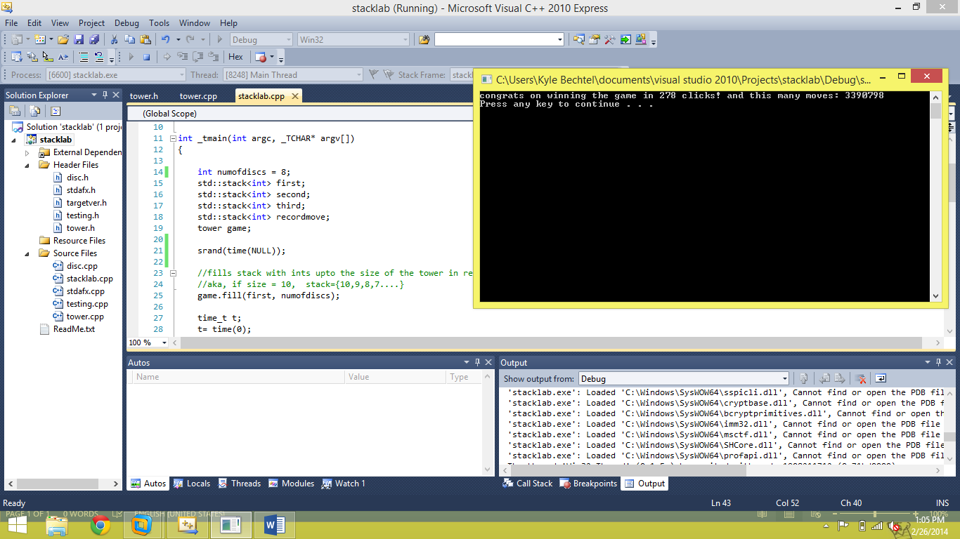

That’s how long it takes with eight discs.