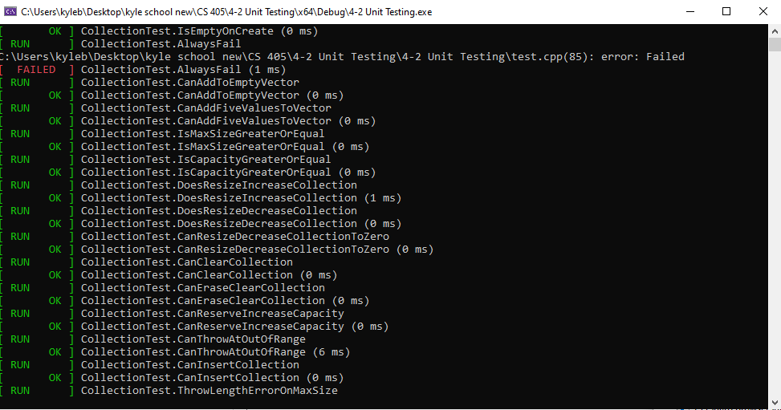

In C++, Google Test provides a powerful feature called parameterized tests, which allow developers to write tests that can be run with different inputs or data sets. This feature simplifies the process of testing functions or classes with various scenarios, reducing the need for writing multiple similar test cases manually. To implement parameterized tests using Google Test, developers define a test fixture class and use the TEST_P macro to declare parameterized test cases. Parameters are specified using the INSTANTIATE_TEST_SUITE_P macro, where developers provide a name for the test suite and a list of parameter values. Google Test then automatically generates and runs test cases for each combination of parameters.