Language of the cube

“[An algorithm must be seen to be believed.](http://www.brainyquote.com/quotes/quotes/d/donaldknut181629.html)”  
**-**[*Donald Knuth*](http://www.brainyquote.com/quotes/authors/d/donald_knuth.html) 

I feel like a good place to start on our Rubik’s cube journey is notation, it’s essentially the language of the cube. As we’ll get into later on the whole basis of solving a Rubik’s cube is algorithms, these come in the form of a string of letters, each letter referring to a turn, these letters are the notation.

Each face of the cube is assigned a letter,

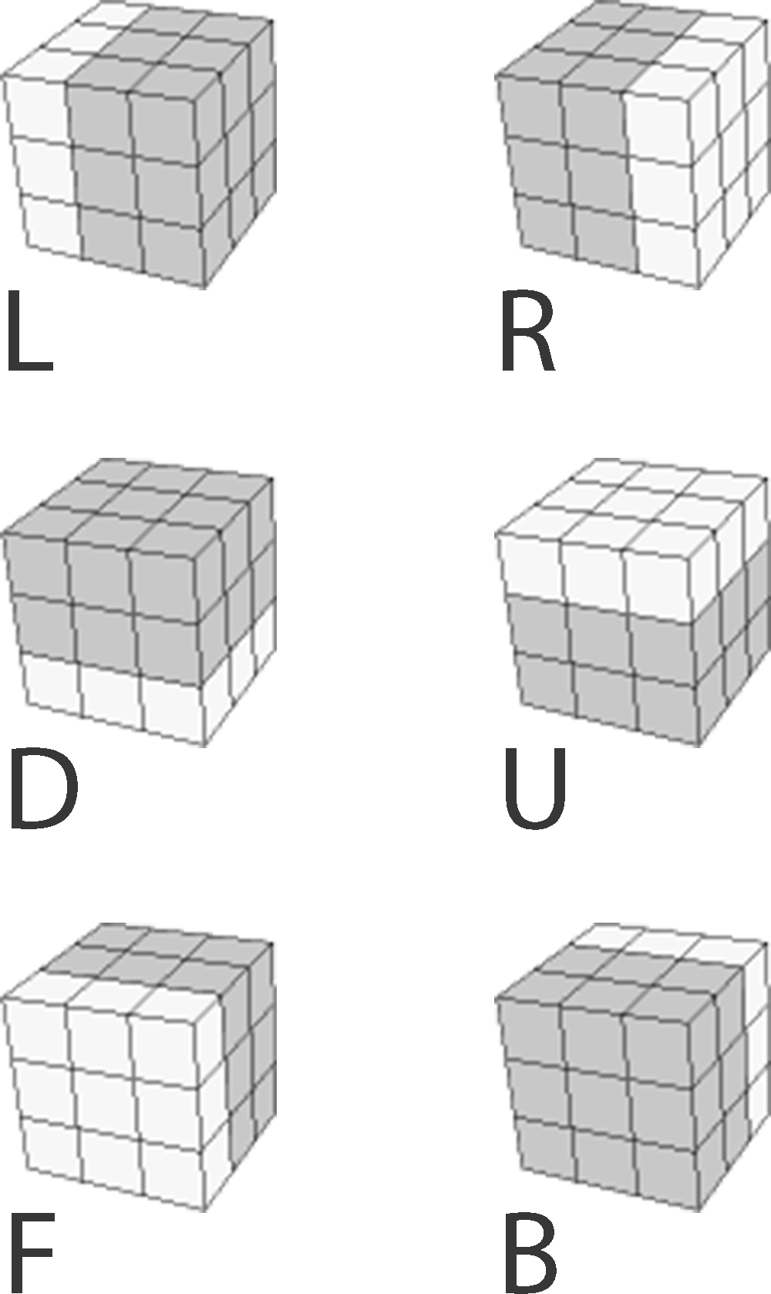

The single capital letter represents a clockwise 90o turn, the letter followed by an apostrophe represents an anti-clockwise 90o turn (e.g. R’ which is pronounced as R prime). The letter followed by a 2 represents a 180o turn of that face. The single letter in lowercase means a ‘wide’ turn, this is the same as a normal 90oturn however you grip two layers instead of one.

Below are some examples of notation and there results on a solved cube

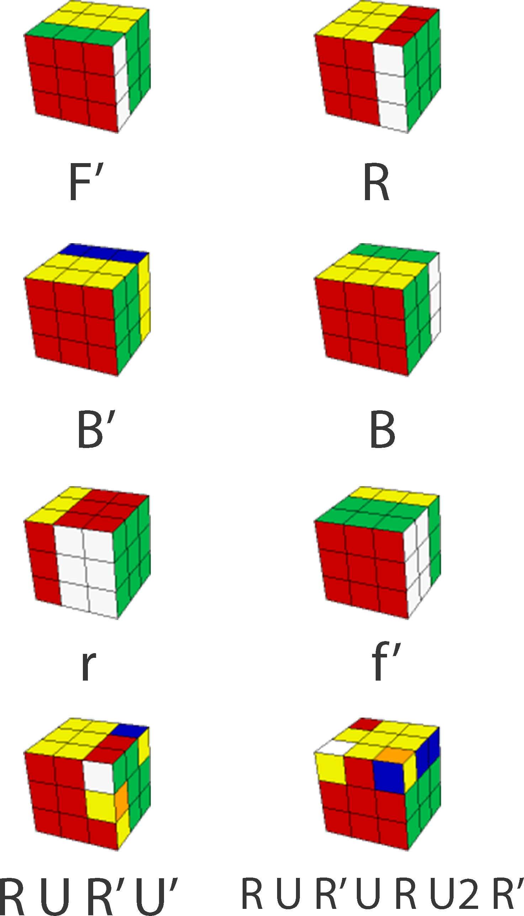

This becomes useful when we start to string the letters together, creating what is known as an algorithm. The word algorithm strikes fear of maths into the heart of laymen and women but in reality we use algorithms in almost every aspect of out lives, but most of us never will have given it a second thought. Any cooking recipe is an algorithm; you get dressed by an algorithm, driving a car, having a shower, making a phone call, they’re all examples of algorithms.

An algorithm is just a step by step procedure for completing a task , it can be as simple as;

1. Walk to the bus stop
2. Get the 13 bus
3. Get off at London road
4. Walk to your house

With respect to the cube the string of letters simply means, do this turn then the next one e.g. RUR’ would mean turn the right face clockwise, then the up face clockwise followed by the right face counterclockwise. Below are some examples of algorithms used in solving the cube and their results.



Throughout the rest of the book I will be using this notation frequently so It would be a good idea to become familiar with it now, try carrying out some of the algorithms in the table at the back of the book.

In a later chapter we will be taking another look at algorithms and their applications in maths and computer science and how this can also be applied to the cube.