AMS 315: Computing Assignment 1 – Appendix
Kyle Chan
Appendix A: Figures
Figure 1. Scatterplot of DV vs. IV with fitted regression line (Part A, after imputation)
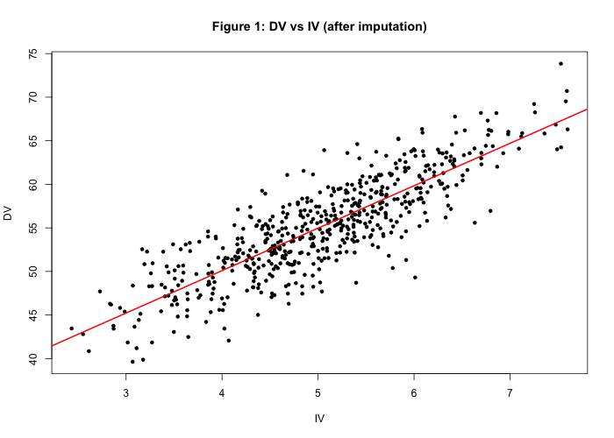
The red line is the fitted function DV = 30.62 + 4.87·IV. The points follow a clear positive linear trend with fairly even scatter around the line.
Figure 2. Raw data (Part B): scatterplot of y vs. x (left) and residuals vs. fitted values (right)
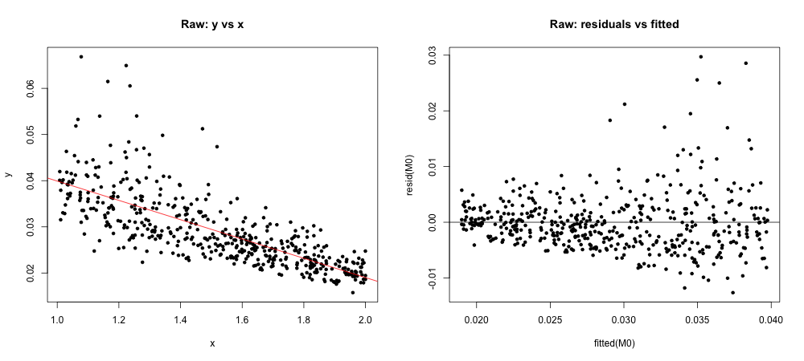
The scatterplot curves downward, and the residuals fan out as the fitted values increase (a funnel shape), so the constant-variance assumption is not met.
Figure 3. Transformed data (Part B): scatterplot of 1/y vs. x (left) and residuals vs. fitted values (right)
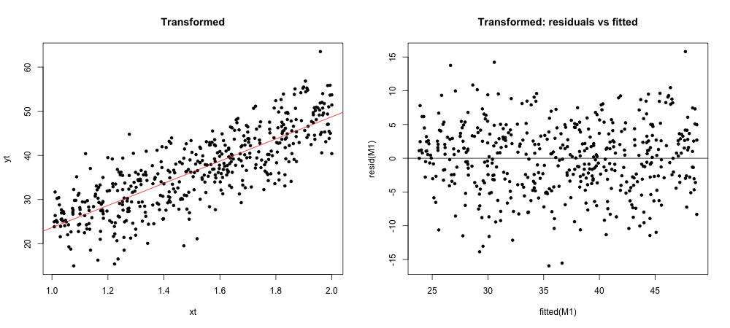
After the 1/y transformation, the relationship is close to linear and the residuals form a random band with roughly constant spread.

Appendix B: Tables
Table 1. Subject ID counts (Part A)
Category | Count
Total subject IDs | 569
IDs with an IV value | 500
IDs with a DV value | 520
IDs with both IV and DV | 454
IDs with at least one of IV or DV | 566
IDs missing both | 3
Fraction of IV missing | 0.1213 (12.1%)
Fraction of DV missing | 0.0861 (8.6%)
Table 2. ANOVA for the regression of DV on IV (Part A)
Source | df | Sum Sq | Mean Sq | F | p-value
IV | 1 | 13020.3 | 13020.3 | 1428.9 | < 2.2e-16
Residuals | 564 | 5139.4 | 9.1
Table 3. R² for candidate transformations (Part B; rows = x transform, columns = y transform)
 | y | log(y) | 1/y | √y | 1/√y
x | 0.5610 | 0.6330 | 0.6602 | 0.6026 | 0.6520
log(x) | 0.5626 | 0.6260 | 0.6434 | 0.6002 | 0.6401
1/x | 0.5547 | 0.6087 | 0.6167 | 0.5877 | 0.6180
√x | 0.5630 | 0.6308 | 0.6530 | 0.6026 | 0.6473
x² | 0.5505 | 0.6302 | 0.6668 | 0.5956 | 0.6538
Bold: the chosen model (1/y vs. x).
Table 4. ANOVA for 1/y regressed on x (Part B)
Source | df | Sum Sq | Mean Sq | F | p-value
x | 1 | 23918 | 23917.7 | 916.98 | < 2.2e-16
Residuals | 472 | 12311 | 26.1
Table 5. Lack-of-fit test, 1/y on binned x (bin width 0.05, 19 bins) (Part B)
Source | df | Sum Sq | Mean Sq | F | p-value
x (binned) | 1 | 23845.6 | 23845.6 | 919.98 | < 2e-16
Residuals | 472 | 12383.3 | 26.2
Lack of fit | 17 | 589.8 | 34.7 | 1.339 | 0.164
Pure error | 455 | 11793.5 | 25.9

Appendix C: R Code
File: run_all.R
# Runs the full analysis and saves all printed output to output/
dir.create("output", showWarnings = FALSE)

sink("output/partA_output.txt", split = TRUE)
source("R/partA.R", echo = TRUE)
sink()

sink("output/partB_output.txt", split = TRUE)
source("R/partB.R", echo = TRUE)
sink()
File: R/partA.R
# =============================================================
# AMS 315 - Project 1, Part A
# Merge IV + DV files by subject ID, count missing data, impute
# Run from the project folder (open ams315-project1.Rproj or setwd() to it)
# =============================================================

# install.packages("mice") # run once
library(mice)

set.seed(315) # makes the imputation reproducible

# ---- 1. Read the two files ----------------------------------
iv <- read.csv("data/partA_IV.csv", header = TRUE)
dv <- read.csv("data/partA_DV.csv", header = TRUE)
str(iv); str(dv)

# ---- 2. Sort by ID and merge (NOT cut-and-paste) ------------
# all = TRUE is a FULL outer join: keeps an ID even if it only
# appears in one file, so no subjects are silently dropped.
iv <- iv[order(iv$ID), ]
dv <- dv[order(dv$ID), ]
partA <- merge(iv, dv, by = "ID", all = TRUE)
str(partA)
write.csv(partA, "data/partA_merged.csv", row.names = FALSE)

# ---- 3. Counts the report asks for --------------------------
n_total <- nrow(partA)
has_iv <- !is.na(partA$IV)
has_dv <- !is.na(partA$DV)

counts <- data.frame(
Quantity = c("Total subject IDs",
"IDs with an IV value",
"IDs with a DV value",
"IDs with both IV and DV",
"IDs with at least one of IV or DV",
"IDs missing both",
"Fraction of IV missing",
"Fraction of DV missing"),
Value = c(n_total,
sum(has_iv),
sum(has_dv),
sum(has_iv & has_dv),
sum(has_iv | has_dv),
sum(!has_iv & !has_dv),
round(mean(!has_iv), 4),
round(mean(!has_dv), 4))
)
print(counts)
md.pattern(partA) # visual missing-data pattern (good for the appendix)

# ---- 4. Drop rows with NO information, then impute ----------
partA_imp <- partA[has_iv | has_dv, ]

# norm.boot = linear regression imputation with bootstrap.
# Other allowed choices: "pmm" (predictive mean matching), "norm".
# NOT allowed: mean, median, listwise deletion.
imp <- mice(partA_imp[, c("IV", "DV")], method = "norm.boot",
m = 5, printFlag = FALSE)
partA_complete <- cbind(ID = partA_imp$ID, complete(imp))
md.pattern(partA_complete) # should say "completely observed"
write.csv(partA_complete, "data/partA_imputed.csv", row.names = FALSE)

# ---- 5. Regression on the completed data --------------------
M <- lm(DV ~ IV, data = partA_complete)
summary(M)
anova(M)
confint(M, level = 0.95)

png("figures/partA_scatter.png", width = 700, height = 500)
plot(DV ~ IV, data = partA_complete, pch = 20,
main = "Figure 1: DV vs IV (after imputation)")
abline(M, col = "red", lwd = 2)
dev.off()
File: R/partB.R
# =============================================================
# AMS 315 - Project 1, Part B
# Find a transformation, fit regression, bin x, lack-of-fit test
# =============================================================

# Run once to install alr3 (provides pureErrorAnova):
# install.packages("remotes")
# remotes::install_github("cran/alr3") # if asked to update packages, type 3
library(alr3)

dat <- read.csv("data/partB.csv", header = TRUE)
str(dat)
summary(dat)

# ---- 1. Look at the raw data ---------------------------------
M0 <- lm(y ~ x, data = dat)
summary(M0)$r.squared # baseline R-squared

png("figures/partB_raw.png", width = 1000, height = 450)
par(mfrow = c(1, 2))
plot(y ~ x, data = dat, pch = 20, main = "Raw: y vs x"); abline(M0, col = "red")
plot(fitted(M0), resid(M0), pch = 20, main = "Raw: residuals vs fitted"); abline(h = 0)
dev.off()

# ---- 2. Try candidate transformations (textbook 11.1) --------
# Compare R-squared for each combination. Also LOOK at each
# residual plot -- the best choice is the one whose residuals
# look patternless with roughly constant spread.
tx <- list(x = function(v) v, `log(x)` = log, `1/x` = function(v) 1/v,
`sqrt(x)` = sqrt, `x^2` = function(v) v^2)
ty <- list(y = function(v) v, `log(y)` = log, `1/y` = function(v) 1/v,
`sqrt(y)` = sqrt, `1/sqrt(y)` = function(v) 1/sqrt(v))
r2 <- outer(names(tx), names(ty), Vectorize(function(a, b) {
summary(lm(ty[[b]](dat$y) ~ tx[[a]](dat$x)))$r.squared
}))
dimnames(r2) <- list(names(tx), names(ty))
round(r2, 4)

# Box-Cox on y can suggest a power (lambda): -1 = 1/y, 0 = log(y), 0.5 = sqrt(y)
# library(MASS); boxcox(M0)

# ---- 3. Fit your chosen model --------------------------------
# >>> EDIT these two lines to the transformation you picked <<<
dat$xt <- dat$x
dat$yt <- 1 / dat$y

M1 <- lm(yt ~ xt, data = dat)
summary(M1)
anova(M1)
confint(M1, level = 0.95)

png("figures/partB_transformed.png", width = 1000, height = 450)
par(mfrow = c(1, 2))
plot(yt ~ xt, data = dat, pch = 20, main = "Transformed"); abline(M1, col = "red")
plot(fitted(M1), resid(M1), pch = 20, main = "Transformed: residuals vs fitted"); abline(h = 0)
dev.off()

# ---- 4. Bin near-repeated x values ---------------------------
# Cut x into intervals; every x in an interval is replaced by the
# interval's mean x. Pick a width so each bin has a decent number
# of points (check table(groups)).
width <- 0.05
groups <- cut(dat$xt,
breaks = c(-Inf,
seq(min(dat$xt) + width, max(dat$xt) - width, by = width),
Inf))
table(groups)
dat$x_bin <- ave(dat$xt, groups) # mean x within each bin

# ---- 5. Lack-of-fit test -------------------------------------
fit_bin <- lm(yt ~ x_bin, data = dat)
pureErrorAnova(fit_bin)
# Large p-value on the "Lack of fit" row => no evidence the straight
# line is the wrong shape for the transformed data.

# Optional: run the same LOF on the UNtransformed data for comparison
dat$x_bin_raw <- ave(dat$x, cut(dat$x, breaks = c(-Inf,
seq(min(dat$x) + width, max(dat$x) - width, by = width), Inf)))
pureErrorAnova(lm(y ~ x_bin_raw, data = dat))

Appendix D: R Output
File: output/partA_output.txt

> # =============================================================
> # AMS 315 - Project 1, Part A
> # Merge IV + DV files by subject ID, count missing .... [TRUNCATED]

> set.seed(315) # makes the imputation reproducible

> # ---- 1. Read the two files ----------------------------------
> iv <- read.csv("data/partA_IV.csv", header = TRUE)

> dv <- read.csv("data/partA_DV.csv", header = TRUE)

> str(iv); str(dv)
'data.frame': 569 obs. of 2 variables:
$ ID: int 440 467 313 446 44 374 201 258 525 45 ...
$ IV: num 4.63 5.24 4.29 4.77 5.57 ...
'data.frame': 569 obs. of 2 variables:
$ ID: int 332 368 164 230 347 323 313 287 269 547 ...
$ DV: num 58.3 47.6 NA 59 58.3 ...

> # ---- 2. Sort by ID and merge (NOT cut-and-paste) ------------
> # all = TRUE is a FULL outer join: keeps an ID even if it only
> # appears in one .... [TRUNCATED]

> dv <- dv[order(dv$ID), ]

> partA <- merge(iv, dv, by = "ID", all = TRUE)

> str(partA)
'data.frame': 569 obs. of 3 variables:
$ ID: int 1 2 3 4 5 6 7 8 9 10 ...
$ IV: num 3.37 3.93 6.3 5.71 5.48 ...
$ DV: num 48.5 54 61.3 58.6 NA ...

> write.csv(partA, "data/partA_merged.csv", row.names = FALSE)

> # ---- 3. Counts the report asks for --------------------------
> n_total <- nrow(partA)

> has_iv <- !is.na(partA$IV)

> has_dv <- !is.na(partA$DV)

> counts <- data.frame(
+ Quantity = c("Total subject IDs",
+ "IDs with an IV value",
+ "IDs with a DV value",
+ .... [TRUNCATED]

> print(counts)
Quantity Value
1 Total subject IDs 569.0000
2 IDs with an IV value 500.0000
3 IDs with a DV value 520.0000
4 IDs with both IV and DV 454.0000
5 IDs with at least one of IV or DV 566.0000
6 IDs missing both 3.0000
7 Fraction of IV missing 0.1213
8 Fraction of DV missing 0.0861

> md.pattern(partA) # visual missing-data pattern (good for the appendix)
ID DV IV
454 1 1 1 0
66 1 1 0 1
46 1 0 1 1
3 1 0 0 2
0 49 69 118

> # ---- 4. Drop rows with NO information, then impute ----------
> partA_imp <- partA[has_iv | has_dv, ]

> # norm.boot = linear regression imputation with bootstrap.
> # Other allowed choices: "pmm" (predictive mean matching), "norm".
> # NOT allowed: mea .... [TRUNCATED]

> partA_complete <- cbind(ID = partA_imp$ID, complete(imp))

> md.pattern(partA_complete) # should say "completely observed"
/\ /\
{ `---' }
{ O O }
==> V <== No need for mice. This data set is completely observed.
\ \|/ /
`-----'

ID IV DV
566 1 1 1 0
0 0 0 0

> write.csv(partA_complete, "data/partA_imputed.csv", row.names = FALSE)

> # ---- 5. Regression on the completed data --------------------
> M <- lm(DV ~ IV, data = partA_complete)

> summary(M)

Call:
lm(formula = DV ~ IV, data = partA_complete)

Residuals:
Min 1Q Median 3Q Max
-10.5837 -1.8232 0.0143 2.0059 8.6393

Coefficients:
Estimate Std. Error t value Pr(>|t|)
(Intercept) 30.6175 0.6607 46.34 <2e-16 ***
IV 4.8703 0.1288 37.80 <2e-16 ***
---
Signif. codes: 0 ‘***’ 0.001 ‘**’ 0.01 ‘*’ 0.05 ‘.’ 0.1 ‘ ’ 1

Residual standard error: 3.019 on 564 degrees of freedom
Multiple R-squared: 0.717, Adjusted R-squared: 0.7165
F-statistic: 1429 on 1 and 564 DF, p-value: < 2.2e-16

> anova(M)
Analysis of Variance Table

Response: DV
Df Sum Sq Mean Sq F value Pr(>F)
IV 1 13020.3 13020.3 1428.9 < 2.2e-16 ***
Residuals 564 5139.4 9.1
---
Signif. codes: 0 ‘***’ 0.001 ‘**’ 0.01 ‘*’ 0.05 ‘.’ 0.1 ‘ ’ 1

> confint(M, level = 0.95)
2.5 % 97.5 %
(Intercept) 29.319672 31.915294
IV 4.617253 5.123397

> png("figures/partA_scatter.png", width = 700, height = 500)

> plot(DV ~ IV, data = partA_complete, pch = 20,
+ main = "Figure 1: DV vs IV (after imputation)")

> abline(M, col = "red", lwd = 2)

> dev.off()
RStudioGD
2
File: output/partB_output.txt

> # =============================================================
> # AMS 315 - Project 1, Part B
> # Find a transformation, fit regression, bin x, la .... [TRUNCATED]

> dat <- read.csv("data/partB.csv", header = TRUE)

> str(dat)
'data.frame': 474 obs. of 3 variables:
$ ID: int 1 2 3 4 5 6 7 8 9 10 ...
$ x : num 1.98 1.64 1.61 1.16 1.69 ...
$ y : num 0.0232 0.025 0.032 0.0311 0.0214 ...

> summary(dat)
ID x y
Min. : 1.0 Min. :1.008 Min. :0.01574
1st Qu.:119.2 1st Qu.:1.270 1st Qu.:0.02330
Median :237.5 Median :1.530 Median :0.02761
Mean :237.5 Mean :1.515 Mean :0.02914
3rd Qu.:355.8 3rd Qu.:1.759 3rd Qu.:0.03368
Max. :474.0 Max. :2.000 Max. :0.06684

> # ---- 1. Look at the raw data ---------------------------------
> M0 <- lm(y ~ x, data = dat)

> summary(M0)$r.squared # baseline R-squared
[1] 0.5609992

> png("figures/partB_raw.png", width = 1000, height = 450)

> par(mfrow = c(1, 2))

> plot(y ~ x, data = dat, pch = 20, main = "Raw: y vs x"); abline(M0, col = "red")

> plot(fitted(M0), resid(M0), pch = 20, main = "Raw: residuals vs fitted"); abline(h = 0)

> dev.off()
RStudioGD
2

> # ---- 2. Try candidate transformations (textbook 11.1) --------
> # Compare R-squared for each combination. Also LOOK at each
> # residual plot -- .... [TRUNCATED]

> ty <- list(y = function(v) v, `log(y)` = log, `1/y` = function(v) 1/v,
+ `sqrt(y)` = sqrt, `1/sqrt(y)` = function(v) 1/sqrt(v))

> r2 <- outer(names(tx), names(ty), Vectorize(function(a, b) {
+ summary(lm(ty[[b]](dat$y) ~ tx[[a]](dat$x)))$r.squared
+ }))

> dimnames(r2) <- list(names(tx), names(ty))

> round(r2, 4)
y log(y) 1/y sqrt(y) 1/sqrt(y)
x 0.5610 0.6330 0.6602 0.6026 0.6520
log(x) 0.5626 0.6260 0.6434 0.6002 0.6401
1/x 0.5547 0.6087 0.6167 0.5877 0.6180
sqrt(x) 0.5630 0.6308 0.6530 0.6026 0.6473
x^2 0.5505 0.6302 0.6668 0.5956 0.6538

> # Box-Cox on y can suggest a power (lambda): -1 = 1/y, 0 = log(y), 0.5 = sqrt(y)
> # library(MASS); boxcox(M0)
>
> # ---- 3. Fit your chosen model .... [TRUNCATED]

> dat$yt <- 1 / dat$y

> M1 <- lm(yt ~ xt, data = dat)

> summary(M1)

Call:
lm(formula = yt ~ xt, data = dat)

Residuals:
Min 1Q Median 3Q Max
-15.9499 -3.2655 0.4368 3.3128 15.7985

Coefficients:
Estimate Std. Error t value Pr(>|t|)
(Intercept) -1.4826 1.2779 -1.16 0.247
xt 25.1132 0.8293 30.28 <2e-16 ***
---
Signif. codes: 0 ‘***’ 0.001 ‘**’ 0.01 ‘*’ 0.05 ‘.’ 0.1 ‘ ’ 1

Residual standard error: 5.107 on 472 degrees of freedom
Multiple R-squared: 0.6602, Adjusted R-squared: 0.6595
F-statistic: 917 on 1 and 472 DF, p-value: < 2.2e-16

> anova(M1)
Analysis of Variance Table

Response: yt
Df Sum Sq Mean Sq F value Pr(>F)
xt 1 23918 23917.7 916.98 < 2.2e-16 ***
Residuals 472 12311 26.1
---
Signif. codes: 0 ‘***’ 0.001 ‘**’ 0.01 ‘*’ 0.05 ‘.’ 0.1 ‘ ’ 1

> confint(M1, level = 0.95)
2.5 % 97.5 %
(Intercept) -3.993664 1.028428
xt 23.483560 26.742787

> png("figures/partB_transformed.png", width = 1000, height = 450)

> par(mfrow = c(1, 2))

> plot(yt ~ xt, data = dat, pch = 20, main = "Transformed"); abline(M1, col = "red")

> plot(fitted(M1), resid(M1), pch = 20, main = "Transformed: residuals vs fitted"); abline(h = 0)

> dev.off()
RStudioGD
2

> # ---- 4. Bin near-repeated x values ---------------------------
> # Cut x into intervals; every x in an interval is replaced by the
> # interval's .... [TRUNCATED]

> groups <- cut(dat$xt,
+ breaks = c(-Inf,
+ seq(min(dat$xt) + width, max(dat$xt) - width, by = width),
+ .... [TRUNCATED]

> table(groups)
groups
(-Inf,1.06] (1.06,1.11] (1.11,1.16] (1.16,1.21] (1.21,1.26] (1.26,1.31]
22 21 18 24 29 25
(1.31,1.36] (1.36,1.41] (1.41,1.46] (1.46,1.51] (1.51,1.56] (1.56,1.61]
20 21 24 24 20 31
(1.61,1.66] (1.66,1.71] (1.71,1.76] (1.76,1.81] (1.81,1.86] (1.86,1.91]
30 29 17 23 33 18
(1.91, Inf]
45

> dat$x_bin <- ave(dat$xt, groups) # mean x within each bin

> # ---- 5. Lack-of-fit test -------------------------------------
> fit_bin <- lm(yt ~ x_bin, data = dat)

> pureErrorAnova(fit_bin)
Analysis of Variance Table

Response: yt
Df Sum Sq Mean Sq F value Pr(>F)
x_bin 1 23845.6 23845.6 919.9754 <2e-16 ***
Residuals 472 12383.3 26.2
Lack of fit 17 589.8 34.7 1.3385 0.1639
Pure Error 455 11793.5 25.9
---
Signif. codes: 0 ‘***’ 0.001 ‘**’ 0.01 ‘*’ 0.05 ‘.’ 0.1 ‘ ’ 1

> # Large p-value on the "Lack of fit" row => no evidence the straight
> # line is the wrong shape for the transformed data.
>
> # Optional: run the .... [TRUNCATED]

> pureErrorAnova(lm(y ~ x_bin_raw, data = dat))
Analysis of Variance Table

Response: y
Df Sum Sq Mean Sq F value Pr(>F)
x_bin_raw 1 0.0165439 0.0165439 596.346 <2e-16 ***
Residuals 472 0.0130575 0.0000277
Lack of fit 17 0.0004348 0.0000256 0.922 0.5479
Pure Error 455 0.0126226 0.0000277
---
Signif. codes: 0 ‘***’ 0.001 ‘**’ 0.01 ‘*’ 0.05 ‘.’ 0.1 ‘ ’ 1

