How to download, Launch and view Holy Family Parish Prototype Website
- Access the Github page link (Ctr + click the hyperlink)
- Select the “Code” dropdown and click “Download ZIP”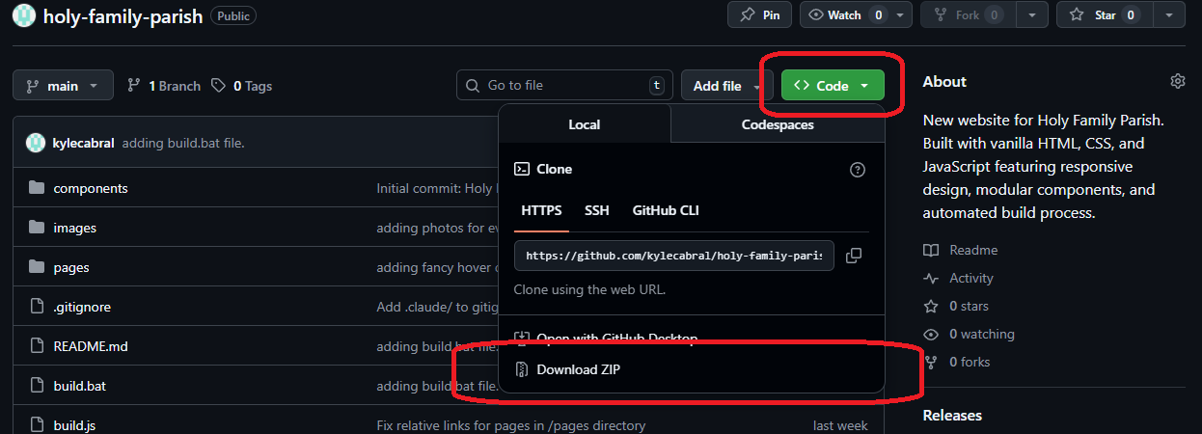
- The .zip file should download to your “Downloads” folder. Open your file explorer and navigate to your Downloads folder; find “holy-family-parish-main.zip”.
- Right click on the .zip file and select “Extract All…”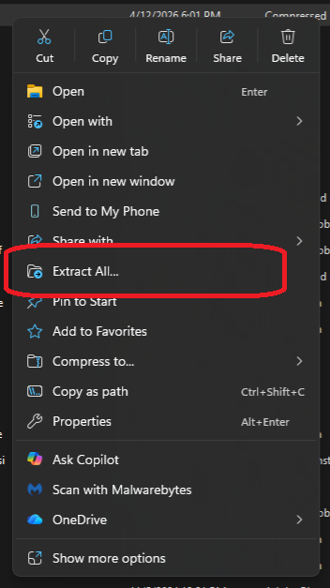
- A popup window asking where to extract the folder will generate. You may select any location. The default will be “Downloads” (which is perfectly fine) Click “Extract”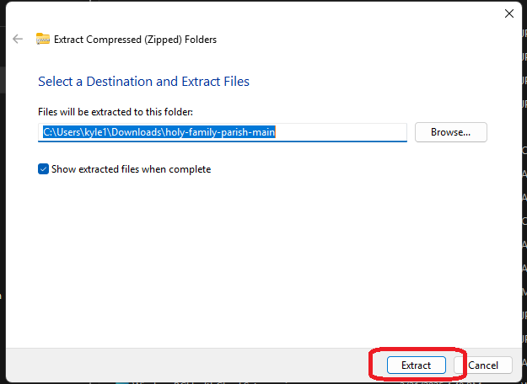
- Once extracted, open the new folder, open the holy-family-parish-main folder. Locate the index.html.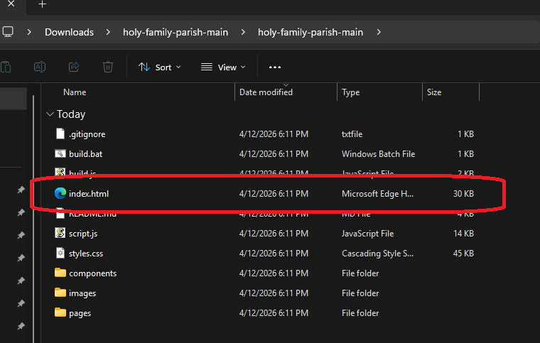
- Right click “index.html” and open with your preferred browser.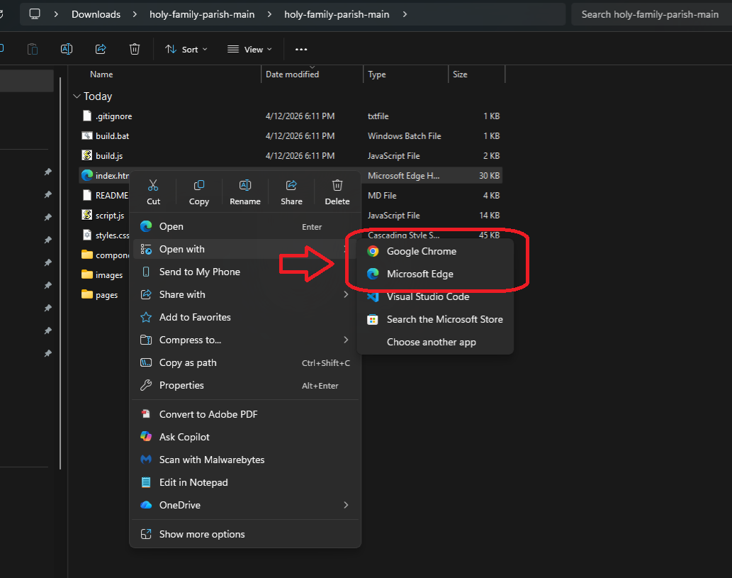
- You should now be able to access and use the site!

