Kyle Carney

CSC 1051-1

Project 6

Trying to learn

For my project I wrote a program that analyzed response times of users when they had to input which number was greater when they were shown two generated numbers. I used data to analyze whether or not there were any specific trends related to:

* Correct responses and the difference between the two generated numbers
* Average response time in relation to correctly answered questions
* Average response time in relation to difference of two generated numbers
* Response time in relation to the greater number being first or second

Time

The project took me about 6 hours to complete. The break after the midterm was perfect, because I am currently in my last week of a coding boot camp and we are working on final projects, so that helped so much. Still, I wish I had more time to work on the project, because I liked how it was open-ended, but I am really busy working on my group project and preparing for a demo day presentation.

Difficulty

I don’t think the project was necessarily easy or hard, because you could make it as complex as you wanted to. I tried some different challenges, but ultimately removed them because they were difficult. I initially was trying to generate random questions by creating an array of questions, but I was having a hard time coding it. I wanted to make sure I had code that was functional and make sure that I was able to complete the project, so I felt like I tried to keep the project manageable. Now that I think about it, I could have used an array of question that would randomly generate the index of each item in the array.

Problems

I came across some problems with variables not being declared in the global scope, and they would not let me utilize them after the for loop. I was trying to print the average response time and was unable to do so because the print statement was outside of the for loop. After I initialized the variables in the global scope I was able to get it to work. I did have problems when I first started trying to arrange questions in an array and randomly pick a question, but I decided to create a program that was more manageable for myself. Also, I came across some problems where I was trying to convert long variables (response time) to an integer (average response time. I ended up declaring them all as long variables and was able to get the code to work.

After reviewing the project, I also realized that I wrote a while loop instead of a for loop. I believe this could be easily corrected by setting up the for loop as (for i = 0; i < NUM_TRIALS; i++) I also can see how a for loop would be beneficial in this case.

Thoughts

I enjoyed the open-ended part of the project. Also, I recently interviewed for a procurement analyst position and the role would involve analyzing data and databases, so this project resonated me in that way because I like to manipulate and analyze data.

Results

I was actually very surprised by the results, because the trends that I came across were not ones that I initially thought of. First, I thought that the difference would matter and it did. The greater the difference was, the users showed a faster response time. Only one user got questions wrong, and I thought that was very interesting because I could gather a few things from his data. Both incorrect questions had the first number as the greater, and the second digit was larger in the number that was less. I think he was trying to do it so fast that the second digit caught his attention and that is why he typed it. That was also a trend across the other users that their times were delayed when the smaller number had a greater second digit than the greater number.

Typing ability also mattered when users input their answers. Still, you could find common trends within each user such as it typically took users longer when the difference between the numbers was less.

After the project I really seen how beneficial data collecting can be in analytics. Ultimately, I believe the more data you collect the more information you can analyze, and you are able to determine more trends.

Source Code

1 1 //*************************************************************  
 2 // Project6.java Author: Kyle Carney  
 3 // Project 6 CSC 1051-1  
 4 //*************************************************************  
 5 import java.util.Scanner;  
 6 import java.util.Random;  
 7   
 8 public class Project6  
 9 {  
 10 public static void main(String[] args)  
 11 {  
 12 Scanner in = new Scanner(System.in);  
 13 Random rand = new Random();  
 14   
 15 //print enter your name  
 16 System.out.print("Please enter your name: ");  
 17 //input name  
 18 String name = in.nextLine();  
 19   
 20 //initialize variables  
 21 int trial = 0;  
 22 int NUM_TRIALS = 4;  
 23 long numberTrials = 4;  
 24 int questionsRight = 0;  
 25 long averageTime = 0;  
 26   
 27 //print Hello "name" please answer as fast as you can  
 28 System.out.println("Hello " + name + ", Welcome to the speed test." +  
 29 "\n\nThere are " + NUM_TRIALS + " questions." +   
 30 "\nAnswer as fast as you can, good luck!");  
 31   
 32 //while trials < number of trials  
 33 while (trial < NUM_TRIALS)  
 34 {  
 35 //print Hit enter when ready   
 36 System.out.println("\n\nHit <ENTER> when ready.");  
 37   
 38 in.nextLine(); // wait for user to hit <ENTER>  
 39 //generate 2 random numbers  
 40 int a = rand.nextInt(100);  
 41 int b = rand.nextInt(100);  
 42   
 43 //startTime = milliseconds  
 44 long startTime = System.currentTimeMillis();  
 45   
 46 //print which number is greater  
 47 System.out.print("Which is the greater number?\n");  
 48 //print num a or num b  
 49 System.out.print(a + " or " + b + " = ");  
 50 //input response  
 51 String response = in.nextLine();  
 52 //convert response to integer  
 53 int number = Integer.parseInt(response);  
 54   
 55 //record time in milliseconds  
 56 long endTime = System.currentTimeMillis();  
 57   
 58 //initialize outcome and greater  
 59 int outcome;  
 60 int greater;  
 61   
 62 //if a > b, greater = a, else b  
 63 if (a > b)  
 64 greater = a;  
 65 else   
 66 greater = b;  
 67   
 68 //if number is greater, outcome is = 1 (correct)   
 69 if (number == greater)  
 70 outcome = 1;  
 71 else  
 72 outcome = 0;  
 73   
 74 //if (outcome == 1) increment questionsRight  
 75 if (outcome == 1)  
 76 questionsRight++;  
 77   
 78 //reaction time = endtime - start time   
 79 long reactionTime = endTime - startTime;  
 80   
 81 //if outcome is 1 print correct, else print incorrect  
 82 if (outcome == 1)  
 83 System.out.println("Correct!");  
 84 else  
 85 System.out.println("Incorrect.");  
 86   
 87 //print reaction time   
 88 System.out.println("That took " + reactionTime + " milliseconds");  
 89 //average time = average time + reaction time  
 90 averageTime = averageTime + reactionTime;  
 91 //increment trial  
 92 trial++;  
 93 }  
 94 //print questions/total questions right  
 95 System.out.println("\nGreat job, you got " + questionsRight +   
 96 "/" + NUM_TRIALS + " questions correct!");  
 97 //average time = averageTime/numberTrials  
 98 averageTime = averageTime/numberTrials;  
 99 //print average response time  
100 System.out.println("Your average response time was " +   
101 averageTime + " milliseconds!\n");   
102 // print goodbye  
103 System.out.println("Thank you " + name + ", goodbye.");  
104 }  
105 }

Test Runs

**TEST 1**  
Hit <ENTER> when ready.  
  
Which is the greater number?  
86 or 65 = 86  
Correct!  
That took 2497 milliseconds  
  
  
Hit <ENTER> when ready.  
  
Which is the greater number?  
76 or 90 = 90  
Correct!  
That took 1551 milliseconds  
  
  
Hit <ENTER> when ready.  
  
Which is the greater number?  
2 or 21 = 21  
Correct!  
That took 1857 milliseconds  
  
  
Hit <ENTER> when ready.  
  
Which is the greater number?  
7 or 68 = 68  
Correct!  
That took 2686 milliseconds  
  
Great job, you got 4/4 questions correct!  
Your average response time was 2147 milliseconds!  
  
Thank you Test 1, goodbye.  
  
 ----jGRASP: operation complete.  
**TEST 2**  
Hit <ENTER> when ready.  
  
Which is the greater number?  
62 or 87 = 87  
Correct!  
That took 3367 milliseconds  
  
  
Hit <ENTER> when ready.  
  
Which is the greater number?  
16 or 9 = 16  
Correct!  
That took 2289 milliseconds  
  
  
Hit <ENTER> when ready.  
  
Which is the greater number?  
80 or 35 = 80  
Correct!  
That took 2933 milliseconds  
  
  
Hit <ENTER> when ready.  
  
Which is the greater number?  
11 or 10 = 11  
Correct!  
That took 1531 milliseconds  
  
Great job, you got 4/4 questions correct!  
Your average response time was 2530 milliseconds!  
  
Thank you Test 2, goodbye.  
  
 ----jGRASP: operation complete.

**TEST 3**  
Hit <ENTER> when ready.  
  
Which is the greater number?  
70 or 71 = 70  
Incorrect.  
That took 3031 milliseconds  
  
  
Hit <ENTER> when ready.  
  
Which is the greater number?  
78 or 94 = 78  
Incorrect.  
That took 2123 milliseconds  
  
  
Hit <ENTER> when ready.  
  
Which is the greater number?  
92 or 38 = 92  
Correct!  
That took 2047 milliseconds  
  
  
Hit <ENTER> when ready.  
  
Which is the greater number?  
66 or 45 = 66  
Correct!  
That took 2425 milliseconds  
  
Great job, you got 2/4 questions correct!  
Your average response time was 2406 milliseconds!  
  
Thank you Test 3, goodbye.  
  
 ----jGRASP: operation complete.

**TEST 4**  
Hit <ENTER> when ready.  
  
Which is the greater number?  
54 or 20 = 54  
Correct!  
That took 1936 milliseconds  
  
  
Hit <ENTER> when ready.  
  
Which is the greater number?  
71 or 38 = 71  
Correct!  
That took 1588 milliseconds  
  
  
Hit <ENTER> when ready.  
  
Which is the greater number?  
4 or 65 = 65  
Correct!  
That took 2232 milliseconds  
  
  
Hit <ENTER> when ready.  
  
Which is the greater number?  
99 or 11 = 99  
Correct!  
That took 1711 milliseconds  
  
Great job, you got 4/4 questions correct!  
Your average response time was 1866 milliseconds!  
  
Thank you Test 4, goodbye.  
  
 ----jGRASP: operation complete.

**TEST 5**  
Hit <ENTER> when ready.  
  
Which is the greater number?  
74 or 57 = 74  
Correct!  
That took 1891 milliseconds  
  
  
Hit <ENTER> when ready.  
  
Which is the greater number?  
20 or 90 = 90  
Correct!  
That took 1403 milliseconds  
  
  
Hit <ENTER> when ready.  
  
Which is the greater number?  
48 or 72 = 72  
Correct!  
That took 1674 milliseconds  
  
  
Hit <ENTER> when ready.  
  
Which is the greater number?  
38 or 43 = 43  
Correct!  
That took 2099 milliseconds  
  
Great job, you got 4/4 questions correct!  
Your average response time was 1766 milliseconds!  
  
Thank you Test 5, goodbye.  
  
**Pilot Run (Fatima)**  
Hit <ENTER> when ready.  
  
Which is the greater number?  
50 or 12 = 50  
Correct!  
That took 2689 milliseconds  
  
  
Hit <ENTER> when ready.  
  
Which is the greater number?  
95 or 54 = 95  
Correct!  
That took 3155 milliseconds  
  
  
Hit <ENTER> when ready.  
  
Which is the greater number?  
93 or 12 = 93  
Correct!  
That took 1382 milliseconds  
  
  
Hit <ENTER> when ready.  
  
Which is the greater number?  
65 or 63 = 65  
Correct!  
That took 5418 milliseconds  
  
Great job, you got 4/4 questions correct!  
Your average response time was 3161 milliseconds!  
  
Thank you Fatima, goodbye.

**Pilot Run (Steve)**  
Hit <ENTER> when ready.  
  
Which is the greater number?  
54 or 63 = 63  
Correct!  
That took 3408 milliseconds  
  
  
Hit <ENTER> when ready.  
  
Which is the greater number?  
8 or 65 = 65  
Correct!  
That took 2503 milliseconds  
  
  
Hit <ENTER> when ready.  
  
Which is the greater number?  
97 or 42 = 97  
Correct!  
That took 2424 milliseconds  
  
  
Hit <ENTER> when ready.  
  
Which is the greater number?  
42 or 90 = 90  
Correct!  
That took 2235 milliseconds  
  
Great job, you got 4/4 questions correct!  
Your average response time was 2642 milliseconds!  
  
Thank you Steve, goodbye.  
  
 ----jGRASP: operation complete.

**Pilot Run (Brian)**  
Hit <ENTER> when ready.  
  
Which is the greater number?  
61 or 55 = 55  
Incorrect.  
That took 1882 milliseconds  
  
  
Hit <ENTER> when ready.  
  
Which is the greater number?  
77 or 41 = 77  
Correct!  
That took 2447 milliseconds  
  
  
Hit <ENTER> when ready.  
  
Which is the greater number?  
67 or 49 = 49  
Incorrect.  
That took 3267 milliseconds  
  
  
Hit <ENTER> when ready.  
  
Which is the greater number?  
38 or 6 = 38  
Correct!  
That took 3416 milliseconds  
  
Great job, you got 2/4 questions correct!  
Your average response time was 2753 milliseconds!  
  
Thank you Brian, goodbye.  
  
 ----jGRASP: operation complete.

**Pilot Run (Drew)**  
Hit <ENTER> when ready.  
  
Which is the greater number?  
73 or 66 = 73  
Correct!  
That took 4782 milliseconds  
  
  
Hit <ENTER> when ready.  
  
Which is the greater number?  
4 or 86 = 86  
Correct!  
That took 3084 milliseconds  
  
  
Hit <ENTER> when ready.  
  
Which is the greater number?  
47 or 15 = 47  
Correct!  
That took 3321 milliseconds  
  
  
Hit <ENTER> when ready.  
  
Which is the greater number?  
64 or 49 = 64  
Correct!  
That took 5890 milliseconds  
  
Great job, you got 4/4 questions correct!  
Your average response time was 4269 milliseconds!  
  
Thank you Drew, goodbye.  
  
 ----jGRASP: operation complete.

**Pilot Run (Michelle)**  
Hit <ENTER> when ready.  
  
Which is the greater number?  
81 or 11 = 81  
Correct!  
That took 3596 milliseconds  
  
  
Hit <ENTER> when ready.  
  
Which is the greater number?  
39 or 50 = 50  
Correct!  
That took 3013 milliseconds  
  
  
Hit <ENTER> when ready.  
  
Which is the greater number?  
89 or 98 = 98  
Correct!  
That took 3475 milliseconds  
  
  
Hit <ENTER> when ready.  
  
Which is the greater number?  
12 or 65 = 65  
Correct!  
That took 2018 milliseconds  
  
Great job, you got 4/4 questions correct!  
Your average response time was 3025 milliseconds!  
  
Thank you Michelle, goodbye.  
  
 ----jGRASP: operation complete.

**Results**

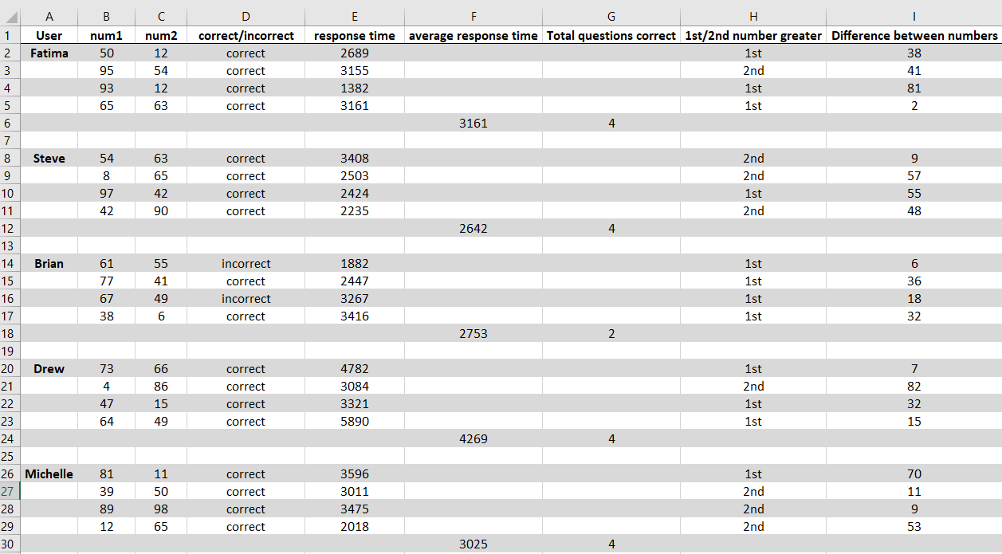

**Comments**

Fatima

It was easy.

It took longer when the numbers were close together

Steve

Harder/longer when numbers are close together

Would be easier if he was a better typer

Brian

Got confused when the 2nd digit was higher

Was trying to do it as fast as he could

Easier when the numbers are more spread apart

Drew

Easier when the difference of the numbers are greater

Slow at typing and did not want to type wrong number

Michelle

Stopped because 2nd digit was the same and second guessed herself

It was easy, not sure how anyone could get one wrong