Kyle Coppedge  
Dr. Bigelow  
16Jan2018

ENGR 1242, Engineering Fundamentals, Project Report 1

1. **Functional Objectives:**
   1. **The robot should be programmable**
      1. **Constraints**
         1. **Layout**

The PIC must be mounted on a small breadboard.

* + - 1. **Components**

The PIC must receive its power from a 8 V Power Supply.

* + - 1. **Time**

The project must be completed by 5:20PM on Jan 11th.

* + 1. **Test Plan 1 and results**
       1. **Setup**

Connect the PIC Kit 2 and program the PIC.

* + - 1. **Test**

Open the UART Tool and press the reset button.

* + - 1. **Results**

“ECE Rules!” was displayed on the UART Tool.

* + 1. **Statement of success**

The project is successful after the objectives have been met within the constraints.

1. **Hardware Design:**
   1. **Hardware System Overview**
      1. **System Block Diagram**

Coming soon.

* + 1. **Subsystem Descriptions**

Coming soon.

* + 1. **Signal Descriptions**

Coming soon.

* 1. **Circuit Diagrams**
     1. **Power System**
     2. **PIC Configuration**

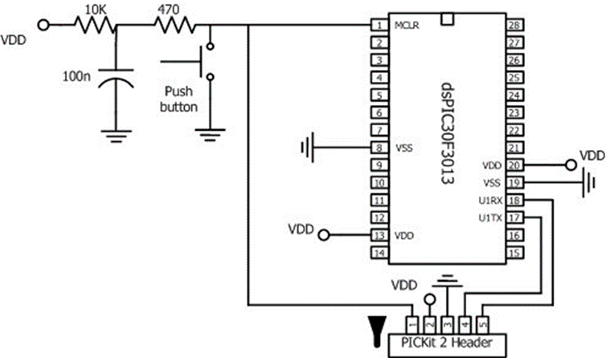

* + 1. **Pinouts**
       1. **Voltage Regulator**

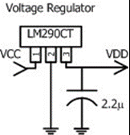

* + - 1. **MOSFET**
      2. **BJT**
      3. **NOR Gate**
    1. **LED Circuits**
    2. **Test Pins**
    3. **Motor Drivers**
    4. **Bumper System**
    5. **Light Detection System**

1. **Software Design**
   1. **Software System Overview:**
      1. **High-Level Description**

The software prints text in the debug console.

* + 1. **Pin Definitions**

|  |  |  |
| --- | --- | --- |
| **PIC Pin** | **Variable name** | **Description** |
| Coming | Soon. |  |

* + 1. **Code Listing of definitions.h**

Coming soon.

* 1. **Detailed Function Descriptions:**

|  |  |
| --- | --- |
| Name: | Coming soon. |
| Purpose: |  |
| Calls: |  |
| Code: |  |
| Flowchart: |  |