1



**NeuroGaze: A Hybrid EEG and Eye-Tracking**

**Brain-Computer Interface for Hands-Free Interaction in Virtual Reality**

# Kyle Coutray1, Wanyea Barbel1, Zack Groth1 and Joseph J LaViola Jr1*,*∗

1*Interactive Systems and User Experience Research Cluster, Department of Computer Science, University of Central Florida, Orlando, FL, USA*

Correspondence*: Joseph J LaViola Jr jlaviola@ucf.edu

# 2 ABSTRACT

3 Brain-Computer Interfaces (BCIs) have traditionally been studied in clinical and laboratory 4 contexts, but the rise of consumer-grade devices now allows exploration of their use in daily 5 activities. Virtual reality (VR) provides a particularly relevant domain, where existing input methods 6 often force trade-offs between speed, accuracy, and physical effort. This study introduces

1. NeuroGaze, a hybrid interface combining electroencephalography (EEG) with eye tracking to
2. enable hands-free interaction in immersive VR. Twenty participants completed a 360° cube-
3. selection task using three different input methods: VR controllers, gaze combined with a pinch
4. gesture, and NeuroGaze. Performance was measured by task completion time and error rate,
5. while workload was evaluated using the NASA Task Load Index (NASA-TLX). NeuroGaze 12 successfully supported target selection with off-the-shelf hardware, producing fewer errors than 13 the alternative methods but requiring longer completion times, reflecting a classic speed-accuracy 14 tradeoff. Workload analysis indicated reduced physical demand for NeuroGaze compared to 15 controllers, though overall ratings and user preferences were mixed. These findings demonstrate 16 the feasibility of hybrid EEG+gaze systems for everyday VR use, highlighting their ergonomic 17 benefits and inclusivity potential. Although not yet competitive in speed, NeuroGaze points toward 18 a practical role for consumer-grade BCIs in accessibility and long-duration applications, and 19 underscores the need for improved EEG signal processing and adaptive multimodal integration 20 to enhance future performance.

21 **Keywords: Brain-Computer Interface (BCI), Electroencephalography (EEG), Eye tracking, Virtual reality (VR), Hybrid interfaces,** 22 **Hands-free interaction, Human-computer interaction (HCI), Accessibility**

# 1 INTRODUCTION

23 Virtual reality (VR) systems have advanced rapidly in terms of visual immersion and motion tracking, but 24 interaction remains a central challenge (Jerald, 2015; LaViola Jr. et al., 2017; Chong et al., 2018). The 25 input devices that mediate user actions fundamentally shape the quality of the experience, and each current

1. method carries trade-offs. Handheld controllers remain the most common solution, offering speed and
2. precision through ray casting and button presses. However, extended use of controllers can be fatiguing,
3. particularly in tasks that require repetitive pointing or in scenarios where hands-free interaction is desirable 29 (Meier et al., 2021). Gaze-based dwell selection has been proposed as a more natural, ergonomic alternative
4. (Sidenmark et al., 2022) where users fixate on a target and selection occurs after a brief dwell time, building
5. on decades of research into the fundamental dynamics of eye movements (Martinez-Conde and Macknik,
6. 2008; Cannon, 1992). While hands-free, this approach is slower, vulnerable to the “Midas touch” problem 33 (Tang et al., 2025) of unintended activations, and can feel unnatural when prolonged fixations are required 34 (Mohan et al., 2018; Isomoto et al., 2018; Chakraborty et al., 2014). More recently, combinations of 35 eye tracking with manual gestures, such as pinch confirmation, have improved speed and reduced false

36 selections (Zhang et al., 2020; Vertegaal, 2008; Stellmach and Dachselt, 2012). Yet these methods still 37 depend on reliable hand mobility and introduce motor demands that limit accessibility for some users 38 (Gherman et al., 2018).

1. Brain-Computer Interfaces (BCIs) offer an intriguing pathway to augment VR interaction by providing a
2. neural channel for intent confirmation (Saxena et al., 2024). Traditionally restricted to clinical and tightly
3. controlled experimental contexts (Padfield et al., 2019; Nicolas-Alonso and Gomez-Gil, 2012), BCIs are 42 now becoming accessible outside the lab with the rise of consumer-grade headsets and biosensors. These 43 devices make it feasible to test interaction techniques not only in laboratory studies but also in the context

44 of daily activities (Vasiljevic and de Miranda, 2020; Pan et al., 2017; Rizzo et al., 2024). Prior research has 45 demonstrated the feasibility of integrating electroencephalography (EEG) with eye tracking for selection

1. tasks in two-dimensional desktop settings and experimental prototypes (Putze et al., 2013, 2016; Hild et al.,
2. 2014). For example, hybrid gaze+EEG systems have been used to disambiguate visual targets, detect covert
3. attention, or reduce false activations (Shishkin et al., 2016; Kalaganis et al., 2018; Vortmann et al., 2022;
4. Evain et al., 2016). However, most of this work has remained confined to controlled laboratory setups or´ 50 2D displays, with limited exploration in fully immersive VR environments (Larsen et al., 2024) and little 51 emphasis on consumer-grade hardware. As a result, the real-world practicality of such systems for daily 52 activities remains uncertain.

53 This study introduces and evaluates NeuroGaze, a hybrid EEG and eye-tracking interface designed for 54 immersive VR using readily available consumer devices (Meta Quest Pro for eye tracking and Emotiv 55 EPOC X for EEG). Unlike prior work that has focused narrowly on proof-of-concept demonstrations, we 56 directly benchmark NeuroGaze against two widely adopted VR input methods: hand controllers and eye

1. tracking with pinch gestures. In doing so, we provide the first comparative validation of a consumer-grade
2. hybrid EEG+gaze system in immersive VR. Our evaluation maps the trade-offs between speed, accuracy,
3. and physical effort across these modalities, situating NeuroGaze within the broader design space of VR
4. interaction. The findings reveal both the potential and the current limitations of hybrid BCIs for daily 61 activities, highlighting their promise as an accessible, ergonomic alternative for users who may benefit 62 from hands-free, low-effort interaction.

# 2 MATERIALS AND METHODS

## 63 2.1 Participants

64 Twenty healthy adult volunteers (12 male, 8 female; age range 18-32 years) were recruited from the 65 university community. All participants reported normal or corrected-to-normal vision, no history of 66 neurological or motor impairments, and no susceptibility to simulator sickness. Inclusion criteria required 67 participants to be at least 18 years of age, proficient in English, and physically able to wear both the EEG 68 headset and the VR head-mounted display.

69 Participants represented a broad range of prior VR experience, from no exposure to frequent recreational 70 use. Approximately 25% of the sample reported little or no prior VR experience, 60% reported moderate to 71 above-moderate experience, and 15% described themselves as very experienced. Comparable distributions 72 were observed for AR exposure and VR gaming, indicating that the sample encompassed both novices and 73 highly experienced users.

74 All participants provided written informed consent prior to participation. The study was approved by the 75 university’s Institutional Review Board (IRB ID: STUDY00006401).

## 76 2.2 Apparatus

77 The immersive environment was presented using a Meta Quest Pro head-mounted display (Meta Platforms 78 Inc., USA) with integrated binocular eye tracking. The headset provided real-time gaze vectors at a sampling

79 rate of 72 Hz (Hou et al., 2024), and participants completed a standard five-point calibration at the beginning 80 of each session. EEG activity was recorded using an Emotiv EPOC X headset (Emotiv Inc., USA), which

81 features 14 active electrodes positioned according to the international 10-20 system (Khazi et al., 2012) 82 (AF3, F7, F3, FC5, T7, P7, O1, O2, P8, T8, FC6, F4, F8, AF4) with mastoid references (TP9, P3, P4, TP10)

83 shown in Figure 1A-B. EEG signals were captured internally at 2048 Hz, then downsampled to 128 Hz or 84 256 Hz for wireless transmission via Bluetooth Low Energy (Emotiv Inc., 2020). Electrode-skin contact 85 quality was continuously monitored, and saline solution (OPTI-FREE saline solution) was reapplied as 86 needed to maintain stable impedance. The entire NeuroGaze setup required users to wear both the Emotiv 87 EPOC X and the Meta Quest Pro simultaneously, often with a comfort headband to keep the EPOC X in 88 place, and saline solution applied to electrodes for stable connection (Figure 1C-E).

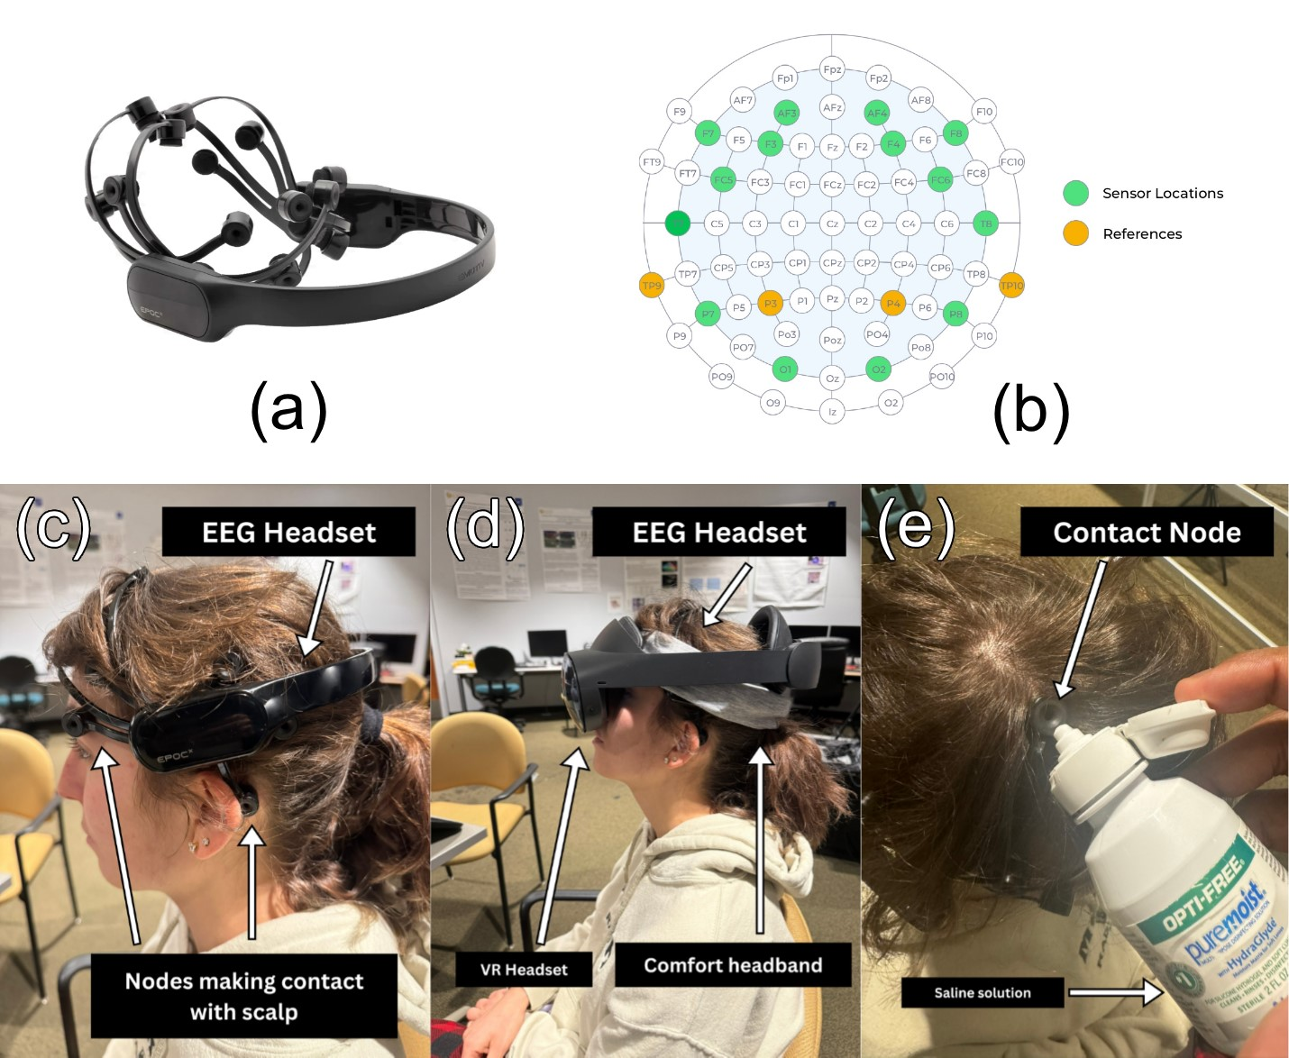

Figure 1. (a) The Emotiv EPOC X headset used for EEG data collection. (b) Electrode montage showing the 14 active sensor locations (green) and mastoid reference electrodes (orange) based on the international 10-20 system. (c) Emotiv EPOC X EEG headset with electrodes in contact with the scalp. (d) Combined configuration of the EPOC X, comfort headband, and Meta Quest Pro VR headset worn simultaneously. (e) Application of saline solution to EPOC X electrodes to maintain stable contact quality.

89 The experimental software was developed in Unity (Unity Technologies, USA) using the Meta XR 90 All-in-One SDK. Eye tracking was used to control a visual ray pointer and object hover state, rendered 91 as a white line from the midpoint of the user’s eyes to 500 meters in the forward direction. This ray cast 92 triggered a scaling effect on interactable objects, causing them to grow to a fixed scale (0.2304m³) when 93 hovered over and shrink back (0.18m³) when not. EEG signals were streamed into Unity through the Emotiv 94 Cortex API. EEG calibration involved training two mental command classes: a neutral state (representing

1. relaxed, unfocused brain activity) and a “pull” command associated with selection. During calibration,
2. participants viewed objects that appeared and shrank in synchrony with their imagined action, providing
3. feedback to reinforce consistent neural patterns (this was achieved through a Wizard-of-Oz approach in
4. which the experiment administrator manually triggered the object to shrink seen in Figure 2). Once trained,
5. the classifier output was integrated into the Unity selection loop: objects under gaze became eligible for 100 interaction, and a detected pull command triggered selection. The EmotivBCI program handled training 101 profiles, EEG noise sanitization, and classification of EEG artifacts. To ensure synchronization across

102 devices, event markers from Unity were transmitted to the EEG stream via the Cortex API, and system 103 timestamps were aligned to the host computer’s monotonic clock. Pilot testing verified timing precision 104 within ±20 ms between modalities, sufficient for behavioral comparison across input conditions.

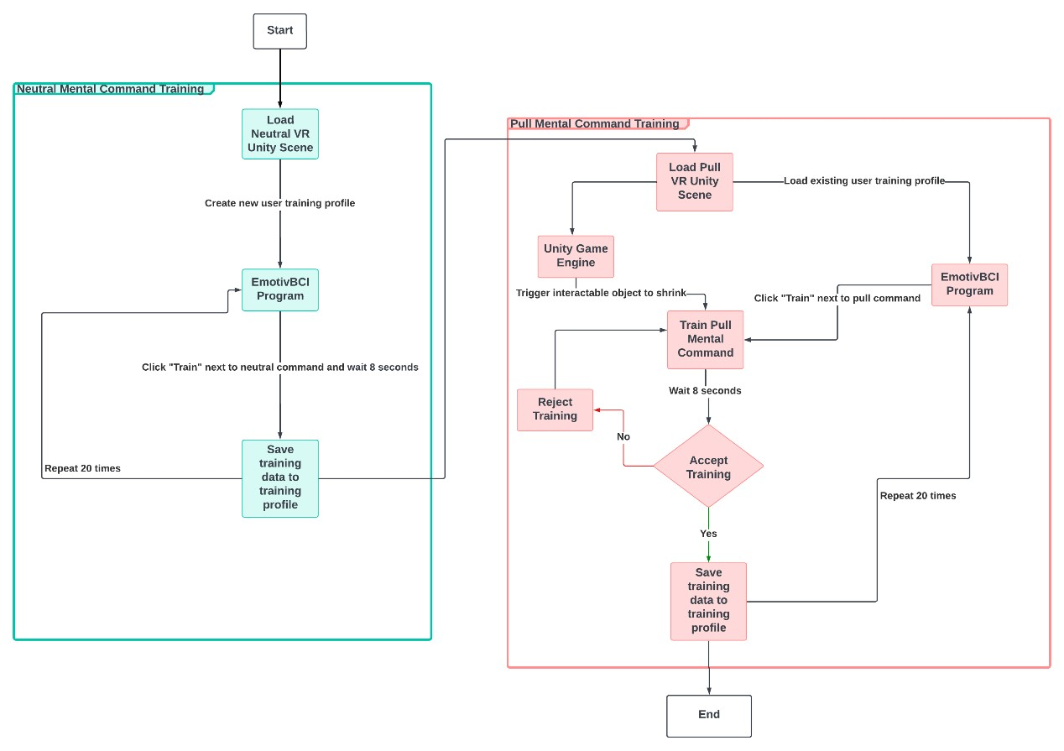

Figure 2. Flowchart of the NeuroGaze EEG calibration procedure. The process consists of two stages: (left, teal) neutral mental command training, where participants repeatedly train a relaxed state in the EmotivBCI program, and (right, red) pull mental command training, where participants attempt to imagine a “pull” action while the Unity engine triggers object shrinkage through a Wizard-of-Oz approach. Each command was trained in 20 repetitions, with accepted trials saved to the user’s training profile for later classification during the experiment

## 105 2.3 Task

106 Participants completed a 360° object-selection task in a virtual environment (VE). The environment 107 consisted of four surrounding walls, each displaying a 4 x 9 array of white cubes (36 per wall; 144 total) as 108 seen in Figure 3.

1. At the start of each block, 12 cubes (three per wall) were designated as targets by turning red. Participants
2. were instructed to select these targets as quickly and accurately as possible. When a target was successfully 111 selected, it disappeared from the scene, and the block concluded once all targets had been cleared (Figure 112 3). The average distance from the user to each wall of cubes was approximately 2 m.

113 The task required participants to actively rotate their heads and bodies to engage with spatially distributed 114 targets across the 360° field. Visual readiness feedback was provided by a scaling effect: when a user’s

1. gaze or pointing ray intersected a cube, it gradually increased in size (from 0.56 m to 0.62 m per side,
2. corresponding to a 0.18 m³ to 0.23 m³ volume). Objects remained fixed in position and provided feedback 117 only through this change in scale.

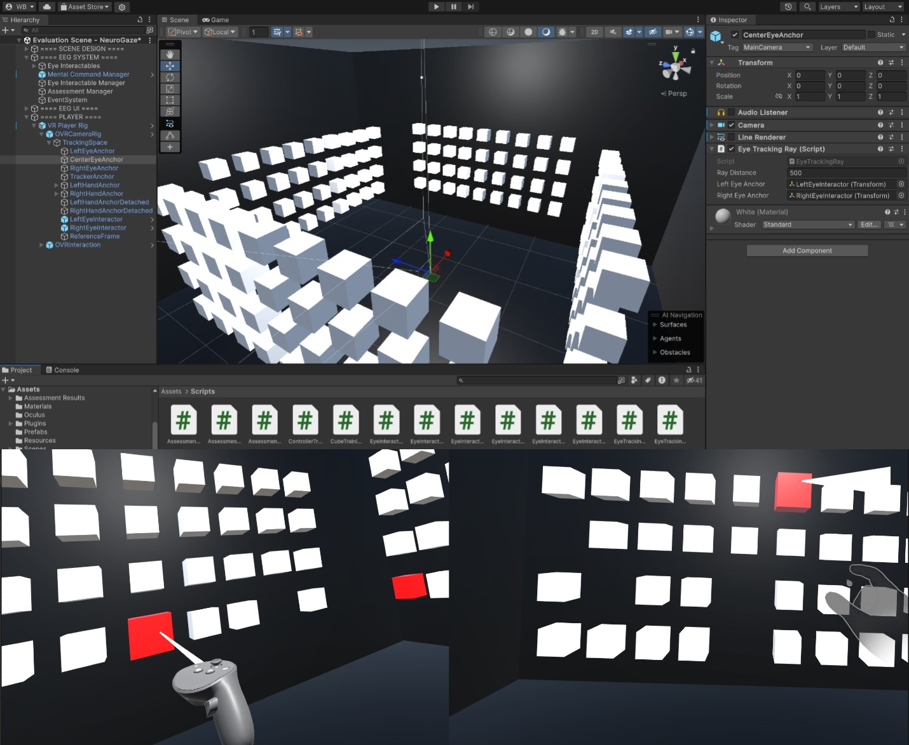

Figure 3. Top: Unity editor view of the 360° object-selection task environment, with four cube arrays surrounding the participant. Bottom: Example participant perspectives during task execution. Left: VR Controller (VRC) condition; Right: Eye Gaze + Hand Gesture (EG+HG) condition.

## 118 2.4 Experimental Conditions

1. Each participant completed the selection task under three input modalities: VR Controllers (VRC).
2. Participants used standard handheld VR controllers to interact with the virtual environment. A ray projected 121 from the end of the controller was used to aim at targets, with selection confirmed via a trigger button press. 122 This condition represented the conventional VR input method and served as the baseline for speed and 123 precision.

124 Eye Tracking + Hand Gesture (EG+HG). Participants aimed by fixating on a target cube using the Quest 125 Pro’s integrated infrared eye-tracking system. Selection was confirmed with a pinch gesture detected by the 126 headset’s optical hand-tracking system. This approach provided gaze-driven aiming with explicit manual 127 confirmation, similar to interaction paradigms employed in emerging augmented reality headsets.

1. NeuroGaze (NG). Participants aimed using eye gaze, with selection confirmed by an EEG-based “pull”
2. mental command classified in real time by the Emotiv EPOC X headset. This condition enabled fully
3. hands-free interaction through a hybrid brain-computer interface. The NeuroGaze system used a closed-
4. loop control design, combining gaze-based ray casting with visual scaling feedback (grow/shrink cues) to 132 indicate selection readiness and execution. The order of conditions was randomized across participants to 133 minimize order and learning effects.

## 134 2.5 Measures

135 Task performance was assessed using two primary behavioral measures. First, completion time was 136 defined as the elapsed time (in milliseconds) between target onset and confirmed selection. This measure 137 captured how long participants required to select all red interactable objects in the scene, with values 138 exported directly from Unity environment logs. Second, error rate was defined as the proportion of incorrect 139 or unintended selections relative to total trials, including both missed targets and incorrect object selections. 140 Error data were compiled from block-level outcomes.

141 Subjective workload was evaluated after each condition using the NASA Task Load Index (NASA-TLX), 142 which provides ratings across six subscales: Mental Demand, Physical Demand, Temporal Demand, 143 Performance, Effort, and Frustration. To derive the overall workload score, the subscales were combined 144 according to Equation 1.

NASA-TLX = Mental Demand + Physical Demand

+ Temporal Demand +(7− Performance) (1)

+ Effort + Frustration

1. Both aggregated NASA-TLX scores and individual subscale ratings were retained for analysis.
2. Finally, overall preference was captured through a post-experiment ranking task. After completing all 147 three input conditions, participants ranked the modalities from most preferred (rank = 1) to least preferred 148 (rank = 3). This ranking provided a simple comparative index of participants’ subjective impressions of 149 each input method.

## 150 2.6 Analysis Plan

151 Task completion time was analyzed with a repeated-measures design. Mauchly’s test of sphericity was 152 first applied; when violations were detected (*p <* 0*.*001), Greenhouse-Geisser corrections were used. 153 A repeated-measures ANOVA was then conducted with Input Condition (VR Controllers, Eye+Pinch,

154 NeuroGaze) as the within-subjects factor. Significant effects were followed up with Bonferroni-corrected 155 pairwise t-tests. Effect sizes (partial *η*2) were reported alongside significance values.

156 Error rates were analyzed similarly. Mauchly’s test indicated that the assumption of sphericity was met 157 (*p* = 0*.*85), so a repeated-measures ANOVA was conducted on average error counts. Post-hoc comparisons 158 were performed with paired t-tests, and *η*2 effect sizes were reported.

1. Subjective workload was evaluated using NASA-TLX ratings. Aggregated workload scores were
2. compared across conditions using a Friedman test. Individual subscales (Mental Demand, Physical Demand, 161 Temporal Demand, Performance, Effort, and Frustration) were analyzed with Wilcoxon signed-rank tests. 162 Bonferroni correction was applied, setting the adjusted threshold for significance at *p <* 0*.*003125.

163 User preference rankings were analyzed with a Chi-squared test of independence to examine associations 164 between input modality and rank position. Across all analyses, 95% confidence intervals were reported to

165 provide interval estimates of effects. Visualizations were prepared to illustrate group-level distributions, 166 including raincloud plots for completion time, bar plots for error rates, and radar charts for NASA-TLX 167 subscales.

# 3 RESULTS

1. The results are organized into three subsections corresponding to the main dependent measures: task
2. completion time, error rate, and subjective workload. Statistical analyses were performed using repeated-
3. measures designs with Condition (VR Controllers, Eye + Hand Gesture, NeuroGaze) as the within-subjects 171 factor. All reported pairwise comparisons used Bonferroni-corrected p-values, and effect sizes are presented 172 alongside significance values.

## 173 3.1 Completion Time

174 Task completion time differed significantly across input conditions. A repeated-measures ANOVA with 175 Greenhouse-Geisser correction (due to sphericity violation, *χ*2(20) = 29*.*22, *p <* 0*.*001) showed a robust

1. main effect of condition,.
2. Participants completed the selection task fastest with VR Controllers (M = 9.25 s, SD = 4.15 s), followed 178 by Eye + Hand Gesture (M = 15.02 s, SD = 5.30 s), and slowest with NeuroGaze (M = 29.23 s, SD = 179 2.25 s) (Figure 4). Pairwise comparisons confirmed that both VR Controllers (*p <* 0*.*001) and Eye + Hand 180 Gesture (*p <* 0*.*001) were significantly faster than NeuroGaze. VR Controllers were also significantly 181 faster than Eye + Hand Gesture (*p <* 0*.*001).
3. This pattern indicates that while NeuroGaze enabled reliable hands-free selection, its current
4. implementation introduced substantial latency compared to standard input methods. This delay likely
5. reflects both the additional processing time required for EEG classification and the conservative strategies 185 participants adopted when using the BCI-based system.

## 186 3.2 Error Rate

187 Error rates differed significantly across input conditions. A repeated-measures ANOVA (Mauchly’s test 188 indicated sphericity was met: *χ*2(20) = 4.93, *p* = 0*.*85) revealed a main effect of condition, *F*(2*,*36) = 5*.*39,

.

190 On average, participants made the fewest errors with NeuroGaze (M = 2.25, SD = 1.08), followed by VR 191 Controllers (M = 4.15, SD = 1.56) and Eye + Hand Gesture (M = 5.30, SD = 2.25) (Figure 4). Pairwise 192 contrasts showed significantly fewer errors in NeuroGaze compared with Eye + Hand Gesture (*p* = 0*.*041).

193 Differences between NeuroGaze and VR Controllers (*p* = 0*.*441) and between VR Controllers and Eye + 194 Hand Gesture (*p* = 0*.*105) were not significant.

195 Although NeuroGaze yielded fewer errors overall, this advantage appears linked to participants’ slower, 196 more deliberate pace rather than inherently superior input fidelity. The pattern aligns with the speed197 accuracy tradeoff observed across modalities.

## 198 3.3 NASA-TLX

199 Subjective workload ratings from the NASA-TLX revealed differences across conditions, although 200 patterns varied by subscale. Aggregated workload scores did not differ significantly between modalities 201 (VR Controllers: M = 19.30; Eye + Hand Gesture: M = 20.10; NeuroGaze: M = 15.75), Friedman 202 *χ*2(2) = 0*.*29, *p >* 0*.*05 (Figure 4).

203 When subscales were examined individually using Wilcoxon signed-rank tests with Bonferroni correction 204 (*p <* 0*.*003125), more specific distinctions emerged. Physical Demand was lowest for NeuroGaze (M = 205 1.3), significantly lower than VR Controllers (M = 3.3, *p* = 0*.*002). The comparison with Eye + Hand 206 Gesture (M = 3.6) trended in the same direction (*p* = 0*.*006) but did not survive correction. No difference 207 was observed between VR Controllers and Eye + Hand Gesture (*p* = 0*.*89).

208 Temporal Demand also differed: NeuroGaze (M = 3.2) was rated significantly less demanding than both 209 VR Controllers (*p* = 0*.*001) and Eye + Hand Gesture (*p* = 0*.*002). For Mental Demand, no significant 210 differences were found (NeuroGaze M = 3.2; VR Controllers M = 3.3; Eye + Hand Gesture M = 2.6).

1. Similarly, Performance, Effort, and Frustration ratings did not differ significantly after correction.
2. Overall, these findings suggest that NeuroGaze reduced perceived physical and temporal demand 213 compared with conventional inputs, while overall cognitive workload remained comparable.

## 214 3.4 User Preference

1. After completing all three conditions, participants ranked the input modalities by overall preference.
2. NeuroGaze was most often ranked first (10 participants), followed by VR Controllers (5) and Eye + Hand 217 Gesture (5). Intermediate rankings were more evenly distributed (VR Controllers: 8; NeuroGaze: 6; Eye 218 + Hand Gesture: 6). Least-preferred rankings were most frequently assigned to Eye + Hand Gesture (9 219 participants), followed by VR Controllers (7) and NeuroGaze (4). A chi-squared test of independence

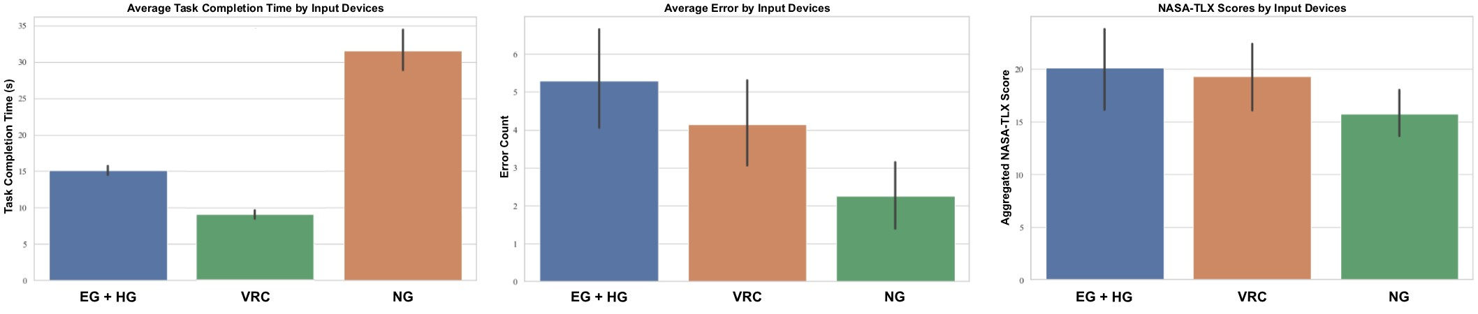

Figure 4. Task performance and subjective workload across input devices. Left: Average task completion time (s). Middle: Average error count. Right: Aggregated NASA-TLX workload scores. Conditions are labeled as follows: EG+HG = Eye Gaze + Hand Gesture, VRC = VR Controllers, NG = NeuroGaze. Error bars represent 95% confidence intervals.

220 revealed no significant association between input modality and preference ranking, *χ*2(2*,N* = 20) = 4*.*8, 221 *p* = 0*.*31.

222 Qualitative feedback provided additional context. VR Controllers were praised for their speed and 223 familiarity. Eye + Hand Gesture was described as intuitive but often unreliable, with several participants 224 noting difficulty executing pinch gestures. NeuroGaze was appreciated for its novelty and hands-free 225 interaction, though some participants reported discomfort from wearing both headsets and noted slower 226 response times.

# 4 DISCUSSION

## 227 4.1 Interpretation

228 The present findings highlight both the strengths and limitations of current VR input modalities. 229 Handheld controllers remain the gold standard for speed, with participants consistently achieving the fastest 230 completion times. This reflects both the maturity of the technology and its optimization for rapid, precise 231 selection tasks. Eye tracking with pinch gestures (EG+HG) occupied an intermediate position, offering 232 more intuitive aiming than controllers but at the expense of occasional mis-selections due to incomplete or 233 unrecognized hand gestures.

234 In contrast, NeuroGaze (NG) yielded fewer errors overall, but this advantage came at the cost of 235 substantially slower task completion times. The observed accuracy therefore appears to result from 236 participants adopting a more deliberate pace rather than from inherently superior input fidelity—a clear

1. example of the classic speed-accuracy tradeoff. Taken together, these results suggest that NG does not
2. currently outperform existing VR inputs on raw performance metrics. Instead, its contribution lies in 239 providing a viable, hands-free alternative that emphasizes accuracy and ergonomic accessibility (Hohne¨

240 et al., 2014; Kos’myna and Tarpin-Bernard, 2013) rather than speed. Rather than competing with controllers 241 in gaming or other high-speed applications, NG is more appropriately positioned for daily-activity contexts 242 where comfort, inclusivity, and error minimization are paramount.

## 243 4.2 Contribution

244 This study provides the first demonstration that a consumer-grade hybrid EEG and eye-tracking system 245 can be implemented and evaluated reliably in a fully immersive VR environment. Prior work on gaze-EEG 246 interaction has largely relied on laboratory-grade hardware or 2D desktop displays, limiting ecological 247 validity and applicability to everyday contexts. By deploying NeuroGaze with widely available devices—the 248 Meta Quest Pro and Emotiv EPOC X—this study shows that hybrid brain-computer interfaces are no longer 249 confined to specialized laboratories and can be assessed under conditions closer to daily VR use.

250 Benchmarking NeuroGaze against two established input modalities (controllers and gaze + pinch) further 251 clarified its comparative strengths and weaknesses. While slower than conventional inputs, NeuroGaze 252 offers a tangible ergonomic benefit, demonstrated by lower physical demand ratings and fully hands-free

253 operation. These qualities suggest that the system is not a competitor to controllers in time-sensitive or 254 performance-critical contexts, but rather a complementary modality where accessibility, comfort, and

1. reduced fatigue are prioritized. The most promising applications of NeuroGaze may therefore lie in
2. daily-activity and accessibility-oriented scenarios that demand sustained interaction without physical
3. strain (Sellers et al., 2010). Examples include VR-based rehabilitation, training for individuals with motor
4. impairments, or prolonged use cases where repetitive arm or hand motions become burdensome. By 259 reframing the role of BCIs away from speed competition and toward ergonomic inclusivity, this study 260 contributes to a broader vision of BCIs as practical tools for everyday human-computer interaction.

## 261 4.3 Limitations

262 Several limitations of the present study should be acknowledged. First, the sample size was modest (N 263 = 20), which restricts the generalizability of the findings and reduces the statistical power to detect more 264 subtle effects. While sufficient for an initial proof-of-concept, larger studies will be needed to establish 265 more robust estimates of performance and variability across different populations. Second, the task design 266 employed static targets arranged across four walls. This setup provided consistency across conditions but

1. does not capture the more dynamic and unpredictable environments in which VR interactions typically
2. occur. Future work should examine performance in tasks involving moving or context-sensitive stimuli
3. to evaluate real-world applicability. Third, the EEG calibration procedure incorporated a Wizard-of-Oz
4. component in which feedback was artificially reinforced to improve classifier training. Although the 271 actual task relied on trained classifiers, this approach may have inflated participants’ perception of system 272 reliability during calibration. A further limitation arises from the use of consumer-grade EEG hardware 273 (Emotiv EPOC X), which is constrained by relatively low signal-to-noise ratios. In practice, this restricted 274 the system to a binary command scheme (neutral vs. pull), as attempts to distinguish more complex
5. mental commands (e.g., push and pull) would have introduced substantial classification errors. Relatedly,
6. reliance on consumer-grade EEG made the system more susceptible to artifacts such as blinking and head 277 movement, and the limited spatial resolution reduced the sophistication of neural information that could be 278 leveraged.

279 Finally, ergonomic incompatibility between the EEG headset and the Meta Quest Pro contributed to 280 discomfort during extended use. While employing commercially available devices strengthens ecological 281 validity, these hardware limitations necessarily constrained both the fidelity of neural input and the overall 282 user experience.

## 283 4.4 Future Work

284 Several avenues for future development emerge from the present findings. A key priority is the 285 reduction of system latency. NeuroGaze’s slower performance relative to traditional input methods reflects 286 both the computational overhead of EEG signal classification and the conservative thresholds used to

1. minimize false activations. Advances in machine learning and signal processing—such as adaptive filtering,
2. transfer learning across users, and real-time artifact rejection—may help reduce response times while 289 maintaining accuracy, thereby improving the practical viability of hybrid BCI input. Another promising 290 direction involves adaptive multimodal switching, in which NeuroGaze could dynamically integrate with 291 conventional controllers or gesture-based systems. For example, users might rely on EEG+gaze input 292 for sustained, low-effort interaction but seamlessly transition to controller-based input when speed or 293 fine-grained control is required. Such hybrid workflows would leverage the strengths of each modality and
3. broaden the contexts in which BCIs are practical. Beyond EEG alone, integration with complementary
4. biosignals represents a further step forward. Modalities such as functional near-infrared spectroscopy
5. (fNIRS), electromyography (EMG), or pupillometry could provide additional channels for intent detection 297 and cognitive-state monitoring. Combining signals could improve classification robustness, reduce reliance 298 on single noisy channels, and support more complex command vocabularies than binary EEG triggers allow. 299 Finally, future studies should move beyond healthy young adults to evaluate NeuroGaze in accessibility

300 scenarios. Populations with motor impairments, fatigue-related conditions, or limited hand mobility stand 301 to benefit most from hands-free BCI interaction. Assessing usability, comfort, and performance in these 302 groups will be essential for determining NeuroGaze’s translational potential in rehabilitation, assistive 303 technology, and daily activity contexts.

# 5 CONCLUSION

304 This study introduced and evaluated NeuroGaze, a hybrid EEG and eye-tracking interface implemented 305 with consumer-grade hardware in an immersive VR environment. Compared to conventional VR controllers 306 and gaze+pinch interaction, NeuroGaze enabled reliable, fully hands-free object selection, though at the 307 cost of slower task completion times. The results reflect a classic speed-accuracy tradeoff: participants 308 made fewer errors with NeuroGaze, but this advantage stemmed largely from more deliberate pacing rather 309 than inherently superior input fidelity. Despite these performance constraints, NeuroGaze demonstrates 310 clear ergonomic and accessibility promise. By reducing physical demand and eliminating the need for 311 handheld controllers, it extends VR interaction beyond speed-driven contexts toward scenarios where 312 comfort, inclusivity, and reduced fatigue are prioritized. Rather than serving as a replacement for controllers

313 in time-critical tasks, NeuroGaze should be considered a complementary modality for daily activities, 314 rehabilitation contexts, and fatigue-sensitive environments where minimizing physical effort is critical. 315 Taken together, these findings establish the feasibility of hybrid EEG+gaze interaction in immersive VR 316 using readily available consumer devices. More broadly, they highlight the potential of consumer-grade 317 BCIs not as direct competitors to established input methods, but as enablers of more inclusive and adaptable 318 human-computer interaction.

# CONFLICT OF INTEREST STATEMENT

319 The authors declare that the research was conducted in the absence of any commercial or financial 320 relationships that could be construed as a potential conflict of interest.

**DATA AVAILABILITY STATEMENT**

321 The datasets analyzed for this study can be found in the GitHub repository here: https://github.com/Wanyea/NeuroGaze

# REFERENCES

322 Cannon, S. (1992). The neurology of eye movements (contemporary neurology series). *Archives of* 323 *Ophthalmology* 110, 326–326. doi:10.1001/archopht.1992.01080150024016

1. Chakraborty, T., Sarcar, S., and Samanta, D. (2014). Design and evaluation of a dwell-free eye typing
2. technique. In *CHI ’14 Extended Abstracts on Human Factors in Computing Systems* (New York, NY,
3. USA: Association for Computing Machinery), CHI EA ’14, 1573–1578. doi:10.1145/2559206.2581265
4. Chong, H. T., Lim, C. K., and Tan, K. L. (2018). Challenges in virtual reality system: A review. *AIP* 328 *Conference Proceedings* 2016, 020037. doi:10.1063/1.5055439

329 Emotiv Inc. (2020). *Emotiv EPOC X Technical Specifications*. Internal sampling: 2048 Hz; downsampled 330 to 128/256 Hz for BLE or other transmission

1. Gherman, O., Schipor, O., and Gheran, B.-F. (2018). Verge: A system for collecting voice, eye gaze,
2. gesture, and eeg data for experimental studies. In *2018 International Conference on Development and* 333 *Application Systems (DAS)*. 150–155. doi:10.1109/DAAS.2018.8396088

334 Hild, J., Putze, F., Kaufman, D., Kuhnle, C., Schultz, T., and Beyerer, J. (2014). Spatio-temporal event¨ 335 selection in basic surveillance tasks using eye tracking and eeg. In *Proceedings of the 7th Workshop on* 336 *Eye Gaze in Intelligent Human Machine Interaction: Eye-Gaze & Multimodality* (New York, NY, USA: 337 Association for Computing Machinery), GazeIn ’14, 3–8. doi:10.1145/2666642.2666645

338 Hou, B. J., Abdrabou, Y., Weidner, F., and Gellersen, H. (2024). Unveiling variations: A comparative 339 study of vr headsets regarding eye tracking volume, gaze accuracy, and precision. In *2024 IEEE* 340 *Conference on Virtual Reality and 3D User Interfaces Abstracts and Workshops (VRW)*. 650–655. 341 doi:10.1109/VRW62533.2024.00127

342 Hohne, J., Holz, E., Staiger-S¨ alzer, P., M¨ uller, K.-R., K¨ ubler, A., and Tangermann, M. (2014). Motor¨ 343 imagery for severely motor-impaired patients: Evidence for brain-computer interfacing as superior 344 control solution. *PLOS ONE* 9, 1–11. doi:10.1371/journal.pone.0104854

1. Isomoto, T., Ando, T., Shizuki, B., and Takahashi, S. (2018). Dwell time reduction technique using fitts’
2. law for gaze-based target acquisition. In *Proceedings of the 2018 ACM Symposium on Eye Tracking* 347 *Research & Applications* (New York, NY, USA: Association for Computing Machinery), ETRA ’18. 348 doi:10.1145/3204493.3204532

349 Jerald, J. (2015). *The VR Book: Human-Centered Design for Virtual Reality* (Association for Computing 350 Machinery and Morgan & Claypool)

351 Kalaganis, F. P., Chatzilari, E., Nikolopoulos, S., and Kompatsiaris, I. (2018). An error-aware gaze-based 352 keyboard by means of a hybrid bci system. *Scientific Reports* 8. doi:10.1038/s41598-018-31425-2

353 Khazi, M., Kumar, A., and J, V. M. (2012). Analysis of EEG Using 10:20 Electrode System. *International* 354 *Journal of Innovative Research in Science, Engineering and Technology* 1

355 Kos’myna, N. and Tarpin-Bernard, F. (2013). Evaluation and comparison of a multimodal combination of 356 bci paradigms and eye tracking with affordable consumer-grade hardware in a gaming context. *IEEE* 357 *Transactions on Computational Intelligence and AI in Games* 5, 150–154. doi:10.1109/TCIAIG.2012.

1. 2230003
2. Larsen, O. F. P., Tresselt, W. G., Lorenz, E. A., Holt, T., Sandstrak, G., Hansen, T. I., et al. (2024). A
3. Method for Synchronized Use of EEG and Eye Tracking in Fully Immersive VR. *Frontiers in Human* 361 *Neuroscience* 18, 1347974. doi:10.3389/fnhum.2024.1347974

362 LaViola Jr., J. J., Kruijff, E., Bowman, D. A., McMahan, R. P., and Poupyrev, I. (2017). *3D User Interfaces:* 363 *Theory and Practice* (Addison-Wesley Professional)

364 Martinez-Conde, S. and Macknik, S. L. (2008). Fixational eye movements across vertebrates: Comparative 365 dynamics, physiology, and perception. *Journal of Vision* 8, 28–28. doi:10.1167/8.14.28

366 Meier, M., Streli, P., Fender, A., and Holz, C. (2021). Demonstrating the use of rapid touch interaction in 367 virtual reality for prolonged interaction in productivity scenarios. In *2021 IEEE Conference on Virtual* 368 *Reality and 3D User Interfaces Abstracts and Workshops (VRW)*. 761–762. doi:10.1109/VRW52623. 369 2021.00263

370 Mohan, P., Goh, W. B., Fu, C.-W., and Yeung, S.-K. (2018). Dualgaze: Addressing the midas touch problem 371 in gaze mediated vr interaction. In *2018 IEEE International Symposium on Mixed and Augmented* 372 *Reality Adjunct (ISMAR-Adjunct)*. 79–84. doi:10.1109/ISMAR-Adjunct.2018.00039

373 Nicolas-Alonso, L. F. and Gomez-Gil, J. (2012). Brain computer interfaces, a review. *Sensors* 12, 374 1211–1279. doi:10.3390/s120201211

1. Padfield, N., Zabalza, J., Zhao, H., Masero, V., and Ren, J. (2019). Eeg-based brain-computer interfaces
2. using motor-imagery: Techniques and challenges. *Sensors* 19. doi:10.3390/s19061423
3. Pan, P., Tan, G., and Wai, A. A. P. (2017). Evaluation of consumer-grade eeg headsets for bci drone control
4. Putze, F., Hild, J., Kargel, R., Herff, C., Redmann, A., Beyerer, J., et al. (2013). Locating user attention¨ 379 using eye tracking and eeg for spatio-temporal event selection. In *Proceedings of the 2013 International*

380 *Conference on Intelligent User Interfaces* (New York, NY, USA: Association for Computing Machinery), 381 IUI ’13, 129–136. doi:10.1145/2449396.2449415

1. Putze, F., Popp, J., Hild, J., Beyerer, J., and Schultz, T. (2016). Intervention-free selection using eeg and
2. eye tracking. In *Proceedings of the 18th ACM International Conference on Multimodal Interaction* (New 384 York, NY, USA: Association for Computing Machinery), ICMI ’16, 153–160. doi:10.1145/2993148. 385 2993199

386 Rizzo, L., Zicari, P., Cicirelli, F., Guerrieri, A., Micieli, M., and Vinci, A. (2024). A study on consumer387 grade eeg headsets in bci applications. In *2024 IEEE Conference on Pervasive and Intelligent Computing* 388 *(PICom)*. 67–74. doi:10.1109/PICom64201.2024.00016

389 Saxena, S., Ranjan, M. K., and Sattar, A. M. (2024). Brain-computer interfaces: A key to neural 390 communication’s limitless possibilities. In *2024 1st International Conference on Cognitive, Green and* 391 *Ubiquitous Computing (IC-CGU)*. 1–8. doi:10.1109/IC-CGU58078.2024.10530664

392 Sellers, E. W., Vaughan, T. M., and Wolpaw, J. R. (2010). A brain-computer interface for long-term 393 independent home use. *Amyotrophic Lateral Sclerosis* 11, 449–455. doi:10.3109/17482961003777470.

1. PMID: 20583947
2. Shishkin, S. L., Nuzhdin, Y. O., Svirin, E. P., Trofimov, A. G., Fedorova, A. A., Kozyrskiy, B. L., 396 et al. (2016). Eeg negativity in fixations used for gaze-based control: Toward converting intentions 397 into actions with an eye-brain-computer interface. *Frontiers in Neuroscience* Volume 10 - 2016.
3. doi:10.3389/fnins.2016.00528
4. Sidenmark, L., Parent, M., Wu, C.-H., Chan, J., Glueck, M., Wigdor, D., et al. (2022). Weighted pointer:
5. Error-aware gaze-based interaction through fallback modalities. *IEEE Transactions on Visualization and* 401 *Computer Graphics* 28, 3585–3595. doi:10.1109/TVCG.2022.3203096

402 Stellmach, S. and Dachselt, R. (2012). Look & touch: gaze-supported target acquisition. In *Proceedings of* 403 *the SIGCHI Conference on Human Factors in Computing Systems* (New York, NY, USA: Association

1. for Computing Machinery), CHI ’12, 2981–2990. doi:10.1145/2207676.2208709
2. Tang, X., Chen, X., Leng, H., Wang, Z., Chen, B., Chen, Y., et al. (2025). Comparison and optimization 406 of target-assisted gaze input technique for enhanced selection in virtual eye-controlled systems. 407 *International Journal of Human–Computer Interaction* 0, 1–19. doi:10.1080/10447318.2025.2505780
3. Vasiljevic, G. A. M. and de Miranda, L. C. (2020). Brain–computer interface games based on consumer-
4. grade eeg devices: A systematic literature review. *International Journal of Human–Computer Interaction* 410 36, 105–142. doi:10.1080/10447318.2019.1612213
5. Vertegaal, R. (2008). A fitts law comparison of eye tracking and manual input in the selection of visual
6. targets. In *Proceedings of the 10th International Conference on Multimodal Interfaces* (New York, NY, 413 USA: Association for Computing Machinery), ICMI ’08, 241–248. doi:10.1145/1452392.1452443
7. Vortmann, L.-M., Ceh, S., and Putze, F. (2022). Multimodal eeg and eye tracking feature fusion approaches
8. for attention classification in hybrid bcis. *Frontiers in Computer Science* Volume 4 - 2022. doi:10.3389/ 416 fcomp.2022.780580
9. Zhang, S., Tian, Y., Wang, C., and Wei, K. (2020). Target selection by gaze pointing and manual
10. confirmation: performance improved by locking the gaze cursor. *Ergonomics* 63, 884–895. doi:10.1080/ 419 00140139.2020.1762934. PMID: 32348191

420 Evain, A., Argelaguet, F., Casiez, G., Roussel, N., and L´ ecuyer, A. (2016). Design and evaluation of fusion´ 421 approach for combining brain and gaze inputs for target selection. *Frontiers in Neuroscience* Volume 10 422 - 2016. doi:10.3389/fnins.2016.00454