Client 1

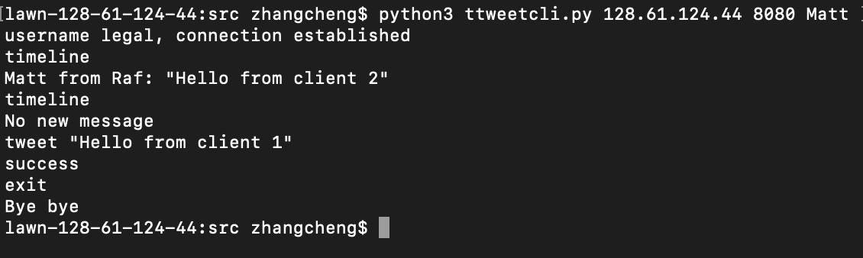

Client 2

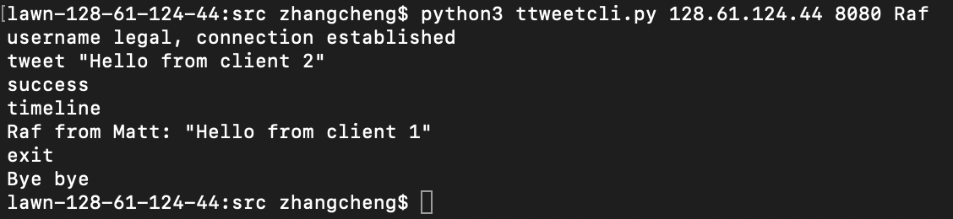

Client 3

