DriverPass System Design
Kyle DeJong
An academic design proposal for the fictional DriverPass driving education business. The diagrams connect user roles, purchases, lessons and account records to the proposed technical requirements. This is analysis and design work, not an implemented or deployed system. The scenario was supplied for SNHU CS-255.
The original UML diagrams are preserved. Full-resolution copies are included separately in the diagrams folder for closer inspection. The technical requirements follow the diagrams.

Use case diagram
Customer and employee roles, external payment processing and DMV updates.
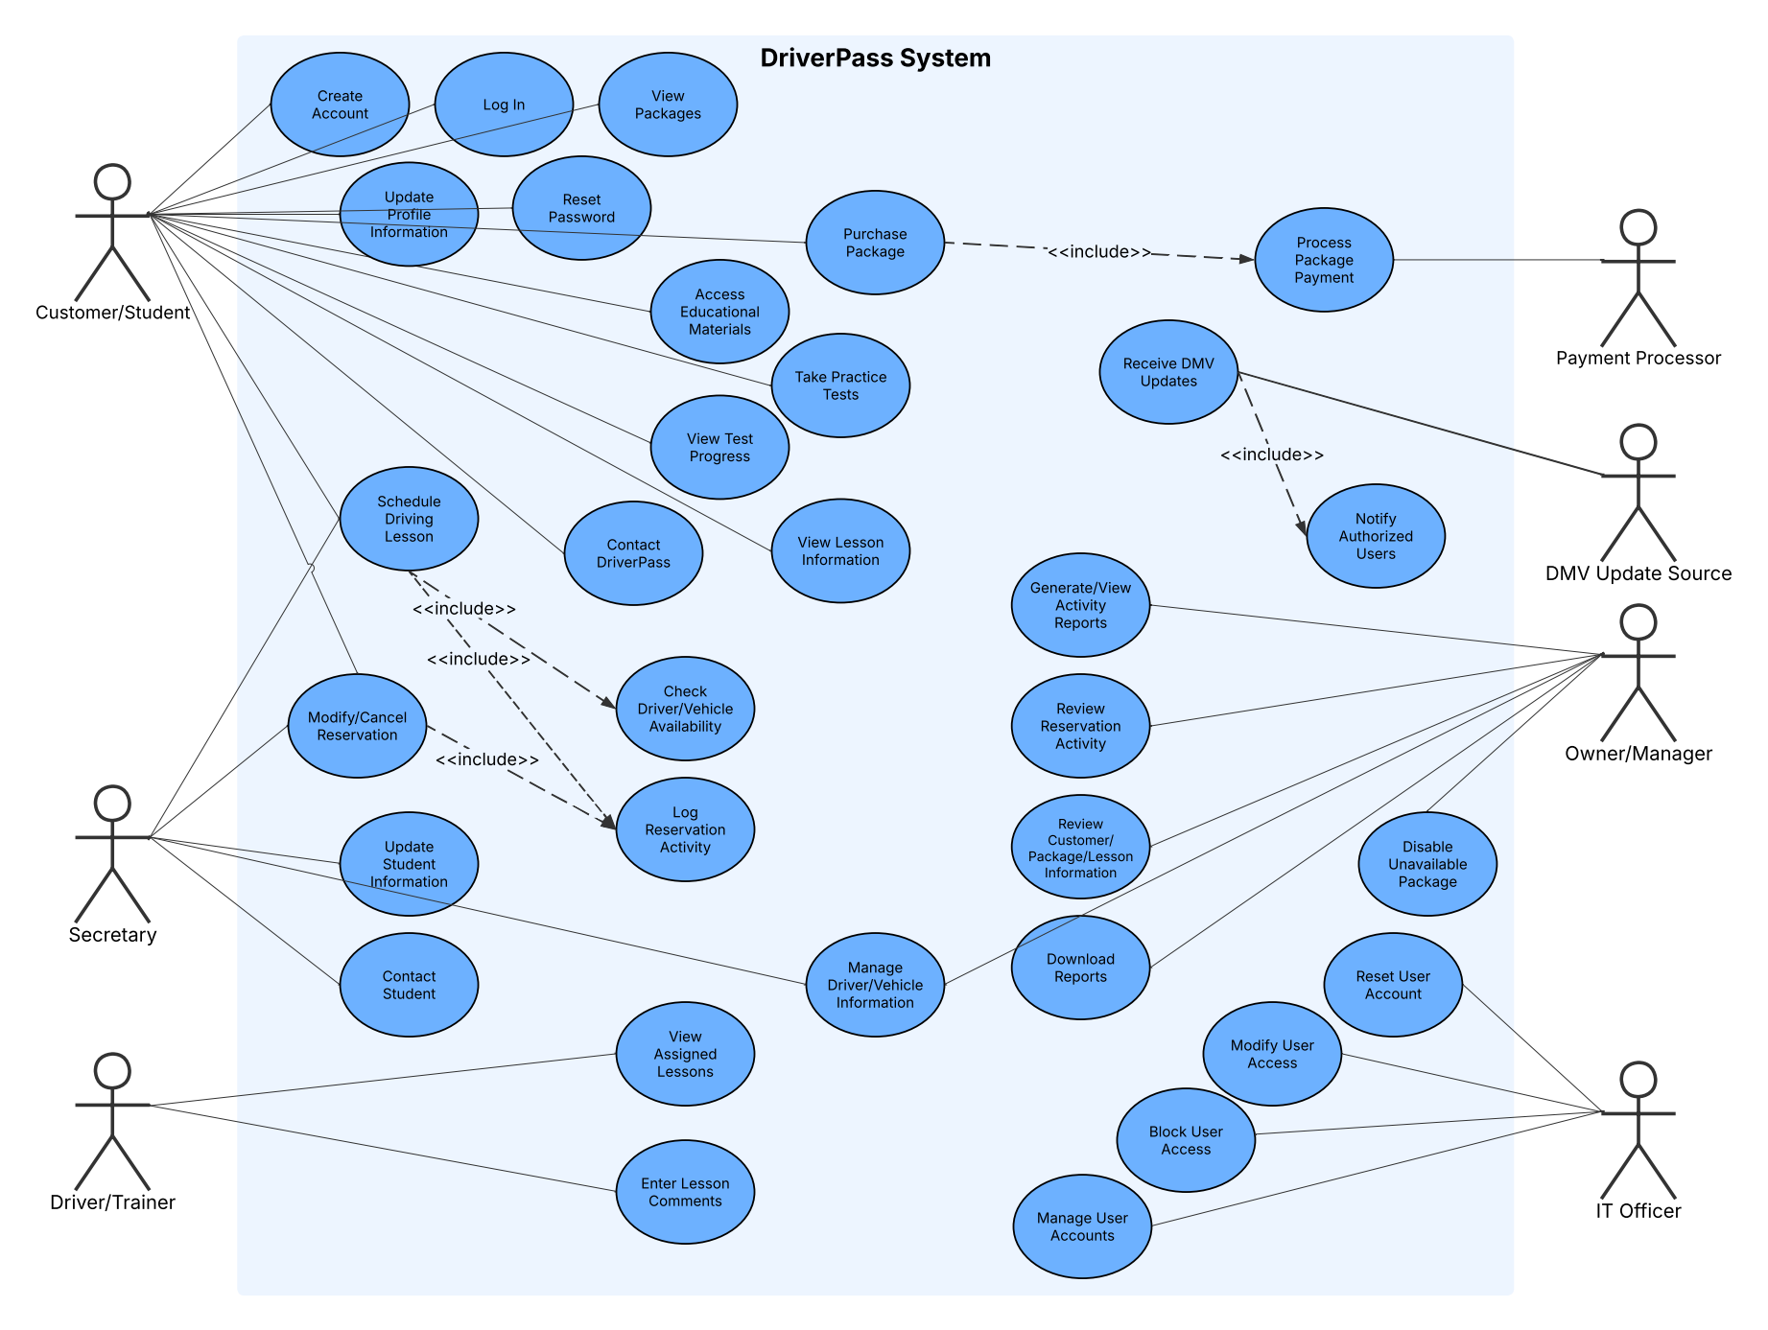

Package purchase activity
Purchase flow including unavailable packages and unsuccessful payments.
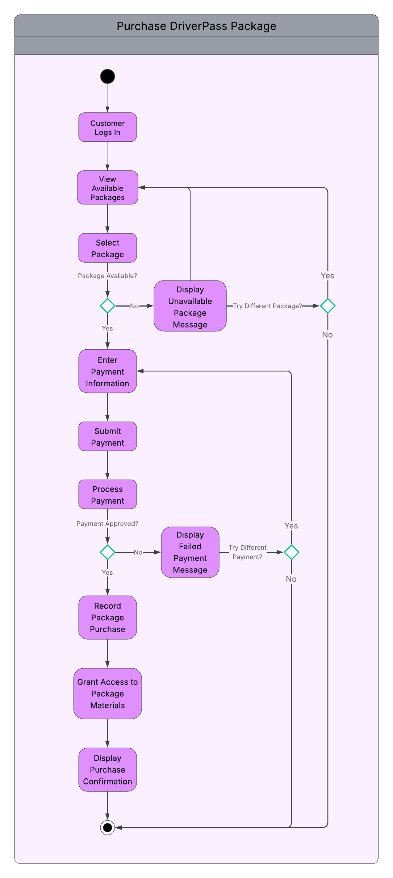

Lesson comments activity
Driver access to assigned lessons and entry of comments after completion.
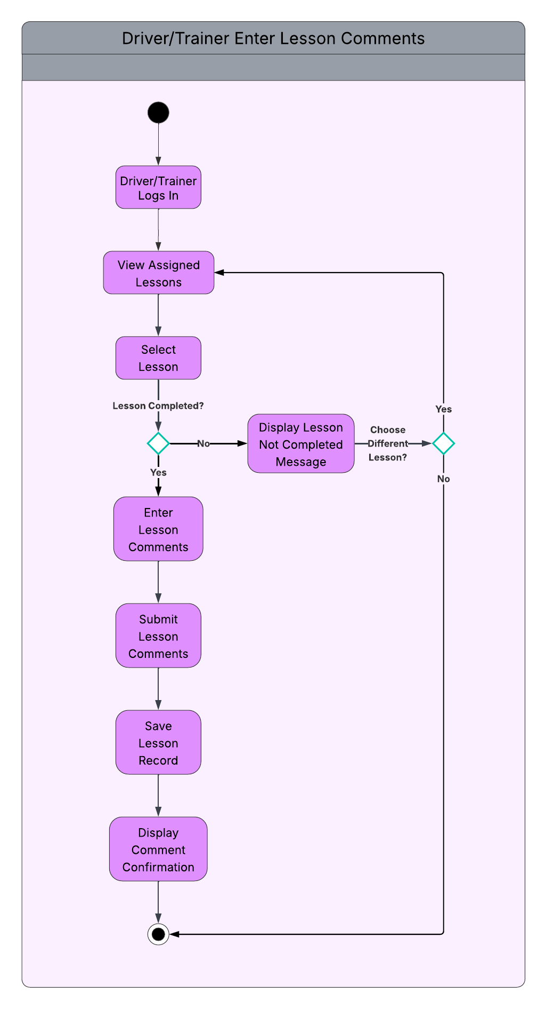

Package purchase sequence
Interactions among the customer, application, account, package records and payment processor.
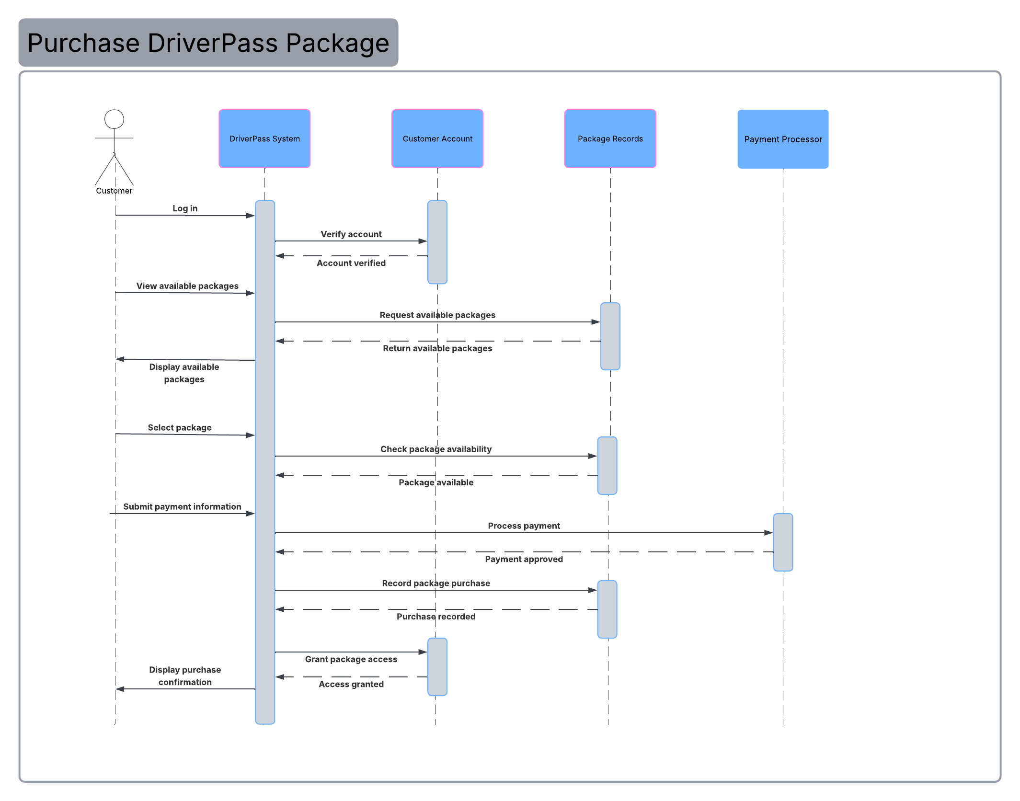

Class model
Accounts and permissions, reservations, lesson records, purchases, payments and training content. Open the full-resolution image for the detailed attributes and relationships.
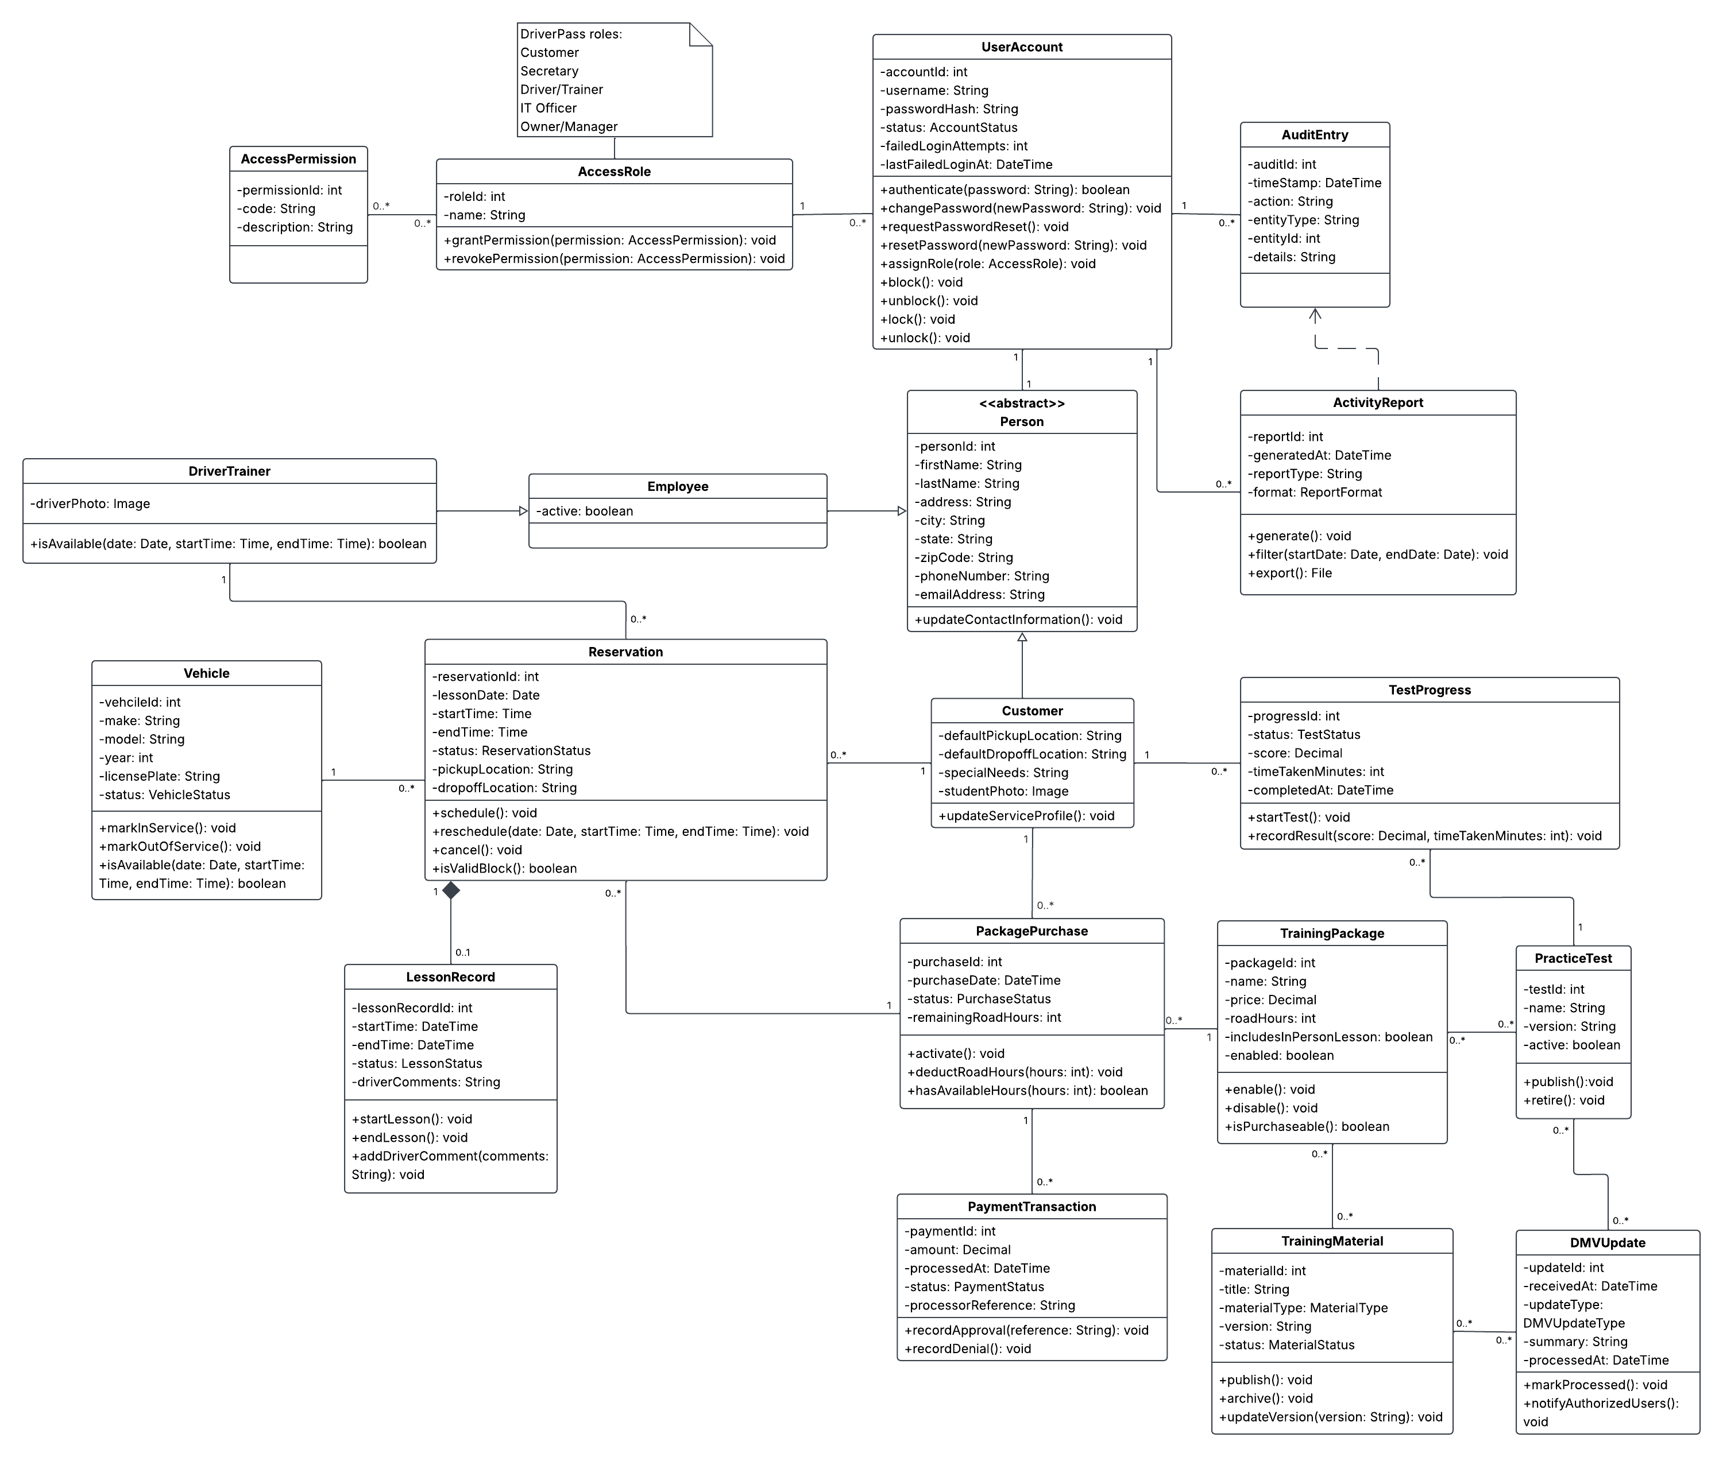

Technical requirements

Hardware
The DriverPass system will not require locally owned server hardware, as it will make use of cloud-based services. Customers and employees will require modern, browser-compatible devices, such as desktop PCs or mobile devices, with reliable internet connections. Application hosting, storage, and database hardware will all be handled on the cloud side. The cloud capacity should initially support a minimum of 25 concurrent customer sessions and five concurrent employee or administrator sessions, with the ability to increase capacity as needed.

Software
The system will be created as a web application accessed through modern browsers on common operating systems such as Windows, macOS, iOS, and Android. As such, it will require a browser-based user interface, server-side software to handle business logic, and a centralized relational database to store relevant information, such as accounts, packages, purchases, payments, reservations, vehicles, practice tests, and lesson records.
The software must support secure account authentication, automated password resets, role-based access control, reservation management, package purchasing, access to training materials, practice-test tracking, lesson records, audit logging, and report generation. It must also integrate with an approved external payment processor, since payment authorization and payment-method information will not be handled directly by DriverPass. The system will also need a method of receiving DMV material updates. This may take the form of an API, data feed, notification service, or supported manual process.

Development and Administration Tools
The development team will require an IDE, source-control software, database administration tools, automated testing tools, and deployment and monitoring tools. Source control will provide the ability to track changes to the system during development and support collaboration across the team. Testing tools should support unit, integration, security, and browser-compatibility testing as the most relevant cases. Deployment and monitoring tools should allow technical staff to manage updates, review errors and system performance, and respond to service issues without directly modifying production data.

Cloud Infrastructure
The system will require cloud application hosting, a managed relational database, file storage for images, educational materials, reports, and other uploaded or generated files, and automatic backups. The hosting environment should provide redundancy, recovery support, performance monitoring, security alerts, and scalable computing and storage capacity.
Browser traffic shall use encrypted connections in accordance with modern industry standards. Passwords will be hashed rather than stored as plain text. Access to customer information, reservations, reports, and administrative functions will be restricted according to user role. After five failed login attempts within 15 minutes, accounts should temporarily lock. Relevant system and reservation changes will be preserved in audit logs. Payments will be handled by the external processing service, while DriverPass will retain only the payment status and processor reference needed for its records, rather than full card numbers or security codes.
The cloud service must be configured to meet the system’s initial performance requirements. Most pages and reservation actions should complete within five seconds under normal conditions. Payment confirmation should finish within ten seconds of the payment processor’s response, activity reports should be generated within ten seconds, and report downloads should complete within 30 seconds. At least once per day, the system should check for DMV updates and notify authorized DriverPass users when new information or material is available.
The live system will be online-only. Reports and other exported information may be downloaded and reviewed offline, but offline files cannot be used to modify the centralized database.

