Java Web Application Security Case Study
Kyle DeJong | Artemis Financial academic scenario | Original work April 19, 2026
This report documents a focused security refactor of a supplied Spring application. I added a SHA-256 checksum route, generated a self-signed certificate and keystore, configured local HTTPS, and reviewed the result with manual testing and OWASP Dependency-Check. AES-256 was a recommendation. The dependency scan retained serious findings that required further work.
Artemis Financial is the fictional client in this undergraduate exercise. The report and screenshots record the original work. Application source and a reproducible build are not included in the repository.

Cryptographic Choices
As Artemis Financial deals with sensitive financial information through a web interface, I recommended AES-256 for confidentiality. AES uses 128-bit blocks and supports 128, 192, and 256-bit keys under NIST FIPS 197 [1]. A 256-bit key provides a large brute-force search space, but key size alone does not establish the security of a complete system. The mode of operation, key handling, and protocol configuration also matter. The retained evidence does not establish which cipher suite the local HTTPS connection negotiated.
For the checksum demonstration, I used SHA-256 through Java’s MessageDigest functionality [2]. SHA-256 produces a fixed-length 256-bit digest rather than reversible encrypted data. The route returned a fixed test string and its digest. This can demonstrate repeatable hashing and comparison, but a plain digest delivered alongside the data does not authenticate the sender or prevent an attacker from changing both values.
Encryption and hashing solve different problems. AES is symmetric, using the same secret key for encryption and decryption, while asymmetric cryptography uses a public and private key pair. Reliable key generation and protection are part of the surrounding design. Configuring HTTPS uses a transport security protocol rather than simply selecting a standalone cipher; certificate validation remains essential to establishing the peer’s identity [4].

Certificate and HTTPS Configuration
I used Java certificate tooling to generate a self-signed certificate and keystore, then updated application.properties for HTTPS [3]. The project-tree screenshot, available separately in the repository, shows certificate.cer and keystore.p12.
The application ran at https://localhost:8443/hash. The browser displayed a certificate warning because the local setup was not trusted. I attempted to add the certificate to the local machine certificate store, but the warning remained. This was accepted for the course exercise; the warning remains visible in the screenshot.

Checksum Output and Functional Testing
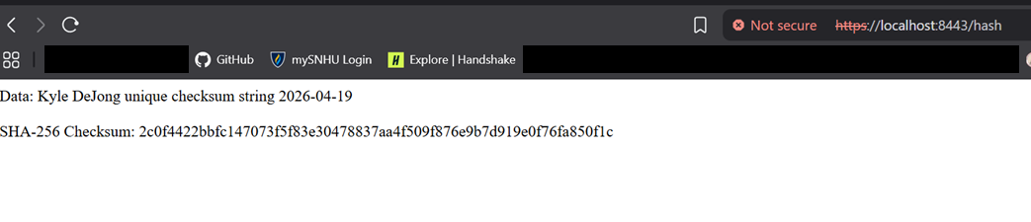
Browser output from April 19, 2026, showing the checksum route and certificate warning.
Manual testing included running the refactored application and reviewing the added code for syntax, logic, and security concerns. I recorded that the route compiled, returned the expected original string, and produced consistent checksum output. The reported operation was read-only, used a fixed string, and added no third-party libraries. Those constraints limited the scope of the change, but successful startup and a narrow route do not prove the absence of vulnerabilities.
An independent SHA-256 calculation reproduces the digest for the exact visible string. This verifies the screenshot’s input/output pair; the original Java application has not been rerun for this report.

Process and Reflection
My process was layered. First, I separated confidentiality from hashing, then generated the certificate and keystore, configured HTTPS, added the checksum route, and tested the result manually and with Dependency-Check. I relied on established Java tools and algorithms rather than inventing custom cryptography, and kept the refactor narrow instead of adding unnecessary libraries.
It was helpful to distinguish existing dependency issues from the changes I made. That separation defines the work’s scope, but does not make inherited vulnerabilities irrelevant. The original report attributed the findings to older starter dependencies. Without a before-and-after baseline and code review, the retained scan cannot establish that my changes introduced no security issues. A usable follow-up would review the findings, update affected components, and rerun both functional and security checks. Those steps are not claimed as completed here.
The project’s value is working within an existing application and explaining a bounded change. Designing with security in mind before coding begins, during development, and after release helps avoid costly rework. Knowing where a change begins and ends helps focus effort, while documenting unresolved risks makes the result easier for the next developer to assess.

Historical Dependency Findings
OWASP Dependency-Check identifies dependencies associated with publicly disclosed vulnerabilities [5]. The retained April 19, 2026 report used version 12.2.1 and recorded 49 dependencies scanned, 29 unique dependencies, 13 vulnerable dependencies, and 160 findings. High and critical entries remain visible. These are historical scanner results, not a verified count of exploitable defects or a statement of current dependency safety.
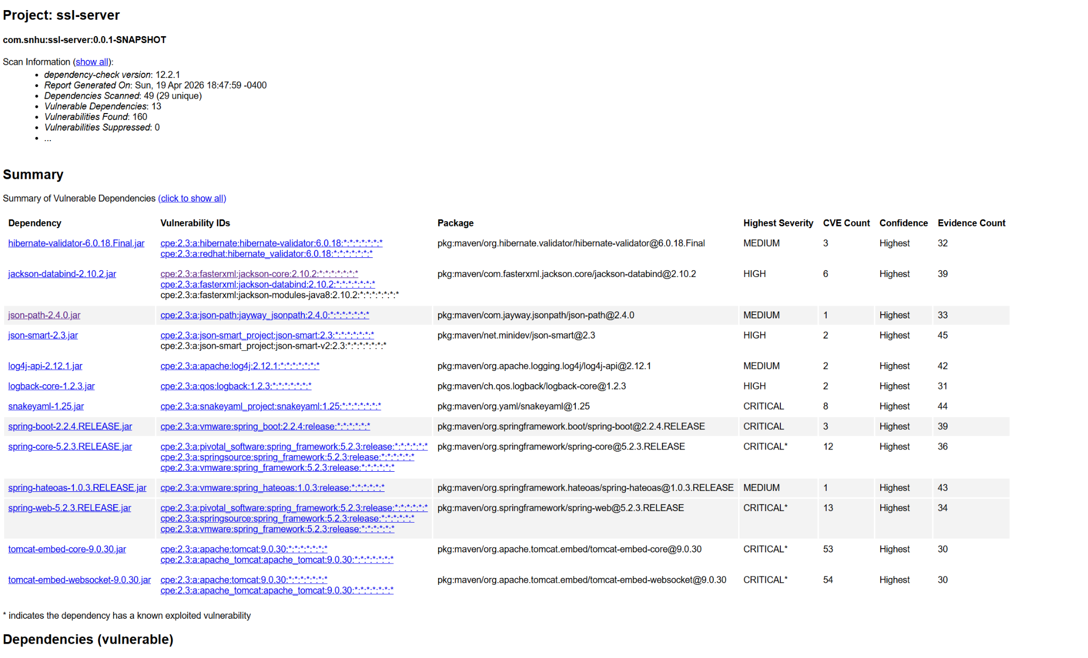
Original dependency report screenshot. The standalone full-resolution image in screenshots/dependency-check.png is easier to enlarge than this document preview.
The scan was not clean. No new libraries were added in the reported refactor, but that fact alone does not establish that no vulnerabilities were introduced. The retained report does not demonstrate remediation or production readiness.

References
[1] NIST. FIPS 197, Advanced Encryption Standard. https://csrc.nist.gov/pubs/fips/197/final
[2] Oracle. Java SE 11 MessageDigest. https://docs.oracle.com/en/java/javase/11/docs/api/java.base/java/security/MessageDigest.html
[3] Oracle. Java SE 11 keytool. https://docs.oracle.com/en/java/javase/11/tools/keytool.html
[4] OWASP. Transport Layer Security Cheat Sheet. https://cheatsheetseries.owasp.org/cheatsheets/Transport_Layer_Security_Cheat_Sheet.html
[5] OWASP. Dependency-Check. https://owasp.org/projects/dependency-check

