**COMP 333 Practice Exam #1**

This is representative of the kinds of topics and kind of questions you may be asked on the midterm.

**Virtual Dispatch - Conceptual Understanding**

1.) Name one reason why someone might want to use virtual dispatch.

Non-exhaustive list of possibilities:

* Allows for the same method call to have different behaviors at runtime, which is more flexible
* Allows for abstraction over code behavior. Calling code only needs to know the signature of a method, and the runtime behavior can be dynamically changed by changing the underlying object the method is called on.
* Improves code modularity. Each distinct behavior can be isolated from each other behavior, and behaviors generally don't need to know about each other.

2.) Name one reason why someone might **not** want to use virtual dispatch.

Non-exhaustive list of possibilities:

* Code can become more bloated. Usually, multiple classes have to be introduced, and these all have their own boilerplate associated with them.
* Code's behavior can become less explicit, and potentially more difficult to reason about. For example, an if/else clearly indicates a condition to test and code to execute depending on the condition. However, a method call may *implicitly* do something similar.
* It generally has worse performance than an explicit if/else. (Beyond what I'd expect: behind the scenes, indirect jumps are often needed, and these can easily jump out of cached instructions. Moreover, it's difficult to predict where an indirect jump will go.)

**Virtual Dispatch in Java**

3.) Consider the following Java code:

public interface I1 {

public void doThing();

}

public class C1 implements I1 {

public void doThing() { System.out.println("c1"); }

}

public class C2 implements I1 {

public void doThing() { System.out.println("c2"); }

}

public class Main {

public void makeCall(I1 value) {

value.doThing();

}

public static void main(String[] args) {

I1 t1 = new C1();

I1 t2 = new C2();

makeCall(t1);

makeCall(t2);

}

}

What is the output of the main method above?

c1

c2

4.) Consider the following code snippet:

public class Main {

public static void main(String[] args) {

Operation op1 = new AddOperation(); // line 3

Operation op2 = new SubtractOperation(); // line 4

int res1 = op1.doOp(5, 3); // line 5

int res2 = op2.doOp(5, 3); // line 6

System.out.println(res1); // line 7; should print 8

System.out.pritnln(res2); // line 8; should print 2

}

}

Define any interfaces and/or classes necessary to make this snippet print 8, followed by 2.

// From lines 3-4, we know that Operation must be a superclass of

// AddOperation and SubtractOperation, based on the types of op1

// and op2. From line 5, we know that Operation must have a doOp

// method, that it must return an int, and that it must take two ints.

// From line 3, 5, and 7, we can infer that AddOperation's doOp must

// be adding its arguments, and similarly from lines 4, 6, and 8, we

// can infer SubtractOperation's doOp must be subtracting its

// arguments.

public interface Operation {

public int doOp(int first, int second);

}

public class AddOperation implements Operation {

public int doOp(int first, int second) {

return first + second;

}

}

public class SubtractOperation implements Operation {

public int doOp(int first, int second) {

return first - second;

}

}

5.) Consider the following Java code, which simulates a lock which can be either locked or unlocked. The lock is an immutable data structure, so locking or unlocking returns a new lock in an appropriate state.

public class Lock {

private final boolean locked;

public Lock(final boolean locked) {

this.locked = locked;

}

public Lock unlock() {

if (locked) {

System.out.println("lock unlocked");

return new Lock(false);

} else {

System.out.println("lock already unlocked");

return this;

}

}

public Lock lock() {

if (!locked) {

System.out.println("lock locked");

return new Lock(true);

} else {

System.out.println("lock already locked");

return this;

}

}

public boolean isLocked() {

return locked;

}

}

Refactor this code to use virtual dispatch, instead of using if/else. As a hint, you should have a base class/interface for Lock, and subclasses for locked and unlocked locks. Lock itself doesn't need a constructor, and you do not need to worry about maintaining compatibility with existing code that uses Lock. (Continued on to next page)

public interface Lock {

public Lock unlock();

public Lock lock();

public boolean isLocked();

}

public class UnlockedLock implements Lock {

public Lock unlock() {

System.out.println("lock already unlocked");

return this;

}

public Lock lock() {

System.out.println("lock locked");

return new LockedLock();

}

public boolean isLocked() {

return false;

}

}

public class LockedLock implements Lock {

public Lock unlock() {

System.out.println("lock unlocked");

return new UnlockedLock();

}

public Lock lock() {

System.out.println("lock already locked");

return this;

}

public boolean isLocked() {

return true;

}

}

**Types**

6.) The code below does not compile. Why?

public interface MyInterface {

public void foo();

}

public class MyClass implements MyInterface {

public void foo() {}

public void bar() {}

public static void main(String[] args) {

MyInterface a = new MyClass();

a.bar();

}

}

The bar method is only available on MyClass, not MyInterface. a is of type MyInterface, so the bar method is not available, even though the runtime type of a will be MyClass (which does have bar).

7.) Java supports subtyping. Write a Java code snippet that compiles and uses subtyping.

Object obj = "foo";

("foo" is of type String, and String is a subtype of Object, so values of type String can be assigned to variables of type Object.)

8.) Name one reason why someone might prefer static typing over dynamic typing.

Possible answers:

* Can help eliminate programming errors at compile time
* Can help in structuring code (types can be a guide for program development)
* Compilers and runtimes can usually optimize code better with type information

9.) Name one reason why someone might prefer dynamic typing over static typing.

Possible answers:

* No need to annotate programs with types, which are a significant amount of code
* More programs are possible, and can fundamentally represent things which cannot be represented in statically-typed code.

10.) Name one reason why someone might prefer strong typing over weak typing.

Possible answers:

* Strongly-typed languages are more predictable, especially in the presence of bugs and errors
* Strongly-typed languages tend to emphasize code correctness

11.) Name one reason why someone might prefer weak typing over strong typing.

Possible answers:

* There is usually a performance benefit. For example, there is no need for runtime array bounds checking.
* Weakly-typed languages tend to be more expressive. (Beyond what I'd expect: C lets you do more than Java in terms of low-level manipulation, but it's easy to hit undefined behavior, meaning programs lose all meaning. This can happen even when the code appears to be working correctly.)

**Higher-Order Functions in JavaScript**

12.) Write the output of the following JavaScript code:

function foo(fooParam) {

return function (innerParam) {

return fooParam - innerParam;

}

}

let f1 = foo(7); // fooParam = 7 for f1

let f2 = foo(10); // fooParam = 10 for f2

console.log(f1(2)); // innerParam = 2 for f1; 7 - 2 = 5

console.log(f2(3)); // innerParam = 3 for f2; 10 - 3 = 7

console.log(f1(4)); // innerParam = 4 for f1; 7 - 4 = 3

console.log(f2(5)); // innerParam = 5 for f2; 10 - 5 = 5

5

7

3

5

13.) Consider the following JavaScript code:

function base() {

return function (f) {};

}

function rec(n) {

return function (f) {

f();

n(f);

}

}

function empty() {}

let f1 = rec(rec(base()));

let f2 = rec(rec(rec(base())));

f1(empty); // calls empty twice

f2(empty); // calls empty three times

How many times is empty called in total in the above code?

5

14.) Consider the following JavaScript code with corresponding output, which calls an unseen function called mystery:

function output() {

console.log("foo");

}

let f1 = mystery(output);

f1();

console.log();

let f2 = mystery(f1);

f2();

console.log();

let f3 = mystery(f2);

f3();

console.log();

Output:

foo

foo

foo

foo

foo

foo

foo

foo

foo

foo

foo

foo

foo

foo

Define the mystery function below.

function mystery(f) {

return function() {

f();

f();

};

}

15.) Write the output of the following JavaScript code:

// returns a function that will bound the output of the wrapped

// function, so the output is never less than min or greater than max

function cap(min, max, wrapped) {

return function (param) {

let temp = wrapped(param);

if (temp < min) {

return min;

} else if (temp > max) {

return max;

} else {

return temp;

}

};

}

function addTen(param) {

return param + 10;

}

function subTen(param) {

return param - 10;

}

let f1 = cap(0, 10, addTen);

let f2 = cap(0, 100, addTen);

let f3 = cap(0, 10, subTen);

let f4 = cap(0, 100, subTen);

console.log(f1(0));

console.log(f1(5));

console.log();

console.log(f2(0));

console.log(f2(5));

console.log();

console.log(f3(0));

console.log(f3(5));

console.log();

console.log(f4(0));

console.log(f4(5));

console.log();

10

10

10

15

0

0

0

0

16.) Consider the following JavaScript code and output:

console.log(

ifNotNull(1 + 1,

a => ifNotNull(2 + 2,

b => a + b)));

console.log(

ifNotNull(7,

function (e) {

console.log(e);

return ifNotNull(null,

function (f) {

console.log(f);

return 8;

})

}));

Output:

6

7

null

ifNotNull takes two parameters:

1. Some arbitrary value, which might be null
2. A function. This function is called with the arbitrary value if the value is not null, and the result of the function is returned. If the value is null, this function isn't called, and null is returned instead.

Define the ifNotNull function below, so that the output above is produced.

function ifNotNull(value, f) {

if (value !== null) {

return f(value);

} else {

return value;

}

}

17.) Consider the following array definition in JavaScript:

let arr = [0, 1, 2, 3, 4, 5, 6, 7, 8, 9, 10]

17.a) Use filter to get an array of all even elements in arr.

// filter takes a function that takes an element and returns true

// if the element should be in the returned array, else false

arr.filter(e => e % 2 === 0)

// alternative answer

arr.filter(function (element) {

return element % 2 === 0;

})

17.b) Use map to get an array of strings, where each string represents a number in arr. As a hint, you can call the toString() method on a number (e.g., 5.toString()) in JavaScript to get its string representation.

// map takes a function that takes an element and returns the

// corresponding value which should be in the output array

arr.map(e => e.toString())

// alternative answer

arr.map(function (element) {

return element.toString()

});

17.c) Use reduce to get the last element in arr.

// reduce takes a function that takes an accumulator and an element,

// and returns the value of the new accumulator. In this case, reduce

// is only given the function, so it will use the first array element

// as the initial accumulator, and start iterating from the second

// array element

arr.reduce((accum, element) => element)

// alternative anser

arr.reduce(function (accum, element) {

return element;

})

17.d) Use a combination of filter and reduce to get the sum of all elements in arr which are greater than 5.

// this use of reduce uses an explicit starting accumulator of 0

arr.filter(e => e > 5).reduce((accum, element) => accum + element, 0)

// alternative answer

arr.filter(function (e) { return e > 5 })

.reduce(function (accum, element) { return accum + element }, 0)

**Prototype-Based Inheritance in JavaScript**

**NOTE: This depends on how far we get by Tuesday, and might not be covered (see Canvas at that point)**

18.a.) Define a constructor for Dog objects, where each Dog object has a name. An example code snippet is below, illustrating usage:

let d = new Dog("Rover"); // line 1

console.log(d.name); // line 2; prints Rover

// From line 1, we need a Dog constructor that takes one parameter.

// From line 2, the constructor must be setting the name field of

// Dog objects to the parameter.

function Dog(param) {

this.name = param;

}

18.b.) Define a different constructor for Dog, which puts a bark method **directly** on the Dog objects. The bark method should print "Woof!" when called. Example usage is below:

let d = new Dog("Sparky");

d.bark(); // prints Woof!

function Dog(name) {

this.name = name; // not explicitly required based on the question

// bark is directly on created Dog objects, as opposed to being

// on the prototype chain for Dog objects

this.bark = function() { console.log("Woof!"); }

}

18.c.) Define a method named growl for Dog objects, which prints "[dog name] growls" when called. Use Dog's **prototype**, instead of putting the method directly on Dog objects themselves. Example usage is below:

let d = new Dog("Rocky");

d.growl(); // prints Rocky growls

Dog.prototype.growl = function() {

// assumes constructor initializes this.name, as with 3.a

console.log(this.name + " growls");

}

19.) Consider the JavaScript code below:

function Animal(name) { this.name = name; }

Animal.prototype.getName = function() { return this.name; }

function Bird(name) { Animal.call(this, name); }

Bird.prototype = Object.create(Animal.prototype);

Bird.prototype.fly = function() {

console.log(this.getName() + " flies");

}

function Mouse(name) {

this.name = name;

this.squeak = function() {

console.log(this.name + " squeaks");

}

}

Mouse.prototype = Object.create(Animal.prototype);

Mouse.prototype.fly = Bird.prototype.fly;

let b1 = new Bird("Coco"); let b2 = new Bird("Sunny");

let m1 = new Mouse("Pip"); let m2 = new Mouse("Ruby");

Write a memory diagram which shows how memory looks after this program executes. Your diagram should include the objects and fields associated with b1, b2, m1, m2, Mouse.prototype, and Bird.prototype, Animal.prototype. As a hint, the __proto__ field on objects refers to the corresponding object's prototype.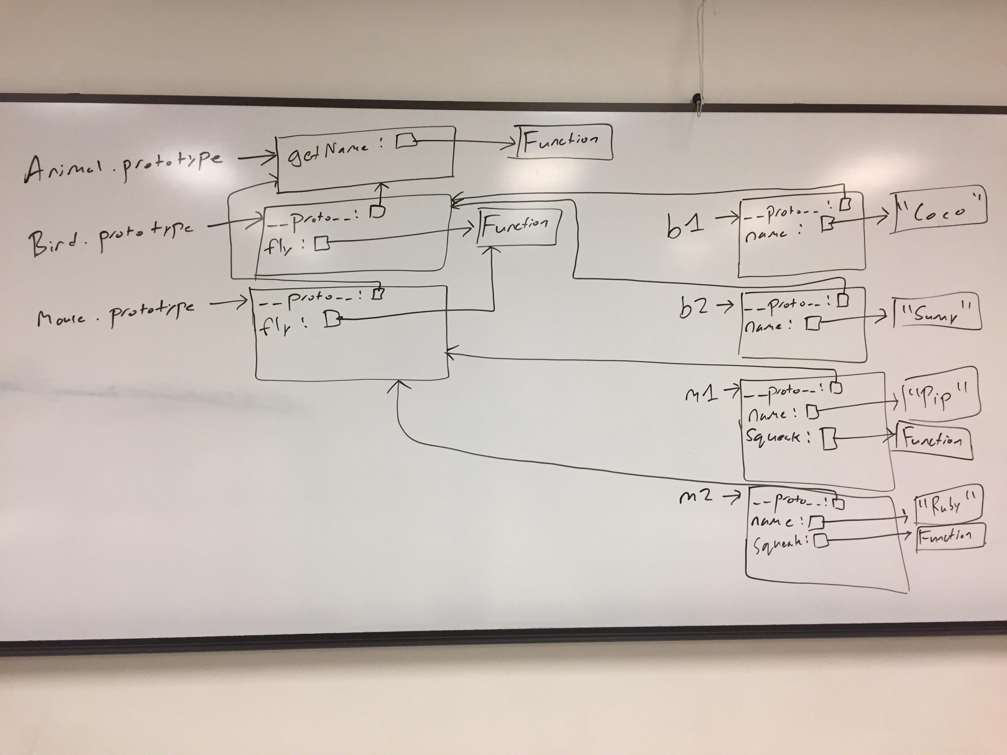

20.) Consider the test suite below, using assertEquals from the second assignment:

function test1() {

let t1 = new Obj("foo");

assertEquals("foo", t1.field);

}

function test2() {

let t2 = new Obj("bar");

assertEquals("barbar", t2.doubleField());

}

function test3() {

let t3 = new Obj("baz");

// hasOwnProperty returns true if the object itself has the field,

// otherwise it returns false. If the field is on the object's

// prototype instead (__proto__), it returns false.

assertEquals(false, t3.hasOwnProperty("doubleField"));

}

Write JavaScript code which will make the above tests pass.

// Object is a built-in in JavaScript, but not Obj. This requires a

// custom constructor. From test1, we know that Obj must be a

// constructor, and that Obj objects need a field named "field". The

// value of this field must be equal to whatever its parameter is.

function Obj(param) {

this.field = param;

}

// From test2, we know that we need a doubleField method on Obj

// objects. From test3, we know that doubleField cannot be directly

// on the Obj objects, so we must put it on Obj's prototype.

Obj.prototype.doubleField = function() {

// + in this context performs string concatenation; this

// concatenates this.field onto itself

return this.field + this.field;

}