**COMP 333 Practice Exam**

This is representative of the kinds of topics and kind of questions you may be asked on the midterm.

**Higher-Order Functions in JavaScript**

1.) Write the output of the following JavaScript code:

function foo(fooParam) {

return function (innerParam) {

return fooParam - innerParam;

}

}

let f1 = foo(7); // fooParam = 7 for f1

let f2 = foo(10); // fooParam = 10 for f2

console.log(f1(2)); // innerParam = 2 for f1; 7 - 2 = 5

console.log(f2(3)); // innerParam = 3 for f2; 10 - 3 = 7

console.log(f1(4)); // innerParam = 4 for f1; 7 - 4 = 3

console.log(f2(5)); // innerParam = 5 for f2; 10 - 5 = 5

5

7

3

5

2.) Consider the following JavaScript code:

function base() {

return function (f) {};

}

function rec(n) {

return function (f) {

f();

n(f);

}

}

function empty() {}

let f1 = rec(rec(base));

let f2 = rec(rec(rec(base)));

f1(empty); // calls empty twice

f2(empty); // calls empty three times

How many times is empty called in total in the above code?

5

3.) Consider the following JavaScript code with corresponding output, which calls an unseen function called mystery:

function output() {

console.log("foo");

}

let f1 = mystery(output);

f1();

console.log();

let f2 = mystery(f1);

f2();

console.log();

let f3 = mystery(f2);

f3();

console.log();

Output:

foo

foo

foo

foo

foo

foo

foo

foo

foo

foo

foo

foo

foo

foo

Define the mystery function below.

function mystery(f) {

return function() {

f();

f();

};

}

4.) Write the output of the following JavaScript code:

// returns a function that will bound the output of the wrapped

// function, so the output is never less than min or greater than

// max

function cap(min, max, wrapped) {

return function (param) {

let temp = wrapped(param);

if (temp < min) {

return min;

} else if (temp > max) {

return max;

} else {

return temp;

}

};

}

function addTen(param) {

return param + 10;

}

function subTen(param) {

return param - 10;

}

let f1 = cap(0, 10, addTen);

let f2 = cap(0, 100, addTen);

let f3 = cap(0, 10, subTen);

let f4 = cap(0, 100, subTen);

console.log(f1(0));

console.log(f1(5));

console.log();

console.log(f2(0));

console.log(f2(5));

console.log();

console.log(f3(0));

console.log(f3(5));

console.log();

console.log(f4(0));

console.log(f4(5));

console.log();

10

10

10

15

0

0

0

0

5.) Consider the following JavaScript code and output:

console.log(

ifNotNull(1 + 1,

a => ifNotNull(2 + 2,

b => a + b)));

console.log(

ifNotNull(7,

function (e) {

console.log(e);

return ifNotNull(null,

function (f) {

console.log(f);

return 8;

})

}));

Output:

6

7

null

ifNotNull takes two parameters:

1. Some arbitrary value, which might be null
2. A function. This function is called with the arbitrary value if the value is not null, and the result of the function is returned. If the value is null, this function isn't called, and null is returned instead.

Define the ifNotNull function below, so that the output above is produced.

function ifNotNull(value, f) {

if (value !== null) {

return f(value);

} else {

return value;

}

}

6.) Consider the following array definition in JavaScript:

let arr = [0, 1, 2, 3, 4, 5, 6, 7, 8, 9, 10]

6.a) Use filter to get an array of all even elements in arr.

// filter takes a function that takes an element and returns true

// if the element should be in the returned array, else false

arr.filter(e => e % 2 === 0)

// alternative answer

arr.filter(function (element) {

return element % 2 === 0;

})

6.b) Use map to get an array of strings, where each string represents a number in arr. As a hint, you can call the toString() method on a number (e.g., 5.toString()) in JavaScript to get its string representation.

// map takes a function that takes an element and returns the

// corresponding value which should be in the output array

arr.map(e => e.toString())

// alternative answer

arr.map(function (element) {

return element.toString()

});

6.c) Use reduce to get the last element in arr.

// reduce takes a function that takes an accumulator and an element,

// and returns the value of the new accumulator. In this case, reduce

// is only given the function, so it will use the first array element

// as the initial accumulator, and start iterating from the second

// array element

arr.reduce((accum, element) => element)

// alternative anser

arr.reduce(function (accum, element) {

return element;

})

6.d) Use a combination of filter and reduce to get the sum of all elements in arr which are greater than 5.

// this use of reduce uses an explicit starting accumulator of 0

arr.filter(e => e > 5).reduce((accum, element) => accum + element, 0)

// alternative answer

arr.filter(function (e) { return e > 5 })

.reduce(function (accum, element) { return accum + element }, 0)

**Prototype-Based Inheritance in JavaScript**

7.a.) Define a constructor for Dog objects, where each Dog object has a name. An example code snippet is below, illustrating usage:

let d = new Dog("Rover"); // line 1

console.log(d.name); // line 2; prints Rover

// From line 1, we need a Dog constructor that takes one parameter.

// From line 2, the constructor must be setting the name field of

// Dog objects to the parameter.

function Dog(param) {

this.name = param;

}

7.b.) Define a different constructor for Dog, which puts a bark method **directly** on the Dog objects. The bark method should print "Woof!" when called. Example usage is below:

let d = new Dog("Sparky");

d.bark(); // prints Woof!

function Dog(name) {

this.name = name; // not explicitly required based on the question

// bark is directly on created Dog objects, as opposed to being

// on the prototype chain for Dog objects

this.bark = function() { console.log("Woof!"); }

}

7.c.) Define a method named growl for Dog objects, which prints "[dog name] growls" when called. Use Dog's **prototype**, instead of putting the method directly on Dog objects themselves. Example usage is below:

let d = new Dog("Rocky");

d.growl(); // prints Rocky growls

Dog.prototype.growl = function() {

// assumes constructor initializes this.name, as with 3.a

console.log(this.name + " growls");

}

8.) Consider the JavaScript code below:

function Animal(name) { this.name = name; }

Animal.prototype.getName = function() { return this.name; }

function Bird(name) { Animal.call(this, name); }

Bird.prototype = Object.create(Animal.prototype);

Bird.prototype.fly = function() {

console.log(this.getName() + " flies");

}

function Mouse(name) {

this.name = name;

this.squeak = function() {

console.log(this.name + " squeaks");

}

}

Mouse.prototype = Object.create(Animal.prototype);

Mouse.prototype.fly = Bird.prototype.fly;

let b1 = new Bird("Coco"); let b2 = new Bird("Sunny");

let m1 = new Mouse("Pip"); let m2 = new Mouse("Ruby");

Write a memory diagram which shows how memory looks after this program executes. Your diagram should include the objects and fields associated with b1, b2, m1, m2, Mouse.prototype, and Bird.prototype, Animal.prototype. As a hint, the __proto__ field on objects refers to the corresponding object's prototype.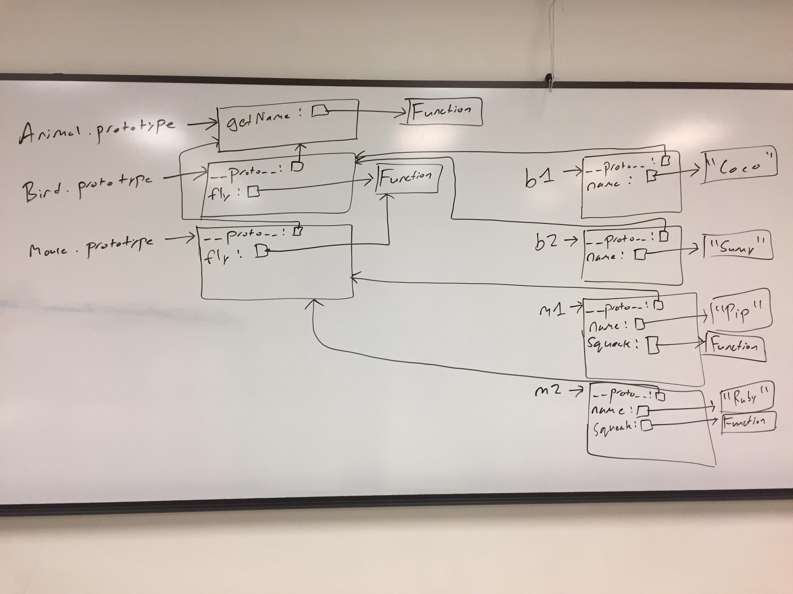

9.) Consider the test suite below, using assertEquals from the second assignment:

function test1() {

let t1 = new Obj("foo");

assertEquals("foo", t1.field);

}

function test2() {

let t2 = new Obj("bar");

assertEquals("barbar", t2.doubleField());

}

function test3() {

let t3 = new Obj("baz");

// hasOwnProperty returns true if the object itself has the field,

// otherwise it returns false. If the field is on the object's

// prototype instead (__proto__), it returns false.

assertEquals(false, t3.hasOwnProperty("doubleField"));

}

Write JavaScript code which will make the above tests pass.

// Object is a built-in in JavaScript, but not Obj. This requires a

// custom constructor. From test1, we know that Obj must be a

// constructor, and that Obj objects need a field named "field". The

// value of this field must be equal to whatever its parameter is.

function Obj(param) {

this.field = param;

}

// From test2, we know that we need a doubleField method on Obj

// objects. From test3, we know that doubleField cannot be directly

// on the Obj objects, so we must put it on Obj's prototype.

Obj.prototype.doubleField = function() {

// + in this context performs string concatenation; this

// concatenates this.field onto itself

return this.field + this.field;

}

**Pattern Matching in Swift**

10.) Consider the following enum definition:

enum SomeEnum {

case foo(Int)

case bar(Int, Int)

case baz(Int, Int, Int)

}

Write a function named test which takes a value of type SomeEnum. The function should do the following:

* If given a foo, it should return the value in the foo
* If given a bar, it should return the sum of the two values in the bar
* If given a baz, it should return the sum of the **first** and **last** values in the baz. You should **not** introduce a variable for the second (middle) value in the baz.

An example call to the function follows: test(SomeEnum.baz(1, 2, 3))

func test(_ value: SomeEnum) -> Int {

switch value {

case .foo(let x):

return x

case .bar(let x, let y):

return x + y

case .baz(let x, _, let y):

return x + y

}

}

**Generics and Higher-Order Functions in Swift**

11.) Write the body of the following function, or say if it's impossible to implement. If it's impossible to implement, explain why.

func combine<A, B>(a: A, b: B) -> (A, B) {

return (a, b)

}

12.) Write the body of the following function, or say if it's impossible to implement. If it's impossible to implement, explain why.

func combine2<A, B>(a: A) -> ((B) -> (A, B)) {

return { b in (a, b) }

}

13.) Write the body of the following function, or say if it's impossible to implement. If it's impossible to implement, explain why.

func combine3<A, B>(tup: (A, B)) -> A {

let (a, _) = tup

return a

}

14.) Write the body of the following function, or say if it's impossible to implement. If it's impossible to implement, explain why.

func combine4<A, B>(a: A, f: (A) -> B) -> (A, B) {

return (a, f(a))

}

15.) Consider the following enum definition:

enum Something<A, B, C> {

case alpha(A)

case beta(B)

case gamma(C)

}

15.a.) Write the body of the following function, or say if it's impossible to implement. If it's impossible to implement, explain why.

func combine5<A, B, C>(s: Something<A, B, C>) -> (A, B, C) {

Impossible to implement. s holds **one** of an A, B, or C, and the return type requires **all** three

}

15.b.) Write the body of the following function, or say if it's impossible to implement. If it's impossible to implement, explain why.

func combine6<A>(s: Something<A, A, A>) -> A {

switch s {

case .alpha(let a): return a

case .beta(let a): return a

case .gamma(let a): return a

}

}

16.) Write the body of the following function, or say if it's impossible to implement. If it's impossible to implement, explain why.

func combine7<A, B>(f: (A) -> B, b: B) -> A {

Impossible to implement. f needs an A, but we only have a B.

}

17.) Consider the following enum definition representing lists:

indirect enum List<A> {

case cons(A, List<A>)

case empty

}

17.a.) Write a function named partition which takes a predicate and divides a generic list into a pair of returned generic lists. The first element of the pair holds all elements for which the predicate returned true, and the second element of the pair holds all elements for which the predicate returned false. An example call is below:

let (matching, nonmatching) =

partition(list: List.cons(1, List.cons(2, List.empty)),

pred: { e in e > 1 })

// matching: List.cons(2, List.empty)

// nonmatching: List.cons(1, List.empty)

func partition<A>(list: List<A>, pred: (A) -> Bool) -> (List<A>, List<A>) {

switch list {

case .empty: return (List.empty, List.empty)

case .cons(let head, let tail):

let (restMatch, restNonMatch) =

partition(list: tail, pred: pred)

if pred(head) {

return (List.cons(head, restMatch), restNonMatch)

} else {

return (restMatch, List.cons(head, restNonMatch))

}

}

}

17.b.) Write a function named takeWhile which returns a list of consecutive list elements for which a given predicate pred returns true. Once pred returns false, the list is returned. takeWhile is generic. Example calls are below:

let list = List.cons(1, List.cons(2, List.cons(3, List.empty)))

let first = takeWhile(list: list, pred: { e in e < 3 })

// first: List.cons(1, List.cons(2, List.empty))

let second = takeWhile(list: list, pred: { e in e < 2 })

// second: List.cons(1, List.empty)

let third = takeWhile(list: list, pred: { e in e > 1 })

// third: List.empty

func takeWhile<A>(list: List<A>, pred: (A) -> Bool) -> List<A> {

switch list {

case .cons(let head, let tail):

if pred(head) {

return List.cons(head, takeWhile(list: tail, pred: pred))

} else {

return List.empty

}

case .empty:

return List.empty

}

}