| **Test Case** | **Output/Input** | **Input Test** | **Output** | **As expected?** |
| --- | --- | --- | --- | --- |
| 1 | Do you want to play the Matrix Game?  Enter Y for yes or N for No: | n | Thanks for playing!  Process finished with exit code 0 | True |
| 2 | Do you want to play the Matrix Game?  Enter Y for yes or N for No:  Y  Enter your phone number(XXX-XXX-XXXX):  123-123-1234  Enter your zipcode+4(XXXXX-XXXX):  123-123 | 123-123 | Your zipcode is not in correct format. Please reenter:  Enter your zipcode+4(XXXXX-XXXX):  12345-1234 | True |
| 3. | Enter your first 3x3 matrix: | 1 2 3  1 2 3  1 2 3 |  |  |
|  | Your first 3x3 matrix is:  1 2 3  1 2 3  1 2 3  Enter your second 3x3 matrix: | 1 2 3  1 2 3  1 2 3 |  |  |
|  | Your second 3x3 matrix is:  1 2 3  1 2 3  1 2 3 |  |  |  |
|  | Please select a matrix operation from below:  a. Addition  b. Subtraction  c. Matrix Multiplication  d. Element by element multiplication | b. |  |  |
|  | You selected Subtraction. The results are:  0 0 0  0 0 0  0 0 0  The Transpose is:  0 0 0  0 0 0  0 0 0  The row and column mean values of the results are:  Row: [0. 0. 0.]  Column: [0. 0. 0.]  Do you want to play the Matrix Game?  Enter Y for yes or N for No: | n | Thanks for playing!  Process finished with exit code 0 | True |

Test Case 1:

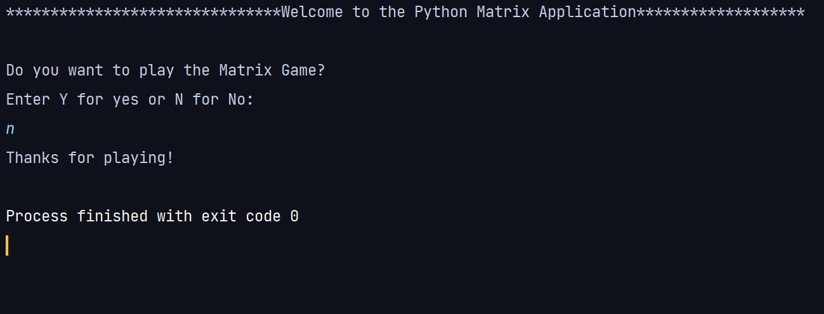

Test Case 2:

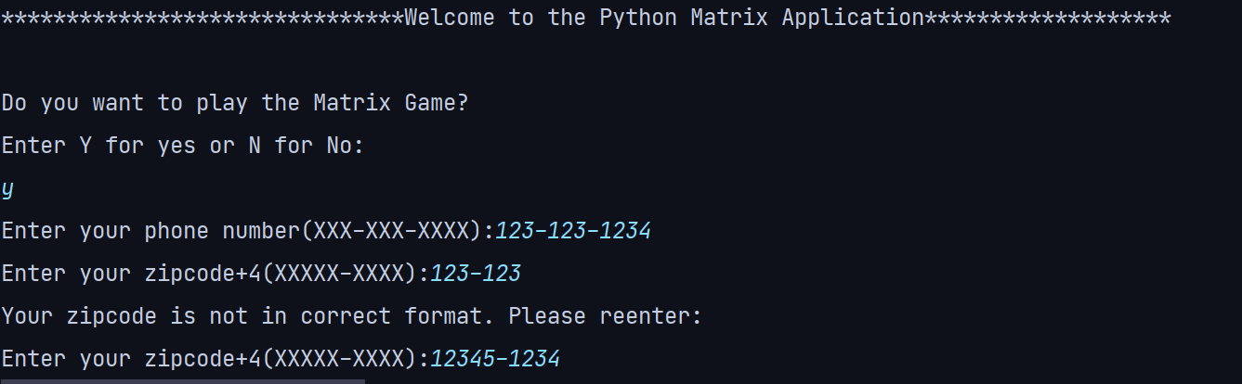

Test Case 3:

