SYSTEMS ANALYSIS & DESIGN PROJECT
QuickPhone Repair Tracking System
Sprint 1 PSPI: Problem Definition & Feasibility
Sprint 1: Monday, September 14 – Sunday, September 20, 2026
Prepared for: QuickPhone store owner and store manager
Prepared by: Project team – Member A, Member B, Member C, Member D (replace with team names)
Status: Version 1.0 – updated September 16, 2026 for owner review at the Sprint 1 review
Companion files
File | Contents
QuickPhone_Product_Backlog.xlsx | Full prioritized product backlog (43 items), epics, summary and capacity check, release plan, Sprint 1 backlog, non-functional requirements
QuickPhone_Context_Diagram.png | Context diagram (Gane-Sarson) at full resolution
QuickPhone_Level0_DFD.png | Level 0 data flow diagram (Gane-Sarson) at full resolution
QuickPhone_Feasibility_Analysis.docx | Feasibility analysis (v1.1): one-time and monthly technology costs, staff hours saved, alternatives (RepairShopr, RepairDesk)
QuickPhone_AI_Decision_Log.docx | AI-assisted outputs and the team decisions made on them
Document control
Version | Date | Author | Change
1.0 | Sep 14, 2026 | Systems analyst (team) | Initial Sprint 1 PSPI package for owner review
1.1 | Sep 16, 2026 | Systems analyst (team) | Removed on-screen signature at pickup (PB-24 re-estimated from 5 to 3 points); economic feasibility aligned with Feasibility Analysis v1.1; RepairShopr and RepairDesk alternatives added

Contents
1. About This Document 5
2. Problem Definition 5
2.1 Background 5
2.2 Problem Statement 5
2.3 Business Objectives and Success Measures 5
2.4 Proposed Solution 6
2.5 Scope 6
2.6 Constraints 6
2.7 Assumptions 6
3. Stakeholders and Users 7
4. System Context Diagram 8
4.1 Data Flows Crossing the System Boundary 9
5. Level 0 Data Flow Diagram 10
5.1 Processes 11
5.2 Data Stores 11
5.3 Balancing Check 12
6. Feasibility Analysis 13
6.1 Technical Feasibility – Feasible (moderate risk) 13
6.2 Economic Feasibility – Feasible (low cash cost) 13
6.3 Operational and Organizational Feasibility – Feasible 14
6.4 Schedule Feasibility – Feasible with conditions 14
6.5 Legal and Privacy Feasibility – Feasible with controls 15
6.6 Recommendation 15
7. Prioritized Product Backlog 15
7.1 Must Have – MVP for the Sprint 4 Demonstration 15
7.2 Should and Could Have 17
7.3 Won't Have (This Release) 17
8. Release Plan 17
9. Sprint 1 PSPI 18
9.1 Sprint Goal 18
9.2 Increment Contents and Acceptance Criteria 18
9.3 Sprint 1 Backlog 18
9.4 Team and Scrum Roles 19
9.5 Sprint Events 19
9.6 Definition of Done (Sprint 1 Artifacts) 20
9.7 Sprint Review Acceptance 20
10. Risk Register 20
11. Open Questions for Sprint 2 21
Appendix A. Job Status Definitions 22
Appendix B. Glossary 22

1. About This Document
A Potentially Shippable Product Increment (PSPI) is the finished, usable result of a sprint that meets the team's Definition of Done. Sprint 1's theme is problem definition and feasibility, so its increment is an analysis package rather than working software. It is “shippable” when the QuickPhone owner can use it to decide whether to proceed and what to build first.
The Sprint 1 increment contains:
- Problem definition: statement, objectives, success measures, scope, constraints and assumptions (Section 2)
- Stakeholder and user analysis (Section 3)
- System context diagram and Level 0 data flow diagram in Gane-Sarson notation (Sections 4-5)
- Feasibility analysis with a recommendation (Section 6)
- Prioritized product backlog and release plan (Sections 7-8, full detail in the workbook)
- Sprint 1 goal, sprint backlog, Definition of Done and acceptance sign-off (Section 9)
- Risk register and open questions to carry into Sprint 2 (Sections 10-11)

2. Problem Definition

2.1 Background
QuickPhone repairs phones, tablets, laptops, game consoles and other devices at two store locations. Front desk staff check devices in and hand them back, repair technicians diagnose and repair them, a store manager buys parts and manages staff accounts, and the owner oversees both stores. Repair status, where each device is, and whether parts are in stock are not visible to everyone in one place.

2.2 Problem Statement
QuickPhone staff do not have a single, shared view of repair jobs and parts inventory across both stores. As a result, customers call to ask where their device is, jobs sit waiting on parts that were not reordered in time, and devices are at risk of being misplaced or released to the wrong person.

2.3 Business Objectives and Success Measures
The owner identified three measures of success. The targets below are proposed. They must be confirmed with the owner once baseline figures are collected (task S1-02).
Objective | Measure | Proposed target | Key backlog items
Fewer "where's my phone?" calls | Status-enquiry calls per week, per store | 50% fewer within 60 days of go-live | PB-22 dashboard, PB-23 quick lookup, PB-29 ready-for-pickup email
Fewer jobs stuck waiting on parts | Jobs in Awaiting Parts for more than 5 days; average days waiting | 50% fewer within 60 days of go-live | PB-16 to PB-21 inventory, low stock, purchasing and receiving
No lost devices | Devices misplaced or released to the wrong person | Zero per quarter | PB-05 device details, PB-07 claim ticket, PB-08 tag label, PB-24 verified release

2.4 Proposed Solution
A web-based system, used by staff at both stores, to check in and schedule repair jobs, track each job from check-in to customer pickup, and manage parts inventory levels. It gives staff one view of open repairs and parts availability. It uses a single database and does not take payments.

2.5 Scope
In scope | Out of scope (this release)
• Customer and device intake: job creation, claim ticket and device tag label  • Drop-off appointments and technician assignment  • Job status tracking from check-in to pickup, including quotes, customer approval, final cost and a paid Yes/No flag  • Pickup verification: ticket number, photo ID check  • Parts inventory per store: parts catalog (cost, supplier, device model, grade) and low-stock list  • Supplier and purchase order tracking; receiving deliveries against POs  • Importing existing inventory from a spreadsheet (CSV)  • Open repairs and parts availability dashboard  • Email-only status alerts to customers  • User accounts and roles (Front Desk, Technician, Manager, Owner) | • Collecting payments or point-of-sale functions  • Customer self-service portal or online booking  • SMS or text notifications  • Reporting and analytics (planned for a later release)  • Integrations with accounting, supplier or manufacturer systems  • Sending purchase orders to suppliers electronically

2.6 Constraints
- Web-based; must work at the counter and at the repair bench in both stores.
- Single database and no complex third-party integrations. Sending customer emails through the shop's existing mailbox (SMTP) is the only outbound connection proposed, and it needs owner approval.
- No payment collection; prices are recorded for reference only.
- Team of four students working to a fixed course calendar; final deliverables due Wednesday, December 9, 2026.
- No budget has been stated; cash costs should be kept minimal.

2.7 Assumptions
- Each store keeps its own stock levels; parts can move between stores (transfer is a Should item).
- The Owner role can view everything, including the dashboard. The Manager role is the only role that manages purchasing and user accounts.
- Customers never use the system directly; front desk staff enter everything on their behalf.
- Supplier orders are placed outside the system (phone, email or supplier website) and recorded in it by the manager.
- Photo ID is checked visually at pickup. Only the ID type and a "checked" flag are stored, never the ID number.
- Story point estimates, build-window hours and data volumes in the workbook are analyst estimates to be re-estimated in Sprint 2.

3. Stakeholders and Users
Stakeholder | Role | Key needs | System access
Store Owner | Project sponsor; oversees both stores | At-a-glance view of open repairs and parts; confidence that no device is lost | Owner role: view all, dashboard
Store Manager | Purchasing, inventory and staff accounts | Low-stock list, purchase orders, receiving, user administration | Manager role
Front Desk Staff | Intake, appointments, technician assignment, quote approvals, pickup | Fast check-in, instant answers to status calls, safe device release | Front Desk role
Repair Technician | Diagnosis, repair, parts usage, status updates | Clear job queue, parts availability, quick status updates from the bench | Technician role
Customer | Drops off and collects the device; approves quotes | Know repair status without calling; device returned safely | None; receives emails (external entity)
Supplier | Supplies parts | Accurate orders (outside the system) | None; orders tracked by manager
Project Team (4 students) | Analyse, design, build, train and hand off | Clear, prioritized requirements; timely owner feedback | Developers, not end users

4. System Context Diagram
The context diagram shows the whole system as a single process (0), the external entities it exchanges data with, and the data flows crossing the system boundary.
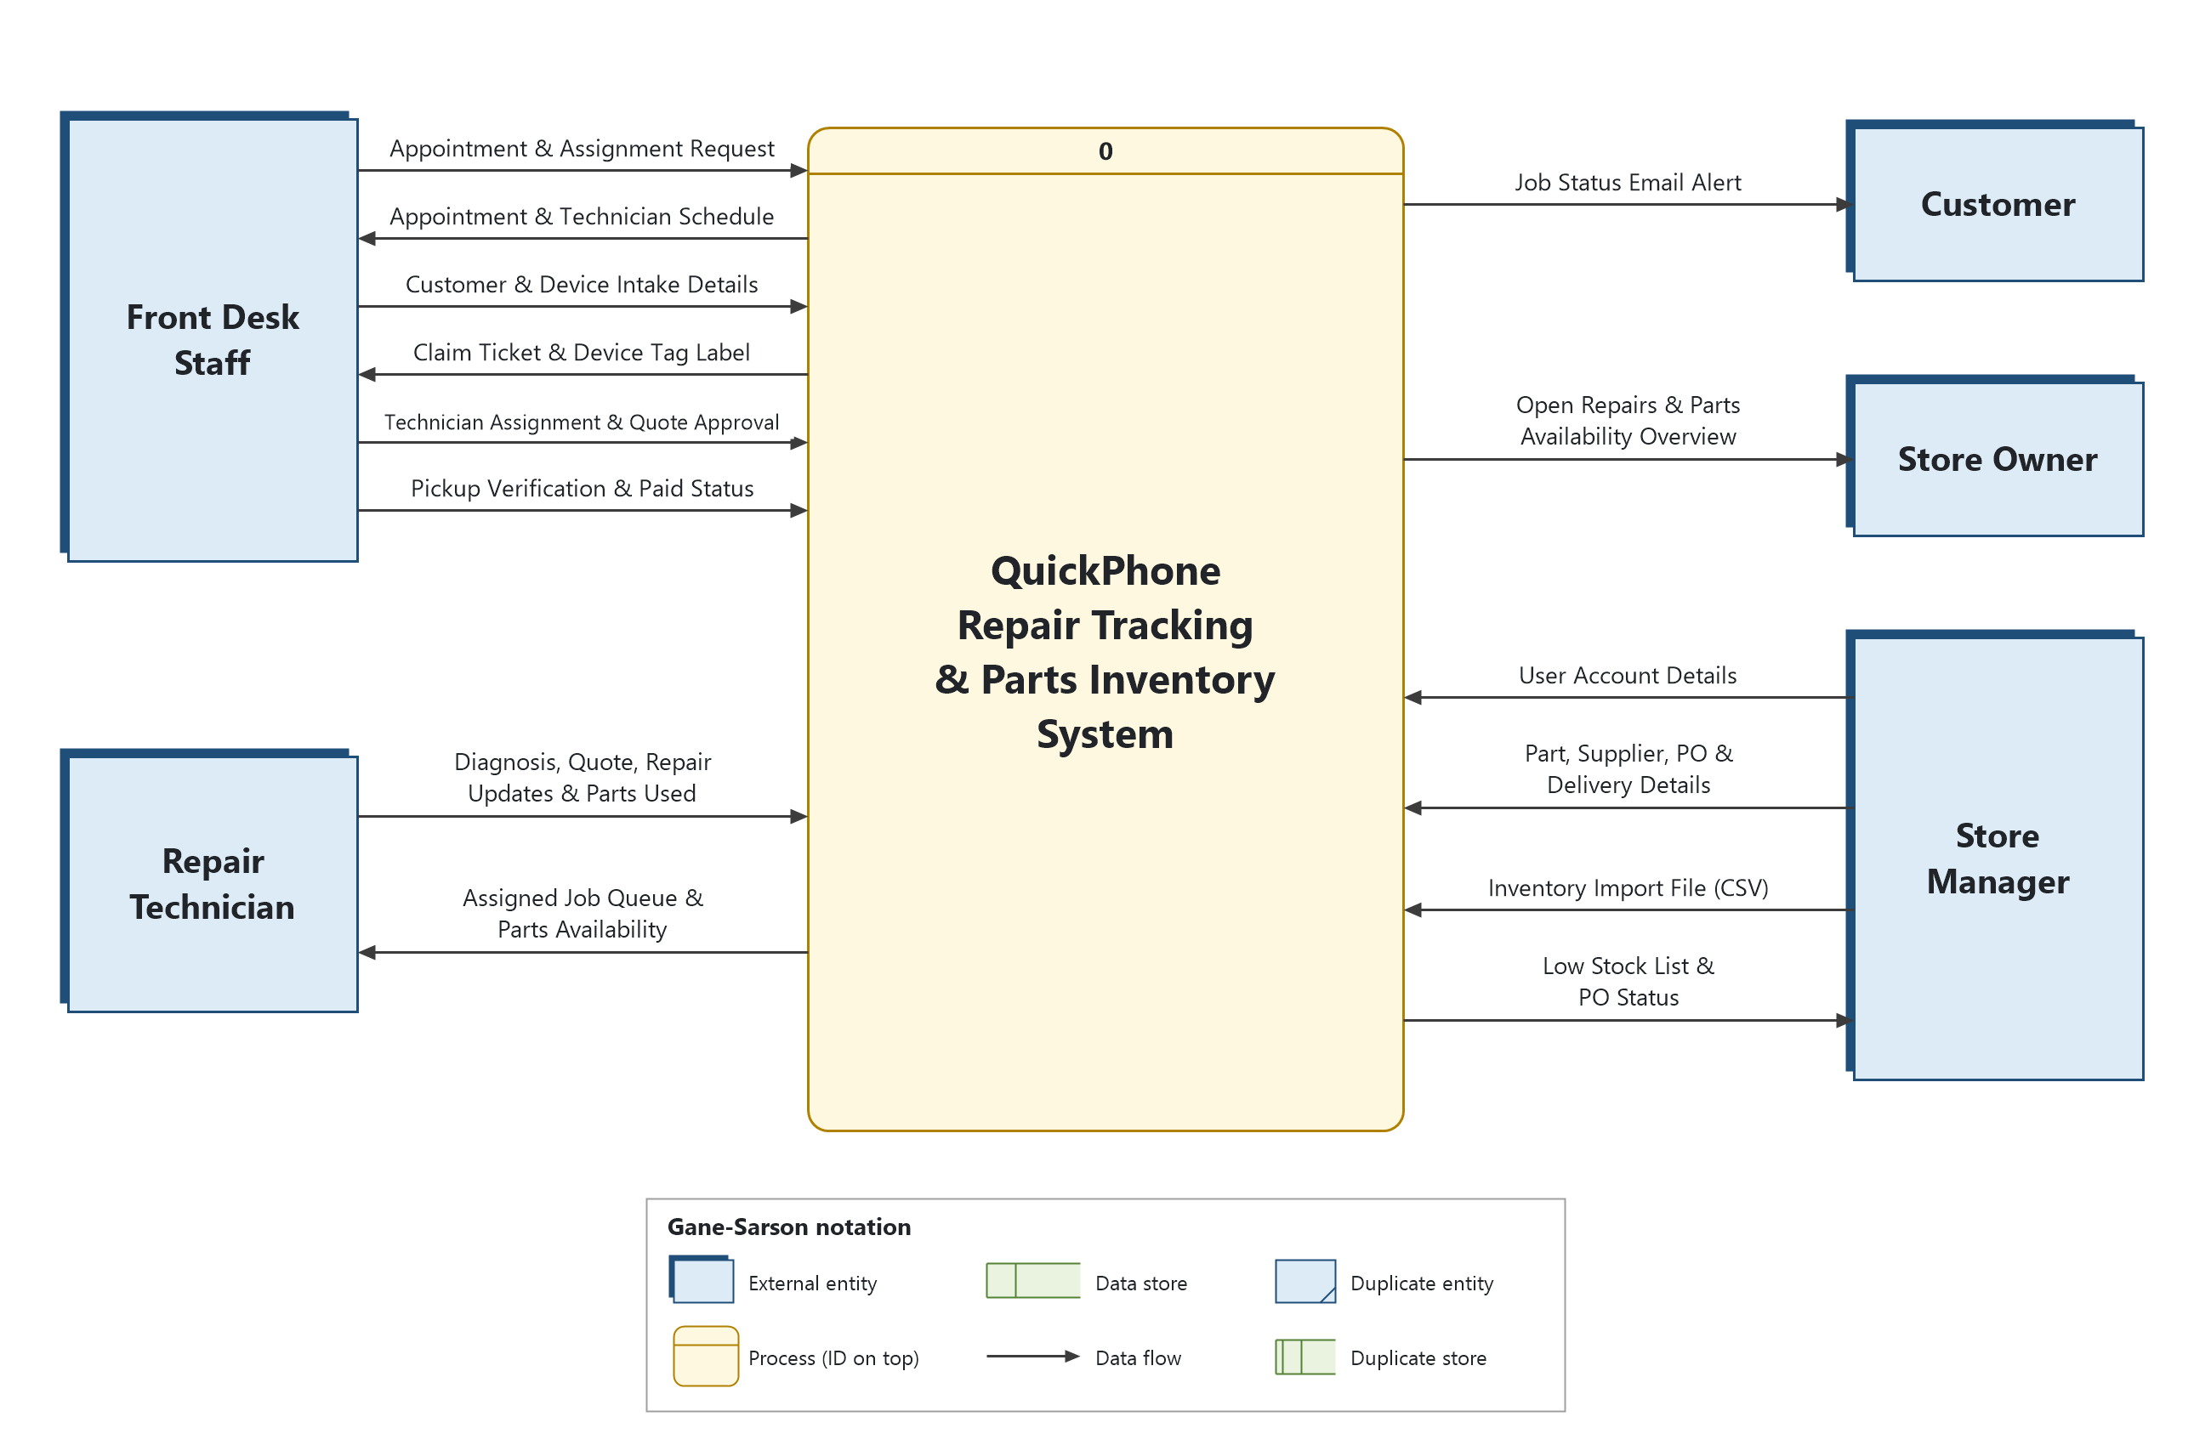
Figure 1. QuickPhone context diagram (Gane-Sarson notation)

4.1 Data Flows Crossing the System Boundary
External entity | Data flow | Direction | Description
Front Desk Staff | Appointment & Assignment Request | In | Customer, device, preferred store and time slot for a drop-off appointment
Front Desk Staff | Appointment & Technician Schedule | Out | Booked slots by store and day
Front Desk Staff | Customer & Device Intake Details | In | Customer contact details, device type/make/model/serial, condition, accessories, reported fault, quote, promised date
Front Desk Staff | Claim Ticket & Device Tag Label | Out | Printed customer claim ticket and label attached to the device
Front Desk Staff | Technician Assignment & Quote Approval | In | Technician assigned to the job; customer approval or decline of a revised quote
Front Desk Staff | Pickup Verification & Paid Status | In | Ticket number match, ID checked and ID type, final cost and paid flag
Repair Technician | Diagnosis, Quote, Repair Updates & Parts Used | In | Diagnosis notes, revised quote, status changes, parts reserved or used
Repair Technician | Assigned Job Queue & Parts Availability | Out | The technician's open jobs and stock available for them
Store Manager | User Account Details | In | New or changed staff accounts, roles and home store
Store Manager | Part, Supplier, PO & Delivery Details | In | Parts catalog changes, supplier details, purchase orders and quantities received
Store Manager | Inventory Import File (CSV) | In | One-time import of the existing parts inventory
Store Manager | Low Stock List & PO Status | Out | Parts at or below reorder point or needed by waiting jobs; open purchase order status
Store Owner | Open Repairs & Parts Availability Overview | Out | Dashboard of open jobs by status, overdue jobs, awaiting-parts jobs and low stock at both stores
Customer | Job Status Email Alert | Out | Email when the device is ready for pickup (and other enabled statuses)
Why Supplier is not an external entity: the system only tracks orders. Suppliers never send data to the system or receive data from it. The store manager enters supplier, purchase order and delivery details. If a later release sends purchase orders electronically, Supplier would be added as an external entity.

5. Level 0 Data Flow Diagram
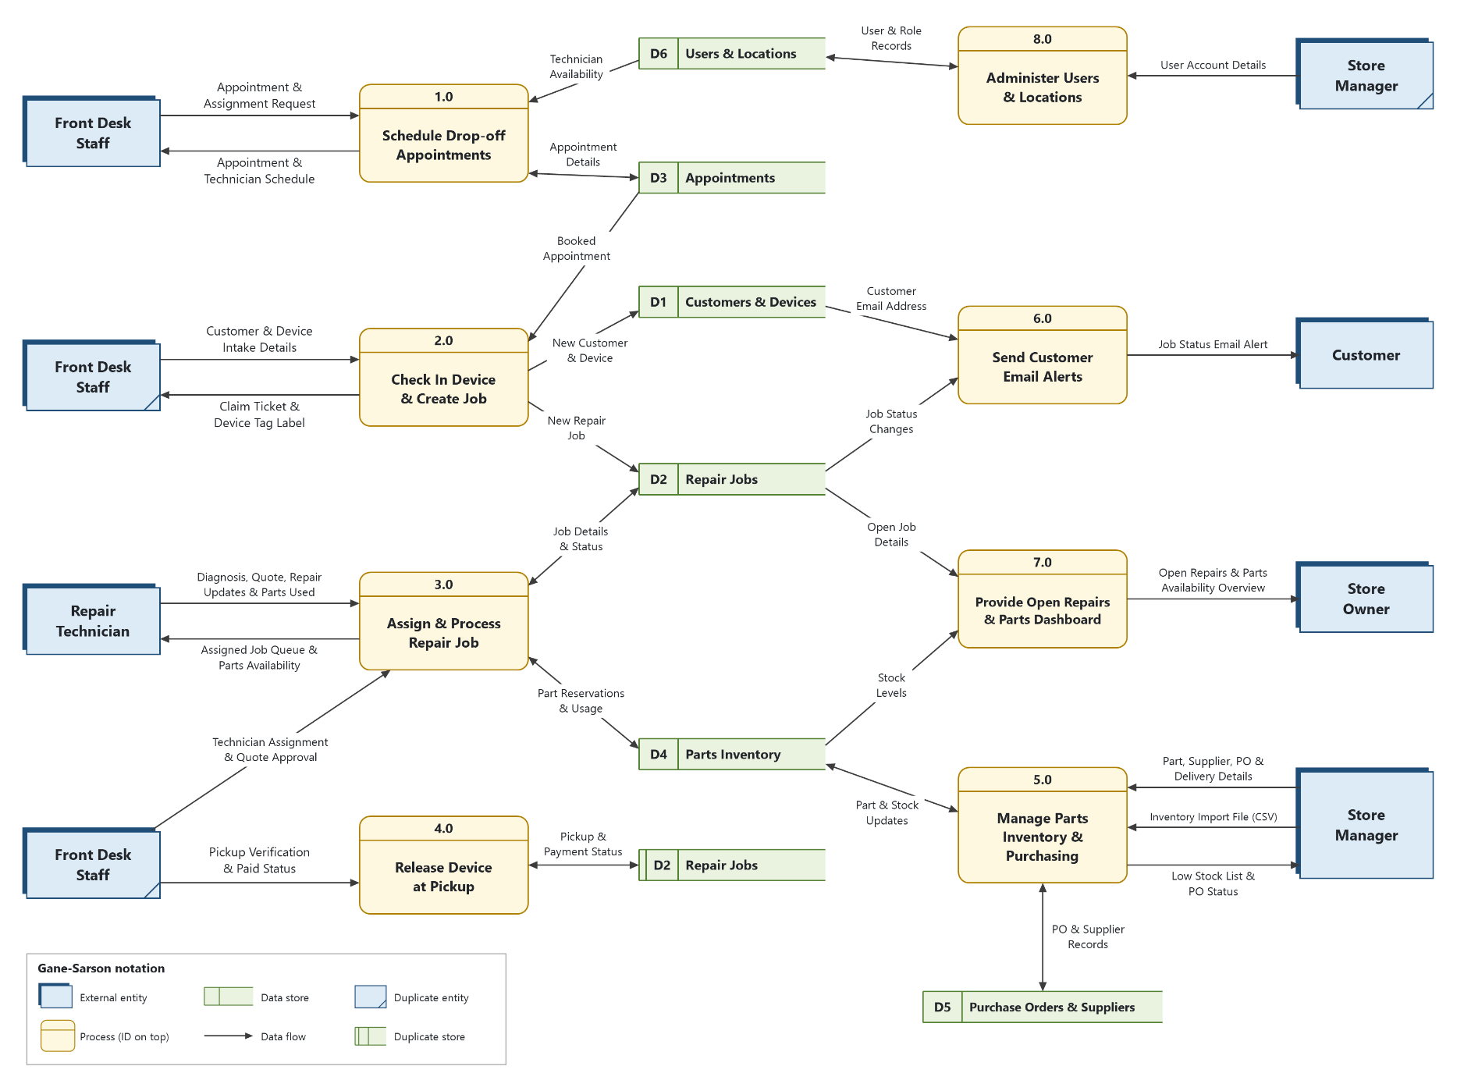
Figure 2. QuickPhone Level 0 DFD (Gane-Sarson notation). Duplicate entities and stores are marked and used only to avoid crossing lines.

5.1 Processes
ID | Process | Description | Inputs | Outputs
1.0 | Schedule Drop-off Appointments | Books drop-off appointments by store and time slot using store hours and technician availability. | Appointment & Assignment Request; Technician Availability (D6); Appointment Details (D3) | Appointment & Technician Schedule; Appointment Details (D3)
2.0 | Check In Device & Create Job | Finds or creates the customer, records the device, creates the job with a ticket number, and prints the claim ticket and tag label. | Customer & Device Intake Details; Booked Appointment (D3) | Claim Ticket & Device Tag Label; New Customer & Device (D1); New Repair Job (D2)
3.0 | Assign & Process Repair Job | Assigns the technician, records diagnosis and quote approval, moves the job through statuses, reserves and consumes parts, and flags jobs awaiting parts. | Technician Assignment & Quote Approval; Diagnosis, Quote, Repair Updates & Parts Used; Job Details & Status (D2); Part Reservations & Usage (D4) | Assigned Job Queue & Parts Availability; Job Details & Status (D2); Part Reservations & Usage (D4)
4.0 | Release Device at Pickup | Verifies ticket and photo ID, records final cost and paid flag, and closes the job as Picked Up. | Pickup Verification & Paid Status; Pickup & Payment Status (D2) | Pickup & Payment Status (D2)
5.0 | Manage Parts Inventory & Purchasing | Maintains parts and suppliers, imports inventory, produces the low-stock list, records purchase orders and receives deliveries. | Part, Supplier, PO & Delivery Details; Inventory Import File (CSV); Part & Stock Updates (D4); PO & Supplier Records (D5) | Low Stock List & PO Status; Part & Stock Updates (D4); PO & Supplier Records (D5)
6.0 | Send Customer Email Alerts | Detects status changes that trigger an alert and emails the customer. | Job Status Changes (D2); Customer Email Address (D1) | Job Status Email Alert
7.0 | Provide Open Repairs & Parts Dashboard | Combines open job and stock data into the single staff view. | Open Job Details (D2); Stock Levels (D4) | Open Repairs & Parts Availability Overview
8.0 | Administer Users & Locations | Creates and maintains staff accounts, roles and the two store locations. | User Account Details; User & Role Records (D6) | User & Role Records (D6)

5.2 Data Stores
ID | Data store | Contents | Used by
D1 | Customers & Devices | Customer name, phone, email, alert consent; devices (type, make, model, colour, serial/IMEI) | 2.0, 6.0
D2 | Repair Jobs | Ticket number, store, device, fault, condition, accessories, quotes and approvals, technician, status history, parts needed/used, final cost, paid flag, pickup verification (ticket match, ID type, checked by) | 2.0, 3.0, 4.0, 6.0, 7.0
D3 | Appointments | Store, date and time slot, customer, device, issue, arrival status | 1.0, 2.0
D4 | Parts Inventory | Part number, description, compatible models, grade, cost, default supplier, reorder point; on-hand and reserved quantity per store | 3.0, 5.0, 7.0
D5 | Purchase Orders & Suppliers | Suppliers; purchase orders, order lines and quantities received | 5.0
D6 | Users & Locations | Staff accounts, roles, home store; store details and business hours | 1.0, 8.0

5.3 Balancing Check
Every data flow on the context diagram appears on the Level 0 DFD with the same name and direction, so the two diagrams are balanced.
Context flow | Entity | Level 0 process
Appointment & Assignment Request / Appointment & Technician Schedule | Front Desk Staff | 1.0
Customer & Device Intake Details / Claim Ticket & Device Tag Label | Front Desk Staff | 2.0
Technician Assignment & Quote Approval | Front Desk Staff | 3.0
Diagnosis, Quote, Repair Updates & Parts Used / Assigned Job Queue & Parts Availability | Repair Technician | 3.0
Pickup Verification & Paid Status | Front Desk Staff | 4.0
Part, Supplier, PO & Delivery Details / Inventory Import File (CSV) / Low Stock List & PO Status | Store Manager | 5.0
Job Status Email Alert | Customer | 6.0
Open Repairs & Parts Availability Overview | Store Owner | 7.0
User Account Details | Store Manager | 8.0

6. Feasibility Analysis

6.1 Technical Feasibility – Feasible (moderate risk)
Factor | Assessment | Risk
Application type | A standard database-backed web application (forms, lists, workflow). Well within the ability of common frameworks the team may already know, such as Django, Laravel, ASP.NET or Express. | Low
Data | One relational database (for example PostgreSQL, MySQL or SQLite) handles customers, jobs, parts and purchase orders at two-store scale. | Low
Printing | Claim tickets and tag labels can print from the browser using print stylesheets. Proposed printer: DYMO LabelWriter 550, one per store; label size to confirm. | Medium
Email alerts | Frameworks can send email through the shop's existing mailbox (SMTP). This is the only outbound connection and needs owner approval. | Medium
Two locations | A hosted web application reached over the internet serves both stores from one database. The hosting choice is still open. | Medium
Team skills | Four students; the technology stack should match existing team skills, to be decided in Sprint 2. | Medium

6.2 Economic Feasibility – Feasible (low cash cost)
Development is carried out by the student team as a course project, so labour is not a cash cost to QuickPhone. Remaining costs are small (detail in QuickPhone_Feasibility_Analysis.docx):
Cost item | Type | Estimate / notes
Label printers (2 x DYMO LabelWriter 550) | One-time | $293.98 total; $0 if the shop already owns suitable printers
Hosting (web server $6.00 + managed database $15.00) | Monthly | $21.00
Domain name and SSL certificate | Monthly | $0.87 (SSL certificate is free)
Device tag labels | Monthly | $10.00
Total technology cost | Monthly | $31.87 a month ($382.46 a year)
Support after handoff | Ongoing | Not costed; owner must decide who maintains the system after December 9, 2026
Benefits are counted as staff hours saved. Volumes are analyst assumptions to confirm against the owner's baseline figures:
Benefit | Hours saved and basis
Fewer status-enquiry calls | 1.7 hours a week (86.7 a year): 2 stores x 25 calls x 50% avoided x 4 minutes
Less time chasing jobs waiting on parts | 2.0 hours a week (104.0 a year): 2 stores x 4 jobs x 0.5 hours x 50%
Less inventory administration | 2.4 hours a week (124.8 a year): 2 stores x 3 manager hours x 40%
Total | About 6.1 staff hours a week (315.5 a year)
Alternatives: RepairShopr (Big Chain plan, $149.99 a month) and RepairDesk (Growth plan, $149.00 a month) cost about $159 a month including labels, compared with $31.87 a month for the custom build (3-year totals $6,054 and $6,018 versus $1,441). The custom build is recommended because it fits the owner's workflow and QuickPhone keeps its data; a subscription is the fallback if no support after handoff is arranged. Confirm vendor prices before the Sprint 2 decision.

6.3 Operational and Organizational Feasibility – Feasible
- The owner sponsors the project, and each staff role maps directly to a system role.
- The system follows the owner's existing repair statuses, so the workflow changes little.
- Pickup verification (ticket and photo ID check) adds a short step at release but protects the business against disputes and lost devices.
- Using the same process at both stores improves consistency; a dedicated training sprint (Sprint 5) supports adoption.
- Front desk staff should review the Sprint 3 designs so the check-in and pickup screens suit a busy counter.

6.4 Schedule Feasibility – Feasible with conditions
Sprint | Dates (2026) | Theme | Recommended work before the next sprint
1 | Sep 14 - 20 | Problem definition & feasibility | Set up repository and environment; technical spikes (Sep 21 - Oct 4)
2 | Oct 5 - 11 | Requirements & analysis | Build Slice 1: foundation (Oct 12 - 18)
3 | Oct 19 - 25 | Interface design | Build Slices 2-4 (Oct 19 - Nov 1)
4 | Nov 2 - 8 | Working system demonstration | Fix defects; import inventory; Should items (Nov 9 - 15)
5 | Nov 16 - 22 | Training session | Address training feedback (Nov 23 - 29)
6 | Nov 30 - Dec 9 | Final presentation & handoff | Final deliverables due Dec 9
The course calendar leaves about three weeks between the end of requirements (Oct 11) and the working demonstration (Nov 2). The MVP (Must) scope is currently 25 items and 93 story points. The schedule is feasible only if:
- Construction starts in the gap weeks, building the data foundation and basic screens before Sprint 3 designs are final.
- The MVP scope is frozen at the end of Sprint 2, and large items (PB-17, PB-22) are split.
- Should items (appointment booking, email alerts, transfers) are built only if capacity allows. Use the capacity check in the workbook's Summary sheet.

6.5 Legal and Privacy Feasibility – Feasible with controls
- Customer names, phone numbers and emails are personal information. Collect only what is needed, restrict access by role, use HTTPS, and follow the privacy law that applies where the stores operate.
- Do not store photo ID numbers; record only the ID type and that it was checked.
- Device passcodes should not be stored in plain text. A policy decision is needed (open question 2).
- Send customer emails only for transactional status updates, and record the customer's consent at intake.
- Claim ticket terms (for example, what happens to uncollected devices) should be written by the owner.

6.6 Recommendation
Proceed, with conditions. The system is technically straightforward and low cost: $293.98 one-time for two label printers and $31.87 a month for hosting, domain and labels, saving about 6.1 staff hours a week. It also costs less than a RepairShopr or RepairDesk subscription (about $159 a month). The main risk is schedule. Conditions: (1) the owner approves the scope and success measures in this document; (2) the MVP scope is frozen by October 11; (3) hosting and label printer decisions are made in Sprint 2; (4) the owner decides whether email alerts may be sent from the shop mailbox; (5) the owner decides who supports the system after handoff, with a subscription as the fallback.

7. Prioritized Product Backlog
The backlog contains 43 items grouped into 11 epics. Items are ranked by their contribution to the three success measures and by build dependencies, and classified using MoSCoW. Story points are initial analyst estimates on a Fibonacci scale; the team should re-estimate them with planning poker in Sprint 2. The workbook QuickPhone_Product_Backlog.xlsx holds the full user stories and acceptance criteria.
Priority | Items | Story points | Planned for
Must | 25 | 93 | MVP - demonstrated in Sprint 4 (Nov 2-8)
Should | 8 | 26 | Release 1.1 - before training if capacity allows
Could | 5 | 12 | After handoff
Won't | 5 | 0 | Excluded from this release
Total | 43 | 131

7.1 Must Have – MVP for the Sprint 4 Demonstration
Rank | ID | Backlog item | Epic | Pts | MVP slice
1 | PB-01 | Staff login & role-based access | Users, Roles & Locations | 5 | S1 Foundation
2 | PB-02 | Manage user accounts | Users, Roles & Locations | 3 | S1 Foundation
3 | PB-03 | Set up two store locations | Users, Roles & Locations | 2 | S1 Foundation
4 | PB-04 | Find or create customer | Customer & Device Intake | 3 | S1 Foundation
5 | PB-05 | Record device details at intake | Customer & Device Intake | 3 | S1 Foundation
6 | PB-06 | Create repair job at check-in | Customer & Device Intake | 5 | S1 Foundation
7 | PB-07 | Print claim ticket | Customer & Device Intake | 3 | S1 Foundation
8 | PB-08 | Print device tag label | Customer & Device Intake | 2 | S1 Foundation
9 | PB-09 | Update job status with history | Repair Job Workflow | 5 | S2 Repair Workflow
10 | PB-10 | Assign technician to job | Appointments & Technician Scheduling | 3 | S2 Repair Workflow
11 | PB-11 | Record diagnosis & revise quote | Repair Job Workflow | 3 | S2 Repair Workflow
12 | PB-12 | Record customer quote approval | Repair Job Workflow | 2 | S2 Repair Workflow
13 | PB-13 | Maintain parts catalog | Parts Inventory | 3 | S3 Inventory & Purchasing
14 | PB-14 | Maintain suppliers | Purchasing & Receiving | 2 | S3 Inventory & Purchasing
15 | PB-15 | Import existing inventory (CSV) | Data Setup & Import | 5 | S3 Inventory & Purchasing
16 | PB-16 | Parts availability lookup | Parts Inventory | 3 | S3 Inventory & Purchasing
17 | PB-17 | Reserve & consume parts on a job | Repair Job Workflow | 8 | S3 Inventory & Purchasing
18 | PB-18 | Flag jobs awaiting parts | Repair Job Workflow | 5 | S3 Inventory & Purchasing
19 | PB-19 | Low stock list | Parts Inventory | 3 | S3 Inventory & Purchasing
20 | PB-20 | Create purchase order | Purchasing & Receiving | 5 | S3 Inventory & Purchasing
21 | PB-21 | Receive delivery against PO | Purchasing & Receiving | 5 | S3 Inventory & Purchasing
22 | PB-22 | Open repairs & parts dashboard | Open Repairs Dashboard | 8 | S4 Dashboard & Pickup
23 | PB-23 | Quick job lookup | Open Repairs Dashboard | 2 | S4 Dashboard & Pickup
24 | PB-24 | Verify & release device at pickup | Pickup & Release | 3 | S4 Dashboard & Pickup
25 | PB-25 | Record final cost & paid flag | Pickup & Release | 2 | S4 Dashboard & Pickup

7.2 Should and Could Have
Rank | ID | Backlog item | MoSCoW | Pts | Release
26 | PB-26 | Book drop-off appointments | Should | 5 | Release 1.1
27 | PB-27 | Convert appointment to check-in | Should | 2 | Release 1.1
28 | PB-28 | Technician workload schedule | Should | 3 | Release 1.1
29 | PB-29 | Ready-for-pickup email alert | Should | 5 | Release 1.1
30 | PB-30 | Other status email alerts | Should | 3 | Release 1.1
31 | PB-31 | Transfer stock between stores | Should | 3 | Release 1.1
32 | PB-32 | Stock adjustments with reason | Should | 3 | Release 1.1
33 | PB-33 | Job audit trail view | Should | 2 | Release 1.1
34 | PB-34 | Uncollected device aging flag | Could | 2 | Future
35 | PB-35 | Rush / priority flag | Could | 1 | Future
36 | PB-36 | Barcode / QR on ticket & tag | Could | 3 | Future
37 | PB-37 | Intake condition photos | Could | 3 | Future
38 | PB-38 | Warranty re-work link | Could | 3 | Future

7.3 Won't Have (This Release)
- PB-39 Payment processing / POS - Excluded by owner decision; only a paid Yes/No flag is recorded (PB-25).
- PB-40 Customer self-service portal / online booking - Excluded: customers do not interact with the system directly.
- PB-41 SMS / text notifications - Excluded: requires a third-party SMS provider; email only.
- PB-42 Reporting & analytics - Deferred to a later release by owner decision.
- PB-43 Third-party integrations - Excluded: single database, no external systems.

8. Release Plan
Sprint | Dates (2026) | Theme | Increment (PSPI) delivered
1 | Sep 14 - 20 | Problem definition & feasibility | This document: problem definition, context diagram, Level 0 DFD, feasibility, prioritized backlog
2 | Oct 5 - 11 | Requirements & analysis | Refined Must stories and acceptance criteria, use cases, ERD and data dictionary, Level 1 DFDs, status transition diagram, frozen MVP scope
3 | Oct 19 - 25 | Interface design | Wireframes for check-in, job, dashboard, parts, PO and pickup; print layouts; front desk walkthrough
4 | Nov 2 - 8 | Working system demonstration | Working MVP (PB-01 to PB-25) shown end to end: check-in, repair with parts, PO receiving, pickup
5 | Nov 16 - 22 | Training session | Training plan, user guide, role quick-reference cards, staff trained at both stores
6 | Nov 30 - Dec 9 | Final presentation & handoff | Final presentation, system and admin documentation, source code, lessons learned

9. Sprint 1 PSPI

9.1 Sprint Goal
Deliver an owner-approved problem definition and feasibility package (scope, system boundary, feasibility recommendation and a prioritized product backlog) so that Sprint 2 can begin requirements analysis on October 5.

9.2 Increment Contents and Acceptance Criteria
# | Increment item | Location | Accepted when
1 | Problem statement, objectives, success measures | Section 2 | Owner confirms the problem statement and the three success measures; targets agreed or adjusted
2 | Scope, constraints and assumptions | Sections 2.5-2.7 | Owner confirms in-scope and out-of-scope lists
3 | Stakeholder and user analysis | Section 3 | All user roles and their access are confirmed
4 | Context diagram | Section 4 | Owner confirms external entities and boundary flows; Gane-Sarson notation used correctly
5 | Level 0 DFD | Section 5 | Eight processes and six data stores reviewed; balanced with the context diagram
6 | Feasibility analysis | Section 6 | Owner accepts the "proceed with conditions" recommendation
7 | Prioritized product backlog | Section 7 and workbook | Every item has ID, user story, acceptance criteria, MoSCoW and estimate; Must list agreed as MVP candidate
8 | Risk register and open questions | Sections 10-11 | Owners are assigned; open questions are scheduled for the Sprint 2 interview

9.3 Sprint 1 Backlog
ID | Task | Owner | Hrs | Due | Status
S1-01 | Sprint planning: confirm sprint goal, roles, working agreement | A | 2 | Mon Sep 14 | In Progress
S1-02 | Owner interview: confirm scope, current process and baseline figures for success measures | B | 3 | Tue Sep 15 | To Do
S1-03 | Write problem statement, objectives, scope (in/out), constraints and assumptions | B | 4 | Wed Sep 16 | In Review
S1-04 | Stakeholder and user role analysis | B | 2 | Wed Sep 16 | In Review
S1-05 | Context diagram (Gane-Sarson) and flow descriptions | C | 3 | Wed Sep 16 | In Review
S1-06 | Level 0 DFD with process and data store descriptions; balance check against context diagram | C | 6 | Thu Sep 17 | In Review
S1-07 | Technical feasibility, including spike plan for label printing | D | 4 | Thu Sep 17 | In Review
S1-08 | Economic feasibility: one-time and monthly technology costs, hours saved, alternatives | A | 4 | Fri Sep 18 | In Review
S1-09 | Operational, schedule and legal/privacy feasibility | D | 3 | Fri Sep 18 | In Review
S1-10 | Initial product backlog: epics, user stories, MoSCoW, planning-poker estimates | C | 6 | Fri Sep 18 | In Review
S1-11 | Risk register and open questions for Sprint 2 | D | 2 | Fri Sep 18 | In Review
S1-12 | Hosting and technology options memo for Sprint 2 decision | D | 3 | Fri Sep 18 | To Do
S1-13 | Assemble PSPI document; peer review against Definition of Done | A | 4 | Fri Sep 18 | In Review
S1-14 | Sprint review with owner; record feedback and sign-off | B | 2 | Sat Sep 19 | To Do
S1-15 | Sprint retrospective; refine backlog for Sprint 2 | A | 1 | Sun Sep 20 | To Do
Total planned effort: 49 hours. Actual and remaining hours are tracked in the workbook's Sprint 1 Backlog sheet.

9.4 Team and Scrum Roles
Key | Team member | Scrum role | Sprint 1 hours
A | Member A | Scrum Master | 11
B | Member B | Product Owner proxy / Business Analyst | 11
C | Member C | Systems Analyst / Modeler | 15
D | Member D | Technical Lead | 12
The store owner is the business Product Owner. Member B acts as Product Owner proxy between owner meetings.

9.5 Sprint Events
Event | When | Purpose
Sprint planning | Mon Sep 14 | Agree the sprint goal, tasks and owners
Stand-ups | Mon, Wed, Fri (15 min, online) | Progress, next steps, blockers
Owner interview | Tue Sep 15 | Confirm scope and gather baseline figures (task S1-02)
Internal peer review | Fri Sep 18 | Check every artifact against the Definition of Done
Sprint review | Sat Sep 19 | Walk the owner through the increment; record acceptance
Retrospective | Sun Sep 20 | What went well, what to improve in Sprint 2

9.6 Definition of Done (Sprint 1 Artifacts)
- Content covers the sprint goal and the course template for problem definition and feasibility.
- Diagrams use Gane-Sarson notation, every flow is named, and the context diagram balances with the Level 0 DFD.
- Every backlog item has an ID, user story ("As a... I want... so that..."), at least one acceptance criterion, MoSCoW priority and estimate.
- Assumptions and open questions are written down, not implied.
- At least one other team member has peer-reviewed each artifact, and spelling and grammar are checked.
- The owner has reviewed the increment at the sprint review, and feedback is recorded.
- Files are saved to the shared team folder with a version number.

9.7 Sprint Review Acceptance
Increment item | Accepted (Y/N) | Comments / changes requested
1-3 Problem definition, scope, stakeholders
4-5 Context diagram and Level 0 DFD
6 Feasibility recommendation
7 Prioritized product backlog
8 Risks and open questions
Owner name: ______________________ Signature: ______________________ Date: __________
Scrum Master: ______________________ Signature: ______________________ Date: __________

10. Risk Register
ID | Risk | Likelihood | Impact | Mitigation | Owner
R1 | Short build window between requirements (Oct 11) and demonstration (Nov 2) | High | High | Start construction in gap weeks; build thin vertical slices; freeze MVP scope at end of Sprint 2 | A
R2 | Must scope (93 points) exceeds team capacity | Medium | High | Re-estimate in Sprint 2; split PB-17 and PB-22; move lower-ranked Musts to Release 1.1 with owner agreement | B
R3 | Label printer model and label size unknown | Medium | Medium | Confirm the printer in Sprint 2; run a browser print spike before Sprint 3 | D
R4 | Email alerts need access to the shop mailbox, which conflicts with "no external services" | Medium | Medium | Get an owner decision in Sprint 2; alerts are a Should item, so the MVP does not depend on them | B
R5 | Existing inventory data is incomplete or inconsistent | Medium | High | Get a sample export in Sprint 2; provide a CSV template with validation (PB-15) | C
R6 | Mishandling customer personal data (ID, passcodes) | Low | High | Data minimization, role-based access, HTTPS, no ID numbers, passcode policy decision | D
R7 | Hosting environment undecided for two-store access | Medium | Medium | Tech options memo in Sprint 1 (S1-12); decision in Sprint 2 | D
R8 | Team availability affected by other courses and exams | Medium | Medium | Plan capacity each sprint; keep a shared task board; pair on critical items | A
R9 | Low staff adoption at one store | Low | Medium | Involve front desk in Sprint 3 design review; role-based training and quick-reference cards in Sprint 5 | B

11. Open Questions for Sprint 2
# | Question | Why it matters
1 | What do you use today to track repairs and parts (paper, spreadsheets, whiteboard)? How many status calls, stalled jobs and lost-device incidents happen per week? | Baseline for success measures and data migration
2 | Do you need to record device passcodes? If yes, how should they be protected and when deleted? | Privacy and security design
3 | What label printer and label size do you use? What printer is used for claim tickets? | Print layouts (PB-07, PB-08)
4 | Where should the system be hosted, and who will support it after December 9? | Architecture, cost and handoff
5 | May the system send customer emails from the shop's existing email account? | Email alerts (PB-29, PB-30)
6 | Are parts stocked separately at each store, and do you move parts between stores? | Inventory design (PB-13, PB-31)
7 | Business hours per store, appointment slot length and bookings per slot? | Appointment booking (PB-26)
8 | Who assigns technicians? Do technicians work at both stores? | Assignment rules (PB-10)
9 | Can a job be released unpaid? What is the policy for uncollected devices and warranty periods? | Pickup rules (PB-25, PB-34, PB-38)
10 | Do you use a standard repair price list, or are all quotes free-form? Should tax appear on quotes? | Quote fields
11 | What columns does your current inventory list have? Can you share a sample? | Import template (PB-15)
12 | What terms and conditions should appear on the claim ticket? | Claim ticket content (PB-07)

Appendix A. Job Status Definitions
Status | Meaning
Booked | Drop-off appointment made; device not yet received
Checked In | Device received, tag label attached, claim ticket issued
Diagnosing | Technician is assessing the fault
Awaiting Customer Approval | Revised quote is waiting for the customer's decision
Awaiting Parts | Work is blocked until a part is received or transferred
In Repair | Repair work is under way
QA/Testing | Repair complete; device is being tested
Ready for Pickup | Final cost recorded; customer notified and can collect
Picked Up | Released after ticket and photo ID verification (closed)
Cancelled | Customer cancelled or declined the quote; device is returned through pickup verification
Unrepairable / Returned | Device cannot be repaired; returned through pickup verification

Appendix B. Glossary
Term | Definition
PSPI | Potentially Shippable Product Increment: the done, usable result of a sprint
MVP | Minimum Viable Product: the smallest set of features that delivers the core value (the Must items)
MoSCoW | Prioritization categories: Must, Should, Could, Won't (this release)
Story point | Relative estimate of effort and complexity for a backlog item
Context diagram | Top-level DFD showing the system as one process and its external entities
Level 0 DFD | Breaks the system into its major processes, data stores and data flows
Gane-Sarson | DFD notation using rounded rectangles for processes, open-ended rectangles for data stores and shaded squares for external entities
PO | Purchase order recorded for parts ordered from a supplier
SMTP | Standard protocol used to send email through an existing mailbox

