jQuery

Common web development patterns

1. Page load
2. Initialize page state
3. Set up event handlers
4. Start app

Or….

1. User event
2. Retrieve page content
3. Manipulate content
4. Update page

Selectors and Filters

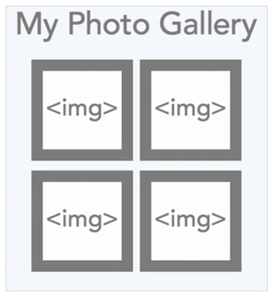

//retrieve all the image tags

var images = $( “img” );

//retrieve all the image tags

images.each(function(){

//operate on each image

});

Basic jQuery Selectors

|  |  |
| --- | --- |
| Selector | Result |
| $(“tagname”) | Select all ***tagName*** elements |
| $(“#identifier”) | Select element with id attribute ***identifier*** |
| $(“.className”) | Select all elements with class ***className*** |

Basic jQuery Filters

|  |  |
| --- | --- |
| Filter | Selects… |
| :first, :last | First or last of given selector type |
| :even, :odd | Only even or items in the matched set |
| :gt(), :lt(), :eq() | Items greater than, less than, equal to an index |
| :animated | Items that are in the process of being animated |
| :focus | Element that currently has the focus |
| :not(expr) | Elements that don’t match the given expression |

Traversing Documents

This is all relative to the second selected <p> element within the div.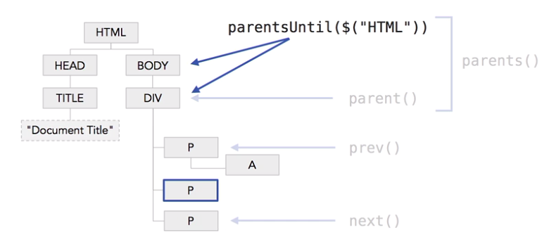

jQuery Statement Chaining

Call multiple functions on a result set in the same line

**$(selector).fn1().fn2().fn3()**

**Statement Chain**

Inserting Page Content

***.append()*** - *Insert content, specified by the parameter, to the end of each element in the set of matched elements.*

***.prepend()*** *- Insert content, specified by the parameter, to the beginning of each element in the set of matched elements.*

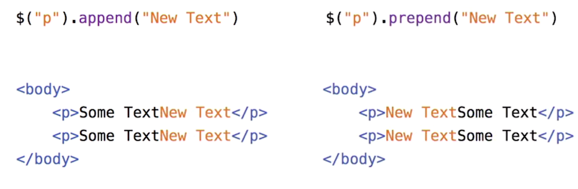

**.appendTo() –** *Insert every element in the set of matched elements to the* ***end*** *of the target.*

**.prependTo() -** *Insert every element in the set of matched elements to the* ***beginning*** *of the target.*

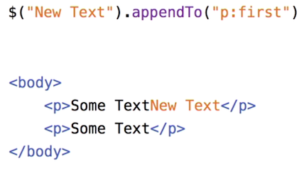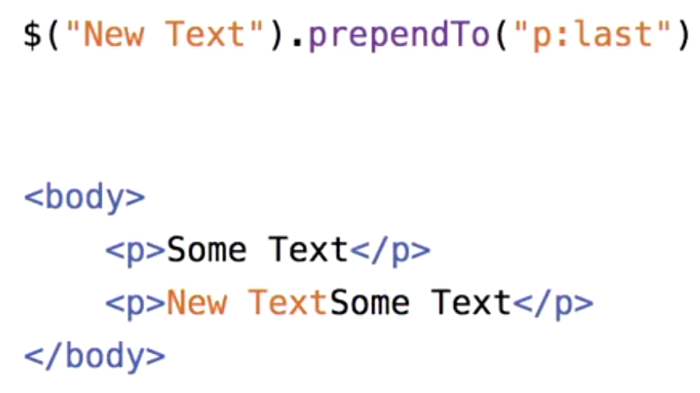

**.before() -** *Insert content, specified by the parameter,* ***before each elemen****t in the set of matched elements.*

**.after() -** *Insert content, specified by the parameter,* ***after each element*** *in the set of matched elements.*

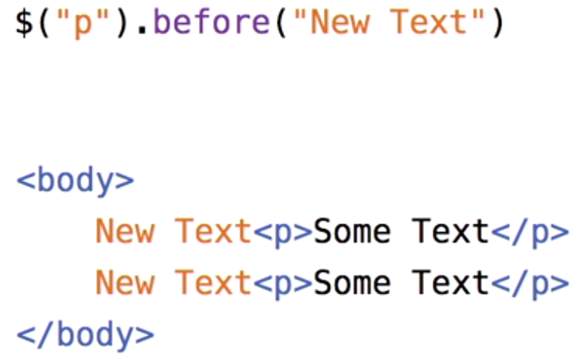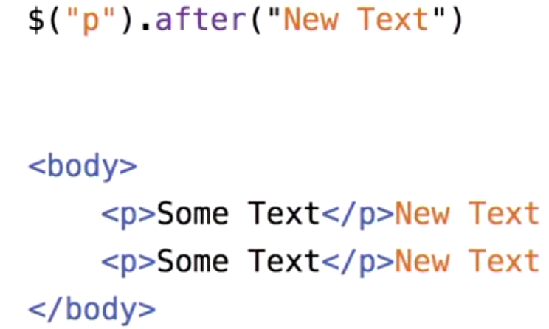

Working with CSS

|  |  |
| --- | --- |
| Selector | Result |
| css(propName) | Get value for the ***propName*** property on an element |
| css(propName, value) | Set value for the CSS property ***propName*** |
| css(propName, fn()) | Set value for the property ***propName*** to the result of ***fn*** |
| css(properties) | Set multiple property values at once |

|  |  |
| --- | --- |
| Selector | Result |
| hasClass(className) | Determine whether the element has className applied |
| addClass(className) | Add the CSS class(es) to the matched elements |
| removeClass(className) | Remove the CSS class(es) from the matched elements |
| toggleClass(className) | Toggle the presence of the CSS class(es) |

AJAX Global Event Handlers

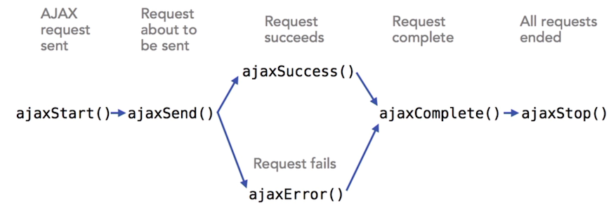

Custom Animation

