Assignment 1 – Web Dev

1. Site content and design
- URL: http://stc905.edu.csesalford.com (index which will redirect to the landing page: http://stc905.edu.csesalford.com/kyles_portfolio)
- My website is a simple portfolio to showcase a couple of projects and personal details.
- It has a fluid/liquid design.

2. Use of HTML5
My home page does not use as many elements as my ‘Bio’(personal.html) page so I will explain this page instead.
I have used a header tag at the start of the page to contain all the branding for the site; the navigation persists throughout all pages and its the contains the heading for each page. The nav tag has been to used to show that it is the main navigation for the website. The aside tag has been used for additional information about each page and for a navigation within the page. The main tag has attribute tabindex set to -1 as this is the first part of the page the tab button should focus to, this helps for accessibility. The content is split up using section tags so that users can navigate to each different topic easily. figure tags have been used to contain images so that they can be accompanied with captions helping users understand the image content. abbr tags have been used around abbreiviations so that users dont have to look up ones they dont know. caption, th, thead, tbody and tfoot have been used in the table tag to format the table correctly following accessibility standards. A footer has been used in the bottom of the page to contain information that is of least importance to users.

3. CSS Explanation
There is a bold banner at the top of the page containing the title of each page, this attracts attention and is ‘above the fold’ so if the user is interested in the title they should want to continue veiwing the site. The title uses a light coloured font on a darker background which creates contrast and increases readability. Directly underneath sits the navbar which helps with usability as it is easier to find due to most sites using a similar design. When the cursor hovers over each nav element a transition in colour shows the user that it will change the page if clicked. A submenu in the nav only drops down when the title of the submenu is hovered to hide unnessecary clutter from the page.
Each section has a svg image as the background so you can easily identify each section. Having the background as svg means the image can be scaled for each size of section or screen without creating pixelation. The svg is only slightly darker than the background so the font on top retains its contrast.
I have used media queries to change the layout of the navbar if the screen is too small to display it horizontally. Also if the screen is too small to display the timetable correctly it is hidden and a link to a seperate page with the timetable on it is shown.
The main inspiration for the colour scheme, fonts and graphics was taken from http://love2d.org/ although none of there images were used and the font is being used under fair use.

4. CSS Techniques
To show one item when another is hovered in the definitions list I used an adjacent siblings selector explained by Itay (http://stackoverflow.com/questions/20114874/css3-display-other-element-on-hover)
To remove the colour outline of focussed elements in a form I used the :focus selector and outline property eplained by CEich http://stackoverflow.com/questions/3397113/how-to-remove-border-outline-around-text-input-boxes-chrome
To make sure the background image for sections scaled with the section correctly I used the property background-size explained by user3385456 http://stackoverflow.com/questions/20565736/my-background-image-get-cut-off-at-the-bottom
To add line numbering to source code on my project pages I used Google Prettify an external javascript and CSS plugin https://github.com/google/code-prettify

5. Graphics
All graphics and images were created by me either a photograph of myself taken on my phone, screenshots of games I play or svg graphics that I created in inkscape. The font I used http://www.dafont.com/quicksand.font

6. Testing
These were all tested on the personal.html page as this shows the biggest range of elements.
I tested on:
Mobile:
  - Galaxy S5
  - Nexus 5
  - Galaxy Tab 4
  - iPad 4
  - iPhone 5S
  - iPhone 6 Plus
The differences between these devices was negligible other than the tablets which displayed the list of navigation items horizontally rather than vertically due to the increased screen width.
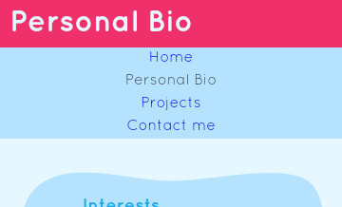
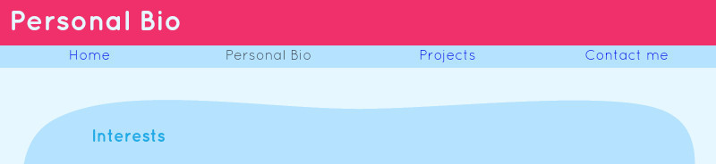

- Multiple browsers/OS’s
  - Chrome 36/Mac Maveric
  - Opera 12/Mac Yosemite
  - Safari 8/Mac Yosemite
  - IE 8/Windows 7
  - IE 9/Windows 7
  - Firefox 30/Windows 8.1
  - IE 11/Windows 8.1
  - Firefox 3/Windows XP
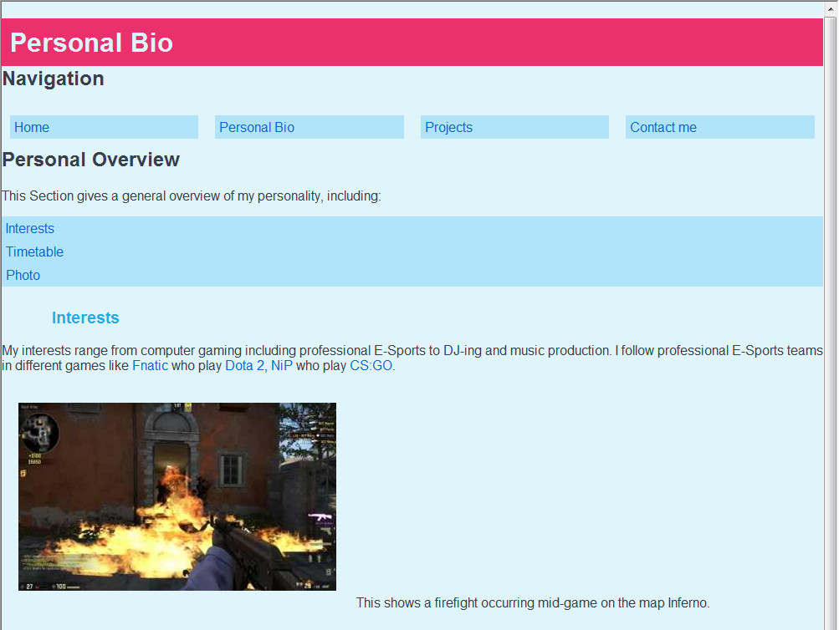
These also all looked very similar to each other, other than IE 8 and Win XP as this display pictures as borders or backgrounds at all and added unwanted spacing between the navigation buttons and above the banner. Although Win XP displayed the aside element correctly whereas IE 8 didn’t.
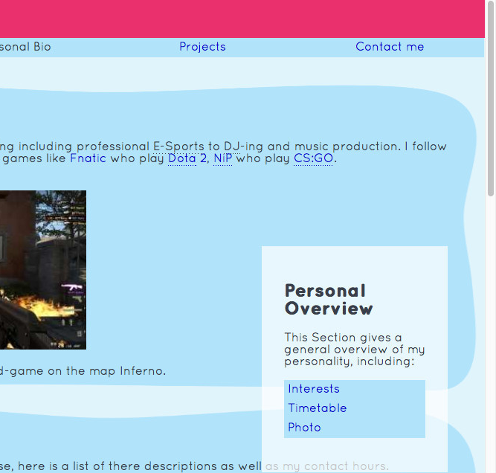

It is different to the mobile website as the in-page navigation is displayed to the right of the page rather than at the bottom as well as the timetable being shown in the page rather than having a link.

- Multiple font sizes/zoom levels (Chrome 54/Ubuntu 16.04)
  - Font Small
  - Font Medium (default)
  - Font Large
  - Font Very Large
  - Zoom 150%
  - Zoom 175%
Zooming the page scaled as if it were on a smaller device so it was still easy to use and read. Changing the font also scaled well.
- Different Resources
  - Without local CSS
  - Without Javascript
  - Without either
  - CLI (Lynx on Linux)
The website was usable no matter the resources available as everything was shown and nothing in the content was created by the CSS or Javascript
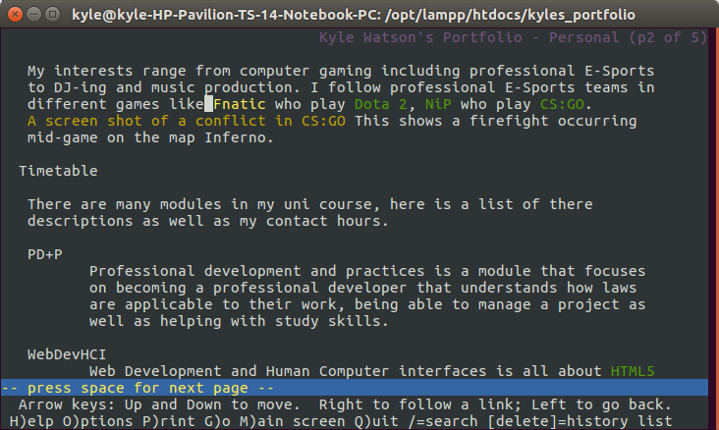

7. Validation
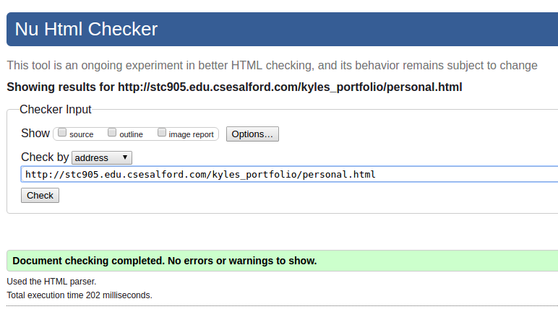
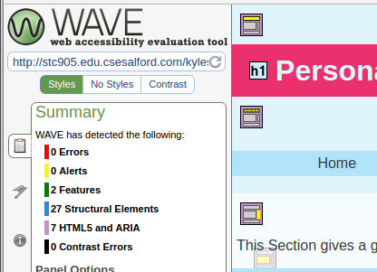

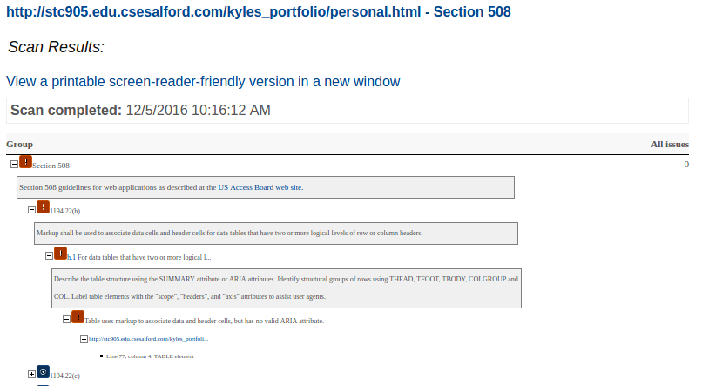
Unsure of this one warning as all my td tags have header attributes linking to an ID of a th tag.

