Kyle Kasmiersky
Aero 4720
Chakraborty
Test 2: for a trapezoidal integration scheme, show:

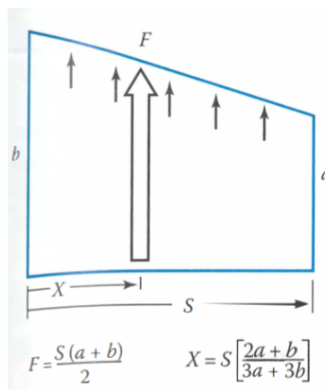
- The resultant force $F$ over the interval S is $F=\frac{S\left(a+b\right)}{2}$
$$F=\int_{0}^{S}{b-\left(b-a\right)\left(\frac{x}{S}\right)dx}$$
$$F=bx-\left(b-a\right)\left(\frac{x^{2}}{2S}\right)\begin{matrix}S \\ │ \\ 0\end{matrix}$$
$$bS-\left(b-a\right)\left(\frac{S^{2}}{2S}\right)-0$$
$$bS-\frac{bS-aS}{2}$$
$$\frac{bS+aS}{2}$$
$$\frac{S\left(a+b\right)}{2}$$
- The resultant force’s location x

$$X=\frac{\int_{0}^{S}{\left(b-\left(b-a\right)\left(\frac{x}{S}\right)\right)xdx}}{F}=\frac{2}{S\left(a+b\right)}\int_{0}^{S}{\left(b-\left(b-a\right)\left(\frac{x}{S}\right)\right)xdx}$$
$$X=\frac{2}{S\left(a+b\right)}\int_{0}^{S}{bx-\left(b-a\right)\left(\frac{x^{2}}{S}\right)dx}$$
$$X=\frac{2}{S\left(a+b\right)}\left[\frac{bx^{2}}{2}-\left(b-a\right)\left(\frac{x^{3}}{3S}\right)\right]\begin{matrix}S \\ | \\ 0\end{matrix}$$
$$X=\frac{2}{S\left(a+b\right)}\left[\frac{bS^{2}}{2}-\left(\frac{bS^{3}}{3S}-\frac{aS^{3}}{3S}\right)\right]$$
$$X=\frac{2}{S\left(a+b\right)}\left[\frac{bS^{2}}{2}-\left(\frac{bS^{2}}{3}-\frac{aS^{2}}{3}\right)\right]$$
$$X=\frac{2}{S\left(a+b\right)}\left[\frac{3bS^{2}}{6}-\left(\frac{2bS^{2}}{6}-\frac{2aS^{2}}{6}\right)\right]$$
$$X=\frac{2}{S\left(a+b\right)}\left[\frac{bS^{2}}{6}+\frac{2aS^{2}}{6}\right]$$
$$X=\frac{S^{2}}{S\left(a+b\right)}\left[\frac{b}{3}+\frac{2a}{3}\right]$$
$$X=\frac{S}{\left(a+b\right)}\frac{b+2a}{3}$$
$$X=S\frac{b+2a}{3a+3b}$$

