Kyle Kasmiersky
Aero 4630
Homework 1
- For each statement below about Newton’s second law, mark “T” if the statement is true and “F” if the statement is false. A statement is false if it is not always true.
- Forces on an object are independent of its acceleration. (F)
- An object in motion will stop unless acted upon by a force. (F)
- The net force on an object is proportional to its mass times its acceleration. (T)$(\dot{m}=0$)
- The net force on an object equals zero at all times. (F)

- A linear damper with a damping constant of $b=10Ns/mm$is subject to a constant force $F=1N$ at $t=0$. Which of the following best describes the motion of the damper? Why?
B. The damper keeps extending at the speed of $0.1 m/s$ forever
$$∑F=ma$$
$$F_{ext}-bv=ma$$
$$1_{N}-{10}_{\frac{Ns}{mm}}v=0$$
$$v={0.1}_{\frac{m}{s}}$$

- Two linear springs are connected in parallel as shown. You can assume that when $F=0$, both springs are at their relaxed lengths and the extensions $x_{1}=x_{2}=x_{rb}=0$.
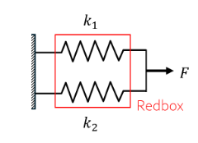
- Write down the constitutive laws for both springs, the force balance equation for the connection on the right, and the geometric continuity equation for this system.
$$F_{k1}=k_{1}x_{1}$$
$$F_{k2}=k_{2}x_{2}$$
$$∑F=0→-F_{k1}-F_{k2}+F=0$$
$$x_{1}=x_{2}=x_{rb}$$
- If the red box were replaced with a single spring, find the spring constant of that spring, $k_{rb}$.
$$F=F_{k1}+F_{k2}$$
$$F=k_{1}x_{1}+k_{2}x_{2}$$
$$F=k_{1}x_{rb}+k_{2}x_{rb}$$
$$F=\left(k_{1}+k_{2}\right)x_{rb}$$

$$\left(k_{1}+k_{2}\right)x_{rb}=k_{rb}x_{rb}$$
$$k_{rb}=k_{1}+k_{2}$$

- Five springs are arranged between two endpoints, as shown. The springs are individually well desribed by Hooke’s law of the form $f_{1}=k_{1}x_{1}$
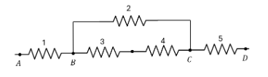
- Write down the force balance equation for the connection labeled B.
$$f_{3}+f_{2}-f_{1}=0$$
- True false, which of the followinga re correct geometric continuity equations if the points a and d are fixed?
- $v_{2}+v_{3}+v_{4}=0 \left(F\right)$
- $v_{2}+v_{4}=v_{5} \left(F\right)$
- $v_{1}+v_{2}+v_{5}=0 \left(T\right)$
- $v_{3}=v_{4}\left(F\right)$
- $v_{1}+v_{3}+v_{4}+v_{5}=0\left(T\right)$
- Write a correct geometric continuity equation involving $v_{5}$ if the absolute velocities of points A and D are nonzero and equal to $v_{A}$ and $v_{D}$, respectively.
$$v_{1}+v_{2}+v_{5}=v_{d}-v_{a}$$

- The springs and dampers in the system below are governed by the linear constitutive laws $f=kx$ and $f=bv$, $k>0,b>0,$ with possibly different k and b for the different elements. The vertical plates are connections and translate only. The walls are stationary. The elements may be moving. Forces, displacements, and velocities are defined according to our usual positive conventions. $F_{ext}$ is an externally applied force.
- Draw the free body diagrams for each connection point, indicating the forces acting on it and their direction.

- For each statement below, mark “T” if the statement is true and “F” if the statement is false.
- $f_{1}=f_{2} \left(F\right)$
- $f_{3}=f_{5}\left(F\right)$
- $f_{4}=f_{5}\left(T\right)$
- $f_{3}+f_{5}=f_{6}\left(T\right)$
- $f_{2}=f_{6}\left(T\right)$
- $f_{3}+f_{4}=f_{2}\left(T\right)$
- $F_{ext}+f_{1}-f_{2}=0\left(T\right)$
- $v_{1}=v_{2}\left(f\right)$
- $v_{3}-v_{4}-v_{5}=0\left(T\right)$
- $v_{3}+v_{4}=v_{6}\left(F\right)$
- $v_{1}+v_{2}+v_{3}+v_{4}+v_{5}+v_{6}=0\left(F\right)$
- If $v_{4}>0,$ then $x_{5}>0\left(T\right)$
- If $v_{3}>0,$ then $f_{3}>0\left(F\right)$

- Consider a perfectly linear spring (s) with $k=10N/m$ and a perfectly linear damper (d) with $b=10Ns/m$ in the arrangement below.
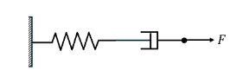
- If the applied force is a constant, F = 100N, find $v_{d},v_{s} and x_{s}.$ Note that $v_{d} and v_{s}$ are the relative velocities between the ends of the damper and the spring respectively.
$$-f_{s}+f_{b}=0;-f_{b}+F=0$$
$$b{\dot{x}}_{b}=kx_{s}; b{\dot{x}}_{b}=F;kx_{s}=F$$
$$v_{d}={\dot{x}}_{b}=\frac{F}{b}$$
$$x_{s}=\frac{F}{k}$$
$$v_{s}=\frac{d}{dt}x_{s}=\frac{d}{dt}\left(\frac{F}{k}\right)=0$$

- If the applied force is instantaneously reduced from $F=100N$ to $F=10N$, are the following True or False? Explain.
- $x_{s}$ changes discontinuously (T)
It’s position function does not have a time variable.
- $x_{d}$ changes discontinuously (F)
After integrating the velocity of the damper, it will have a time variable
- $v_{d}$ changes discontinuously (T)
The damper velocity function does not have a time element

- Is $v_{s}$ zero, finite, or infinite as the system is transitioning from the state corresponding to $F=100N$ to $F=10N$? Explain your answer briefly.
$v_{s}$ is infinite in the negative direction, because it’s position function has a discontinuity during the change. Because it’s not a smooth function, its derivative is undefined, which it would be if it was finite or zero.

- This problem uses Matlab. Turn in your program, graph (s0, and answers to the following parts:
Consider the following simple spring-damper system. No other forces are acting on the system, for instance, no one is pulling on the right end. If the spring is initially stretched, it will shortened towards its relaxed length, slowed down by the damper.
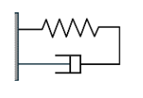
- Write the force balance and continuity equations
$$-f_{s}-f_{d}=0$$
$$-kx_{s}-b{\dot{x}}_{d}=0$$
$$x_{s}=x_{d}=x$$
$$v_{s}=v_{d}=v$$
- Use Matlab to produce a graph relating the spring’s velocity to its displacement, considering forces in the spring ranging from -6N to 6N, by following these steps:
- Start by thinking about how to find just one point on the graph you are seeking if you are given the springs velocity or its displacement. For $x_{s}=3mm,$ use the constitutive law graphs, force balance, and continuity equations as necessary to find $f_{s}, f_{d} ,v_{d},$ and $v_{s}.$
$$f_{s}\left(3\right)=4 \left(graph\right)$$
$$f_{d}=-f\left(3\right)=-4$$
$$f_{d}=-4→v_{d}=-4 \left(graph\right)$$
$$v_{s}=v_{d}=-4$$
- In writing your code, it’s a good idea to break this problem down into parts. First, recreate the constitutive law graphs shown for both the spring and the damper in order to make sure that you have coded these constitutive laws correctly. Don’t forget axis labels and a legend! It may help to consider whether the chunks of code that you write to capture the spring’s constitutive law graph should start with xs and find fs, or vice versa. Same question for the damper. Consider how you used the graphs when you solved the problem “by hand” in part i.
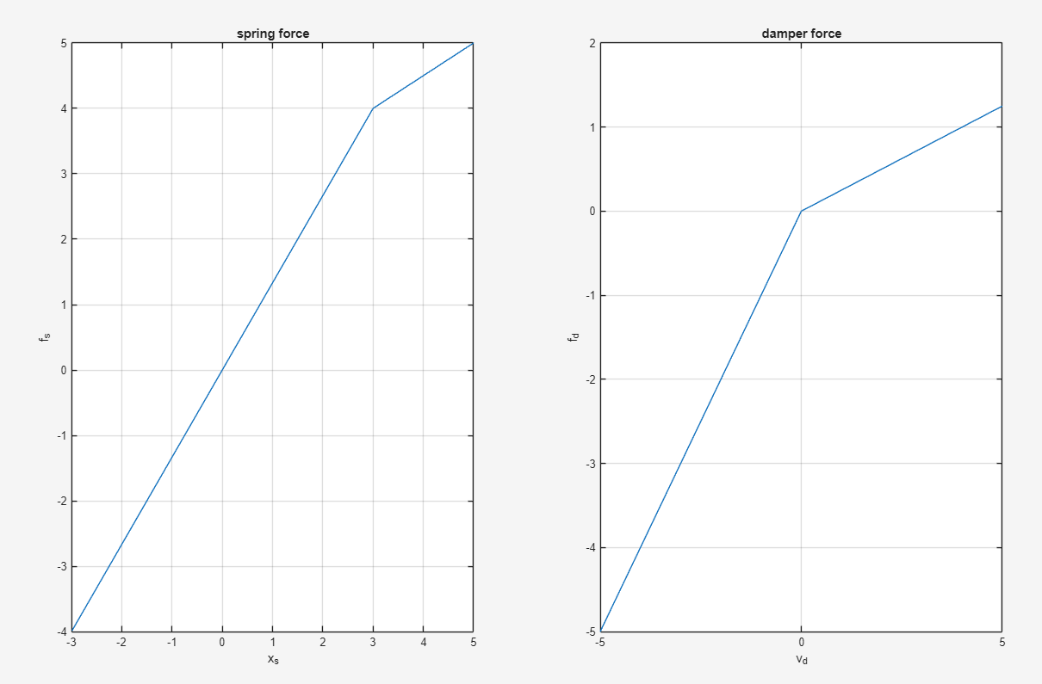
- Now plot the spring’s velocity $v_{s}$ as a function of its displacement $(v_{s})$ as a function of its displacement $(x_{s})$ for forces in the spring ranging from -6N to +6N. Don’t forget axis labels.
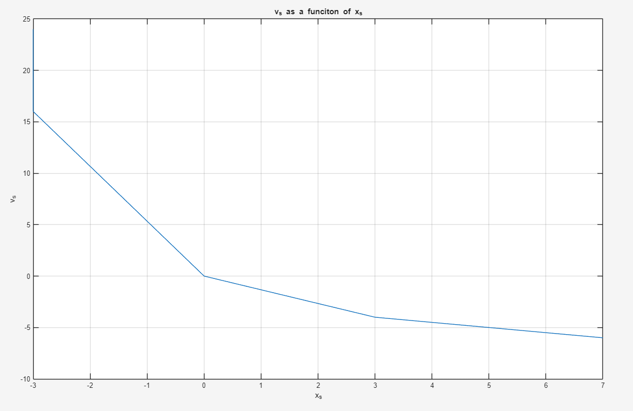

- Considering the spring constitutive response plot above, what is likely occurring physically in compression for $f_{s}<-4N$?
The spring hits maximum compression, and becomes a normal force

- According to your result from part b, what happends to the spring’s velocity for $f_{s}<-4N \left(x_{s}<-3mm\right)$
The velocity approaches infinity at -3mm or -4N.

- Is your result from d physically reasonable? Why or why not? If not, how should the code be changed to reflect physical constraints?
The answer is unphysical, because you cant have infinite velocity in real life. For spring forces less than -4 newtons, the function should output not a number or null to represent an undefined portion of the function.

- Would your solution to the problem change if the spring and damper were connected in series instead of parallel? Why or why not.
Just instinctively, if the length of the damper isn’t limited by the spring, the damper would be allowed to expand or compress forever.

