**WARNING: These are AP Physics C Free Response Practice – Use with caution!**

SECTION A – Torque and Statics

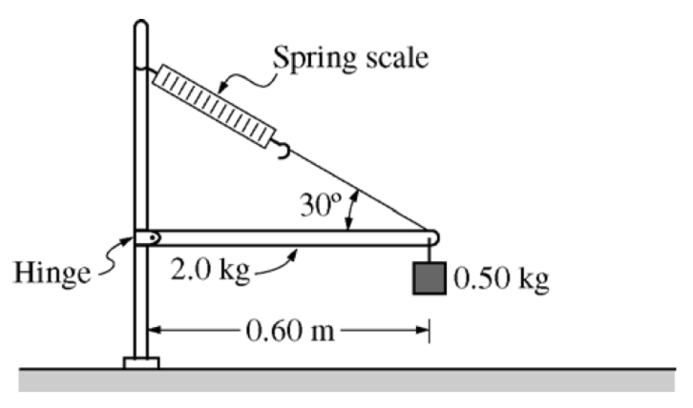

2008M2. The horizontal uniform rod shown above has length 0.60 m and mass 2.0 kg. The left end of the rod is attached to a vertical support by a frictionless hinge that allows the rod to swing up or down. The right end of the rod is supported by a cord that makes an angle of 30° with the rod. A spring scale of negligible mass measures the tension in the cord. A 0.50 kg block is also attached to the right end of the rod.

a. On the diagram below, draw and label vectors to represent all the forces acting on the rod. Show each force vector originating at its point of application.

b. Calculate the reading on the spring scale.

The rotational inertia of a rod about its center is, where *M* is the mass of the rod and *L* is its length.

c. Calculate the rotational inertia of the rod-block system about the hinge.

d. If the cord that supports the rod is cut near the end of the rod, calculate the initial angular acceleration of the rod-block system about the hinge.

SECTION B – Rotational Kinematics and Dynamics

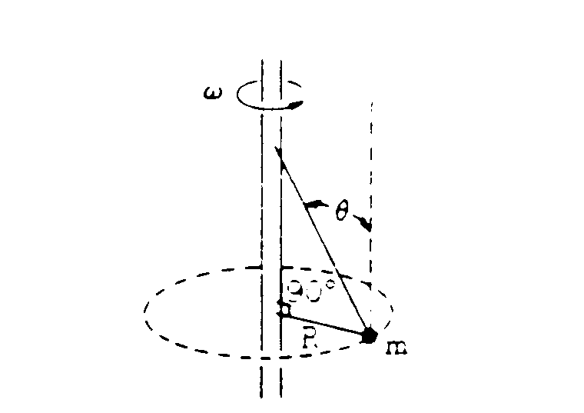

1973M3. A ball of mass m is attached by two strings to a vertical rod. as shown above. The entire system rotates at constant angular velocity ω about the axis of the rod.

a. Assuming ω is large enough to keep both strings taut, find the force each string exerts on the ball in terms of ω, m, g, R, and θ.

b. Find the minimum angular velocity, ωmin for which the lower string barely remains taut.

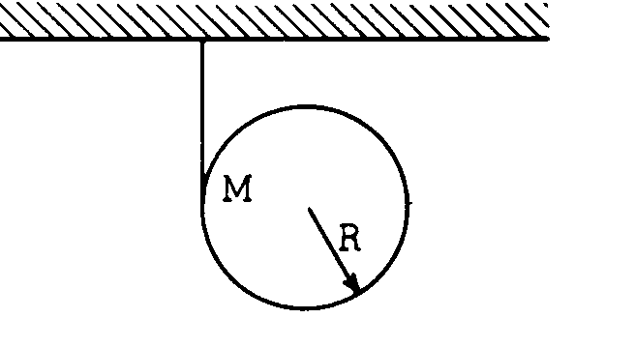

1976M2. A cloth tape is wound around the outside of a uniform solid cylinder (mass M, radius R) and fastened to the ceiling as shown in the diagram above. The cylinder is held with the tape vertical and then released from rest. As the cylinder descends, it unwinds from the tape without slipping. The moment of inertia of a uniform solid cylinder about its center is ½MR2.

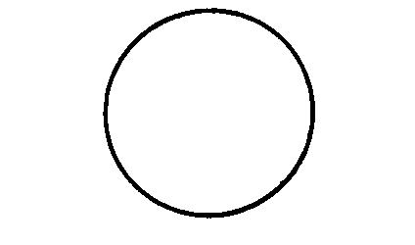

a. On the circle above draw vectors showing all the forces acting on the cylinder after it is released. Label each force clearly.

b. In terms of g, find the downward acceleration of the center of the cylinder as it unrolls from the tape.

c. While descending, does the center of the cylinder move toward the left, toward the right, or straight down? Explain.

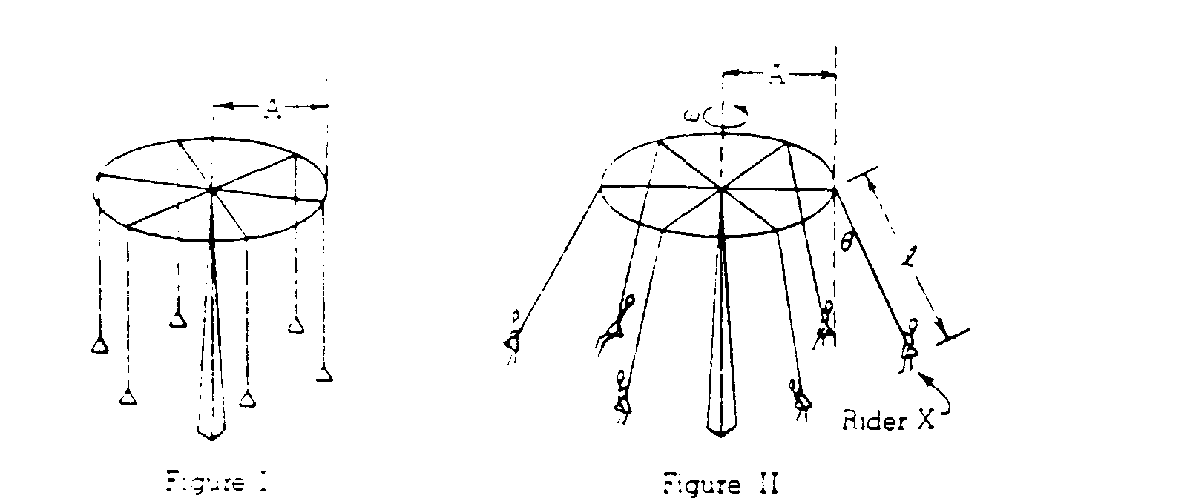

1978M1. An amusement park ride consists of a ring of radius A from which hang ropes of length *l* with seats for the riders as shown in Figure I. When the ring is rotating at a constant angular velocity ω each rope forms a constant angle θ with the vertical as shown in Figure II. Let the mass of each rider be m and neglect friction, air resistance, and the mass of the ring, ropes, and seats.

a. In the space below, draw and label all the forces acting on rider X (represented by the point below) under the constant rotating condition of Figure II. Clearly define any symbols you introduce.



b. Derive an expression for ω in terms of A*, l,* θ and the acceleration of gravity g.

c. Determine the minimum work that the motor that powers the ride would have to perform to bring the system from rest to the constant rotating condition of Figure II. Express your answer in terms of m, g, *l*, θ, and the speed v of each rider.

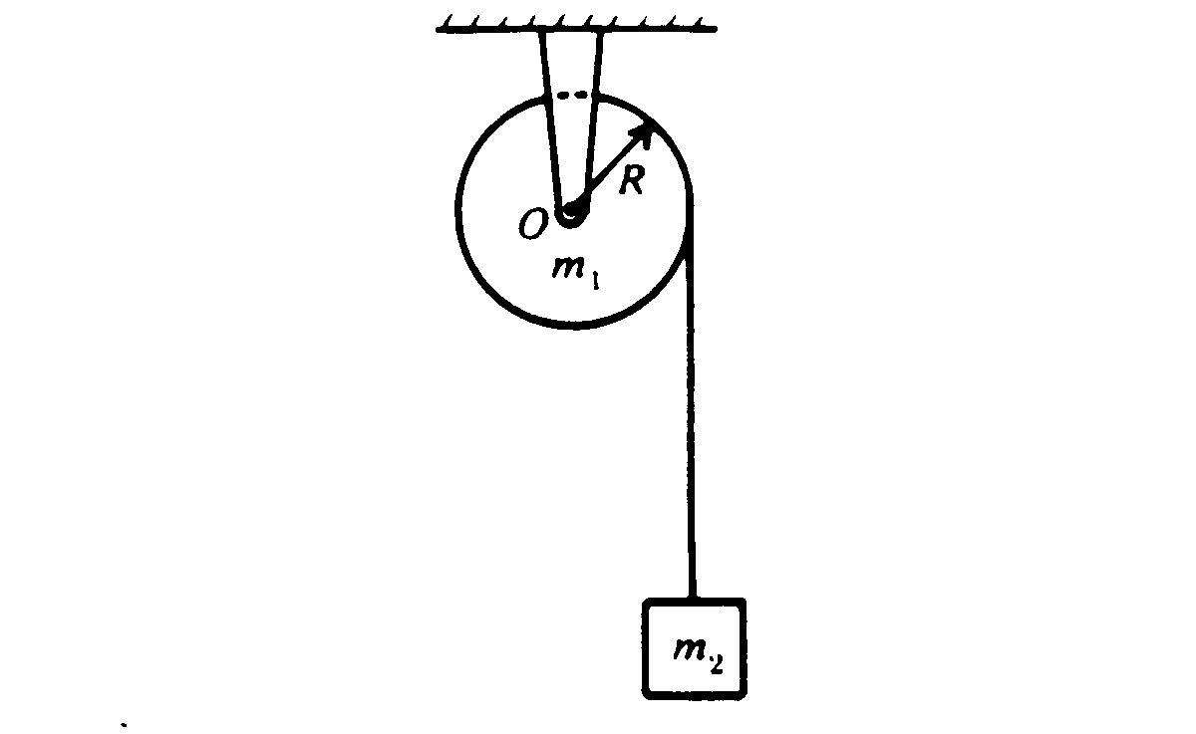

1983M2. A uniform solid cylinder of mass m1 and radius *R* is mounted on frictionless bearings about a fixed axis through O. The moment of inertia of the cylinder about the axis is I = ½m1R2. A block of mass m2, suspended by a cord wrapped around the cylinder as shown above, is released at time t = 0.

a. On the diagram below draw and identify all of the forces acting on the cylinder and on the block.

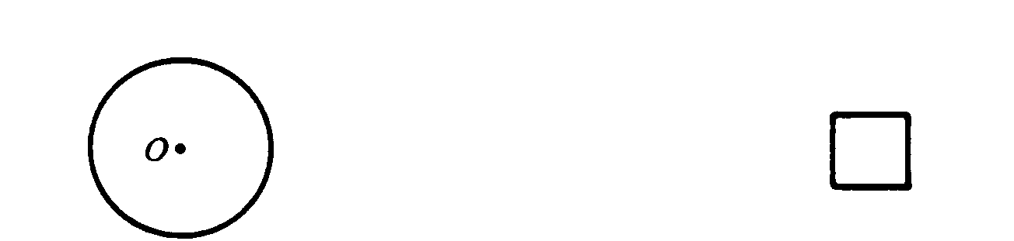

b. In terms of ml, m2, *R.* and g, determine each of the following.

i. The acceleration of the block

ii. The tension in the cord

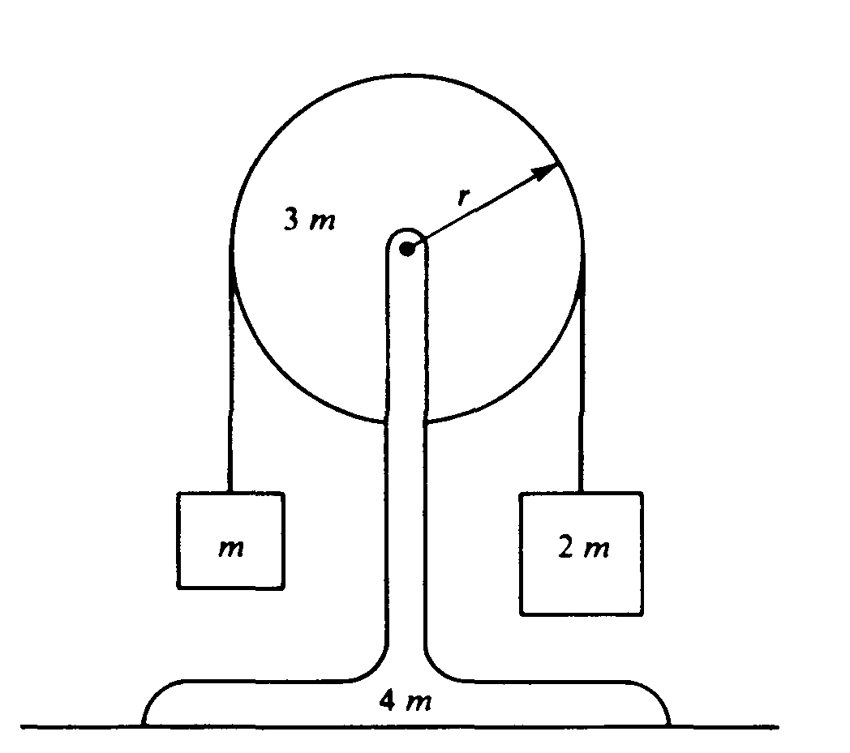

1985M3. A pulley of mass 3m and radius r is mounted on frictionless bearings and supported by a stand of mass 4m at rest on a table as shown above. The moment of inertia of this pulley about its axis is 1.5mr2.

Passing over the pulley is a massless cord supporting a block of mass m on the left and a block of mass 2m on the right. The cord does not slip on the pulley, so after the block‑pulley system is released from rest, the pulley begins to rotate.

a. On the diagrams below, draw and label all the forces acting on each block.

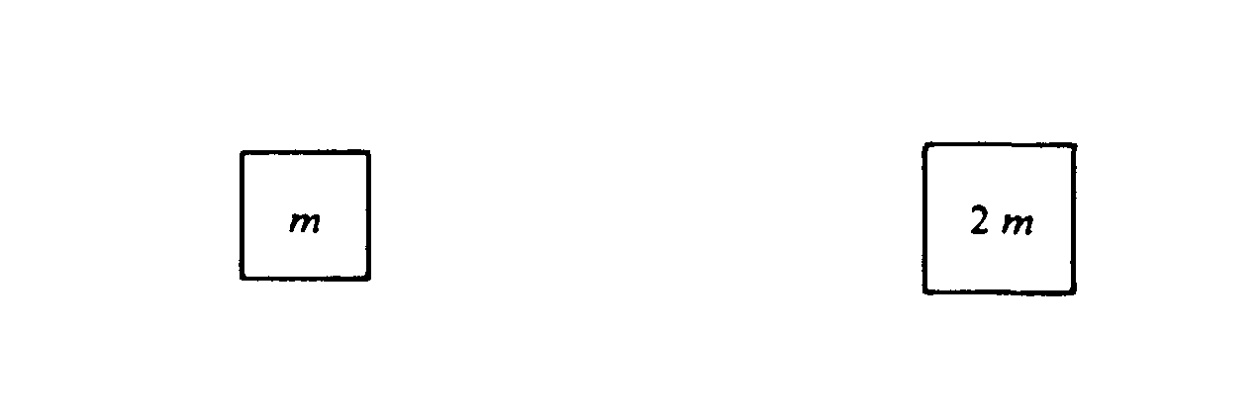

b. Use the symbols identified in part a. to write each of the following.

i. The equations of translational motion (Newton's second law) for each of the two blocks

ii. The analogous equation for the rotational motion of the pulley

c. Solve the equations in part b. for the acceleration of the two blocks.

d. Determine the tension in the segment of the cord attached to the block of mass m.

e. Determine the normal force exerted on the apparatus by the table while the blocks are in motion.

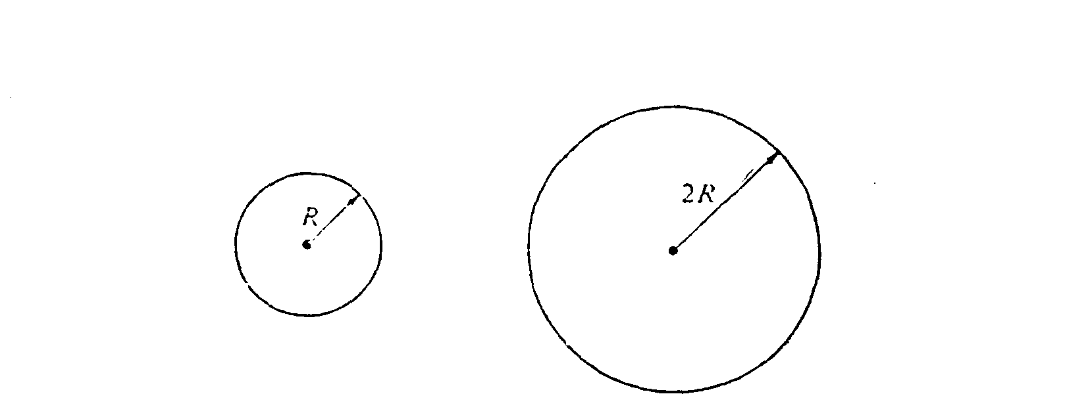

1988M3. The two uniform disks shown above have equal mass, and each can rotate on frictionless bearings about a fixed axis through its center. The smaller disk has a radius R and moment of inertia I about its axis. The larger disk has a radius 2R

a. Determine the moment of inertia of the larger disk about its axis in terms of I.

The two disks are then linked as shown below by a light chain that cannot slip. They are at rest when, at time t = 0, a student applies a torque to the smaller disk, and it rotates counterclockwise with constant angular acceleration α. Assume that the mass of the chain and thetension in the lower part of the chain, are negligible. In terms of I, R, α, and t, determine each of the following:

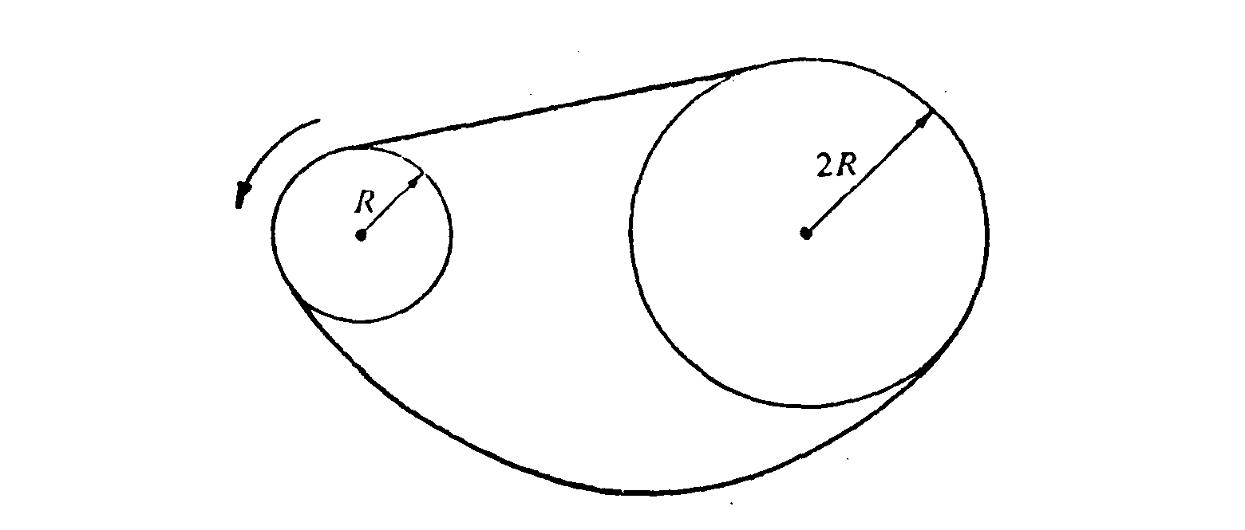

b. The angular acceleration of the larger disk

c. The tension in the upper part of the chain

d. The torque that the student applied to the smaller disk

e. The rotational kinetic energy of the smaller disk as a function of time

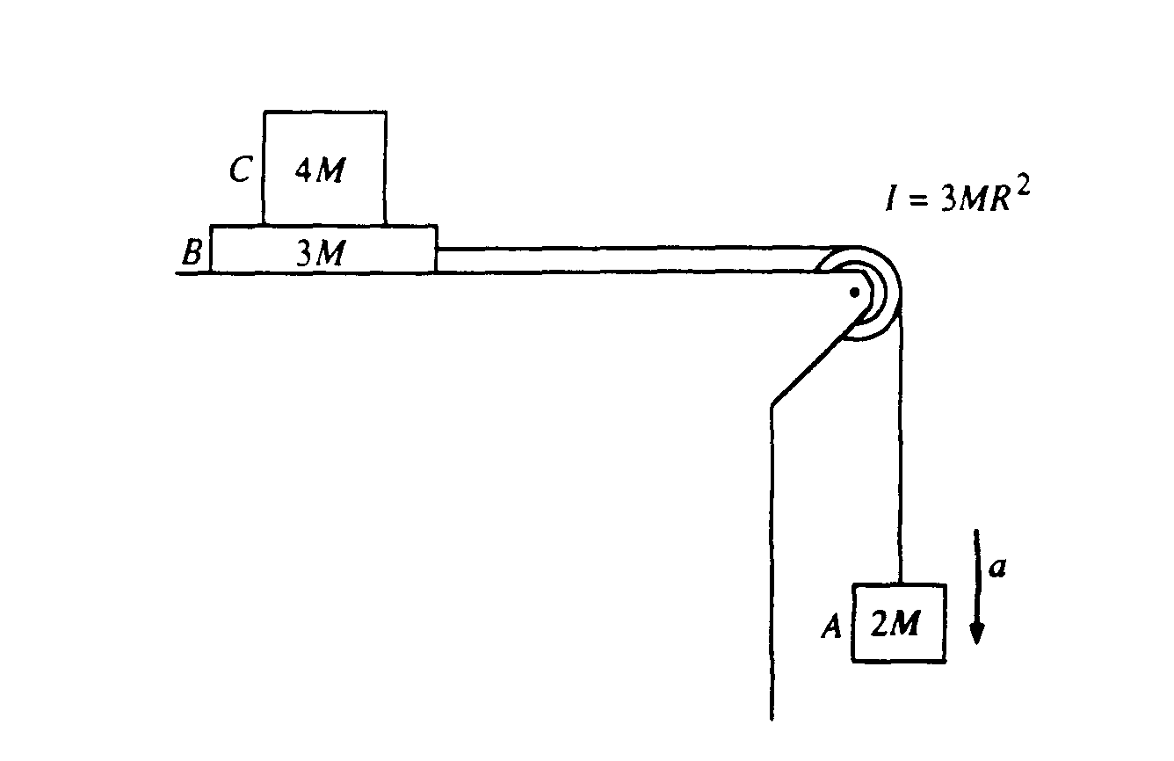

1989M2. Block A of mass 2M hangs from a cord that passes over a pulley and is connected to block B of mass 3M that is free to move on a frictionless horizontal surface, as shown above. The pulley is a disk with frictionless bearings, having a radius R and moment of inertia 3MR2. Block C of mass 4M is on top of block B. The surface between blocks B and C is NOT frictionless. Shortly after the system is released from rest, block A moves with a downward acceleration a, and the two blocks on the table move relative to each other.

In terms of M, g, and a, determine the

a. tension Tv in the vertical section of the cord

b. tension Th in the horizontal section of the cord

If a = 2 meters per second squared, determine the

c. coefficient of kinetic friction between blocks B and C

d. acceleration of block C

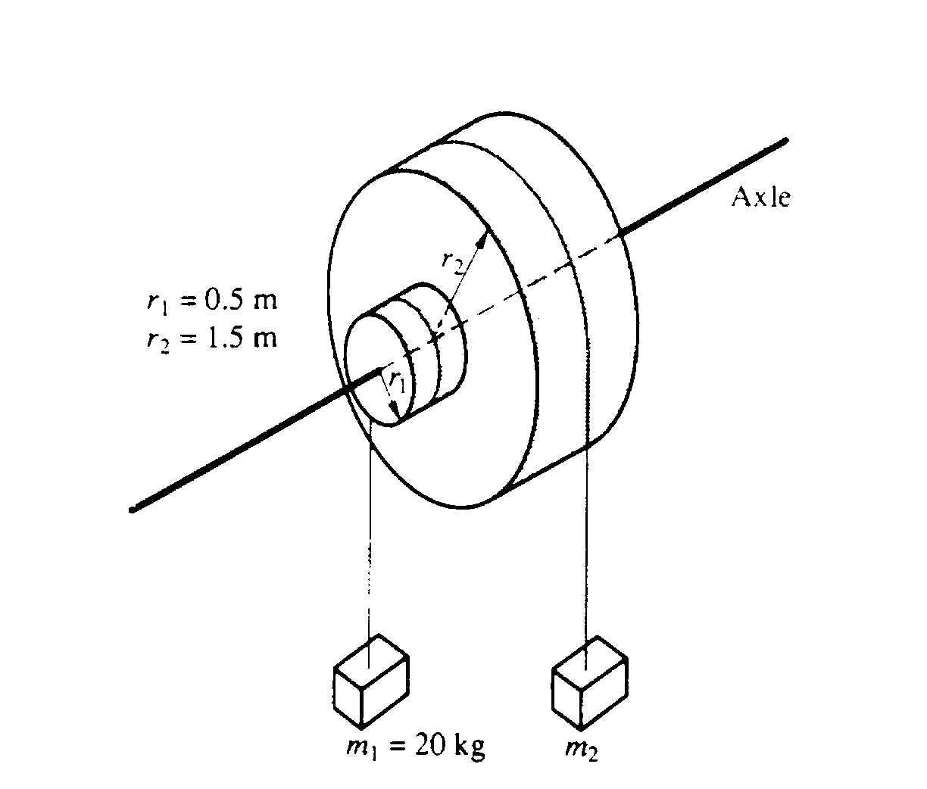

1991M2. Two masses. m1 and m2 are connected by light cables to the perimeters of two cylinders of radii r1 and r2, respectively. as shown in the diagram above. The cylinders are rigidly connected to each other but are free to rotate without friction on a common axle. The moment of inertia of the pair of cylinders is I = 45 kg•m2   
Also r1 = 0.5 meter, r2 = 1.5 meters, and m1 = 20 kilograms.

a. Determine m2such that the system will remain in equilibrium.

The mass m2 is removed and the system is released from rest.

b. Determine the angular acceleration of the cylinders.

c. Determine the tension in the cable supporting m1

d. Determine the linear speed of m 1 at the time it has descended 1.0 meter.

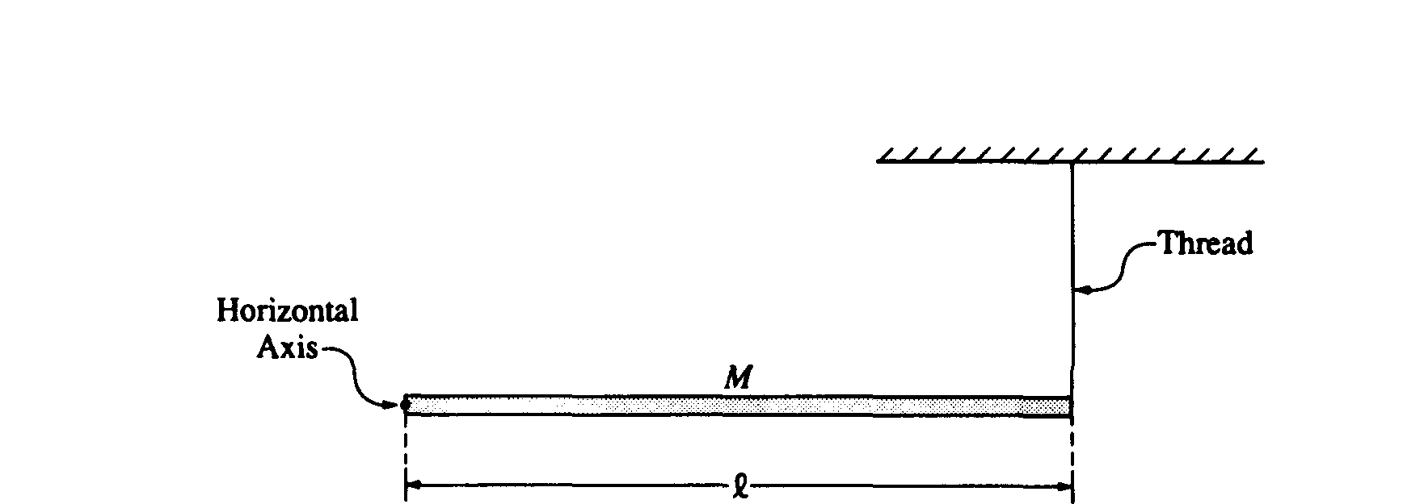

1993M3. A long, uniform rod of mass *M* and length *l*is supported at the left end by a horizontal axis into the page and perpendicular to the rod, as shown above. The right end is connected to the ceiling by a thin vertical thread so that the rod is horizontal. The moment of inertia of the rod about the axis at the end of the rod is *Ml*2/3. Express the answers to all parts of this question in terms of *M, l,* and *g*.

a. Determine the magnitude and direction of the force exerted on the rod by the axis.

The thread is then burned by a match. For the time immediately after the thread breaks, determine each of the following:

b. The angular acceleration of the rod about the axis

c. The translational acceleration of the center of mass of the rod

d. The force exerted on the end of the rod by the axis

The rod rotates about the axis and swings down from the horizontal position.

e. Determine the angular velocity of the rod as a function of *θ,* the arbitrary angle through which the rod has swung.

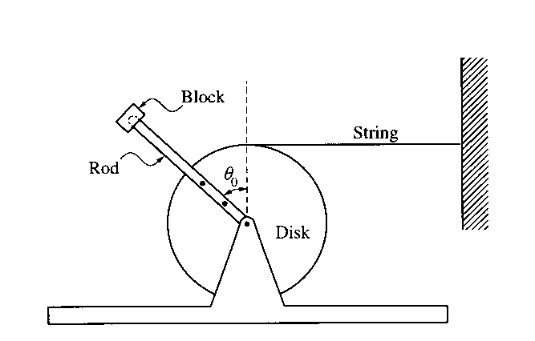

1999M3 As shown above, a uniform disk is mounted to an axle and is free to rotate without friction. A thin uniform rod is rigidly attached to the disk so that it will rotate with the disk. A block is attached to the end of the rod. Properties of the disk, rod, and block are as follows.

Disk: mass = 3m, radius = R, moment of inertia about center ID = 1.5mR2

Rod: mass = m, length = 2R, moment of inertia about one end IR = 4/3(mR2)

Block: mass = 2m

The system is held in equilibrium with the rod at an angle θ0 to the vertical, as shown above, by a horizontal string of negligible mass with one end attached to the disk and the other to a wall. Express your answers to the following in terms of m, R, θ0, and g.

a. Determine the tension in the string.

The string is now cut, and the disk‑rod‑block system is free to rotate.

b. Determine the following for the instant immediately after the string is cut.

i. The magnitude of the angular acceleration of the disk

ii. The magnitude of the linear acceleration of the mass at the end of the rod

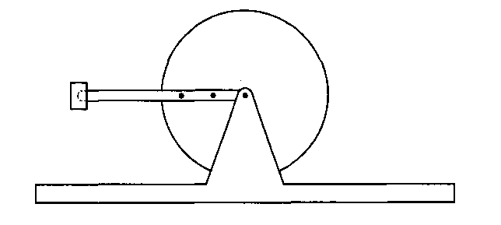

As the disk rotates, the rod passes the horizontal position shown above.

c. Determine the linear speed of the mass at the end of the rod for the instant the rod is in the horizontal position.

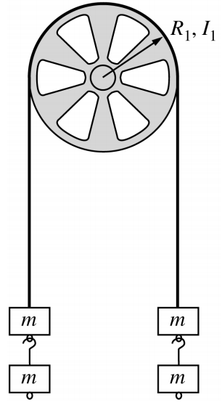

2000M3. A pulley of radius *R*1and rotational inertia *I*1 is mounted on an axle with negligible friction. A light cord passing over the pulley has two blocks of mass m attached to either end, as shown above. Assume that the cord does not slip on the pulley. Determine the answers to parts a. and b. in terms of *m*, *R*1, *I*1, and fundamental constants.

a. Determine the tension T in the cord.

b. One block is now removed from the right and hung on the left. When the system is released from rest, the three blocks on the left accelerate downward with an acceleration g/3 . Determine the following.

i. The tension T3 in the section of cord supporting the three blocks on the left

ii. The tension Tl in the section of cord supporting the single block on the right

iii. The rotational inertia *I*1of the pulley

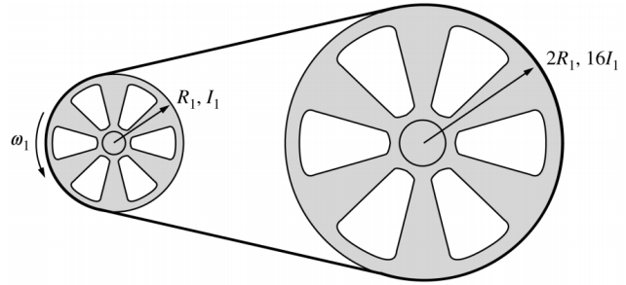

c. The blocks are now removed and the cord is tied into a loop, which is passed around the original pulley and a second pulley of radius 2R1 and rotational inertia 16I1. The axis of the original pulley is attached to a motor that rotates it at angular speed ω1, which in turn causes the larger pulley to rotate. The loop does not slip on the pulleys. Determine the following in terms of I1, RI, and ω1*.*

i. The angular speed ω2of the larger pulley

ii. The angular momentum L2 of the larger pulley

iii. The total kinetic energy of the system

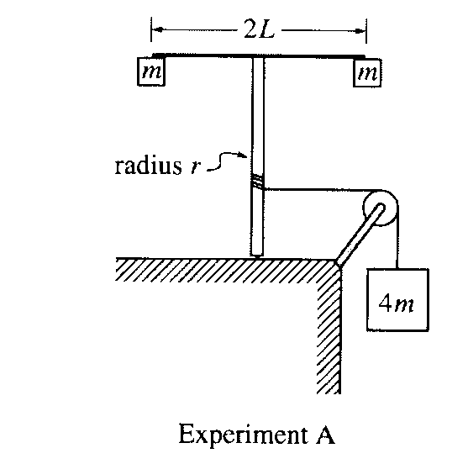

2001M3. A light string that is attached to a large block of mass *4m* passes over a pulley with negligible rotational inertia and is wrapped around a vertical pole of radius r, as shown in Experiment A above. The system is released from rest, and as the block descends the string unwinds and the vertical pole with its attached apparatus rotates. The apparatus consists of a horizontal rod of length 2L, with a small block of mass *m* attached at each end. The rotational inertia of the pole and the rod are negligible.

a. Determine the rotational inertia of the rod‑and‑block apparatus attached to the top of the pole.

b. Determine the downward acceleration of the large block.

c. When the large block has descended a distance *D,* how does the instantaneous total kinetic energy of the three blocks compare with the value *4mgD*? Check the appropriate space below and justify your answer.

Greater than 4mgD Equal to 4mgD __ Less than 4mgD _____

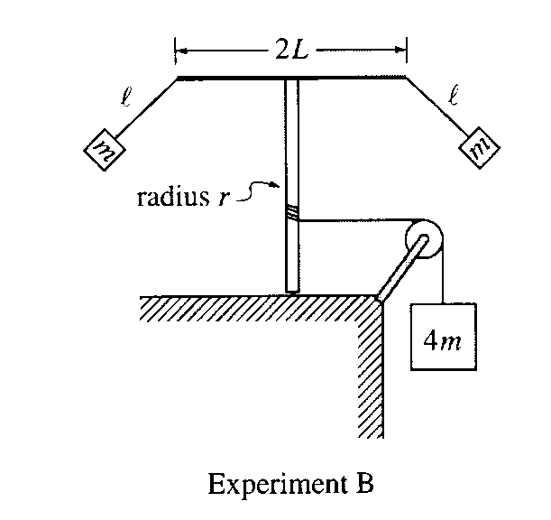

The system is now reset. The string is rewound around the pole to bring the large block back to its original location. The small blocks are detached from the rod and then suspended from each end of the rod, using strings of length *l*. The system is again released from rest so that as the large block descends and the apparatus rotates, the small blocks swing outward, as shown in Experiment B above. This time the downward acceleration of the block decreases with time after the system is released.

d. When the large block has descended a distance D, how does the instantaneous total kinetic energy of the three blocks compare to that in part c.? Check the appropriate space below and justify your answer.

Greater before _ Equal to before __ Less than before ___

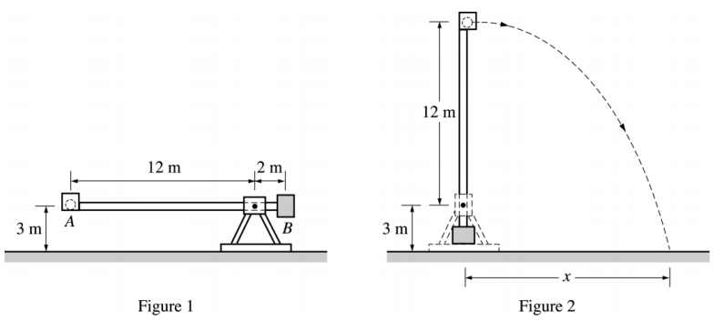

2003M3. Some physics students build a catapult, as shown above. The supporting platform is fixed firmly to the ground. The projectile, of mass 10 kg, is placed in cup *A* at one end of the rotating arm. A counterweight bucket *B* that is to be loaded with various masses greater than 10 kg is located at the other end of the arm. The arm is released from the horizontal position, shown in Figure 1, and begins rotating. There is a mechanism (not shown) that stops the arm in the vertical position, allowing the projectile to be launched with a horizontal velocity as shown in Figure 2.

a. The students load five different masses in the counterweight bucket, release the catapult, and measure the resulting distance x traveled by the 10 kg projectile, recording the following data.

|  |  |  |  |  |  |
| --- | --- | --- | --- | --- | --- |
| Mass (kg) | 100 | 300 | 500 | 700 | 900 |
| *x* (m) | 18 | 37 | 45 | 48 | 51 |

i. The data are plotted on the axes below. Sketch a best-fit curve for these data points.

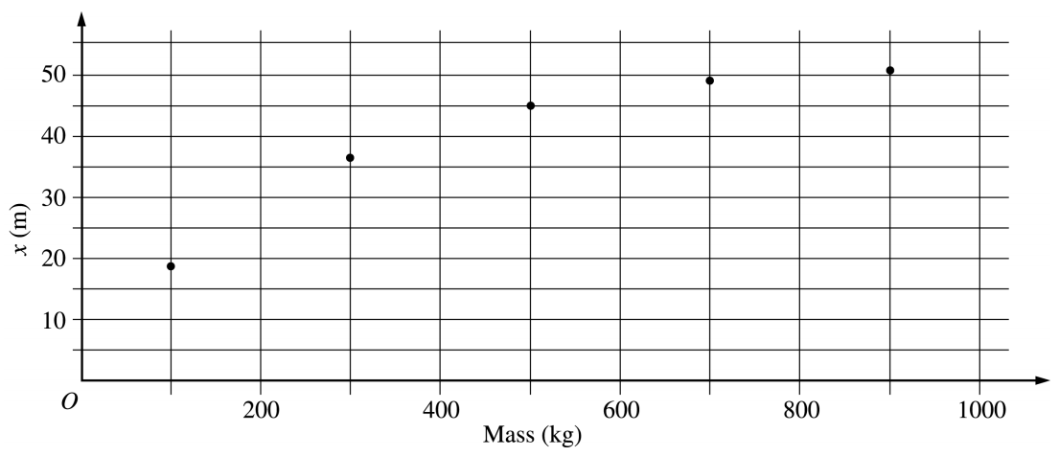

ii. Using your best-fit curve, determine the distance *x* traveled by the projectile if 250 kg is placed in the counterweight bucket.

b. The students assume that the mass of the rotating arm, the cup, and the counterweight bucket can be neglected. With this assumption, they develop a theoretical model for *x* as a function of the counterweight mass using the relationship *x* = *vxt*, where *v*, is the horizontal velocity of the projectile as it leaves the cup and *t* is the time after launch.

i. How many seconds after leaving the cup will the projectile strike the ground?

ii. Derive the equation that describes the gravitational potential energy of the system relative to the ground when in the position shown in Figure 1, assuming the mass in the counterweight bucket is *M*.

iii. Derive the equation for the velocity of the projectile as it leaves the cup, as shown in Figure 2.

c. i. Complete the theoretical model by writing the relationship for *x* as a function of the counterweight mass using the results from b. i and b. iii.

ii. Compare the experimental and theoretical values of *x* for a counterweight bucket mass of 300 kg. Offer a reason for any difference.

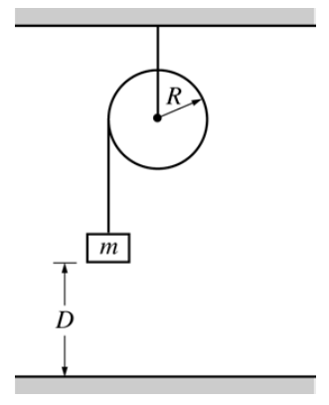

2004M2. A solid disk of unknown mass and known radius *R* is used as a pulley in a lab experiment, as shown above. A small block of mass *m* is attached to a string, the other end of which is attached to the pulley and wrapped around it several times. The block of mass *m* is released from rest and takes a time *t* to fall the distance *D* tothe floor.

a. Calculate the linear acceleration *a* of the falling block in terms of the given quantities.

b. The time *t* is measured for various heights *D* and the data are recorded in the following table.

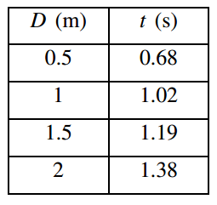

i. What quantities should be graphed in order to best determine the acceleration of the block? Explain your reasoning.

ii. On the grid below, plot the quantities determined in b. i., label the axes, and draw the best‑fit line to the data.



iii. Use your graph to calculate the magnitude of the acceleration.

c. Calculate the rotational inertia of the pulley in terms of *m*, *R*, *a*, and fundamental constants.

d. The value of acceleration found in b.iii, along with numerical values for the given quantities and your answer to c., can be used to determine the rotational inertia of the pulley. The pulley is removed from its support and its rotational inertia is found to be greater than this value. Give one explanation for this discrepancy.

SECTION C – Rolling

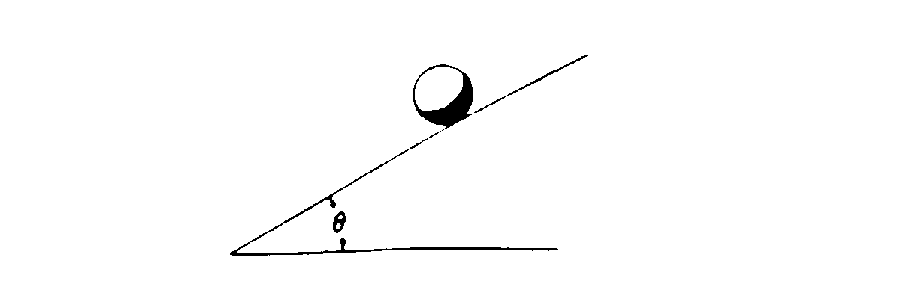

1974M2. The moment of inertia of a uniform solid sphere (mass M, radius R) about a diameter is 2MR²/5. The sphere is placed on an inclined plane (angle θ) as shown above and released from rest.

a. Determine the minimum coefficient of friction μ between the sphere and plane with which the sphere will roll down the incline without slipping

b. If μ were zero, would the speed of the sphere at the bottom be greater, smaller, or the same as in part a.? Explain your answer.

1977M2. A uniform cylinder of mass M, and radius R is initially at rest on a rough horizontal surface. The moment of inertia of a cylinder about its axis is ½MR2. A string, which is wrapped around the cylinder, is pulled upwards with a force T whose magnitude is 0.6Mg and whose direction is maintained vertically upward at all times. In consequence, the cylinder both accelerates horizontally and slips. The coefficient of kinetic friction is 0.5.

a. On the diagram below, draw vectors that represent each of the forces acting on the cylinder identify and clearly label each force.

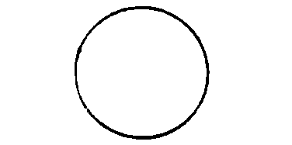

b. Determine the linear acceleration a of the center of the cylinder.

c. Calculate the angular acceleration α of the cylinder.

d. Your results should show that a and αR are not equal. Explain.

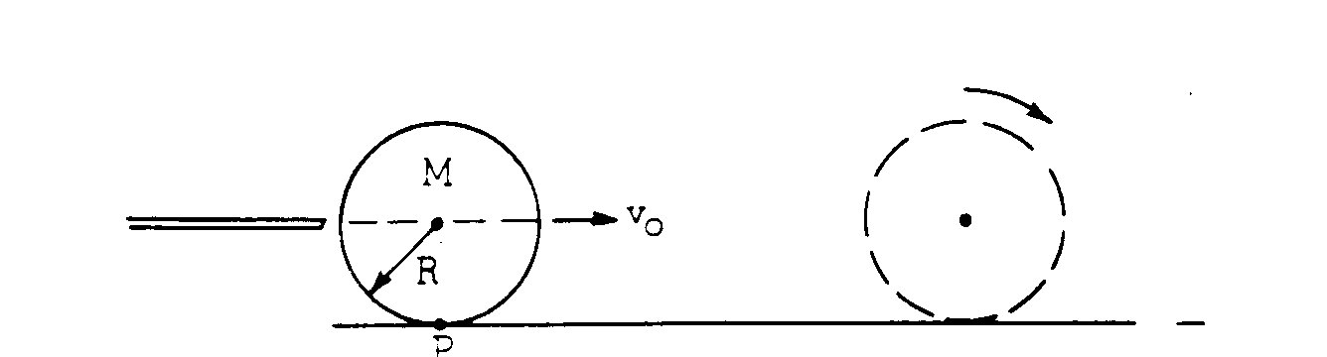

1980M3. A billiard ball has mass M, radius R, and moment of inertia about the center of mass Ic = 2 MR²/5

The ball is struck by a cue stick along a horizontal line through the ball's center of mass so that the ball initially slides with a velocity vo as shown above. As the ball moves across the rough billiard table (coefficient of sliding friction μk), its motion gradually changes from pure translation through rolling with slipping to rolling without slipping.

a. Develop an expression for the linear velocity v of the center of the ball as a function of time while it is rolling with slipping.

b. Develop an expression for the angular velocity ω of the ball as a function of time while it is rolling with slipping.

c. Determine the time at which the ball begins to roll without slipping.

d. When the ball is struck it acquires an angular momentum about the fixed point P on the surface of the table. During the subsequent motion the angular momentum about point P remains constant despite the frictional force. Explain why this is so.

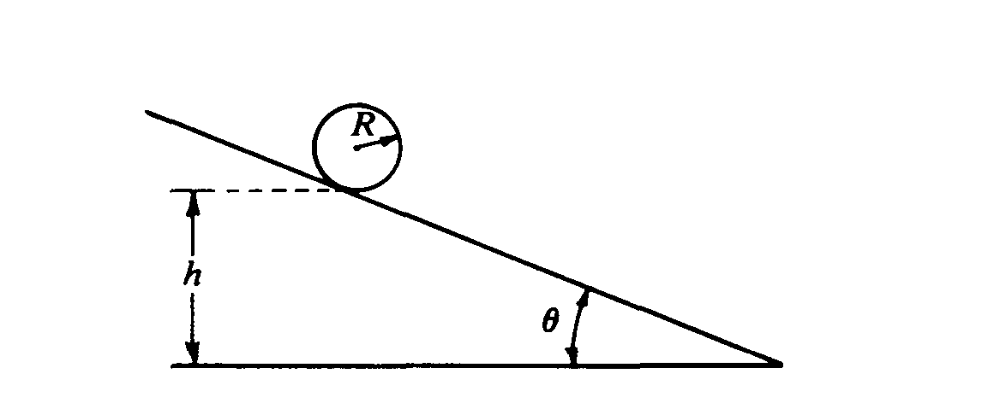

1986M2. An inclined plane makes an angle of θ with the horizontal, as shown above. A solid sphere of radius R and mass M is initially at rest in the position shown, such that the lowest point of the sphere is a vertical height *h* above the base of the plane. The sphere is released and rolls down the plane without slipping. The moment of inertia of the sphere about an axis through its center is 2MR2/5. Express your answers in terms of M, R. *h,* g,and θ.

a. Determine the following for the sphere when it is at the bottom of the plane:

i. Its translational kinetic energy

ii. Its rotational kinetic energy

b. Determine the following for the sphere when it is on the plane.

i. Its linear acceleration

ii. The magnitude of the frictional force acting on it

The solid sphere is replaced by a hollow sphere of identical radius R and mass M. The hollow sphere, which is released from the same location as the solid sphere, rolls down the incline without slipping.

c. What is the total kinetic energy of the hollow sphere at the bottom of the plane?

d. State whether the rotational kinetic energy of the hollow sphere is greater than, less than, or equal to that of the solid sphere at the bottom of the plane. Justify your answer.

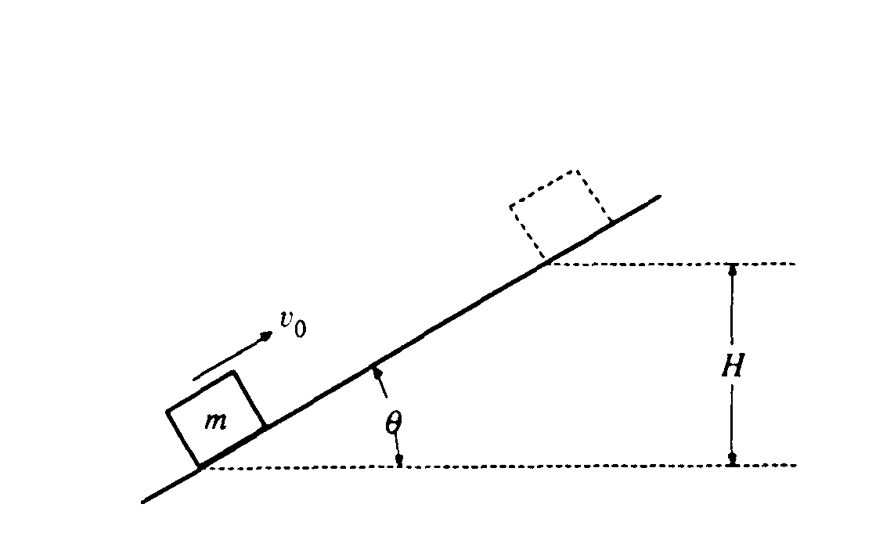

1990M2. A block of mass m slides up the incline shown above with an initial speed vO in the position shown.

a. If the incline is frictionless, determine the maximum height H to which the block will rise, in terms of the given quantities and appropriate constants.

b. If the incline is rough with coefficient of sliding friction μ, determine the maximum height to which the block will rise in terms of Hand the given quantities.

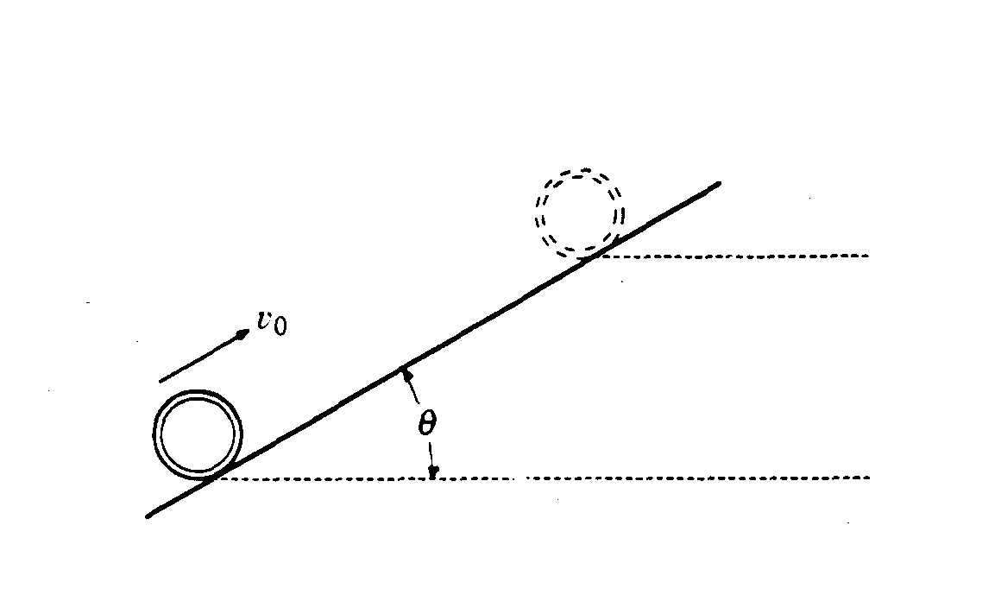

A thin hoop of mass m and radius R moves up the incline shown above with an initial speed vO in the position shown.

c. If the incline is rough and the hoop rolls up the incline without slipping, determine the maximum height to which the hoop will rise in terms of H and the given quantities.

d. If the incline is frictionless, determine the maximum height to which the hoop will rise in terms of H and the given quantities.

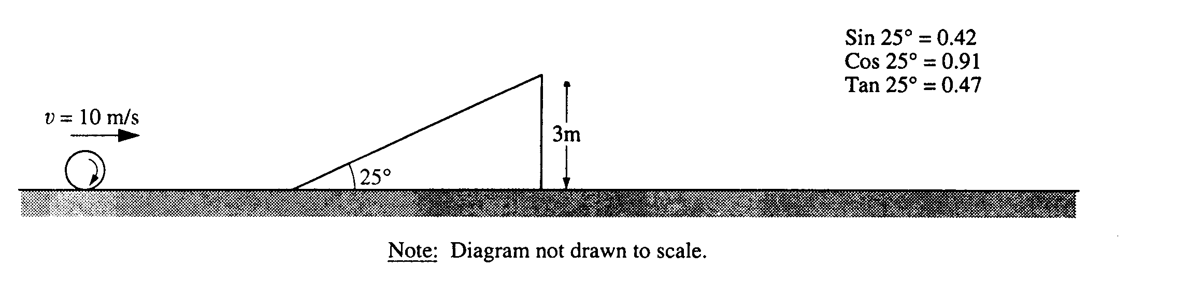

1994M2. A large sphere rolls without slipping across a horizontal surface. The sphere has a constant translational speed of 10 meters per second, a mass m of 25 kilograms, and a radius r of 0.2 meter. The moment of inertia of the sphere about its center of mass is I = 2mr2/5. The sphere approaches a 25° incline of height 3 meters as shown above and rolls up the incline without slipping.

a. Calculate the total kinetic energy of the sphere as it rolls along the horizontal surface.

b. i. Calculate the magnitude of the sphere's velocity just as it leaves the top of the incline.

ii. Specify the direction of the sphere's velocity just as it leaves the top of the incline.

c. Neglecting air resistance, calculate the horizontal distance from the point where the sphere leaves the incline to the point where the sphere strikes the level surface.

d. Suppose, instead, that the sphere were to roll toward the incline as stated above, but the incline were frictionless. State whether the speed of the sphere just as it leaves the top of the incline would be less than, equal to, or greater than the speed calculated in b. Explain briefly.

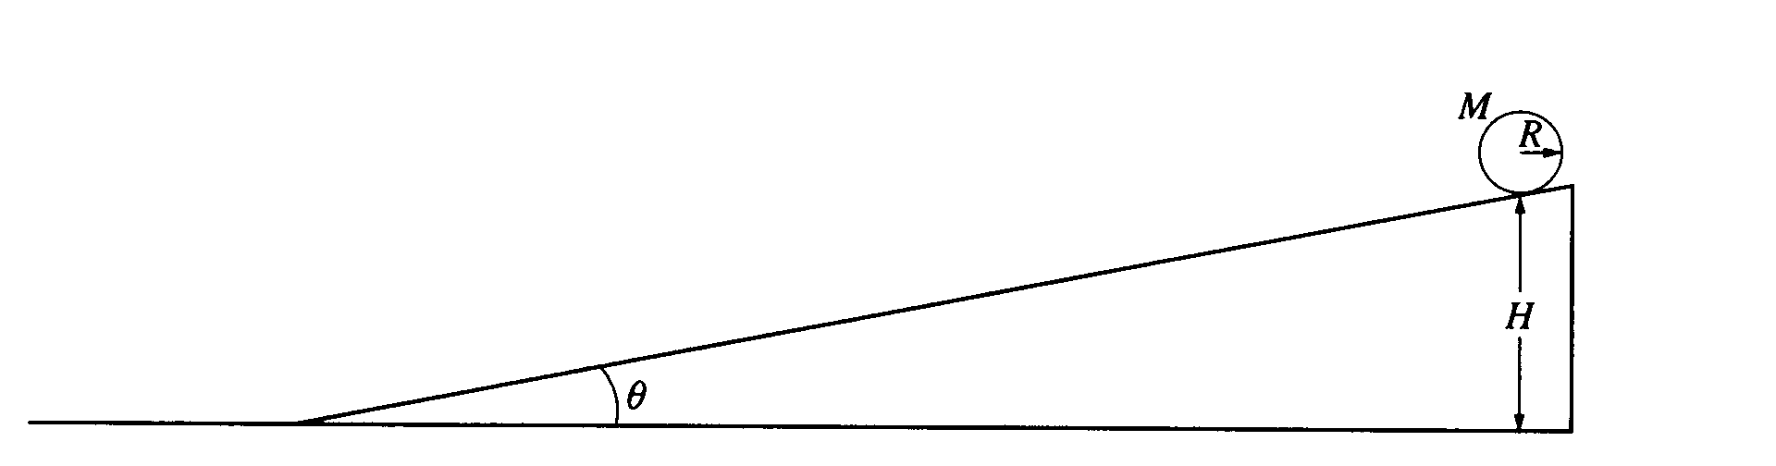

1997M3. A solid cylinder with mass M, radius R, and rotational inertia ½MR2 rolls without slipping down the inclined plane shown above. The cylinder starts from rest at a height H. The inclined plane makes an angle θ with the horizontal. Express all solutions in terms of M, R, H, θ, and g.

a. Determine the translational speed of the cylinder when it reaches the bottom of the inclined plane.

b. On the figure below, draw and label the forces acting on the cylinder as it rolls down the inclined plane Your arrow should begin at the **point of application** of each force.

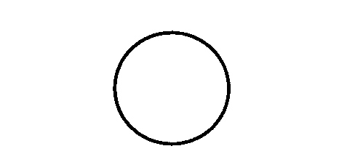

c. Show that the acceleration of the center of mass of the cylinder while it is rolling down the inclined plane is (2/3)g sinθ.

d. Determine the minimum coefficient of friction between the cylinder and the inclined plane that is required for the cylinder to roll without slipping.

e. The coefficient of friction μ is now made less than the value determined in part d., so that the cylinder both rotates and slips.

i. Indicate whether the translational speed of the cylinder at the bottom of the inclined plane is greater than, less than, or equal to the translational speed calculated in part a. Justify your answer.

ii. Indicate whether the total kinetic energy of the cylinder at the bottom of the inclined plane is greater than, less than, or equal to the total kinetic energy for the previous case of rolling without slipping. Justify your answer.

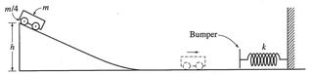

2002M2. The cart shown above is made of a block of mass m and four solid rubber tires each of mass m/4 and radius r. Each tire may be considered to be a disk. (A disk has rotational inertia ½ *ML2,* where M is the mass and L is the radius of the disk.) The cart is released from rest and rolls without slipping from the top of an inclined plane of height h. Express all algebraic answers in terms of the given quantities and fundamental constants.

a. Determine the total rotational inertia of all four tires.

b. Determine the speed of the cart when it reaches the bottom of the incline.

c. After rolling down the incline and across the horizontal surface, the cart collides with a bumper of negligible mass attached to an ideal spring, which has a spring constant k. Determine the distance xm the spring is compressed before the cart and bumper come to rest.

d. Now assume that the bumper has a non‑negligible mass. After the collision with the bumper, the spring is compressed to a maximum distance of about 90% of the value of xm in part c.. Give a reasonable explanation for this decrease.

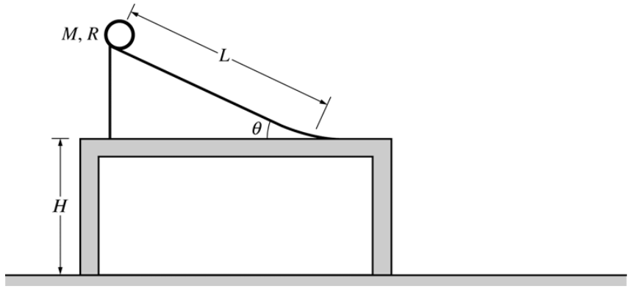

2006M3. A thin hoop of mass *M*, radius *R*, and rotational inertia *MR2* is released from rest from the top of the ramp of length *L* above. The ramp makes an angle *θ* with respect to a horizontal tabletop to which the ramp is fixed. The table is a height *H* above the floor. Assume that the hoop rolls without slipping down the ramp and across the table. Express all algebraic answers in terms of given quantities and fundamental constants.

a. Derive an expression for the acceleration of the center of mass of the hoop as it rolls down the ramp.

b. Derive an expression for the speed of the center of mass of the hoop when it reaches the bottom of the ramp.

c. Derive an expression for the horizontal distance from the edge of the table to where the hoop lands on the floor.

d. Suppose that the hoop is now replaced by a disk having the same mass *M* and radius *R*. How will the distance from the edge of the table to where the disk lands on the floor compare with the distance determined in part c. for the hoop?

Less than____ The same as____ Greater than____

Briefly justify your response.

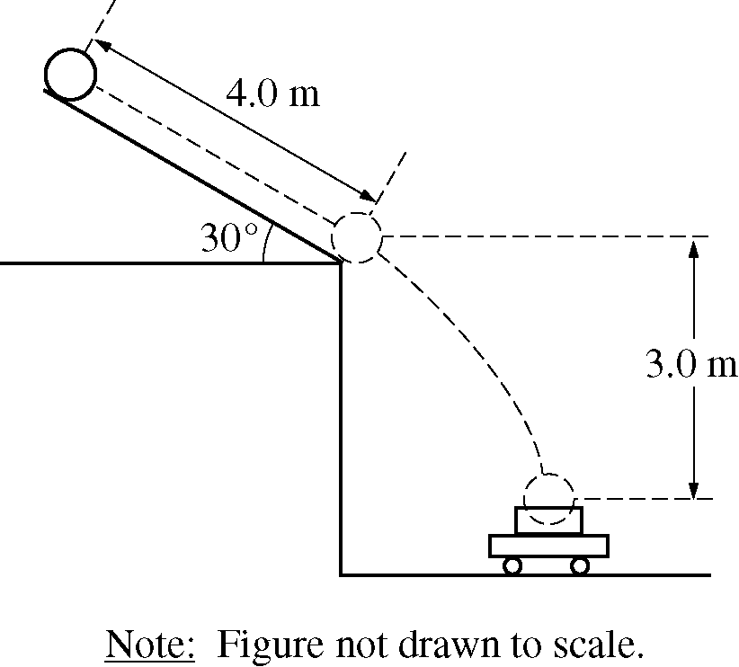

2010M2. A bowling ball of mass 6.0 kg is released from rest from the top of a slanted roof that is 4.0 m long and angled at 30°, as shown above. The ball rolls along the roof without slipping. The rotational inertia of a sphere of mass *M* and radius *R* about its center of mass is 2MR2/5.

a. On the figure below, draw and label the forces (not components) acting on the ball at their points of application as it rolls along the roof.

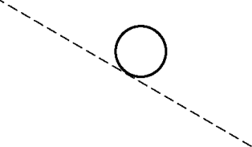

b. Calculate the force due to friction acting on the ball as it rolls along the roof. If you need to draw anything other than what you have shown in part a. to assist in your solution, use the space below. Do NOT add anything to the figure in part a.

c. Calculate the linear speed of the center of mass of the ball when it reaches the bottom edge of the roof.

d. A wagon containing a box is at rest on the ground below the roof so that the ball falls a vertical distance of 3.0 m and lands and sticks in the center of the box. The total mass of the wagon and the box is 12 kg. Calculate the horizontal speed of the wagon immediately after the ball lands in it.

SECTION D – Angular Momentum

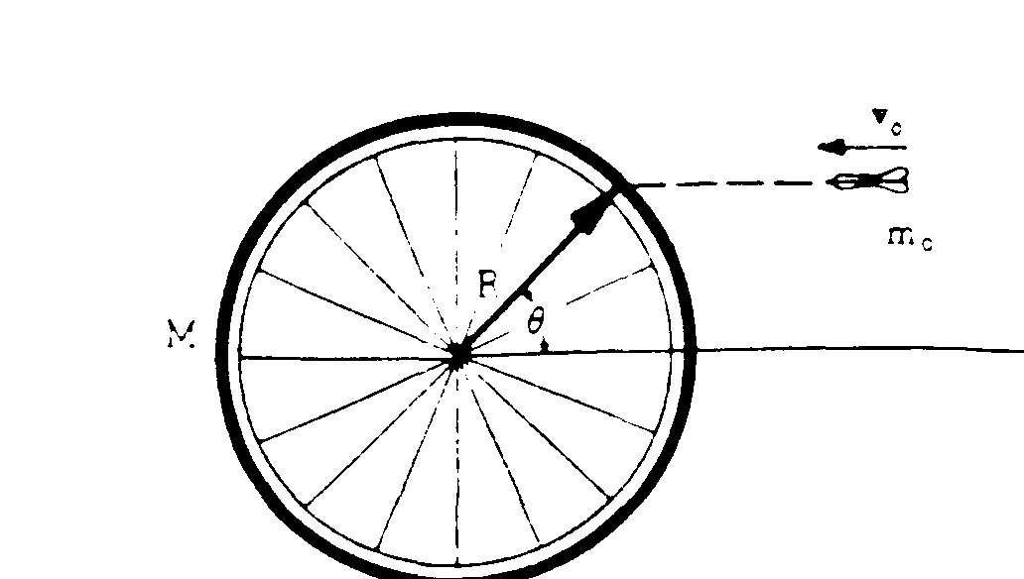

View From Above

1975M2. A bicycle wheel of mass M (assumed to be concentrated at its rim) and radius R is mounted horizontally so it may turn without friction on a vertical axle. A dart of mass mo is thrown with velocity vo as shown above and sticks in the tire.

a. If the wheel is initially at rest, find its angular velocity ω after the dart strikes.

b. In terms of the given quantities, determine the ratio:

final kinetic energy of the system

initial kinetic energy of the system

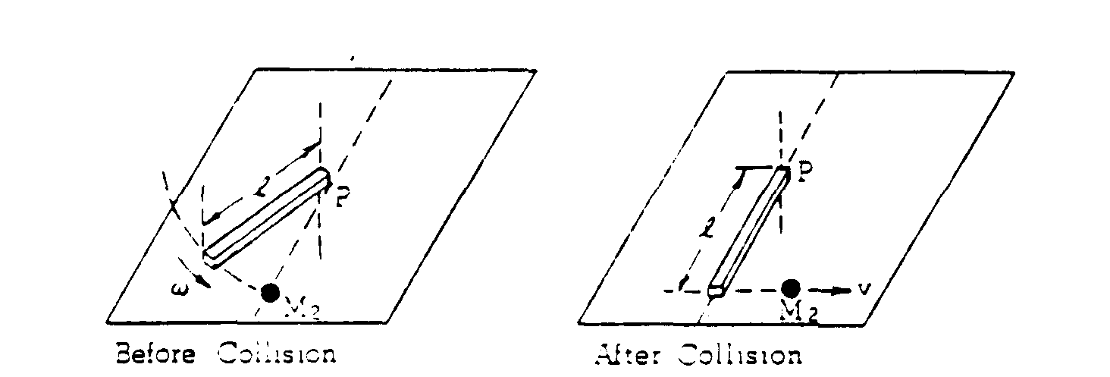

1978M2. A system consists of a mass M2 and a uniform rod of mass M1 and length *l*. The rod is initially rotating with an angular speed ω on a horizontal frictionless table about a vertical axis fixed at one end through point P. The moment of inertia of the rod about P is M*l*²/3. The rod strikes the stationary mass M2. As a result of this collision, the rod is stopped and the mass M2 moves away with speed v.

a. Using angular momentum conservation determine the speed v in terms of M1, M2, *l*, and ω.

b. Determine the linear momentum of this system just before the collision in terms of M1, *l*, and ω.

c. Determine the linear momentum of this system just after the collision in terms of M1 *l*, and ω.

d. What is responsible for the change in the linear momentum of this system during the collision?

e. Why is the angular momentum of this system about point P conserved during the collision?

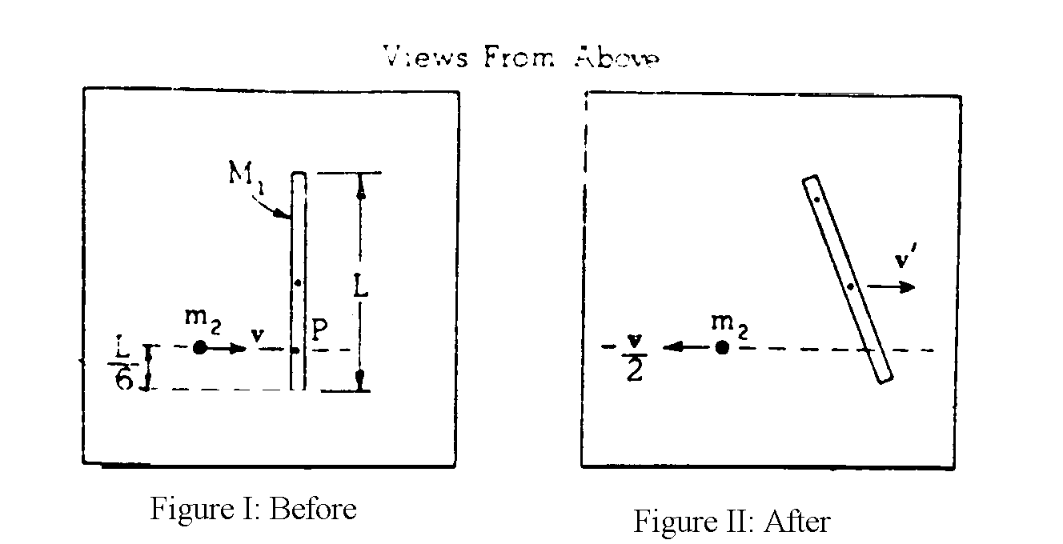

1981M3. A thin, uniform rod of mass M1 and length L , is initially at rest on a frictionless horizontal surface. The moment of inertia of the rod about its center of mass is M1L2/12. As shown in Figure I, the rod is struck at point P by a mass m2 whose initial velocity v is perpendicular to the rod. After the collision, mass m2 has velocity   
–½**v** as shown in Figure II. Answer the following in terms of the symbols given.

a. Using the principle of conservation of linear momentum, determine the velocity **v**’ of the center of mass of this rod after the collision.

b. Using the principle of conservation of angular momentum, determine the angular velocity ω of the rod about its center of mass after the collision.

c. Determine the change in kinetic energy of the system resulting from the collision.

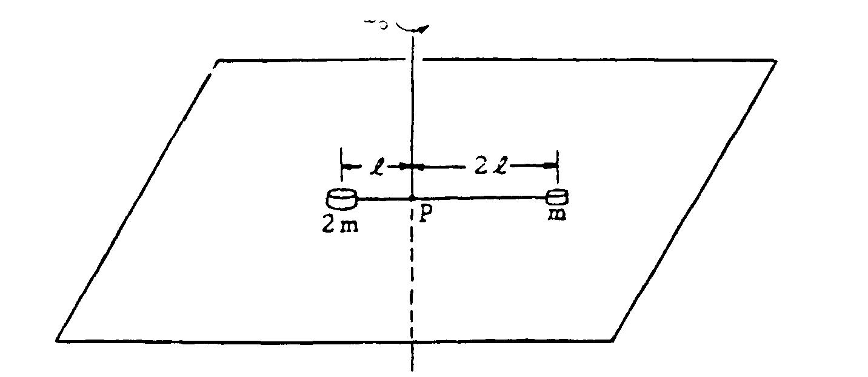

1982M3. A system consists of two small disks, of masses m and 2m, attached to a rod of negligible mass of length 3*l* as shown above. The rod is free to turn about a vertical axis through point P. The two disks rest on a rough horizontal surface; the coefficient of friction between the disks and the surface is μ. At time t = 0, the rod has an initial counterclockwise angular velocity ωo about P. The system is gradually brought to rest by friction. Develop expressions for the following quantities in terms of μ m, *l*, g, and ωo

a. The initial angular momentum of the system about the axis through P

b. The frictional torque acting on the system about the axis through P

c. The time T at which the system will come to rest.

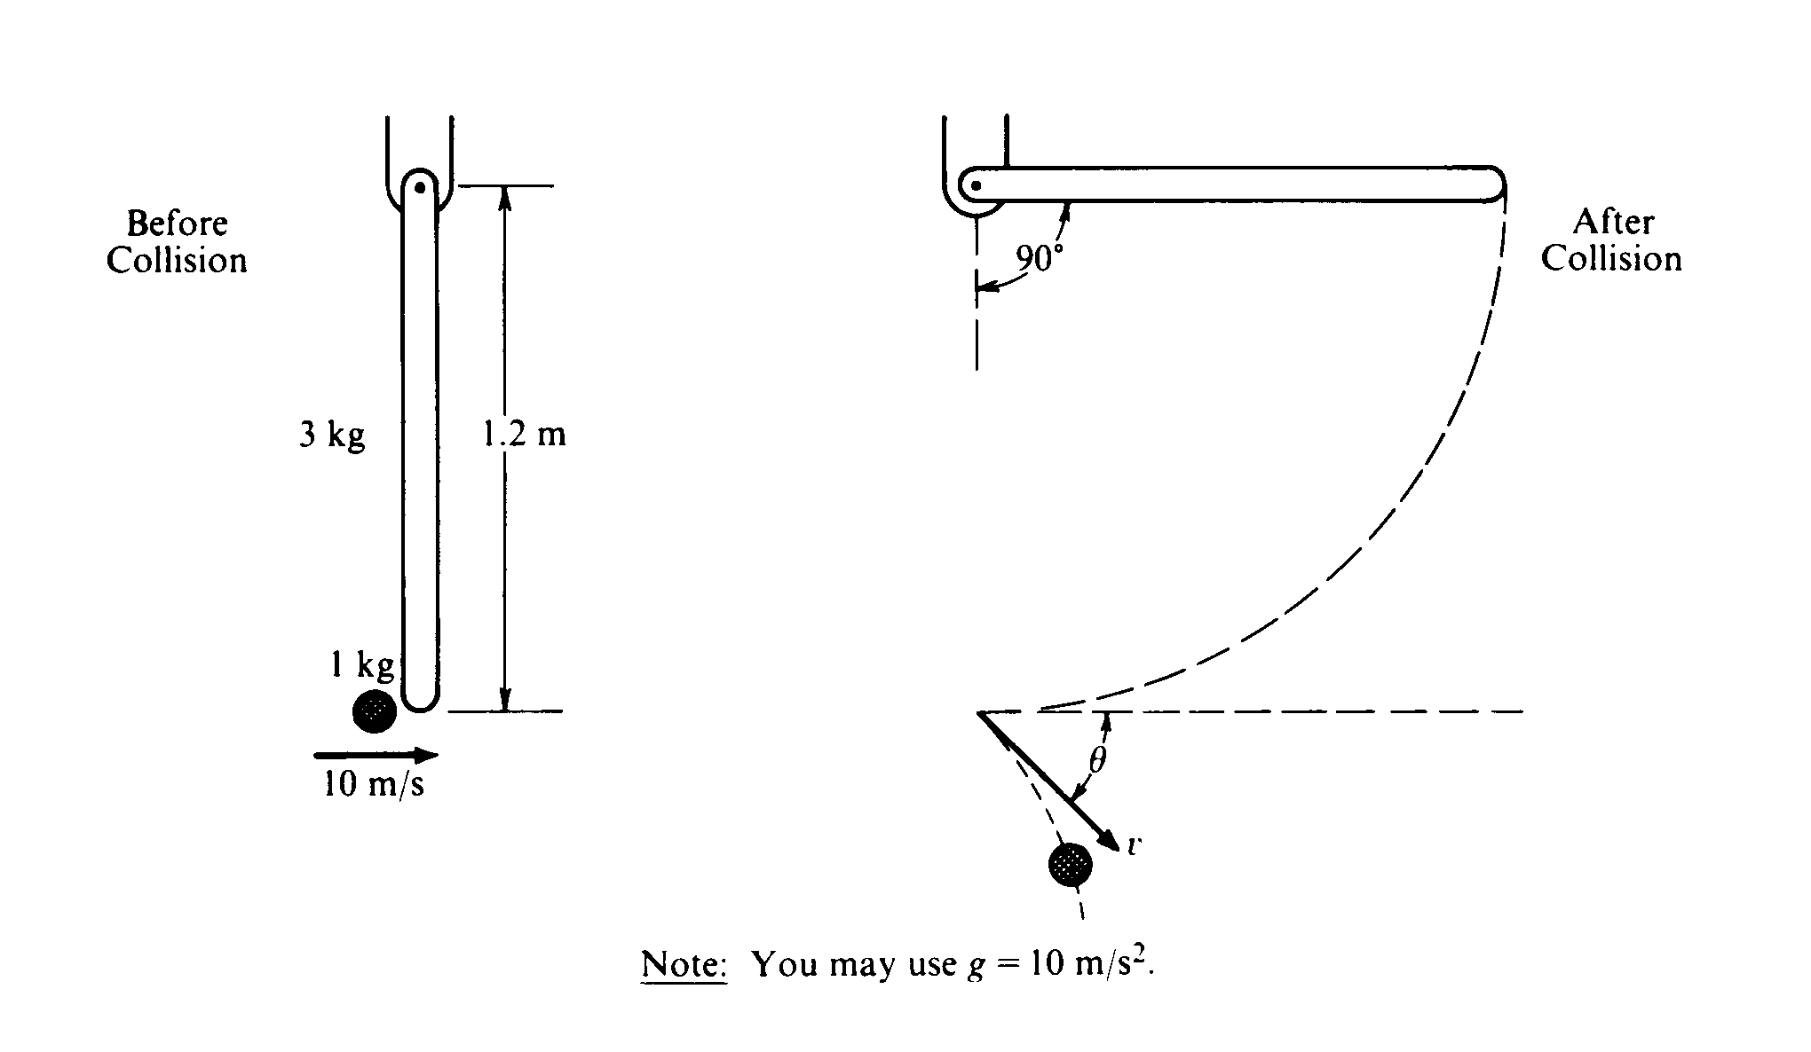

1987M3. A l.0‑kilogram object is moving horizontally with a velocity of 10 meters per second, as shown above, when it makes a glancing collision with the lower end of a bar that was hanging vertically at rest before the collision. For the system consisting of the object and bar, linear momentum is not conserved in this collision, but kinetic energy is conserved. The bar, which has a length *l* of 1.2 meters and a mass m of 3.0 kilograms, is pivoted about the upper end. Immediately after the collision the object moves with speed v at an angle θ relative to its original direction. The bar swings freely, and after the collision reaches a maximum angle of 90° with respect to the vertical. The moment of inertia of the bar about the pivot is Ibar = m*l*²/3 Ignore all friction.

a. Determine the angular velocity of the bar immediately after the collision.

b. Determine the speed v of the l‑kilogram object immediately after the collision.

c. Determine the magnitude of the angular momentum of the object about the pivot just before the collision.

d. Determine the angle θ.

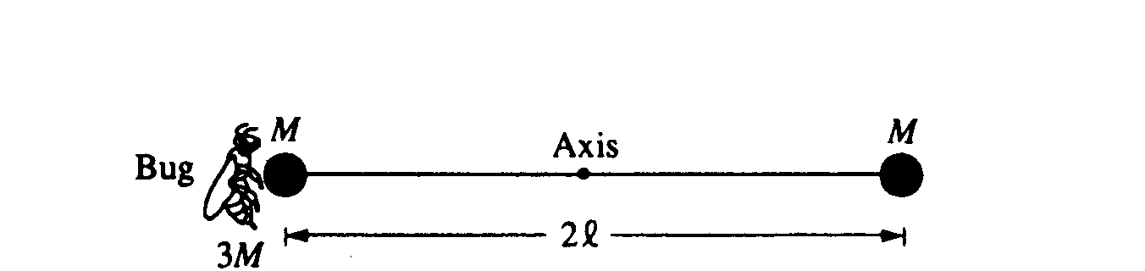

1992M2. Two identical spheres, each of mass Mand negligible radius, are fastened to opposite ends of a rod of negligible mass and length 2*l*. This system is initially at rest with the rod horizontal, as shown above, and is free to rotate about a frictionless, horizontal axis through the center of the rod and perpendicular to the plane of the page. A bug, of mass 3M*,* lands gently on the sphere on the left. Assume that the size of the bug is small compared to the length of the rod. Express your answers to all parts of the question in terms of M, *l*, and physical constants.

a. Determine the torque about the axis immediately after the bug lands on the sphere.

b. Determine the angular acceleration of the rod‑spheres‑bug system immediately after the bug lands.

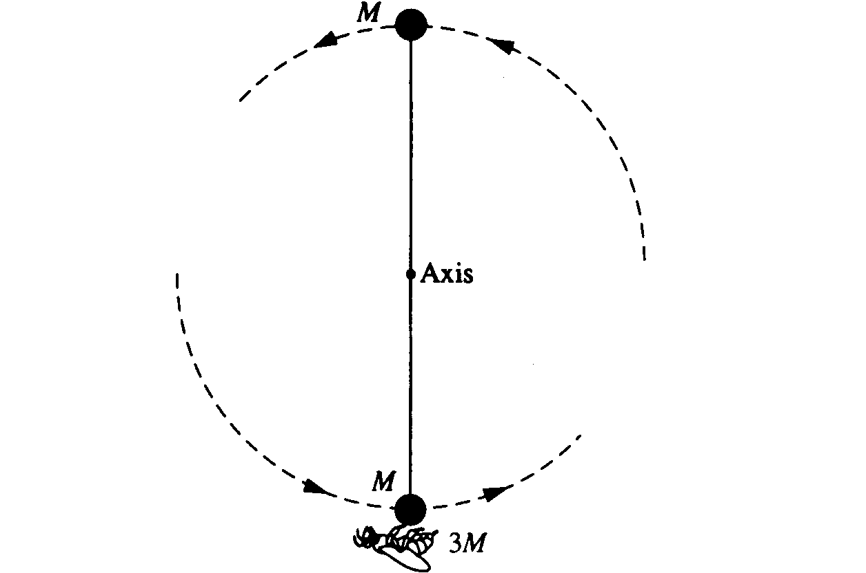

The rod‑spheres‑bug system swings about the axis. At the instant that the rod is vertical, as shown above, determine each of the following.

c. The angular speed of the bug

d. The angular momentum of the system

e. The magnitude and direction of the force that must be exerted on the bug by the sphere to keep the bug from being thrown off the sphere

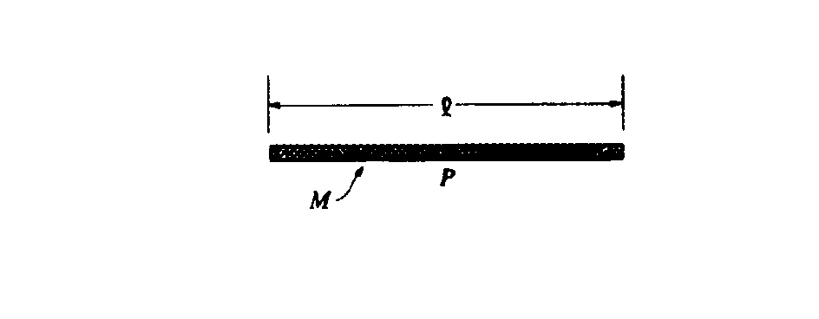

1996M3. Consider a thin uniform rod of mass M and length *l*, as shown above.

a. Show that the rotational inertia of the rod about an axis through its center and perpendicular to its length is M*l*2/12.

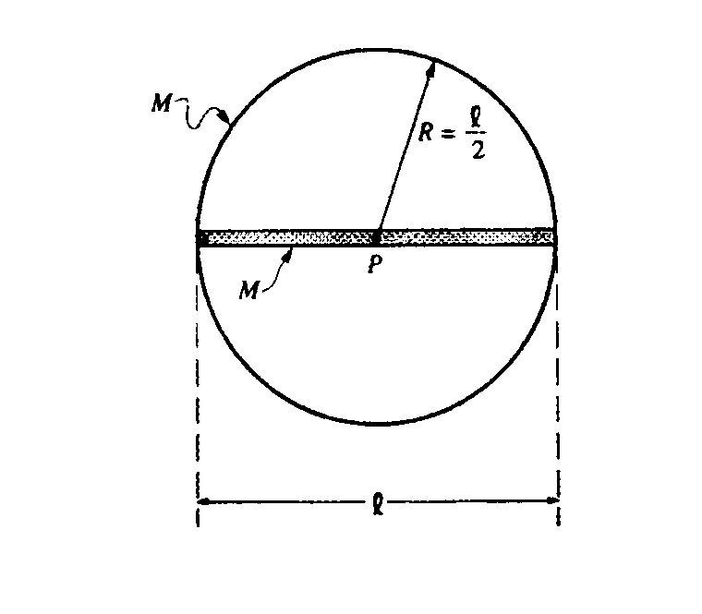

The rod is now glued to a thin hoop of mass M and radius R/2 to form a rigid assembly, as shown above. The centers of the rod and the hoop coincide at point P. The assembly is mounted on a horizontal axle through point P and perpendicular to the page.

b. What is the rotational inertia of the rod‑hoop assembly about the axle?

Several turns of string are wrapped tightly around the circumference of the hoop. The system is at rest when a cat, also of mass M, grabs the free end of the string and hangs vertically from it without swinging as it unwinds, causing the rod‑hoop assembly to rotate. Neglect friction and the mass of the string.

c. Determine the tension T in the string.

d. Determine the angular acceleration a of the rod‑hoop assembly.

e. Determine the linear acceleration of the cat.

f. After descending a distance H = 5*l*/3, the cat lets go of the string. At that instant, what is the angular momentum of the cat about point P?

1998M2. A space shuttle astronaut in a circular orbit around the Earth has an assembly consisting of two small dense spheres, each of mass m, whose centers are connected by a rigid rod of length *l* and negligible mass. The astronaut also has a device that will launch a small lump of clay of mass m at speed v0 . Express your answers in terms of m, v0 *l*. and fundamental constants.

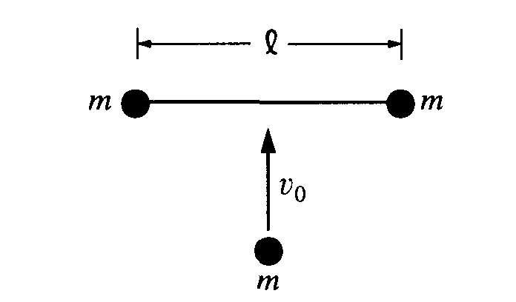

a. Initially, the assembly is "floating" freely at rest relative to the cabin, and the astronaut launches the clay lump so that it perpendicularly strikes and sticks to the midpoint of the rod, as shown above.

i. Determine the total kinetic energy of the system (assembly and clay lump) after the collision.

ii. Determine the change in kinetic energy as a result of the collision.

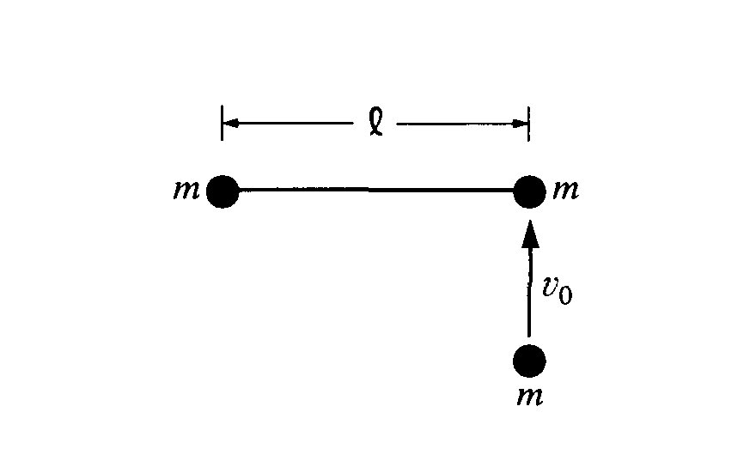

b. The assembly is brought to rest, the clay lump removed, and the experiment is repeated as shown above, with the clay lump striking perpendicular to the rod but this time sticking to one of the spheres of the assembly.

i. Determine the distance from the left end of the rod to the center of mass of the system (assembly and clay lump) immediately after the collision. (Assume that the radii of the spheres and clay lump are much smaller than the separation of the spheres.)

ii. On the figure above, indicate the direction of the motion of the center of mass immediately after the

collision.

iii. Determine the speed of the center of mass immediately after the collision.

iv. Determine the angular speed of the system (assembly and clay lump) immediately after the collision.

v. Determine the change in kinetic energy as a result of the collision.

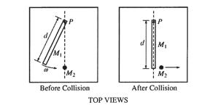

2005M3. A system consists of a ball of mass *M2*and a uniform rod of mass *M1* and length *d.* The rod is attached to a horizontal frictionless table by a pivot at point *P* and initially rotates at an angular speed ω, as shown above left. The rotational inertia of the rod about point P is  *M1d2* . The rod strikes the ball, which is initially at rest. As a result of this collision, the rod is stopped and the ball moves in the direction shown above right. Express all answers in terms of *M1*, *M2, ω, d,* and fundamental constants.

a. Derive an expression for the angular momentum of the rod about point *P* before the collision.

b. Derive an expression for the speed *v* of the ball after the collision.

c. Assuming that this collision is elastic, calculate the numerical value of the ratio *M1 / M2*

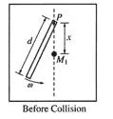

d. A new ball with the same mass *M1* as the rod is now placed a distance *x* from the pivot, as shown above. Again assuming the collision is elastic, for what value of *x* will the rod stop moving after hitting the ball?