COMPSCI 260 - Problem Set 4, Problem 2

Due: Fri 25 Oct 2019, 5pm

Name: Kyle Mitra

NetID: km423

Statement of collaboration and resources used (put None if you worked

entirely without collaboration or resources; otherwise cite carefully): None

My solutions and comments for this problem are below.

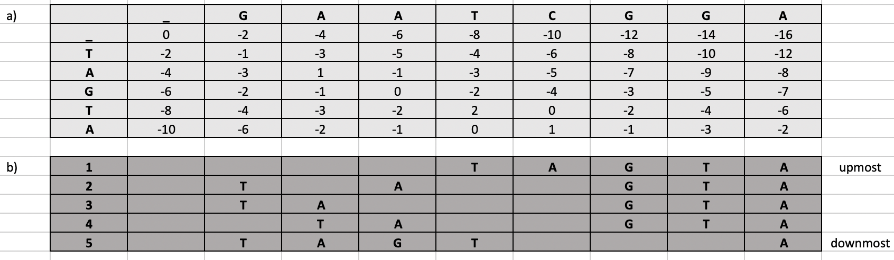______________________________________________________________________________

b) The optimal score for these sequences is -2. The 5 scores shown in the image above achieve this score.

c) If an affine gap score was used instead of a linear gap score, alignments 2 and 4 would not be optimal since they have more than one gap in their sequence. When using affine gap score, opening a new gap requires a new gap penalty in addition to the regular gap penalty so the optimal alignment would require the minimal number of gaps, which in this scenario is 1 gap. Therefore, only alignments 1, 3, and 5 would remain optimal since they each achieve the optimal score with only a singular gap.