COMPSCI 260 - Problem Set 6, Problem 2

Due: Fri 22 Nov 2019, 5pm

Name: Kyle Mitra

NetID: km423

Statement of collaboration and resources used (put None if you worked

entirely without collaboration or resources; otherwise cite carefully): None

My solutions and comments for this problem are below.

-----------------------------------------------------

1. 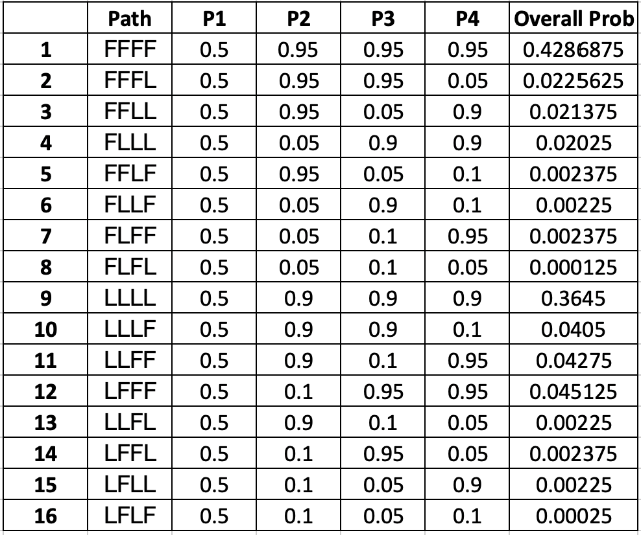
2. The probability of going through the states FFLL and observing the rolls 1662 [P(FFLL & 1662) is equal to P(FFLL)\*P(1662) which is 3.29861E-06. However, the P(FFLL|1662) = [P(FFLL) & P(1662)] / (1662) = 0.002375. These probabilties are not the same and it is expected that P(FFLL|1662) should be higher since the loaded die is weighted to a 6 and the presence of a 6 makes it more probable that the loaded die was used.

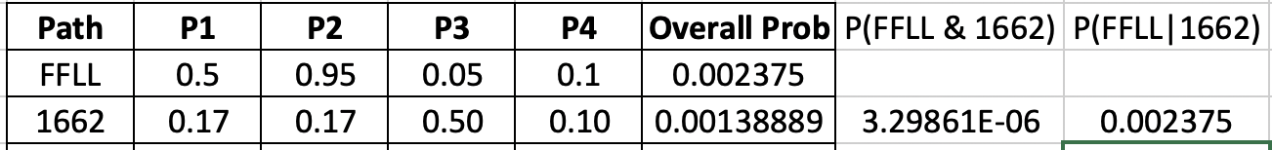

1. 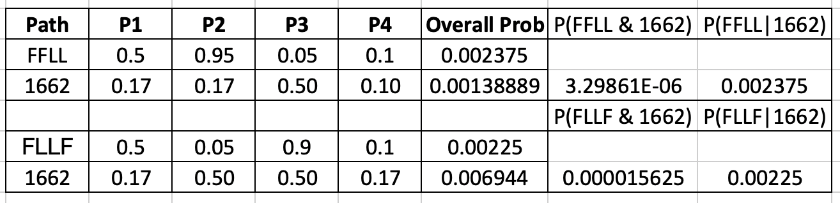The P(Π = FFLL|X = 1662) > P(Π = FLLF|X = 1662). This is expected because the transition probabilities are low and it is very unlikely that you transition between the two dice. Since FFLL only has one transition and FLLF has two, it is more expected that FFLL would occur. This holds true despite the fact that the emission probabilities indicate a higher likelihood of using the loaded die when a 6 is rolled, since the probability of transitioning between the two is lower.
2. Since the likelihood of rolling a 6 is much higher with the loaded die, it is expected that the loaded die will be used on the 2nd and 3rd rolls which results in a six. For the 1st and 4th rolls, the probability of roiling a 1 and a 2 is higher when using the fair die. However, the previous question demonstrates that the low likelihood of transitioning between the two die overrules a higher likelihood of rolling a particular number with a certain die. Therefore, even though the probability of rolling a 1 or a 2 is higher using the fair die, it seems most likely that the loaded die would be used for all four rolls due to the low likelihood of switching them at any given time.
3. We want to know the P(Π = L|X = 6) compared to P(Π = F|X = 6). Based on the calculations below, it is more likely that the fair die was used on the next roll.

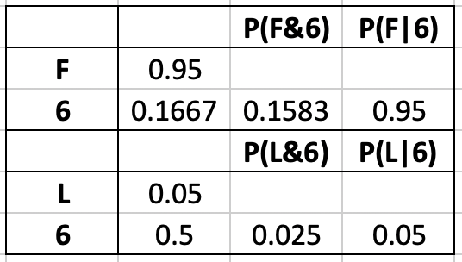

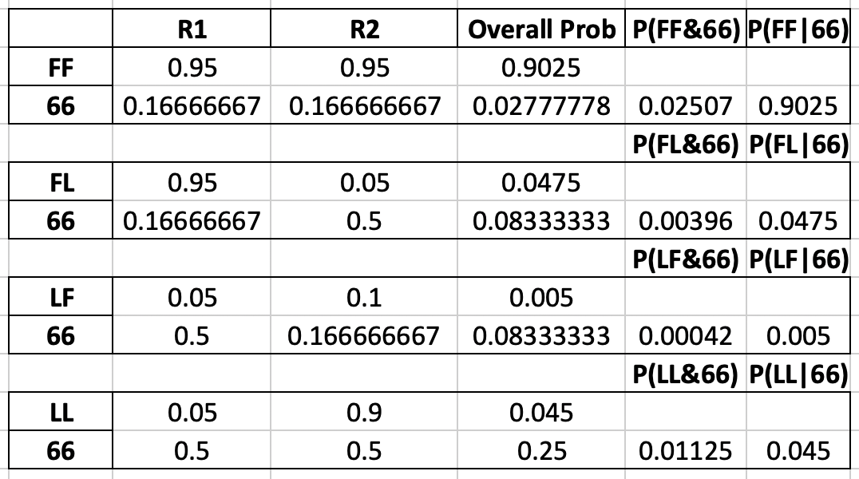However, if we rolled two consecutive 6s, the probabilities that the last two states are as follows:

Therefore, it is most likely that the last two states were FF.

1. See dice.roll.sequence.txt
2. See Code

Dict of Counts {'F F F F': 315, 'L L L L': 198, 'F F L L': 9, 'L F L L': 26, 'L L F L': 24, 'L F F L': 5, 'L L L F': 13, 'F L L L': 16, 'F L F F': 9, 'L L F F': 4, 'F F F L': 2, 'F F L F': 7, 'F L L F': 2, 'L F F F': 2}

1. The frequency of FFLL if 9 and the frequency of FLLF is 2. This is expected based on the results of c since the likelihood of switching dice is very low and FLLF has two dice switches compared to FFLL which only has one.
2. The two most frequent states were FFFF and LLLL which makes sense since the probability of switching between different dice is low and will not happen most of the time. It also makes sense that FFFF has more than LLLL since the first roll in the sequence (1) is more likely to be generated by a fair die than a loaded die. s