**Adding self-hosted TinyMCE to an Angular project**

* https://www.tiny.cloud/get-tiny/self-hosted/
* Extract package to /client/src/assets/
  + ? cannot be higher than src folder ?
* In **index.html**, add script info in head section:

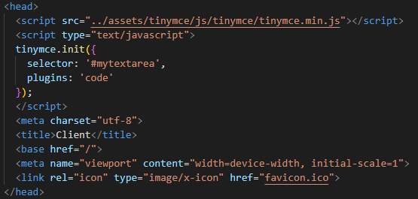

* In **app.component.html**, add a textarea with an id of mytextarea

