Overwintering Western Monarch Butterflies: Empirical Tests of the Microclimate Hypothesis
Kyle Nessen
Abstract
The western monarch butterfly (Danaus plexippus) population has declined by over 99% since the 1980s, making conservation of overwintering habitat along California’s coast a management priority. For three decades, the primary perspective on overwintering habitat has utilized a broad Microclimate Hypothesis which posits monarch butterflies seek a narrow microclimate for overwintering, including a nested Disruptive Wind Hypothesis which posits that wind speeds exceeding 2 m/s disrupt butterfly clusters and cause roost abandonment. In earlier work, we tested and rejected the Microclimate Hypothesis for temperature, humidity and light, but did not address wind. This study provides the first direct experimental test of wind effects on overwintering monarch clusters. Importantly, the Disruptive Wind Hypothesis has substantially influenced overwintering habitat restoration and management practices, despite lacking direct empirical validation.
We deployed cameras and wind sensors at two sites on Vandenberg Space Force Base during the 2023-2024 overwintering season. Time-lapse photography, documenting butterfly abundance, and wind sensors at roost height, simultaneously collected 1,894 paired observations at 30-minute intervals across 78 days. Linear regression analysis revealed a poor relationship between wind speed and changes in cluster size at either 30-minute or daily timescales ($R^{2}$ = 0.002, p = 0.073 and $R^{2}$ = 0.013, p = 0.252, respectively). Every day butterflies that were present experienced wind speeds exceeding 2 m/s, yet clusters persisted throughout the monitoring period. Generalized additive mixed models identified temperature, time of day, and an interaction between wind and sunlight as factors influencing cluster behavior (p $<$ 0.001). Wind alone showed no independent effect. Instead, wind effects appeared to be light dependent: when butterflies remained in shade, wind speed had no effect on cluster behavior across the entire observed range (0 to 12.4 m/s). Effects appeared, and the number of clustering butterflies declined, only when butterflies occupied sunlit positions, suggesting that thermoregulation may be a primary driver of clustering behavior.
Our findings challenge a fundamental assumption in monarch habitat management. The absence of wind disruption indicates that monarchs may be more resilient to environmental variation than previously believed, with suitable habitat potentially more extensive than currently recognized. Conservation efforts should continue promoting healthy groves while reconsidering strict wind-based management requirements. Future research should investigate canopy structure and resulting light patterns, monarchs roost site selection, thermoregulation, and ecophysiology.
While the threshold approach (2 m/s) may not optimally characterize wind effects, the interaction between wind (as a continuous or discrete variable) and solar exposure is a better optimization.
. Notably, the overwhelming majority of observations occurred at low counts of butterflies in direct sun, emphasizing that most clustering behavior happens in indirect light.
This six-fold improvement in explanatory power strongly suggests that cumulative weather exposure over day-long periods is more strongly associated with roosting decisions than immediate short-term conditions.

Introduction
The distribution and survival of invertebrate species are governed by complex interplays of biotic and abiotic factors. While biotic interactions influence community assembly in part through predation, competition, and parasitism (Blois-Heulin et al. 1990; Lafferty and Shaw 2013; Miller-ter Kuile et al. 2022), abiotic conditions often set the fundamental limits determining where invertebrates can persist. Temperature constrains invertebrate physiology across all latitudes, from Antarctic midges (Everatt et al. 2015) to desert land snails (Schweizer, Triebskorn, and Köhler 2019). In invertebrates, temperature correlates positively with metabolic rates and respiratory water loss, creating compound stresses that limit activity windows (Chown, Sørensen, and Terblanche 2011). In addition, via a correlation with temperature, solar radiation can drive both direct physiological impacts and behavioral responses. Examples range from army ants demonstrating habitat-specific thermal maxima tied to insolation exposure (Baudier et al. 2018), to terrestrial gastropods climbing vertical surfaces to escape ground-level heat (Schweizer, Triebskorn, and Köhler 2019).
Wind is another abiotic factor that can influence invertebrate distribution and behavior through diverse mechanisms that vary across species. There are remarkably specific wind detection thresholds and behavioral responses. For example, cockroaches perceive air currents as low as 0.015–0.03 m/s and demonstrate predictable orientation shifts in response to wind velocities (Bell and Kramer 1979). Mosquitos' sensitivity to winds as light as 1.0 m/s can effectively ground entire populations (Bidlingmayer, Day, and Evans 1995). Some species exploit wind for dispersal through specific behaviors, such as spiders’ stereotypic ‘tiptoe’ behavior which initiates ballooning but only when winds permit controlled trajectories (Bonte and Lens 2007). Some species respond to wind as an environmental stressor requiring active avoidance. For mad hatterpillar larvae, 3 m/s winds are a disturbance cue, triggering movements to stable microsites on branches, and behavioral shifts to leeward sides and abaxial leaf surfaces (Leonard, McArthur, and Hochuli 2016). Underlying many of these behavioral avoidance responses are the fundamental thermal and hydric effects of wind, as convective cooling from air movement significantly alters both heat and water exchanges between organisms and their environment, particularly when wind interacts with solar radiation (Riddell and Porter 2025). Thus, wind can be recognized as having direct mechanical effects, and indirect thermal and hydric effects through covariates such as heat and insolation.
The monarch butterfly (Danaus plexippus) offers an exceptional system for studying how abiotic factors shape invertebrate ecology, and much is known about this migratory species. Late summer environmental cues, such as shortening day length and cooling temperatures, trigger the emergence of a migratory monarch generation (Reppert and de Roode 2018; Goehring and Oberhauser 2002; Herman and Tatar 2001; Barker and Herman 1976). These adults exhibit unique characteristics including reproductive diapause (suspended reproduction), and an elongated-wing long-travel-distance phenotype (Barker and Herman 1976; Yang et al. 2016; Tuskes and Brower 1978). The fall migrants collect nectar enroute thus building lipid reserves needed for overwintering (Herman and Tatar 2001; Chaplin and Wells 1982; Urquhart and Urquhart 1978). And while Eastern monarchs travel to high-altitude oyamel fir (Abies religiosa) forests in central Mexico, our focus, the Western monarch population, migrates to overwintering groves widely scattered along the Pacific coast of California (L. Brower 1995; Urquhart and Urquhart 1978).
While overwintering, roughly from mid-October through mid-March, monarchs survive on accumulated lipid reserves and associated thermoregulatory balancing (Chaplin and Wells 1982; Masters, Malcolm, and Brower 1988). As ectotherms, monarchs face a fundamental trade-off: maintain body temperatures cool enough through metabolic suppression to conserve energy for the entire overwintering season, yet warm enough to permit for bouts of essential flights (Masters, Malcolm, and Brower 1988; Chaplin and Wells 1982; Kammer 1970; Alonso-Mejia and Arellano-Guillermo 1992). Temperatures of 12.7-16.0°C represent the minimum thoracic temperature required for powered flight (Masters, Malcolm, and Brower 1988) and represent flight threshold temperature for (Eastern) monarchs. Below this threshold, monarchs employ behavioral thermoregulation either through dorsal basking, which can elevate body temperature to flight capability within 30 seconds of sun exposure, or through energetically costly shivering that consumes energy 25 times faster than resting (Masters, Malcolm, and Brower 1988). Thus “warm enough” can be environmentally or physiologically attained, but at significantly different costs to lipid stores. Conversely, direct sun exposure can rapidly elevate thoracic temperatures to 33.6°C, forcing butterflies to adopt sun-minimizing postures or engage in heat-dissipating flights (Barker and Herman 1976). This energetic balancing means that monarchs selecting overwintering sites must find locations that minimize both freezing risk and elevated metabolic expenditure (Masters, Malcolm, and Brower 1988; Alonso-Mejia and Arellano-Guillermo 1992; Calvert, Zuchowski, and Brower 1983).
Our focus on abiotic conditions, but more specifically wind, builds on early studies from Mexican overwintering sites that lead Leong (1990) to propose the Microclimate Hypothesis for western monarchs overwintering in California. This hypothesis posits that monarchs select clustering locations within groves based on a measurable microenvironmental envelope characterized by four key parameters each with a specific benefit: wind protection or speeds below 2 m/s ( 5 mph) preventing cluster disruption, cool temperatures maintaining diapause while minimizing freezing risk and elevated metabolic expenditure, dappled sunlight enabling behavioral thermoregulation, and high humidity or accessible moisture to prevent desiccation (Kingston L. H. Leong 1990; Kingston L. H. Leong et al. 1991). Wind emerged as particularly critical in Leong’s Microclimate Hypothesis.
Leong’s initial studies measured wind speeds at trees with and without butterfly clusters, concluding that “during winter storms, the butterflies clustered on those few trees that offered the greatest protection against winds of 2 m/s or greater” (Kingston L. H. Leong 1990). Though, technically the highest wind speed measured in this study was 1.66 m/s. Based on these inferred correlations Leong reported that “butterflies cluster in areas of the grove that offer exposure to filtered sunlight and shelter from strong wind movement” (Kingston L. H. Leong et al. 1991). In later publications, Leong added anecdotal observations, noting that “roosting butterflies were blown from their clusters or dislodged by excessive branch movements (shaking) caused by winds exceeding 2 m/s” and that “upon dislodgment, the butterflies flew to and resettled on foliage of trees that offered better shelter from strong winds” (K. L. H. Leong 1999). When storm winds coincided with morning temperatures below 15°C, “the dislodged butterflies would be blown to the ground and remain there until temperatures reached flight threshold,” with “butterflies littering the ground at the base of roosting trees” commonly observed after winter storms (K. L. H. Leong 1999). Though the Microclimate Hypothesis originated from untested anecdotal observations, it still gained widespread acceptance and came to directly inform management guidelines at multiple levels. Leong’s 2016 synthesis for California Department of Fish and Wildlife formally established that “winds $≥$ 2 m/s are disruptive to the aggregating butterflies by blowing them from their roosting branches or dislodging them by shaking the branches,” and that when subjected to such winds when above flight threshold temperature, butterflies “either flew to a more sheltered area of the grove or, if no refuge area was available, abandoned the grove temporarily or for the remainder of the season” (Kingston L. H. Leong 2016). Thus, the Microclimate Hypothesis "made obvious” that successful overwintering sites would consistently exhibit a specific suite of conditions, including protection from wind $≥$ 2 m/s. This then implied that specific abiotic parameters should guide habitat management and restoration efforts, a principle now widely adopted in monarch conservation plans (Xerces Society 2016; S. Jepsen et al. 2017; E. Pelton 2020; Stuart B. Weiss and Rich 2008; Althouse & Meade, Inc. and Creekside Science 2023).
However, empirical testing has gradually dismantled the Microclimate Hypothesis’ core assumption of a uniform environmental envelope. When researchers tested whether monarchs select for consistent microclimatic attributes (temperature, light, and humidity) across groves, they found that the realized microclimate varied significantly with latitude and local geography (Saniee and Villablanca 2022). Temperature responses proved more complex than originally proposed, with monarchs avoiding freezing temperatures but selecting the warmest cold temperatures available at their latitude (Fisher et al. 2024). Humidity showed geographic variability rather than consistency (Saniee and Villablanca 2022). Of the three Microclimate Hypothesis parameters tested, only light exposure showed potential support as a unifying factor, with successful overwintering sites exhibiting consistent patterns of canopy openness (Stuart B. Weiss et al. 1991) and resultant high intensity light of short duration (Saniee and Villablanca 2022), or specific shading patterns (Ibsen et al. 2025). This geographic variability in microclimate utilization, where selection occurs hierarchically across multiple spatial scales rather than for a single environmental envelope, fundamentally contradicts Leong’s original hypothesis (Fisher et al. 2024; Saniee and Villablanca 2022).
Among the four parameters of Leong’s Microclimate Hypothesis, the wind disruption component of the Microclimate Hypothesis (hereafter Wind Disruption Hypothesis) stands apart as the only major component that has never undergone direct empirical testing of butterfly behavioral responses. Despite widespread adoption of the Wind Disruption Hypothesis’ 2 m/s wind protection threshold in restoration efforts (Xerces Society 2018; S. Jepsen et al. 2017; Althouse & Meade, Inc. and Creekside Science 2023; U.S. Fish and Wildlife Service 2024; Stuart B. Weiss 2018; Kingston L. H. Leong 2016), no study has established causal relationships between wind exposure and butterfly behavior. Leong’s methodology of comparing wind measurements between occupied and unoccupied trees provided only correlational evidence, never directly testing butterfly responses to wind exposure, or distinguishing whether butterflies actively avoid wind, hydric or thermic effects of wind, or some other correlated unmeasured variables (error term).
The absence of empirical testing for the Wind Disruption Hypothesis becomes critically important given the catastrophic decline of western monarch populations. Between the 1980s and mid-2010s, populations collapsed by approximately 97% (Schultz et al. 2017), with population viability analyses revealing a 72% quasi-extinction risk within 20 years (Schultz et al. 2017). The winter 2018 to 2019 count recorded fewer than 30,000 monarchs, a single-year drop of 86%, representing over 99% decline from 1980s abundance (E. M. Pelton et al. 2019). The situation reached its most critical state in 2020 when the Western Monarch Thanksgiving Count documented only 1,901 butterflies, the lowest number ever recorded (Xerces Society 2025a). While populations showed some recovery in subsequent years, the 2024 to 2025 count of 9,119 represents the second-lowest count and the latest count of 12,260 (2025-2026) is the third lowest on record, demonstrating the population’s continued precarity (Xerces Society 2025a). These dramatic declines result from multiple interacting stressors including herbicide use and associated breeding habitat loss, pesticide exposure, climate change, and the loss and degradation of overwintering habitat (Crone et al. 2019; E. M. Pelton et al. 2019). Evidence increasingly suggests that the overwintering stage represents the most limiting phase of the monarch’s annual cycle, with population declines concentrated during winter and early spring periods (E. M. Pelton et al. 2019; Marini and Zalucki 2017). California’s coastal overwintering groves, where the entire western population concentrates into small, forested areas from October through March, have thus emerged as the focal point of Western Monarch conservation priorities. Yet management of these critical sites continues to rely on the untested Disruptive Wind Hypothesis, with restoration efforts investing millions of conservation dollars based on the presumed necessity of maintaining wind speeds below 2 m/s (Althouse & Meade, Inc. and Creekside Science 2023; The Monarch Press 2019).
Testing the Disruptive Wind Hypothesis requires addressing a fundamental methodological challenge: isolating wind effects from confounding environmental variables that naturally covary in field settings. Solar radiation is a potential covariate that can trigger butterfly departures through direct heating (Masters, Malcolm, and Brower 1988; Kammer 1970). Temperature is a potential covariate known to independently influence activity patterns, with monarchs exhibiting predictable responses as temperatures approach and exceed flight thresholds (Barker and Herman 1976). Time of day creates inherent activity rhythms related to sun angle and thermal conditions (Mouritsen and Frost 2002) if clusters reform nightly. Furthermore, wind itself is multidimensional, characterized not only by average speed but also by gustiness and variability (Nathan et al. 2005) that could differentially affect butterfly behavior. A rigorous test must therefore control for potentially confounding factors while examining multiple aspects of wind exposure.
This study provides the first direct empirical test of whether wind disrupts overwintering monarch butterflies. Our primary objective was to evaluate the 2 m/s wind disruption threshold that has guided over three decades of conservation practice. First, we hypothesized that wind, alongside other environmental factors, predicts butterfly abundance at overwintering clusters. If true, we predict that wind will emerge as a significant predictor of abundance changes, with monarch abundance (i.e.: cluster size) decreasing when exposed to higher wind speeds. Second, we hypothesized that wind becomes disruptive above a specific threshold of 2 m/s. If this threshold represents a meaningful biological boundary, we predict that monarch abundance (i.e.: cluster size) will decline at roosts experiencing winds exceeding 2 m/s. Third, we hypothesized that wind’s disruptive effects scale with intensity. If disruption increases with wind speed, we predict proportionally greater decreases in monarch abundance (i.e.: cluster size) as wind speeds rise above the threshold. Finally, we hypothesized that experiencing disruptive winds affects monarch site fidelity. If wind disruption influences future roost selection, we predict decreased site fidelity manifested as sustained abundance reductions at wind-disturbed roosts compared to pre-disturbance levels.

Materials and Methods

Study Site
Vandenberg Space Force Base (VSFB, 34.7398°N, 120.5725°W) in Santa Barbara County, California, was selected based on: extensive historical plantings of blue gum eucalyptus (Eucalyptus globulus) that support overwintering habitat, historical occupation of that habitat, restricted access providing security for long-term equipment deployment, and federal funding that mandated research be conducted on federal lands. VSFB contains thirty documented overwintering groves, with several over the last decade consistently in the top 10% statewide based on population abundance (Xerces Society 2025b). Ten locations were selected from the thirty based on consistent occupancy by monarch aggregations, year-round research access, and local knowledge by Jessica Griffiths the VSFB Monarch Conservation Coordinator and long-term VSFB coordinator of Western Monarch Thanksgiving Counts (Xerces Society 2025b). We deployed monitoring equipment at these locations across two overwintering seasons, with only four sites monitored during 2023-2024 and all ten sites during 2024-2025. However, due to low monarch abundance during the first season and no observed overwintering monarchs during the second season, only two sites (Spring Canyon and UDMH in 2023-2024) produced measurable butterfly clusters suitable for our analysis. Spring Canyon (34.6315°N, 120.6182°W) is the most historically reliable and highest overwintering abundance site on VSFB. In the South Base and within 300 meters of Space Launch Complex 4, it is approximately 2.0-hectares of mature blue gum eucalyptus (BGU) ranging to 40 meters in height. A perennial creek runs through the center of the overwintering grove, creating a riparian corridor supporting heterogeneous canopy structure, variable tree spacing, and diverse understory vegetation. Surf Road, an infrequently used but paved access road, bisects both the creek and forest canopy. Although only recently (2022) documented, UDMH has emerged as a significant overwintering site, ranking among the base’s highest population sites since 2022. UDMH (34.6719°N, 120.5950°W), is also located in South Base, comprises 5.1-hectares of BGE windrows planted adjacent to a waste treatment facility, and has an understory of scattered low shrubs.

Monitoring Strategy
The 2023-2024 season employed two strategies: targeted deployments at sites with monarchs present (Spring Canyon and UDMH), and anticipatory deployments based on historical occupancy data but without evident occupancy. Anticipatory deployments occurred at four overwintering groves: additional locations within Spring Canyon and UDMH, plus SLC-6 and Tangair. No monarchs were recorded at anticipatory deployment sites in 2023-2024; consequently, these data are excluded from analysis. Unfortunately, the 2024-2025 season coincided with historically low monarch abundance throughout California (Xerces Society 2025b), thus we do not present deployment strategies, data or analysis for any of the sites monitored in 2024-2025.

Field Equipment
To observe changes in monarch abundance (cluster size) in response to wind, we deployed remote monitoring equipment adjacent to butterfly clusters using 15-meter-tall fiberglass telescoping poles (Max-Gain Systems, Inc., Marietta, GA). Poles were anchored at three points, with ground anchors and guy lines connecting the base (anchors) to the pole’s top, thus creating stable freestanding structures. Poles were 4-17 meters (horizontal distance) from their cluster. This distance was determined through field testing to provide the image resolution required by our grid-based counting method (see below). Specifically, this positioning minimized disturbance to monarchs, provided sufficient field of view, and provided necessary resolution of individual clustered butterflies. In addition, pole placement was often constrained by ground stability relative to the freestanding structure, structure footprint, clearance requirements, and viewing angles. Deployments near active clusters did minimize disturbance; no butterfly dispersal was observed during equipment deployment.
Monarch abundance (cluster size) was monitored using trail cameras (GardePro E7 and E8, Shenzhen, China) modified for near-infrared (NIR) imaging which enhanced clustering butterfly and vegetation contrast (Hristov et al. 2019), which in turn improved abundance estimation. Cameras were chosen for durability under extended field deployment, native time-lapse functionality, and modification potential. Modifications exploited an internal filter-switching mechanism by engaging the clear glass filter, disconnecting power to prevent reversion to infrared, and mounting NIR pass filters ($>$850 nm) externally. Restrict incoming light to NIR wavelengths produced black and white images where clustering butterflies appeared as dark masses against bright eucalyptus foliage. Field comparison to human-labeler (see below) confirmed sufficient visual contrast for accurate estimation of cluster size. Cameras, in time-lapse mode with motion detection disabled, were mounting atop poles and positioned horizontally toward butterfly clusters at roost height. Wireless live-view enabled real-time preview and precise camera aiming at the time of deployment. The camera sampling interval, which balanced information content and temporal resolution, battery life and human-labeler data processing capacity, was determined through statistical validation. Initial deployments used 10-minute intervals to capture images of changing butterfly abundance. Post-deployment analyses using mixed-effects models and information-theoretic approaches systematically conducted sequential subsampling starting with full temporal resolution (10-minute interval) and progressively testing reduced frequencies. Model comparison, using Akaike Information Criterion (AIC), demonstrated that 30-minute intervals provided optimal balance, losing less than 5% of information (measured by root mean square error) compared to full temporal resolution while reducing image processing workload by 67%. Variance comparison analysis and visual assessment of fitted trend lines confirmed that this interval preserved essential time-series patterns including diurnal activity cycles, weather-response dynamics, and multi-day population trends. Battery life constraints and field deployment logistics were consistent with this interval, enabling extended autonomous operation essential for capturing complete behavioral sequences during variable weather conditions.
To quantify if predicted wind conditions influenced butterfly behavior, wind monitoring equipment (WindLog Wind Data Loggers, Rain Wise Inc., Trenton, Maine) was installed at pole apices thereby measuring wind at approximal butterfly roost heights. Wind loggers recorded average wind speed and maximum wind gust at one-minute intervals. This was the shortest interval supported by the sensors, enabled calculation of wind speed minimum, maximum, and variance within each 30-minute photographic interval, and captured gustiness otherwise lost with longer intervals.
Monitoring equipment was reused across locations within a season, with repositioning following cluster aggregations. To systematically organize our monitoring efforts, we defined discrete monitoring periods as deployment units. Each deployment unit represented a unique combination of monitoring location, camera configuration (camera ID, mounting height, and viewing angle), associated wind measurements, and photos for abundance estimates, over a temporal period. This deployment-based structure provided standardized sampling units that accounted for variation in environmental conditions and equipment configurations while treating each deployment as an independent time-series.

Image Analysis

Grid-based Counting Method for Images
To systematically quantify changes in overwintering butterfly abundance from deployment images, we developed a grid-based counting protocol that balanced accuracy with the practical constraints of analyzing tens of thousands of images. This approach addresses the challenge presented by large aggregations where counts of all individuals would be prohibitively time-consuming, and where estimates of abundance would be a normal alternative, as is typical in monarch field researcher (e.g.: Thanksgiving Count, Xerces Society 2018). But, because images were available, and we were not under field conditions, we could be somewhat more systematic. Thus, we subdivided each image using a grid overlay system whereafter human labelers assigned order-of-magnitude estimates (0 - no butterflies, 1–9 - single digits, 10–99 - dozens, and 100–999 - hundreds) per cell. Grid dimensions (and thus number of cells) were optimized per deployment to ensure most occupied cells contained butterflies in the 10–99 count range. Grid dimensions remained fixed within each deployment to ensure consistency in estimates of abundance within a time series. Grid dimensions varied across deployments based on camera-to-cluster distance. This standardization balanced classification efficiency (effort) with spatial resolution, minimized cells randomly/erroneously alternating between different order-of-magnitude categories within a time series, and was facilitated with custom software developed using the Electron framework in JavaScript.

Counting Protocol
Human labelers, trained on a comprehensive online guide with example images and detailed classification criteria, estimated butterfly abundance within each grid cell using the four order-of-magnitude categories (https://kylenessen.github.io/monarch_trailcam_classifier/). The protocol optimized efficiency while maintaining consistency across observers. For example, abundance estimates derived from two-dimensional image planes only, without estimating three-dimensional cluster abundance, structure or depth. This approach intentionally excluded hidden individuals behind visible butterflies in overlapping aggregations, thus providing a conservative and less subjective but more consistent measure of abundance. When cells contained partial butterflies at grid boundaries, labelers included these in counts unless double-counting bumped an adjacent cell into a higher category. When butterfly counts fluctuated between categories along images of a time series, we consistently tried to apply the lower estimate as the starting point. Labelers also recorded whether cells received direct sunlight, and classified cells as receiving direct sunlight when branches or butterflies exhibited additional illumination clearly from direct rather than indirect light. This measurement was recorded only for occupied cells and stored separately. When individual butterflies became difficult to distinguish due to pixel oversaturation, classification required careful attention to subtle shape recognition and contextual awareness about butterfly locations established from previous images in the time series. Labelers received ongoing feedback throughout the classification process. All classifications underwent review (KN) for common errors including mislabeled cells, incorrect category assignments, and inconsistent counting-criteria application. Direct communication of corrections to all labelers ensured consistent protocol application.

Abundance Calculation
We calculated a butterfly abundance index (BAI) for each frame in a deployment time series:
Abundance index=i​ρi×Ci
where $ρ_{i}$ represents the number of cells in category $i$, and $C_{i}$ represents the protocol based count estimate for that category. We used minimum (conservative) category values ($C_{1}=1$ for category 1–9, $C_{2}=10$ for category 10–99, and $C_{3}=100$ for category 100–999) rather than midpoint or maximum values to ensure temporal analyses reflected genuine population shifts on an order of magnitude scale.

Temperature Data Extraction
Given that temperature may influence monarch activity and potentially confound wind effects, ambient temperature data were extracted from camera images (30 minute interval) using optical character recognition (OCR). Cameras displayed temperature readings on the image overlay, but values were not accessible through EXIF metadata, necessitating visual extraction. We developed an automated OCR-technology Python script to extract temperature values from images (~56,000) across all deployments using multiple preprocessing strategies and pattern matching algorithms to accommodate variations in image quality and display characteristics. Following automated extraction, we manually reviewed and corrected edge cases where OCR failed or produced anomalous values. Systematic quality control through visualization of deployment-specific time series enabled identification and correction of erroneous values. This process ensured complete and validated time series temperature values, providing the ambient temperature covariate data required for modeling analyses.

Statistical Analysis

Data Preparation
We employed a lag-based framework to capture the temporal dynamics of butterfly responses to environmental changes, comparing the butterfly abundance index (BAI) between consecutive 30-minute intervals. Observation pairs were constructed by matching BAI at time $t$ with BAI at time $t-30$ minutes, applying a ±5-minute tolerance window to accommodate minor temporal variations in image capture. Observation pairs where both time points recorded zero butterflies were excluded as uninformative, reducing the dataset from approximately 2,500 potential pairs to 1,894 across 115 unique deployment-day combinations. The response variable (change in BAI between time points) underwent cube root transformation to achieve approximate normality while preserving directional information: $y=\text{sign}(Δ)×|Δ|^{1/3}$, where $Δ$ represents the difference in BAI (DiBAI). Data analysis revealed generally well-behaved distributions except for bimodality in the DiBAI data from SC deployment 8. At SC8, a large butterfly aggregation abruptly declined to near zero without any corresponding changes in the measured environmental variables. This was unlike any other observation in the dataset. Regardless of the bimodality we retained SC8 in the final analysis for three reasons: to maximize sample size, avoid arbitrary data exclusion, and sensitivity analysis showed that the cube root transformation of DiBAI adequately addressed the distributional concerns, and model selection and parameter estimates remaining consistent whether SC8 was included or excluded.

Variable Selection
Predictor variables were selected to test specific hypotheses while avoiding multicollinearity. Maximum wind gust speed during each 30-minute interval served as the primary wind metric, while average sustained speed, modal gust, and gust standard deviation were excluded due to high correlation ($r>0.75$). Other environmental predictors were average temperature between observation pairs, number of butterflies in direct sunlight at the t time point, and to capture diurnal patterns, the time of day was defined as minutes elapsed since the first observation of each day. BAI at the previous time point was included as a control variable, enabling distinction between proportional and absolute changes in abundance. When included, this variable tests effects on proportional change; when excluded, models test effects on absolute change.

Model Framework
To test for environmental effects on the response variable (BAI), the analyses employed generalized additive mixed models (GAMMs) implemented through the mgcv package in R. Model selection compared 52 candidate models using AIC. The candidate set comprised two fundamental frameworks: models including the lag abundance term (24 models) and models excluding it (24 models), with each framework containing null models, single predictor models, additive combinations, two- and three-way interactions, and models incorporating smooth terms for non-linear relationships. Random effects accounted for variation at three hierarchical levels: deployment location, observer, and deployment-day. Temporal autocorrelation within days was addressed using a first-order autoregressive (AR1) correlation structure grouped by deployment-day. All models were fitted using REML estimation.
To specifically test for threshold effects of the Disruptive Wind Hypothesis’ proposed 2 m/s disruptive wind speed, we conducted a threshold analysis using an alternative wind metric. We repeated the entire model selection process with a threshold-based predictor: the count of minutes within each 30-minute period where wind gusts equaled or exceeded 2 m/s. This variable ranged from 0 to 30 minutes and was tested using the same 52 model structures (above), allowing direct comparison of continuous versus threshold-based wind effects.

Model Validation
Model assumptions were verified through standard residual diagnostics including examination of residual distributions, fitted versus residual plots, and quantile-quantile plots. Convergence was confirmed for all candidate models in both the continuous and threshold wind disruption analyses. Model performance and predictor significance were evaluated through AIC comparison, with models differing by less than 2 AIC units considered equivalent.

Statistical Power Analysis
We evaluated the statistical power to detect wind effects (if present) by conducting a simulation-based power analysis, thereby assessing our ability to detect various effect sizes given 1,894 paired observations. We simulated 200 datasets from the best-fitting model (which excluded wind effects) and artificially introduced wind effects of known magnitude ranging from 0.05 to 0.20 standard deviations of the response variable. For each effect size, we refitted models including wind terms to determine the proportion of simulations where the artificial effect was detected as statistically significant ($α=0.05$). This The simulation approach accounts for the complexity of our GAMM framework and hierarchical data structure, providing robust estimates of statistical power for detecting wind effects across a range of biologically plausible magnitudes.

Dynamic Window Analysis
The response time expected for changes in the response variable is technically unknown. The Disruptive Wind Hypothesis does not address response time(s), but we surmise they should be a function of environmental conditions and butterfly overwintering biology. In the analyses outlined above (30-minute), we assumed that the response time could be at that level of resolution (30-minutes) under flight temperature conditions or after shivering. But it could be longer. For example, a response could occur over the course of one day: a daytime disruptive wind event, later followed by a threshold temperature that might support a behavioral response. Or an evening/overnight disruptive wind event might lead to a response the following day. Furthermore, monarchs may make clustering decisions on longer temporal horizons by not responding to immediate environmental conditions. To examine whether day-to-day changes in BAI depend on cumulative weather exposure and are not just dependent on changes over a 30-minute interval, we conducted a complementary analysis using dynamic temporal windows. We tested two longer time windows to examine the robustness of our findings based on the 30-minute response window. First, a “24-hour” window provided a standardized comparison, extending exactly 24 hours from the previous day’s maximum BAI (i.e.: allowing for the maximum possible response). Second, a biologically-aligned “sunset window” spanning from the previous day’s maximum BAI to the current day’s last observation, approximating functional sunset on the second day when roosting decisions would have a second chance to be finalize. The sunset window interval might thus allow for roosting decisions that could not be made the previous evening because of temperatures below flight threshold. This window varied in duration (mean = 29.6 hours) capturing the exposure period of a peak aggregation through two potential opportunities for a subsequent roosting decision.
Daily aggregate metrics were computed for each deployment-day combination, including maximum BAI, 95th percentile BAI, and mean of the top three BAIs. We retained only days with 15-25 daytime photographs to ensure adequate temporal coverage, then constructed consecutive day pairs separated by exactly one day. Pairs where both days had a maximum BAI of zero were excluded as uninformative. The response variable, defined as the change in maximum daily BAI over the designated dynamic window, underwent signed square root transformation to achieve approximate normality while preserving directional information.
Weather metric variable selection for the dynamic window analyses began with 19 candidate predictors. Candidates included: spanning baseline BAI metrics, temperature summaries (minimum, maximum, and mean values, plus cumulative metrics such as degree-hours above 15°C), wind exposure measures (average sustained speed, maximum gust, cumulative gust exposure, and time above the proposed 2 m/s threshold), and cumulative sun exposure (the cumulative BAIs observed in direct sunlight across all frames within the window). The sun exposure candidate predictor integrated both exposure duration and instantaneous abundance. We conducted correlation analysis to identify multicollinearity within predictor families. Based on this analysis, we selected predictors that minimized redundancy while maintaining interpretability and adequate degrees of freedom relative to sample size. We selected maximum wind gust as the primary wind metric because it captured the variance of all wind variables in a single interpretable measure, showed high correlation with sustained speed, gust summation, and threshold exceedance metrics, and duplicated our selection for the 30-minute analysis. Mode wind gust was excluded because it contained too few unique values, causing model convergence issues. We excluded the candidate predictors mean temperature and degree-hours above 15°C to reduce multicollinearity. We selected two non-overlapping candidate predictors for temperature (minimum and maximum). The cumulative direct sun exposure variable was retained. For the sunset window analysis, we included lag duration (hours) as a control variable to account for varying window lengths. Overall, we required 95% data completeness across temperature, wind, and daylight observations, calculated as the geometric mean of coverage ratios.
Model selection followed the same information-theoretic approach as the 30-minute analysis. We evaluated 78 candidate models per window type using generalized additive mixed models with deployment random intercepts and AR(1) temporal correlation structures. The candidate set included null models, single predictors, additive combinations, and models with smooth interaction terms. To address potential overfitting given the reduced sample size (n = 94-96 pairs), we applied conservative thresholds for the ratio of effective degrees of freedom to sample size and conducted leave-one-deployment-out cross-validation on top-performing models.
Temporal analysis windows for monarch butterfly monitoring. The figure illustrates two complementary approaches: (1) 30-minute lag analysis comparing consecutive observation intervals to capture immediate responses to environmental changes, and (2) sunset window analysis spanning from the previous day’s maximum BAI to the current day’s final observation (mean duration $∼$29.6 hours). Camera observations occur at 30-minute intervals during daylight hours only. Background shading indicates day-night cycles with transitions at sunrise and sunset.

Results

Descriptive Statistics

Environmental conditions varied substantially across the 80-day monitoring period at SC and UDMH during the 2023-2024 overwintering season. The dataset comprised 2,028 unique observations collected at 30-minute intervals during daylight hours (06:00–17:00) from November 17, 2023, to February 4, 2024, totaling 1,014 observation hours across 115 unique deployment-days and producing approximately 56,000 images. Of these, 1,894 formed consecutive 30-minute pairs used in the primary analysis.
Wind speeds ranged from complete calm to moderately strong, with mean = 2.2 ± 1.4 m/s, median = 2.2 m/s, and maximum gust speeds reaching 12.4 m/s. The interquartile range of 1.3–3.0 m/s indicated that most observations occurred under relatively mild wind conditions. Temperatures showed considerable variation throughout the monitoring period, ranging from 3.0 to 30.0°C, with mean = 14.5 ± 3.9°C, median = 14.0°C, and an interquartile range of 12.0–17.0°C typical of California coastal winter conditions. Direct solar exposure of clustering monarchs occurred in 30.2% of observations (n = 612), with butterflies actively basking when present in sunlight. When direct sunlight was available, an average of 16.8 individual butterflies occupied sunlit positions (range: 1–295), though most observations recorded no butterflies in direct sun, with the distribution heavily skewed toward low or zero values.
Collectively, butterfly abundance ranged from 0 to 950 individuals per image, with mean of 80.9 ± 101.4 and median of 36 butterflies. The wide interquartile range (8–118) reflected substantial variation in cluster sizes (BAI). Zero-count observations, representing either the beginning of cluster formation or cluster dissolution, comprised 3.5% of the dataset (n = 71).
Monarch abundance (BAI) exhibited high variability across site and time. BAIs varied noticeably among the deployment locations, with site UDMH2 recording the largest aggregation at 950 monarchs, while mean abundances per deployment ranged from 0.5 at SC9 to 382.5 at UDMH2. Eight deployments observed maximum BAI exceeding 100 butterflies, with mean maximum BAI across sites reaching 336.7 individuals. This variation in BAI across deployments captured the heterogeneous distribution of monarchs. Peak activity occurred at 16:00 hours (196 observations), corresponding with afternoon warming periods when monarchs typically exhibit increased movement (see below).

Linear Regression Between Maximum Wind Speed & Cluster Dynamics
We tested whether wind speed alone could explain changes in monarch cluster size (CiBAI). The 30-minute window (Figure 3.1) revealed no statistically significant relationship between maximum wind speed and CiBAI ($β$￼ = 1.19 butterflies per m/s, SE = 0.66, p = 0.073, n = 1,894), with a negligible correlation (r = 0.041,$R^{2}$￼ = 0.002) explaining only 0.17% of the variance in CiBAI. Data points scattered uniformly across all wind speeds from calm conditions to 12.4 m/s. Additionally, a heuristic test of the Disruptive Wind Hypothesis 2 m/s behavioral threshold (Figure 3.1) showed no apparent demarcation in butterfly responses, with similar variance in CiBAI both above and below this threshold. The sunset-window analyses (Figure 3.2) similarly revealed no significant relationship between maximum wind exposure and CiBAI ($β$ = 5.34 butterflies per m/s, SE = 4.63, p = 0.252, n = 101). The correlation remained weak (r = 0.115, $R^{2}$ = 0.013), with wind speed explaining only 1.3% of the variance in CiBAI between consecutive days. All observation periods in the sunset-window analysis experienced maximum wind speeds exceeding the Disruptive Wind Hypothesis 2 m/s behavioral threshold with no apparent response (i.e.: winds > 2m/s do not seem to have been avoided). Likewise, despite consistent exposure to winds that exceeded the threshold, no clear heuristic pattern emerged linking wind intensity to subsequent roost abandonment or growth.
These null linear regression relationships indicated that the Disruptive Wind Hypothesis alone cannot predict monarch clustering behavior, thus necessitating examination of more complex environmental interactions and conditional relationships that may modulate wind effects.
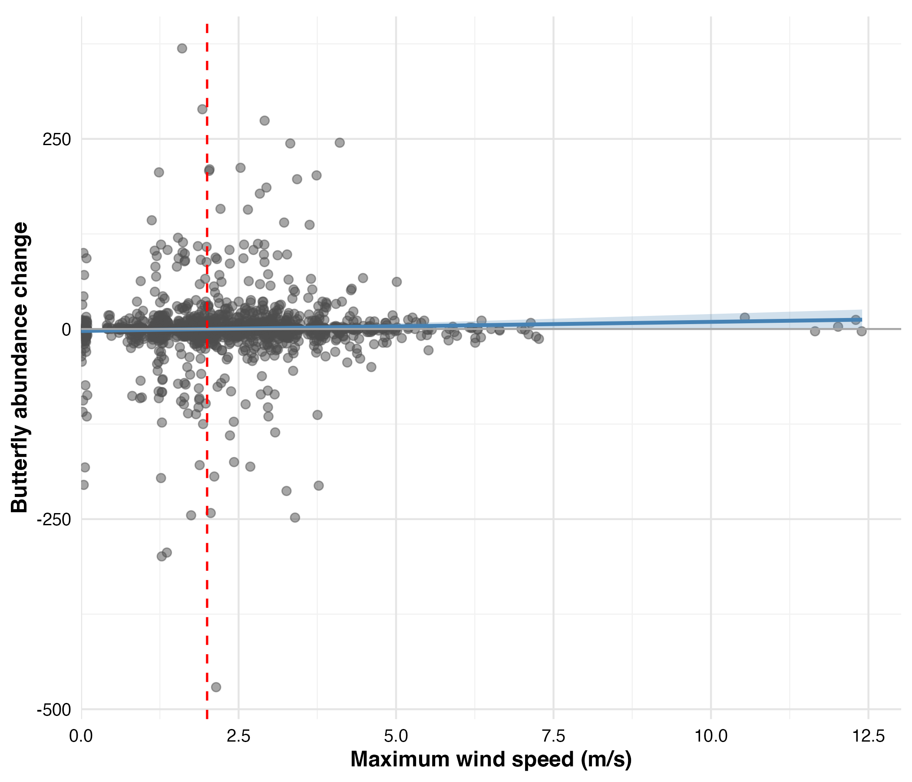
Figure 3.1. Maximum wind speed vs.CiBAI (30-minute window). Linear regression of maximum wind speed and CiBAI at 30-minute intervals. Each point represents a paired observation (n = 1,894) of abundance (or CiBAI) over a 30-minute interval. Positive values denote an increase in abundance, and negative values denote a decrease. Linear regression showed no significant relationship ($β$ = 1.19, SE = 0.66, p = 0.073, r = 0.041, $R^{2}$ = 0.002). The red dashed line indicates the proposed 2 m/s behavioral threshold. The blue regression line is shown for reference despite non-significance.
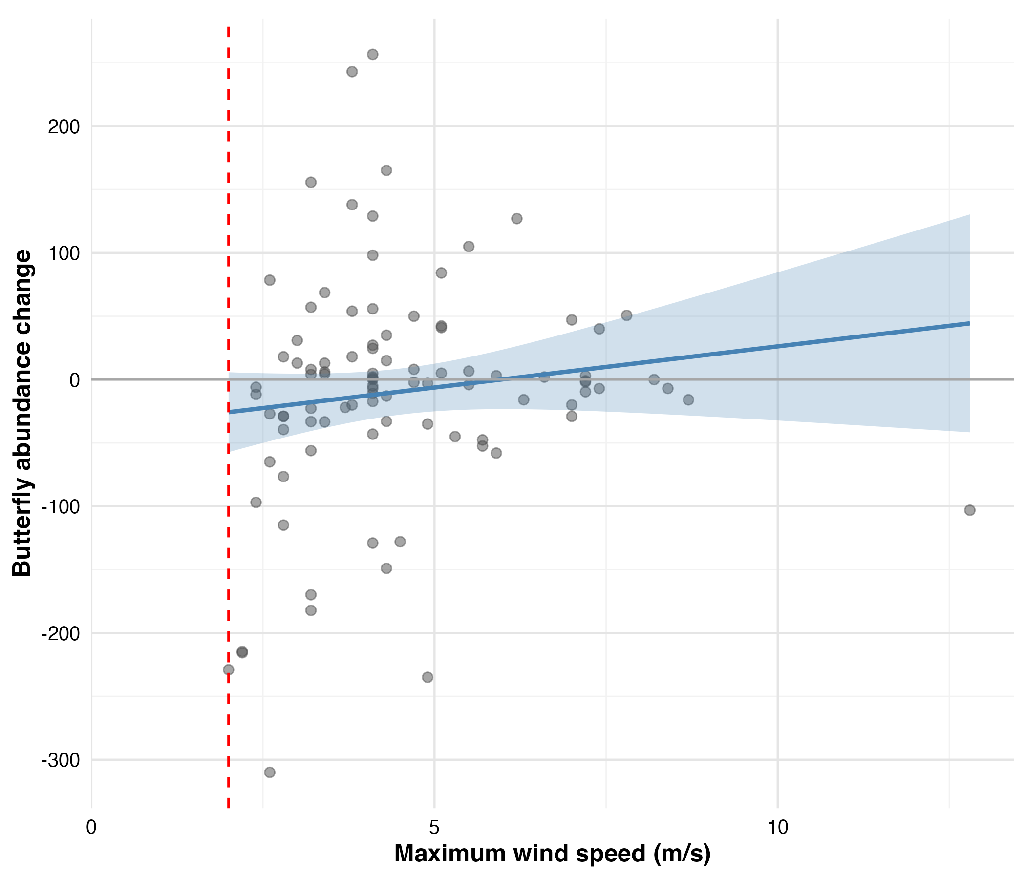
Figure #. Maximum wind speed vs.CiBAI (sunset-window). Linear regression of maximum wind speed and sunset-window time interval which is the CiBAI from maximum BAI to the next day’s sunset BAI (see methods). Positive values denote an increase in abundance, and negative values denote a decrease. $β$￼$R^{2}$￼￼ = 0.013). The red dashed line indicates the 2 m/s threshold. All observations experienced winds exceeding this threshold. The blue regression line is shown for reference despite non-significance.

Wind Disruption Analysis
To examine more complex environmental interactions and conditional relationships that may modulate how monarchs respond to wind effects and other immediate environmental conditions, we analyzed 1,894 paired observations collected at 30-minute intervals throughout the overwintering season. This responsive change analysis tested whether short-term fluctuations in cluster size (CiBAI) could be explained by concurrent weather variables.

Model Selection: 30-Minute Analysis
We evaluated 52 candidate models using generalized additive mixed models (GAMMs) to identify potential environmental predictors of monarch abundance changes (CiBAI). Model selection via AIC identified the decisively best-fit model (M50), capturing 85.8% of the total model weight (Table 3.1). The next best model (M23) showed substantially weaker support with $Δ$AIC = 3.8 and only 12.6% model weight.
Table #. Top 5 models ranked by AIC (30-minute window) of environmental predictors of CiBAI.
Model | Terms | AIC | $Δ$AIC | Weight
M50 | Previous butterfly count, Temperature, Time since sunrise, Interaction (tensor): Maximum wind speed, Butterflies in direct sun | 8074.03 | 0.00 | 0.86
M23 | Previous butterfly count, Temperature, Butterflies in direct sun, Time since sunrise | 8077.86 | 3.83 | 0.13
M22 | Previous butterfly count, Temperature (linear), Butterflies in direct sun, Time since sunrise | 8082.90 | 8.87 | 0.01
M24 | Previous butterfly count, Maximum wind speed, Temperature, Butterflies in direct sun, Time since sunrise | 8084.05 | 10.02 | 0.01
M52 | Temperature, Time since sunrise, Interaction (tensor): Maximum wind speed, Butterflies in direct sun | 8092.72 | 18.69 | 0.00

Analysis of Best Fit Model
The best-fit model (M50) from the 30-minute wind disruption analysis predicted CiBAI as a function of: (1) the previous 30-minute observation’s BAI, (2) average 30-minute temperature, (3) time of day (minutes since sunrise), and (4) a tensor interaction between maximum wind gust speed and the number of butterflies in direct sunlight. Statistical analysis of this responsive change model revealed significant effects for three of the four predictors (Table 3.2). The previous butterfly count (F = 12.50, p $<$ 0.001), time of day (F = 9.85, p $<$ 0.001), and the wind-sunlight interaction (F = 4.67, p $<$ 0.001) all showed strong statistical significance. Temperature effects approached but did not reach conventional significance thresholds (F = 3.19, p = 0.057). The model only explained 6.4% of the variance in CiBAI (adjusted $R^{2}$ = 0.064, n = 1894).
Summary of best-fit model (M50).
Smooth Term | edf | Ref.df | F | p-value
Previous butterfly count | 2.41 | 2.41 | 12.50 | $<$ 0.001***
Average temperature | 3.68 | 3.68 | 3.19 | 0.057
Time since sunrise | 4.87 | 4.87 | 9.85 | $<$ 0.001***
Wind gust × Sunlight exposure | 7.35 | 7.35 | 4.67 | $<$ 0.001***
Model performance: Adj. $R^{2}$ = 0.064, Scale est. = 4.03, n = 1894
Partial effects for the smooth terms, which represent the isolated influence of each predictor while holding other variables constant at their mean, are shown in Figure 3.3. The previous butterfly count (BAI) showed a significant non-linear negative relationship (p $<$ 0.001) consistent with proportionally greater departures from larger aggregations. Time of day captured a significant diurnal pattern (p $<$ 0.001) with morning departures (reductions in BAI) and afternoon returns (increases in BAI). Temperature showed a marginally non-significant trend (p = 0.057) suggesting possible effects near the 12.7–16°C flight threshold range.
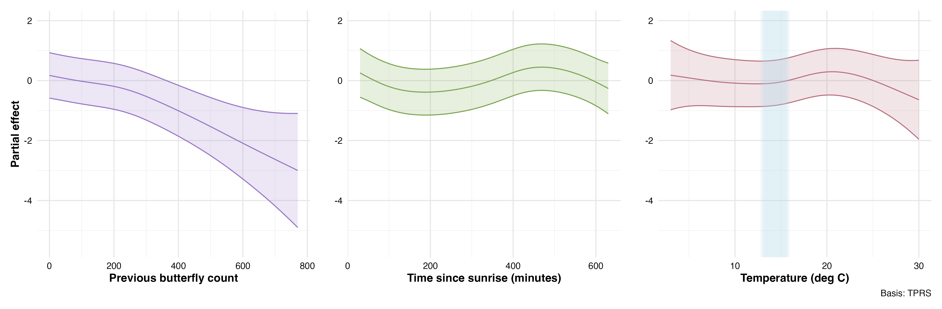
Figure #. Partial effects for best fit wind disruption model. (30-minute window). Partial effects of environmental predictors on CiBAI from the best-fit GAMM model (M50) in the 30-minute wind disruption analysis. Partial effects show how each environmental factor influences butterfly abundance while holding all other variables constant, thus isolating each predictor’s individual contribution to the response. Shaded regions represent 95% confidence intervals. The blue vertical shading in the right panel shows the range of temperatures over which the flight threshold occurs.

The tensor interaction between wind speed and butterflies in direct sun (p $<$ 0.001) revealed a complex conditional relationship where wind effects on CiBAI depended on solar exposure conditions. Bivariate heat maps (Figure 3.4) show the combined response to wind and light by monarchs that were present in the clusters. When none of the butterflies present were in direct sun (Figure # origin of ordinate), CiBAI showed no consistent trend (blue or red) across the observed wind speed range (0–12 m/s). Conversely, when wind was held constant and low (near origin of abscissa Figure #), low numbers of butterflies in direct sun (<50) were associated with decreasing cluster sizes (blue or negative CiBAI values in Figure #), while larger cluster sizes (~100-150) led to increasing in size (red or positive CiBAI values in Figure #). At higher counts of butterflies in sun (e.g.: $>$100) and considering wind: in wind <1 m/s clusters increase, then decrease in winds between 2 and 3 m/s, and then the pattern reverses and cluster sizes increase when wind speeds exceeded 3 m/s .￼The red dashed line at 2 m/s indicates the proposed behavioral threshold, which does not seem to be a boundary or threshold when wind and light are considered simultaneously. Gray regions mask areas too distant from observed data points for reliable interpretation, and caution is warranted when interpreting the strongest partial effects at the edges of the data distribution because observations are sparse and interpolation artifacts may occur. Notably, the overwhelming majority of observations occurred at low counts of butterflies in direct sun, emphasizing that most clustering behavior happens in indirect light.
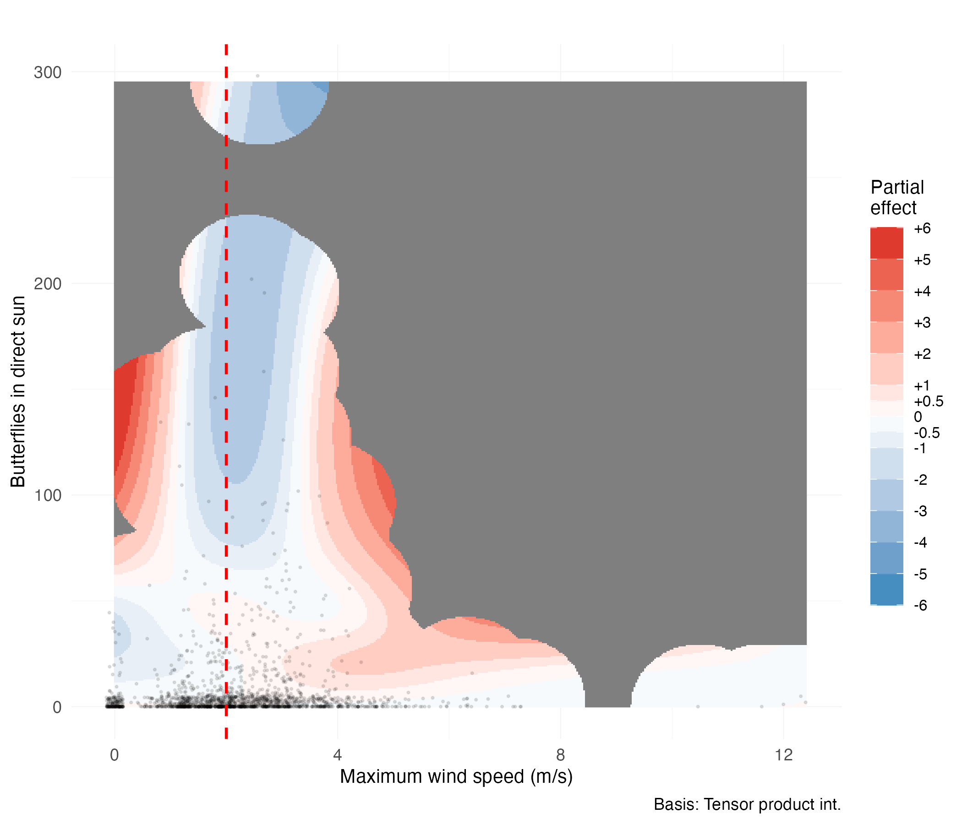
Figure #. CiBAI response to interaction of wind and direct sun (30-minute window). Tensor smooth interaction between maximum wind speed (m/s) and the count of butterflies in direct sun on change in butterfly abundance index (CiBAI) in the 30-minute time windows. Color gradient indicates partial effects magnitude on CiBAI (red = positive, blue = negative). Black points show observed data distribution. Red dashed line marks the 2 m/s behavioral threshold. Gray regions indicate areas beyond reliable interpolation range.

Model Diagnostics
Model diagnostic plots confirmed the adequacy of the GAMM specification (Figure 3.5) for the best fit model. The quantile-quantile plot revealed approximately normal residual distribution with minor deviations in the tails. Residual versus fitted value plots showed no systematic patterns or heteroscedasticity.
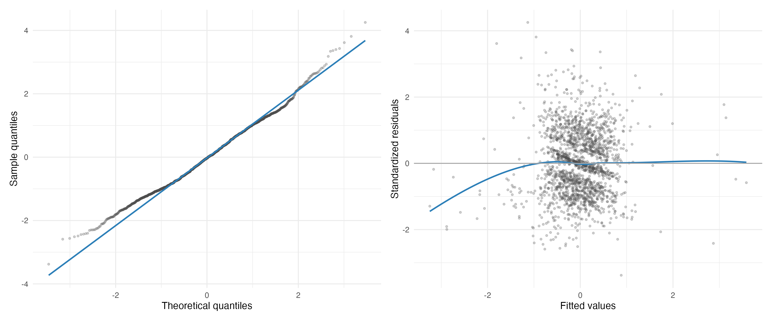
Figure #. Quantile-quantile and residual plots for the best fit 30-minute wind disruption model. Quantile-quantile plot (left panel) comparing model residuals to theoretical normal distribution. Residuals versus fitted values (right panel) assess homoscedasticity and model adequacy.
Basis dimension checks confirmed adequate smoothing parameter selection for all model terms (Table 3.3). All smooth functions showed k-index values near 1.0, indicating sufficient basis dimensions to capture the underlying functional forms. None of the smooth terms showed evidence of undersmoothing (all p-values $>$ 0.05), with the possible exception of time within day which showed marginal evidence (k-index = 0.96, p = 0.065). These diagnostics confirm that overall, chosen basis dimensions adequately represent the complexity of the relationships without overfitting.
Table #. Basis dimension adequacy checks for the best fit 30-minute wind disruption model.
Smooth Term | k’ | edf | k-index | p-value
s(total butterflies $t_{lag}$) | 9.00 | 2.41 | 1.00 | 0.735
s(temperature avg) | 9.00 | 3.67 | 1.02 | 0.895
s(time within day $t$) | 9.00 | 4.87 | 0.96 | 0.065
ti(max gust, butterflies direct sun $t_{lag}$) | 16.00 | 7.35 | 0.99 | 0.490
Temporal autocorrelation analysis revealed minimal residual correlation structure after accounting for the AR(1) correlation within deployment-day time series (Figure 3.6). The rapid decay of autocorrelation function and all lags beyond lag 1 falling within the significance bounds, confirms the model adequately captured appropriately addressed the repeated measures nature of the time-series observations.

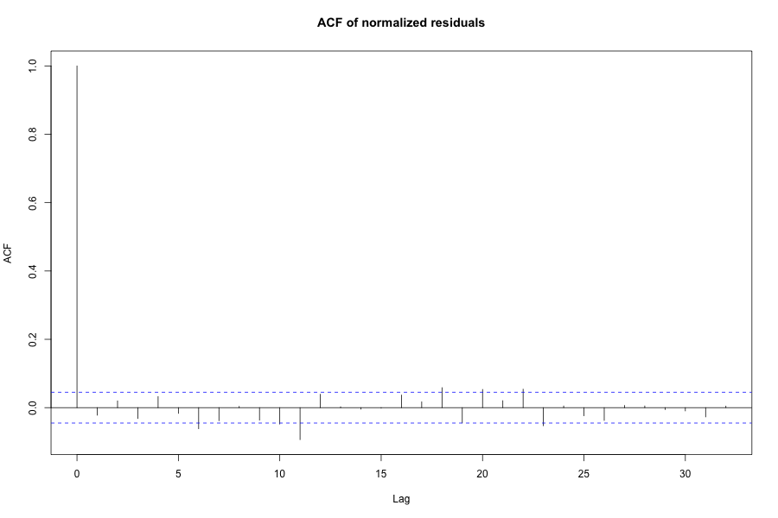
Figure #. Autocorrelation function for best fit 30-minute wind disruption model. Autocorrelation function of model residuals showing minimal temporal correlation after accounting for AR(1) structure within deployment-day time series. Blue dashed lines indicate 95% confidence bounds for white noise.

Threshold Wind Disruption Analysis
To determine whether wind is best characterized as a continuous variable or a binary disruption threshold, regardless of operating independently or conditionally on other factors, we used the wind predictor “minutes above 2 m/s” within the 30-minute analysis framework. This threshold-based approach directly tests our second hypothesis that wind becomes disruptive above the 2 m/s threshold. The best threshold model (T50) maintained the same structure as our primary analysis (Table 3.4). While T50 achieved the lowest AIC it: captured only 55.4% of model weight compared to 40.4% for model T23 without any wind term, was as plausible as model T23 give a ￼$Δ$, and showed explanatory power (adjusted ￼$R^{2}$) compared to the original non-threshold (0.064) model (M50 above). This suggests that the threshold approach does not improve the characterization of wind effects. Notably, the interaction term between minutes above threshold and butterflies in direct sun achieved statistical significance (p = 0.0001). This suggests that while the threshold approach does not improve the characterization of wind effects, the interaction between wind (as continuous or discrete variable) and solar exposure warrants examination.
Table #. Top 5 models ranked by AIC (30-minute threshold analysis).
Model | Terms | AIC | $Δ$AIC | Weight
T50 | Previous butterfly count, Temperature, Time since sunrise, Interaction (tensor): Minutes above 2 m/s, Butterflies in direct sun | 8077.23 | 0.00 | 0.55
T23 | Previous butterfly count, Temperature, Butterflies in direct sun, Time since sunrise | 8077.86 | 0.63 | 0.40
T22 | Previous butterfly count, Temperature (linear), Butterflies in direct sun, Time since sunrise | 8082.90 | 5.67 | 0.03
T24 | Previous butterfly count, Minutes above 2 m/s, Temperature, Butterflies in direct sun, Time since sunrise | 8085.41 | 8.18 | 0.01
T47 | Temperature, Butterflies in direct sun, Time since sunrise | 8097.30 | 20.07 | 0.00

While we do not consider the parameter estimation results from the best fit threshold model, we present them here for completeness. The interaction partial effects plot from the 30-minute threshold analysis reveals complex conditional relationships between wind exposure duration above threshold and solar conditions (Figure 3.7). For example, when all butterflies are in indirect light (no butterflies in direct sun), CiBAI shows no apparent trend across the entire time range of wind exposure duration (0 to 30 minutes above threshold). This suggests that wind effects on shaded butterflies are minimal regardless of the duration of wind exposure above threshold. But as the counts of butterflies in direct sun increase, distinct patterns emerge. At a moderate count of butterflies in direct sun (~100), cluster sizes tend to decrease when wind exposure extends from 20-25 minutes above threshold but tend to increase as sustained wind exposure approaches 30 minutes (our observational limit). Thus, the strongest effects appear at intermediate to higher wind exposure durations (20-30 minutes) combined with moderate solar exposure levels. The same caveats apply regarding the grey portions of Figure # and regarding sparse data at the extremes and limits of interpolation, particularly given that most observations occurred at low butterfly counts in direct sun.
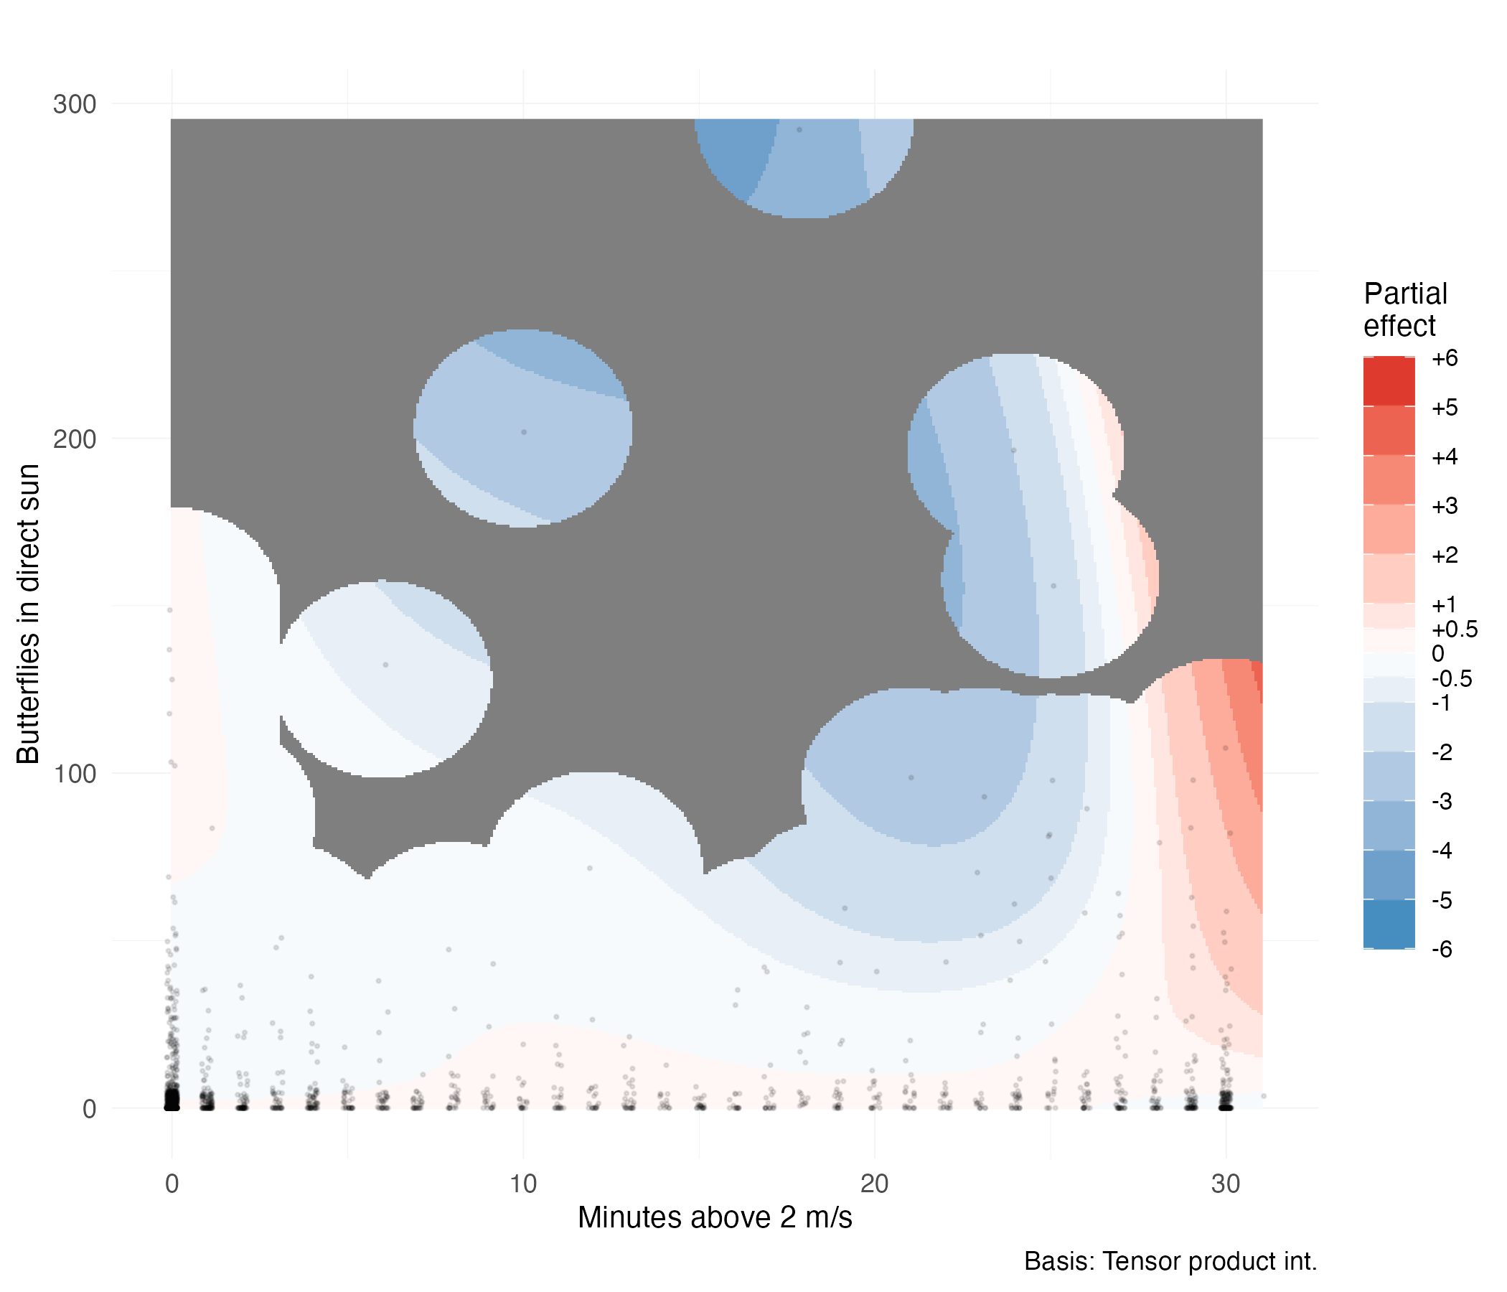
Figure #. CiBAI response to interaction of wind and direct sun (30-minute threshold analysis). Tensor smooth interaction between minutes above 2 m/s wind threshold and the count of butterflies in direct sun on CiBAI. Color gradient indicates partial effect magnitude (red = positive, blue = negative) on CiBAI. Black points show observed data distribution. Gray regions indicate areas beyond reliable interpolation range.

Statistical Power to Detect Wind Effects
Post-hoc power analysis indicate that 1,894 paired observations achieved 98.5% power to detect larger effects (0.20 standard deviations), 87.5% power to detect moderate effect sizes (0.15 standard deviations), 56% power for small effects (0.10 standard deviations), but only 16.5% power for very small effects (0.05 standard deviations). These results confirm sufficient statistical power for effect sizes of biological relevance (Table 3.5).
Table #. Statistical power to detect wind effects.
 | Effect Size (SD units) | Power (Proportion) | Power (%)
0.05 | 0.05 | 0.165 | 16.5%
0.1 | 0.10 | 0.560 | 56%
0.15 | 0.15 | 0.875 | 87.5%
0.2 | 0.20 | 0.985 | 98.5%

Sunset Window and Site Fidelity Analysis
As noted, in the 30-minute interval analysis we assume butterflies can respond to unfavorable conditions over that interval. This assumption may not hold when temperatures fall below the flight threshold, or when shivering is too physiologically expensive, or when clustering decisions occur on a longer temporal horizon. Meaning there could be an apparent lag in response (CiBAI). To address these limitations, we examined 96 consecutive-day pairs using a variable time interval spanning from the previous day’s maximum BAI to the consecutive day’s last observation at sunset (mean duration = 29.6 hours). This approach tests whether cumulative weather exposure over a longer interval is what actually influences CiBAI. Inadvertently, it is also a test of site fidelity decisions over the course of two evening: if butterflies leave a cluster, they could choose to return or not by the following day’s sunset. Returning would boast or maintain the maximum ABI at sunset; not returning would lower it. A secondary analysis (below) using a standard 24-hour window (n = 94 pairs) provided a sensitivity test of our findings.
Daily maximum BAI per cluster ranged from 0 to 770 butterflies (mean = 134.7 ± 138.1), with sunset-window changes in maximum BAI ranging from losses of 376 butterflies to gains of 464 butterflies (mean change = -10.5 ± 111.6). Maximum interval wind gusts ranged from 2.0 to 12.8 m/s (mean = 4.5 ± 1.8 m/s), with all intervals exceeding the proposed 2 m/s threshold. Cumulative direct sun exposure varied from 0 to 1,122 butterflies observed per interval (mean = 139.8 ± 206.9), reflecting diverse thermal exposure conditions across monitoring days.

Model Selection: Sunset Window and Site Fidelity Analysis
We evaluated 78 candidate models using generalized additive mixed models (GAMMs) to identify environmental predictors of changes in maximum BAI from one day to the consecutive day’s sunset. The model space included null, single-predictor, interaction-only, additive, main effects with interactions, and complex formulations, all incorporating deployment random intercepts and AR(1) temporal correlation. Model selection via AICc identified the best-fit model (M32) as capturing 84.7% of the total model weight (Table 3.6). The next best model showed substantially weaker support with $Δ$AICc = 5.6 and only 5.2% model weight. The best-fit model predicted square-root transformed change in BAI as a function of: (1) the previous day’s maximum butterfly count, (2) window duration in hours, and (3) a tensor smooth interaction between maximum wind gust speed and cumulative butterflies in direct sunlight.
Table #. Top 5 models ranked by AICc (sunset window and site fidelity analysis).
Model | Terms | AICc | $Δ$AICc | Weight
M32 | Interaction (tensor): Maximum wind gust, Cumulative butterflies in direct sun | 648.85 | 0.00 | 0.85
M52 | Maximum wind gust, Cumulative butterflies in direct sun, Interaction (tensor): Maximum wind gust, Cumulative butterflies in direct sun | 654.45 | 5.60 | 0.05
M20 | Interaction (tensor): Minimum temperature, Cumulative butterflies in direct sun | 656.77 | 7.92 | 0.02
M46 | Maximum temperature, Cumulative butterflies in direct sun, Interaction (tensor): Maximum temperature, Cumulative butterflies in direct sun | 657.70 | 8.85 | 0.01
M30 | Interaction (tensor): Temperature at previous maximum count, Cumulative butterflies in direct sun | 657.90 | 9.06 | 0.01

Analysis of Best Fit Model
The sunset window/site fidelity model explained 39.7% of the variance in maximum$R^{2}$ (adjusted ￼ = 0.397, n = 96), representing over a six-fold improvement in explanatory power compared to the 30-minute continuous (adjusted ￼ = 0.064) and threshold (adjusted R2 = 0.061) analyses. This strongly suggests that cumulative weather exposure over day-long periods is more strongly associated with roosting decisions than immediate short-term conditions. Analysis revealed significant effects on CiBAI for the previous day’s maximum BAI (F = 24.88, p $<$ 0.001) and the wind-sunlight interaction (F = 4.10, p $<$ 0.001). In addition, the partial effects of the previous day’s maximum BAI showed a significant negative linear relationship with maximum (coefficient = -0.030, SE = 0.006, ￼￼￼). Meaning that larger clusters experienced proportionally greater losses between days (as found in the 30-minute analysis). Window duration showed no significant relationship with (￼￼.

Table A. Summary of best-fit models for sunset window and fidelity analysis.
Smooth Term | edf | Ref.df | F | p-value
Previous day maximum count | 1.00 | 1.00 | 24.88 | $<$ 0.001***
Window duration | 1.00 | 1.00 | 1.14 | 0.289
Wind gust × Sunlight exposure | 6.68 | 6.68 | 4.10 | $<$ 0.001***
Model performance: Adj. $R^{2}$ = 0.397, Scale est. = 41.06, n = 96

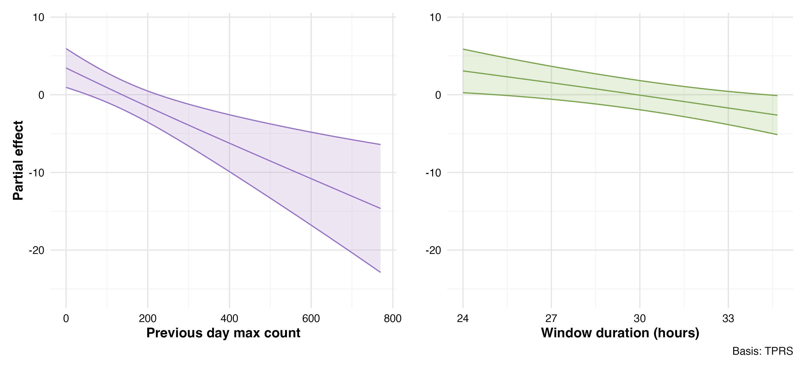
Figure #. Partial effects of control variables in best fit sunset-window model. Partial effects of control variables on sunset-window time interval on monarch butterfly maximum CiBAI from the best-fit GAMM model (M32). Partial effects isolate how each variable influences BAI changes while holding other factors constant at their average values. Left panel shows the strong negative effect of previous-day maximum BAI. Right panel shows window duration with no significant effect on cluster BAI changes. Shaded regions represent 95% confidence intervals.
In the sunset-window and site fidelity analysis, the tensor smooth interaction between maximum wind gust and cumulative direct sun exposure (p $<$ 0.001) revealed complex conditional relationships (Figure 3.9). For example, under low wind gust speeds around 2 m/s and low butterfly counts (<60-70) in direct sun, BAI increased the following day. Yet under low wind gust speeds (~2 m/s), and higher butterfly counts (>100) this pattern reversed, resulting in decreased BAI. And at intermediate to high values of both wind gust speed and butterfly sun exposure, cluster sizes (BAI) increased the next day. These patterns suggest monarchs redistribute within the grove, moving from unfavorable wind and light conditions (blue regions showing cluster decreases) to more favorable wind and light conditions (red regions showing cluster increases) in complex but predictable ways. This movement may occur between researcher monitored and unmonitored areas of the grove or involve butterflies entering or leaving the site. Again, interpretation requires caution at interpolation boundaries and regions with single or low observations.
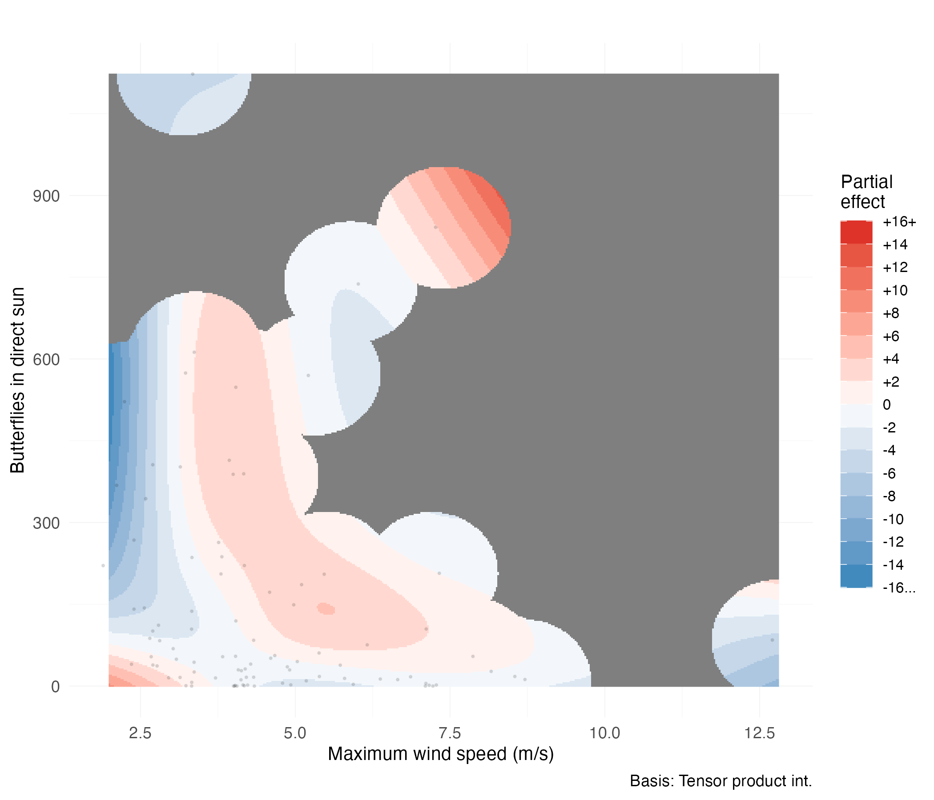
Figure #. CiBAI response to interactions of wind and sun exposure (sunset-window). Tensor smooth interaction between maximum wind gust (m/s) and cumulative butterflies in direct sun on day-to-day cluster size changes (CiBAI). Color gradient indicates partial effect magnitude on square-root transformed scale (red = positive, blue = negative). Black points show observed data distribution. Gray regions indicate areas beyond reliable interpolation range.

Model Diagnostics
The quantile-quantile plot revealed approximately normal residual distribution with some minor deviations (Figure 3.10). Residual versus fitted value plots showed no systematic patterns or heteroscedasticity, indicating appropriate model structure (Figure 3.10). Basis dimension checks confirmed adequate smoothing parameter selection for the tensor smooth interaction term. The wind-sunlight interaction showed a k-index value of 1.06 (p = 0.72), indicating sufficient basis dimensions to capture the underlying functional form without evidence of undersmoothing. Temporal autocorrelation analysis revealed minimal residual correlation structure after accounting for the AR(1) correlation within deployment days (Figure 3.11). The autocorrelation function showed rapid decay with all lags beyond lag 1 falling within the significance bounds.

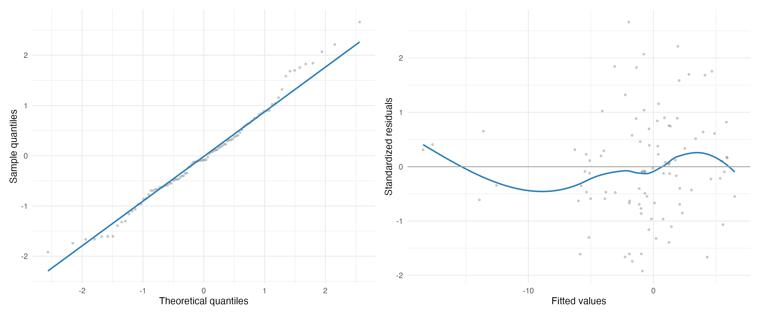
Figure #. Quantile-quantile and residual diagnostic plot for best fit sunset-window model. Diagnostic plots for the best-fit GAMM model (M32) of the sunset-window analysis. Left panel shows quantile-quantile plot comparing model residuals to theoretical normal distribution. Right panel displays residuals versus fitted values to assess homoscedasticity and model adequacy.
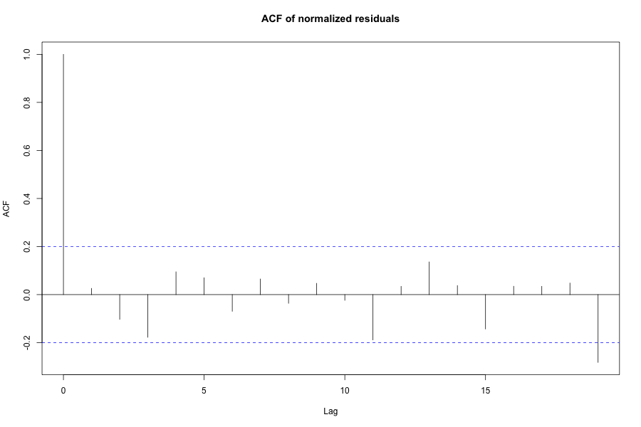
Figure #. Autocorrelation function for best fit sunset window model. Autocorrelation function of model residuals showing minimal temporal correlation after accounting for AR(1) structure within deployment days. Blue dashed lines indicate 95% confidence bounds for white noise.

Robustness Analysis: 24-Hour Change in BAI
To assess the robustness of our sunset-window and site fidelity findings, we conducted an analysis examining butterfly cluster changes over 24-hour periods rather than sunset-specific intervals. This analysis evaluated the same 76 candidate models using identical GAMM specifications with deployment random intercepts and AR(1) temporal correlation. Notably, model selection converged on the same structural form as the primary sunset-window/site fidelity analysis. The decisive best-fit model (M31), incorporating a tensor smooth interaction between maximum wind gust and cumulative direct sun exposure, emerged with 50.7% of the total model weight (Table 3.8). Alternative models showed substantially weaker support, with the next best model achieving only 8.4% weight and $Δ$AICc = 3.6.
Table #. Top models from 24-hour robustness analysis.
Model | Description | AICc | $Δ$AICc | Weight | adj. $R^{2}$
M31 | Wind $×$ sun exposure (smooth) | 636.3 | 0.0 | 0.507 | 0.235
M23 | Temperature $×$ wind (smooth) | 639.9 | 3.6 | 0.084 | –
M29 | Temperature $×$ sun exposure (smooth) | 640.8 | 4.4 | 0.056 | –
M19 | Min. temp. $×$ sun exposure (smooth) | 641.1 | 4.8 | 0.047 | –
M51 | Wind + sun + wind$×$sun (smooth) | 641.7 | 5.4 | 0.034 | –
The 24-hour robustness analysis revealed qualitatively similar interaction patterns to the sunset-window site fidelity analysis, though with attenuated effect magnitudes (Figure 3.12). For example, under low wind gust speeds around 2 m/s and low butterfly counts (<60-70) in direct sun, BAI increased the following day. Yet under low wind gust speeds (~2 m/s), and higher butterfly counts (>100) this pattern reversed, resulting in decreased BAI. And at intermediate to high values of both wind gust speed and butterfly sun exposure, cluster sizes (BAI) increased the next day. The convergent model selection and consistent interaction patterns across standardized (24hr) and variable scales strengthen confidence in the tested environmental interrelationships. This is also consistent with window duration showing no significant relationship with maximum CiBAI (Figure 3.8) in the sunset-window analysis. Pattern interpretation requires similar caution near data boundaries and regions with sparse observations.
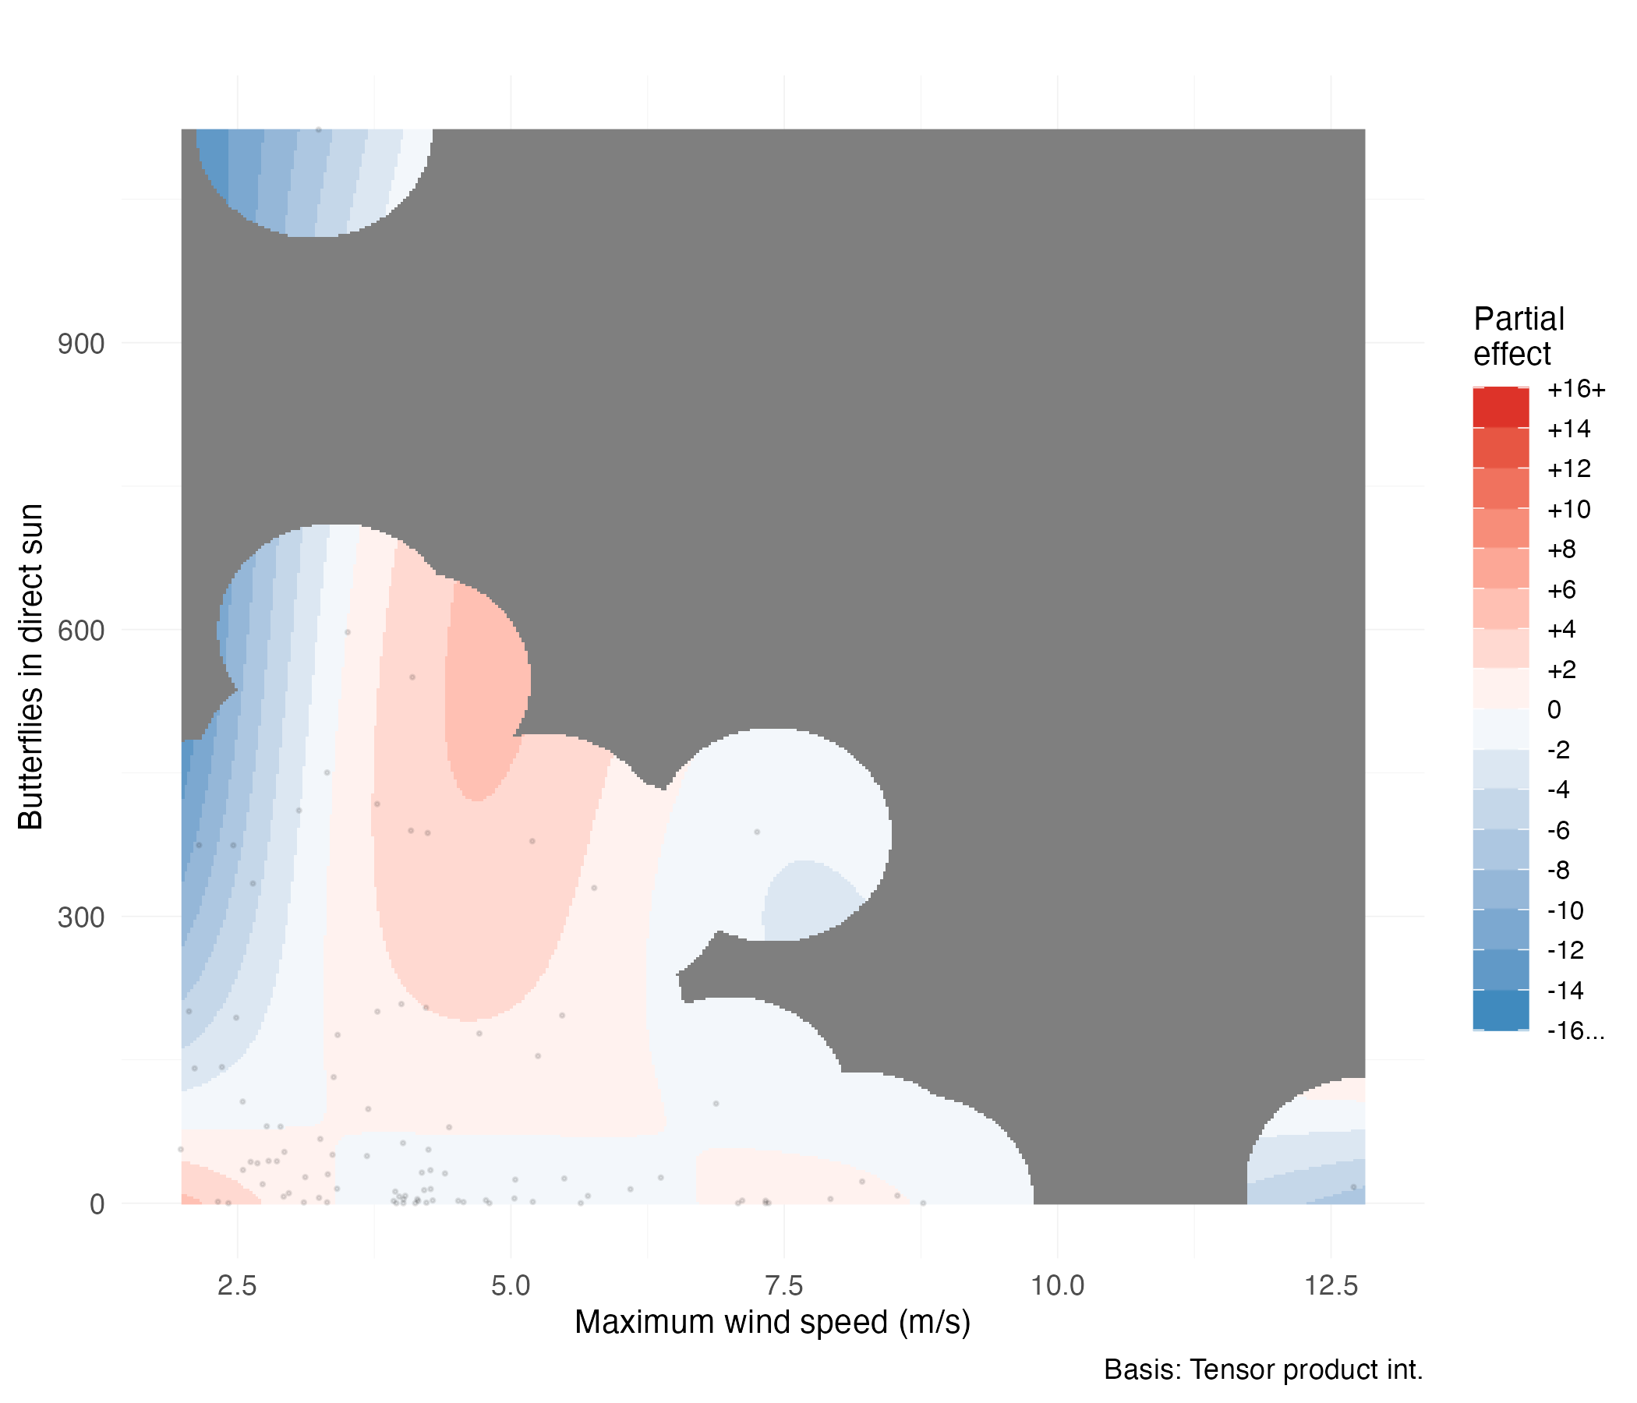
Figure #. CiBAI response to interactions of wind and sun exposure over 24-hours. Tensor smooth interaction between maximum wind gust (m/s) and cumulative butterflies in direct sun on 24-hour cluster size changes (CiBAI). Color gradient indicates partial effect magnitude on square-root transformed scale (red = positive, blue = negative). Black points show observed data distribution. Gray regions indicate areas beyond reliable interpolation range. The interaction pattern mirrors that observed in the sunset-specific analysis, supporting the robustness of identified environmental relationships.

Discussion
For over three decades, conservation practice has operated under the assumption that wind speeds exceeding 2 m/s force butterflies to abandon their roosts, either by physically dislodging them or triggering behavioral avoidance (Kingston L. H. Leong 1999, 2016, Xerces Society 2016; S. Jepsen et al. 2017; E. Pelton 2020; Stuart B. Weiss and Rich 2008; Althouse & Meade, Inc. and Creekside Science 2023.). Our empirical assessment of the Disruptive Wind Hypothesis tested predictions made under this hypothesis: a) that wind would emerge as a significant predictor of change in overwintering cluster size, b) that cluster size would decline at roosts experiencing winds exceeding 2 m/s, c) that cluster size decline would be proportional to wind speeds increases over 2m/s, d) and that disruptive winds decrease cluster site fidelity manifested as cluster size reductions over consecutive days. Our findings reject the predictions of the Disruptive Wind Hypothesis. Though there does appear to be a ’wind effect,’ it is not at 2 m/s; it is not a threshold; it is not a sole effect; it exists only in combination with direct sunlight. Therefore, we find that maximum wind speed and exposure to direct sunlight interact and scale in complex ways, with other factors, including time of day, previous overwintering cluster size, and potentially temperature also having predictive power. Ibsen et al. (2026) have also come to this conclusion regarding climatic variables; shade and wind are key explanatory variables.

Evidence Against Wind Disruption
We tested the most basic prediction of the Disruptive Wind Hypothesis, that increasing wind speed should produce decreasing cluster sizes. We found essentially no correlation at either temporal scale (30-minute $R^{2}$ = 0.002, n = 1,894; two sunset cycles $R^{2}$ = 0.013, n = 96) across wind speeds ranging from calm to six times the proposed threshold.
Modeling revealed that wind alone showed no disruptive effect. Instead, monarch responses were a complex interaction of wind and solar exposure. This interaction showed significance $<$￼ 0.001; two sunset cycles$<$￼ 0.001). Indeed, wind effects depended entirely on light conditions. For butterflies in shade, wind speed (0 to 12.4 m/s) had no effect on cluster dynamics. Yet once butterflies occurred in sunlit positions, relationships became complex and conditional.
Strikingly, every observation period over the two sunset cycle experienced maximum wind speeds that exceeded 2 m/s (range: 2.0–12.8 m/s), yet monarch clusters persisted throughout the 78-day study period. If the Disruptive Wind Hypothesis were correct, we should have observed either mass departures when temperatures permitted flight or butterflies physically dislodged and littering the ground when too cold to fly (K. L. H. Leong 1999). We observed neither.

Thermoregulation as an Alternative Explanation
Empirical testing has gradually rejected the Microclimate Hypothesis’ prediction that overwintering western monarch butterflies have a uniform set of microclimate requirements (Fisher et al. 2024; Saniee and Villablanca 2022; Ibsen et al. 2026, and herein). Rejection of the Microclimate Hypothesis has pointed to the alternative hypothesis that monarch overwintering habitat utilization is driven by physiological and energetic constraints interacting with local conditions (Fisher et al. 2024; Saniee and Villablanca 2022, herein). None of this work has specifically tested physiological and energetic constraints or the thermic and convective environment. But all of it points to the physiological and energetic constraint hypothesis proposed by Chaplin and Wells (1982) and Masters et al. (1988). Here we briefly summarize salient features of the physiological and energetic constraint hypothesis, while acknowledging that we did not attempt to explote this parameter space either .
Masters et al. (1988) demonstrated that cold monarchs actively seek sun. The seeking allows warming from below flight threshold (12.7°C) to well above it within one minute. Solar basking is effective from ambient temperatures as low as 9°C (ibid.). This is inferred to provide an energetic advantage over the alternative warming mechanism, as Kammer (1970) showed that shivering requires 25 to 31 times more energy than resting. However, Masters et al. (1988) also found that monarchs avoid sun when thoracic temperatures approach 30°C. They conclude that monarchs depart sunny cluster sites to avoid overheating and excessive lipid depletion. These patterns, and the inferences that result from them, are what we refer to as the physiological and energetic constraint hypothesis. Here, we outline how the present work also points to the physiological and energetic constraint hypothesis, or possibly a physiological and energetic facilitation hypothesis.
Through modeling we find that time since sunrise (Kyle - include the significance stats here) and a diurnal pattern (30-minute F = 9.85, p 0.001) with morning departures (reductions in BAI) and afternoon returns (increases in BAI) (Figure#) are significant explanatory variables. This captures a diurnal pattern that has been consistently documented at California overwintering sites (Tuskes and Brower 1978; Chaplin and Wells 1982). Temperature showed a marginally non-significant effect herein (p = 0.057) (Figure), but a significant one in Saniee and Villablanca (2022). So, if we allow ourselves to interpret the pattern between BAI and temperature, we see departures (reductions in BAI) are associated with a short time since sunrise and a rise from the lowest temperatures sampled (Figure).
Physiologically, what would we predict from a combination of air temperature and sun exposure? We imagine an exclusive effect of heat transfer from air (that avoids shivering) when direct sun exposure is not an option (shade or cloudy). Conversely, we imagine that when clusters are exposed to the morning sun and a clear sky, for a sufficient duration (i.e.: one minute), the effect of low air temperatures would be irrelevant. Potentially, the duration of sun exposure required to reach flight temperature could be a function of ambient air temperature. But, overall, we would predict direct sun exposure to be a more significant term than air temperature. Direct sunlight changes thermal status much faster (Masters et al. 1988), could cause a larger absolute change in thermal state (Barker and Herman 1976), and could even cause thoracic temperature to exceed ambient temperature (Masters et al. 1988.). In summary, air temperature alone could define thoracic temperature (under shady conditions), could be preempted by direct sun (especially under cold sunny conditions), or could interact with sun exposure to define behavioral responses under intermediate conditions.
On the cooling side of the equation, there seems to be an obvious potential for a wind effect. The observed increase in cluster size at intermediate wind and sun levels (Figure#) could reflect a thermoregulatory balance where wind moderates the heating effects of sun exposure. Masters et al. (1988) observed that monarchs dissipate heat while gliding via airflow across their bodies. Similarly, wind could provide passive convective cooling to stationary butterflies. Riddell and Porter (2025) found that wind-driven convective cooling interacts strongly with solar radiation effects in terrestrial organisms. These hypothetical wind, sun, and temperature interactions are consistent with the literature and with a physiological and energetic constraint hypothesis. This hypothesis then leads to a number of interesting predictions.
This potential three-way interaction leads to one prediction that is counterintuitive under a Disruptive Wind Hypothesis. Butterflies may seek windier roosts. By not avoiding wind but instead seeking it they would be able to dissipate heat. This cooling mechanism might allow butterflies to utilize warmer locations in a grove, or to persist at a cluster site longer than they otherwise could. Wind could effectively offset solar heat gain or ambient heat load cancelling the need for departure. Interestingly, the absence of solar heat gain or ambient heat load would lead to another prediction that is counterintuitive under a Disruptive Wind Hypothesis. Monarchs may not avoid winds. Shaded butterflies would experience no solar heat gain, making wind-driven cooling less unnecessary and potentially explaining the absence of wind effects in shade (Figure). Finally, if our interpretation is correct, then we predict that under the warmest ambient conditions overwintering butterflies should be observed occupying shadier and windier sites in order to dissipate heat and conserve lipids.
If we combine convective wind dynamics, air temperature, direct sun exposure, shading and cloudiness, to the determination of thoracic temperature and lipid thermodynamics, then we begin to consider the parameters of a physiological and energetic constraint model that should better explain cluster dynamics than a Disruptive Wind model. We propose this as the next line of inquiry for understanding the dynamics of overwinter clustering relative to local environmental factors.

Limitations and Context
Several factors shape the interpretation of our findings. First, our data come from a single overwintering season (2023–2024) when the monarch population was low (Xerces Society 2025a, Ibsen et al. 2026). The 2024–2025 season saw near-complete absence of monarchs at our study sites, coinciding with the second-lowest overwintering population on record (Xerces Society 2025b). This absence prevented temporal replication but underscored the urgency of understanding overwintering ecology with the data we have.
Second, though we did not observe it, we do not dispute that wind can dislodge butterflies from a cluster. The wind disruption hypothesis was developed during an era of massive aggregations containing hundreds of thousands of individuals, where many butterflies attached only to other butterflies in multi-layered formations (Kingston L. H. Leong 1990; L. P. Brower et al. 2008). In contrast, our study observed relatively small clusters where a large proportion of clustering butterflies could maintain direct contact with eucalyptus substrates. If substrate attachment provides greater wind resistance than butterfly-to-butterfly attachment, wind might affect these different clustering configurations differently. It is thus possible that the Disruptive Wind Hypothesis may be more accurate for the extreme densities of past decades but less relevant to today’s smaller populations. Alternatively, the fact that we did not see dislodged butterflies even at wind speeds above 12m/s when branches were swinging wildly, leads us to suspect that there may be an unrecognized interaction between wind and near freezing temperature that facilitates dislodgement.
Finally, our models explained relatively little variance overall (30-minute 6.4%; two sunset cycles 39.7%), reflecting both the complexity of butterfly behavior and our focus on testing specific hypotheses rather than comprehensively explaining movement patterns. Regardless, the Wind Disruption Hypothesis predicts substantial observable impacts, not subtle ones. Our analyses achieved 87.5% power to detect moderate effects and 98.5% power for large effects. Our failure to detect effects, despite adequate power, validated methodology, and successful identification of other environmental predictors and interaction terms, provides strong evidence against the hypothesis rather than merely absence of evidence.

Unexplained factors of variation, resolution and replication
Our best models explained 39.7% of variance and suggested the existence of unaccounted for sources of variance. Here we identify possible sources of variation that we did not address. One is additional time intervals for predicting changes in the response variable (CiBAI). Given a sixfold increase in variance explained between the shorter and longer time frames, we suspect that further increases in time frame would allow for an explanation of more variance. Environmental factors that did explain variance were predominantly thermal in nature. Thermal factors seem to clearly play an important role in organizing clustering behavior. This, and the marginal lack of significance for temperature attributes, suggests that sampling over a greater range of temperatures would provide more information.
Beyond environmental factors, social dynamics may explain additional variance. The strong effect of previous butterfly count on CiBAI (figure #) suggests that monarchs exhibit statistically clumped spatial distributions. In spatial statistics, clumped or aggregated distributions are characterized by a higher variance relative to the mean (ref). This pattern is overdispersion, or a contagious distribution (FXV ref), and is common in aposematic overwintering species (FXV ref). A positive feedback mechanism, where initial settlement increases the probability of others joining, creates self-reinforcing (contagious) aggregation patterns independent of immediate environmental conditions (Berdahl et al. 2013). That monarchs form clusters thus suggests that modeling could incorporate clustering itself to help explain variance.
Finally, testing these patterns across the broader overwintering range would establish their generality while allowing the capture of both temporal and spatial variance. Sites with different tree species, latitudes, and especially population densities could reveal whether wind responses vary with clustering configuration or if our findings represent fundamental aspects of western monarch overwintering behavior.

Implications for Conservation
Our findings suggest that wind protection, long considered an essential environmental factor in overwintering monarch conservation, may constrain habitat suitability far less than previously believed. This realization carries important implications for how we understand, manage, and restore overwintering sites. Specifically, we contend that light and wind cannot interact in a positive manner if butterflies are not exposed to both. While butterflies exposed to negative interactions of light and wind would be expected to respond with compensatory avoidance reducing cluster size or cluster site fidelity.

Expanded Habitat Availability and Population Limitations
Are we observing limited suitable habitat for overwintering western monarchs? Or, with western monarch populations at historically low levels, is there a limit to the butterflies that can occupy suitable space? The absence of wind disruption despite frequent threshold exceedances indicates that suitable habitat within existing groves may be more extensive than currently recognized, at least at modern temperatures and population sizes. Therefore, groves previously dismissed due to wind exposure might support clusters under larger population conditions, simply because there would be butterflies to occupy them.

Simplified Management Requirements
Current management frameworks recommend protecting buffer zones around clustering sites. For example, Althouse & Meade, Inc. and Creekside Science (2023) recommended maintaining trees up to six tree-heights away from clustering locations to ensure adequate wind protection. This translates, for example, to protecting all trees within approximately 240 meters for mature trees 40 meters tall. Substantial complexity and potential management hurdles could derive in coastal California where overwintering sites often involve diverse stakeholders and contentious land use decisions. For example, at a major overwintering site in Pacific Grove, California, cluster trees are within meters of a neighborhood fenceline, and a cluster tree extends over the parking lot of a hotel (F.X.V. pers. obs.)
If wind protection plays a less critical role than assumed, these extensive buffer requirements may not be necessary. Trees adjacent to groves, considered essential for wind breaks, may contribute far less than currently thought. This simplification allows focusing conservation efforts on grove structure rather than on controlling wind in surrounding areas. More importantly, if light and wind (and maybe temperature) are all inter-related through butterfly thermal physiology, then a focus just on wind would be myopic. Likewise, all buffer trees may not have the same role. Saniee and Villablanca (2022) note that buffer trees to the southeast of a grove reduce storm winds but also early morning winter light.

Proactive Habitat Creation Through Canopy Management
The current practice of wind protection employs planting trees and waiting decades for maturation, and also the maintenance of healthy, mature specimens. If monarchs respond primarily to light and thermal patterns rather than strict wind thresholds, strategic canopy modification for light-based management might enable shorter-timeframe interventions.
Real-world examples support this possibility. Stuart B. Weiss et al. (1991) found that successful overwintering sites maintain consistent canopy openness around 20%, while unsuccessful sites show greater variability. At Monarch Lane in Los Osos, California, strategic canopy opening resulted in monarchs reoccupying an overwintering site (K. L. H. Leong 1999; Xerces Society 2025a). At Andrew Molera State Park in Big Sur, California, clearing an overgrown grove increased butterfly counts from zero to over one thousand (E. Pelton, pers. comm.). Conversely, tree planting at Pacific Grove required approximately 15 years of canopy maturation before monarchs returned (S. Weiss, pers. comm.). These patterns suggest that appropriate canopy structure, including carefully designed openings creating dappled light, can attract butterflies far more quickly than waiting for tree growth alone.
Unoccupied eucalyptus stands or overly dense groves might thus be converted to functional habitat through selective thinning. However, additional research is needed before implementing large-scale canopy modifications, particularly at established overwintering sites. Rather than passive waiting, managers might proactively create suitable conditions by strategically opening existing canopies at appropriate locations (for example previously occupied but currently unused sites), representing a significant departure from previous approaches that focused almost entirely on wind protection and tree growth. This additional approach might be thought of as site restoration and could increase resilience for overwintering monarch butterflies.

Long-term Optimism Despite Current Uncertainty
While this study reduces certainty regarding some aspects of overwintering ecology, the long-term trajectory points toward management practices that may be simpler to implement, are grounded in empirical evidence, and potentially are outright effective instead of simply somewhat effective. We conclude that the strict 2 m/s threshold created an overly constraining understanding of habitat requirements, while even suggesting suitable sites were limited. The long-term trajectory suggests managers could be offering more to overwintering monarchs than just wind abatement. Our results indicate that adding access to light and wind should provide significant thermoregulatory and energetic benefits. Likewise, Saniee and Villablanca (2022) suggest that managing canopy structure to create light and temperature gradients should provide significant thermoregulatory and energetic benefits. But if we can use the Disruptive Wind Hypothesis and the last 30 years as a cautionary tale, then clearly predictions from the physiological and energetic constraint hypothesis (sensu Chaplin and Wells (1982) and Masters et al. (1988)) should be rigorously tested.

Conclusions
Our direct test of the wind disruption hypothesis found no evidence that wind speeds above 2 m/s force overwintering monarchs to abandon their clusters. Every observation in our two sunset cycle analysis exceeded this threshold, yet clusters persisted. Linear regression analyses showed no relationship between wind and cluster changes. Model selection consistently identified other factors as more important. These multiple lines of evidence converge on a clear conclusion. Wind alone does not disrupt overwintering monarch butterflies as has been assumed for over three decades.
Instead, our results suggest that thermal factors may play a more important role in clustering dynamics than previously recognized. Monarchs responded strongly to direct sunlight which could directly influence body temperature. The unexpected wind-light interaction, where moderate wind combined with sun exposure sometimes increased cluster sizes, suggests that environmental conditions interact in complex ways that simple threshold-based management metrics cannot capture.
These findings arrive at a critical moment for monarch conservation. With western populations at historic lows, every assumption about habitat requirements deserves scrutiny. While questions remain about the precise mechanisms, our findings suggest that exploring a physiological and energetic constraint model will be useful, and demonstrate that current management guidelines based on wind speed thresholds are not supported by empirical evidence. Moving forward, conservation efforts should prioritize maintaining existing overwintering groves and restoring unoccupied sites or creating new sites. As we face the challenge of preserving overwintering habitat for a declining population, evidence-based understanding of monarch ecology becomes not just scientifically important, but essential for preserving the remarkable phenomenon of monarch migration in western North America.

Acknowledgements
This research benefited immensely from the “Super Study” group, whose many members provided excellent feedback and insights at all stages of my project, specifically Emma Pelton, Peter Ibsen, Jay Diffendorfer, Jessica Griffiths, Ashley Fisher, Sara Cuadra-Vargas, Charis van der Heide, Stephanie Little, and Ray Danner. Emma Pelton (Xerces) was instrumental in gathering Super Study experts, advancing funding, and initial study ideas. Peter Ibsen and Jay Diffendorfer (USGS) also provided funding and valuable feedback throughout. Jessica Griffiths (VSFB) helped secure access, select study sites, and interpret results. Ashley Fisher (Xerces) provided insights into monarch ecology and field support. Undergraduate research assistants Skyler Meinholz, Vincent Rios, Emery Doornbos, and Kevin Untalan conducted photo labeling and provided essential field assistance. LynneDee Althouse, Dan Meade, Stu Weiss, and Charis van der Heide, and collaborators at Althouse and Meade, Inc., contributed to the conceptual foundations. Funding support was provided by The Xerces Society for Invertebrate Conservation, US Forest Service International Programs, Department of Defense Legacy Resource Management Program, the United States Geological Survey, and the College of Science and Mathematics at California State University, San Luis Obispo. Finally, we dedicate this work to the memory of Dan Meade, who shared the fascinating mysteries of monarch butterflies and encouraged both of us to explore them. His patience, generosity, and belief in us will for ever be appreciated.

APPENDICES

30-Minute Wind Disruption Analysis: Candidate Models
This appendix documents all candidate models tested in the 30-minute wind disruption analysis. A total of 52 models were evaluated to identify the best-fitting model for predicting short-term changes in butterfly cluster presence based on weather conditions and direct sun exposure.

Model Structure
All models used Generalized Additive Mixed Models (GAMM) with the following structure:
- Response variable: $\sqrt[3]{Δ\text{Butterflies}}$ (cube root of butterfly count change between consecutive 30-minute intervals)
- Random effects: Random intercept for deployment site
- Correlation structure: AR(1) autocorrelation within observation days
- Estimation method: Restricted Maximum Likelihood (REML)

Variable Definitions
- total_butterflies_t_lag: Previous butterfly count (lagged)
- max_gust: Maximum wind gust speed (m/s)
- temperature_avg: Average temperature ($​^{∘}$C)
- butterflies_direct_sun_t_lag: Butterflies in direct sun (lagged)
- time_within_day_t: Time since sunrise (hours)
- s(): Thin-plate regression spline smooth term
- ti(): Tensor product interaction smooth
- *: Linear interaction term

Candidate Models
Complete list of 52 candidate models tested in 30-minute wind disruption analysis
Model | Formula
Model | Formula
M1 | total_butterflies_t_lag
M2 | total_butterflies_t_lag + max_gust
M3 | total_butterflies_t_lag + temperature_avg
M4 | total_butterflies_t_lag + butterflies_direct_sun_t_lag
M5 | total_butterflies_t_lag + max_gust + temperature_avg
M6 | total_butterflies_t_lag + max_gust + butterflies_direct_sun_t_lag
M7 | total_butterflies_t_lag + temperature_avg + butterflies_direct_sun_t_lag
M8 | total_butterflies_t_lag + max_gust + temperature_avg + butterflies_direct_sun_t_lag
M9 | total_butterflies_t_lag + max_gust * temperature_avg
M10 | total_butterflies_t_lag + max_gust * butterflies_direct_sun_t_lag
M11 | total_butterflies_t_lag + temperature_avg * butterflies_direct_sun_t_lag
M12 | total_butterflies_t_lag + max_gust * temperature_avg + butterflies_direct_sun_t_lag
M13 | total_butterflies_t_lag + max_gust * butterflies_direct_sun_t_lag + temperature_avg
M14 | total_butterflies_t_lag + temperature_avg * butterflies_direct_sun_t_lag + max_gust
M15 | total_butterflies_t_lag + max_gust * temperature_avg + max_gust * butterflies_direct_sun_t_lag + temperature_avg * butterflies_direct_sun_t_lag
M16 | total_butterflies_t_lag + max_gust * temperature_avg * butterflies_direct_sun_t_lag
M17 | s(total_butterflies_t_lag) + s(temperature_avg) + s(butterflies_direct_sun_t_lag)
M18 | s(total_butterflies_t_lag) + temperature_avg + s(butterflies_direct_sun_t_lag)
M19 | s(total_butterflies_t_lag) + s(max_gust) + temperature_avg + s(butterflies_direct_sun_t_lag)
M20 | s(total_butterflies_t_lag) + s(temperature_avg) + s(butterflies_direct_sun_t_lag)
M21 | s(total_butterflies_t_lag) + s(max_gust) + s(temperature_avg) + s(butterflies_direct_sun_t_lag)
M22 | s(total_butterflies_t_lag) + temperature_avg + s(butterflies_direct_sun_t_lag) + s(time_within_day_t)
M23 | s(total_butterflies_t_lag) + s(temperature_avg) + s(butterflies_direct_sun_t_lag) + s(time_within_day_t)
M24 | s(total_butterflies_t_lag) + s(max_gust) + s(temperature_avg) + s(butterflies_direct_sun_t_lag) + s(time_within_day_t)
M25 | (intercept only)
M26 | max_gust
M27 | temperature_avg
M28 | butterflies_direct_sun_t_lag
M29 | max_gust + temperature_avg
M30 | max_gust + butterflies_direct_sun_t_lag
M31 | temperature_avg + butterflies_direct_sun_t_lag
M32 | max_gust + temperature_avg + butterflies_direct_sun_t_lag
M33 | max_gust * temperature_avg
M34 | max_gust * butterflies_direct_sun_t_lag
M35 | temperature_avg * butterflies_direct_sun_t_lag
M36 | max_gust * temperature_avg + butterflies_direct_sun_t_lag
M37 | max_gust * butterflies_direct_sun_t_lag + temperature_avg
M38 | temperature_avg * butterflies_direct_sun_t_lag + max_gust
M39 | max_gust * temperature_avg + max_gust * butterflies_direct_sun_t_lag + temperature_avg * butterflies_direct_sun_t_lag
M40 | max_gust * temperature_avg * butterflies_direct_sun_t_lag
M41 | s(temperature_avg) + s(butterflies_direct_sun_t_lag)
M42 | temperature_avg + s(butterflies_direct_sun_t_lag)
M43 | s(max_gust) + temperature_avg + s(butterflies_direct_sun_t_lag)
M44 | s(temperature_avg) + s(butterflies_direct_sun_t_lag)
M45 | s(max_gust) + s(temperature_avg) + s(butterflies_direct_sun_t_lag)
M46 | temperature_avg + s(butterflies_direct_sun_t_lag) + s(time_within_day_t)
M47 | s(temperature_avg) + s(butterflies_direct_sun_t_lag) + s(time_within_day_t)
M48 | s(max_gust) + s(temperature_avg) + s(butterflies_direct_sun_t_lag) + s(time_within_day_t)
M49 | s(total_butterflies_t_lag) + ti(max_gust, butterflies_direct_sun_t_lag)
M50 | s(total_butterflies_t_lag) + s(temperature_avg) + s(time_within_day_t) + ti(max_gust, butterflies_direct_sun_t_lag)
M51 | ti(max_gust, butterflies_direct_sun_t_lag)
M52 | s(temperature_avg) + s(time_within_day_t) + ti(max_gust, butterflies_direct_sun_t_lag)

Model Selection Results
Model M50 was identified as the best-fit model based on Akaike Information Criterion (AIC). Complete model selection statistics and parameter estimates for the best-fit model are reported in the main text.

Threshold Wind Disruption Analysis: Candidate Models
This appendix documents all candidate models tested in the threshold wind disruption sensitivity analysis. A total of 52 models were evaluated using a binary threshold-based wind metric to compare with the continuous maximum gust approach.

Model Structure
All models used Generalized Additive Mixed Models (GAMM) with the following structure:
- Response variable: $\sqrt[3]{Δ\text{Butterflies}}$ (cube root of butterfly count change between consecutive 30-minute intervals)
- Random effects: Random intercept for deployment site
- Correlation structure: AR(1) autocorrelation within observation days
- Estimation method: Restricted Maximum Likelihood (REML)

Variable Definitions
- total_butterflies_t_lag: Previous butterfly count (lagged)
- minutes_above_threshold: Minutes with wind speed $≥$ 2 m/s
- temperature_avg: Average temperature ($​^{∘}$C)
- butterflies_direct_sun_t_lag: Butterflies in direct sun (lagged)
- time_within_day_t: Time since sunrise (hours)
- s(): Thin-plate regression spline smooth term
- ti(): Tensor product interaction smooth
- *: Linear interaction term

Candidate Models
Complete list of 52 candidate models tested in threshold wind disruption analysis
Model | Formula
Model | Formula
T1 | total_butterflies_t_lag
T2 | total_butterflies_t_lag + minutes_above_threshold
T3 | total_butterflies_t_lag + temperature_avg
T4 | total_butterflies_t_lag + butterflies_direct_sun_t_lag
T5 | total_butterflies_t_lag + minutes_above_threshold + temperature_avg
T6 | total_butterflies_t_lag + minutes_above_threshold + butterflies_direct_sun_t_lag
T7 | total_butterflies_t_lag + temperature_avg + butterflies_direct_sun_t_lag
T8 | total_butterflies_t_lag + minutes_above_threshold + temperature_avg + butterflies_direct_sun_t_lag
T9 | total_butterflies_t_lag + minutes_above_threshold * temperature_avg
T10 | total_butterflies_t_lag + minutes_above_threshold * butterflies_direct_sun_t_lag
T11 | total_butterflies_t_lag + temperature_avg * butterflies_direct_sun_t_lag
T12 | total_butterflies_t_lag + minutes_above_threshold * temperature_avg + butterflies_direct_sun_t_lag
T13 | total_butterflies_t_lag + minutes_above_threshold * butterflies_direct_sun_t_lag + temperature_avg
T14 | total_butterflies_t_lag + temperature_avg * butterflies_direct_sun_t_lag + minutes_above_threshold
T15 | total_butterflies_t_lag + minutes_above_threshold * temperature_avg + minutes_above_threshold * butterflies_direct_sun_t_lag + temperature_avg * butterflies_direct_sun_t_lag
T16 | total_butterflies_t_lag + minutes_above_threshold * temperature_avg * butterflies_direct_sun_t_lag
T17 | s(total_butterflies_t_lag) + s(temperature_avg) + s(butterflies_direct_sun_t_lag)
T18 | s(total_butterflies_t_lag) + temperature_avg + s(butterflies_direct_sun_t_lag)
T19 | s(total_butterflies_t_lag) + s(minutes_above_threshold) + temperature_avg + s(butterflies_direct_sun_t_lag)
T20 | s(total_butterflies_t_lag) + s(temperature_avg) + s(butterflies_direct_sun_t_lag)
T21 | s(total_butterflies_t_lag) + s(minutes_above_threshold) + s(temperature_avg) + s(butterflies_direct_sun_t_lag)
T22 | s(total_butterflies_t_lag) + temperature_avg + s(butterflies_direct_sun_t_lag) + s(time_within_day_t)
T23 | s(total_butterflies_t_lag) + s(temperature_avg) + s(butterflies_direct_sun_t_lag) + s(time_within_day_t)
T24 | s(total_butterflies_t_lag) + s(minutes_above_threshold) + s(temperature_avg) + s(butterflies_direct_sun_t_lag) + s(time_within_day_t)
T25 | (intercept only)
T26 | minutes_above_threshold
T27 | temperature_avg
T28 | butterflies_direct_sun_t_lag
T29 | minutes_above_threshold + temperature_avg
T30 | minutes_above_threshold + butterflies_direct_sun_t_lag
T31 | temperature_avg + butterflies_direct_sun_t_lag
T32 | minutes_above_threshold + temperature_avg + butterflies_direct_sun_t_lag
T33 | minutes_above_threshold * temperature_avg
T34 | minutes_above_threshold * butterflies_direct_sun_t_lag
T35 | temperature_avg * butterflies_direct_sun_t_lag
T36 | minutes_above_threshold * temperature_avg + butterflies_direct_sun_t_lag
T37 | minutes_above_threshold * butterflies_direct_sun_t_lag + temperature_avg
T38 | temperature_avg * butterflies_direct_sun_t_lag + minutes_above_threshold
T39 | minutes_above_threshold * temperature_avg + minutes_above_threshold * butterflies_direct_sun_t_lag + temperature_avg * butterflies_direct_sun_t_lag
T40 | minutes_above_threshold * temperature_avg * butterflies_direct_sun_t_lag
T41 | s(temperature_avg) + s(butterflies_direct_sun_t_lag)
T42 | temperature_avg + s(butterflies_direct_sun_t_lag)
T43 | s(minutes_above_threshold) + temperature_avg + s(butterflies_direct_sun_t_lag)
T44 | s(temperature_avg) + s(butterflies_direct_sun_t_lag)
T45 | s(minutes_above_threshold) + s(temperature_avg) + s(butterflies_direct_sun_t_lag)
T46 | temperature_avg + s(butterflies_direct_sun_t_lag) + s(time_within_day_t)
T47 | s(temperature_avg) + s(butterflies_direct_sun_t_lag) + s(time_within_day_t)
T48 | s(minutes_above_threshold) + s(temperature_avg) + s(butterflies_direct_sun_t_lag) + s(time_within_day_t)
T49 | s(total_butterflies_t_lag) + ti(minutes_above_threshold, butterflies_direct_sun_t_lag)
T50 | s(total_butterflies_t_lag) + s(temperature_avg) + s(time_within_day_t) + ti(minutes_above_threshold, butterflies_direct_sun_t_lag)
T51 | ti(minutes_above_threshold, butterflies_direct_sun_t_lag)
T52 | s(temperature_avg) + s(time_within_day_t) + ti(minutes_above_threshold, butterflies_direct_sun_t_lag)

Model Selection Results
Model T50 was identified as the best-fit model based on Akaike Information Criterion (AIC). This model structure mirrors M50 from the continuous wind analysis, enabling direct comparison between threshold-based and continuous wind metrics. Complete model selection statistics are reported in the main text.

Site Fidelity Analysis (Sunset Window): Candidate Models
This appendix documents all candidate models tested in the sunset window site fidelity analysis. A total of 78 models were evaluated to identify factors predicting daily changes in roost abandonment using a biologically-aligned weather window (from time of maximum count through functional sunset).

Model Structure
All models used Generalized Additive Mixed Models (GAMM) with the following structure:
- Response variable: $\sqrt{Δ{\text{Butterflies}}_{95th}}$ (square root of change in 95th percentile butterfly count between days)
- Random effects: Random intercept for deployment site
- Correlation structure: AR(1) autocorrelation for temporal dependence
- Estimation method: Restricted Maximum Likelihood (REML)

Variable Definitions
- max_butterflies_t_1: Previous day maximum count (tested as smooth or linear)
- lag_duration_hours: Weather window duration (tested as smooth or linear)
- temp_min: Minimum temperature from max count to sunset ($​^{∘}$C)
- temp_max: Maximum temperature from max count to sunset ($​^{∘}$C)
- temp_at_max_count_t_1: Temperature when max count occurred ($​^{∘}$C)
- wind_max_gust: Maximum wind gust in window (m/s)
- sum_butterflies_direct_sun: Cumulative butterflies in direct sun
- s(): Thin-plate regression spline smooth term
- ti(): Tensor product interaction smooth

Candidate Models
Models were generated programmatically across seven categories. The first number in parentheses indicates models with smooth baseline controls; the second indicates linear baseline controls.
Complete list of 78 candidate models tested in sunset window site fidelity analysis
Model | Description
Model | Description
M1 | Null (smooth baseline)
M2 | Null (linear baseline)
M3, M4 | Single: temp_min (smooth, linear)
M5, M6 | Single: temp_max (smooth, linear)
M7, M8 | Single: temp_at_max_count_t_1 (smooth, linear)
M9, M10 | Single: wind_max_gust (smooth, linear)
M11, M12 | Single: sum_butterflies_direct_sun (smooth, linear)
M13, M14 | Interaction: temp_min $×$ temp_max (smooth, linear)
M15, M16 | Interaction: temp_min $×$ temp_at_max_count_t_1 (smooth, linear)
M17, M18 | Interaction: temp_min $×$ wind_max_gust (smooth, linear)
M19, M20 | Interaction: temp_min $×$ sum_butterflies_direct_sun (smooth, linear)
M21, M22 | Interaction: temp_max $×$ temp_at_max_count_t_1 (smooth, linear)
M23, M24 | Interaction: temp_max $×$ wind_max_gust (smooth, linear)
M25, M26 | Interaction: temp_max $×$ sum_butterflies_direct_sun (smooth, linear)
M27, M28 | Interaction: temp_at_max_count_t_1 $×$ wind_max_gust (smooth, linear)
M29, M30 | Interaction: temp_at_max_count_t_1 $×$ sum_butterflies_direct_sun (smooth, linear)
M31, M32 | Interaction: wind_max_gust $×$ sum_butterflies_direct_sun (smooth, linear)
M33, M34 | Additive + Interaction: temp_min + temp_max + interaction (smooth, linear)
M35, M36 | Additive + Interaction: temp_min + temp_at_max_count_t_1 + interaction (smooth, linear)
M37, M38 | Additive + Interaction: temp_min + wind_max_gust + interaction (smooth, linear)
M39, M40 | Additive + Interaction: temp_min + sum_butterflies_direct_sun + interaction (smooth, linear)
M41, M42 | Additive + Interaction: temp_max + temp_at_max_count_t_1 + interaction (smooth, linear)
M43, M44 | Additive + Interaction: temp_max + wind_max_gust + interaction (smooth, linear)
M45, M46 | Additive + Interaction: temp_max + sum_butterflies_direct_sun + interaction (smooth, linear)
M47, M48 | Additive + Interaction: temp_at_max_count_t_1 + wind_max_gust + interaction (smooth, linear)
M49, M50 | Additive + Interaction: temp_at_max_count_t_1 + sum_butterflies_direct_sun + interaction (smooth, linear)
M51, M52 | Additive + Interaction: wind_max_gust + sum_butterflies_direct_sun + interaction (smooth, linear)
M53, M54 | Additive: All temperature variables (smooth, linear)
M55, M56 | Additive: temp_min + temp_max (smooth, linear)
M57, M58 | Additive: temp_min + wind_max_gust (smooth, linear)
M59, M60 | Additive: temp_max + wind_max_gust (smooth, linear)
M61, M62 | Additive: temp_at_max_count_t_1 + wind_max_gust (smooth, linear)
M63, M64 | Additive: All temperature + wind (smooth, linear)
M65, M66 | Additive: All predictors (smooth, linear)
M67, M68 | All temperature main effects + all temperature interactions (smooth, linear)
M69, M70 | All main effects + all temperature $×$ wind interactions (smooth, linear)
M71, M72 | FULL MODEL: All main effects + all two-way interactions (smooth, linear)
M77 | Linear interaction: wind_max_gust $×$ sum_butterflies_direct_sun
M78 | Linear interaction + temp_min + temp_max

Model Selection Results
Model M32 (Interaction: wind_max_gust $×$ sum_butterflies_direct_sun with linear baseline) was identified as the best-fit model based on AICc (small-sample corrected AIC). Of the 78 candidate models, 42 converged successfully; models with smooth baseline controls generally failed to converge due to sample size limitations (n = 96 lag pairs). Complete model selection statistics are reported in the main text.

24-Hour Robustness Analysis: Candidate Models
This appendix documents all candidate models tested in the 24-hour robustness analysis. A total of 76 models were evaluated using a fixed 24-hour weather window to validate findings from the sunset window analysis.

Model Structure
All models used Generalized Additive Mixed Models (GAMM) with the following structure:
- Response variable: $\sqrt{Δ{\text{Butterflies}}_{95th}}$ (square root of change in 95th percentile butterfly count between days)
- Random effects: Random intercept for deployment site
- Correlation structure: AR(1) autocorrelation for temporal dependence
- Estimation method: Restricted Maximum Likelihood (REML)

Variable Definitions
- max_butterflies_t_1: Previous day maximum count (tested as smooth or linear)
- lag_duration_hours: Weather window duration (24 hours, constant)
- temp_min: Minimum temperature in 24-hour window ($​^{∘}$C)
- temp_max: Maximum temperature in 24-hour window ($​^{∘}$C)
- temp_at_max_count_t_1: Temperature when max count occurred ($​^{∘}$C)
- wind_max_gust: Maximum wind gust in 24-hour window (m/s)
- sum_butterflies_direct_sun: Cumulative butterflies in direct sun
- s(): Thin-plate regression spline smooth term
- ti(): Tensor product interaction smooth

Candidate Models
Models were generated programmatically across seven categories, identical to the sunset window analysis structure. The first number in parentheses indicates models with smooth baseline controls; the second indicates linear baseline controls.
Complete list of 76 candidate models tested in 24-hour robustness analysis
Model | Description
Model | Description
M1 | Null (smooth baseline)
M2 | Null (linear baseline)
M3, M4 | Single: temp_min (smooth, linear)
M5, M6 | Single: temp_max (smooth, linear)
M7, M8 | Single: temp_at_max_count_t_1 (smooth, linear)
M9, M10 | Single: wind_max_gust (smooth, linear)
M11, M12 | Single: sum_butterflies_direct_sun (smooth, linear)
M13, M14 | Interaction: temp_min $×$ temp_max (smooth, linear)
M15, M16 | Interaction: temp_min $×$ temp_at_max_count_t_1 (smooth, linear)
M17, M18 | Interaction: temp_min $×$ wind_max_gust (smooth, linear)
M19, M20 | Interaction: temp_min $×$ sum_butterflies_direct_sun (smooth, linear)
M21, M22 | Interaction: temp_max $×$ temp_at_max_count_t_1 (smooth, linear)
M23, M24 | Interaction: temp_max $×$ wind_max_gust (smooth, linear)
M25, M26 | Interaction: temp_max $×$ sum_butterflies_direct_sun (smooth, linear)
M27, M28 | Interaction: temp_at_max_count_t_1 $×$ wind_max_gust (smooth, linear)
M29, M30 | Interaction: temp_at_max_count_t_1 $×$ sum_butterflies_direct_sun (smooth, linear)
M31, M32 | Interaction: wind_max_gust $×$ sum_butterflies_direct_sun (smooth, linear)
M33, M34 | Additive + Interaction: temp_min + temp_max + interaction (smooth, linear)
M35, M36 | Additive + Interaction: temp_min + temp_at_max_count_t_1 + interaction (smooth, linear)
M37, M38 | Additive + Interaction: temp_min + wind_max_gust + interaction (smooth, linear)
M39, M40 | Additive + Interaction: temp_min + sum_butterflies_direct_sun + interaction (smooth, linear)
M41, M42 | Additive + Interaction: temp_max + temp_at_max_count_t_1 + interaction (smooth, linear)
M43, M44 | Additive + Interaction: temp_max + wind_max_gust + interaction (smooth, linear)
M45, M46 | Additive + Interaction: temp_max + sum_butterflies_direct_sun + interaction (smooth, linear)
M47, M48 | Additive + Interaction: temp_at_max_count_t_1 + wind_max_gust + interaction (smooth, linear)
M49, M50 | Additive + Interaction: temp_at_max_count_t_1 + sum_butterflies_direct_sun + interaction (smooth, linear)
M51, M52 | Additive + Interaction: wind_max_gust + sum_butterflies_direct_sun + interaction (smooth, linear)
M53, M54 | Additive: All temperature variables (smooth, linear)
M55, M56 | Additive: temp_min + temp_max (smooth, linear)
M57, M58 | Additive: temp_min + wind_max_gust (smooth, linear)
M59, M60 | Additive: temp_max + wind_max_gust (smooth, linear)
M61, M62 | Additive: temp_at_max_count_t_1 + wind_max_gust (smooth, linear)
M63, M64 | Additive: All temperature + wind (smooth, linear)
M65, M66 | Additive: All predictors (smooth, linear)
M67, M68 | All temperature main effects + all temperature interactions (smooth, linear)
M69, M70 | All main effects + all temperature $×$ wind interactions (smooth, linear)
M71, M72 | FULL MODEL: All main effects + all two-way interactions (smooth, linear)
M73 | Linear interaction: wind_max_gust $×$ sum_butterflies_direct_sun (smooth baseline)
M74 | Linear interaction: wind_max_gust $×$ sum_butterflies_direct_sun (linear baseline)
M75 | Linear interaction + temp_min + temp_max (smooth baseline)
M76 | Linear interaction + temp_min + temp_max (linear baseline)

Model Selection Results
Model M31 (Interaction: wind_max_gust $×$ sum_butterflies_direct_sun with smooth baseline) was identified as the best-fit model based on AICc. Of the 76 candidate models, 72 converged successfully. This analysis validated the key finding from the sunset window analysis: the interaction between wind and direct sun exposure is the strongest predictor of roost abandonment. Complete model selection statistics are reported in the main text.
Alonso-Mejia, Alfonso, and Alfredo Arellano-Guillermo. 1992. “Influence of Temperature, Surface Body Moisture and Height Aboveground on Survival of Monarch Butterflies Overwintering in Mexico.” Biotropica 24 (3): 415–19. https://doi.org/10.2307/2388612.
Althouse & Meade, Inc., and Creekside Science. 2023. “Ellwood Mesa/Sperling Preserve Open Space Monarch Butterfly Overwintering Habitat Analysis and Recommendations For Restoration.” Goleta, CA: City of Goleta - Public Works Department.
Barker, John F., and William S. Herman. 1976. “Effect of Photoperiod and Temperature on Reproduction of the Monarch Butterfly, Danaus Plexippus.” Journal of Insect Physiology 22 (12): 1565–68. https://doi.org/10.1016/0022-1910(76)90046-9.
Baudier, Kaitlin M., Catherine L. D’Amelio, Rumaan Malhotra, Michael P. O’Connor, and Sean O’Donnell. 2018. “Extreme Insolation: Climatic Variation Shapes the Evolution of Thermal Tolerance at Multiple Scales.” The American Naturalist 192 (3): 347–59. https://doi.org/10.1086/698656.
Bell, William J., and Ernst Kramer. 1979. “Search and Anemotactic Orientation of Cockroaches.” Journal of Insect Physiology 25 (8): 631–40. https://doi.org/10.1016/0022-1910(79)90112-4.
Berdahl, Andrew, Colin J. Torney, Christos C. Ioannou, Jolyon J. Faria, and Iain D. Couzin. 2013. “Emergent Sensing of Complex Environments by Mobile Animal Groups.” Science 339 (6119): 574–76. https://doi.org/10.1126/science.1225883.
Bidlingmayer, W. L., J. F. Day, and D. G. Evans. 1995. “Effect of Wind Velocity on Suction Trap Catches of Some Florida Mosquitoes.” Journal of the American Mosquito Control Association 11 (3): 295–301. https://www.ncbi.nlm.nih.gov/pubmed/8551296.
Blois-Heulin, Catherine, Philip H. Crowley, Margarett Arrington, and Dan M. Johnson. 1990. “Direct and Indirect Effects of Predators on the Dominant Invertebrates of Two Freshwater Littoral Communities.” Oecologia 84 (3): 295–306. https://doi.org/10.1007/BF00329753.
Bonte, D., and L. Lens. 2007. “Heritability of Spider Ballooning Motivation Under Different Wind Velocities.” Evolutionary Ecology Research 9: 817–27.
Brower, L. 1995. “Understanding and Misunderstanding the Migration of the Monarch Butterfly (Nymphalidae) in North America: 1857-1995.” Journal of The Lepidopterists Society, March. https://www.semanticscholar.org/paper/Understanding-and-misunderstanding-the-migration-of-Brower/79380ddbf559e310fef9bb8919c03c63ccddecb7.
Brower, Lincoln P., Ernest Williams, Linda Fink, Raúl Zubieta, and M. Ramírez. 2008. “Monarch Butterfly Clusters Provide Microclimatic Advantages During the Overwintering Season in Mexico.” Journal of the Lepidopterists’ Society 62 (December): 177–88.
Calvert, William H., Willow Zuchowski, and Lincoln P. Brower. 1983. “The Effect of Rain, Snow and Freezing Temperatures on Overwintering Monarch Butterflies in Mexico.” Biotropica 15 (1): 42–47. https://doi.org/10.2307/2387997.
Chaplin, Susan B., and Patrick H. Wells. 1982. “Energy Reserves and Metabolic Expenditures of Monarch Butterflies Overwintering in Southern California.” Ecological Entomology 7 (3): 249–56. https://doi.org/10.1111/j.1365-2311.1982.tb00664.x.
Chown, Steven L., Jesper G. Sørensen, and John S. Terblanche. 2011. “Water Loss in Insects: An Environmental Change Perspective.” Journal of Insect Physiology, "Cold and Desiccation Tolerance" honoring Karl Erik Zachariassen, 57 (8): 1070–84. https://doi.org/10.1016/j.jinsphys.2011.05.004.
Cockrell, Barbara J., Stephen B. Malcolm, and Lincoln P. Brower. 1993. “Time, Temperature, and Latitudinal Constraints on the Annual Recolonization of Eastern North America by the Monarch Butterfly.” Biology and Conservation of the Monarch Butterfly 38: 233–51. https://hero.epa.gov/hero/index.cfm/reference/details/reference_id/52731.
Crone, Elizabeth E., Emma M. Pelton, Leone M. Brown, Cameron C. Thomas, and Cheryl B. Schultz. 2019. “Why Are Monarch Butterflies Declining in the West? Understanding the Importance of Multiple Correlated Drivers.” Ecological Applications 29 (7). https://doi.org/10.1002/eap.1975.
Everatt, Matthew J., Pete Convey, Jeffrey S. Bale, M. Roger Worland, and Scott A. L. Hayward. 2015. “Responses of Invertebrates to Temperature and Water Stress: A Polar Perspective.” Journal of Thermal Biology, What sets the limit? How thermal limits, performance and preference in ectotherms are influenced by water or energy balance, 54 (December): 118–32. https://doi.org/10.1016/j.jtherbio.2014.05.004.
Fisher, Ashley, Kiana Saniee, Charis Van der Heide, Jessica Griffiths, Daniel Meade, and Francis Villablanca. 2018. “Climatic Niche Model for Overwintering Monarch Butterflies in a Topographically Complex Region of California.” Insects 9 (4): 167. https://doi.org/10.3390/insects9040167.
Freedman, Micah G., Jacobus C. de Roode, Matthew L. Forister, Marcus R. Kronforst, Amanda A. Pierce, Cheryl B. Schultz, Orley R. Taylor, and Elizabeth E. Crone. 2021. “Are Eastern and Western Monarch Butterflies Distinct Populations? A Review of Evidence for Ecological, Phenotypic, and Genetic Differentiation and Implications for Conservation.” Conservation Science and Practice 3 (7): e432. https://doi.org/10.1111/csp2.432.
Goehring, Liz, and Karen S. Oberhauser. 2002. “Effects of Photoperiod, Temperature, and Host Plant Age on Induction of Reproductive Diapause and Development Time in Danaus Plexippus.” Ecological Entomology 27 (6): 674–85. https://doi.org/10.1046/j.1365-2311.2002.00454.x.
Hanrahan, Shirley A., and Wolfgang H. and Kirchner. 1997. “The Effect of Wind on Foraging Activity of the Tenebrionid Beetle Lepidochora Discoidalis in the Sand Dunes of the Namib Desert.” South African Journal of Zoology 32 (4): 136–39. https://doi.org/10.1080/02541858.1997.11448445.
Herman, W. S., and M. Tatar. 2001. “Juvenile Hormone Regulation of Longevity in the Migratory Monarch Butterfly.” Proceedings of the Royal Society B: Biological Sciences 268 (1485): 2509–14. https://doi.org/10.1098/rspb.2001.1765.
Hristov, Nickolay I., Dionysios Nikolaidis, Tatjana Y. Hubel, and Louise C. Allen. 2019. “Estimating Overwintering Monarch Butterfly Populations Using Terrestrial LiDAR Scanning.” Frontiers in Ecology and Evolution 7. https://www.frontiersin.org/articles/10.3389/fevo.2019.00266.
Jepsen, Sarina J., and Scott Hoffman Black. 2015. “Understanding and Conserving the Western North American Monarch Population.” In Monarchs in a Changing World: Biology and Conservation of an Iconic Butterfly, edited by Karen S. Oberhauser, Kelly R. Nail, and Sonia Altizer, 147–56. Cornell University Press.
Jepsen, Sarina, Emma Pelton, Scott Hoffman Black, Candace Fallon, Carly Voight, and Stuart B. Weiss. 2017. “Protecting California’s Butterfly Groves: Management Guidelines for Monarch Butterfly Overwintering Habitat.” Portland, OR: The Xerces Society for Invertebrate Conservation. https://xerces.org/protecting-californias-butterfly-groves.
Jepsen, Sarina, Dale F Schweitzer, Bruce Young, Nicole Sears, Margaret Ormes, and Scott Hoffman Black. 2015. “Conservation Status and Ecology of the Monarch Butterfly in the United States.” 15-016_01. Arlington, VA; Portland, OR. https://www.xerces.org.
Kammer, Ann E. 1970. “Thoracic Temperature, Shivering, and Flight in the Monarch Butterfly, Danaus Plexippus (L.).” Zeitschrift Für Vergleichende Physiologie 68 (3): 334–44. https://doi.org/10.1007/BF00298260.
Lafferty, Kevin D., and Jenny C. Shaw. 2013. “Comparing Mechanisms of Host Manipulation Across Host and Parasite Taxa.” Journal of Experimental Biology 216 (1): 56–66. https://doi.org/10.1242/jeb.073668.
Leonard, Ryan J, Clare McArthur, and Dieter F Hochuli. 2016. “Exposure to Wind Alters Insect Herbivore Behaviour in Larvae of Uraba Lugens (Lepidoptera: Nolidae).” Austral Entomology 55 (3): 242–46. https://doi.org/10.1111/aen.12175.
Leong, K. L. H. 1999. “Restoration of an Overwintering Grove in Los Osos, San Luis Obispo County, California.” In 1997 North American Conference on the Monarch Butterfly. Eds. J. Hoth, L. Merino, K. Oberhauser, I. Pisanty, S. Price, and T. Wilkinson, 221–18.
Leong, Kingston L H. 2016. “Evaluation and Management of California Monarch Winter Sites.”
Leong, Kingston L. H. 1990. “Microenvironmental Factors Associated with the Winter Habitat of the Monarch Butterfly (Lepidoptera: Danaidae) in Central California.” Annals of the Entomological Society of America 83 (5): 906–10. https://doi.org/10.1093/aesa/83.5.906.
Leong, Kingston L. H., D. Frey, G. Brenner, S. Baker, and D. Fox. 1991. “Use of Multivariate Analyses to Characterize the Monarch Butterfly (Lepidoptera: Danaidae) Winter Habitat.” Annals of the Entomological Society of America 84 (3): 263–67. https://doi.org/10.1093/aesa/84.3.263.
Marini, Lorenzo, and Myron P Zalucki. 2017. “Density-Dependence in the Declining Population of the Monarch Butterfly.” Scientific Reports 7. https://doi.org/10.1038/s41598-017-14510-w.
Masters, Alan R., Stephen B. Malcolm, and Lincoln P. Brower. 1988. “Monarch Butterfly (Danaus Plexippus) Thermoregulatory Behavior and Adaptations for Overwintering in Mexico.” Ecology 69 (2): 458–67. https://doi.org/10.2307/1940444.
Miller-ter Kuile, Ana, Austen Apigo, An Bui, Bartholomew DiFiore, Elizabeth S. Forbes, Michelle Lee, Devyn Orr, et al. 2022. “Predator–Prey Interactions of Terrestrial Invertebrates Are Determined by Predator Body Size and Species Identity.” Ecology 103 (5): e3634. https://doi.org/10.1002/ecy.3634.
Mouritsen, Henrik, and Barrie J. Frost. 2002. “Virtual Migration in Tethered Flying Monarch Butterflies Reveals Their Orientation Mechanisms.” Proceedings of the National Academy of Sciences of the United States of America 99 (15): 10162–66. https://doi.org/10.1073/pnas.152137299.
Nathan, Ran, Nir Sapir, Ana Trakhtenbrot, Gabriel G. Katul, Gil Bohrer, Martin Otte, Roni Avissar, et al. 2005. “Long-Distance Biological Transport Processes Through the Air: Can Nature’s Complexity Be Unfolded in Silico?” Diversity and Distributions 11 (2): 131–37. https://doi.org/10.1111/j.1366-9516.2005.00146.x.
Nguyen, Tu Anh Thi, M. Jerome Beetz, Christine Merlin, and Basil el Jundi. 2021. “Sun Compass Neurons Are Tuned to Migratory Orientation in Monarch Butterflies.” Proceedings of the Royal Society B: Biological Sciences 288 (1945): 20202988. https://doi.org/10.1098/rspb.2020.2988.
Pelton, Emma. 2020. “Monarch Butterfly Overwintering Site Management Plan for Pismo State Beach: North Beach Campground Site.” Pismo State Beach, California: The Xerces Society for Invertebrate Conservation.
Pelton, Emma M., Cheryl B. Schultz, Sarina J. Jepsen, Scott Hoffman Black, and Elizabeth E. Crone. 2019. “Western Monarch Population Plummets: Status, Probable Causes, and Recommended Conservation Actions.” Frontiers in Ecology and Evolution 7. https://www.frontiersin.org/articles/10.3389/fevo.2019.00258.
Reppert, Steven M., and Jacobus C. de Roode. 2018. “Demystifying Monarch Butterfly Migration.” Current Biology 28 (17): R1009–22. https://doi.org/10.1016/j.cub.2018.02.067.
Riddell, E A, and C K Porter. 2025. “The Wind Niche: The Thermal and Hydric Effects of Wind Speed on Terrestrial Organisms.” Integrative and Comparative Biology, May, icaf025. https://doi.org/10.1093/icb/icaf025.
Saniee, Kiana, and Francis Villablanca. 2022. “Hierarchy and Scale Influence the Western Monarch Butterfly Overwintering Microclimate.” Frontiers in Conservation Science 3. https://www.frontiersin.org/articles/10.3389/fcosc.2022.844299.
Schultz, Cheryl B., Leone M. Brown, Emma Pelton, and Elizabeth E. Crone. 2017. “Citizen Science Monitoring Demonstrates Dramatic Declines of Monarch Butterflies in Western North America.” Biological Conservation 214 (October): 343–46. https://doi.org/10.1016/j.biocon.2017.08.019.
Schweizer, Mona, Rita Triebskorn, and Heinz-R. Köhler. 2019. “Snails in the Sun: Strategies of Terrestrial Gastropods to Cope with Hot and Dry Conditions.” Ecology and Evolution 9 (22): 12940–60. https://doi.org/10.1002/ece3.5607.
Solensky, Michelle J. 2004. “Overview of Monarch Migration.” In The Monarch Butterfly: Biology and Conservation, edited by Karen S. Oberhauser and Michelle J. Solensky, 79–83. Ithaca, NY: Cornell University Press.
The Monarch Press. 2019. “City Awarded $3.9 Million in Funding for the Monarch Butterfly Habitat Management Plan.” June 2019. https://www.goletamonarchpress.com/2019/06/city-awarded-3-9-million-in-funding-for-the-monarch-butterfly-habitat-management-plan/.
Tuskes, P. M., and L. P. Brower. 1978. “Overwintering Ecology of the Monarch Butterfly, Danaus Plexippus L., in California.” Ecological Entomology 3 (2): 141–53. https://doi.org/10.1111/j.1365-2311.1978.tb00912.x.
Urquhart, F. A., and N. R. Urquhart. 1978. “Autumnal Migration Routes of the Eastern Population of the Monarch Butterfly (Danaus p. Plexippus L.; Danaidae; Lepidoptera) in North America to the Overwintering Site in the Neovolcanic Plateau of Mexico.” Canadian Journal of Zoology 56 (8): 1759–64.
U.S. Fish and Wildlife Service. 2024. “Monarch (Danaus Plexippus) Species Status Assessment Report.” version 2.3. Washington, DC. https://www.fws.gov/media/monarch-butterfly-danaus-plexippus-species-status-assessment-report-version-23.
Velilla, Estefania, Matías Muñoz, Nicol Quiroga, Laurel Symes, Hannah M. ter Hofstede, Rachel A. Page, Ralph Simon, Jacintha Ellers, and Wouter Halfwerk. 2020. “Gone with the Wind: Is Signal Timing in a Neotropical Katydid an Adaptive Response to Variation in Wind-Induced Vibratory Noise?” Behavioral Ecology and Sociobiology 74 (5): 59. https://doi.org/10.1007/s00265-020-02842-z.
Vidal, Omar, and Eduardo Rendón-Salinas. 2014. “Dynamics and Trends of Overwintering Colonies of the Monarch Butterfly in Mexico.” Biological Conservation 180 (December): 165–75. https://doi.org/10.1016/j.biocon.2014.09.041.
Weiss, Stuart B. 2018. “Albany Hill Monarch Habitat Assessment.” Creekside Science.
Weiss, Stuart B., and Paul M. Rich. 2008. “Recommendations for Restoration of Monarch Butterfly Winter Habitat at Norma B. Gibbs Park, Huntington Beach, CA.” Menlo Park, CA: Creekside Center for Earth Observation. http://www.creeksidescience.com.
Weiss, Stuart B., Paul M. Rich, Dennis D. Murphy, William H. Calvert, and Paul R. Ehrlich. 1991. “Forest Canopy Structure at Overwintering Monarch Butterfly Sites: Measurements with Hemispherical Photography.” Conservation Biology 5 (2): 165–75. https://doi.org/10.1111/j.1523-1739.1991.tb00121.x.
Xerces Society. 2016. “State of the Monarch Overwintering Sites in California.” 16-015_01. Portland, OR: The Xerces Society for Invertebrate Conservation. https://www.xerces.org/sites/default/files/2018-05/16-015_01_XercesSoc_State-of-Monarch-Overwintering-Sites-in-California_web.pdf.
———. 2017. “Step-by-Step Western Monarch Thanksgiving Count Monitoring Guide.”
———. 2018. “Managing for Monarchs in the West: Best Management Practices for Conserving the Monarch Butterfly and Its Habitat.” Portland, OR: The Xerces Society for Invertebrate Conservation. www.xerces.org.
———. 2025a. “Western Monarch Thanksgiving Count and New Year’s Count Data, 1997-2025.” https://westernmonarchcount.org/.
———. 2025b. “Western Monarch Butterfly Population Declines to Near Record Low.” March 6, 2025. https://www.xerces.org/press/western-monarch-butterfly-population-declines-to-near-record-low.
Yang, Louie H., Dmitry Ostrovsky, Matthew C. Rogers, and Jeffery M. Welker. 2016. “Intra‐population Variation in the Natal Origins and Wing Morphology of Overwintering Western Monarch Butterflies Danaus Plexippus.” Ecography 39 (10): 998–1007. https://doi.org/10.1111/ecog.01994.
Zalucki, Myron P. 1982. “Temperature and Rate of Development in Danaus Plexippus L. And D. Chrysippus L. (Lepidoptera:nymphalidae).” Australian Journal of Entomology 21 (4): 241–46. https://doi.org/10.1111/j.1440-6055.1982.tb01803.x.

