# Introduction

## Introduction Outline

The distribution and survival of invertebrate species are governed by a complex interplay of biotic and abiotic factors. For many insects, abiotic conditions such as temperature, humidity, and wind can be primary drivers of behavior, physiology, and habitat selection. Wind, in particular, can influence everything from dispersal and migration to foraging efficiency and predation risk.

The monarch butterfly (*Danaus plexippus*) presents an excellent system for studying these dynamics. Its diverse life history, which includes distinct breeding and overwintering phases, exposes it to a unique suite of environmental challenges. As a charismatic and threatened species, understanding the factors that limit monarch populations is not only of scientific interest but also critical for effective conservation.

The overwintering stage, when monarchs form dense aggregations in coastal California and central Mexico, is a period of immense physiological stress where abiotic factors are paramount. During this time, the "microclimate hypothesis" suggests that monarchs select groves that provide a specific suite of conditions necessary for survival: protection from freezing temperatures, access to moisture, dappled sunlight for thermal regulation, and shelter from wind.

Among the abiotic factors shaping monarch overwintering habitat, wind has emerged as potentially critical yet remains poorly understood. Leong’s influential work (2016) proposed that wind acts as a primary determinant of habitat suitability, specifically asserting that winds exceeding 2 m/s physically disrupt monarch clusters. According to this "disruptive wind hypothesis," such winds dislodge butterflies from their roosts or trigger escape responses, forcing monarchs to expend critical energy reserves needed for winter survival while increasing predation exposure. This 2 m/s threshold has become dogma in monarch conservation, directly informing management guidelines adopted by organizations including the Xerces Society.

Yet despite its widespread influence on conservation practice, Leong’s hypothesis rests on indirect evidence. The original conclusions derived from comparing wind measurements between occupied and unoccupied roost trees. An observational approach that cannot establish causation or demonstrate actual butterfly responses to wind exposure. No study has directly observed whether monarchs actually abandon roosts when winds exceed 2 m/s, whether such abandonment represents temporary displacement or permanent desertion, or whether the presumed energy costs actually occur. This empirical gap is remarkable given that habitat management decisions affecting millions of conservation dollars assume these wind effects are real.

Testing the disruptive wind hypothesis requires isolating wind’s effects from confounding environmental drivers. As ectotherms, monarchs depend on solar radiation for flight, with sunlight exposure triggering departures for foraging, water-seeking, or mate-searching. The warming effect of solar radiation itself depends on ambient temperature—direct sunlight enables flight at lower intensities on warm days than cold ones. Without accounting for this temperature-sunlight interaction, any observed correlation between wind and monarch departures could be spurious. Furthermore, wind itself is multidimensional: its potential disruption may depend not only on average speed but also on consistency (sustained winds versus calm periods) and turbulence (gustiness). A meaningful test must therefore examine how different wind characteristics influence monarch behavior while controlling for thermal conditions.

This study provides the first direct, empirical test of whether wind disrupts overwintering monarch butterflies. Using continuous time-series observations of butterfly behavior within an occupied roost, paired with simultaneous monitoring of wind conditions and thermal variables, we can finally determine whether the foundational assumption underlying current management practices is valid.

We tested whether wind disrupts overwintering monarch butterflies through a series of hierarchical hypotheses, each building upon the previous findings.

First, we hypothesized that wind acts as a disruptive force to overwintering monarch butterflies. If true, we predict that monarch abundance at roosts will decrease when exposed to disruptive winds.

Second, we hypothesized that wind becomes disruptive above a specific threshold of 2 m/s. If this threshold represents a meaningful biological boundary, we predict that monarch abundance will decline at roosts experiencing winds exceeding 2 m/s.

Third, we hypothesized that wind’s disruptive effects scale with intensity. If disruption increases with wind speed, we predict proportionally greater decreases in monarch abundance as wind speeds rise above the threshold.

## Materials and Methods

### Study Site

Site selection followed a systematic filtering process driven by project requirements and practical constraints. The study was supported by a federal grant that mandated research be conducted on federal lands. We selected Vandenberg Space Force Base (VSFB, 34.7398°N, 120.5725°W) in Santa Barbara County, California, based on several key advantages: mild winters with infrequent frost events, extensive historical plantings of blue gum eucalyptus (*Eucalyptus globulus*) that have created suitable overwintering habitat throughout the installation, and restricted access that provided security for long-term equipment deployment. The base contains thirty documented monarch overwintering groves, with several sites consistently ranking within the top 10% of population counts statewide over the past decade (Xerces Society 2025a).

Working with the base’s monarch conservation coordinator, we initially screened twelve locations from the thirty sites based on their documented capacity to support monarch aggregations and provide year-round access. This collaboration leveraged local expertise from managing Western Monarch Thanksgiving Count activities for multiple years (Xerces Society 2025a). During the study period, ten of these sites were actively monitored. However, due to low monarch populations during the 2023-2024 season and no observed overwintering behavior in the 2024-2025 season, only two sites (Spring Canyon and UDMH) produced measurable butterfly clusters suitable for our analysis.

Spring Canyon (34.6315°N, 120.6182°W) represents the most productive and historically reliable overwintering site on VSFB. Located in South Base within 300 meters of Space Launch Complex 4, this approximately 2.0-hectare site consists entirely of mature blue gum eucalyptus trees reaching heights of approximately 40 meters. An unnamed perennial creek runs through the center of the grove, creating a riparian corridor that supports heterogeneous canopy structure with variable tree spacing and diverse understory vegetation. Surf Road, an infrequently used paved access road, bisects both the perennial creek and forest canopy.

The UDMH site (34.6719°N, 120.5950°W), also located in South Base, comprises a 5.1-hectare eucalyptus grove planted in windrows adjacent to a waste treatment facility. The uniformly spaced trees maintain a largely clear understory with scattered low shrubs. Although only recently documented as an overwintering location in 2022, UDMH immediately emerged as a significant site, supporting over 6,000 monarchs during its initial count and ranking among the base’s highest population sites.

### Monitoring Strategy

Equipment deployment strategies differed between monitoring seasons to accommodate research objectives and field experience. During the 2023-2024 season, we employed two strategies: targeted deployments at sites with confirmed monarch presence, and anticipatory deployments at locations where monarchs were expected based on historical data but not currently observed. Targeted deployments concentrated at Spring Canyon and UDMH where active aggregations were documented throughout the season. Anticipatory deployments occurred at four overwintering sites: additional locations within Spring Canyon and UDMH, plus SLC-6 and Tangair. No monarchs were recorded at anticipatory deployment sites; consequently, these data are excluded from analysis.

Building on insights from the initial season, for the 2024-2025 season we modified our approach to establish monitoring stations at ten sites before monarch arrival, based on historical occurrence records compiled by the base conservation coordinator. This expanded spatial coverage aimed to capture greater environmental variation across potential overwintering sites. However, the 2024-2025 season coincided with historically low monarch abundance throughout California (Xerces Society 2025b), resulting in no observed clustering behavior at any monitored location on base. Consequently, our final dataset comprises two sites (Spring Canyon and UDMH) from the 2023-2024 season only.

### Field Equipment

To observe changes in monarch abundance in response to strong wind events, we deployed remote monitoring equipment near butterfly clusters at overwintering sites. Field observations utilized 15-meter telescoping fiberglass poles (Max-Gain Systems, Inc., Marietta, GA) anchored at three points using ground anchors with guy lines securing both the top and base to create stable, freestanding structures.

Poles were positioned 4-17 meters from cluster locations. This range, determined through field testing, balanced image resolution requirements for our grid-based counting method against disturbance minimization. Closer positioning compromised field of view, while greater distances degraded butterfly visibility below classification thresholds. Pole placement considered ground stability for the 15-meter structures, infrastructure clearance requirements, and clear viewing angles. When deploying near active clusters, we approached from directions that minimized disturbance; no butterfly dispersal was observed during equipment deployment.

We monitored monarch abundance using modified trail cameras (GardePro E7 and E8, Shenzhen, China) configured for near-infrared imaging to enhance contrast between clustering butterflies and surrounding vegetation. Trail cameras were selected for their durability in extended field deployment, native time-lapse functionality, and modification potential. Near-infrared wavelength selection followed previous literature demonstrating effectiveness for butterfly population estimation (Hristov et al. 2019).

Hardware modifications exploited the camera’s internal filter-switching mechanism by engaging nighttime mode to access the clear glass filter position, then disconnecting power to prevent reversion to the infrared cut filter. Near-infrared pass filters (>850 nm) were mounted externally to restrict incoming light to NIR wavelengths. This configuration produced images where clustering butterflies appeared as dark masses against bright eucalyptus foliage reflectance in the near-infrared spectrum. Field validation confirmed sufficient contrast for visual distinction of monarch clusters from background vegetation, supporting our human-labeler analytical approach.

Cameras were mounted atop poles using lightweight tie-down straps and positioned horizontally toward butterfly clusters at roosting height. The wireless live view feature enabled real-time preview and precise camera aiming during deployment. Cameras operated in time-lapse mode with motion detection disabled.

Sampling interval selection balanced temporal resolution, battery life, and data processing feasibility through empirical optimization and rigorous statistical validation. Initial deployments used 10-minute intervals to capture significant changes in butterfly abundance, which preliminary observations indicated occurred on hourly rather than minute scales, while maintaining approximately 6-week continuous operation. Post-deployment statistical analysis using mixed-effects models and information-theoretic approaches systematically compared multiple sampling intervals across deployments. We conducted sequential subsample analyses starting with full temporal resolution and progressively testing reduced frequencies. Information-theoretic model comparison using Akaike Information Criterion (AIC) demonstrated that 30-minute intervals provided optimal balance, losing less than 5% of information compared to full temporal resolution (measured by root mean square error) while reducing image classification workload by 67%. Variance comparison analysis and visual assessment of fitted trend lines confirmed that this interval preserved essential time-series patterns including diurnal activity cycles, weather-response dynamics, and multi-day population trends. Battery life constraints and field deployment logistics further supported this interval choice, enabling extended autonomous operation essential for capturing complete behavioral sequences during variable weather conditions.

To quantify the wind conditions hypothesized to influence butterfly behavior, wind monitoring equipment consisted of Rain Wise WindLog Wind Data Loggers (Rain Wise Inc., Trenton, Maine) installed at pole apices to measure wind at heights approximating butterfly roosting locations. These instruments recorded average wind speed and maximum wind gust at one-minute intervals, the highest frequency supported by the sensors. This recording interval enabled calculation of wind speed variance within each photographic sampling period, capturing gustiness lost with longer averaging periods.

To systematically organize our heterogeneous monitoring efforts, we defined discrete monitoring periods as deployment units. Each deployment represented a unique combination of monitoring location, camera configuration (including camera ID, mounting height, and viewing angle), associated wind measurements, and temporal coverage period. Since equipment was frequently reused across locations and time periods, this deployment-based structure provided standardized sampling units that accounted for variation in environmental conditions and equipment configurations while treating each deployment as independent for statistical analyses. This approach produced time-series images from each deployment for estimating monarch cluster abundance through systematic grid-based counting methods, enabling analysis of abundance patterns in relation to wind speed and other environmental variables.

### Image Analysis

#### Grid-based Counting Method

To quantify changes in monarch butterfly abundance from collected imagery, we developed a systematic grid-based counting protocol balancing accuracy with the practical constraints of analyzing tens of thousands of images. This approach addressed the challenge of estimating abundance in large aggregations where individual counts would be prohibitively time-consuming and emulated field researcher methods, including those used in the annual Thanksgiving Count (Xerces Society 2017). We subdivided each image using a grid overlay system where human labelers assigned order-of-magnitude estimates per cell. Grid dimensions remained fixed throughout each deployment to ensure consistency. Custom software developed using the Electron framework in JavaScript facilitated this labeling effort.

Grid cell size varied by deployment based on camera-to-cluster distance. Cell dimensions were optimized to ensure most occupied cells contained butterflies in the 10–99 count range, balancing classification efficiency with spatial resolution. This standardization minimized cells alternating between widely different order-of-magnitude categories across the time series.

#### Counting Protocol

Human labelers estimated butterfly abundance within each grid cell using four order-of-magnitude categories: 0 (no butterflies), 1–9 (single digits), 10–99 (dozens), and 100–999 (hundreds). Labelers trained using a comprehensive online guide with example images and detailed classification criteria (<https://kylenessen.github.io/monarch_trailcam_classifier/>). The protocol prioritized efficiency while maintaining consistency across observers.

Because abundance estimates derived exclusively from two-dimensional photographic images, our classification protocol quantified only butterflies visible in the image plane without estimating three-dimensional cluster structure or depth. This approach intentionally excluded hidden individuals behind visible butterflies in overlapping aggregations, providing a conservative but consistent measure reflecting observable surface area rather than total volume. For cells containing partial butterflies at grid boundaries, labelers included these in counts unless double-counting would cause an adjacent cell to move to a higher category. When butterfly counts fluctuated between categories across the time series, we consistently applied the lower estimate to maintain conservative abundance estimates.

In addition to estimating monarch abundance, labelers recorded whether cells received direct sunlight. Direct sunlight classification presented challenges because oversaturated conditions eliminated the contrast enabling butterfly detection in shaded areas. Labelers classified cells as receiving direct sunlight when branches or butterflies exhibited additional illumination clearly from direct rather than indirect light, even when individual butterflies became difficult to distinguish due to pixel oversaturation. This classification required careful attention to subtle shape recognition and contextual awareness about butterfly locations established from previous images in the time series. This measurement was recorded only for occupied cells and stored separately.

Labelers received ongoing feedback throughout the classification process. All classifications underwent review for common errors including mislabeled cells, incorrect category assignments, and inconsistent counting criteria application. Direct communication of corrections to labelers ensured consistent protocol application.

#### Abundance Calculation

We calculated an abundance index for each frame by summing the products of cell counts and their assigned category values across all grid cells, employing conservative estimates using minimum values within each order-of-magnitude category:

where represents the number of cells in category , and represents the conservative estimate for that category. We used minimum category values ( for category 1–9, for category 10–99, and for category 100–999) rather than midpoint or maximum values to ensure temporal analyses reflected genuine population shifts rather than estimation uncertainty.

### Temperature Data Extraction

Temperature represents a critical environmental variable influencing monarch activity patterns and potentially confounding wind effects. Ambient temperature data were extracted from trail camera images using optical character recognition (OCR). Each camera displayed temperature readings on the image overlay, but these values were not accessible through EXIF metadata, necessitating visual extraction methods. We developed an automated Python script utilizing OCR technology to extract temperature values from approximately 56,000 images across all deployments. The extraction process employed multiple preprocessing strategies and pattern matching algorithms to accommodate variations in image quality and display characteristics.

Following initial automated extraction, we manually reviewed and corrected edge cases where OCR failed or produced anomalous values. All temperature data underwent systematic quality control through visualization of deployment-specific time series, enabling identification and correction of erroneous values. This process ensured complete temperature coverage for all analyzed images, providing the ambient temperature covariate required for our statistical models.

### Statistical Analysis

#### Data Preparation

Statistical analysis employed a lag-based framework to capture the temporal dynamics of butterfly responses to environmental changes, comparing butterfly counts between consecutive 30-minute intervals. Observation pairs were constructed by matching counts at time with counts at time minutes, applying a ±5 minute tolerance window to accommodate minor temporal variations in image capture. The response variable (change in butterfly abundance between time points) underwent cube root transformation to achieve approximate normality while preserving directional information: , where represents the difference in butterfly counts. While exploratory data analysis revealed generally well-behaved distributions, we observed bimodality in the raw butterfly abundance data driven primarily by a single anomalous event at deployment SC8. At this deployment, a large butterfly aggregation abruptly declined to near zero without corresponding changes in the measured environmental variables (wind speed, temperature, or solar exposure). This singular event was unlike any other observation in the dataset. We retained this deployment in the final analysis for two reasons: first, to maximize sample size and avoid arbitrary data exclusion, and second, sensitivity analysis showed that the cube root transformation of abundance differences adequately addressed the distributional concerns, with model selection and parameter estimates remaining consistent whether SC8 was included or excluded. The transformation approach made the anomaly’s inclusion or exclusion immaterial to the final results. Observation pairs where both time points recorded zero butterflies were excluded as uninformative, reducing the dataset from approximately 2,500 potential pairs to 1,894 analyzable observations across 115 unique deployment-day combinations.

#### Variable Selection

Predictor variables were selected to test specific hypotheses while avoiding multicollinearity. Maximum wind gust speed during each 30-minute interval served as the primary wind metric, with alternative wind measurements (average sustained speed, modal gust, gust standard deviation) excluded due to high correlation (). Environmental predictors included average temperature between observation pairs, number of butterflies in direct sunlight at the previous time point, and minutes elapsed since the first observation of each day to capture diurnal patterns. Total butterfly count at the previous time point was included as a control variable, enabling distinction between proportional and absolute changes in abundance. When included, this variable tests effects on proportional change; when excluded, models test effects on absolute change.

#### Model Framework

Analysis employed generalized additive mixed models (GAMMs) implemented through the mgcv package in R. Model selection followed an information-theoretic approach, comparing 48 candidate models using Akaike Information Criterion (AIC). The candidate set comprised two fundamental frameworks: models including the lag abundance term (24 models) and models excluding it (24 models), with each framework containing null models, single predictor models, additive combinations, two- and three-way interactions, and models incorporating smooth terms for non-linear relationships. Random effects structure accounted for variation at three hierarchical levels: deployment location, observer, and deployment-day. Temporal autocorrelation within days was addressed using a first-order autoregressive (AR1) correlation structure grouped by deployment-day. All models were fitted using restricted maximum likelihood (REML) estimation.

To test specifically for threshold effects at the proposed 2 m/s disruptive wind speed, we conducted a sensitivity analysis using an alternative wind metric. We repeated the entire model selection process, replacing maximum wind gust speed with a threshold-based predictor: the count of minutes within each 30-minute observation period where wind gusts equaled or exceeded 2 m/s. This variable ranged from 0 to 30 minutes and was tested using the same 48 model structures, allowing direct comparison of continuous versus threshold-based wind effects.

#### Model Validation

Model assumptions were verified through standard residual diagnostics including examination of residual distributions, fitted versus residual plots, and quantile-quantile plots. Convergence was confirmed for all candidate models in both the primary and sensitivity analyses. Model performance and predictor significance were evaluated through AIC comparison, with models differing by less than 2 AIC units considered equivalent.

#### Statistical Power Analysis

To evaluate whether our study had adequate statistical power to detect wind effects if present, we conducted a simulation-based power analysis. This approach assessed our ability to detect various effect sizes given our sample size of 1,894 paired observations. We simulated 200 datasets from the best-fitting model (which excluded wind effects) and artificially introduced wind effects of known magnitude ranging from 0.05 to 0.20 standard deviations of the response variable. For each effect size, we refitted models including wind terms to determine the proportion of simulations where the artificial effect was detected as statistically significant (). This simulation approach accounts for the complexity of our GAMM framework and hierarchical data structure, providing robust estimates of statistical power for detecting wind effects across a range of biologically plausible magnitudes.

## Results

### Summary of Data and Model Selection

Environmental factors, but not wind, drove monarch abundance changes in 1,894 paired observations from 115 monitoring periods at two overwintering sites during the 2023-2024 season. Testing of 48 candidate models identified M23 as the best-fit model.

Model M23 included smooth terms for previous butterfly count, temperature, butterflies in direct sun, and time since sunrise, achieving an AIC value of 8081.848 (Table 1.1). This model accounted for 88% of the model weight (AIC weight = 0.88), with the next-best model (M22) showing substantially less support (ΔAIC = 4.796). Wind variables appeared in only one of the top five models (M24), which included maximum wind speed but performed substantially worse than M23 (ΔAIC = 6.2, AIC weight = 0.04), with the wind effect showing weak evidence of an association (p = 0.218).

Model selection results showing the top five candidate models ranked by AIC. Model terms are shown with their respective AIC values, ΔAIC relative to the best model, and AIC weights. Wind p-values are shown where applicable; NA indicates the model did not include wind variables.

| Model | Terms | AIC | ΔAIC | Weight | Wind p |
| --- | --- | --- | --- | --- | --- |
| M23 | Previous butterfly count, Temperature, | 8081.8 | 0.0 | 0.880 | NA |
|  | Butterflies in direct sun, Time since sunrise |  |  |  |  |
| M22 | Previous butterfly count, Temperature (linear), | 8086.6 | 4.8 | 0.080 | NA |
|  | Butterflies in direct sun, Time since sunrise |  |  |  |  |
| M24 | Previous butterfly count, Maximum wind speed, | 8088.0 | 6.2 | 0.040 | 0.218 |
|  | Temperature, Butterflies in direct sun, Time since sunrise |  |  |  |  |
| M47 | Temperature, Butterflies in direct sun, | 8101.3 | 19.4 | <0.001 | NA |
|  | Time since sunrise |  |  |  |  |
| M17 | Previous butterfly count, Temperature, | 8105.9 | 24.0 | <0.001 | NA |
|  | Butterflies in direct sun |  |  |  |  |

### Analysis of the Best-Fit Model

The best-fit model (M23) explained 5.7% of variance in monarch abundance changes (adjusted R² = 0.057). The model formula was:

where denotes smooth terms. All four smooth terms showed significant effects on monarch abundance changes.

Summary of smooth terms in the best-fit model (M23). EDF represents effective degrees of freedom, indicating the complexity of each smooth relationship.

| Term | EDF | Ref. df | F-value | p-value |
| --- | --- | --- | --- | --- |
| Previous butterfly count | 2.62 | 2.62 | 12.02 | 8.26e-07 |
| Temperature | 3.93 | 3.93 | 3.23 | 0.028 |
| Butterflies in direct sun | 1.53 | 1.53 | 19.36 | 1.22e-05 |
| Time since sunrise | 4.90 | 4.90 | 8.90 | <2e-16 |

All four predictors in the best-fit model showed significant effects on monarch abundance changes (Figure 1.1). The previous butterfly count exhibited a significant non-linear negative relationship (EDF = 2.62, F = 12.02, p < 0.001), with increasingly negative changes as the previous count increased, indicating proportionally greater departures from larger aggregations. Butterflies in direct sun showed a strong negative effect on roost abundance (EDF = 1.53, F = 19.36, p < 0.001), with greater numbers in direct sun associated with larger decreases in total abundance.

Time since sunrise revealed a pronounced diurnal pattern (EDF = 4.90, F = 8.90, p < 0.001), capturing cyclical changes in monarch activity throughout the day. Temperature exhibited a complex non-linear relationship (EDF = 3.93, F = 3.23, p = 0.028), with effects peaking at approximately 20°C.

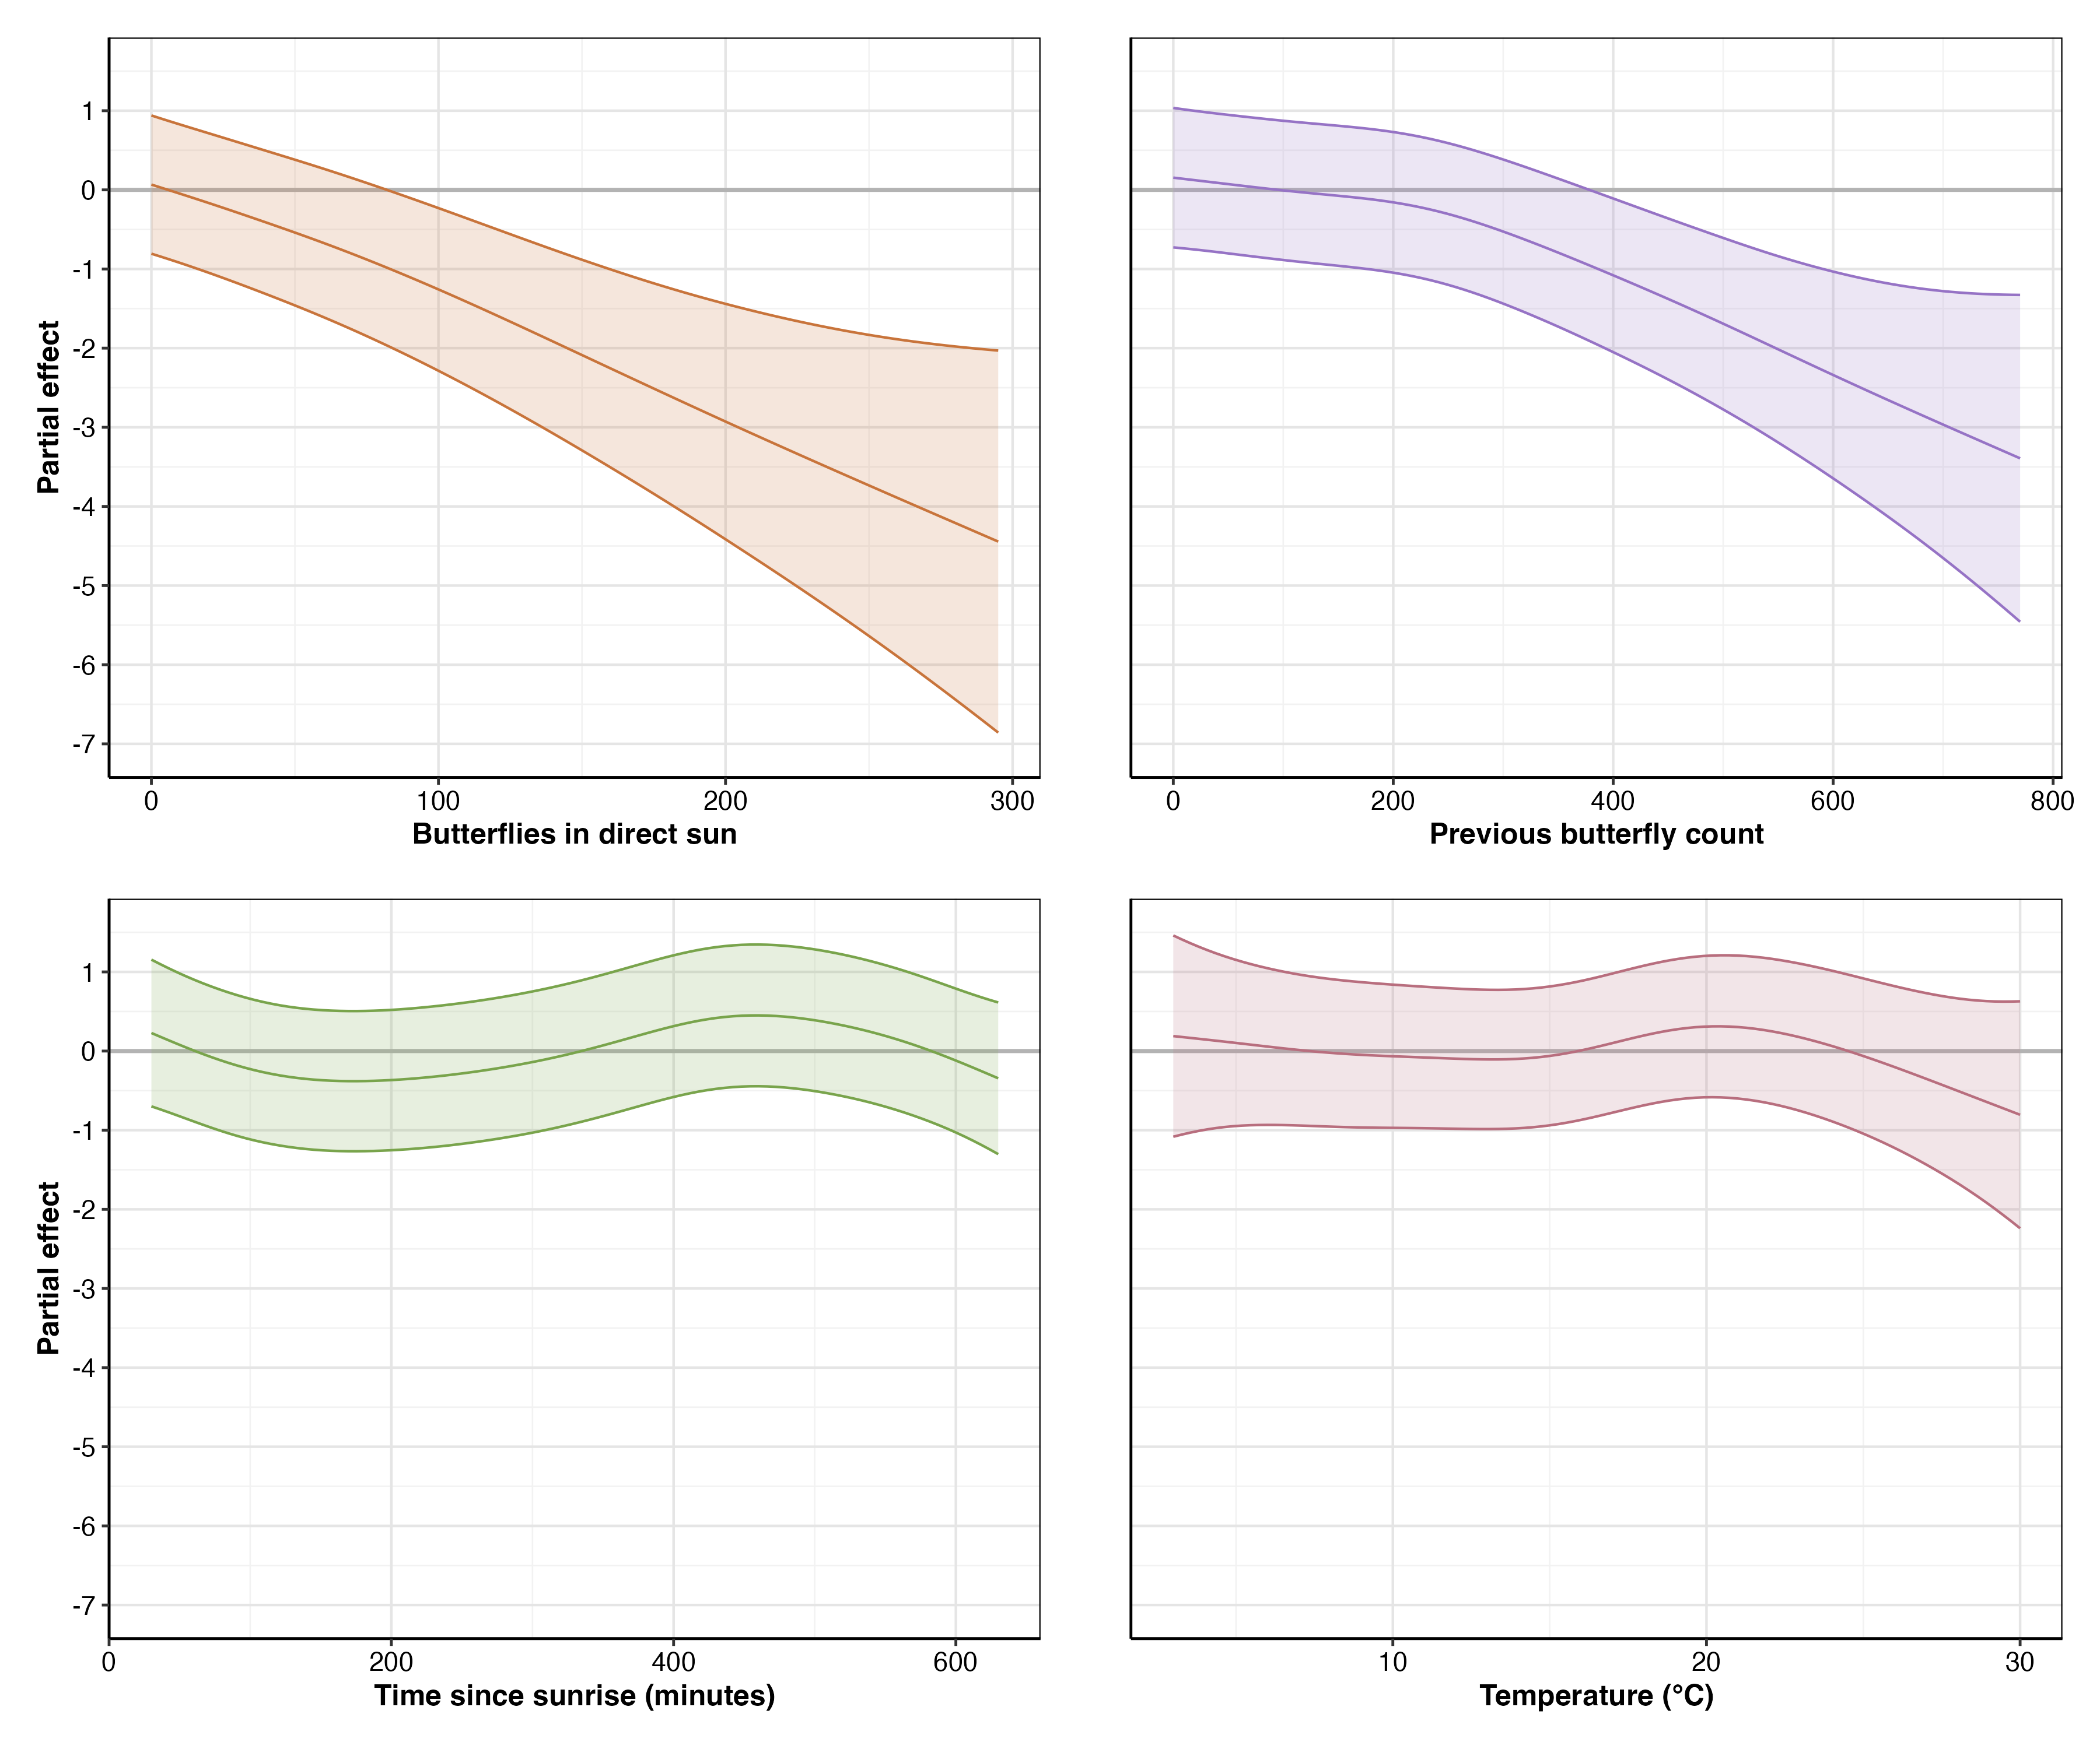

Partial effects of the four significant predictors on monarch abundance change in a 2x2 layout. Top row: butterflies in direct sun (left) and previous butterfly count (right). Bottom row: time since sunrise in minutes (left) and temperature in °C (right). Solid lines show the estimated smooth functions with 95% confidence intervals (shaded regions). All effects are shown on the same scale for comparison.

### Evaluation of the Disruptive Wind Hypothesis

Our analysis provided no support for the three hierarchical wind hypotheses:

First, wind did not act as a disruptive force to overwintering monarchs. Among our 48 candidate models, wind appeared in only one of the top five models (M24), where it showed little evidence of an effect (p = 0.218) and resulted in substantially poorer model performance compared to the best model (ΔAIC = 6.2).

Second, we found no evidence for disruption above the proposed 2 m/s threshold. A sensitivity analysis using a specific threshold predictor (’minutes with wind speed > 2 m/s’) confirmed this lack of a threshold effect, as models with this variable performed poorly and did not rank among the top candidates. Visually, the relationship between wind and monarch abundance change remained flat across the 2 m/s boundary (Figure 1.2). With mean maximum wind speeds of 2.2 m/s (SD = 1.4 m/s), conditions that should have revealed threshold effects if present, no disruption occurred at or above this boundary.

Third, wind’s effects did not scale with intensity. The relationship remained flat across all observed wind speeds (0–12 m/s), with confidence intervals consistently encompassing zero (Figure 1.2).

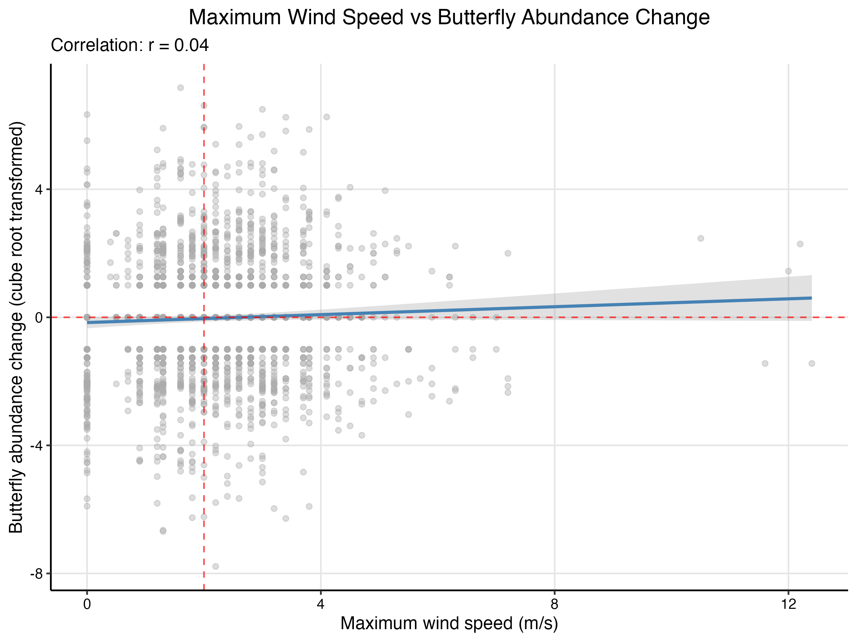

Relationship between maximum wind speed (m/s) and monarch abundance change. The red dashed line shows the proposed 2 m/s disruptive wind threshold, while the flat trend line indicates no effect of wind on butterfly departures. Points represent 30-minute observation periods.

### Statistical Power to Detect Wind Effects

Post-hoc power analysis confirmed our study had adequate statistical power to detect biologically meaningful wind effects (Table 1.3). With 1,894 paired observations, we achieved 87.5% power to detect moderate effect sizes (0.15 standard deviations) and 98.5% power to detect larger effects (0.20 standard deviations). Power for small effects (0.10 standard deviations) was 56%, while very small effects (0.05 standard deviations) yielded only 16.5% power. These results indicate that our failure to detect wind effects is unlikely due to insufficient statistical power for effect sizes of biological relevance.

Estimated power to detect wind effects of varying magnitudes. Effect sizes are expressed in standard deviations of the response variable (cube root transformed change in butterfly abundance).

|  | Effect Size (SD units) | Power (Proportion) | Power (%) |
| --- | --- | --- | --- |
| 0.05 | 0.05 | 0.165 | 16.5% |
| 0.1 | 0.10 | 0.560 | 56% |
| 0.15 | 0.15 | 0.875 | 87.5% |
| 0.2 | 0.20 | 0.985 | 98.5% |

### Model Diagnostics

Model residuals showed distinct linear banding patterns consistent with the discrete counting method used to estimate butterfly abundance, while the Q-Q plot indicated approximately normal residual distribution with minor tail deviations (Figure 1.3).

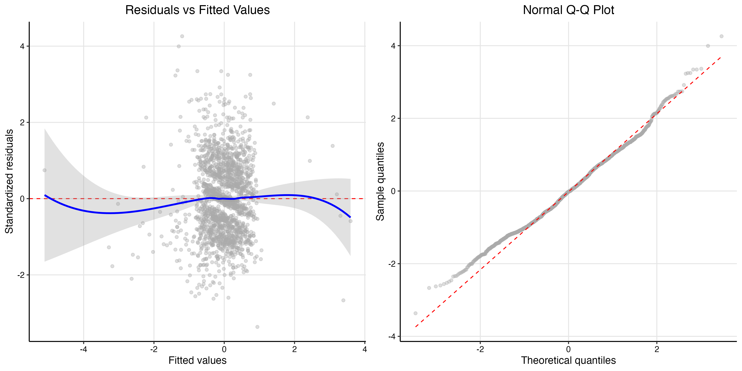

Model diagnostics for M23. Left: Residuals versus fitted values showing banding that reflects the discrete counting method, with smoothed relationship shown in blue. Right: Normal Q-Q plot of model residuals showing reasonable normality with minor tail deviations.

## Discussion

### Wind Does Not Disrupt Overwintering Monarch Butterflies

Our study provides the first direct empirical test of the disruptive wind hypothesis and finds no support for wind as a primary factor influencing monarch butterfly clustering behavior. Despite the widespread adoption of the 2 m/s wind threshold in conservation practice (Society 2016), our data reveal no relationship between wind speed and butterfly departures across the full range of observed conditions (0–12 m/s). While our models explain only 5.7% of variance in butterfly movements, reflecting our focus on testing wind effects rather than comprehensively explaining movement patterns, they had sufficient statistical power to detect environmental signals. This finding challenges assumptions underlying three decades of management guidance.

The absence of wind effects in our data is particularly striking given that mean maximum wind speeds (2.2 m/s, SD = 1.4) frequently exceeded the proposed threshold. If the disruptive wind hypothesis were valid, we should have observed a clear signal: transitions from aggregated butterflies to zero butterflies, as strictly predicted by the hypothesis. Instead, we observed no change, small changes, or even positive changes in butterfly abundance at wind speeds six times the proposed threshold.

Importantly, our analysis had adequate statistical power to detect biologically meaningful wind effects. Power analysis demonstrated 87.5% power to detect moderate effect sizes (0.15 standard deviations) and 98.5% power for larger effects (0.20 standard deviations). Among our 48 candidate models, wind appeared in only one of the top five models (M24), where it showed little evidence of an effect (p = 0.218) and resulted in substantially poorer model performance compared to the best model (ΔAIC = 6.2, capturing only 4% of model weight). This weak wind signal, combined with our high statistical power, allows us to rule out all but very small wind effects. Given that the disruptive wind hypothesis predicts complete cluster abandonment above threshold speeds, a large effect by any measure, our failure to detect such patterns provides strong evidence against the hypothesis rather than merely absence of evidence.

The methodological validity of our approach is confirmed by the strong signals detected for other environmental variables. Had our counting method or analytical framework been flawed, we would not have captured the pronounced effects of direct sunlight (F = 19.36, p < 0.001) or the complex diurnal patterns (F = 8.90, p < 0.001) that emerged from the same dataset.

### Alternative Drivers of Monarch Movement

While our study was designed specifically to test the wind hypothesis, our results suggest that thermoregulation, light exposure, and diurnal rhythms play more important roles than wind in driving short-term movements at overwintering sites.

#### Direct Sunlight as the Strongest Predictor

Direct sunlight exposure emerged as the strongest environmental predictor of cluster abandonment in our study (F = 19.36, p < 0.001). Butterflies exposed to direct sunlight at the beginning of an observation interval showed the largest decreases in abundance, suggesting that solar radiation rapidly warms butterfly body temperatures well above ambient conditions. This finding aligns with Masters, Malcolm, and Brower (1988)’s work showing that monarchs in direct sunlight can elevate their body temperature above ambient conditions within minutes (Masters, Malcolm, and Brower 1988). This rapid warming capability explains why direct sunlight exposure is such a strong predictor of cluster abandonment, butterflies must quickly respond to avoid overheating.

The relationship between sunlight and departure represents a key component of the thermoregulatory equation. While monarchs have evolved efficient solar heat absorption capabilities that enable activity during cool conditions, this same efficiency forces them to abandon energetically favorable clustering positions when exposed to direct solar radiation. This trade-off between the benefits of clustering and the thermal constraints imposed by solar exposure may fundamentally shape daily movement patterns at overwintering sites.

#### Temperature Effects and Their Interpretation

Ambient temperature showed a subtle but significant relationship with monarch abundance changes (EDF = 3.93, F = 3.23, p = 0.028). The data suggest minimal change below 15°C (the known flight threshold), a slight positive association around 20–21°C, and sharp declines above 25°C consistent with thermoregulatory constraints. Given that thermal preferences vary between sites (Saniee and Villablanca 2022), these patterns require validation across the overwintering range before we can generalize about monarch thermal preferences.

#### Diurnal Activity Patterns

Time since sunrise revealed distinct diurnal patterns (EDF = 4.90, F = 8.90, p < 0.001), with butterflies departing clusters in the morning and reforming aggregations in the afternoon. This pattern persists even after controlling for temperature and sunlight, aligning with anecdotal observations from overwintering sites throughout California.

### Study Limitations

Several limitations warrant consideration. Our data derive from a single season (2023–2024) at two sites, with historically low monarch abundance preventing temporal replication. Additionally, our counting methodology introduced discretization artifacts that contributed to large confidence intervals for environmental predictors. While we detected strong signals like direct sunlight effects, more subtle relationships require careful interpretation.

### Management Implications

Our findings suggest that management strategies prioritizing wind protection warrant reconsideration. The absence of wind effects despite frequent threshold exceedances indicates that usable habitat within existing groves may be larger than currently recognized. Areas previously dismissed due to perceived wind exposure may provide suitable conditions if they offer appropriate light and thermal regimes.

While past management efforts aimed at wind protection may have been based on incomplete understanding, they likely produced beneficial outcomes by increasing tree density. The fundamental recommendation to plant and maintain trees remains sound. Management should prioritize maintaining existing mature trees while establishing future roosting habitat at densities that support healthy, long-lived growth.

### Future Research Directions

Our findings open several important avenues for future research. First, explicit testing of light patterns as predictors of clustering locations could establish whether canopy structure guides habitat selection. The strong effect of direct sunlight (F = 19.36, p < 0.001) combined with the predictability of canopy-created light patterns suggests this may be a primary factor in roost site selection.

Second, investigation of social dynamics and positive feedback mechanisms could address unexplained variation in our models. Monarchs may exhibit emergent clustering behaviors where initial settlement increases the probability of others joining, creating self-reinforcing patterns independent of environmental conditions.

Research should also examine whether our findings extend across the broader overwintering range. Testing these patterns at sites with different tree species, latitudes, and population densities would strengthen conclusions about the generality of wind effects, or their absence.

### Conclusions

Wind did not disrupt monarch clusters even at speeds far exceeding established thresholds. Instead, butterflies responded primarily to thermal conditions, light exposure, and diurnal rhythms. These findings challenge current assumptions about overwintering habitat requirements and suggest that management priorities should be reevaluated. While our study represents one season at two sites, the absence of wind effects despite adequate statistical power raises important questions about three decades of conservation guidance. As monarch populations face continued threats, evidence-based management becomes increasingly critical for conserving the overwintering sites essential for this iconic species.

## References

Hristov, Nickolay I., Dionysios Nikolaidis, Tatjana Y. Hubel, and Louise C. Allen. 2019. “Estimating Overwintering Monarch Butterfly Populations Using Terrestrial LiDAR Scanning.” *Frontiers in Ecology and Evolution* 7. <https://www.frontiersin.org/articles/10.3389/fevo.2019.00266>.

Masters, Alan R., Stephen B. Malcolm, and Lincoln P. Brower. 1988. “Monarch Butterfly (Danaus Plexippus) Thermoregulatory Behavior and Adaptations for Overwintering in Mexico.” *Ecology* 69 (2): 458–67. <https://doi.org/10.2307/1940444>.

Saniee, Kiana, and Francis Villablanca. 2022. “Hierarchy and Scale Influence the Western Monarch Butterfly Overwintering Microclimate.” *Frontiers in Conservation Science* 3. <https://www.frontiersin.org/articles/10.3389/fcosc.2022.844299>.

Society, Xerces. 2016. “State of the Monarch Overwintering Sites in California.” <https://www.xerces.org/sites/default/files/2018-05/16-015_01_XercesSoc_State-of-Monarch-Overwintering-Sites-in-California_web.pdf>.

Xerces Society. 2017. “Step-by-Step Western Monarch Thanksgiving Count Monitoring Guide.”

———. 2025a. “Western Monarch Thanksgiving Count and New Year’s Count Data, 1997-2025.” [WesternMonarchCount.com](https://WesternMonarchCount.com).

———. 2025b. “Western Monarch Butterfly Population Declines to Near Record Low.” March 6, 2025. <https://www.xerces.org/press/western-monarch-butterfly-population-declines-to-near-record-low>.