# Introduction

The distribution and survival of invertebrate species are governed by a complex interplay of biotic and abiotic factors. While biotic interactions influence community assembly in part through predation, competition, and parasitism (Blois-Heulin et al. 1990; Lafferty and Shaw 2013; Miller-ter Kuile et al. 2022), abiotic conditions often set the fundamental limits determining where invertebrates can persist. Temperature constrains invertebrate physiology across all latitudes, from Antarctic midges (*Belgica antarctica*) that survive freeze-thaw cycles through cryoprotective dehydration (Everatt et al. 2015), to desert land snails (*Sphincterochila boissieri*) that tolerate 55°C through metabolic downregulation (Schweizer, Triebskorn, and Köhler 2019). Rising temperatures directly increase metabolic rates and respiratory water loss, creating compound stress that limits activity windows (Chown, Sørensen, and Terblanche 2011). Solar radiation drives both direct physiological impacts and behavioral responses. Army ants demonstrate habitat-specific evolution of thermal maxima tied to insolation exposure (Baudier et al. 2018), while terrestrial gastropods climb vertical surfaces to escape ground-level heat and evolve reflective pigmentation in exposed populations (Schweizer, Triebskorn, and Köhler 2019). Among these abiotic factors, wind emerges as a particularly complex environmental force shaping invertebrate ecology through remarkably diverse mechanisms.

Wind influences invertebrate behavior and ecology through diverse mechanisms that vary across species, exhibiting remarkably specific wind detection thresholds and behavioral responses. Cockroaches perceive air currents as low as 0.015–0.03 m/s, with *Periplaneta americana* demonstrating predictable orientation shifts from upwind movement at low velocities to downwind escape at higher speeds (Bell and Kramer 1979). Mosquito flight activity shows sensitivity to even light winds, with trap catches declining 75% when wind speeds approach their normal flight velocity of 1.0 m/s, effectively grounding entire populations (Bidlingmayer, Day, and Evans 1995). Some species exploit wind for dispersal through specific behavioral triggers, such as spiders exhibiting stereotypic ‘tiptoe’ behavior to initiate ballooning when wind conditions permit controlled trajectories (Bonte and Lens 2007). Others respond to wind as an environmental stressor requiring active avoidance. Herbivorous larvae like *Uraba lugens* treat moderate winds of 3 m/s as disturbance cues, triggering increased movement to stable microsites on branches and behavioral shifts to leeward sides and abaxial leaf surfaces for protection (Leonard, McArthur, and Hochuli 2016).

Beyond direct physical effects, invertebrates detect wind through indirect sensory pathways. The Namib desert beetle *Lepidochora discoidalis* perceives substrate vibrations when winds exceeding 5 m/s lift sand grains, using these cues to time surface foraging when detritus becomes concentrated (Hanrahan and and Kirchner 1997). The katydid *Copiphora brevirostris* adjusts vibratory communication to avoid wind-induced noise, concentrating signaling between 2:00 and 5:00 AM when winds are calmest and exploiting short-term lulls during gusty periods (Velilla et al. 2020). This complexity in wind-organism interactions becomes particularly evident when examining species that must navigate multiple life stages with different environmental exposures.

The monarch butterfly (*Danaus plexippus*) offers an exceptional system for studying how abiotic factors, particularly wind, shape invertebrate ecology through its remarkable multi-generational migration. North American monarchs complete an annual cycle that links vast northern breeding ranges with small, highly specific overwintering sites (L. Brower 1995; Solensky 2004; S. Jepsen et al. 2015). The continent is home to two populations separated by the Rocky Mountains: a larger Eastern population and a Western population (Cockrell, Malcolm, and Brower 1993; S. Jepsen et al. 2015; Freedman et al. 2021). During the spring and summer, multiple short-lived generations of butterflies (2–5 weeks) breed throughout North America, with females laying eggs exclusively on milkweed (*Asclepias* spp.), the larval host plant (Zalucki 1982; Cockrell, Malcolm, and Brower 1993). This breeding phase builds the population as they radiate northward, but as late summer approaches, environmental cues such as shortening day length and cooling temperatures trigger the shift to the migratory generation (Reppert and de Roode 2018; Goehring and Oberhauser 2002; Herman and Tatar 2001; Barker and Herman 1976). These migratory adults exhibit a unique phenotype: they enter a state of reproductive diapause (suspended reproduction) and possess elongated wings suited for long-distance travel (Barker and Herman 1976; Yang et al. 2016; Tuskes and Brower 1978).

The fall migration begins as these long-lived adults (6–8 months) orient themselves southward, flying up to thousands of kilometers, a journey fueled by energy stored as lipid reserves accumulated from nectaring flowers along their route (Herman and Tatar 2001; Chaplin and Wells 1982; Urquhart and Urquhart 1978). Navigational feats are guided by a sophisticated system that includes a time-compensated sun compass residing in the antennae, allowing them to maintain direction throughout the day (Mouritsen and Frost 2002; Nguyen et al. 2021). Eastern monarchs travel to the high-altitude oyamel fir (*Abies religiosa*) forests in central Mexico, while the Western population migrates to overwintering groves located along the Pacific coast of California (L. Brower 1995; Urquhart and Urquhart 1978).

The overwintering period, lasting roughly from mid-October through mid-March, represents an important phase of the annual migration where the entire North American population concentrates into remarkably small forested areas (Solensky 2004; Vidal and Rendón-Salinas 2014; S. J. Jepsen and Black 2015). During these months, monarchs must survive exclusively on lipid reserves accumulated during autumn migration while maintaining precise thermoregulatory balance (Chaplin and Wells 1982; Masters, Malcolm, and Brower 1988). As ectotherms, monarchs face a fundamental trade-off: they must maintain body temperatures cool enough to conserve energy through metabolic suppression, yet warm enough to permit essential daily movement (Masters, Malcolm, and Brower 1988; Chaplin and Wells 1982; Kammer 1970; Alonso-Mejia and Arellano-Guillermo 1992). The flight threshold, established at 12.7-16.0°C for Mexican populations, represents the minimum thoracic temperature required for powered flight (Masters, Malcolm, and Brower 1988). Below this threshold, monarchs employ behavioral thermoregulation through dorsal basking, which can elevate body temperature to flight capability within 30 seconds of sun exposure, or through energetically costly shivering that consumes energy 25 times faster than resting (Masters, Malcolm, and Brower 1988). Conversely, temperatures above 20°C risk terminating reproductive diapause and triggering premature remigration, while direct sun exposure can rapidly elevate thoracic temperatures to 33.6°C, forcing butterflies to adopt sun-minimizing postures or engage in heat-dissipating flights (Barker and Herman 1976, 1976). This delicate energetic balance means that monarchs selecting overwintering sites must find locations that minimize both freezing risk and elevated metabolic expenditure (Masters, Malcolm, and Brower 1988; Alonso-Mejia and Arellano-Guillermo 1992; Calvert, Zuchowski, and Brower 1983).

Building on early studies from Mexican overwintering sites that identified abiotic factors limiting butterfly survival, Leong proposed the microclimate hypothesis for western monarchs overwintering in California (Kingston. L. H. Leong 1990). This hypothesis posited that monarchs select clustering locations within groves based on a measurable microenvironmental envelope characterized by four key parameters: wind protection below 2 m/s to prevent cluster disruption, cool temperatures maintaining reproductive diapause while avoiding freezing mortality, dappled sunlight enabling behavioral thermoregulation, and high humidity with accessible moisture to prevent desiccation (Kingston. L. H. Leong 1990; Kingston L. H. Leong et al. 1991). Wind emerged as particularly critical in this framework, though these conclusions derived from correlational measurements rather than direct behavioral observations. Leong’s initial studies measured wind speeds at trees with and without butterfly clusters, while noting that “during winter storms, the butterflies clustered on those few trees that offered the greatest protection against winds of 2 m/s or greater” (Kingston. L. H. Leong 1990), though the highest wind speed measured in this study was 1.66 m/s. Based on these correlational patterns, Leong reported that “butterflies cluster in areas of the grove that offer exposure to filtered sunlight and shelter from strong wind movement” (Kingston L. H. Leong et al. 1991). In later publications, Leong described increasingly dramatic wind effects through anecdotal observations, noting that “roosting butterflies were blown from their clusters or dislodged by excessive branch movements (shaking) caused by winds exceeding 2 m/sec” and that “upon dislodgment, the butterflies flew to and resettled on foliage of trees that offered better shelter from strong winds” (K. L. H. Leong 1999). When storm winds coincided with cold morning temperatures below 15°C, “the dislodged butterflies would be blown to the ground and remain there until temperatures reached flight threshold,” with “butterflies littering the ground at the base of roosting trees” commonly observed after winter storms (K. L. H. Leong 1999). Despite originating from correlational field measurements and anecdotal obervations, this hypothesis gained widespread acceptance and directly informed management guidelines at multiple levels. Leong’s 2016 synthesis for California Department of Fish and Wildlife formally established that “winds ≥ 2 m/s are disruptive to the aggregating butterflies by blowing them from their roosting branches or dislodging them by shaking the branches,” and that when subjected to such winds above flight threshold, butterflies “either flew to a more sheltered area of the grove or, if no refuge area was available, abandoned the grove temporarily or for the remainder of the season” (Kingston L. H. Leong 2016). The microclimate hypothesis thus dictated that successful overwintering sites must consistently exhibit this specific suite of conditions, particularly wind protection, implying that these abiotic parameters should guide habitat restoration efforts, a principle now widely adopted in monarch conservation plans (Xerces Society 2016; S. Jepsen et al. 2017; E. Pelton 2020; Stuart B. Weiss and Rich 2008; Althouse & Meade, Inc. and Creekside Science 2023).

However, empirical testing has gradually dismantled the microclimate hypothesis’s core assumption of a uniform environmental envelope. When researchers tested whether monarchs select for consistent microclimatic attributes across groves, they found that the realized microclimate varied significantly with latitude and local geography (Saniee and Villablanca 2022). Temperature responses proved more complex than originally proposed, with monarchs avoiding freezing temperatures but selecting the warmest of cold temperatures available at their latitude (Fisher et al. 2018). Humidity requirements showed geographic variability rather than consistency (Saniee and Villablanca 2022). Of the four original parameters, only light exposure showed potential support as a unifying factor, with successful overwintering sites exhibiting consistent patterns of canopy openness (Saniee and Villablanca 2022; Stuart B. Weiss et al. 1991). This geographic variability in microclimate preferences, where selection occurs hierarchically across multiple spatial scales rather than for a single environmental envelope, fundamentally contradicts Leong’s original hypothesis (Fisher et al. 2018; Saniee and Villablanca 2022). The gradual rejection of the uniform microclimate hypothesis through empirical testing suggests that monarch habitat selection may be driven by physiological and energetic constraints that vary with local environmental conditions rather than by a rigid set of universal requirements.

The wind disruption component of the hypothesis stands apart as the only major parameter that has never undergone direct empirical testing of butterfly behavioral responses to wind exposure. Despite wind protection below 2 m/s being identified as a critical factor in Leong’s framework (Kingston L. H. Leong 2016), widely adopted in restoration efforts (Xerces Society 2018; S. Jepsen et al. 2017; Althouse & Meade, Inc. and Creekside Science 2023; U.S. Fish and Wildlife Service 2024; Stuart B. Weiss 2018), no study has established causal relationships between wind exposure and butterfly behavior. Leong’s methodology of comparing wind measurements between occupied and unoccupied trees provided only correlational evidence, never directly testing butterfly responses to wind exposure or distinguishing whether butterflies actively avoid wind or whether wind simply correlates with other unmeasured variables.

The absence of empirical testing for the wind disruption hypothesis becomes critically important given the catastrophic decline of western monarch populations. Between the 1980s and mid-2010s, populations collapsed by approximately 97% (Schultz et al. 2017), with population viability analyses revealing a 72% quasi-extinction risk within 20 years (Schultz et al. 2017). The winter 2018 to 2019 count recorded fewer than 30,000 monarchs, a single-year drop of 86%, representing over 99% decline from 1980s abundance (E. M. Pelton et al. 2019). The situation reached its most critical state in 2020 when the Western Monarch Thanksgiving Count documented only 1,901 butterflies, the lowest number ever recorded (Xerces Society 2025a). While populations showed some recovery in subsequent years, the 2024 to 2025 count of just 9,119 butterflies represents the second-lowest count on record, demonstrating the population’s continued precarity (Xerces Society 2025a). These dramatic declines result from multiple interacting stressors including breeding habitat loss, pesticide exposure, climate change, and critically, the loss and degradation of overwintering habitat (Crone et al. 2019; E. M. Pelton et al. 2019). Evidence increasingly suggests that the overwintering stage represents the most limiting phase of the monarch’s annual cycle, with population declines concentrated during winter and early spring periods (E. M. Pelton et al. 2019; Marini and Zalucki 2017). California’s coastal overwintering groves, where the entire western population concentrates into remarkably small forested areas from October through March, have thus emerged as critical conservation priorities. Yet management of these critical sites continues to rely on the untested wind disruption hypothesis, with restoration efforts investing millions of conservation dollars based on the presumed necessity of maintaining wind speeds below 2 m/s (Althouse & Meade, Inc. and Creekside Science 2023; The Monarch Press 2019).

Testing the wind disruption hypothesis requires addressing a fundamental methodological challenge: isolating wind effects from confounding environmental variables that naturally covary in field settings. Solar radiation can trigger butterfly departures through direct heating, enabling flight when ambient temperatures remain below thermal thresholds (Masters, Malcolm, and Brower 1988; Kammer 1970). Temperature independently influences activity patterns, with monarchs exhibiting predictable responses as temperatures approach and exceed flight thresholds (Barker and Herman 1976). Time of day creates inherent activity rhythms related to sun angle and thermal conditions (Mouritsen and Frost 2002). Furthermore, wind itself is multidimensional, characterized not only by average speed but also by gustiness and variability (Nathan et al. 2005) that could differentially affect butterfly behavior. A rigorous test must therefore control for these confounding factors while examining multiple aspects of wind exposure, including both maximum wind speeds and duration above the proposed 2 m/s threshold. With western monarch populations facing potential extinction and limited conservation resources available, the need for empirically validated management strategies has never been more urgent.

This study provides the first direct empirical test of whether wind disrupts overwintering monarch butterflies. Our primary objective was to evaluate the foundational 2 m/s wind disruption threshold that has guided over three decades of conservation practice. We employed continuous monitoring at 30-minute intervals throughout the overwintering season, simultaneously measuring wind speed, temperature, and solar radiation at butterfly clustering locations. This approach enabled direct observation of butterfly responses to changing environmental conditions while controlling for confounding variables. We analyzed the data using an information-theoretic framework that compared multiple competing models to identify the strongest predictors of butterfly movement.

First, we hypothesized that wind, alongside other environmental factors, predicts butterfly abundance at overwintering clusters. If true, we predict that an information-theoretic approach will identify wind as a significant predictor of abundance changes, with monarch abundance decreasing when exposed to higher wind speeds.

Second, we hypothesized that wind becomes disruptive above a specific threshold of 2 m/s. If this threshold represents a meaningful biological boundary, we predict that monarch abundance will decline at roosts experiencing winds exceeding 2 m/s.

Third, we hypothesized that wind’s disruptive effects scale with intensity. If disruption increases with wind speed, we predict proportionally greater decreases in monarch abundance as wind speeds rise above the threshold.

## Materials and Methods

### Study Site

Site selection followed a systematic filtering process driven by project requirements and practical constraints. The study was supported by a federal grant that mandated research be conducted on federal lands. We selected Vandenberg Space Force Base (VSFB, 34.7398°N, 120.5725°W) in Santa Barbara County, California, based on several key advantages: mild winters with infrequent frost events, extensive historical plantings of blue gum eucalyptus (*Eucalyptus globulus*) that have created suitable overwintering habitat throughout the installation, and restricted access that provided security for long-term equipment deployment. The base contains thirty documented monarch overwintering groves, with several sites consistently ranking within the top 10% of population counts statewide over the past decade (Xerces Society 2025b).

Working with the base’s monarch conservation coordinator, we initially screened twelve locations from the thirty sites based on their documented capacity to support monarch aggregations and provide year-round access. This collaboration leveraged local expertise from managing Western Monarch Thanksgiving Count activities for multiple years (Xerces Society 2025b). During the study period, ten of these sites were actively monitored. However, due to low monarch populations during the 2023-2024 season and no observed overwintering behavior in the 2024-2025 season, only two sites (Spring Canyon and UDMH) produced measurable butterfly clusters suitable for our analysis.

Spring Canyon (34.6315°N, 120.6182°W) represents the most productive and historically reliable overwintering site on VSFB. Located in South Base within 300 meters of Space Launch Complex 4, this approximately 2.0-hectare site consists entirely of mature blue gum eucalyptus trees reaching heights of approximately 40 meters. An unnamed perennial creek runs through the center of the grove, creating a riparian corridor that supports heterogeneous canopy structure with variable tree spacing and diverse understory vegetation. Surf Road, an infrequently used paved access road, bisects both the perennial creek and forest canopy.

The UDMH site (34.6719°N, 120.5950°W), also located in South Base, comprises a 5.1-hectare eucalyptus grove planted in windrows adjacent to a waste treatment facility. The uniformly spaced trees maintain a largely clear understory with scattered low shrubs. Although only recently documented as an overwintering location in 2022, UDMH immediately emerged as a significant site, supporting over 6,000 monarchs during its initial count and ranking among the base’s highest population sites.

### Monitoring Strategy

Equipment deployment strategies differed between monitoring seasons to accommodate research objectives and field experience. During the 2023-2024 season, we employed two strategies: targeted deployments at sites with confirmed monarch presence, and anticipatory deployments at locations where monarchs were expected based on historical data but not currently observed. Targeted deployments concentrated at Spring Canyon and UDMH where active aggregations were documented throughout the season. Anticipatory deployments occurred at four overwintering sites: additional locations within Spring Canyon and UDMH, plus SLC-6 and Tangair. No monarchs were recorded at anticipatory deployment sites; consequently, these data are excluded from analysis.

Building on insights from the initial season, for the 2024-2025 season we modified our approach to establish monitoring stations at ten sites before monarch arrival, based on historical occurrence records compiled by the base conservation coordinator. This expanded spatial coverage aimed to capture greater environmental variation across potential overwintering sites. However, the 2024-2025 season coincided with historically low monarch abundance throughout California (Xerces Society 2025b), resulting in no observed clustering behavior at any monitored location on base. Consequently, our final dataset comprises two sites (Spring Canyon and UDMH) from the 2023-2024 season only.

### Field Equipment

To observe changes in monarch abundance in response to strong wind events, we deployed remote monitoring equipment near butterfly clusters at overwintering sites. Field observations utilized 15-meter telescoping fiberglass poles (Max-Gain Systems, Inc., Marietta, GA) anchored at three points using ground anchors with guy lines securing both the top and base to create stable, freestanding structures.

Poles were positioned 4-17 meters from cluster locations. This range, determined through field testing, balanced image resolution requirements for our grid-based counting method against disturbance minimization. Closer positioning compromised field of view, while greater distances degraded butterfly visibility below classification thresholds. Pole placement considered ground stability for the 15-meter structures, infrastructure clearance requirements, and clear viewing angles. When deploying near active clusters, we approached from directions that minimized disturbance; no butterfly dispersal was observed during equipment deployment.

We monitored monarch abundance using modified trail cameras (GardePro E7 and E8, Shenzhen, China) configured for near-infrared imaging to enhance contrast between clustering butterflies and surrounding vegetation. Trail cameras were selected for their durability in extended field deployment, native time-lapse functionality, and modification potential. Near-infrared wavelength selection followed previous literature demonstrating effectiveness for butterfly population estimation (Hristov et al. 2019).

Hardware modifications exploited the camera’s internal filter-switching mechanism by engaging nighttime mode to access the clear glass filter position, then disconnecting power to prevent reversion to the infrared cut filter. Near-infrared pass filters (>850 nm) were mounted externally to restrict incoming light to NIR wavelengths. This configuration produced images where clustering butterflies appeared as dark masses against bright eucalyptus foliage reflectance in the near-infrared spectrum. Field validation confirmed sufficient contrast for visual distinction of monarch clusters from background vegetation, supporting our human-labeler analytical approach.

Cameras were mounted atop poles using lightweight tie-down straps and positioned horizontally toward butterfly clusters at roosting height. The wireless live view feature enabled real-time preview and precise camera aiming during deployment. Cameras operated in time-lapse mode with motion detection disabled.

Sampling interval selection balanced temporal resolution, battery life, and data processing feasibility through empirical optimization and rigorous statistical validation. Initial deployments used 10-minute intervals to capture significant changes in butterfly abundance, which preliminary observations indicated occurred on hourly rather than minute scales, while maintaining approximately 6-week continuous operation. Post-deployment statistical analysis using mixed-effects models and information-theoretic approaches systematically compared multiple sampling intervals across deployments. We conducted sequential subsample analyses starting with full temporal resolution and progressively testing reduced frequencies. Information-theoretic model comparison using Akaike Information Criterion (AIC) demonstrated that 30-minute intervals provided optimal balance, losing less than 5% of information compared to full temporal resolution (measured by root mean square error) while reducing image classification workload by 67%. Variance comparison analysis and visual assessment of fitted trend lines confirmed that this interval preserved essential time-series patterns including diurnal activity cycles, weather-response dynamics, and multi-day population trends. Battery life constraints and field deployment logistics further supported this interval choice, enabling extended autonomous operation essential for capturing complete behavioral sequences during variable weather conditions.

To quantify the wind conditions hypothesized to influence butterfly behavior, wind monitoring equipment consisted of Rain Wise WindLog Wind Data Loggers (Rain Wise Inc., Trenton, Maine) installed at pole apices to measure wind at heights approximating butterfly roosting locations. These instruments recorded average wind speed and maximum wind gust at one-minute intervals, the highest frequency supported by the sensors. This recording interval enabled calculation of wind speed variance within each photographic sampling period, capturing gustiness lost with longer averaging periods.

To systematically organize our heterogeneous monitoring efforts, we defined discrete monitoring periods as deployment units. Each deployment represented a unique combination of monitoring location, camera configuration (including camera ID, mounting height, and viewing angle), associated wind measurements, and temporal coverage period. Since equipment was frequently reused across locations and time periods, this deployment-based structure provided standardized sampling units that accounted for variation in environmental conditions and equipment configurations while treating each deployment as independent for statistical analyses. This approach produced time-series images from each deployment for estimating monarch cluster abundance through systematic grid-based counting methods, enabling analysis of abundance patterns in relation to wind speed and other environmental variables.

### Image Analysis

#### Grid-based Counting Method

To quantify changes in monarch butterfly abundance from collected imagery, we developed a systematic grid-based counting protocol balancing accuracy with the practical constraints of analyzing tens of thousands of images. This approach addressed the challenge of estimating abundance in large aggregations where individual counts would be prohibitively time-consuming and emulated field researcher methods, including those used in the annual Thanksgiving Count (Xerces Society 2018). We subdivided each image using a grid overlay system where human labelers assigned order-of-magnitude estimates per cell. Grid dimensions remained fixed throughout each deployment to ensure consistency. Custom software developed using the Electron framework in JavaScript facilitated this labeling effort.

Grid cell size varied by deployment based on camera-to-cluster distance. Cell dimensions were optimized to ensure most occupied cells contained butterflies in the 10–99 count range, balancing classification efficiency with spatial resolution. This standardization minimized cells alternating between widely different order-of-magnitude categories across the time series.

#### Counting Protocol

Human labelers estimated butterfly abundance within each grid cell using four order-of-magnitude categories: 0 (no butterflies), 1–9 (single digits), 10–99 (dozens), and 100–999 (hundreds). Labelers trained using a comprehensive online guide with example images and detailed classification criteria (<https://kylenessen.github.io/monarch_trailcam_classifier/>). The protocol prioritized efficiency while maintaining consistency across observers.

Because abundance estimates derived exclusively from two-dimensional photographic images, our classification protocol quantified only butterflies visible in the image plane without estimating three-dimensional cluster structure or depth. This approach intentionally excluded hidden individuals behind visible butterflies in overlapping aggregations, providing a conservative but consistent measure reflecting observable surface area rather than total volume. For cells containing partial butterflies at grid boundaries, labelers included these in counts unless double-counting would cause an adjacent cell to move to a higher category. When butterfly counts fluctuated between categories across the time series, we consistently applied the lower estimate to maintain conservative abundance estimates.

In addition to estimating monarch abundance, labelers recorded whether cells received direct sunlight. Direct sunlight classification presented challenges because oversaturated conditions eliminated the contrast enabling butterfly detection in shaded areas. Labelers classified cells as receiving direct sunlight when branches or butterflies exhibited additional illumination clearly from direct rather than indirect light, even when individual butterflies became difficult to distinguish due to pixel oversaturation. This classification required careful attention to subtle shape recognition and contextual awareness about butterfly locations established from previous images in the time series. This measurement was recorded only for occupied cells and stored separately.

Labelers received ongoing feedback throughout the classification process. All classifications underwent review for common errors including mislabeled cells, incorrect category assignments, and inconsistent counting criteria application. Direct communication of corrections to labelers ensured consistent protocol application.

#### Abundance Calculation

We calculated an abundance index for each frame by summing the products of cell counts and their assigned category values across all grid cells, employing conservative estimates using minimum values within each order-of-magnitude category:

where represents the number of cells in category , and represents the conservative estimate for that category. We used minimum category values ( for category 1–9, for category 10–99, and for category 100–999) rather than midpoint or maximum values to ensure temporal analyses reflected genuine population shifts rather than estimation uncertainty.

### Temperature Data Extraction

Temperature represents a critical environmental variable influencing monarch activity patterns and potentially confounding wind effects. Ambient temperature data were extracted from trail camera images using optical character recognition (OCR). Each camera displayed temperature readings on the image overlay, but these values were not accessible through EXIF metadata, necessitating visual extraction methods. We developed an automated Python script utilizing OCR technology to extract temperature values from approximately 56,000 images across all deployments. The extraction process employed multiple preprocessing strategies and pattern matching algorithms to accommodate variations in image quality and display characteristics.

Following initial automated extraction, we manually reviewed and corrected edge cases where OCR failed or produced anomalous values. All temperature data underwent systematic quality control through visualization of deployment-specific time series, enabling identification and correction of erroneous values. This process ensured complete temperature coverage for all analyzed images, providing the ambient temperature covariate required for our statistical models.

### Statistical Analysis

#### Data Preparation

Statistical analysis employed a lag-based framework to capture the temporal dynamics of butterfly responses to environmental changes, comparing butterfly counts between consecutive 30-minute intervals. Observation pairs were constructed by matching counts at time with counts at time minutes, applying a ±5 minute tolerance window to accommodate minor temporal variations in image capture. The response variable (change in butterfly abundance between time points) underwent cube root transformation to achieve approximate normality while preserving directional information: , where represents the difference in butterfly counts. While exploratory data analysis revealed generally well-behaved distributions, we observed bimodality in the raw butterfly abundance data driven primarily by a single anomalous event at deployment SC8. At this deployment, a large butterfly aggregation abruptly declined to near zero without corresponding changes in the measured environmental variables (wind speed, temperature, or solar exposure). This singular event was unlike any other observation in the dataset. We retained this deployment in the final analysis for two reasons: first, to maximize sample size and avoid arbitrary data exclusion, and second, sensitivity analysis showed that the cube root transformation of abundance differences adequately addressed the distributional concerns, with model selection and parameter estimates remaining consistent whether SC8 was included or excluded. The transformation approach made the anomaly’s inclusion or exclusion immaterial to the final results. Observation pairs where both time points recorded zero butterflies were excluded as uninformative, reducing the dataset from approximately 2,500 potential pairs to 1,894 analyzable observations across 115 unique deployment-day combinations.

#### Variable Selection

Predictor variables were selected to test specific hypotheses while avoiding multicollinearity. Maximum wind gust speed during each 30-minute interval served as the primary wind metric, with alternative wind measurements (average sustained speed, modal gust, gust standard deviation) excluded due to high correlation (). Environmental predictors included average temperature between observation pairs, number of butterflies in direct sunlight at the previous time point, and minutes elapsed since the first observation of each day to capture diurnal patterns. Total butterfly count at the previous time point was included as a control variable, enabling distinction between proportional and absolute changes in abundance. When included, this variable tests effects on proportional change; when excluded, models test effects on absolute change.

#### Model Framework

Analysis employed generalized additive mixed models (GAMMs) implemented through the mgcv package in R. Model selection followed an information-theoretic approach, comparing 48 candidate models using Akaike Information Criterion (AIC). The candidate set comprised two fundamental frameworks: models including the lag abundance term (24 models) and models excluding it (24 models), with each framework containing null models, single predictor models, additive combinations, two- and three-way interactions, and models incorporating smooth terms for non-linear relationships. Random effects structure accounted for variation at three hierarchical levels: deployment location, observer, and deployment-day. Temporal autocorrelation within days was addressed using a first-order autoregressive (AR1) correlation structure grouped by deployment-day. All models were fitted using restricted maximum likelihood (REML) estimation.

To test specifically for threshold effects at the proposed 2 m/s disruptive wind speed, we conducted a sensitivity analysis using an alternative wind metric. We repeated the entire model selection process, replacing maximum wind gust speed with a threshold-based predictor: the count of minutes within each 30-minute observation period where wind gusts equaled or exceeded 2 m/s. This variable ranged from 0 to 30 minutes and was tested using the same 48 model structures, allowing direct comparison of continuous versus threshold-based wind effects.

#### Model Validation

Model assumptions were verified through standard residual diagnostics including examination of residual distributions, fitted versus residual plots, and quantile-quantile plots. Convergence was confirmed for all candidate models in both the primary and sensitivity analyses. Model performance and predictor significance were evaluated through AIC comparison, with models differing by less than 2 AIC units considered equivalent.

#### Statistical Power Analysis

To evaluate whether our study had adequate statistical power to detect wind effects if present, we conducted a simulation-based power analysis. This approach assessed our ability to detect various effect sizes given our sample size of 1,894 paired observations. We simulated 200 datasets from the best-fitting model (which excluded wind effects) and artificially introduced wind effects of known magnitude ranging from 0.05 to 0.20 standard deviations of the response variable. For each effect size, we refitted models including wind terms to determine the proportion of simulations where the artificial effect was detected as statistically significant (). This simulation approach accounts for the complexity of our GAMM framework and hierarchical data structure, providing robust estimates of statistical power for detecting wind effects across a range of biologically plausible magnitudes.

#### Dynamic Window Analysis

To examine whether day-to-day changes in roost size depend on cumulative weather exposure aligned with butterfly roosting biology, we conducted a complementary analysis using dynamic temporal windows. This approach tested wind effects at a daily scale, capturing overnight and full-day weather exposure that the 30-minute lag analysis could not assess.

We constructed two window definitions to test the robustness of our findings. The sunset window spanned from the previous day’s maximum butterfly count to the current day’s last observation, approximating functional sunset when roosting decisions finalize. This biologically-aligned window varied in duration (mean = 29.6 hours) to capture the complete exposure period from peak aggregation through the subsequent roosting decision point. The 24-hour window provided a standardized comparison, extending exactly 24 hours from the previous day’s maximum count.

Daily aggregates were computed for each deployment-day combination, including maximum butterfly count, 95th percentile count, and mean of the top three counts. We retained only days with 15-25 daytime photographs to ensure adequate temporal coverage, then constructed consecutive day pairs separated by exactly one day. Pairs where both days recorded zero butterflies were excluded as uninformative. The response variable, defined as the change in maximum daily count between consecutive days, underwent signed square root transformation to achieve approximate normality while preserving directional information.

Weather metrics were calculated within each dynamic window. Temperature variables included minimum, maximum, and mean values, plus cumulative metrics such as degree-hours above 15°C. Wind measurements comprised average sustained speed, maximum gust, cumulative gust exposure, and time above the proposed 2 m/s threshold. Direct sun exposure was quantified as the cumulative count of butterflies observed in direct sunlight across all frames within the window, integrating both exposure duration and instantaneous abundance. We required 95% data completeness across temperature, wind, and daylight observations, calculated as the geometric mean of coverage ratios.

Variable selection for the dynamic window analysis began with 19 candidate predictors spanning baseline abundance metrics, temperature summaries, wind exposure measures, and cumulative sun exposure. We conducted correlation analysis to identify multicollinearity within predictor families, particularly among the highly intercorrelated wind metrics (all pairwise correlations ) and temperature variables. Based on this analysis, we selected predictors that minimized redundancy while maintaining interpretability and adequate degrees of freedom relative to sample size.

For wind exposure, we selected maximum wind gust as the primary metric because it captured the variance of all wind variables in a single interpretable measure, showed high correlation with sustained speed, gust summation, and threshold exceedance metrics, and maintained consistency with the 30-minute analysis. We excluded wind mode gust despite its biological relevance because it contained only approximately five unique values across the dataset, causing model convergence issues. Temperature representation focused on non-overlapping summaries that captured both the exposure range (minimum and maximum) and the thermal state at the previous day’s peak abundance. We excluded highly correlated metrics such as mean temperature and degree-hours above 15°C to reduce multicollinearity. The cumulative direct sun exposure variable was retained as a biologically relevant measure of thermal conditions that integrated both exposure duration and instantaneous abundance. For the sunset window analysis, we included lag duration (hours) as a control variable to account for varying window lengths.

Model selection followed the same information-theoretic approach as the 30-minute analysis. We evaluated 76 candidate models per window type using generalized additive mixed models with deployment random intercepts and AR(1) temporal correlation structures. The candidate set included null models, single predictors, additive combinations, and models with smooth interaction terms. To address potential overfitting given the reduced sample size (n = 94-96 pairs), we applied conservative thresholds for the ratio of effective degrees of freedom to sample size and conducted leave-one-deployment-out cross-validation on top-performing models. The final predictor set comprised: temperature minimum and maximum, maximum wind gust, cumulative direct sun exposure, and baseline abundance controls.

## Results

### Descriptive Statistics

Environmental conditions varied substantially across the 78-day monitoring period at Spring Canyon and UDMH during the 2023-2024 overwintering season. The dataset comprised 1,894 observations collected at 30-minute intervals during daylight hours (07:00–17:00) from November 17, 2023, to February 4, 2024, totaling 947 observation hours across 115 unique deployment-day combinations.

Wind speeds ranged from complete calm to moderately strong conditions, with maximum gusts reaching 12.4 m/s (mean = 2.2 ± 1.4 m/s, median = 2.2 m/s). The interquartile range of 1.3–3.0 m/s indicated that most observations occurred under relatively mild wind conditions. Temperature showed considerable variation throughout the monitoring period, ranging from 3.0 to 30.0°C (mean = 14.6 ± 3.8°C, median = 14.0°C), with an interquartile range of 12.5–17.0°C typical of California coastal winter conditions. Direct solar exposure occurred in 31.7% of observations (n = 601), with butterflies actively basking when present in sunlight, averaging 17.0 individuals in direct sun (range: 1–295).

Monarch abundance exhibited high variability across sites and time periods. Butterfly counts ranged from 0 to 770 individuals per observation, with a mean of 81.4 ± 100.0 butterflies and a median of 37 butterflies. The wide interquartile range (9–119 butterflies) reflected substantial variation in cluster sizes. Zero-count observations, representing either the beginning of cluster formation or cluster dissolution, comprised 2.3% of the dataset (n = 43).

Cluster sizes varied markedly among the 10 deployment locations. Site SC10 recorded the largest aggregation with 770 monarchs, while mean abundances ranged from 0 at SC9 to 325.8 at UDMH2. Eight deployments observed maximum cluster sizes exceeding 100 butterflies, with mean maximum cluster size across sites reaching 315.6 individuals. This variation in cluster sizes across deployments reflects the heterogeneous distribution of monarchs across overwintering microhabitats within the study sites.

The comprehensive temporal coverage, with observations at 30-minute intervals capturing 16.5 observations per deployment-day on average, provided fine-scale resolution of monarch behavioral responses to changing environmental conditions. Peak observation activity occurred at 16:00 hours (196 observations), corresponding with afternoon warming periods when monarchs typically exhibit increased movement.

### Responsive Change

To examine how monarchs respond to immediate environmental conditions, we analyzed 1,894 paired observations collected at 30-minute intervals throughout the overwintering season. This responsive change analysis tested whether short-term fluctuations in cluster size could be explained by concurrent weather variables, particularly wind exposure.

#### Model Selection

We evaluated 52 candidate models using generalized additive mixed models (GAMMs) to identify the environmental predictors of monarch abundance changes. Model selection via Akaike Information Criterion (AIC) identified M50 as the decisively best-fit model, capturing 85.8% of the total model weight (Table [tab:export-model-selection-table]). The next best model (M23) showed substantially weaker support with AIC = 3.8 and only 12.6% model weight. Model M50 incorporated smooth terms for previous butterfly count, temperature, and time since sunrise, along with a tensor interaction between maximum wind speed and butterflies in direct sun.

Top 5 models ranked by AIC (30-minute analysis)

| Model | Terms | AIC | AIC | Weight |
| --- | --- | --- | --- | --- |
| M50 | Previous butterfly count, Temperature, Time since sunrise, Interaction (tensor): Maximum wind speed, Butterflies in direct sun | 8074.03 | 0.00 | 0.86 |
| M23 | Previous butterfly count, Temperature, Butterflies in direct sun, Time since sunrise | 8077.86 | 3.83 | 0.13 |
| M22 | Previous butterfly count, Temperature (linear), Butterflies in direct sun, Time since sunrise | 8082.90 | 8.87 | 0.01 |
| M24 | Previous butterfly count, Maximum wind speed, Temperature, Butterflies in direct sun, Time since sunrise | 8084.05 | 10.02 | 0.01 |
| M52 | Temperature, Time since sunrise, Interaction (tensor): Maximum wind speed, Butterflies in direct sun | 8092.72 | 18.69 | 0.00 |

#### Analysis of Best Fit Model

The best-fit model (M50) predicted change in butterfly abundance as a function of: (1) the previous observation’s butterfly count, (2) average temperature, (3) time since sunrise, and (4) an interaction between maximum wind gust speed and the number of butterflies in direct sunlight.

Statistical analysis of the model revealed significant effects for three of the four predictors (Table 1.1). The previous butterfly count (F = 12.50, p 0.001), time since sunrise (F = 9.85, p 0.001), and the wind-sunlight interaction (F = 4.67, p 0.001) all showed strong statistical significance. Temperature effects approached but did not reach conventional significance thresholds (F = 3.19, p = 0.057). The model explained 6.4% of the variance in butterfly abundance changes (adjusted = 0.064, n = 1894).

Summary of best-fit model (M50) for predicting changes in butterfly abundance. The model uses cube-root transformed butterfly count differences as the response variable.

| **Smooth Term** | **edf** | **Ref.df** | **F** | **p-value** |
| --- | --- | --- | --- | --- |
| Previous butterfly count | 2.41 | 2.41 | 12.50 | 0.001*** |
| Average temperature | 3.68 | 3.68 | 3.19 | 0.057 |
| Time since sunrise | 4.87 | 4.87 | 9.85 | 0.001*** |
| Wind gust × Sunlight exposure | 7.35 | 7.35 | 4.67 | 0.001*** |
| *Model performance:* Adj. = 0.064, Scale est. = 4.03, n = 1894 | | | | |

Partial effects for the smooth terms are shown in Figure 1.1. The previous butterfly count showed a significant non-linear negative relationship (p < 0.001) consistent with proportionally greater departures from larger aggregations. Time since sunrise captured a significant diurnal pattern (p < 0.001) with morning departures and afternoon returns. Temperature showed a marginally non-significant trend (p = 0.057) suggesting possible effects near the 12.7–16°C flight threshold range.

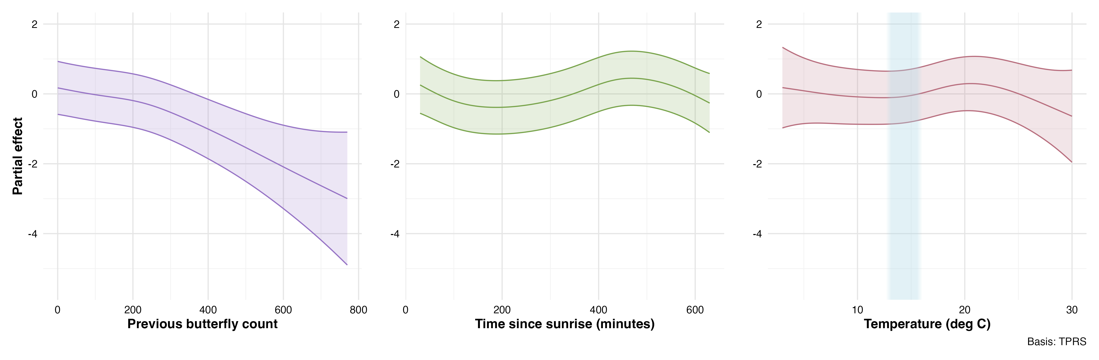

Partial effects of environmental predictors on monarch butterfly abundance changes from the best-fit GAMM model (M50). Shaded regions represent 95% confidence intervals.

The tensor interaction between wind speed and butterflies in direct sun (p < 0.001) revealed a conditional relationship where wind effects depended on solar exposure conditions (Figure 1.2). This interaction term improved model fit substantially, suggesting that the influence of wind on cluster dynamics varies with the thermal environment experienced by roosting monarchs.

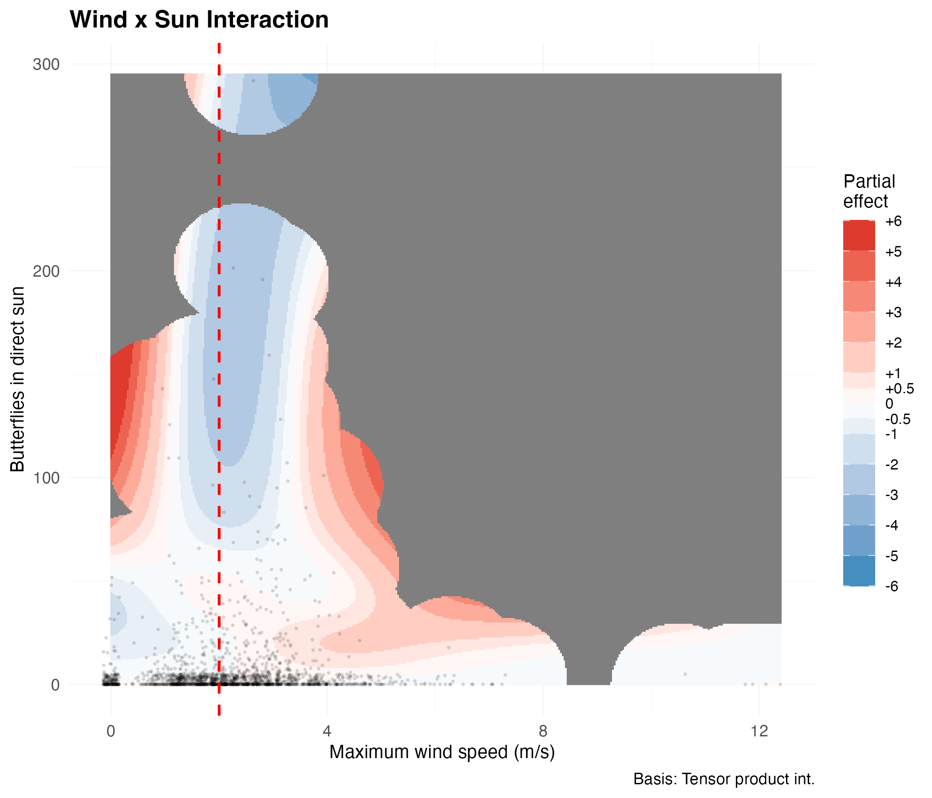

Interaction effect between maximum wind gust speed and butterflies in direct sun on abundance changes. The tensor smooth interaction reveals how wind effects vary with solar exposure conditions.

#### Model Diagnostics

Model diagnostic plots confirmed the adequacy of the GAMM specification (Figure 1.3). Residual versus fitted value plots showed no systematic patterns or heteroscedasticity, indicating appropriate model structure. The quantile-quantile plot revealed approximately normal residual distribution with minor deviations in the tails, acceptable given the large sample size and complexity of ecological data. Basis dimension checks indicated adequate smoothing parameter selection, with all k-indices near 1.0 and p-values > 0.05, except for time since sunrise which showed marginal evidence of potential undersmoothing (k-index = 0.96, p = 0.065).

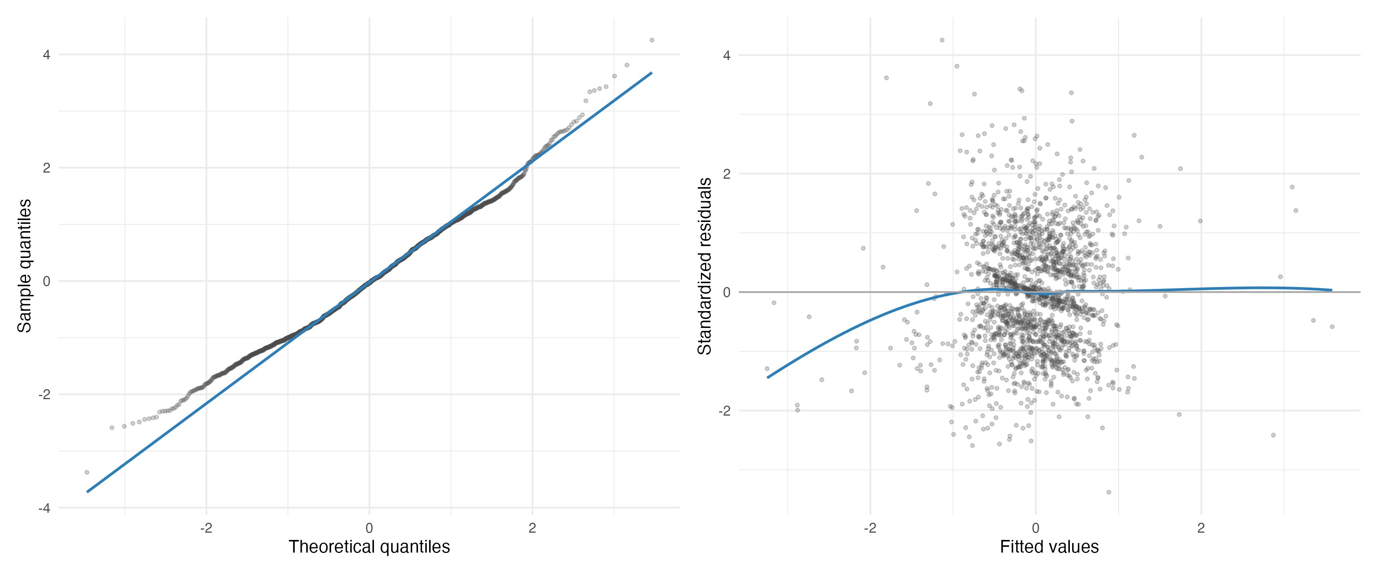

Diagnostic plots for the best-fit GAMM model (M50). Left panel shows quantile-quantile plot comparing model residuals to theoretical normal distribution. Right panel displays residuals versus fitted values to assess homoscedasticity and model adequacy.

Temporal autocorrelation analysis revealed minimal residual correlation structure after accounting for the AR(1) correlation within deployment days (Figure 1.4). The autocorrelation function showed rapid decay with all lags beyond lag 1 falling within the significance bounds, confirming that the model adequately captured temporal dependencies in the data. This indicates that our mixed-effects structure with autoregressive errors appropriately addressed the repeated measures nature of the time-series observations.

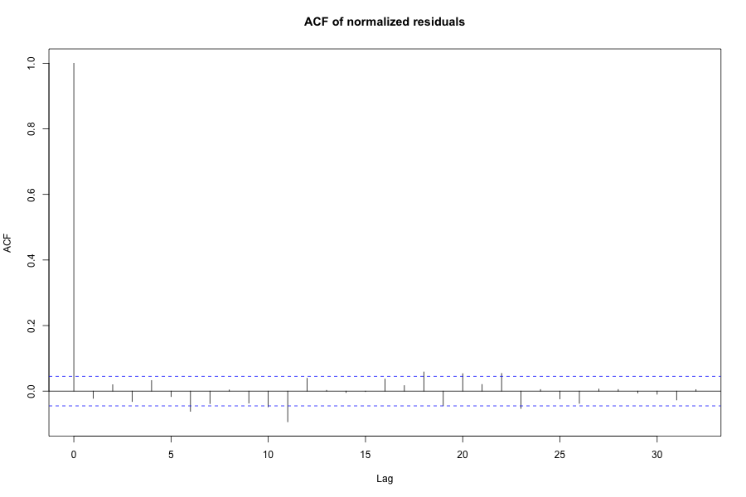

Autocorrelation function of model residuals showing minimal temporal correlation after accounting for AR(1) structure within deployment days. Blue dashed lines indicate 95% confidence bounds for white noise.

#### Sensitivity Analysis

To test the hypothesis that wind acts as a binary disruption threshold rather than a continuous variable, we repeated the entire analysis using minutes above 2 m/s as the wind predictor. This threshold-based approach directly tests whether exceeding the proposed 2 m/s wind speed threshold drives butterfly movement, as suggested by previous literature. The best threshold model (T50) maintained the same structure as our primary analysis but showed notably weaker performance (Table 1.2).

While T50 achieved the lowest AIC among threshold models, it failed to decisively outperform simpler alternatives, capturing only 55.4% of model weight compared to 40.4% for the model without any wind term (T23). The negligible difference in AIC (AIC = 0.63) between these models indicates substantial uncertainty about whether the threshold wind variable improves predictions. Furthermore, the wind threshold term showed weak statistical support even in the best model (p = 0.0001), and non-significant effects in alternative model specifications (e.g., T24: p = 0.372).

Model selection results from sensitivity analysis using wind threshold predictor (minutes with wind speed > 2 m/s). Poor model performance (high <U+0394>AIC values) demonstrates lack of support for the 2 m/s disruption threshold.

| Model ID | Terms included | AIC value | <U+0394>AIC | Weight | Wind threshold p-value |
| --- | --- | --- | --- | --- | --- |
| T24 | - Previous butterfly count\n- Minutes above 2 m/s\n- Temperature\n- Butterflies in direct sun\n- Time since sunrise | 8089.408 | 7.560 | 0.0205 | 0.372 |
| T44 | - Minutes above 2 m/s\n- Temperature\n- Butterflies in direct sun\n- Time since sunrise | 8108.379 | 26.530 | 0.0000 | 0.256 |
| T21 | - Previous butterfly count\n- Minutes above 2 m/s\n- Temperature\n- Butterflies in direct sun | 8110.567 | 28.719 | 0.0000 | 0.0528 |
| T43 | - Minutes above 2 m/s\n- Temperature (linear)\n- Butterflies in direct sun\n- Time since sunrise | 8115.505 | 33.657 | 0.0000 | 0.275 |
| T19 | - Previous butterfly count\n- Minutes above 2 m/s\n- Temperature (linear)\n- Butterflies in direct sun | 8119.798 | 37.949 | 0.0000 | 0.0776 |

The interaction plot from the threshold analysis provides additional evidence against meaningful wind effects on monarch clustering behavior (Figure 1.5). The relatively flat response surface across different combinations of wind exposure duration and solar conditions suggests that time above the 2 m/s threshold does not substantially influence butterfly abundance changes, regardless of thermal conditions. This lack of clear pattern, combined with the poor model performance, supports our conclusion that direct measurement of wind speed provides more appropriate characterization than binary threshold approaches, though neither reveals biologically important effects on monarch cluster dynamics.

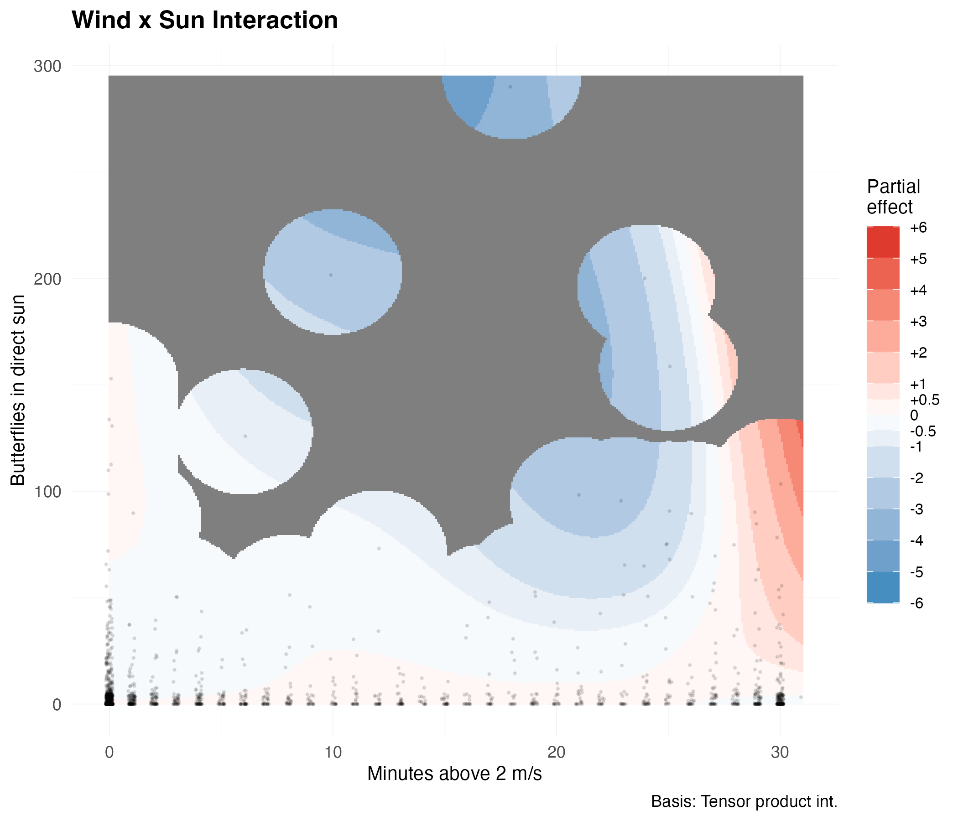

Interaction effect between minutes above 2 m/s wind threshold and butterflies in direct sun from sensitivity analysis. The minimal variation in response across wind exposure categories provides evidence against the threshold disruption hypothesis.

### Statistical Power to Detect Wind Effects

Post-hoc power analysis confirmed our study had adequate statistical power to detect biologically meaningful wind effects (Table 1.3). With 1,894 paired observations, we achieved 87.5% power to detect moderate effect sizes (0.15 standard deviations) and 98.5% power to detect larger effects (0.20 standard deviations). Power for small effects (0.10 standard deviations) was 56%, while very small effects (0.05 standard deviations) yielded only 16.5% power. These results indicate that our study has sufficient statistical power for effect sizes of biological relevance.

Estimated power to detect wind effects of varying magnitudes. Effect sizes are expressed in standard deviations of the response variable (cube root transformed change in butterfly abundance).

|  | Effect Size (SD units) | Power (Proportion) | Power (%) |
| --- | --- | --- | --- |
| 0.05 | 0.05 | 0.165 | 16.5% |
| 0.1 | 0.10 | 0.560 | 56% |
| 0.15 | 0.15 | 0.875 | 87.5% |
| 0.2 | 0.20 | 0.985 | 98.5% |

### Daily Change

To test whether cumulative weather exposure influenced day-to-day roost dynamics, we analyzed 96 consecutive-day pairs from the same deployment dataset using biologically-aligned temporal windows. The primary analysis employed a sunset window spanning from the previous day’s maximum count to the current day’s last observation (mean duration = 29.6 hours), capturing the full period from peak aggregation through the subsequent roosting decision. A secondary analysis using fixed 24-hour windows (n = 94 pairs) provided a sensitivity test of our findings.

Daily maximum cluster sizes ranged from 0 to 770 butterflies (mean = 134.7 ± 138.1), with day-to-day changes in maximum count ranging from losses of 376 butterflies to gains of 464 butterflies (mean change = -10.5 ± 111.6). Within the sunset windows, maximum wind gusts ranged from 2.0 to 12.8 m/s (mean = 4.5 ± 1.8 m/s), with all observation windows exceeding the proposed 2 m/s threshold. Cumulative direct sun exposure varied from 0 to 1,122 butterfly-observations in sunlight per window (mean = 139.8 ± 206.9), reflecting diverse thermal exposure conditions across monitoring days.

## Discussion

### Wind Does Not Disrupt Overwintering Monarch Butterflies

Our study provides the first direct empirical test of the disruptive wind hypothesis and finds no support for wind as a primary factor influencing monarch butterfly clustering behavior. Despite the widespread adoption of the 2 m/s wind threshold in conservation practice, our data reveal no relationship between wind speed and butterfly departures across the full range of observed conditions (0–12 m/s). While our models explain only 5.7% of variance in butterfly movements, reflecting our focus on testing wind effects rather than comprehensively explaining movement patterns, they had sufficient statistical power to detect environmental signals. This finding challenges assumptions underlying over three decades of management guidance.

The absence of wind effects in our data is particularly striking given that observed mean maximum wind speeds (2.2 m/s, SD = 1.4) frequently exceeded the proposed threshold. If the disruptive wind hypothesis were valid, we should have observed a clear signal: substantial reductions in butterfly abundance, as predicted by the disruptive wind hypothesis. Instead, we observed no change, small changes, or even positive changes in butterfly abundance at wind speeds six times the proposed disruption threshold.

Importantly, our power analysis demonstrated 87.5% power to detect moderate effect sizes (0.15 standard deviations) and 98.5% power for larger effects (0.20 standard deviations), while wind appeared in only one of the top five models (M24). In that model wind showed little evidence of an effect (p = 0.218) and resulted in substantially poorer model performance compared to the best model (ΔAIC = 6.2, capturing only 4% of model weight). This weak wind signal, combined with our high statistical power, allows us to rule out all but very small wind effects. Given that the disruptive wind hypothesis predicts conspicious reduction in abundance above threshold wind speeds, a substantial effect by any measure, our failure to detect such patterns provides strong evidence against the hypothesis rather than merely absence of evidence.

The methodological validity of our approach is confirmed by the strong signals detected for other environmental variables. Had our counting method or analytical framework been flawed, we would not have captured the pronounced effects of direct sunlight (F = 19.36, p < 0.001) or the complex diurnal patterns (F = 8.90, p < 0.001) that emerged from the same dataset.

### Alternative Drivers of Monarch Movement

While our study was designed specifically to test the wind hypothesis, our results suggest that thermoregulation, light exposure, and diurnal rhythms play more important roles than wind in driving short-term movements at overwintering sites.

#### Direct Sunlight as the Strongest Predictor

Direct sunlight exposure emerged as the strongest environmental predictor of reductions in cluster abundance in our study (F = 19.36, p < 0.001). Butterflies exposed to direct sunlight at the beginning of an observation interval showed the largest decreases in abundance, suggesting that solar radiation rapidly increases butterfly body temperatures well above ambient conditions. This finding aligns with Masters, Malcolm, and Brower (1988)’s work showing that monarchs in direct sunlight can elevate their body temperature above ambient conditions within minutes. This rapid warming capability could readily explain why direct sunlight exposure is such a strong predictor of decreased abundance at clusters.

The relationship between sunlight and departure represents a key component of the thermoregulatory equation. Monarchs have evolved to efficiently absorb solar radiation, an adaptation that enables flight at temperatures below what would otherwise be physiologically possible (Masters, Malcolm, and Brower 1988). Yet this same efficiency becomes a liability when clustering. Butterflies cannot avoid absorbing heat when exposed to direct sun, risking overheating and accelerated depletion of their finite lipid reserves through elevated metabolism (Masters, Malcolm, and Brower 1988). This forces them to abandon energetically favorable clustering positions even when ambient temperatures remain cool. This trade-off between the benefits of clustering and the thermal constraints imposed by solar exposure may fundamentally shape daily movement patterns at overwintering sites.

#### Temperature Effects and Their Interpretation

Ambient temperature showed a subtle but significant relationship with monarch abundance changes (EDF = 3.93, F = 3.23, p = 0.028). The data suggest minimal change below 15°C (within the known flight threshold), a slight positive association around 20–21°C, and sharp declines above 25°C, consistent with thermoregulatory constraints. Given that available temperatures vary latitudinally across overwintering sites (Saniee and Villablanca 2022), our results from Spring Canyon capture only a portion of the temperature continuum experienced across the entire overwintering range. The temperature effects we observed reflect responses within the specific thermal envelope available at our study latitude. Testing these patterns at sites spanning the full latitudinal gradient would reveal whether monarch responses to temperature are consistent or vary with local thermal regimes.

#### Diurnal Activity Patterns

Time since sunrise revealed distinct diurnal patterns (EDF = 4.90, F = 8.90, p < 0.001), with butterflies departing clusters in the morning and reforming aggregations in the afternoon. This pattern persists even after controlling for temperature and sunlight, aligning with anecdotal observations from overwintering sites throughout California (Tuskes and Brower 1978; Chaplin and Wells 1982; Frey and Leong 1993).

### Study Limitations

Several limitations warrant consideration. Our data derive from a single season (2023–2024) with typical monarch abundance at two sites (Xerces Society 2025a). The following season (2024–2025), virtually no clustering monarchs were observed at Vandenberg Space Force Base (23 individuals total) despite monitoring 10 sites. This coincided with the second-lowest overwintering population on record statewide (Xerces Society 2025b), preventing temporal replication of our study. Additionally, our counting methodology introduced discretization artifacts that contributed to large confidence intervals for environmental predictors. While we detected strong signals like direct sunlight effects, more subtle relationships require careful interpretation.

Furthermore, our study observed clusters where butterflies maintained direct substrate contact. In historically massive aggregations containing hundreds of thousands of individuals, many butterflies attach only to other butterflies, creating multi-layered formations (L. P. Brower et al. 2008). If substrate attachment confers greater wind resistance than butterfly-to-butterfly attachment, the disruptive wind hypothesis might apply specifically to these larger aggregations. Future work should examine whether wind responses differ between substrate-attached and butterfly-attached individuals, particularly at sites supporting extreme densities.

### Management Implications

Our findings suggest that management strategies prioritizing wind protection warrant reconsideration. The absence of wind effects despite frequent threshold exceedances indicates that usable habitat within existing groves may be larger than currently recognized. Areas previously dismissed due to perceived wind exposure may provide suitable conditions because they offer appropriate light and thermal regimes.

While past management efforts aimed at wind protection may have been based on incomplete understanding, they likely produced beneficial outcomes by increasing tree density. The fundamental recommendation to plant and maintain trees remains sound. Management should prioritize maintaining existing mature trees while establishing future roosting habitat at densities that support healthy, long-lived growth. In addition, as suggested by Saniee and Villablanca (2022), it may become relevant to explore ways in which to manage for thermal attributes, specifically sunlight.

### Future Research Directions

Our findings open several important avenues for future research. First, explicit testing of light patterns as predictors of clustering locations could establish whether canopy structure guides habitat selection. The strong effect of direct sunlight (F = 19.36, p < 0.001) combined with the predictability of canopy-created light patterns suggests this may be a primary factor in roost site selection. Monarchs possess well-developed visual systems that enable sophisticated navigation during migration, including specialized neurons tuned to track celestial cues and the ability to detect polarized light patterns (Nguyen et al. 2021; Mouritsen and Frost 2002). This visual acuity, demonstrated in their use of sun compass orientation during long-distance migration, suggests they are fully capable of detecting and responding to the consistent light patterns created by canopy structure. Previous research also suggests light conditions may play an important role in habitat selection. (Stuart B. Weiss et al. 1991) examined canopy structure across monarch aggregation sites with different occupancy histories in Santa Barbara County, California. Sites were classified as “permanent sites” that support aggregations throughout the overwintering season (October through March), “transient sites” that support aggregations for only part of the season, or “former sites” that once supported aggregations but no longer do so. Using hemispherical photography to measure the Indirect Site Factor (ISF), which quantifies percent canopy openness, Weiss found that permanent overwintering sites clustered within a narrow range of canopy openness (approximately 20%) with relatively low variance, while transient and former sites showed progressively greater variability (Figure 1.6). This pattern of consistent light conditions at successful sites provides additional context for understanding how canopy structure might influence clustering behavior.

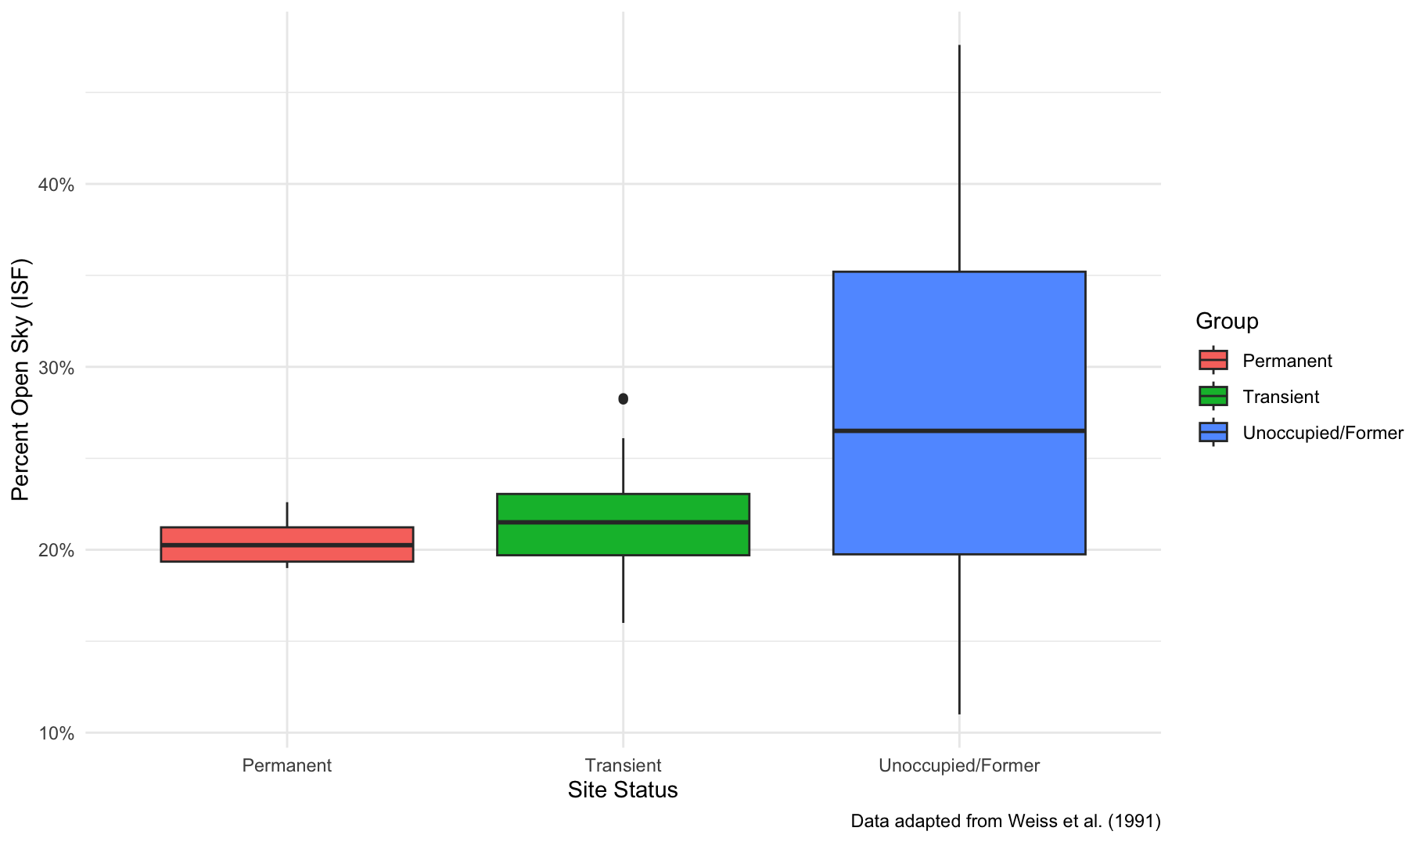

Percent canopy openness (Indirect Site Factor) by occupancy status, adapted from Weiss et al. (1991). Permanent overwintering sites exhibit both a specific range of canopy openness ( 20%) and lower variance compared to transient and unoccupied/former sites.

Second, investigation of social dynamics and positive behavioral feedback mechanisms could address unexplained variation in our models. Monarchs may exhibit emergent clustering behaviors where initial settlement increases the probability of others joining, creating self-reinforcing patterns independent of environmental conditions (Berdahl et al. 2013).

Research should also examine whether our findings extend across the broader overwintering range. Testing these patterns at sites with different tree species, latitudes, and in particular population densities would strengthen conclusions about the generality of wind effects, or their absence.

### Conclusions

Wind did not disrupt monarch clusters even at speeds far exceeding presumptive thresholds. Instead, butterflies responded primarily to thermal conditions, including light exposure and ambient temperature, and to diurnal rhythms. These findings challenge current assumptions about overwintering habitat requirements and suggest that management priorities should be reevaluated. While our study represents one season at two sites, the absence of wind effects despite adequate statistical power raises important questions regarding decades of conservation guidelines. As monarch populations face continued threats, evidence-based management becomes increasingly critical for conserving the overwintering sites essential for this iconic species.

## References

Alonso-Mejia, Alfonso, and Alfredo Arellano-Guillermo. 1992. “Influence of Temperature, Surface Body Moisture and Height Aboveground on Survival of Monarch Butterflies Overwintering in Mexico.” *Biotropica* 24 (3): 415–19. <https://doi.org/10.2307/2388612>.

Althouse & Meade, Inc., and Creekside Science. 2023. “Ellwood Mesa/Sperling Preserve Open Space Monarch Butterfly Overwintering Habitat Analysis and Recommendations For Restoration.” Goleta, CA: City of Goleta - Public Works Department.

Barker, John F., and William S. Herman. 1976. “Effect of Photoperiod and Temperature on Reproduction of the Monarch Butterfly, *Danaus Plexippus*.” *Journal of Insect Physiology* 22 (12): 1565–68. <https://doi.org/10.1016/0022-1910(76)90046-9>.

Baudier, Kaitlin M., Catherine L. D’Amelio, Rumaan Malhotra, Michael P. O’Connor, and Sean O’Donnell. 2018. “Extreme Insolation: Climatic Variation Shapes the Evolution of Thermal Tolerance at Multiple Scales.” *The American Naturalist* 192 (3): 347–59. <https://doi.org/10.1086/698656>.

Bell, William J., and Ernst Kramer. 1979. “Search and Anemotactic Orientation of Cockroaches.” *Journal of Insect Physiology* 25 (8): 631–40. <https://doi.org/10.1016/0022-1910(79)90112-4>.

Berdahl, Andrew, Colin J. Torney, Christos C. Ioannou, Jolyon J. Faria, and Iain D. Couzin. 2013. “Emergent Sensing of Complex Environments by Mobile Animal Groups.” *Science* 339 (6119): 574–76. <https://doi.org/10.1126/science.1225883>.

Bidlingmayer, W. L., J. F. Day, and D. G. Evans. 1995. “Effect of Wind Velocity on Suction Trap Catches of Some Florida Mosquitoes.” *Journal of the American Mosquito Control Association* 11 (3): 295–301. <https://www.ncbi.nlm.nih.gov/pubmed/8551296>.

Blois-Heulin, Catherine, Philip H. Crowley, Margarett Arrington, and Dan M. Johnson. 1990. “Direct and Indirect Effects of Predators on the Dominant Invertebrates of Two Freshwater Littoral Communities.” *Oecologia* 84 (3): 295–306. <https://doi.org/10.1007/BF00329753>.

Bonte, D., and L. Lens. 2007. “Heritability of Spider Ballooning Motivation Under Different Wind Velocities.” *Evolutionary Ecology Research*. <https://www.semanticscholar.org/paper/Heritability-of-spider-ballooning-motivation-under-Bonte-Lens/d6118c2cd143572bc4f098b5916186ec63c0f12a>.

Brower, L. 1995. “Understanding and Misunderstanding the Migration of the Monarch Butterfly (Nymphalidae) in North America: 1857-1995.” *Journal of The Lepidopterists Society*, March. <https://www.semanticscholar.org/paper/Understanding-and-misunderstanding-the-migration-of-Brower/79380ddbf559e310fef9bb8919c03c63ccddecb7>.

Brower, Lincoln P., Ernest Williams, Linda Fink, Raúl Zubieta, and M. Ramírez. 2008. “Monarch Butterfly Clusters Provide Microclimatic Advantages During the Overwintering Season in Mexico.” *Journal of the Lepidopterists’ Society* 62 (December): 177–88.

Calvert, William H., Willow Zuchowski, and Lincoln P. Brower. 1983. “The Effect of Rain, Snow and Freezing Temperatures on Overwintering Monarch Butterflies in Mexico.” *Biotropica* 15 (1): 42–47. <https://doi.org/10.2307/2387997>.

Chaplin, Susan B., and Patrick H. Wells. 1982. “Energy Reserves and Metabolic Expenditures of Monarch Butterflies Overwintering in Southern California.” *Ecological Entomology* 7 (3): 249–56. <https://doi.org/10.1111/j.1365-2311.1982.tb00664.x>.

Chown, Steven L., Jesper G. Sørensen, and John S. Terblanche. 2011. “Water Loss in Insects: An Environmental Change Perspective.” *Journal of Insect Physiology*, "Cold and Desiccation Tolerance" honoring Karl Erik Zachariassen, 57 (8): 1070–84. <https://doi.org/10.1016/j.jinsphys.2011.05.004>.

Cockrell, Barbara J., Stephen B. Malcolm, and Lincoln P. Brower. 1993. “Time, Temperature, and Latitudinal Constraints on the Annual Recolonization of Eastern North America by the Monarch Butterfly.” *Biology and Conservation of the Monarch Butterfly* 38: 233–51. <https://hero.epa.gov/hero/index.cfm/reference/details/reference_id/52731>.

Crone, Elizabeth E., Emma M. Pelton, Leone M. Brown, Cameron C. Thomas, and Cheryl B. Schultz. 2019. “Why Are Monarch Butterflies Declining in the West? Understanding the Importance of Multiple Correlated Drivers.” *Ecological Applications* 29 (7). <https://doi.org/10.1002/eap.1975>.

Everatt, Matthew J., Pete Convey, Jeffrey S. Bale, M. Roger Worland, and Scott A. L. Hayward. 2015. “Responses of Invertebrates to Temperature and Water Stress: A Polar Perspective.” *Journal of Thermal Biology*, What sets the limit? How thermal limits, performance and preference in ectotherms are influenced by water or energy balance, 54 (December): 118–32. <https://doi.org/10.1016/j.jtherbio.2014.05.004>.

Fisher, Ashley, Kiana Saniee, Charis Van der Heide, Jessica Griffiths, Daniel Meade, and Francis Villablanca. 2018. “Climatic Niche Model for Overwintering Monarch Butterflies in a Topographically Complex Region of California.” *Insects* 9 (4): 167. <https://doi.org/10.3390/insects9040167>.

Freedman, Micah G., Jacobus C. de Roode, Matthew L. Forister, Marcus R. Kronforst, Amanda A. Pierce, Cheryl B. Schultz, Orley R. Taylor, and Elizabeth E. Crone. 2021. “Are Eastern and Western Monarch Butterflies Distinct Populations? A Review of Evidence for Ecological, Phenotypic, and Genetic Differentiation and Implications for Conservation.” *Conservation Science and Practice* 3 (7): e432. <https://doi.org/10.1111/csp2.432>.

Frey, Dennis F., and Kingston L. H. Leong. 1993. “Can Microhabitat Selection or Differences in ’Catchability’ Explain Male-Biased Sex Ratios in Overwintering Populations of Monarch Butterflies?” *Animal Behaviour* 45 (5): 1025–27. <https://doi.org/10.1006/anbe.1993.1120>.

Goehring, Liz, and Karen S. Oberhauser. 2002. “Effects of Photoperiod, Temperature, and Host Plant Age on Induction of Reproductive Diapause and Development Time in Danaus Plexippus.” *Ecological Entomology* 27 (6): 674–85. <https://doi.org/10.1046/j.1365-2311.2002.00454.x>.

Hanrahan, Shirley A., and Wolfgang H. and Kirchner. 1997. “The Effect of Wind on Foraging Activity of the Tenebrionid Beetle Lepidochora Discoidalis in the Sand Dunes of the Namib Desert.” *South African Journal of Zoology* 32 (4): 136–39. <https://doi.org/10.1080/02541858.1997.11448445>.

Herman, W. S., and M. Tatar. 2001. “Juvenile Hormone Regulation of Longevity in the Migratory Monarch Butterfly.” *Proceedings of the Royal Society B: Biological Sciences* 268 (1485): 2509–14. <https://doi.org/10.1098/rspb.2001.1765>.

Hristov, Nickolay I., Dionysios Nikolaidis, Tatjana Y. Hubel, and Louise C. Allen. 2019. “Estimating Overwintering Monarch Butterfly Populations Using Terrestrial LiDAR Scanning.” *Frontiers in Ecology and Evolution* 7. <https://www.frontiersin.org/articles/10.3389/fevo.2019.00266>.

Jepsen, Sarina J., and Scott Hoffman Black. 2015. “Understanding and Conserving the Western North American Monarch Population.” In *Monarchs in a Changing World: Biology and Conservation of an Iconic Butterfly*, edited by Karen S. Oberhauser, Kelly R. Nail, and Sonia Altizer, 147–56. Cornell University Press.

Jepsen, Sarina, Emma Pelton, Scott Hoffman Black, Candace Fallon, Carly Voight, and Stuart B. Weiss. 2017. “Protecting California’s Butterfly Groves: Management Guidelines for Monarch Butterfly Overwintering Habitat.” Portland, OR: The Xerces Society for Invertebrate Conservation. <https://xerces.org/protecting-californias-butterfly-groves>.

Jepsen, Sarina, Dale F Schweitzer, Bruce Young, Nicole Sears, Margaret Ormes, and Scott Hoffman Black. 2015. “Conservation Status and Ecology of the Monarch Butterfly in the United States.” 15-016_01. Arlington, VA; Portland, OR. <https://www.xerces.org>.

Kammer, Ann E. 1970. “Thoracic Temperature, Shivering, and Flight in the Monarch Butterfly, Danaus Plexippus (L.).” *Zeitschrift Für Vergleichende Physiologie* 68 (3): 334–44. <https://doi.org/10.1007/BF00298260>.

Lafferty, Kevin D., and Jenny C. Shaw. 2013. “Comparing Mechanisms of Host Manipulation Across Host and Parasite Taxa.” *Journal of Experimental Biology* 216 (1): 56–66. <https://doi.org/10.1242/jeb.073668>.

Leonard, Ryan J, Clare McArthur, and Dieter F Hochuli. 2016. “Exposure to Wind Alters Insect Herbivore Behaviour in Larvae of Uraba Lugens (Lepidoptera: Nolidae).” *Austral Entomology* 55 (3): 242–46. <https://doi.org/10.1111/aen.12175>.

Leong, K. L. H. 1999. “Restoration of an Overwintering Grove in Los Osos, San Luis Obispo County, California.” In *1997 North American Conference on the Monarch Butterfly. Eds. J. Hoth, L. Merino, K. Oberhauser, I. Pisanty, S. Price, and T. Wilkinson*, 221–18.

Leong, Kingston L H. 2016. “Evaluation and Management of California Monarch Winter Sites.”

Leong, Kingston L. H., D. Frey, G. Brenner, S. Baker, and D. Fox. 1991. “Use of Multivariate Analyses to Characterize the Monarch Butterfly (Lepidoptera: Danaidae) Winter Habitat.” *Annals of the Entomological Society of America* 84 (3): 263–67. <https://doi.org/10.1093/aesa/84.3.263>.

Leong, Kingston. L. H. 1990. “Microenvironmental Factors Associated with the Winter Habitat of the Monarch Butterfly (Lepidoptera: Danaidae) in Central California.” *Annals of the Entomological Society of America* 83 (5): 906–10. <https://doi.org/10.1093/aesa/83.5.906>.

Marini, Lorenzo, and Myron P Zalucki. 2017. “Density-Dependence in the Declining Population of the Monarch Butterfly.” *Scientific Reports* 7. <https://doi.org/10.1038/s41598-017-14510-w>.

Masters, Alan R., Stephen B. Malcolm, and Lincoln P. Brower. 1988. “Monarch Butterfly (Danaus Plexippus) Thermoregulatory Behavior and Adaptations for Overwintering in Mexico.” *Ecology* 69 (2): 458–67. <https://doi.org/10.2307/1940444>.

Miller-ter Kuile, Ana, Austen Apigo, An Bui, Bartholomew DiFiore, Elizabeth S. Forbes, Michelle Lee, Devyn Orr, et al. 2022. “Predator–Prey Interactions of Terrestrial Invertebrates Are Determined by Predator Body Size and Species Identity.” *Ecology* 103 (5): e3634. <https://doi.org/10.1002/ecy.3634>.

Mouritsen, Henrik, and Barrie J. Frost. 2002. “Virtual Migration in Tethered Flying Monarch Butterflies Reveals Their Orientation Mechanisms.” *Proceedings of the National Academy of Sciences of the United States of America* 99 (15): 10162–66. <https://doi.org/10.1073/pnas.152137299>.

Nathan, Ran, Nir Sapir, Ana Trakhtenbrot, Gabriel G. Katul, Gil Bohrer, Martin Otte, Roni Avissar, et al. 2005. “Long-Distance Biological Transport Processes Through the Air: Can Nature’s Complexity Be Unfolded in Silico?” *Diversity and Distributions* 11 (2): 131–37. <https://doi.org/10.1111/j.1366-9516.2005.00146.x>.

Nguyen, Tu Anh Thi, M. Jerome Beetz, Christine Merlin, and Basil el Jundi. 2021. “Sun Compass Neurons Are Tuned to Migratory Orientation in Monarch Butterflies.” *Proceedings of the Royal Society B: Biological Sciences* 288 (1945): 20202988. <https://doi.org/10.1098/rspb.2020.2988>.

Pelton, Emma. 2020. “Monarch Butterfly Overwintering Site Management Plan for Pismo State Beach: North Beach Campground Site.” Pismo State Beach, California: The Xerces Society for Invertebrate Conservation.

Pelton, Emma M., Cheryl B. Schultz, Sarina J. Jepsen, Scott Hoffman Black, and Elizabeth E. Crone. 2019. “Western Monarch Population Plummets: Status, Probable Causes, and Recommended Conservation Actions.” *Frontiers in Ecology and Evolution* 7. <https://www.frontiersin.org/articles/10.3389/fevo.2019.00258>.

Reppert, Steven M., and Jacobus C. de Roode. 2018. “Demystifying Monarch Butterfly Migration.” *Current Biology* 28 (17): R1009–22. <https://doi.org/10.1016/j.cub.2018.02.067>.

Saniee, Kiana, and Francis Villablanca. 2022. “Hierarchy and Scale Influence the Western Monarch Butterfly Overwintering Microclimate.” *Frontiers in Conservation Science* 3. <https://www.frontiersin.org/articles/10.3389/fcosc.2022.844299>.

Schultz, Cheryl B., Leone M. Brown, Emma Pelton, and Elizabeth E. Crone. 2017. “Citizen Science Monitoring Demonstrates Dramatic Declines of Monarch Butterflies in Western North America.” *Biological Conservation* 214 (October): 343–46. <https://doi.org/10.1016/j.biocon.2017.08.019>.

Schweizer, Mona, Rita Triebskorn, and Heinz-R. Köhler. 2019. “Snails in the Sun: Strategies of Terrestrial Gastropods to Cope with Hot and Dry Conditions.” *Ecology and Evolution* 9 (22): 12940–60. <https://doi.org/10.1002/ece3.5607>.

Solensky, Michelle J. 2004. “Overview of Monarch Migration.” *The Monarch Butterfly: Biology and Conservation* 546: 79–83. <https://books.google.com/books?hl=en&lr=&id=H5nRqhCGA4UC&oi=fnd&pg=PA79&dq=Solensky,+M.J.+2004.+%22Overview+of+monarch+migration.%22+Pp.+79%E2%80%9383+in+Oberhauser+K.S.,+Solensky+M.J.,+eds.+The+Monarch+Butterfly:+Biology+and+Conservation.+Ithaca,+NY:+Cornell+University+Press.+(Cited+for+overwintering+locations)+.&ots=VnM9RX0Zgf&sig=eF0U4gBCGf47G-d3TFVnGnmB4ZY>.

The Monarch Press. 2019. “City Awarded $3.9 Million in Funding for the Monarch Butterfly Habitat Management Plan.” June 2019. <https://www.goletamonarchpress.com/2019/06/city-awarded-3-9-million-in-funding-for-the-monarch-butterfly-habitat-management-plan/>.

Tuskes, P. M., and L. P. Brower. 1978. “Overwintering Ecology of the Monarch Butterfly, Danaus Plexippus L., in California.” *Ecological Entomology* 3 (2): 141–53. <https://doi.org/10.1111/j.1365-2311.1978.tb00912.x>.

Urquhart, F. A., and N. R. Urquhart. 1978. “Autumnal Migration Routes of the Eastern Population of the Monarch Butterfly (*Danaus p*. *Plexippus* L.; Danaidae; Lepidoptera) in North America to the Overwintering Site in the Neovolcanic Plateau of Mexico.” *Canadian Journal of Zoology* 56 (8): 1759–64.

U.S. Fish and Wildlife Service. 2024. “Monarch (Danaus Plexippus) Species Status Assessment Report.” version 2.3.

Velilla, Estefania, Matías Muñoz, Nicol Quiroga, Laurel Symes, Hannah M. ter Hofstede, Rachel A. Page, Ralph Simon, Jacintha Ellers, and Wouter Halfwerk. 2020. “Gone with the Wind: Is Signal Timing in a Neotropical Katydid an Adaptive Response to Variation in Wind-Induced Vibratory Noise?” *Behavioral Ecology and Sociobiology* 74 (5): 59. <https://doi.org/10.1007/s00265-020-02842-z>.

Vidal, Omar, and Eduardo Rendón-Salinas. 2014. “Dynamics and Trends of Overwintering Colonies of the Monarch Butterfly in Mexico.” *Biological Conservation* 180 (December): 165–75. <https://doi.org/10.1016/j.biocon.2014.09.041>.

Weiss, Stuart B. 2018. “Albany Hill Monarch Habitat Assessment.” Creekside Science.

Weiss, Stuart B., and Paul M. Rich. 2008. “Recommendations for Restoration of Monarch Butterfly Winter Habitat at Norma B. Gibbs Park, Huntington Beach, CA.” Menlo Park, CA: Creekside Center for Earth Observation. <http://www.creeksidescience.com>.

Weiss, Stuart B., Paul M. Rich, Dennis D. Murphy, William H. Calvert, and Paul R. Ehrlich. 1991. “Forest Canopy Structure at Overwintering Monarch Butterfly Sites: Measurements with Hemispherical Photography.” *Conservation Biology* 5 (2): 165–75. <https://doi.org/10.1111/j.1523-1739.1991.tb00121.x>.

Xerces Society. 2016. “State of the Monarch Overwintering Sites in California.” 16-015_01. Portland, OR: The Xerces Society for Invertebrate Conservation. <https://www.xerces.org/sites/default/files/2018-05/16-015_01_XercesSoc_State-of-Monarch-Overwintering-Sites-in-California_web.pdf>.

———. 2018. “Managing for Monarchs in the West: Best Management Practices for Conserving the Monarch Butterfly and Its Habitat.” Portland, OR: The Xerces Society for Invertebrate Conservation. [www.xerces.org](https://www.xerces.org).

———. 2025a. “Western Monarch Thanksgiving Count and New Year’s Count Data, 1997-2025.” [WesternMonarchCount.com](https://WesternMonarchCount.com).

———. 2025b. “Western Monarch Butterfly Population Declines to Near Record Low.” March 6, 2025. <https://www.xerces.org/press/western-monarch-butterfly-population-declines-to-near-record-low>.

Yang, Louie H., Dmitry Ostrovsky, Matthew C. Rogers, and Jeffery M. Welker. 2016. “Intra‐population Variation in the Natal Origins and Wing Morphology of Overwintering Western Monarch Butterflies *Danaus Plexippus*.” *Ecography* 39 (10): 998–1007. <https://doi.org/10.1111/ecog.01994>.

Zalucki, Myron P. 1982. “Temperature and Rate of Development in Danaus Plexippus L. And D. Chrysippus L. (Lepidoptera:nymphalidae).” *Australian Journal of Entomology* 21 (4): 241–46. <https://doi.org/10.1111/j.1440-6055.1982.tb01803.x>.