# Introduction

The distribution and survival of invertebrate species are governed by a complex interplay of biotic and abiotic factors. Biotic interactions shape community dynamics through competition for resources, predation pressure, parasitism, and mutualistic relationships. For example, predators can exert strong indirect effects on prey populations through behavioral avoidance strategies that alter habitat use and activity patterns (Blois-Heulin et al. 1990). Parasites can manipulate host behavior to enhance their own transmission, often through neuromodulatory mechanisms that alter microhabitat selection (Lafferty and Shaw 2013). Recent work using DNA metabarcoding has confirmed that predator size and species identity are key drivers structuring highly diverse terrestrial invertebrate communities (Miller-ter Kuile et al. 2022). While these biotic interactions profoundly influence community assembly, abiotic conditions often set the fundamental limits determining where invertebrates can persist. Temperature fundamentally constrains invertebrate physiology across all latitudes, from Antarctic midges (*Belgica antarctica*) that survive repeated freeze-thaw cycles through cryoprotective dehydration (Everatt et al. 2015), to desert land snails (*Sphincterochila boissieri*) that tolerate internal temperatures up to 55°C through metabolic downregulation and behavioral thermoregulation (Schweizer, Triebskorn, and Köhler 2019). In marine systems, temperature acts as the primary driver of larval development rates, creating predictable latitudinal gradients in reproductive timing and dispersal potential (HOEGH-GULDBERG and PEARSE 1995). Rising temperatures mechanistically increase metabolic rates and respiratory water loss, creating compound stress in warming environments (Chown, Sørensen, and Terblanche 2011). Water availability shapes invertebrate communities, with stream macroinvertebrates exhibiting rapid recolonization strategies in ephemeral systems where rainfall controls hydrological disturbance regimes (Carvallo et al. 2022). Terrestrial invertebrates display remarkable water stress adaptations, from desert beetles that harvest fog water (Chown, Sørensen, and Terblanche 2011) to soil invertebrates employing cryoprotective dehydration to avoid tissue freezing (Holmstrup, Bayley, and Ramløv 2002). Cave arthropods require near-saturation humidity, with species composition shifting as relative humidity fluctuates daily in twilight zones (Mammola and Isaia 2018). Solar radiation structures communities through both physiological impacts and behavioral effects. In intertidal zones, high solar radiation proves lethal to early life stages through synergistic interactions with heat and desiccation stress (Gosselin and Jones 2010; Chapperon et al. 2016). Army ants demonstrate habitat-specific evolution of critical thermal maxima tied to insolation exposure (Baudier et al. 2018), while terrestrial gastropods climb vertical surfaces to escape ground-level heat and evolve reflective pigmentation in sun-exposed populations (Schweizer, Triebskorn, and Köhler 2019). Solar cycles drive activity patterns from diurnal butterflies synchronizing with daylight to subtidal invertebrates timing nocturnal emergence to avoid visual predators (Saigusa 2001). Among these abiotic factors, wind emerges as a particularly complex environmental force shaping invertebrate ecology.

Wind influences invertebrate behavior and ecology through diverse mechanisms that vary across species and life stages. Some species exploit wind for dispersal, such as spiders that exhibit heritable variation in ballooning motivation based on wind velocity thresholds (Bonte and Lens 2007). Other invertebrates respond to wind as an environmental stressor, with herbivorous larvae moving to leeward sides of leaves to maintain feeding efficiency when exposed to turbulent conditions (Leonard, McArthur, and Hochuli 2016). Cockroaches demonstrate clear behavioral thresholds, shifting from upwind orientation to crosswind escape when wind speeds exceed specific velocities (Bell and Kramer 1979). Beyond simple average speeds, wind’s effects depend on its multidimensional characteristics including consistency, gustiness, and turbulence patterns. Understanding long-distance biological transport through air requires knowledge of turbulent deviations from mean flow, not just average conditions (Nathan et al. 2005). Species-specific thresholds trigger distinct behavioral responses, from foraging cessation to microhabitat shifts to active dispersal. This complexity in wind-organism interactions becomes particularly evident when examining species that must navigate multiple life stages with different environmental exposures.

Many invertebrates exploit habitats where other organisms, particularly plants, modify local abiotic conditions to create more favorable microclimates. Forest canopies exemplify this phenomenon by moderating environmental extremes within their three-dimensional structure. Trees reduce wind speeds through physical baffling, with dense canopies capable of reducing wind penetration by over 90% compared to open areas. Light exposure becomes filtered and heterogeneous, creating a mosaic of sun flecks and shade that shifts throughout the day. Temperature fluctuations are buffered, with forest interiors experiencing cooler maximum temperatures during the day and warmer minimum temperatures at night compared to adjacent open areas. Humidity remains elevated through reduced evaporation and continuous transpiration from foliage. This moderation of environmental conditions by vegetation structure creates distinct microclimates that can differ dramatically from regional conditions, enabling species to persist in areas that would otherwise exceed their physiological tolerances. The creation and exploitation of these modified environments is fundamental to understanding habitat selection patterns in many invertebrate species.

The monarch butterfly (*Danaus plexippus*) presents an excellent system for studying how abiotic factors, particularly wind, influence invertebrate ecology across complex life histories. This species undergoes one of nature’s most remarkable migrations, with individuals traveling thousands of kilometers between breeding and overwintering grounds. Throughout their annual cycle, monarchs experience dramatically different environmental conditions: from temperate breeding habitats to coastal overwintering sites, from open meadows to dense forest groves, from solitary existence to massive aggregations. Their clear behavioral responses to temperature, light, wind, and other abiotic factors have been documented across multiple life stages. This combination of complex life history, long-distance movement, and observable responses to environmental conditions makes monarchs an ideal model for examining how invertebrates navigate heterogeneous abiotic landscapes.

Individual monarch development proceeds through complete metamorphosis with each stage exhibiting specific thermal requirements and tolerances. Temperature governs development rates from egg through adult emergence, with development accelerating within physiological limits as temperatures increase. During the breeding phase, monarchs produce multiple generations per year, with three to four generations typical in northern portions of their range. Each generation exploits milkweed (*Asclepias* spp.) as larvae spread across an expanding geographic range following spring warming. This obligate relationship with milkweed constrains breeding opportunities, as larvae require these plants both for nutrition and for sequestering cardiac glycosides that provide chemical defense against predators. Milkweed distribution and phenology, in turn, depend on temperature and precipitation patterns. During favorable conditions, rapid reproduction enables population growth, with individual females capable of laying hundreds of eggs. Temperature limits both larval development and adult flight activity, while precipitation affects milkweed quality and nectar availability from adult food sources. Photoperiod provides critical seasonal cues, signaling when environmental conditions will soon become unsuitable for continued breeding.

As autumn approaches, decreasing photoperiod and cooling temperatures trigger a remarkable physiological transformation in the final summer generation. These environmental cues, combined with declining milkweed quality, induce reproductive diapause through juvenile hormone suppression. This hormonal shift halts reproductive development and initiates a suite of changes that create a "super generation" adapted for long-distance migration and extended survival. Monarchs accumulate lipids up to 125% of their lean body weight, storing energy reserves that must sustain them through migration and months of overwintering. Their lifespan extends from the typical 2-5 weeks of breeding adults to 8-9 months. Body size increases, with larger wings providing enhanced flight capacity. Perhaps most remarkably, oriented flight behavior emerges, enabling navigation across thousands of kilometers to specific overwintering locations. These coordinated changes prepare monarchs for the energetic demands of migration and the extended period of reproductive dormancy during overwintering.

Overwintering represents a critical phase in the monarch annual cycle, driven by the unsuitability of breeding habitat during winter months. Persistent freezing temperatures across northern breeding ranges would kill adults, while milkweed senesces and disappears from the landscape, making reproduction impossible even if adults could survive. Eastern monarch populations migrate to high-elevation Oyamel fir forests in central Mexico, where tens of millions of individuals concentrate in forest patches totaling less than 30 hectares. Western populations migrate to coastal California sites, primarily roosting in introduced eucalyptus groves but also utilizing native conifers and other trees. The overwintering period extends 4-5 months, during which monarchs must survive exclusively on lipid reserves accumulated during autumn migration. Survival requires avoiding multiple threats including predation, freezing, and desiccation while maintaining energy balance without significant feeding opportunities. To meet these challenges, monarchs form dense aggregations containing thousands to millions of individuals. Clustering reduces individual surface area exposure to environmental extremes, provides thermal benefits through reduced convective heat loss, and offers protection from predators through dilution effects and collective vigilance. However, storms can devastate entire aggregations, temperature fluctuations can trigger premature lipid depletion, and concentrated populations become vulnerable to disease transmission and localized habitat degradation.

Early research on monarch overwintering sites in the 1970s and 1980s focused primarily on understanding the thermal benefits of clustering behavior, particularly in Mexican overwintering sites where freezing represents a major mortality source. Researchers recognized that forest structure played a crucial role in protecting butterflies from environmental extremes. Building on these observations, Leong synthesized field observations from California overwintering sites into a formal "microclimate hypothesis" in 1990 (Kingston. L. H. Leong 1990). This hypothesis proposed that monarchs select groves providing a specific envelope of suitable abiotic conditions. The original parameters included mild temperatures averaging 13°C to keep butterflies below their flight threshold and minimize metabolic expenditure, high humidity to prevent desiccation during months without drinking water, dappled sunlight allowing thermoregulation without triggering dispersal from clusters, and critically, protection from wind speeds exceeding 2 m/s to prevent physical disruption of aggregations. The underlying principle suggested that all these conditions work synergistically to minimize metabolic expenditure, thereby conserving precious lipid reserves. This conceptual framework quickly gained widespread adoption, becoming the foundation for management guidelines at overwintering sites throughout California.

Over the subsequent decades, empirical research has systematically challenged most components of the original microclimate hypothesis, revealing a more complex and scale-dependent pattern of habitat selection. The temperature component has proven particularly problematic. Saniee and Villablanca (2022) found no significant temperature differences within groves at the scale of tens of meters, contradicting the assumption that monarchs select specific thermal microsites. Instead, temperature varies predictably with latitude across California’s overwintering range, spanning an 8-18°C gradient from south to north. This suggests monarchs exhibit flexible thermal tolerance rather than requiring a fixed temperature regime. The humidity component has similarly failed empirical tests, with no meaningful variation detected at the grove scale and vapor pressure deficit showing little variation among roost sites. Perhaps most significantly, Fisher et al. (2018) demonstrated that regional macroclimate variables, particularly minimum December temperature, better predict grove occurrence than local microclimate conditions. This shift from microclimate to macroclimate causation fundamentally challenges the scale at which we understand habitat selection. Among the original parameters, only light exposure has received consistent empirical support. Weiss et al. (1991) documented that permanent overwintering sites cluster around approximately 20% canopy openness, while transient and abandoned sites show much greater variability. Saniee and Villablanca (2022) confirmed significant light differences at actual butterfly clustering locations within groves. Yet remarkably, the wind protection component, despite being invoked as critical for management, has never received direct empirical testing in over 30 years since its proposal.

The development of the disruptive wind hypothesis followed a trajectory of increasingly strong claims based solely on correlational observations. Leong’s initial 1990 work noted that occupied trees experienced lower wind speeds than unoccupied trees (Kingston. L. H. Leong 1990). Subsequent multivariate analysis in 1991 reinforced this pattern, showing wind speed as a significant variable distinguishing occupied from unoccupied locations. By 1999, restoration success at Los Osos was attributed primarily to enhanced wind protection. In 2004, Leong elevated wind to a primary importance in site selection. Finally, in 2016, management guidelines codified the specific 2 m/s threshold as a critical standard (K. L. H. Leong 2016). The hypothesis specifically asserts that winds exceeding 2 m/s physically dislodge butterflies from clusters, trigger energetically costly escape responses, and create unsuitable overwintering conditions. However, these conclusions rest entirely on correlational observations comparing occupied and unoccupied sites. This methodology cannot establish causation, as multiple environmental variables covary in nature. No study has documented whether monarchs actually abandon roosts when winds exceed the threshold, whether any abandonment is temporary or permanent, or whether presumed energetic costs actually occur. The analysis also ignored wind complexity, considering only average speeds while overlooking gustiness, turbulence, and temporal variability that may be equally or more important. Despite these limitations, the 2 m/s threshold has been adopted in federal and state management guidelines, shapes restoration designs at sites like Ellwood Mesa and Pismo Beach, and influences allocation of millions of conservation dollars for windbreak plantings.

The urgency for evidence-based monarch conservation has intensified with catastrophic population declines. Western monarch populations have declined to less than 5% of 1980s abundance levels, with some analyses suggesting even steeper declines exceeding 95% (Pelton et al. 2019). The population faces quasi-extinction risk, having crossed threshold levels below which stochastic events could eliminate remaining individuals (Schultz et al. 2017). These declines prompted the U.S. Fish and Wildlife Service to propose federal listing as a threatened species with critical habitat designation in 2024 (U.S. Fish and Wildlife Service 2024). While the total monarch breeding range spans much of North America, making comprehensive management logistically impossible, overwintering sites represent a critical bottleneck comprising less than 0.001% of the total range. California’s overwintering habitat is confined to a narrow 1.6 km coastal strip where specific climatic conditions occur. The concentration of the entire western population into approximately 400 sites for 4-5 months creates both vulnerability and opportunity. Each surviving female can lay 400+ eggs, providing exponential growth potential if overwintering survival is high. The starting population size after winter directly determines breeding season success. These sites also provide the only reliable opportunity for population monitoring through standardized counts. Over 50% of overwintering habitat occurs on state park lands, enabling coordinated management through established partnerships. Current management strategies rely heavily on assumptions from the microclimate hypothesis, with special emphasis on achieving wind protection below the 2 m/s threshold. Major restoration investments totaling millions of dollars focus on establishing windbreaks and enhancing canopy cover based on these untested assumptions.

The critical gap in monarch conservation science is that the wind disruption hypothesis drives management decisions affecting millions of conservation dollars yet has never been empirically tested. The hypothesis has been accepted as fact for three decades without any study establishing causal relationships between wind exposure and butterfly behavior. Correlational observations comparing occupied and unoccupied sites cannot determine causation because multiple environmental factors covary in natural settings. Confounding variables must be controlled to isolate wind effects: solar radiation triggers thermoregulation independent of wind, temperature affects activity thresholds regardless of wind exposure, time of day creates predictable activity patterns, and social dynamics influence clustering behavior. Previous analyses considered only average wind speeds, ignoring the complexity of wind characteristics that may determine biological impacts. Maximum speeds may trigger escape responses even if averages remain low, consistency versus gustiness likely affects energy expenditure differently, and turbulence patterns may be more disruptive than laminar flow at the same speed. Nathan et al. (2005) emphasized that understanding biological responses to wind requires examining deviations from mean flow, not just averages. With western monarch populations facing potential extinction, the stakes for evidence-based management have never been higher. Ineffective restoration based on untested assumptions wastes limited conservation resources and time that declining populations cannot afford.

To our knowledge, this study provides the first direct empirical test of whether wind disrupts overwintering monarch butterflies. Our primary objective was to evaluate the foundational 2 m/s wind disruption threshold that has guided three decades of conservation practice. We employed continuous monitoring at 30-minute intervals throughout the overwintering season, simultaneously measuring wind speed, temperature, and solar radiation at butterfly clustering locations. This approach enabled direct observation of butterfly responses to changing environmental conditions while controlling for confounding variables. We analyzed the data using an information-theoretic framework that compared multiple competing models to identify the strongest predictors of butterfly movement.

We tested three hierarchical hypotheses about wind effects on monarch clustering behavior. First, we hypothesized that wind, alongside other environmental factors (temperature, solar exposure, time of day), predicts changes in butterfly abundance at clusters. If true, we predict that wind will emerge as a significant predictor in model selection, with higher wind speeds associated with decreased monarch abundance. Second, we hypothesized that wind becomes specifically disruptive above the 2 m/s threshold proposed by Leong. If this threshold represents a meaningful biological boundary, we predict a discontinuous response in butterfly abundance, with stable clusters below 2 m/s and increasing departures above this speed. Third, we hypothesized that wind’s disruptive effects scale with intensity above the threshold. If true, we predict a dose-response relationship where progressively higher wind speeds cause proportionally greater reductions in cluster abundance. The results of these tests will provide the evidence-based foundation necessary for effective conservation of remaining western monarch populations.

## Materials and Methods

### Study Site

Site selection followed a systematic filtering process driven by project requirements and practical constraints. The study was supported by a federal grant that mandated research be conducted on federal lands. We selected Vandenberg Space Force Base (VSFB, 34.7398°N, 120.5725°W) in Santa Barbara County, California, based on several key advantages: mild winters with infrequent frost events, extensive historical plantings of blue gum eucalyptus (*Eucalyptus globulus*) that have created suitable overwintering habitat throughout the installation, and restricted access that provided security for long-term equipment deployment. The base contains thirty documented monarch overwintering groves, with several sites consistently ranking within the top 10% of population counts statewide over the past decade (Xerces Society 2025a).

Working with the base’s monarch conservation coordinator, we initially screened twelve locations from the thirty sites based on their documented capacity to support monarch aggregations and provide year-round access. This collaboration leveraged local expertise from managing Western Monarch Thanksgiving Count activities for multiple years (Xerces Society 2025a). During the study period, ten of these sites were actively monitored. However, due to low monarch populations during the 2023-2024 season and no observed overwintering behavior in the 2024-2025 season, only two sites (Spring Canyon and UDMH) produced measurable butterfly clusters suitable for our analysis.

Spring Canyon (34.6315°N, 120.6182°W) represents the most productive and historically reliable overwintering site on VSFB. Located in South Base within 300 meters of Space Launch Complex 4, this approximately 2.0-hectare site consists entirely of mature blue gum eucalyptus trees reaching heights of approximately 40 meters. An unnamed perennial creek runs through the center of the grove, creating a riparian corridor that supports heterogeneous canopy structure with variable tree spacing and diverse understory vegetation. Surf Road, an infrequently used paved access road, bisects both the perennial creek and forest canopy.

The UDMH site (34.6719°N, 120.5950°W), also located in South Base, comprises a 5.1-hectare eucalyptus grove planted in windrows adjacent to a waste treatment facility. The uniformly spaced trees maintain a largely clear understory with scattered low shrubs. Although only recently documented as an overwintering location in 2022, UDMH immediately emerged as a significant site, supporting over 6,000 monarchs during its initial count and ranking among the base’s highest population sites.

### Monitoring Strategy

Equipment deployment strategies differed between monitoring seasons to accommodate research objectives and field experience. During the 2023-2024 season, we employed two strategies: targeted deployments at sites with confirmed monarch presence, and anticipatory deployments at locations where monarchs were expected based on historical data but not currently observed. Targeted deployments concentrated at Spring Canyon and UDMH where active aggregations were documented throughout the season. Anticipatory deployments occurred at four overwintering sites: additional locations within Spring Canyon and UDMH, plus SLC-6 and Tangair. No monarchs were recorded at anticipatory deployment sites; consequently, these data are excluded from analysis.

Building on insights from the initial season, for the 2024-2025 season we modified our approach to establish monitoring stations at ten sites before monarch arrival, based on historical occurrence records compiled by the base conservation coordinator. This expanded spatial coverage aimed to capture greater environmental variation across potential overwintering sites. However, the 2024-2025 season coincided with historically low monarch abundance throughout California (Xerces Society 2025b), resulting in no observed clustering behavior at any monitored location on base. Consequently, our final dataset comprises two sites (Spring Canyon and UDMH) from the 2023-2024 season only.

### Field Equipment

To observe changes in monarch abundance in response to strong wind events, we deployed remote monitoring equipment near butterfly clusters at overwintering sites. Field observations utilized 15-meter telescoping fiberglass poles (Max-Gain Systems, Inc., Marietta, GA) anchored at three points using ground anchors with guy lines securing both the top and base to create stable, freestanding structures.

Poles were positioned 4-17 meters from cluster locations. This range, determined through field testing, balanced image resolution requirements for our grid-based counting method against disturbance minimization. Closer positioning compromised field of view, while greater distances degraded butterfly visibility below classification thresholds. Pole placement considered ground stability for the 15-meter structures, infrastructure clearance requirements, and clear viewing angles. When deploying near active clusters, we approached from directions that minimized disturbance; no butterfly dispersal was observed during equipment deployment.

We monitored monarch abundance using modified trail cameras (GardePro E7 and E8, Shenzhen, China) configured for near-infrared imaging to enhance contrast between clustering butterflies and surrounding vegetation. Trail cameras were selected for their durability in extended field deployment, native time-lapse functionality, and modification potential. Near-infrared wavelength selection followed previous literature demonstrating effectiveness for butterfly population estimation (Hristov et al. 2019).

Hardware modifications exploited the camera’s internal filter-switching mechanism by engaging nighttime mode to access the clear glass filter position, then disconnecting power to prevent reversion to the infrared cut filter. Near-infrared pass filters (>850 nm) were mounted externally to restrict incoming light to NIR wavelengths. This configuration produced images where clustering butterflies appeared as dark masses against bright eucalyptus foliage reflectance in the near-infrared spectrum. Field validation confirmed sufficient contrast for visual distinction of monarch clusters from background vegetation, supporting our human-labeler analytical approach.

Cameras were mounted atop poles using lightweight tie-down straps and positioned horizontally toward butterfly clusters at roosting height. The wireless live view feature enabled real-time preview and precise camera aiming during deployment. Cameras operated in time-lapse mode with motion detection disabled.

Sampling interval selection balanced temporal resolution, battery life, and data processing feasibility through empirical optimization and rigorous statistical validation. Initial deployments used 10-minute intervals to capture significant changes in butterfly abundance, which preliminary observations indicated occurred on hourly rather than minute scales, while maintaining approximately 6-week continuous operation. Post-deployment statistical analysis using mixed-effects models and information-theoretic approaches systematically compared multiple sampling intervals across deployments. We conducted sequential subsample analyses starting with full temporal resolution and progressively testing reduced frequencies. Information-theoretic model comparison using Akaike Information Criterion (AIC) demonstrated that 30-minute intervals provided optimal balance, losing less than 5% of information compared to full temporal resolution (measured by root mean square error) while reducing image classification workload by 67%. Variance comparison analysis and visual assessment of fitted trend lines confirmed that this interval preserved essential time-series patterns including diurnal activity cycles, weather-response dynamics, and multi-day population trends. Battery life constraints and field deployment logistics further supported this interval choice, enabling extended autonomous operation essential for capturing complete behavioral sequences during variable weather conditions.

To quantify the wind conditions hypothesized to influence butterfly behavior, wind monitoring equipment consisted of Rain Wise WindLog Wind Data Loggers (Rain Wise Inc., Trenton, Maine) installed at pole apices to measure wind at heights approximating butterfly roosting locations. These instruments recorded average wind speed and maximum wind gust at one-minute intervals, the highest frequency supported by the sensors. This recording interval enabled calculation of wind speed variance within each photographic sampling period, capturing gustiness lost with longer averaging periods.

To systematically organize our heterogeneous monitoring efforts, we defined discrete monitoring periods as deployment units. Each deployment represented a unique combination of monitoring location, camera configuration (including camera ID, mounting height, and viewing angle), associated wind measurements, and temporal coverage period. Since equipment was frequently reused across locations and time periods, this deployment-based structure provided standardized sampling units that accounted for variation in environmental conditions and equipment configurations while treating each deployment as independent for statistical analyses. This approach produced time-series images from each deployment for estimating monarch cluster abundance through systematic grid-based counting methods, enabling analysis of abundance patterns in relation to wind speed and other environmental variables.

### Image Analysis

#### Grid-based Counting Method

To quantify changes in monarch butterfly abundance from collected imagery, we developed a systematic grid-based counting protocol balancing accuracy with the practical constraints of analyzing tens of thousands of images. This approach addressed the challenge of estimating abundance in large aggregations where individual counts would be prohibitively time-consuming and emulated field researcher methods, including those used in the annual Thanksgiving Count (Xerces Society 2017). We subdivided each image using a grid overlay system where human labelers assigned order-of-magnitude estimates per cell. Grid dimensions remained fixed throughout each deployment to ensure consistency. Custom software developed using the Electron framework in JavaScript facilitated this labeling effort.

Grid cell size varied by deployment based on camera-to-cluster distance. Cell dimensions were optimized to ensure most occupied cells contained butterflies in the 10–99 count range, balancing classification efficiency with spatial resolution. This standardization minimized cells alternating between widely different order-of-magnitude categories across the time series.

#### Counting Protocol

Human labelers estimated butterfly abundance within each grid cell using four order-of-magnitude categories: 0 (no butterflies), 1–9 (single digits), 10–99 (dozens), and 100–999 (hundreds). Labelers trained using a comprehensive online guide with example images and detailed classification criteria (<https://kylenessen.github.io/monarch_trailcam_classifier/>). The protocol prioritized efficiency while maintaining consistency across observers.

Because abundance estimates derived exclusively from two-dimensional photographic images, our classification protocol quantified only butterflies visible in the image plane without estimating three-dimensional cluster structure or depth. This approach intentionally excluded hidden individuals behind visible butterflies in overlapping aggregations, providing a conservative but consistent measure reflecting observable surface area rather than total volume. For cells containing partial butterflies at grid boundaries, labelers included these in counts unless double-counting would cause an adjacent cell to move to a higher category. When butterfly counts fluctuated between categories across the time series, we consistently applied the lower estimate to maintain conservative abundance estimates.

In addition to estimating monarch abundance, labelers recorded whether cells received direct sunlight. Direct sunlight classification presented challenges because oversaturated conditions eliminated the contrast enabling butterfly detection in shaded areas. Labelers classified cells as receiving direct sunlight when branches or butterflies exhibited additional illumination clearly from direct rather than indirect light, even when individual butterflies became difficult to distinguish due to pixel oversaturation. This classification required careful attention to subtle shape recognition and contextual awareness about butterfly locations established from previous images in the time series. This measurement was recorded only for occupied cells and stored separately.

Labelers received ongoing feedback throughout the classification process. All classifications underwent review for common errors including mislabeled cells, incorrect category assignments, and inconsistent counting criteria application. Direct communication of corrections to labelers ensured consistent protocol application.

#### Abundance Calculation

We calculated an abundance index for each frame by summing the products of cell counts and their assigned category values across all grid cells, employing conservative estimates using minimum values within each order-of-magnitude category:

where represents the number of cells in category , and represents the conservative estimate for that category. We used minimum category values ( for category 1–9, for category 10–99, and for category 100–999) rather than midpoint or maximum values to ensure temporal analyses reflected genuine population shifts rather than estimation uncertainty.

### Temperature Data Extraction

Temperature represents a critical environmental variable influencing monarch activity patterns and potentially confounding wind effects. Ambient temperature data were extracted from trail camera images using optical character recognition (OCR). Each camera displayed temperature readings on the image overlay, but these values were not accessible through EXIF metadata, necessitating visual extraction methods. We developed an automated Python script utilizing OCR technology to extract temperature values from approximately 56,000 images across all deployments. The extraction process employed multiple preprocessing strategies and pattern matching algorithms to accommodate variations in image quality and display characteristics.

Following initial automated extraction, we manually reviewed and corrected edge cases where OCR failed or produced anomalous values. All temperature data underwent systematic quality control through visualization of deployment-specific time series, enabling identification and correction of erroneous values. This process ensured complete temperature coverage for all analyzed images, providing the ambient temperature covariate required for our statistical models.

### Statistical Analysis

#### Data Preparation

Statistical analysis employed a lag-based framework to capture the temporal dynamics of butterfly responses to environmental changes, comparing butterfly counts between consecutive 30-minute intervals. Observation pairs were constructed by matching counts at time with counts at time minutes, applying a ±5 minute tolerance window to accommodate minor temporal variations in image capture. The response variable (change in butterfly abundance between time points) underwent cube root transformation to achieve approximate normality while preserving directional information: , where represents the difference in butterfly counts. While exploratory data analysis revealed generally well-behaved distributions, we observed bimodality in the raw butterfly abundance data driven primarily by a single anomalous event at deployment SC8. At this deployment, a large butterfly aggregation abruptly declined to near zero without corresponding changes in the measured environmental variables (wind speed, temperature, or solar exposure). This singular event was unlike any other observation in the dataset. We retained this deployment in the final analysis for two reasons: first, to maximize sample size and avoid arbitrary data exclusion, and second, sensitivity analysis showed that the cube root transformation of abundance differences adequately addressed the distributional concerns, with model selection and parameter estimates remaining consistent whether SC8 was included or excluded. The transformation approach made the anomaly’s inclusion or exclusion immaterial to the final results. Observation pairs where both time points recorded zero butterflies were excluded as uninformative, reducing the dataset from approximately 2,500 potential pairs to 1,894 analyzable observations across 115 unique deployment-day combinations.

#### Variable Selection

Predictor variables were selected to test specific hypotheses while avoiding multicollinearity. Maximum wind gust speed during each 30-minute interval served as the primary wind metric, with alternative wind measurements (average sustained speed, modal gust, gust standard deviation) excluded due to high correlation (). Environmental predictors included average temperature between observation pairs, number of butterflies in direct sunlight at the previous time point, and minutes elapsed since the first observation of each day to capture diurnal patterns. Total butterfly count at the previous time point was included as a control variable, enabling distinction between proportional and absolute changes in abundance. When included, this variable tests effects on proportional change; when excluded, models test effects on absolute change.

#### Model Framework

Analysis employed generalized additive mixed models (GAMMs) implemented through the mgcv package in R. Model selection followed an information-theoretic approach, comparing 48 candidate models using Akaike Information Criterion (AIC). The candidate set comprised two fundamental frameworks: models including the lag abundance term (24 models) and models excluding it (24 models), with each framework containing null models, single predictor models, additive combinations, two- and three-way interactions, and models incorporating smooth terms for non-linear relationships. Random effects structure accounted for variation at three hierarchical levels: deployment location, observer, and deployment-day. Temporal autocorrelation within days was addressed using a first-order autoregressive (AR1) correlation structure grouped by deployment-day. All models were fitted using restricted maximum likelihood (REML) estimation.

To test specifically for threshold effects at the proposed 2 m/s disruptive wind speed, we conducted a sensitivity analysis using an alternative wind metric. We repeated the entire model selection process, replacing maximum wind gust speed with a threshold-based predictor: the count of minutes within each 30-minute observation period where wind gusts equaled or exceeded 2 m/s. This variable ranged from 0 to 30 minutes and was tested using the same 48 model structures, allowing direct comparison of continuous versus threshold-based wind effects.

#### Model Validation

Model assumptions were verified through standard residual diagnostics including examination of residual distributions, fitted versus residual plots, and quantile-quantile plots. Convergence was confirmed for all candidate models in both the primary and sensitivity analyses. Model performance and predictor significance were evaluated through AIC comparison, with models differing by less than 2 AIC units considered equivalent.

#### Statistical Power Analysis

To evaluate whether our study had adequate statistical power to detect wind effects if present, we conducted a simulation-based power analysis. This approach assessed our ability to detect various effect sizes given our sample size of 1,894 paired observations. We simulated 200 datasets from the best-fitting model (which excluded wind effects) and artificially introduced wind effects of known magnitude ranging from 0.05 to 0.20 standard deviations of the response variable. For each effect size, we refitted models including wind terms to determine the proportion of simulations where the artificial effect was detected as statistically significant (). This simulation approach accounts for the complexity of our GAMM framework and hierarchical data structure, providing robust estimates of statistical power for detecting wind effects across a range of biologically plausible magnitudes.

## Results

### Descriptive Statistics

Environmental conditions varied substantially across the 78-day monitoring period at Spring Canyon and UDMH during the 2023-2024 overwintering season. The dataset comprised 1,894 observations collected at 30-minute intervals during daylight hours (07:00–17:00) from November 17, 2023, to February 4, 2024, totaling 947 observation hours across 115 unique deployment-day combinations.

Wind speeds ranged from complete calm to moderately strong conditions, with maximum gusts reaching 12.4 m/s (mean = 2.2 ± 1.4 m/s, median = 2.2 m/s). The interquartile range of 1.3–3.0 m/s indicated that most observations occurred under relatively mild wind conditions. Temperature showed considerable variation throughout the monitoring period, ranging from 3.0 to 30.0°C (mean = 14.6 ± 3.8°C, median = 14.0°C), with an interquartile range of 12.5–17.0°C typical of California coastal winter conditions. Direct solar exposure occurred in 31.7% of observations (n = 601), with butterflies actively basking when present in sunlight, averaging 17.0 individuals in direct sun (range: 1–295).

Monarch abundance exhibited high variability across sites and time periods. Butterfly counts ranged from 0 to 770 individuals per observation, with a mean of 81.4 ± 100.0 butterflies and a median of 37 butterflies. The wide interquartile range (9–119 butterflies) reflected substantial variation in cluster sizes. Zero-count observations, representing either the beginning of cluster formation or cluster dissolution, comprised 2.3% of the dataset (n = 43).

Cluster sizes varied markedly among the 10 deployment locations. Site SC10 recorded the largest aggregation with 770 monarchs, while mean abundances ranged from 0 at SC9 to 325.8 at UDMH2. Eight deployments observed maximum cluster sizes exceeding 100 butterflies, with mean maximum cluster size across sites reaching 315.6 individuals. This variation in cluster sizes across deployments reflects the heterogeneous distribution of monarchs across overwintering microhabitats within the study sites.

The comprehensive temporal coverage, with observations at 30-minute intervals capturing 16.5 observations per deployment-day on average, provided fine-scale resolution of monarch behavioral responses to changing environmental conditions. Peak observation activity occurred at 16:00 hours (196 observations), corresponding with afternoon warming periods when monarchs typically exhibit increased movement.

### Summary of Data and Model Selection

Environmental factors, but not wind, drove monarch abundance changes in 1,894 paired observations from 115 monitoring periods at two overwintering sites during the 2023-2024 season. Testing of 48 candidate models identified M23 as the best-fit model.

Model M23 included smooth terms for previous butterfly count, temperature, butterflies in direct sun, and time since sunrise, achieving an AIC value of 8081.848 (Table 1.1). M23 captured all the model weight across 48 candidates (AIC = 8081.8), with the next best model ΔAIC = 4.8. Wind variables appeared in only one of the top five models (M24), which included maximum wind speed but performed substantially worse than M23 (ΔAIC = 6.2), with the wind effect showing weak evidence of an association (p = 0.218).

Model selection results showing the top five candidate models from 48 tested, ranked by AIC. Model terms are shown with their respective AIC values, ΔAIC relative to the best model, and AIC weights calculated across all 48 models. Wind p-values are shown where applicable; NA indicates the model did not include wind variables.

| Model | Terms | AIC | ΔAIC | Weight | Wind p |
| --- | --- | --- | --- | --- | --- |
| M23 | Previous butterfly count, Temperature, | 8081.8 | 0.0 | 1.000 | NA |
|  | Butterflies in direct sun, Time since sunrise |  |  |  |  |
| M22 | Previous butterfly count, Temperature (linear), | 8086.6 | 4.8 | <0.001 | NA |
|  | Butterflies in direct sun, Time since sunrise |  |  |  |  |
| M24 | Previous butterfly count, Maximum wind speed, | 8088.0 | 6.2 | <0.001 | 0.218 |
|  | Temperature, Butterflies in direct sun, Time since sunrise |  |  |  |  |
| M47 | Temperature, Butterflies in direct sun, | 8101.3 | 19.4 | <0.001 | NA |
|  | Time since sunrise |  |  |  |  |
| M17 | Previous butterfly count, Temperature, | 8105.9 | 24.0 | <0.001 | NA |
|  | Butterflies in direct sun |  |  |  |  |

### Analysis of the Best-Fit Model

The best-fit model (M23) explained 5.7% of variance in monarch abundance changes (adjusted R² = 0.057). The model formula was:

where denotes smooth terms. All four smooth terms showed significant effects on monarch abundance changes.

Summary of smooth terms in the best-fit model (M23). EDF represents effective degrees of freedom, indicating the complexity of each smooth relationship.

| Term | EDF | Ref. df | F-value | p-value |
| --- | --- | --- | --- | --- |
| Previous butterfly count | 2.62 | 2.62 | 12.02 | 8.26e-07 |
| Temperature | 3.93 | 3.93 | 3.23 | 0.028 |
| Butterflies in direct sun | 1.53 | 1.53 | 19.36 | 1.22e-05 |
| Time since sunrise | 4.90 | 4.90 | 8.90 | <2e-16 |

All four predictors in the best-fit model showed significant effects on monarch abundance changes (Figure 1.1). The previous butterfly count exhibited a significant non-linear negative relationship (EDF = 2.62, F = 12.02, p < 0.001), with increasingly negative changes as the previous count increased, indicating proportionally greater departures from larger aggregations. Butterflies in direct sun showed a strong negative effect on roost abundance (EDF = 1.53, F = 19.36, p < 0.001), with greater numbers in direct sun associated with larger decreases in total abundance.

Time since sunrise revealed a pronounced diurnal pattern (EDF = 4.90, F = 8.90, p < 0.001), with monarchs departing clusters throughout the morning and reaching peak departures approximately 3.25 hours after sunrise. Cluster reformation began in the afternoon, with most butterflies returning around 8.25 hours after sunrise, capturing the characteristic daily rhythm of monarch activity at overwintering sites. Temperature exhibited a complex non-linear relationship (EDF = 3.93, F = 3.23, p = 0.028). Below the flight threshold (blue vertical band) of 12.7-16°C established by Masters et al. (1988), temperature had minimal effect on cluster abundance. Above this threshold, clusters reformed as temperatures increased up to 25°C, with peak reformation occurring around 21°C. Beyond 25°C, the pattern reversed, with each additional degree Celsius increasing departure rates from clusters.

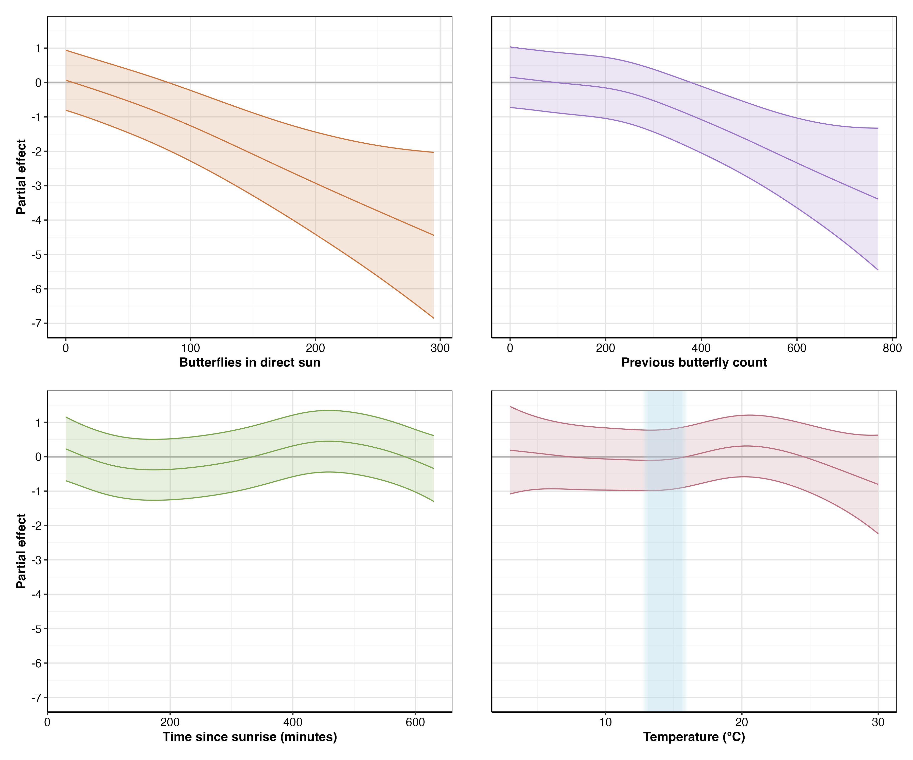

Partial effects of the four significant predictors on monarch abundance change in a 2x2 layout. The partial effect on monarch abundance as estimated from the single attribute being compared to abundance while assuming all other attribute values are held constant. Top row: butterflies in direct sun (left) and previous butterfly count (right). Bottom row: time since sunrise in minutes (left) and temperature in °C (right). Solid lines show the estimated smooth functions with 95% confidence intervals (shaded regions). All effects are shown on the same scale for comparison.

### Evaluation of the Disruptive Wind Hypothesis

Our analysis provided no support for the three hierarchical wind hypotheses:

First, wind did not act as a disruptive force to overwintering monarchs. Among our 48 candidate models, wind appeared in only one of the top five models (M24), where it showed little evidence of an effect (p = 0.218) and resulted in substantially poorer model performance compared to the best model (ΔAIC = 6.2). The partial effect of maximum wind speed from this model remains flat with wide uncertainty across the observed range, reinforcing the lack of a coherent signal (Figure 1.2).

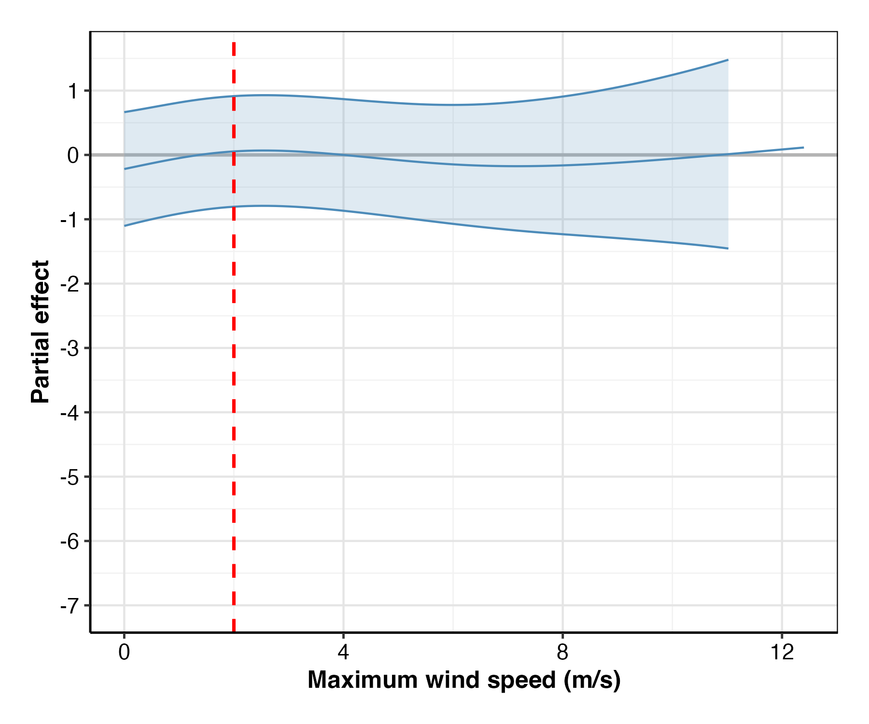

Partial effect of maximum wind speed on monarch abundance change from model M24. The flat relationship with wide confidence intervals demonstrates no clear effect of wind on butterfly departures. The red dashed line indicates the proposed 2 m/s disruptive threshold.

Second, we found no evidence for disruption above the proposed 2 m/s threshold. A sensitivity analysis using a specific threshold predictor (’minutes with wind speed > 2 m/s’) confirmed this lack of a threshold effect, as models with this variable performed poorly and did not rank among the top candidates (Table 1.3). Visually, the relationship between wind and monarch abundance change remained flat across the 2 m/s boundary (Figure 1.3). With mean maximum wind speeds of 2.2 m/s (SD = 1.4 m/s), conditions that should have revealed threshold effects if present, no disruption occurred at or above this boundary.

Model selection results from sensitivity analysis using wind threshold predictor (minutes with wind speed > 2 m/s). Poor model performance (high AIC values) demonstrates lack of support for the 2 m/s disruption threshold.

| Model | Terms | AIC | AIC | Weight | Wind p |
| --- | --- | --- | --- | --- | --- |
| T24 | Previous butterfly count, Minutes above 2 m/s, | 8089.4 | 7.6 | 0.021 | 0.372 |
|  | Temperature, Butterflies in direct sun, Time since sunrise |  |  |  |  |
| T44 | Minutes above 2 m/s, Temperature, | 8108.4 | 26.5 | <0.001 | 0.256 |
|  | Butterflies in direct sun, Time since sunrise |  |  |  |  |
| T21 | Previous butterfly count, Minutes above 2 m/s, | 8110.6 | 28.7 | <0.001 | 0.053 |
|  | Temperature, Butterflies in direct sun |  |  |  |  |
| T43 | Minutes above 2 m/s, Temperature (linear), | 8115.5 | 33.7 | <0.001 | 0.275 |
|  | Butterflies in direct sun, Time since sunrise |  |  |  |  |
| T19 | Previous butterfly count, Minutes above 2 m/s, | 8119.8 | 37.9 | <0.001 | 0.078 |
|  | Temperature (linear), Butterflies in direct sun |  |  |  |  |

Third, wind’s effects did not scale with intensity. The relationship remained flat across all observed wind speeds (0–12 m/s), with confidence intervals consistently encompassing zero (Figure 1.3).

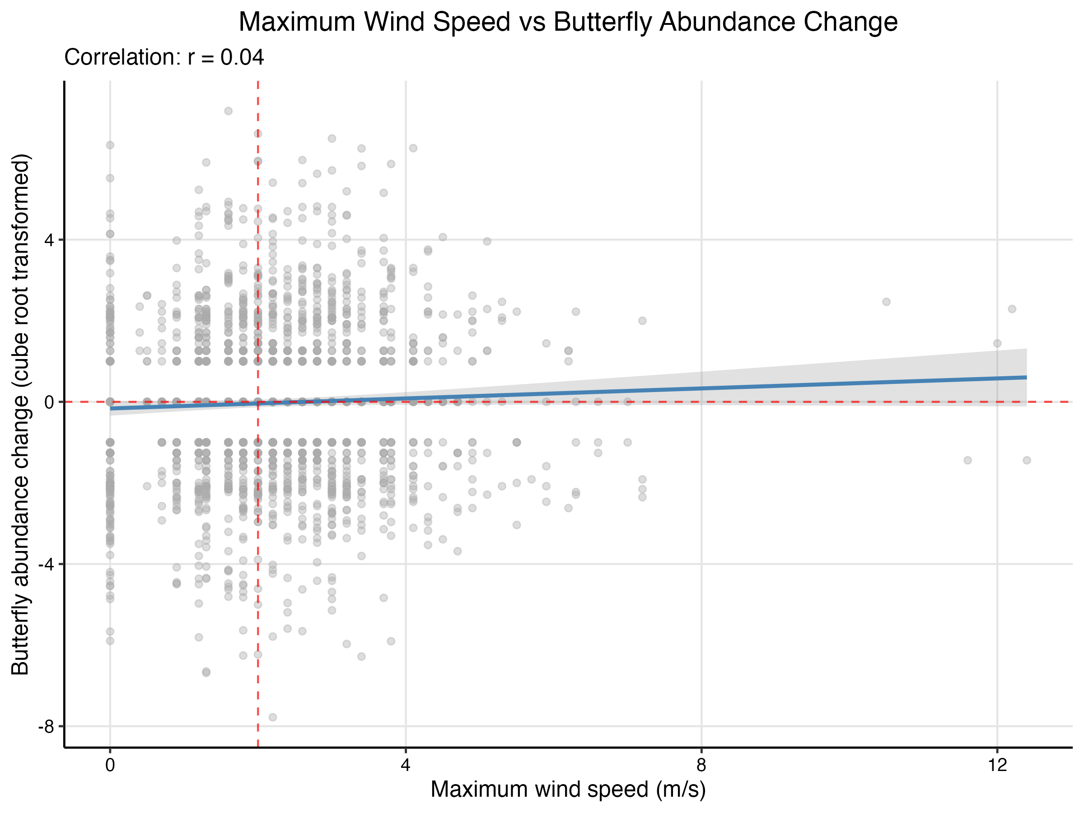

Relationship between maximum wind speed (m/s) and monarch abundance change. The red dashed line shows the proposed 2 m/s disruptive wind threshold, while the flat trend line indicates no effect of wind on butterfly departures. Points represent 30-minute observation periods.

### Statistical Power to Detect Wind Effects

Post-hoc power analysis confirmed our study had adequate statistical power to detect biologically meaningful wind effects (Table 1.4). With 1,894 paired observations, we achieved 87.5% power to detect moderate effect sizes (0.15 standard deviations) and 98.5% power to detect larger effects (0.20 standard deviations). Power for small effects (0.10 standard deviations) was 56%, while very small effects (0.05 standard deviations) yielded only 16.5% power. These results indicate that our failure to detect wind effects is unlikely due to insufficient statistical power for effect sizes of biological relevance.

Estimated power to detect wind effects of varying magnitudes. Effect sizes are expressed in standard deviations of the response variable (cube root transformed change in butterfly abundance).

|  | Effect Size (SD units) | Power (Proportion) | Power (%) |
| --- | --- | --- | --- |
| 0.05 | 0.05 | 0.165 | 16.5% |
| 0.1 | 0.10 | 0.560 | 56% |
| 0.15 | 0.15 | 0.875 | 87.5% |
| 0.2 | 0.20 | 0.985 | 98.5% |

### Model Diagnostics

Model residuals showed distinct linear banding patterns consistent with the discrete counting method used to estimate butterfly abundance, while the Q-Q plot indicated approximately normal residual distribution with minor tail deviations (Figure 1.4).

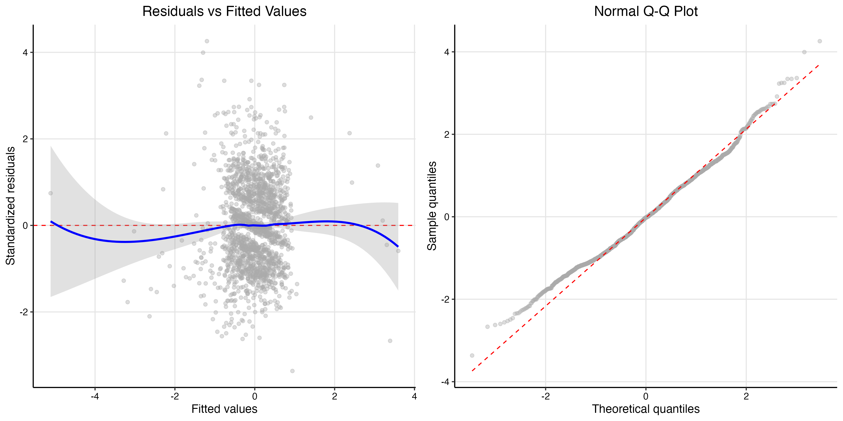

Model diagnostics for M23. Left: Residuals versus fitted values showing banding that reflects the discrete counting method, with smoothed relationship shown in blue. Right: Normal Q-Q plot of model residuals showing reasonable normality with minor tail deviations.

## Discussion

### Wind Does Not Disrupt Overwintering Monarch Butterflies

Our study provides the first direct empirical test of the disruptive wind hypothesis and finds no support for wind as a primary factor influencing monarch butterfly clustering behavior. Despite the widespread adoption of the 2 m/s wind threshold in conservation practice (Xerces Society 2016), our data reveal no relationship between wind speed and butterfly departures across the full range of observed conditions (0–12 m/s). While our models explain only 5.7% of variance in butterfly movements, reflecting our focus on testing wind effects rather than comprehensively explaining movement patterns, they had sufficient statistical power to detect environmental signals. This finding challenges assumptions underlying three decades of management guidance.

The absence of wind effects in our data is particularly striking given that observed mean maximum wind speeds (2.2 m/s, SD = 1.4) frequently exceeded the proposed threshold. If the disruptive wind hypothesis were valid, we should have observed a clear signal: substantial reductions in butterfly abundance, as predicted by the disruptive wind hypothesis. Instead, we observed no change, small changes, or even positive changes in butterfly abundance at wind speeds six times the proposed disruption threshold.

Importantly, our power analysis demonstrated 87.5% power to detect moderate effect sizes (0.15 standard deviations) and 98.5% power for larger effects (0.20 standard deviations), while wind appeared in only one of the top five models (M24). In that model wind showed little evidence of an effect (p = 0.218) and resulted in substantially poorer model performance compared to the best model (ΔAIC = 6.2, capturing only 4% of model weight). This weak wind signal, combined with our high statistical power, allows us to rule out all but very small wind effects. Given that the disruptive wind hypothesis predicts conspicious reduction in abundance above threshold wind speeds, a substantial effect by any measure, our failure to detect such patterns provides strong evidence against the hypothesis rather than merely absence of evidence.

The methodological validity of our approach is confirmed by the strong signals detected for other environmental variables. Had our counting method or analytical framework been flawed, we would not have captured the pronounced effects of direct sunlight (F = 19.36, p < 0.001) or the complex diurnal patterns (F = 8.90, p < 0.001) that emerged from the same dataset.

### Alternative Drivers of Monarch Movement

While our study was designed specifically to test the wind hypothesis, our results suggest that thermoregulation, light exposure, and diurnal rhythms play more important roles than wind in driving short-term movements at overwintering sites.

#### Direct Sunlight as the Strongest Predictor

Direct sunlight exposure emerged as the strongest environmental predictor of reductions in cluster abundance in our study (F = 19.36, p < 0.001). Butterflies exposed to direct sunlight at the beginning of an observation interval showed the largest decreases in abundance, suggesting that solar radiation rapidly increases butterfly body temperatures well above ambient conditions. This finding aligns with Masters, Malcolm, and Brower (1988)’s work showing that monarchs in direct sunlight can elevate their body temperature above ambient conditions within minutes. This rapid warming capability could readily explain why direct sunlight exposure is such a strong predictor of decreased abundance at clusters.

The relationship between sunlight and departure represents a key component of the thermoregulatory equation. Monarchs have evolved to efficiently absorb solar radiation, an adaptation that enables flight at temperatures below what would otherwise be physiologically possible (Masters, Malcolm, and Brower 1988). Yet this same efficiency becomes a liability when clustering. Butterflies cannot avoid absorbing heat when exposed to direct sun, risking overheating and accelerated depletion of their finite lipid reserves through elevated metabolism (Masters, Malcolm, and Brower 1988). This forces them to abandon energetically favorable clustering positions even when ambient temperatures remain cool. This trade-off between the benefits of clustering and the thermal constraints imposed by solar exposure may fundamentally shape daily movement patterns at overwintering sites.

#### Temperature Effects and Their Interpretation

Ambient temperature showed a subtle but significant relationship with monarch abundance changes (EDF = 3.93, F = 3.23, p = 0.028). The data suggest minimal change below 15°C (the known flight threshold), a slight positive association around 20–21°C, and sharp declines above 25°C consistent with thermoregulatory constraints. Given that available temperatures vary latitudinally across overwintering sites (Saniee and Villablanca 2022), our results from Spring Canyon capture only a portion of the temperature continuum experienced across the entire overwintering range. The temperature effects we observed reflect responses within the specific thermal envelope available at our study latitude. Testing these patterns at sites spanning the full latitudinal gradient would reveal whether monarch responses to temperature are consistent or vary with local thermal regimes.

#### Diurnal Activity Patterns

Time since sunrise revealed distinct diurnal patterns (EDF = 4.90, F = 8.90, p < 0.001), with butterflies departing clusters in the morning and reforming aggregations in the afternoon. This pattern persists even after controlling for temperature and sunlight, aligning with anecdotal observations from overwintering sites throughout California.

### Study Limitations

Several limitations warrant consideration. Our data derive from a single season (2023–2024) with typical monarch abundance at two sites. The following season (2024–2025), virtually no clustering monarchs were observed at Vandenberg Space Force Base (23 individuals total) despite monitoring 10 sites. This coincided with the second-lowest overwintering population on record statewide (Xerces Society 2025b), preventing temporal replication of our study. Additionally, our counting methodology introduced discretization artifacts that contributed to large confidence intervals for environmental predictors. While we detected strong signals like direct sunlight effects, more subtle relationships require careful interpretation.

Furthermore, our study observed clusters where butterflies maintained direct substrate contact. In historically massive aggregations containing hundreds of thousands of individuals, many butterflies attach only to other butterflies, creating multi-layered formations. If substrate attachment confers greater wind resistance than butterfly-to-butterfly attachment, the disruptive wind hypothesis might apply specifically to these larger aggregations. Future work should examine whether wind responses differ between substrate-attached and butterfly-attached individuals, particularly at sites supporting extreme densities.

### Management Implications

Our findings suggest that management strategies prioritizing wind protection warrant reconsideration. The absence of wind effects despite frequent threshold exceedances indicates that usable habitat within existing groves may be larger than currently recognized. Areas previously dismissed due to perceived wind exposure may provide suitable conditions because they offer appropriate light and thermal regimes.

While past management efforts aimed at wind protection may have been based on incomplete understanding, they likely produced beneficial outcomes by increasing tree density. The fundamental recommendation to plant and maintain trees remains sound. Management should prioritize maintaining existing mature trees while establishing future roosting habitat at densities that support healthy, long-lived growth. In addition, as suggested by Saniee and Villablanca (2022), it may become relevant to explore ways in which to manage for thermal attributes, specifically sunlight.

### Future Research Directions

Our findings open several important avenues for future research. First, explicit testing of light patterns as predictors of clustering locations could establish whether canopy structure guides habitat selection. The strong effect of direct sunlight (F = 19.36, p < 0.001) combined with the predictability of canopy-created light patterns suggests this may be a primary factor in roost site selection. Previous research also suggests light conditions may play an important role in habitat selection. (Weiss et al. 1991) used hemispherical photography to measure the Indirect Site Factor (ISF), which quantifies percent canopy openness, across sites with different occupancy histories. Permanent overwintering sites clustered within a narrow range of canopy openness (approximately 20%) with relatively low variance, while transient and unoccupied sites showed progressively greater variability (Figure 1.5). This pattern of consistent light conditions at successful sites provides additional context for understanding how canopy structure might influence clustering behavior.

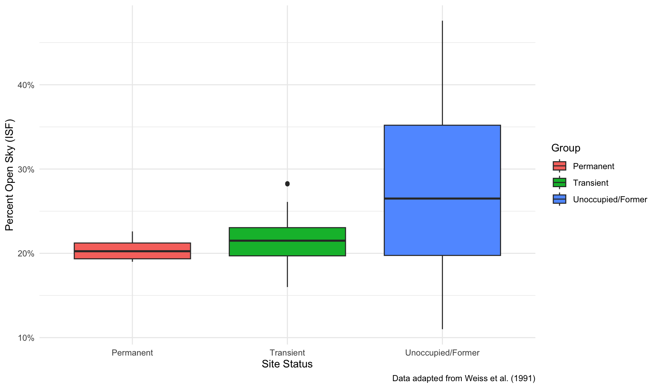

Percent canopy openness (Indirect Site Factor) by occupancy status, adapted from Weiss et al. (1991). Permanent overwintering sites exhibit both a specific range of canopy openness ( 20%) and lower variance compared to transient and unoccupied/former sites.

Second, investigation of social dynamics and positive behavioral feedback mechanisms could address unexplained variation in our models. Monarchs may exhibit emergent clustering behaviors where initial settlement increases the probability of others joining, creating self-reinforcing patterns independent of environmental conditions.

Research should also examine whether our findings extend across the broader overwintering range. Testing these patterns at sites with different tree species, latitudes, and in particular population densities would strengthen conclusions about the generality of wind effects, or their absence.

### Conclusions

Wind did not disrupt monarch clusters even at speeds far exceeding presumptive thresholds. Instead, butterflies responded primarily to thermal conditions, including light exposure and ambient temperature, and to diurnal rhythms. These findings challenge current assumptions about overwintering habitat requirements and suggest that management priorities should be reevaluated. While our study represents one season at two sites, the absence of wind effects despite adequate statistical power raises important questions regarding decades of conservation guidelines. As monarch populations face continued threats, evidence-based management becomes increasingly critical for conserving the overwintering sites essential for this iconic species.

## References

Baudier, Kaitlin M., Catherine L. D’Amelio, Rumaan Malhotra, Michael P. O’Connor, and Sean O’Donnell. 2018. “Extreme Insolation: Climatic Variation Shapes the Evolution of Thermal Tolerance at Multiple Scales.” *The American Naturalist* 192 (3): 347–59. <https://doi.org/10.1086/698656>.

Bell, William J., and Ernst Kramer. 1979. “Search and Anemotactic Orientation of Cockroaches.” *Journal of Insect Physiology* 25 (8): 631–40. <https://doi.org/10.1016/0022-1910(79)90112-4>.

Blois-Heulin, Catherine, Philip H. Crowley, Margarett Arrington, and Dan M. Johnson. 1990. “Direct and Indirect Effects of Predators on the Dominant Invertebrates of Two Freshwater Littoral Communities.” *Oecologia* 84 (3): 295–306. <https://doi.org/10.1007/BF00329753>.

Bonte, D., and L. Lens. 2007. “Heritability of Spider Ballooning Motivation Under Different Wind Velocities.” *Evolutionary Ecology Research*. <https://www.semanticscholar.org/paper/Heritability-of-spider-ballooning-motivation-under-Bonte-Lens/d6118c2cd143572bc4f098b5916186ec63c0f12a>.

Carvallo, Fernando R., Bradley A. Strickland, Sean K. Kinard, Brandi Kiel Reese, James Derek Hogan, and Christopher J. Patrick. 2022. “Structure and Functional Composition of Macroinvertebrate Communities in Coastal Plain Streams Across a Precipitation Gradient.” *Freshwater Biology* 67 (10): 1725–38. <https://doi.org/10.1111/fwb.13968>.

Chapperon, Coraline, Nils Volkenborn, Jacques Clavier, Sarah Séité, Rui Seabra, and Fernando P. Lima. 2016. “Exposure to Solar Radiation Drives Organismal Vulnerability to Climate: Evidence from an Intertidal Limpet.” *Journal of Thermal Biology* 57 (April): 92–100. <https://doi.org/10.1016/j.jtherbio.2016.03.002>.

Chown, Steven L., Jesper G. Sørensen, and John S. Terblanche. 2011. “Water Loss in Insects: An Environmental Change Perspective.” *Journal of Insect Physiology*, "Cold and Desiccation Tolerance" honoring Karl Erik Zachariassen, 57 (8): 1070–84. <https://doi.org/10.1016/j.jinsphys.2011.05.004>.

Everatt, Matthew J., Pete Convey, Jeffrey S. Bale, M. Roger Worland, and Scott A. L. Hayward. 2015. “Responses of Invertebrates to Temperature and Water Stress: A Polar Perspective.” *Journal of Thermal Biology*, What sets the limit? How thermal limits, performance and preference in ectotherms are influenced by water or energy balance, 54 (December): 118–32. <https://doi.org/10.1016/j.jtherbio.2014.05.004>.

Fisher, Ashley, Kiana Saniee, Charis Van der Heide, Jessica Griffiths, Daniel Meade, and Francis Villablanca. 2018. “Climatic Niche Model for Overwintering Monarch Butterflies in a Topographically Complex Region of California.” *Insects* 9 (4): 167. <https://doi.org/10.3390/insects9040167>.

Gosselin, Louis A., and Lisa A. Jones. 2010. “Effects of Solar Radiation on Barnacle Settlement, Early Post-Settlement Mortality and Community Development in the Intertidal Zone.” *Marine Ecology Progress Series* 407 (May): 149–58. <https://doi.org/10.3354/meps08567>.

HOEGH-GULDBERG, OVE, and JOHN S. PEARSE. 1995. “Temperature, Food Availability, and the Development of Marine Invertebrate Larvae1.” *American Zoologist* 35 (4): 415–25. <https://doi.org/10.1093/icb/35.4.415>.

Holmstrup, Martin, Mark Bayley, and Hans Ramløv. 2002. “Supercool or Dehydrate? An Experimental Analysis of Overwintering Strategies in Small Permeable Arctic Invertebrates.” *Proceedings of the National Academy of Sciences* 99 (8): 5716–20. <https://doi.org/10.1073/pnas.082580699>.

Hristov, Nickolay I., Dionysios Nikolaidis, Tatjana Y. Hubel, and Louise C. Allen. 2019. “Estimating Overwintering Monarch Butterfly Populations Using Terrestrial LiDAR Scanning.” *Frontiers in Ecology and Evolution* 7. <https://www.frontiersin.org/articles/10.3389/fevo.2019.00266>.

Lafferty, Kevin D., and Jenny C. Shaw. 2013. “Comparing Mechanisms of Host Manipulation Across Host and Parasite Taxa.” *Journal of Experimental Biology* 216 (1): 56–66. <https://doi.org/10.1242/jeb.073668>.

Leonard, Ryan J, Clare McArthur, and Dieter F Hochuli. 2016. “Exposure to Wind Alters Insect Herbivore Behaviour in Larvae of Uraba Lugens (Lepidoptera: Nolidae).” *Austral Entomology* 55 (3): 242–46. <https://doi.org/10.1111/aen.12175>.

Leong, Kingston L H. 2016. “Evaluation and Management of California Monarch Winter Sites.”

Leong, Kingston. L. H. 1990. “Microenvironmental Factors Associated with the Winter Habitat of the Monarch Butterfly (Lepidoptera: Danaidae) in Central California.” *Annals of the Entomological Society of America* 83 (5): 906–10. <https://doi.org/10.1093/aesa/83.5.906>.

Mammola, Stefano, and Marco Isaia. 2018. “Day–Night and Seasonal Variations of a Subterranean Invertebrate Community in the Twilight Zone.” *Subterranean Biology* 27 (September): 31–51. <https://doi.org/10.3897/subtbiol.27.28909>.

Masters, Alan R., Stephen B. Malcolm, and Lincoln P. Brower. 1988. “Monarch Butterfly (Danaus Plexippus) Thermoregulatory Behavior and Adaptations for Overwintering in Mexico.” *Ecology* 69 (2): 458–67. <https://doi.org/10.2307/1940444>.

Miller-ter Kuile, Ana, Austen Apigo, An Bui, Bartholomew DiFiore, Elizabeth S. Forbes, Michelle Lee, Devyn Orr, et al. 2022. “Predator–Prey Interactions of Terrestrial Invertebrates Are Determined by Predator Body Size and Species Identity.” *Ecology* 103 (5): e3634. <https://doi.org/10.1002/ecy.3634>.

Nathan, Ran, Nir Sapir, Ana Trakhtenbrot, Gabriel G. Katul, Gil Bohrer, Martin Otte, Roni Avissar, et al. 2005. “Long-Distance Biological Transport Processes Through the Air: Can Nature’s Complexity Be Unfolded in Silico?” *Diversity and Distributions* 11 (2): 131–37. <https://doi.org/10.1111/j.1366-9516.2005.00146.x>.

Pelton, Emma M., Cheryl B. Schultz, Sarina J. Jepsen, Scott Hoffman Black, and Elizabeth E. Crone. 2019. “Western Monarch Population Plummets: Status, Probable Causes, and Recommended Conservation Actions.” *Frontiers in Ecology and Evolution* 7. <https://www.frontiersin.org/articles/10.3389/fevo.2019.00258>.

Saigusa, Masayuki. 2001. “Daily Rhythms of Emergence of Small Invertebrates Inhabiting Shallow Subtidal Zones: A Comparative Investigation at Four Locations in Japan.” *Ecological Research* 16 (1): 1–28. <https://doi.org/10.1046/j.1440-1703.2001.00367.x>.

Saniee, Kiana, and Francis Villablanca. 2022. “Hierarchy and Scale Influence the Western Monarch Butterfly Overwintering Microclimate.” *Frontiers in Conservation Science* 3. <https://www.frontiersin.org/articles/10.3389/fcosc.2022.844299>.

Schultz, Cheryl B., Leone M. Brown, Emma Pelton, and Elizabeth E. Crone. 2017. “Citizen Science Monitoring Demonstrates Dramatic Declines of Monarch Butterflies in Western North America.” *Biological Conservation* 214 (October): 343–46. <https://doi.org/10.1016/j.biocon.2017.08.019>.

Schweizer, Mona, Rita Triebskorn, and Heinz-R. Köhler. 2019. “Snails in the Sun: Strategies of Terrestrial Gastropods to Cope with Hot and Dry Conditions.” *Ecology and Evolution* 9 (22): 12940–60. <https://doi.org/10.1002/ece3.5607>.

U.S. Fish and Wildlife Service. 2024. “Endangered and Threatened Wildlife and Plants; Threatened Species Status With Section 4(d) Rule for Monarch Butterfly and Designation of Critical Habitat.” Federal Register. December 12, 2024. <https://www.federalregister.gov/documents/2024/12/12/2024-28855/endangered-and-threatened-wildlife-and-plants-threatened-species-status-with-section-4d-rule-for>.

Weiss, Stuart B., Paul M. Rich, Dennis D. Murphy, William H. Calvert, and Paul R. Ehrlich. 1991. “Forest Canopy Structure at Overwintering Monarch Butterfly Sites: Measurements with Hemispherical Photography.” *Conservation Biology* 5 (2): 165–75. <https://doi.org/10.1111/j.1523-1739.1991.tb00121.x>.

Xerces Society. 2016. “State of the Monarch Overwintering Sites in California.” 16-015_01. Portland, OR: The Xerces Society for Invertebrate Conservation. <https://www.xerces.org/sites/default/files/2018-05/16-015_01_XercesSoc_State-of-Monarch-Overwintering-Sites-in-California_web.pdf>.

———. 2017. “Step-by-Step Western Monarch Thanksgiving Count Monitoring Guide.”

———. 2025a. “Western Monarch Thanksgiving Count and New Year’s Count Data, 1997-2025.” [WesternMonarchCount.com](https://WesternMonarchCount.com).

———. 2025b. “Western Monarch Butterfly Population Declines to Near Record Low.” March 6, 2025. <https://www.xerces.org/press/western-monarch-butterfly-population-declines-to-near-record-low>.