Nicholas Cage Galore

By:
Kyle Nicola
Nam Nguyen
Stephen Ridings

October 17, 2014

- Welcome/Splash Page.
The splash screen features an elegant picture of the app’s main man, Nicolas Cage. The start

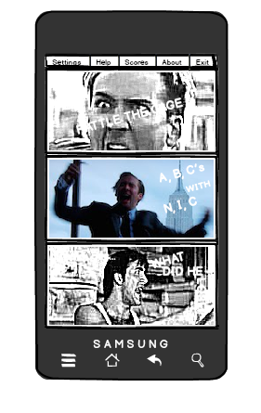
II. Main Menu
The menu features a collage of Nicolas Cage buttons each leading to a different game. The three games are as follows:
  - Rattle The Cage – Game featuring a picture of Nicolas Cage. You shake it until he gets made
  - A, B, C’s with N, I, C – A spell along game where Nicolas Cage yells at a therapist from the movie Vampire’s Kiss.
  - Cage Clues, What Did He Lose? -- A game where you try to solve the mystery of what Nicolas Cage lost
  - Score! – Your score, how long you’ve played the game, etc.

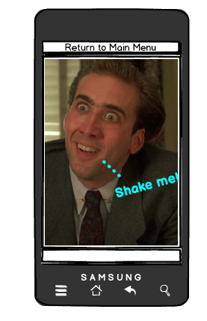

- Rattle The Cage
Rattle The Cage will start with a friendly picture of Nicolas Cage and the suggestion of “shake me!” So you do. The picture of Cage starts changing into disgruntled, to mad, to angry, to Nic Cage Angry. Audio of Nicolas Cage yelling starts playing. Eventually if you’ve rattled the Cage long enough and fast enough the clip from Wickerman where Nicolas Cage gets stung by bees starts to play (https://www.youtube.com/watch?v=-1GadTfGFvU)
The amount you’ve shaken Nic Cage determines your arbitrary points.

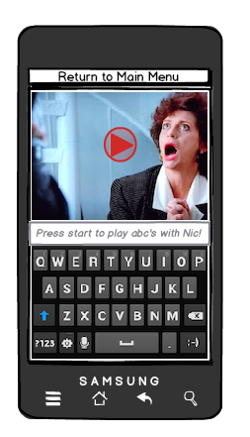
- A, B, C’s with N, I, C
This game’s screen will be split in half with a keyboard on the bottom and a video on top from the movie Vampire’s Kiss (https://www.youtube.com/watch?v=68BjP5f0ccE). There will be a start button. Once you press start the video will start and you must type the alphabet along with Nicolas Cage. The closer you get to the letter the more points you get.

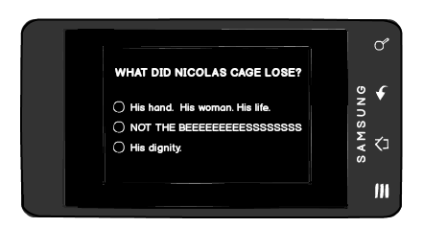

- Cage Clues, What Did He Lose?

The game most likely to change. It’s a constantly looping video Nicolas Cage yelling, “I LOST MY HAND.” from the movie Moonstruck (http://youtu.be/C7yK8cuP1Bw?t=2m41s)

Every time the video loops you get a point. At the end there is a questionnaire with the question:

What did Nicolas Cage Lose?

- His hand. His woman. His life.
- NOT THE BEEEEEEEEEEEEEEEEEEESSSSSSSSSSSSSSSSSSSSSSS
- His dignity.
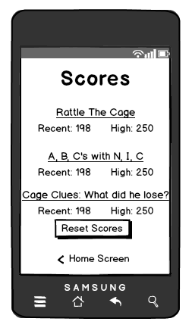
You get 10 points for the right answer. (Every answer is the right answer)

- Score Page
This page features your most recent score for each game, your high score and for Cage Clues, What Did He Lose?
There will be an option to reset your score. If you click on it, you’re notified that while the app may forget, Nicolas Cage never will.

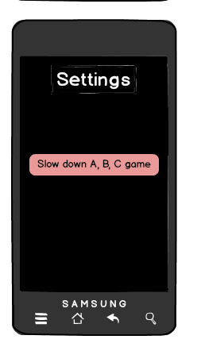

- Settings
Options:
  - Turn off sound
  - Slow down A, B, C game. Once clicked, it says “Nicolas Cage SLOWS DOWN FOR NO MAN.”
  - Help
  - About

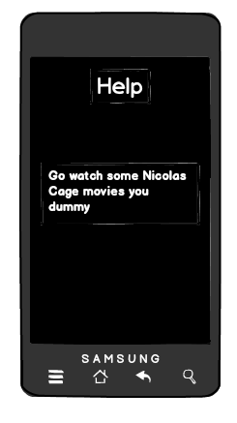

- Help Screen
Just a screen that says, “Go watch some Nicolas Cage movies you dummy.”

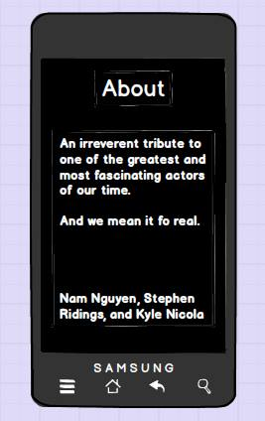
VIII. About
This game is made by Nicolas Cage
Nam Nguyen, Stephen Ridings, and Kyle Nicola are mere vehicles.

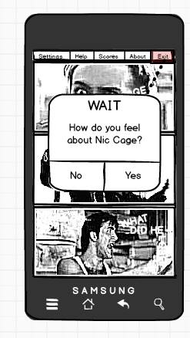

VIV. Exit
Do you hate Cage?
Yes No

a) Alpha Version

The alpha version with have the most basic features, with little enhancements implemented. It will be the base for completing the project

- Splash Page – image of nicholas cage riding on horseback
- Main Menu – menu select for which game the user wants to play – ABC's of NIC, Rattle the Cage, or Cage clues what did he lose? - Additionally there will be a settings button the user can click on to access that feature of the app.
- ABC's of NIC – A timed typing game where the user tries to keep pace with angry Nicholas Cage heads
- Rattle The Cage – A shake game that progressively gets Nicholas Cage angrier and angrier until he reaches full psycho
- Cage clues what did he lose? - A trivia game based on Nicholas Cage movies
- Settings – the user can turn the sound on or off

b) Beta Version

The beta version will add more customization to the features, as well as the scoreboard and victory/loss videos

- The scoreboard – displays most recent scores, and the highest score for each of the three games
- Menu items –
- Additional settings – in addition to turning the sound on or off, we will be adding another setting for ABC's of NIC that allows the user to change the tempo of the game
- Videos – there will be videos from Nicholas Cage movies at the end of each game and will differ depending on if you win or lose

- Future releases

There was a small window to get this project done, and there are several features that could be added in future releases

- The addition of more mini-games
- Animation in the mini-games instead of static images

