CME213 PA5
Dong-Bang Tsai

- (a)
I compared the result with hw2, and I got the same result for several selected grid size, async, and sync. The decomposition should be along the column (y direction) due to the memory access pattern favor to read along the row direction. (ie, group several rows into one processors.)
(b)
I also compared the result with hw2, it works accurately for any square number of processors. I don’t implement the arbitrary number of processors.
- (a) 8th order, 1000 iterations. 1000X1000
8th order, 1000 iterations, 2000x2000
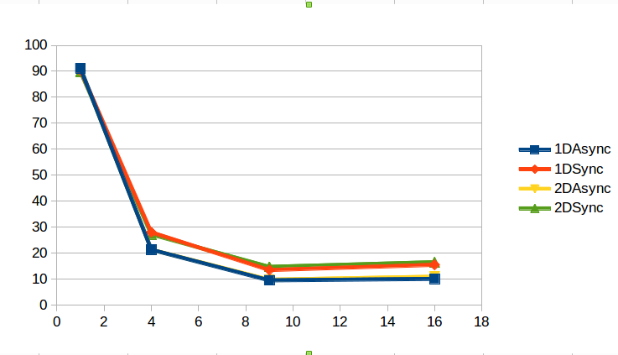

The async version is slightly faster than sync version as we expected.
(b) I will expect the performance of async and sync will be closer since the impact from the network will be reduced.
8th order, 1000 iterations. 1000X1000
8th order, 1000 iterations, 2000x2000
3. If we were to use synchronous MPI calls to implement the synchronous communication, I believe that the performance will be better due to that some of the overhead will be reduced.

