**Business Simulation Report for *PACE***

**Names:** Frances Fahey, Ignas Utyra, Mark McKeon, Eoin Bridgeman, Gary Maguire, Kyle O’Neill

**Student numbers:** C21311491, C21427616, C21440394, C20378561, C21481232, C21464626.

**Course**: TU912/2

**Module title:** Simulation for Business Analytics

**Module Code:** BSMT 2001

**Lecturer:** Dr. Tobail Ayman

**Topic:** To gather information regarding the current operations of the organisation *PACE* and to understand the responses received.

***Declaration of originality:***

*We hereby certify that this material, which we now submit for assessment on the module, Simulation for Business Analytics (BSMT2001) is entirely our own work, except where fully and properly referenced. We certify that this has not been submitted in whole or in part for assessment for any academic purpose other than in partial fulfilment for that stated above.*

Date: 25th of April 2023

Signed: Frances Fahey, Ignas Utyra, Mark McKeon, Eoin Bridgeman, Gary Maguire, Kyle O’Neill.

***Table of contents***

Executive Summary…………………………………………………….………………….….3

Introduction....…………………………………………………………………….….….…….3

Pace Organisation Goals……………………………………………………………………….3

Conceptual Model……………………….……………………………………………….….…4

Communication and Meetings………………………………………………………………....5

Final Model………………………………………………………………………………….…6

Recommendations………………………………………………………………………...….11 Conclusion…………………………………………………………………………………....12

**Executive summary**

Throughout the contents of this report the group will discuss the steps which were carried out in order to provide the company *PACE* with an efficient business model to try and improve their current business structure. The report consists of an introduction that offers insight into the company we were working with. Following the introduction, a description of the conceptual model is demonstrated. Also included in this report is a detailed summarisation of the communication which occurred between the team and the official representatives of the *PACE* organisation. The report then goes on to demonstrate the final model created through ExtendSim software. A description on how the model is constructed and the function of the model is discussed. The report finishes out with a conclusion of all the work carried out and the recommendations seen fit to provide to the *PACE* organisation.

**Introduction**

The focus of this report is to record and relay the information and operations which were dealt with throughout this project. Out team worked with the non-profit organisation *PACE*. *PACE* is an acronym for *‘Prevention-Accommodation-Community-Enterprise*'. The official statement of their mission is “Working inclusively with people with criminal convictions to support them in moving away from offending behaviour and to enhance community wellbeing by reducing offending.” *(Admin, Mission statement 2022).* For the duration of the project the team leader, Gary, was in contact with the organization through the medium of email. The project model was established through the resource ExtendSim10. This allowed us access to a convenient yet detailed model to use for the project.

***PACE* organisation goals**

Upon discussions with the organisation’s representatives, it was unveiled that the main objective for the company is to increase overall revenue. *PACE* aims to increase their current sales to achieve a total revenue of €250,000 by the end of 2023 within their woodwork/metalwork section. Also, the organisation has a company aim to utilise their new powder-coating to booth to assist in increasing overall revenue. This powder-coating operation improves the quality of their products as well as decreasing the time need to produce a finished product. With this new operation the organisation wishes to reach a financial revenue of €100,000.

Ultimately, *PACE* is looking to improve their revenue and continue to develop their business which will allow for the continued expansion within the organisation.

**Conceptual model**

Following the in class visit the conceptual model was able to be prepared. The conceptual model was designed in terms of an *E.R. model (Entity relationship model)* which is a format which was previously familiar to all members of the team.

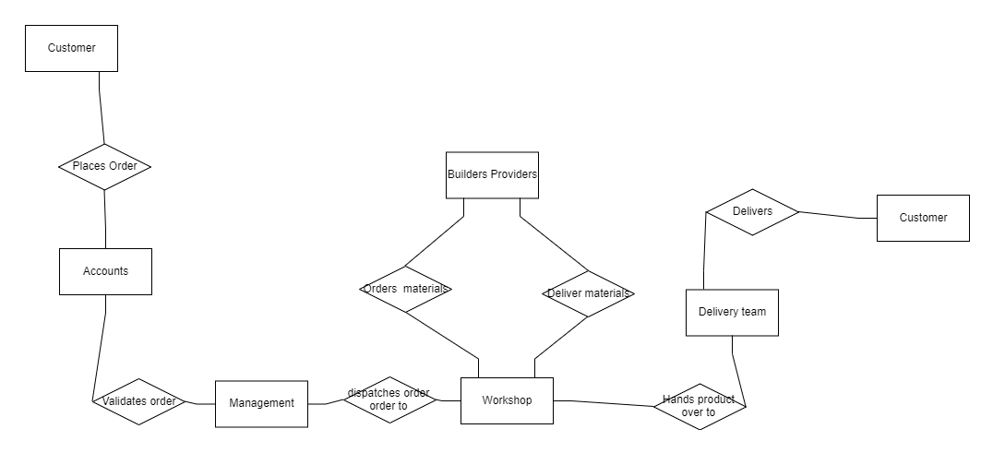

This model allowed us to demonstrate the key processes involved in a standard order placed with the company. Firstly, the customer places an order by contacting the organisation and identifying the specifications they require. Once the order is recorded it is then transferred to the accounts department which validates the order and ensures the resources are ordered to be readily available for when they are required. The management then takes on the order and coordinates the required workforce and supplies to be accessible upon request. This involves ensuring that supply orders have been completed and delivered and the proper tools are onsite for the order. Following the completion of the manual construction and the implementation of specifications on the order the workshop hands over the final product to the delivery team. The final stage of the process refers to the delivery of the product. The organisation delivers in and around the Dublin area and company vans deliver direct to the customer.

**Communication and Meetings**

For the duration of the project there were a total of three interactive meetings that took place in order to obtain and specify data needed to produce the most efficient model possible. This was alongside the utilisation of emails.

*Emails*

Continually throughout the project any necessary communication between the team and the *PACE* representatives was done through the medium of emails. This was conducted by the team leader to ensure professionality and efficiency.

*In-class introduction*

Firstly, Dr. Tobail Ayman arranged for representatives of the organisation to visit the college in order to introduce themselves and provide an oversight into their operations and goals of their establishment. This was an extremely beneficial meeting as it allowed a sense of understanding for the organisation and how the initial model should be designed. This meeting also allowed us the opportunity to establish a formal method of communication between the team leader and the organisation representatives.

*Phone call*

The next time in which communication in relation to the project occurred over a phone call between the two representatives and the team leader Gary. The aim of this specific phone call was to further gather needed data and information to better grasp an understanding of the enterprise and their operations. The resulting data obtained from the phone call consisted of the goals they aim to achieve as an organisation as well as numerical and informational data related to the operations for a product order.

*Phone call questions and answers:*

***What is the general process for a received order?***

*Orders come in for standard products, customer is sent quote, once agreed, materials are ordered, workshop starts making products, once completed, customer contacted, product delivered, customer sent invoice.*

***What are the organisations main goals for the upcoming year?***

*We hope to achieve sales of 250K in 2023 in the woodwork/metalwork section We hope to grow from 0k to 100k through the powder-coating booth by year end 2023.*

***How many products can be manufactured at one time?***

*10*

***How many workers are usually present at one time?***

*3*

***What is the estimated time taken for materials to arrive onsite?***

*Materials could either be in stock on the premises or it could take up to 2 days to collect to materials.*

***What is the estimated average completion time of manufacturing process?***

*2 weeks*

***What is the estimated delivery time to get the product to the customer?***

*2 days*

***Do products leave the premises as soon as they are finished?***

*Products are either sent to the customer or sent to a specific section for spray painting.*

*Zoom meeting*

Our final official communication with the enterprise took place over a Microsoft Teams video call. This call was arranged by the lecturer, Dr. Tobail Ayman. It took place on Monday the 27th of march at 12:30-13:00. This meeting was between all team members as well as the two representatives. Firstly, it was ensured that all members had access to the call and then proceeded to present our work which was easily demonstrated through the rough model of the project. This was the initial conceptual model was designed which was found to be most convenient and easily understandable for presentation to the representatives.

Following the description of the model and the relaying of data currently possessed, all relevant questions were asked. These questions consisted of topics surrounding any areas the team were not entirely confident in regarding the enterprise, for example delivery times and locations. The meeting was finished out by asking if the representatives had any questions in response for the team. Once all queries had been resolved, thank you pleasantries were carried out before signing off.

**Final model**

*Run settings:*

The model is set to run from day 0 to 260. We chose 260 days as this is around the number of working days in a year and we only run the simulation once.

We simulated the process by creating one order every five days.

*Order created:*

In ExtendSim, the Create block is used to create new entities or items to enter a simulation model. An entity in ExtendSim represents an object, such as a customer, order, or vehicle, which moves through a simulation model and is subject to various processes and conditions. The team used the create block by connecting it to the set block.

When a Set block receives an input signal, it changes the value of the specified variable to the value provided by the input signal. This new value can then be used by other blocks in the simulation model. The set block contained four raw materials that were legs, screws, top, and quantity.

When a Unbatch block receives a batch of items as an input signal, it separates the batch into individual items and sends each item as a separate output signal. The Unbatch block can be configured to control the size of the batches that it receives and the frequency with which it separates them. The set block connected to the unbatch activity block which received the requirements of the order.

Here we created an order item with materials and quantity and sent it to the unbatch block.

*Assembly:*

The Activity block in ExtendSim is a fundamental tool used to model the processing of entities through specific activities or processes. When an entity arrives at an Activity block, it is queued and waits to be processed. The processing time can be configured in several ways, such as a fixed time, a time based on a mathematical formula, or a time that varies based on the entity's properties or system state. This was implemented in the simulation to assemble the products.

After the entity has completed processing, it is released from the Activity block and sent to the next block in the simulation model. Additionally, the Activity block can perform other actions, such as generating a new entity or updating the properties of the processed entity.

The Activity block can be used in combination with other blocks, such as Create, Queue, or Resource blocks, to model complex systems involving the processing of entities through multiple activities and stages. This allows for the analysis and optimization of system performance, as well as the identification of potential bottlenecks or areas for improvement in the process.

Here we batched our materials and requirements together to add to our assembly activity. When the activity is finished the available space is unbatched with activity and the activity is pushed forward.

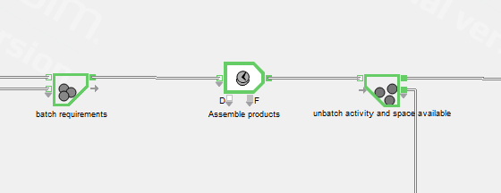 *Procure:*

When an entity arrives at a Resource Item block, it can request the use of the corresponding resource. If the resource is available, the entity is assigned to it, and the resource begins processing the entity. This allows the user to model how resources are utilized in a system and how they interact with entities to affect overall system performance.

Here is where we gather our materials from our set block with our get block and add it to our resource item and to replicate the procurement activity, we added an activity block with 2-day process time.

*Requirements...*

Here we batch our quantity of products, labour, and space available.

*Post assembly:…….*

Here we either send products straight to delivery or send to spray booth first. Each Unbatch will release available labour as the process goes on depending on which way it goes different labour is released.

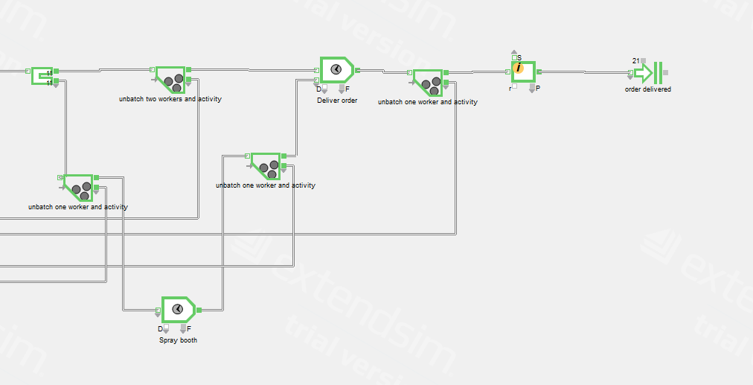

**Recommendations.**

Following the overall work carried out on this project, an in-depth understanding was achieved regarding the operations of the *PACE* company. With this knowledge, relevant recommendations can be provided to *PACE* to assist them in reaching their goals.

Firstly, an effort to increase staff onsite daily is advised. By increasing staffing, it would allow for the opportunity to produce multiple orders at once. It will also allow for the time for order completion to be reduced, this will fundamentally improve customer satisfaction and encourage more orders. This development in the organization will aid the reaching of revenue goals.

Also, the storage space could be increased but we concluded that it would have no effect on the number of orders that are processed as *PACE* have a variety of different orders daily with products like chairs and tables being the only consistent orders. We would recommend storing raw materials based on the season and previous yearly orders.

The other recommendation the team has identified is for the organisation to make efforts to track seasonality in regard to the customer orders. This will coincide with the need for staffing as it will allow for understanding the staffing required throughout the year. Also, by tracking seasonality the company can better plan for expected orders and ensure correct supplies and resources will be available for when required.

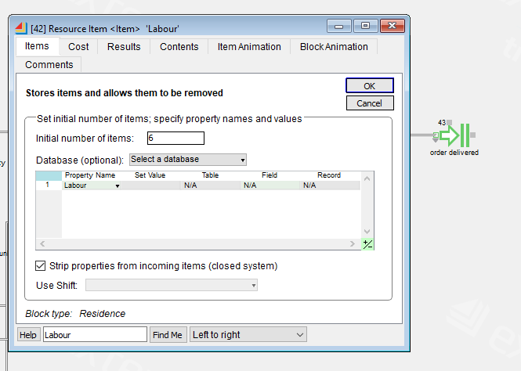

*Testing of increasing the storage space had no effect on throughput and would be extra cost for no improvements.*

**Conclusion**

In summary, working on this project together and using the program was a fulfilling experience despite the initial unfamiliarity with it. We put in a lot of challenging work for a few weeks to accurately capture the representative’s recorded processes of the organisation. Seeing our envisioned concept come to life in the program was satisfying. As a team, the required work was put in to resolve mistakes and utilised available resources to perfect the details, leading to a successful outcome. The journey was a learning experience both individually for each team member as well as a cooperative team. We are pleased with our achievements and enjoyed the process. This project provided us with valuable learning experiences that are beneficial for both our future careers and personal growth. We gained skills in conceptual modelling, working with ExtendSim, and collaborating with a real organisation on a project that has the potential to directly benefit their work. This was all orchestrated by our lecturer Dr. Ayman who provided criticism and support to help us complete this project. This experience is a valuable addition to our CVs. We also improved our communication and teamwork skills throughout the project, making it a fantastic learning opportunity overall.