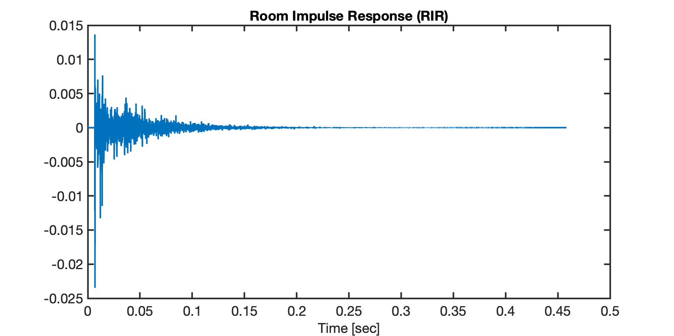

Early Reflections

Late Reflections  
 (Reverberation

Direct Sound