## Theory

The Earth is constantly bombarded by high-energy particles, which consist of mostly protons, but also light nuclei. With interactions in the atmosphere, we see the final products of these interactions at the surface. Interactions with oxygen and nitrogen nuclei in the atmosphere produce unstable products that decay into particles that include muons, electrons, and neutrinos [Melissinos]. We only see these lighter particles at the surface of the Earth, since the strongly interacting particles are absorbed in the atmosphere.

The particles we see at the surface have a total flux crossing the horizontal area of $2.4 x {10}^{2}/{(m}^{2}∙s)$, where 75% of this flux are $μ^{±}$ (muons) [Melissinos]. The positive and negative muons have different decay processes. The negative muon can either decay spontaneously, or be captured in matter. The positive muon is strongly repulsed by nuclei in the matter and thus decays spontaneously.

To detect these particles, scintillators and photomultiplier tubes (PMTs) are used. Scintillators are materials that fluoresces when interacted with by a high-energy radiation. Plastic scintillators have a response time on the order of microseconds, and the light output of the scintillator is proportional to the energy of the ionizing radiation. This energy is carried to the photomultiplier tube in the form of blue to long-UV wavelength photons [from extra notes]. About 10% of this energy reaches the PMT, which has about 10-15% efficiency. The gain required to see a pulse using the PMT requires approximately 2000-2700 volts.

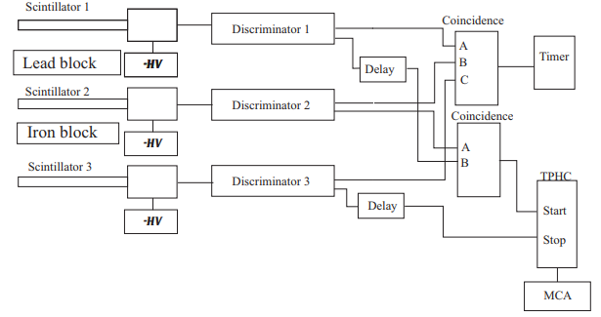

Figure —Experimental setup to explore the lifetime of incident muons

To study the decay and lifetime of the muons, we require a discriminator to convert the pulses created by the PMT into standard logical 1 pulses. This pulse can be used in a logic circuit, along with known delays see a coincidence between signals from multiple scintillators. In the case of this experiment, three scintillators labelled A, B, and C are aligned vertically. To study the lifetime of the muons, pulses corresponding to interactions in the A and B, but not the C scintillator correspond to a “starting time” which is recorded for reference with a “stopping time” corresponding to the logical signal from a subsequent electron. By making this time window only as large as necessary, accidental events can be made manageable. This is done by manipulating the delays between scintillator detections, and screening only for the times of interest.

By using a time to pulse height converter (TPHC) and a multichannel analyzer, a decay curve can be created. The TPHC takes the start and stop pulses, and creates a pulse with amplitude proportional to the time separation of the initial pulses, while the MCA bins the values from 0 to 10 volts.

The following function will be fitted to the decay curve with $b$, $N_{1}$, $N_{2}$, $τ_{1}$, and $τ_{2}$ being the parameters for fitting:

$$F\left(t\right)=b+N_{1}∙e^{\frac{-\left(t-t_{0}\right)}{τ_{1}}}+N_{2}∙e^{\frac{-\left(t-t_{0}\right)}{τ_{2}}}$$

The background incidents are reflected by the term $b$, whereas the second and third terms represent the negative and positive muon decays.