Authors:

Kyler Callahan

Project:

NSF Observation Collar (shared with permission)

Sponsor and Faculty Advisor:

National Science Foundation (NSF)

Dr. Ross Snider

**Project Summary and Level One Requirements**

The project that we are working on is a collar that will go on a marmoset monkey. Our goal on this project is to make a self contained PCB that will interface with future peripheral boards. The board will need to run a Cyclone V FPGA as well as a low power MAX V CPLD while being as small as possible. We also need to develop circuitry that will charge a battery via solar cells. This circuitry will be used to power an already existing prototype board of the project.

**Needs Description**

Current animal communication is modeled as a communication pair, a transmitter and a receiver. Communication as a group is largely an under researched topic. While observation collars for animals exist to obtain data on GPS location and to monitor movements collars with multiple functionality are far and few between. The collar that is being created will monitor a wide variety of things as well as be battery operated. The particular collar that we will be making has a focus on audio recording, but also collects GPS data as well as localized movement, such as acceleration. This will help us not only monitor what noises the animal is making, but how the animal is acting during that period of communication.

The collars will be placed on Marmoset monkeys but can also be adapted to other animals. These monkey have been chosen because they are quick to breed, remain vocal in captivity, and their auditory cortex is located near their skull. These are useful qualities for study of group communication

**Project Goals**

The goal of this project was to create printed circuit boards (PCBs) to connect the electronics for an observation collar for a marmoset monkey. The collar will record various sensory data such as acoustic data to monitor animal vocalizations, global position via GPS, and local movement from an inertial measurement unit (IMU). It will then store this data to a microSD card. The collar will be battery powered and will be charged via solar cells.

**Level One Requirements**

* Build a circuit that will power and run a Cyclone V FPGA as well as MAX V
* Design on PCB
* Be able to interface with a future peripheral board
* Make as small as possible

**Design Metrics**

This collar is going to be used in the wild and with the size of the animal that the collar is going to be attached to only being on average 186.5 mm and weighing 246 grams it could be a very easily be a prey animal. So the small size along with the nature of the animal the collar has to be as small and light as possible to allow the animal to survive so that data can be recorded and recovered. So with everything needing to be as small as possible size, weight and power consumption will be what is weighted most. All the components have been selected so the objective now is to shrink the board and get power measurements to see if any of the systems can be eliminated. Since the main purpose of the project is recording vocalizations that will be something that can not be sacrificed. Some things that will be considered for elimination for power saving are recording time, some of the inertial module functions and GPS updates.

**Functional Analysis**

Here we are going to give you a “black box model” of what and how the collar will work, give some functional specifications and design specifications. In the design specifications some functions that may need to be eliminated will be listed as well as the order of importance that each function has.

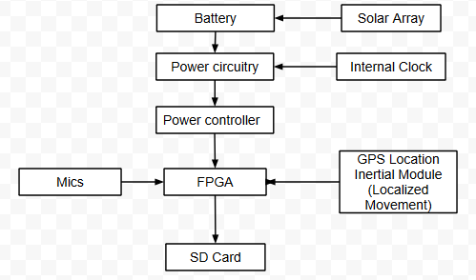

**Black Box Model**

The “black box” model shown above is the very basics of how the collar is going to work. A solar array will charge a battery which will run the power circuitry which will have an internal clock to tell it when to turn on. The power circuitry will go to the power controller which will be input to the FPGA. The FPGA will also gather and process information from the GPS, Inertial Module, and microphones and store it out to an SD card for future retrieval.

**System Architecture Plan**

The mechanical interface of the board is relatively simple, we just need to hook them together. The electrical connections however are much more complex. The entire system is made up of a large amount of smaller electrical components that share data and power with each other.

Mechanical:

* Board connectors: Since the collar is split into 2 sections the PCBs will be stacked on top of each other. One will house the FPGA and power circuitry and the other will house the Sensors, battery, and solar cell circuitry
* Solar Cells: The solar cells will need to be placed in such a manner that the will receive the maximum amount of sunlight.

Electrical:

* Power from the Solar cells: Solar cells will provide power that will charge the battery
* Power from the battery: The battery will provide power to to whole system
* Solar Controller: The solar controller monitor the power coming from the solar cells
* BUCK Converter: This will take power from the battery and convert it into 3.3V,2.5V and 1.8V to provide power to the rest of the system
* 1.1V Converter: This component will take power from the batter and convert it into 1.1V for the FPGA core voltages
* Battery monitor: This devices is used to monitor how much charge the battery has on it. It also monitors temperature.
* FPGA: This is the core component of the system. It will take data coming from all the other components and process it and store it on the SD card
* CPLD: This is a low power controller. This is used to turn power to devices on and off. This talks to the battery monitor
* Octal buffer: Ensures that devices do not turn on at the wrong time
* Flash: Store the data to program the FPGA on start-up
* SDRAM: Additional memory for the FPGA to use
* 50MHz Clock: Provides the clock for both the CPLD and FPGA
* JTAG: Used to program the whole system
* I2C: Communication BUS for the Battery Monitor, FPGA, CPLD, and Real Time Clock to talk to each other.
* Inertial Module: Sensor that will obtain data for localized movement.
* Magnetic Memory: A storage buffer for writing to the SD Card in case power is lost.
* GPS: Sensor that will obtain data for global movement
* SD-Card: Stores data
* Microphones: Obtains audio data
* Data Transfer: A device to transmit data to a user
* Real Time Clock: Keeps track of the time of day. Useful for telling the collar to wake up or go to sleep at a certain time of day

**System Interfaces**

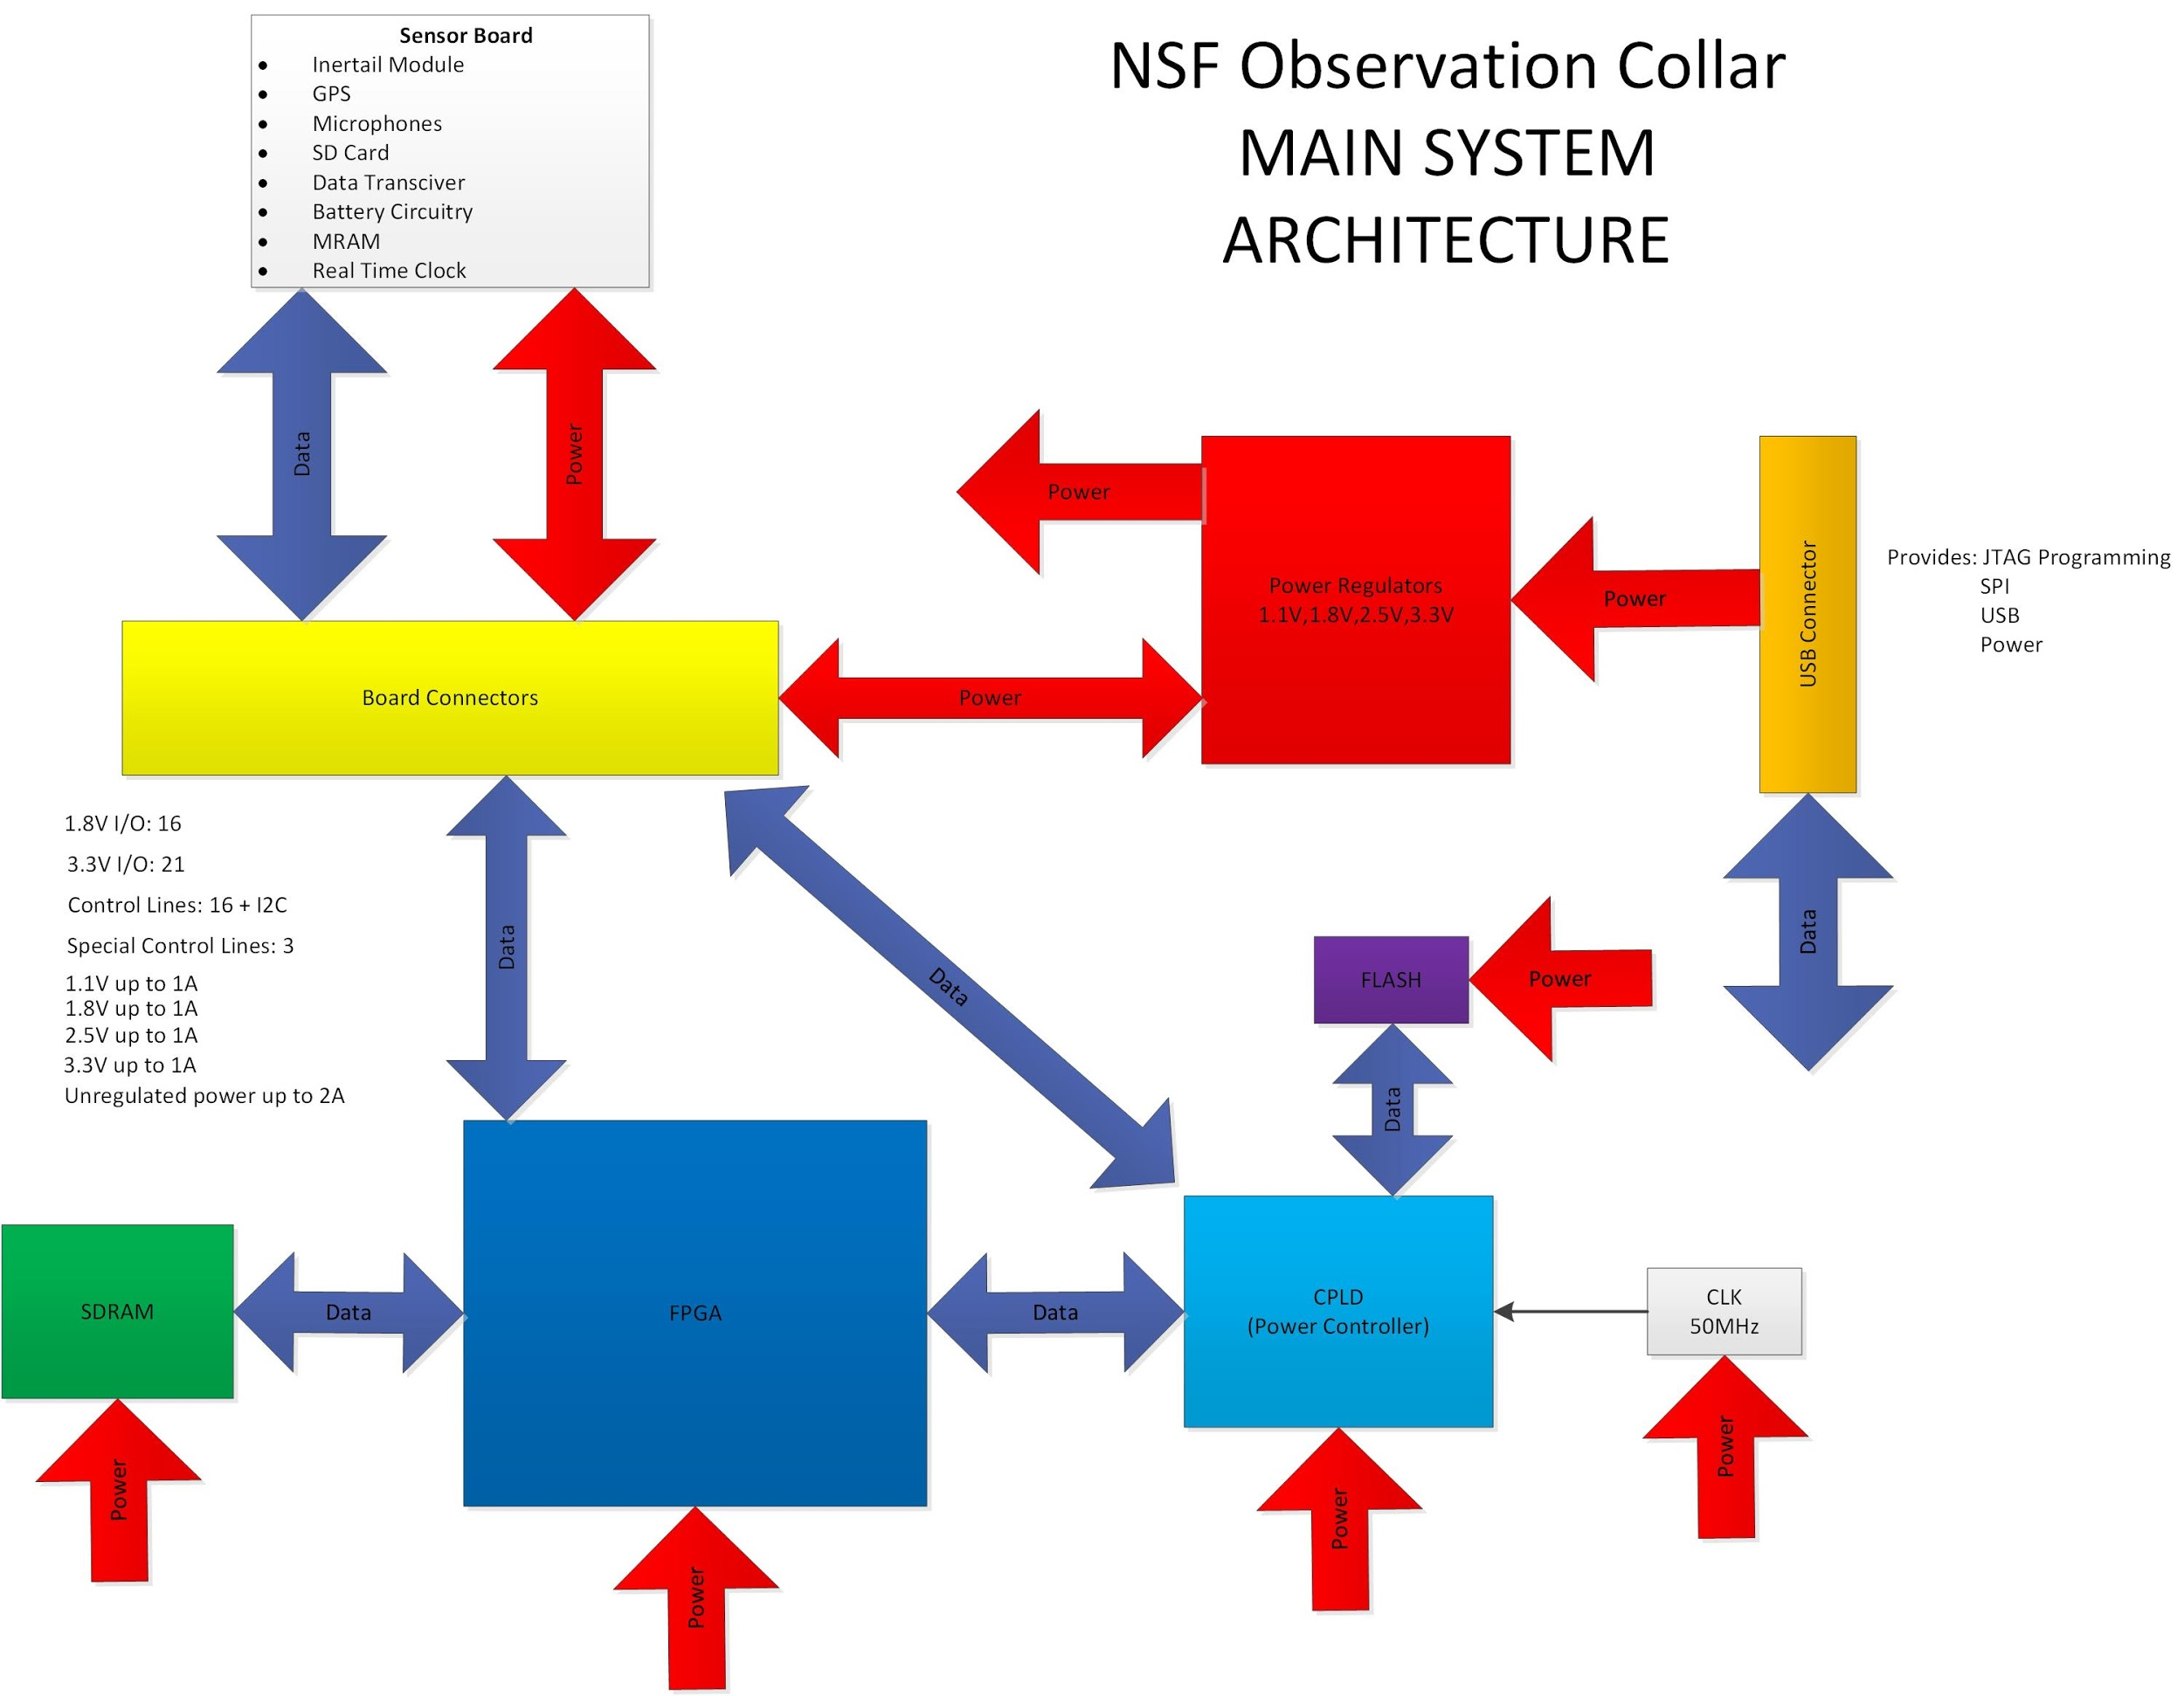

**Sub-System Interfaces**

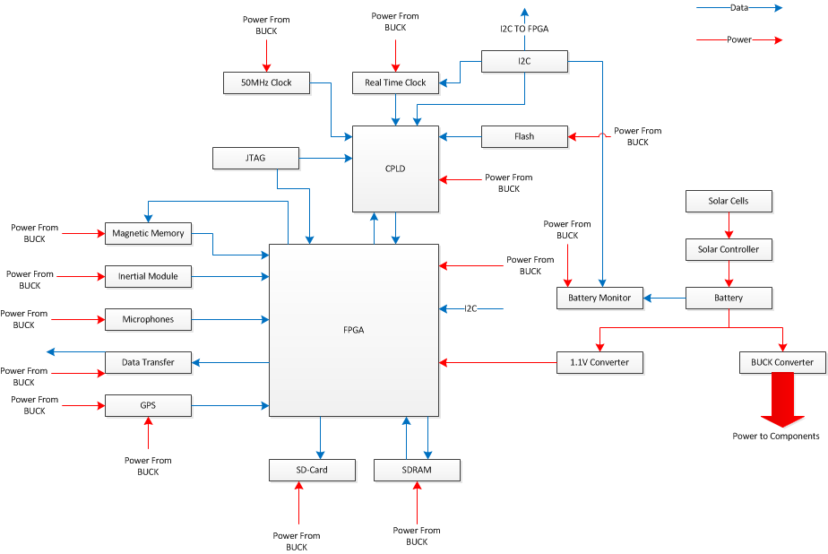

**User Interfaces**

The will be a single custom USB 3.0 plug on the board. This plug will provide power and programming to the device.

**Workload Distribution**

* Kyler Callahan: PCB design

**Testing and Verification**

PCB’s are difficult to debug in that many of the signal lines are not easily or in some cases physically possible to access. So the testing procedure was mostly be software related. First we measured the voltages coming out of all the power regulators to make sure they are within spec. After we determined it was in spec we tested the JTAG chain in Quartus. The FPGA, FLASH, and CPLD all showed up on the JTAG chain. We programmed the CPLD with an initial image, after the inital image was loaded we loaded a second image into FLASH that is used during run time. We then programmed the FPGA with a simple counting program and tested some I/O pins to verify that it was running. All tests were passed.

**Change of Project Scope**

There were 2 changes that were made for the project. The first change in the scope of the project is moving from a 3 PCB design to a 2 PCB design that is stacked on top of each other. This change was made so we didn't have to deal cable connectors. We moved to a much more reliable vertical connector. This also allowed for easier board layout to be done.

The second change of scope that was made for this project was the deliverables have gone from 2 PCB’s to 1 PCB. Originally we were to design the MAIN board and a SENSOR board that will collect data. However the design for the SENSOR board kept changing and we were running out of time. So to ensure that we could finish the project on time with as few errors as possible we removed the SENSOR board from this project scope to be designed at a later date. Since the SENSOR board requires the MAIN board to work this did not create any issues.

**Results**

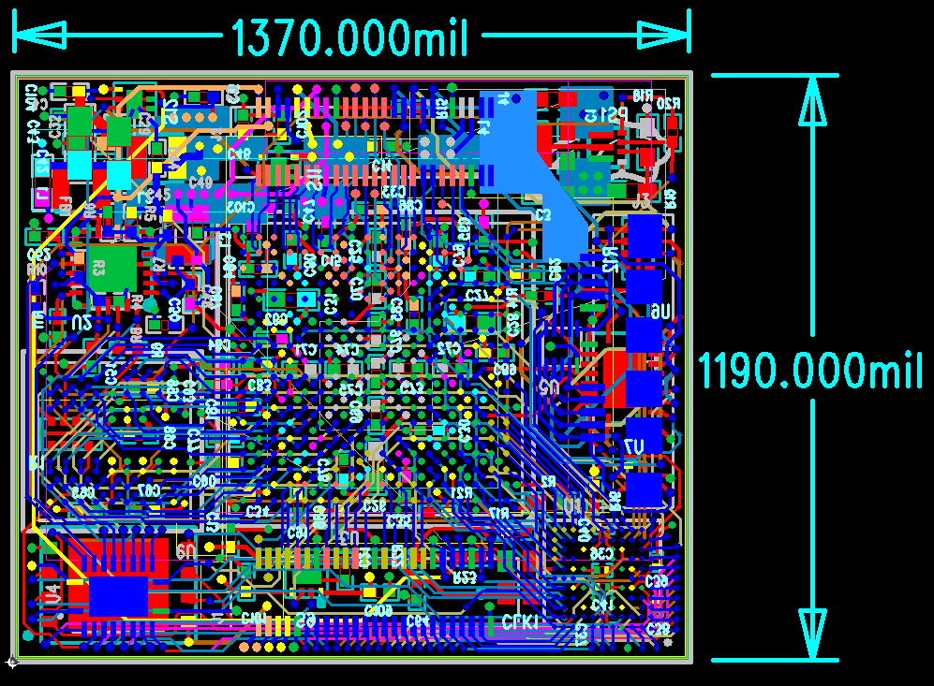

*PADS project file*

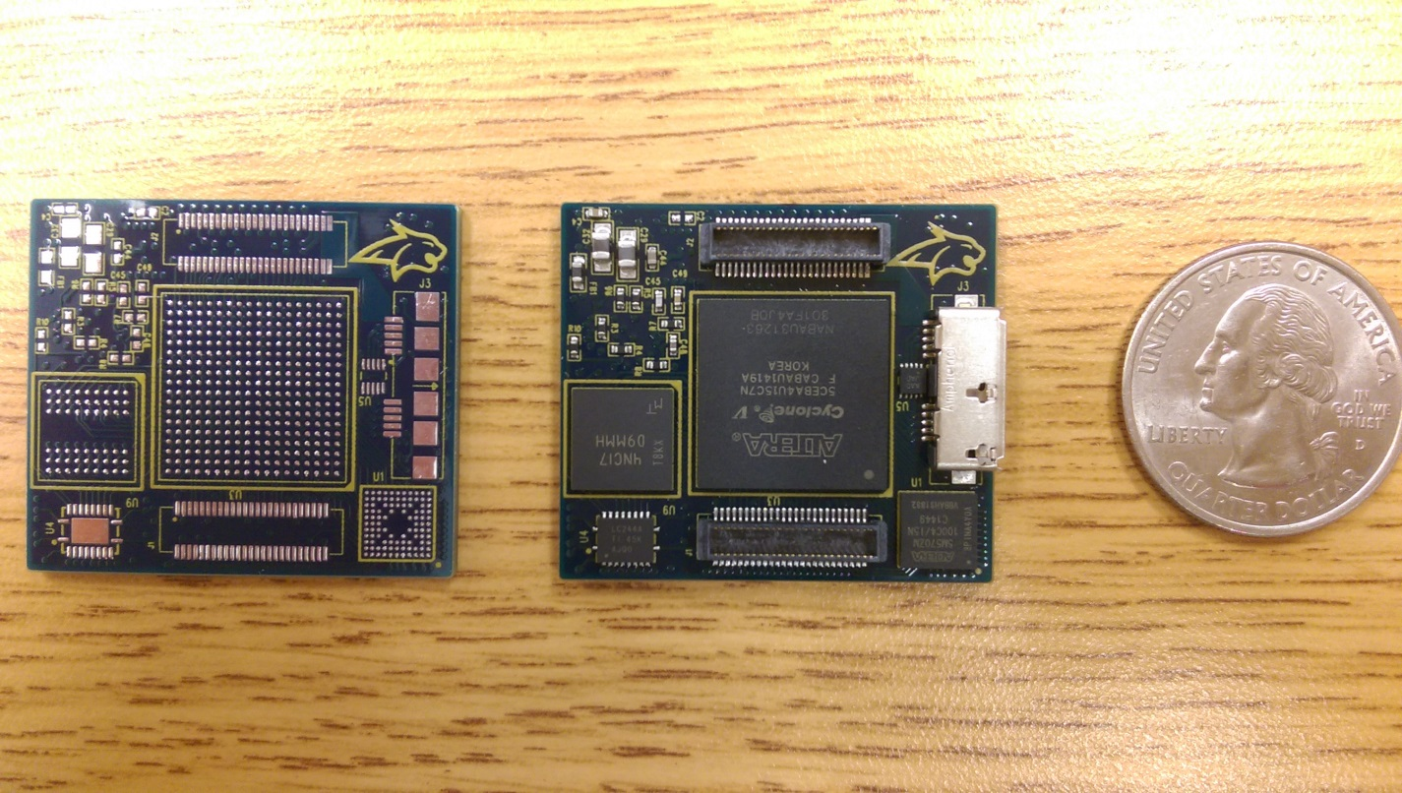

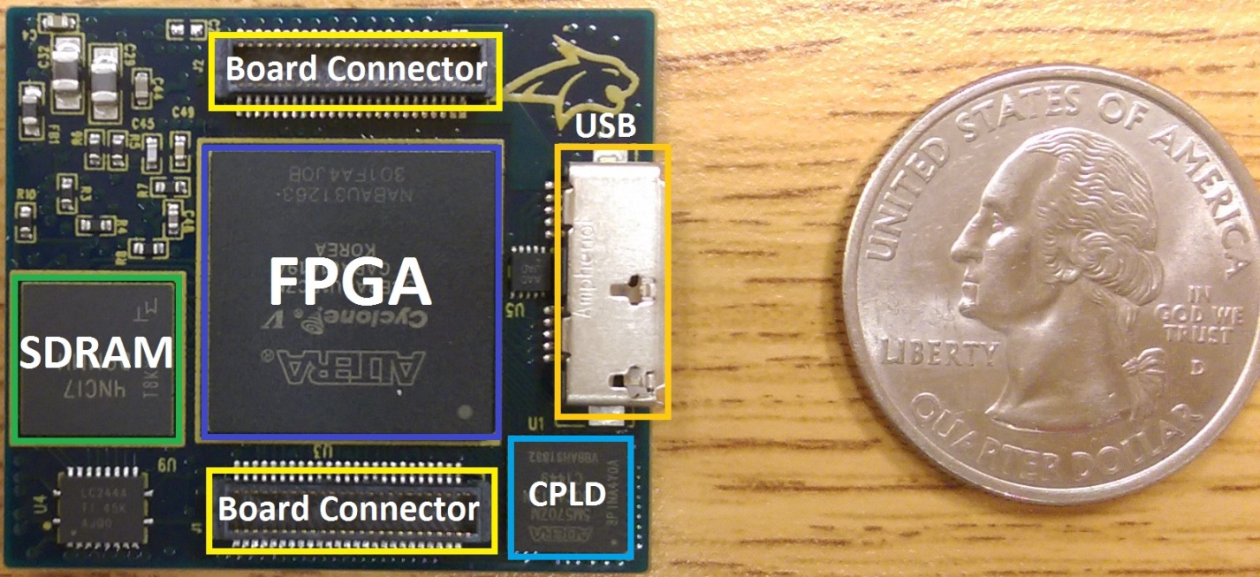

*Top of the PCB*

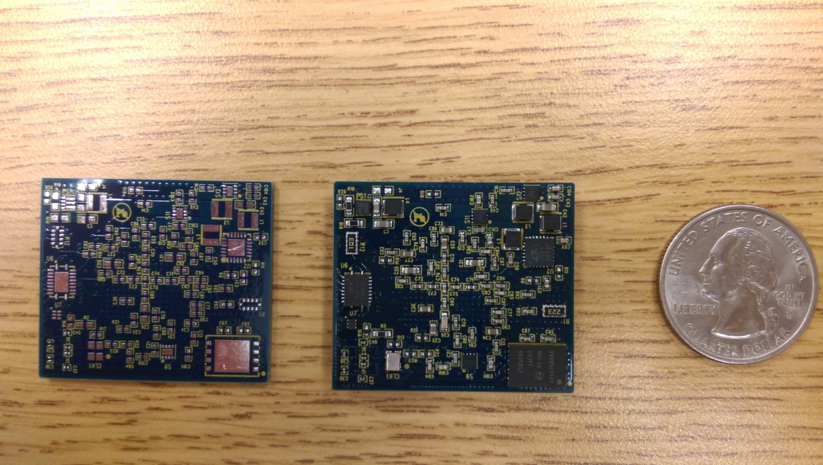

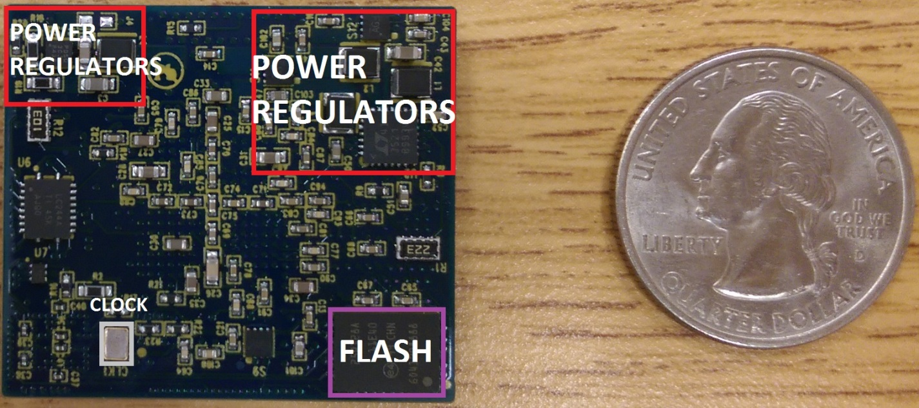

*Bottom of the PCB*

* 47 Unique Parts
* 24 Total parts on Top
* 95 total parts on bottom
* 435 drill holes
* 650 total connections
* 10 layers
* 1.66 square inches

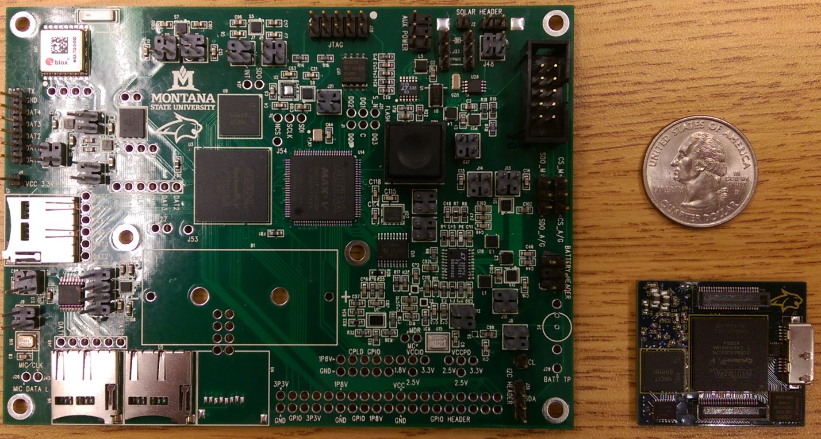

*Comparison to development board (also created by Kyler Callahan)*