PANER, Luke Eleazar R.

PRESTADO, Kyle Ross T.

2ECE-A

**Problem 1 MATLAB:**

function x = prob1()

f=(0:99);

for n=1:100

if f(n)<=9;

f(n)=(f(n)^2)-7;

elseif f(n)>=10;

f(n)=f(n-10);

end

end

stem(f);

xlabel('x-axis')

ylabel('y-axis')

title('Problem 1')

end

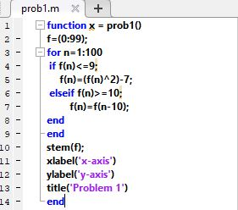

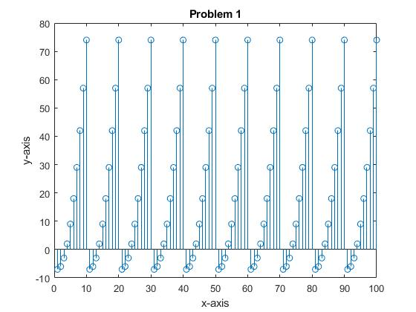

Description:

The MatLab program displayed a periodical and repeating graph. The command stem will display ‘f’ along the x-axis that scale from the range of ‘f’ with the conditions of f(n).