SPLIT FILE OFF.
EXAMINE VARIABLES=trvtime_cbd_bsas BY ASENT_MAJ_YN
/PLOT=BOXPLOT
/STATISTICS=NONE
/NOTOTAL.

Explore

Notes
Output Created |  | 03-APR-2018 18:37:54
Comments
Input | Data | F:\Data_Final\3cases_traveltime_indec.sav
Input | Active Dataset | DataSet1
Input | Filter | <none>
Input | Weight | <none>
Input | Split File | <none>
Input | N of Rows in Working Data File | 284
Missing Value Handling | Definition of Missing | User-defined missing values for dependent variables are treated as missing.
Missing Value Handling | Cases Used | Statistics are based on cases with no missing values for any dependent variable or factor used.
Syntax |  | EXAMINE VARIABLES=trvtime_cbd_bsas BY ASENT_MAJ_YN  /PLOT=BOXPLOT  /STATISTICS=NONE  /NOTOTAL.
Resources | Processor Time | 00:00:00.22
Resources | Elapsed Time | 00:00:00.22

Majority overlap with asentamiento, yes/no

Case Processing Summary
 | Majority overlap with asentamiento, yes/no | Cases
 | Majority overlap with asentamiento, yes/no | Valid |  | Missing |  | Total
 | Majority overlap with asentamiento, yes/no | N | Percent | N | Percent | N
Buenos Aires CBD | Minority/None | 220 | 94.8% | 12 | 5.2% | 232
Buenos Aires CBD | Majority | 50 | 96.2% | 2 | 3.8% | 52

Case Processing Summary
 | Majority overlap with asentamiento, yes/no | Cases
 | Majority overlap with asentamiento, yes/no | Total
 | Majority overlap with asentamiento, yes/no | Percent
Buenos Aires CBD | Minority/None | 100.0%
Buenos Aires CBD | Majority | 100.0%

Buenos Aires CBD

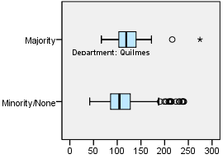

EXAMINE VARIABLES=trvtime_cbd_loc BY ASENT_MAJ_YN
/PLOT=BOXPLOT
/STATISTICS=NONE
/NOTOTAL.

Explore

Notes
Output Created |  | 03-APR-2018 18:38:05
Comments
Input | Data | F:\Data_Final\3cases_traveltime_indec.sav
Input | Active Dataset | DataSet1
Input | Filter | <none>
Input | Weight | <none>
Input | Split File | <none>
Input | N of Rows in Working Data File | 284
Missing Value Handling | Definition of Missing | User-defined missing values for dependent variables are treated as missing.
Missing Value Handling | Cases Used | Statistics are based on cases with no missing values for any dependent variable or factor used.
Syntax |  | EXAMINE VARIABLES=trvtime_cbd_loc BY ASENT_MAJ_YN  /PLOT=BOXPLOT  /STATISTICS=NONE  /NOTOTAL.
Resources | Processor Time | 00:00:00.20
Resources | Elapsed Time | 00:00:00.20

Majority overlap with asentamiento, yes/no

Case Processing Summary
 | Majority overlap with asentamiento, yes/no | Cases
 | Majority overlap with asentamiento, yes/no | Valid |  | Missing |  | Total
 | Majority overlap with asentamiento, yes/no | N | Percent | N | Percent | N
Departmental CBD | Minority/None | 222 | 95.7% | 10 | 4.3% | 232
Departmental CBD | Majority | 50 | 96.2% | 2 | 3.8% | 52

Case Processing Summary
 | Majority overlap with asentamiento, yes/no | Cases
 | Majority overlap with asentamiento, yes/no | Total
 | Majority overlap with asentamiento, yes/no | Percent
Departmental CBD | Minority/None | 100.0%
Departmental CBD | Majority | 100.0%

Departmental CBD

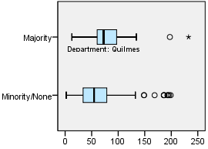

EXAMINE VARIABLES=trvtime_cbd_ngh_min BY ASENT_MAJ_YN
/PLOT=BOXPLOT
/STATISTICS=NONE
/NOTOTAL.

Explore

Notes
Output Created |  | 03-APR-2018 18:38:13
Comments
Input | Data | F:\Data_Final\3cases_traveltime_indec.sav
Input | Active Dataset | DataSet1
Input | Filter | <none>
Input | Weight | <none>
Input | Split File | <none>
Input | N of Rows in Working Data File | 284
Missing Value Handling | Definition of Missing | User-defined missing values for dependent variables are treated as missing.
Missing Value Handling | Cases Used | Statistics are based on cases with no missing values for any dependent variable or factor used.
Syntax |  | EXAMINE VARIABLES=trvtime_cbd_ngh_min BY ASENT_MAJ_YN  /PLOT=BOXPLOT  /STATISTICS=NONE  /NOTOTAL.
Resources | Processor Time | 00:00:00.20
Resources | Elapsed Time | 00:00:00.20

Majority overlap with asentamiento, yes/no

Case Processing Summary
 | Majority overlap with asentamiento, yes/no | Cases
 | Majority overlap with asentamiento, yes/no | Valid |  | Missing
 | Majority overlap with asentamiento, yes/no | N | Percent | N | Percent
Any departmental CBD | Minority/None | 222 | 95.7% | 10 | 4.3%
Any departmental CBD | Majority | 50 | 96.2% | 2 | 3.8%

Case Processing Summary
 | Majority overlap with asentamiento, yes/no | Cases
 | Majority overlap with asentamiento, yes/no | Total
 | Majority overlap with asentamiento, yes/no | N | Percent
Any departmental CBD | Minority/None | 232 | 100.0%
Any departmental CBD | Majority | 52 | 100.0%

Any departmental CBD

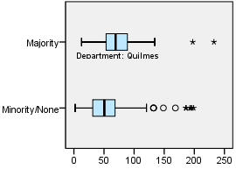

EXAMINE VARIABLES=trvtime_rail_min BY ASENT_MAJ_YN
/PLOT=BOXPLOT
/STATISTICS=NONE
/NOTOTAL.

Explore

Notes
Output Created |  | 03-APR-2018 18:38:20
Comments
Input | Data | F:\Data_Final\3cases_traveltime_indec.sav
Input | Active Dataset | DataSet1
Input | Filter | <none>
Input | Weight | <none>
Input | Split File | <none>
Input | N of Rows in Working Data File | 284
Missing Value Handling | Definition of Missing | User-defined missing values for dependent variables are treated as missing.
Missing Value Handling | Cases Used | Statistics are based on cases with no missing values for any dependent variable or factor used.
Syntax |  | EXAMINE VARIABLES=trvtime_rail_min BY ASENT_MAJ_YN  /PLOT=BOXPLOT  /STATISTICS=NONE  /NOTOTAL.
Resources | Processor Time | 00:00:00.22
Resources | Elapsed Time | 00:00:00.22

Majority overlap with asentamiento, yes/no

Case Processing Summary
 | Majority overlap with asentamiento, yes/no | Cases
 | Majority overlap with asentamiento, yes/no | Valid |  | Missing |  | Total
 | Majority overlap with asentamiento, yes/no | N | Percent | N | Percent | N
Railway station | Minority/None | 222 | 95.7% | 10 | 4.3% | 232
Railway station | Majority | 50 | 96.2% | 2 | 3.8% | 52

Case Processing Summary
 | Majority overlap with asentamiento, yes/no | Cases
 | Majority overlap with asentamiento, yes/no | Total
 | Majority overlap with asentamiento, yes/no | Percent
Railway station | Minority/None | 100.0%
Railway station | Majority | 100.0%

Railway station

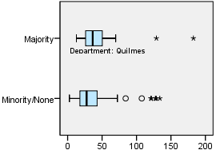

EXAMINE VARIABLES=trvtime_upa_min BY ASENT_MAJ_YN
/PLOT=BOXPLOT
/STATISTICS=NONE
/NOTOTAL.

Explore

Notes
Output Created |  | 03-APR-2018 18:38:27
Comments
Input | Data | F:\Data_Final\3cases_traveltime_indec.sav
Input | Active Dataset | DataSet1
Input | Filter | <none>
Input | Weight | <none>
Input | Split File | <none>
Input | N of Rows in Working Data File | 284
Missing Value Handling | Definition of Missing | User-defined missing values for dependent variables are treated as missing.
Missing Value Handling | Cases Used | Statistics are based on cases with no missing values for any dependent variable or factor used.
Syntax |  | EXAMINE VARIABLES=trvtime_upa_min BY ASENT_MAJ_YN  /PLOT=BOXPLOT  /STATISTICS=NONE  /NOTOTAL.
Resources | Processor Time | 00:00:00.22
Resources | Elapsed Time | 00:00:00.22

Majority overlap with asentamiento, yes/no

Case Processing Summary
 | Majority overlap with asentamiento, yes/no | Cases
 | Majority overlap with asentamiento, yes/no | Valid |  | Missing |  | Total
 | Majority overlap with asentamiento, yes/no | N | Percent | N | Percent | N
Public UPA | Minority/None | 220 | 94.8% | 12 | 5.2% | 232
Public UPA | Majority | 50 | 96.2% | 2 | 3.8% | 52

Case Processing Summary
 | Majority overlap with asentamiento, yes/no | Cases
 | Majority overlap with asentamiento, yes/no | Total
 | Majority overlap with asentamiento, yes/no | Percent
Public UPA | Minority/None | 100.0%
Public UPA | Majority | 100.0%

Public UPA

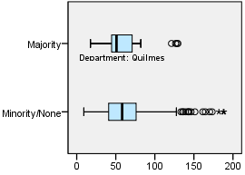

EXAMINE VARIABLES=trvtime_hspt_min BY ASENT_MAJ_YN
/PLOT=BOXPLOT
/STATISTICS=NONE
/NOTOTAL.

Explore

Notes
Output Created |  | 03-APR-2018 18:38:35
Comments
Input | Data | F:\Data_Final\3cases_traveltime_indec.sav
Input | Active Dataset | DataSet1
Input | Filter | <none>
Input | Weight | <none>
Input | Split File | <none>
Input | N of Rows in Working Data File | 284
Missing Value Handling | Definition of Missing | User-defined missing values for dependent variables are treated as missing.
Missing Value Handling | Cases Used | Statistics are based on cases with no missing values for any dependent variable or factor used.
Syntax |  | EXAMINE VARIABLES=trvtime_hspt_min BY ASENT_MAJ_YN  /PLOT=BOXPLOT  /STATISTICS=NONE  /NOTOTAL.
Resources | Processor Time | 00:00:00.20
Resources | Elapsed Time | 00:00:00.22

Majority overlap with asentamiento, yes/no

Case Processing Summary
 | Majority overlap with asentamiento, yes/no | Cases
 | Majority overlap with asentamiento, yes/no | Valid |  | Missing |  | Total
 | Majority overlap with asentamiento, yes/no | N | Percent | N | Percent | N
Public hospital | Minority/None | 222 | 95.7% | 10 | 4.3% | 232
Public hospital | Majority | 50 | 96.2% | 2 | 3.8% | 52

Case Processing Summary
 | Majority overlap with asentamiento, yes/no | Cases
 | Majority overlap with asentamiento, yes/no | Total
 | Majority overlap with asentamiento, yes/no | Percent
Public hospital | Minority/None | 100.0%
Public hospital | Majority | 100.0%

Public hospital

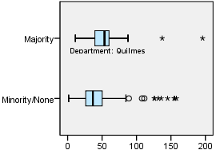

EXAMINE VARIABLES=trvtime_dgntrt_min BY ASENT_MAJ_YN
/PLOT=BOXPLOT
/STATISTICS=NONE
/NOTOTAL.

Explore

Notes
Output Created |  | 03-APR-2018 18:38:42
Comments
Input | Data | F:\Data_Final\3cases_traveltime_indec.sav
Input | Active Dataset | DataSet1
Input | Filter | <none>
Input | Weight | <none>
Input | Split File | <none>
Input | N of Rows in Working Data File | 284
Missing Value Handling | Definition of Missing | User-defined missing values for dependent variables are treated as missing.
Missing Value Handling | Cases Used | Statistics are based on cases with no missing values for any dependent variable or factor used.
Syntax |  | EXAMINE VARIABLES=trvtime_dgntrt_min BY ASENT_MAJ_YN  /PLOT=BOXPLOT  /STATISTICS=NONE  /NOTOTAL.
Resources | Processor Time | 00:00:00.23
Resources | Elapsed Time | 00:00:00.22

Majority overlap with asentamiento, yes/no

Case Processing Summary
 | Majority overlap with asentamiento, yes/no | Cases
 | Majority overlap with asentamiento, yes/no | Valid |  | Missing
 | Majority overlap with asentamiento, yes/no | N | Percent | N | Percent
Public diag./treat. center | Minority/None | 230 | 99.1% | 2 | 0.9%
Public diag./treat. center | Majority | 52 | 100.0% | 0 | 0.0%

Case Processing Summary
 | Majority overlap with asentamiento, yes/no | Cases
 | Majority overlap with asentamiento, yes/no | Total
 | Majority overlap with asentamiento, yes/no | N | Percent
Public diag./treat. center | Minority/None | 232 | 100.0%
Public diag./treat. center | Majority | 52 | 100.0%

Public diag./treat. center

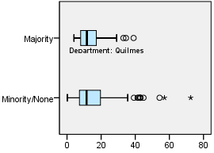

EXAMINE VARIABLES=trvtime_edsec_min BY ASENT_MAJ_YN
/PLOT=BOXPLOT
/STATISTICS=NONE
/NOTOTAL.

Explore

Notes
Output Created |  | 03-APR-2018 18:38:48
Comments
Input | Data | F:\Data_Final\3cases_traveltime_indec.sav
Input | Active Dataset | DataSet1
Input | Filter | <none>
Input | Weight | <none>
Input | Split File | <none>
Input | N of Rows in Working Data File | 284
Missing Value Handling | Definition of Missing | User-defined missing values for dependent variables are treated as missing.
Missing Value Handling | Cases Used | Statistics are based on cases with no missing values for any dependent variable or factor used.
Syntax |  | EXAMINE VARIABLES=trvtime_edsec_min BY ASENT_MAJ_YN  /PLOT=BOXPLOT  /STATISTICS=NONE  /NOTOTAL.
Resources | Processor Time | 00:00:00.23
Resources | Elapsed Time | 00:00:00.22

Majority overlap with asentamiento, yes/no

Case Processing Summary
 | Majority overlap with asentamiento, yes/no | Cases
 | Majority overlap with asentamiento, yes/no | Valid |  | Missing
 | Majority overlap with asentamiento, yes/no | N | Percent | N | Percent
Public secondary school | Minority/None | 232 | 100.0% | 0 | 0.0%
Public secondary school | Majority | 52 | 100.0% | 0 | 0.0%

Case Processing Summary
 | Majority overlap with asentamiento, yes/no | Cases
 | Majority overlap with asentamiento, yes/no | Total
 | Majority overlap with asentamiento, yes/no | N | Percent
Public secondary school | Minority/None | 232 | 100.0%
Public secondary school | Majority | 52 | 100.0%

Public secondary school

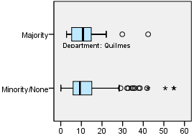

EXAMINE VARIABLES=trvtime_edprm_min BY ASENT_MAJ_YN
/PLOT=BOXPLOT
/STATISTICS=NONE
/NOTOTAL.

Explore

Notes
Output Created |  | 03-APR-2018 18:38:54
Comments
Input | Data | F:\Data_Final\3cases_traveltime_indec.sav
Input | Active Dataset | DataSet1
Input | Filter | <none>
Input | Weight | <none>
Input | Split File | <none>
Input | N of Rows in Working Data File | 284
Missing Value Handling | Definition of Missing | User-defined missing values for dependent variables are treated as missing.
Missing Value Handling | Cases Used | Statistics are based on cases with no missing values for any dependent variable or factor used.
Syntax |  | EXAMINE VARIABLES=trvtime_edprm_min BY ASENT_MAJ_YN  /PLOT=BOXPLOT  /STATISTICS=NONE  /NOTOTAL.
Resources | Processor Time | 00:00:00.22
Resources | Elapsed Time | 00:00:00.22

Majority overlap with asentamiento, yes/no

Case Processing Summary
 | Majority overlap with asentamiento, yes/no | Cases
 | Majority overlap with asentamiento, yes/no | Valid |  | Missing
 | Majority overlap with asentamiento, yes/no | N | Percent | N | Percent
Public primary school | Minority/None | 232 | 100.0% | 0 | 0.0%
Public primary school | Majority | 52 | 100.0% | 0 | 0.0%

Case Processing Summary
 | Majority overlap with asentamiento, yes/no | Cases
 | Majority overlap with asentamiento, yes/no | Total
 | Majority overlap with asentamiento, yes/no | N | Percent
Public primary school | Minority/None | 232 | 100.0%
Public primary school | Majority | 52 | 100.0%

Public primary school

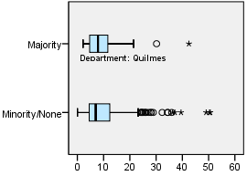

EXAMINE VARIABLES=trvtime_edknd_min BY ASENT_MAJ_YN
/PLOT=BOXPLOT
/STATISTICS=NONE
/NOTOTAL.

Explore

Notes
Output Created |  | 03-APR-2018 18:39:02
Comments
Input | Data | F:\Data_Final\3cases_traveltime_indec.sav
Input | Active Dataset | DataSet1
Input | Filter | <none>
Input | Weight | <none>
Input | Split File | <none>
Input | N of Rows in Working Data File | 284
Missing Value Handling | Definition of Missing | User-defined missing values for dependent variables are treated as missing.
Missing Value Handling | Cases Used | Statistics are based on cases with no missing values for any dependent variable or factor used.
Syntax |  | EXAMINE VARIABLES=trvtime_edknd_min BY ASENT_MAJ_YN  /PLOT=BOXPLOT  /STATISTICS=NONE  /NOTOTAL.
Resources | Processor Time | 00:00:00.22
Resources | Elapsed Time | 00:00:00.22

Majority overlap with asentamiento, yes/no

Case Processing Summary
 | Majority overlap with asentamiento, yes/no | Cases
 | Majority overlap with asentamiento, yes/no | Valid |  | Missing
 | Majority overlap with asentamiento, yes/no | N | Percent | N | Percent
Public kindergarten | Minority/None | 232 | 100.0% | 0 | 0.0%
Public kindergarten | Majority | 52 | 100.0% | 0 | 0.0%

Case Processing Summary
 | Majority overlap with asentamiento, yes/no | Cases
 | Majority overlap with asentamiento, yes/no | Total
 | Majority overlap with asentamiento, yes/no | N | Percent
Public kindergarten | Minority/None | 232 | 100.0%
Public kindergarten | Majority | 52 | 100.0%

Public kindergarten

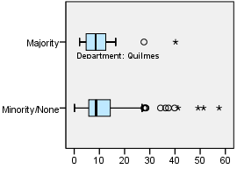

SORT CASES BY DEPTO.
SPLIT FILE SEPARATE BY DEPTO.
EXAMINE VARIABLES=trvtime_cbd_bsas BY ASENT_MAJ_YN
/PLOT=BOXPLOT
/STATISTICS=NONE
/NOTOTAL.

Explore

Notes
Output Created |  | 03-APR-2018 18:39:23
Comments
Input | Data | F:\Data_Final\3cases_traveltime_indec.sav
Input | Active Dataset | DataSet1
Input | Filter | <none>
Input | Weight | <none>
Input | Split File | Department
Input | N of Rows in Working Data File | 284
Missing Value Handling | Definition of Missing | User-defined missing values for dependent variables are treated as missing.
Missing Value Handling | Cases Used | Statistics are based on cases with no missing values for any dependent variable or factor used.
Syntax |  | EXAMINE VARIABLES=trvtime_cbd_bsas BY ASENT_MAJ_YN  /PLOT=BOXPLOT  /STATISTICS=NONE  /NOTOTAL.
Resources | Processor Time | 00:00:00.61
Resources | Elapsed Time | 00:00:00.61

Department = La Matanza

Majority overlap with asentamiento, yes/no

Case Processing Summaryª
 | Majority overlap with asentamiento, yes/no | Cases
 | Majority overlap with asentamiento, yes/no | Valid |  | Missing |  | Total
 | Majority overlap with asentamiento, yes/no | N | Percent | N | Percent | N
Buenos Aires CBD | Minority/None | 90 | 100.0% | 0 | 0.0% | 90
Buenos Aires CBD | Majority | 28 | 93.3% | 2 | 6.7% | 30

Case Processing Summaryª
 | Majority overlap with asentamiento, yes/no | Cases
 | Majority overlap with asentamiento, yes/no | Total
 | Majority overlap with asentamiento, yes/no | Percent
Buenos Aires CBD | Minority/None | 100.0%
Buenos Aires CBD | Majority | 100.0%

a. Department = La Matanza

Buenos Aires CBD

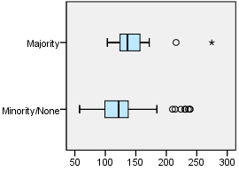

Department = Pilar

Majority overlap with asentamiento, yes/no

Case Processing Summaryª
 | Majority overlap with asentamiento, yes/no | Cases
 | Majority overlap with asentamiento, yes/no | Valid |  | Missing |  | Total
 | Majority overlap with asentamiento, yes/no | N | Percent | N | Percent | N
Buenos Aires CBD | Minority/None | 54 | 81.8% | 12 | 18.2% | 66
Buenos Aires CBD | Majority | 6 | 100.0% | 0 | 0.0% | 6

Case Processing Summaryª
 | Majority overlap with asentamiento, yes/no | Cases
 | Majority overlap with asentamiento, yes/no | Total
 | Majority overlap with asentamiento, yes/no | Percent
Buenos Aires CBD | Minority/None | 100.0%
Buenos Aires CBD | Majority | 100.0%

a. Department = Pilar

Buenos Aires CBD

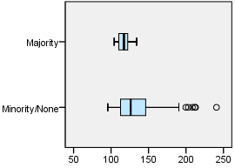

Department = Quilmes

Majority overlap with asentamiento, yes/no

Case Processing Summaryª
 | Majority overlap with asentamiento, yes/no | Cases
 | Majority overlap with asentamiento, yes/no | Valid |  | Missing |  | Total
 | Majority overlap with asentamiento, yes/no | N | Percent | N | Percent | N
Buenos Aires CBD | Minority/None | 76 | 100.0% | 0 | 0.0% | 76
Buenos Aires CBD | Majority | 16 | 100.0% | 0 | 0.0% | 16

Case Processing Summaryª
 | Majority overlap with asentamiento, yes/no | Cases
 | Majority overlap with asentamiento, yes/no | Total
 | Majority overlap with asentamiento, yes/no | Percent
Buenos Aires CBD | Minority/None | 100.0%
Buenos Aires CBD | Majority | 100.0%

a. Department = Quilmes

Buenos Aires CBD

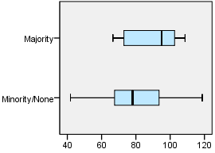

EXAMINE VARIABLES=trvtime_cbd_loc BY ASENT_MAJ_YN
/PLOT=BOXPLOT
/STATISTICS=NONE
/NOTOTAL.

Explore

Notes
Output Created |  | 03-APR-2018 18:39:32
Comments
Input | Data | F:\Data_Final\3cases_traveltime_indec.sav
Input | Active Dataset | DataSet1
Input | Filter | <none>
Input | Weight | <none>
Input | Split File | Department
Input | N of Rows in Working Data File | 284
Missing Value Handling | Definition of Missing | User-defined missing values for dependent variables are treated as missing.
Missing Value Handling | Cases Used | Statistics are based on cases with no missing values for any dependent variable or factor used.
Syntax |  | EXAMINE VARIABLES=trvtime_cbd_loc BY ASENT_MAJ_YN  /PLOT=BOXPLOT  /STATISTICS=NONE  /NOTOTAL.
Resources | Processor Time | 00:00:00.61
Resources | Elapsed Time | 00:00:00.61

Department = La Matanza

Majority overlap with asentamiento, yes/no

Case Processing Summaryª
 | Majority overlap with asentamiento, yes/no | Cases
 | Majority overlap with asentamiento, yes/no | Valid |  | Missing |  | Total
 | Majority overlap with asentamiento, yes/no | N | Percent | N | Percent | N
Departmental CBD | Minority/None | 90 | 100.0% | 0 | 0.0% | 90
Departmental CBD | Majority | 28 | 93.3% | 2 | 6.7% | 30

Case Processing Summaryª
 | Majority overlap with asentamiento, yes/no | Cases
 | Majority overlap with asentamiento, yes/no | Total
 | Majority overlap with asentamiento, yes/no | Percent
Departmental CBD | Minority/None | 100.0%
Departmental CBD | Majority | 100.0%

a. Department = La Matanza

Departmental CBD

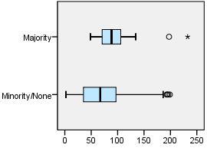

Department = Pilar

Majority overlap with asentamiento, yes/no

Case Processing Summaryª
 | Majority overlap with asentamiento, yes/no | Cases
 | Majority overlap with asentamiento, yes/no | Valid |  | Missing |  | Total
 | Majority overlap with asentamiento, yes/no | N | Percent | N | Percent | N
Departmental CBD | Minority/None | 56 | 84.8% | 10 | 15.2% | 66
Departmental CBD | Majority | 6 | 100.0% | 0 | 0.0% | 6

Case Processing Summaryª
 | Majority overlap with asentamiento, yes/no | Cases
 | Majority overlap with asentamiento, yes/no | Total
 | Majority overlap with asentamiento, yes/no | Percent
Departmental CBD | Minority/None | 100.0%
Departmental CBD | Majority | 100.0%

a. Department = Pilar

Departmental CBD

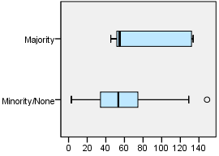

Department = Quilmes

Majority overlap with asentamiento, yes/no

Case Processing Summaryª
 | Majority overlap with asentamiento, yes/no | Cases
 | Majority overlap with asentamiento, yes/no | Valid |  | Missing |  | Total
 | Majority overlap with asentamiento, yes/no | N | Percent | N | Percent | N
Departmental CBD | Minority/None | 76 | 100.0% | 0 | 0.0% | 76
Departmental CBD | Majority | 16 | 100.0% | 0 | 0.0% | 16

Case Processing Summaryª
 | Majority overlap with asentamiento, yes/no | Cases
 | Majority overlap with asentamiento, yes/no | Total
 | Majority overlap with asentamiento, yes/no | Percent
Departmental CBD | Minority/None | 100.0%
Departmental CBD | Majority | 100.0%

a. Department = Quilmes

Departmental CBD

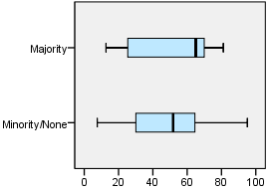

EXAMINE VARIABLES=trvtime_cbd_ngh_min BY ASENT_MAJ_YN
/PLOT=BOXPLOT
/STATISTICS=NONE
/NOTOTAL.

Explore

Notes
Output Created |  | 03-APR-2018 18:39:40
Comments
Input | Data | F:\Data_Final\3cases_traveltime_indec.sav
Input | Active Dataset | DataSet1
Input | Filter | <none>
Input | Weight | <none>
Input | Split File | Department
Input | N of Rows in Working Data File | 284
Missing Value Handling | Definition of Missing | User-defined missing values for dependent variables are treated as missing.
Missing Value Handling | Cases Used | Statistics are based on cases with no missing values for any dependent variable or factor used.
Syntax |  | EXAMINE VARIABLES=trvtime_cbd_ngh_min BY ASENT_MAJ_YN  /PLOT=BOXPLOT  /STATISTICS=NONE  /NOTOTAL.
Resources | Processor Time | 00:00:00.62
Resources | Elapsed Time | 00:00:00.62

Department = La Matanza

Majority overlap with asentamiento, yes/no

Case Processing Summaryª
 | Majority overlap with asentamiento, yes/no | Cases
 | Majority overlap with asentamiento, yes/no | Valid |  | Missing
 | Majority overlap with asentamiento, yes/no | N | Percent | N | Percent
Any departmental CBD | Minority/None | 90 | 100.0% | 0 | 0.0%
Any departmental CBD | Majority | 28 | 93.3% | 2 | 6.7%

Case Processing Summaryª
 | Majority overlap with asentamiento, yes/no | Cases
 | Majority overlap with asentamiento, yes/no | Total
 | Majority overlap with asentamiento, yes/no | N | Percent
Any departmental CBD | Minority/None | 90 | 100.0%
Any departmental CBD | Majority | 30 | 100.0%

a. Department = La Matanza

Any departmental CBD

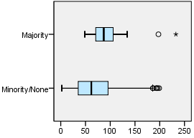

Department = Pilar

Majority overlap with asentamiento, yes/no

Case Processing Summaryª
 | Majority overlap with asentamiento, yes/no | Cases
 | Majority overlap with asentamiento, yes/no | Valid |  | Missing
 | Majority overlap with asentamiento, yes/no | N | Percent | N | Percent
Any departmental CBD | Minority/None | 56 | 84.8% | 10 | 15.2%
Any departmental CBD | Majority | 6 | 100.0% | 0 | 0.0%

Case Processing Summaryª
 | Majority overlap with asentamiento, yes/no | Cases
 | Majority overlap with asentamiento, yes/no | Total
 | Majority overlap with asentamiento, yes/no | N | Percent
Any departmental CBD | Minority/None | 66 | 100.0%
Any departmental CBD | Majority | 6 | 100.0%

a. Department = Pilar

Any departmental CBD

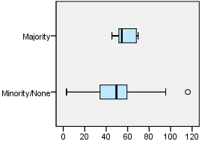

Department = Quilmes

Majority overlap with asentamiento, yes/no

Case Processing Summaryª
 | Majority overlap with asentamiento, yes/no | Cases
 | Majority overlap with asentamiento, yes/no | Valid |  | Missing
 | Majority overlap with asentamiento, yes/no | N | Percent | N | Percent
Any departmental CBD | Minority/None | 76 | 100.0% | 0 | 0.0%
Any departmental CBD | Majority | 16 | 100.0% | 0 | 0.0%

Case Processing Summaryª
 | Majority overlap with asentamiento, yes/no | Cases
 | Majority overlap with asentamiento, yes/no | Total
 | Majority overlap with asentamiento, yes/no | N | Percent
Any departmental CBD | Minority/None | 76 | 100.0%
Any departmental CBD | Majority | 16 | 100.0%

a. Department = Quilmes

Any departmental CBD

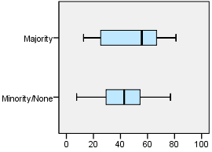

EXAMINE VARIABLES=trvtime_rail_min BY ASENT_MAJ_YN
/PLOT=BOXPLOT
/STATISTICS=NONE
/NOTOTAL.

Explore

Notes
Output Created |  | 03-APR-2018 18:39:47
Comments
Input | Data | F:\Data_Final\3cases_traveltime_indec.sav
Input | Active Dataset | DataSet1
Input | Filter | <none>
Input | Weight | <none>
Input | Split File | Department
Input | N of Rows in Working Data File | 284
Missing Value Handling | Definition of Missing | User-defined missing values for dependent variables are treated as missing.
Missing Value Handling | Cases Used | Statistics are based on cases with no missing values for any dependent variable or factor used.
Syntax |  | EXAMINE VARIABLES=trvtime_rail_min BY ASENT_MAJ_YN  /PLOT=BOXPLOT  /STATISTICS=NONE  /NOTOTAL.
Resources | Processor Time | 00:00:00.66
Resources | Elapsed Time | 00:00:00.64

Department = La Matanza

Majority overlap with asentamiento, yes/no

Case Processing Summaryª
 | Majority overlap with asentamiento, yes/no | Cases
 | Majority overlap with asentamiento, yes/no | Valid |  | Missing |  | Total
 | Majority overlap with asentamiento, yes/no | N | Percent | N | Percent | N
Railway station | Minority/None | 90 | 100.0% | 0 | 0.0% | 90
Railway station | Majority | 28 | 93.3% | 2 | 6.7% | 30

Case Processing Summaryª
 | Majority overlap with asentamiento, yes/no | Cases
 | Majority overlap with asentamiento, yes/no | Total
 | Majority overlap with asentamiento, yes/no | Percent
Railway station | Minority/None | 100.0%
Railway station | Majority | 100.0%

a. Department = La Matanza

Railway station

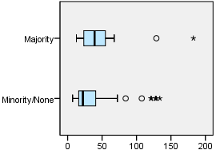

Department = Pilar

Majority overlap with asentamiento, yes/no

Case Processing Summaryª
 | Majority overlap with asentamiento, yes/no | Cases
 | Majority overlap with asentamiento, yes/no | Valid |  | Missing |  | Total
 | Majority overlap with asentamiento, yes/no | N | Percent | N | Percent | N
Railway station | Minority/None | 56 | 84.8% | 10 | 15.2% | 66
Railway station | Majority | 6 | 100.0% | 0 | 0.0% | 6

Case Processing Summaryª
 | Majority overlap with asentamiento, yes/no | Cases
 | Majority overlap with asentamiento, yes/no | Total
 | Majority overlap with asentamiento, yes/no | Percent
Railway station | Minority/None | 100.0%
Railway station | Majority | 100.0%

a. Department = Pilar

Railway station

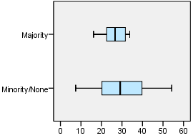

Department = Quilmes

Majority overlap with asentamiento, yes/no

Case Processing Summaryª
 | Majority overlap with asentamiento, yes/no | Cases
 | Majority overlap with asentamiento, yes/no | Valid |  | Missing |  | Total
 | Majority overlap with asentamiento, yes/no | N | Percent | N | Percent | N
Railway station | Minority/None | 76 | 100.0% | 0 | 0.0% | 76
Railway station | Majority | 16 | 100.0% | 0 | 0.0% | 16

Case Processing Summaryª
 | Majority overlap with asentamiento, yes/no | Cases
 | Majority overlap with asentamiento, yes/no | Total
 | Majority overlap with asentamiento, yes/no | Percent
Railway station | Minority/None | 100.0%
Railway station | Majority | 100.0%

a. Department = Quilmes

Railway station

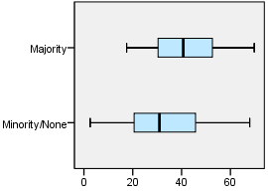

EXAMINE VARIABLES=trvtime_upa_min BY ASENT_MAJ_YN
/PLOT=BOXPLOT
/STATISTICS=NONE
/NOTOTAL.

Explore

Notes
Output Created |  | 03-APR-2018 18:39:55
Comments
Input | Data | F:\Data_Final\3cases_traveltime_indec.sav
Input | Active Dataset | DataSet1
Input | Filter | <none>
Input | Weight | <none>
Input | Split File | Department
Input | N of Rows in Working Data File | 284
Missing Value Handling | Definition of Missing | User-defined missing values for dependent variables are treated as missing.
Missing Value Handling | Cases Used | Statistics are based on cases with no missing values for any dependent variable or factor used.
Syntax |  | EXAMINE VARIABLES=trvtime_upa_min BY ASENT_MAJ_YN  /PLOT=BOXPLOT  /STATISTICS=NONE  /NOTOTAL.
Resources | Processor Time | 00:00:00.62
Resources | Elapsed Time | 00:00:00.62

Department = La Matanza

Majority overlap with asentamiento, yes/no

Case Processing Summaryª
 | Majority overlap with asentamiento, yes/no | Cases
 | Majority overlap with asentamiento, yes/no | Valid |  | Missing |  | Total
 | Majority overlap with asentamiento, yes/no | N | Percent | N | Percent | N
Public UPA | Minority/None | 90 | 100.0% | 0 | 0.0% | 90
Public UPA | Majority | 28 | 93.3% | 2 | 6.7% | 30

Case Processing Summaryª
 | Majority overlap with asentamiento, yes/no | Cases
 | Majority overlap with asentamiento, yes/no | Total
 | Majority overlap with asentamiento, yes/no | Percent
Public UPA | Minority/None | 100.0%
Public UPA | Majority | 100.0%

a. Department = La Matanza

Public UPA

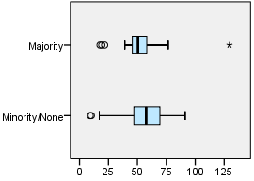

Department = Pilar

Majority overlap with asentamiento, yes/no

Case Processing Summaryª
 | Majority overlap with asentamiento, yes/no | Cases
 | Majority overlap with asentamiento, yes/no | Valid |  | Missing |  | Total
 | Majority overlap with asentamiento, yes/no | N | Percent | N | Percent | N
Public UPA | Minority/None | 54 | 81.8% | 12 | 18.2% | 66
Public UPA | Majority | 6 | 100.0% | 0 | 0.0% | 6

Case Processing Summaryª
 | Majority overlap with asentamiento, yes/no | Cases
 | Majority overlap with asentamiento, yes/no | Total
 | Majority overlap with asentamiento, yes/no | Percent
Public UPA | Minority/None | 100.0%
Public UPA | Majority | 100.0%

a. Department = Pilar

Public UPA

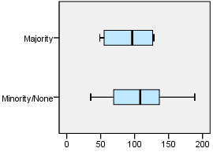

Department = Quilmes

Majority overlap with asentamiento, yes/no

Case Processing Summaryª
 | Majority overlap with asentamiento, yes/no | Cases
 | Majority overlap with asentamiento, yes/no | Valid |  | Missing |  | Total
 | Majority overlap with asentamiento, yes/no | N | Percent | N | Percent | N
Public UPA | Minority/None | 76 | 100.0% | 0 | 0.0% | 76
Public UPA | Majority | 16 | 100.0% | 0 | 0.0% | 16

Case Processing Summaryª
 | Majority overlap with asentamiento, yes/no | Cases
 | Majority overlap with asentamiento, yes/no | Total
 | Majority overlap with asentamiento, yes/no | Percent
Public UPA | Minority/None | 100.0%
Public UPA | Majority | 100.0%

a. Department = Quilmes

Public UPA

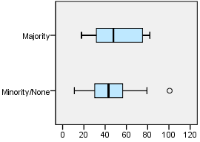

EXAMINE VARIABLES=trvtime_hspt_min BY ASENT_MAJ_YN
/PLOT=BOXPLOT
/STATISTICS=NONE
/NOTOTAL.

Explore

Notes
Output Created |  | 03-APR-2018 18:40:03
Comments
Input | Data | F:\Data_Final\3cases_traveltime_indec.sav
Input | Active Dataset | DataSet1
Input | Filter | <none>
Input | Weight | <none>
Input | Split File | Department
Input | N of Rows in Working Data File | 284
Missing Value Handling | Definition of Missing | User-defined missing values for dependent variables are treated as missing.
Missing Value Handling | Cases Used | Statistics are based on cases with no missing values for any dependent variable or factor used.
Syntax |  | EXAMINE VARIABLES=trvtime_hspt_min BY ASENT_MAJ_YN  /PLOT=BOXPLOT  /STATISTICS=NONE  /NOTOTAL.
Resources | Processor Time | 00:00:00.58
Resources | Elapsed Time | 00:00:00.59

Department = La Matanza

Majority overlap with asentamiento, yes/no

Case Processing Summaryª
 | Majority overlap with asentamiento, yes/no | Cases
 | Majority overlap with asentamiento, yes/no | Valid |  | Missing |  | Total
 | Majority overlap with asentamiento, yes/no | N | Percent | N | Percent | N
Public hospital | Minority/None | 90 | 100.0% | 0 | 0.0% | 90
Public hospital | Majority | 28 | 93.3% | 2 | 6.7% | 30

Case Processing Summaryª
 | Majority overlap with asentamiento, yes/no | Cases
 | Majority overlap with asentamiento, yes/no | Total
 | Majority overlap with asentamiento, yes/no | Percent
Public hospital | Minority/None | 100.0%
Public hospital | Majority | 100.0%

a. Department = La Matanza

Public hospital

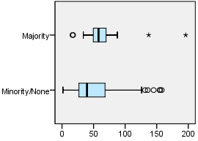

Department = Pilar

Majority overlap with asentamiento, yes/no

Case Processing Summaryª
 | Majority overlap with asentamiento, yes/no | Cases
 | Majority overlap with asentamiento, yes/no | Valid |  | Missing |  | Total
 | Majority overlap with asentamiento, yes/no | N | Percent | N | Percent | N
Public hospital | Minority/None | 56 | 84.8% | 10 | 15.2% | 66
Public hospital | Majority | 6 | 100.0% | 0 | 0.0% | 6

Case Processing Summaryª
 | Majority overlap with asentamiento, yes/no | Cases
 | Majority overlap with asentamiento, yes/no | Total
 | Majority overlap with asentamiento, yes/no | Percent
Public hospital | Minority/None | 100.0%
Public hospital | Majority | 100.0%

a. Department = Pilar

Public hospital

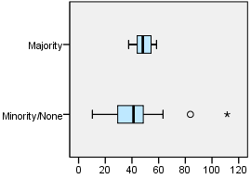

Department = Quilmes

Majority overlap with asentamiento, yes/no

Case Processing Summaryª
 | Majority overlap with asentamiento, yes/no | Cases
 | Majority overlap with asentamiento, yes/no | Valid |  | Missing |  | Total
 | Majority overlap with asentamiento, yes/no | N | Percent | N | Percent | N
Public hospital | Minority/None | 76 | 100.0% | 0 | 0.0% | 76
Public hospital | Majority | 16 | 100.0% | 0 | 0.0% | 16

Case Processing Summaryª
 | Majority overlap with asentamiento, yes/no | Cases
 | Majority overlap with asentamiento, yes/no | Total
 | Majority overlap with asentamiento, yes/no | Percent
Public hospital | Minority/None | 100.0%
Public hospital | Majority | 100.0%

a. Department = Quilmes

Public hospital

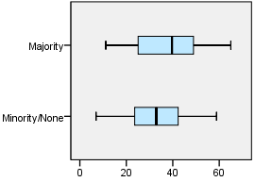

EXAMINE VARIABLES=trvtime_dgntrt_min BY ASENT_MAJ_YN
/PLOT=BOXPLOT
/STATISTICS=NONE
/NOTOTAL.

Explore

Notes
Output Created |  | 03-APR-2018 18:40:10
Comments
Input | Data | F:\Data_Final\3cases_traveltime_indec.sav
Input | Active Dataset | DataSet1
Input | Filter | <none>
Input | Weight | <none>
Input | Split File | Department
Input | N of Rows in Working Data File | 284
Missing Value Handling | Definition of Missing | User-defined missing values for dependent variables are treated as missing.
Missing Value Handling | Cases Used | Statistics are based on cases with no missing values for any dependent variable or factor used.
Syntax |  | EXAMINE VARIABLES=trvtime_dgntrt_min BY ASENT_MAJ_YN  /PLOT=BOXPLOT  /STATISTICS=NONE  /NOTOTAL.
Resources | Processor Time | 00:00:00.62
Resources | Elapsed Time | 00:00:00.61

Department = La Matanza

Majority overlap with asentamiento, yes/no

Case Processing Summaryª
 | Majority overlap with asentamiento, yes/no | Cases
 | Majority overlap with asentamiento, yes/no | Valid |  | Missing
 | Majority overlap with asentamiento, yes/no | N | Percent | N | Percent
Public diag./treat. center | Minority/None | 90 | 100.0% | 0 | 0.0%
Public diag./treat. center | Majority | 30 | 100.0% | 0 | 0.0%

Case Processing Summaryª
 | Majority overlap with asentamiento, yes/no | Cases
 | Majority overlap with asentamiento, yes/no | Total
 | Majority overlap with asentamiento, yes/no | N | Percent
Public diag./treat. center | Minority/None | 90 | 100.0%
Public diag./treat. center | Majority | 30 | 100.0%

a. Department = La Matanza

Public diag./treat. center

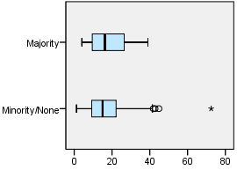

Department = Pilar

Majority overlap with asentamiento, yes/no

Case Processing Summaryª
 | Majority overlap with asentamiento, yes/no | Cases
 | Majority overlap with asentamiento, yes/no | Valid |  | Missing
 | Majority overlap with asentamiento, yes/no | N | Percent | N | Percent
Public diag./treat. center | Minority/None | 64 | 97.0% | 2 | 3.0%
Public diag./treat. center | Majority | 6 | 100.0% | 0 | 0.0%

Case Processing Summaryª
 | Majority overlap with asentamiento, yes/no | Cases
 | Majority overlap with asentamiento, yes/no | Total
 | Majority overlap with asentamiento, yes/no | N | Percent
Public diag./treat. center | Minority/None | 66 | 100.0%
Public diag./treat. center | Majority | 6 | 100.0%

a. Department = Pilar

Public diag./treat. center

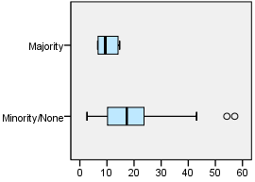

Department = Quilmes

Majority overlap with asentamiento, yes/no

Case Processing Summaryª
 | Majority overlap with asentamiento, yes/no | Cases
 | Majority overlap with asentamiento, yes/no | Valid |  | Missing
 | Majority overlap with asentamiento, yes/no | N | Percent | N | Percent
Public diag./treat. center | Minority/None | 76 | 100.0% | 0 | 0.0%
Public diag./treat. center | Majority | 16 | 100.0% | 0 | 0.0%

Case Processing Summaryª
 | Majority overlap with asentamiento, yes/no | Cases
 | Majority overlap with asentamiento, yes/no | Total
 | Majority overlap with asentamiento, yes/no | N | Percent
Public diag./treat. center | Minority/None | 76 | 100.0%
Public diag./treat. center | Majority | 16 | 100.0%

a. Department = Quilmes

Public diag./treat. center

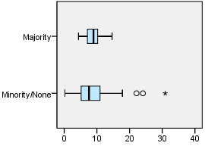

EXAMINE VARIABLES=trvtime_edsec_min BY ASENT_MAJ_YN
/PLOT=BOXPLOT
/STATISTICS=NONE
/NOTOTAL.

Explore

Notes
Output Created |  | 03-APR-2018 18:40:17
Comments
Input | Data | F:\Data_Final\3cases_traveltime_indec.sav
Input | Active Dataset | DataSet1
Input | Filter | <none>
Input | Weight | <none>
Input | Split File | Department
Input | N of Rows in Working Data File | 284
Missing Value Handling | Definition of Missing | User-defined missing values for dependent variables are treated as missing.
Missing Value Handling | Cases Used | Statistics are based on cases with no missing values for any dependent variable or factor used.
Syntax |  | EXAMINE VARIABLES=trvtime_edsec_min BY ASENT_MAJ_YN  /PLOT=BOXPLOT  /STATISTICS=NONE  /NOTOTAL.
Resources | Processor Time | 00:00:00.66
Resources | Elapsed Time | 00:00:00.62

Department = La Matanza

Majority overlap with asentamiento, yes/no

Case Processing Summaryª
 | Majority overlap with asentamiento, yes/no | Cases
 | Majority overlap with asentamiento, yes/no | Valid |  | Missing
 | Majority overlap with asentamiento, yes/no | N | Percent | N | Percent
Public secondary school | Minority/None | 90 | 100.0% | 0 | 0.0%
Public secondary school | Majority | 30 | 100.0% | 0 | 0.0%

Case Processing Summaryª
 | Majority overlap with asentamiento, yes/no | Cases
 | Majority overlap with asentamiento, yes/no | Total
 | Majority overlap with asentamiento, yes/no | N | Percent
Public secondary school | Minority/None | 90 | 100.0%
Public secondary school | Majority | 30 | 100.0%

a. Department = La Matanza

Public secondary school

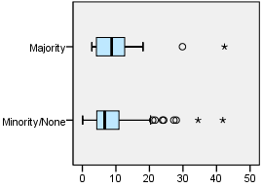

Department = Pilar

Majority overlap with asentamiento, yes/no

Case Processing Summaryª
 | Majority overlap with asentamiento, yes/no | Cases
 | Majority overlap with asentamiento, yes/no | Valid |  | Missing
 | Majority overlap with asentamiento, yes/no | N | Percent | N | Percent
Public secondary school | Minority/None | 66 | 100.0% | 0 | 0.0%
Public secondary school | Majority | 6 | 100.0% | 0 | 0.0%

Case Processing Summaryª
 | Majority overlap with asentamiento, yes/no | Cases
 | Majority overlap with asentamiento, yes/no | Total
 | Majority overlap with asentamiento, yes/no | N | Percent
Public secondary school | Minority/None | 66 | 100.0%
Public secondary school | Majority | 6 | 100.0%

a. Department = Pilar

Public secondary school

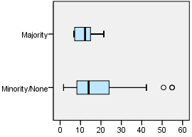

Department = Quilmes

Majority overlap with asentamiento, yes/no

Case Processing Summaryª
 | Majority overlap with asentamiento, yes/no | Cases
 | Majority overlap with asentamiento, yes/no | Valid |  | Missing
 | Majority overlap with asentamiento, yes/no | N | Percent | N | Percent
Public secondary school | Minority/None | 76 | 100.0% | 0 | 0.0%
Public secondary school | Majority | 16 | 100.0% | 0 | 0.0%

Case Processing Summaryª
 | Majority overlap with asentamiento, yes/no | Cases
 | Majority overlap with asentamiento, yes/no | Total
 | Majority overlap with asentamiento, yes/no | N | Percent
Public secondary school | Minority/None | 76 | 100.0%
Public secondary school | Majority | 16 | 100.0%

a. Department = Quilmes

Public secondary school

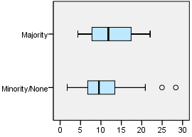

EXAMINE VARIABLES=trvtime_edprm_min BY ASENT_MAJ_YN
/PLOT=BOXPLOT
/STATISTICS=NONE
/NOTOTAL.

Explore

Notes
Output Created |  | 03-APR-2018 18:40:25
Comments
Input | Data | F:\Data_Final\3cases_traveltime_indec.sav
Input | Active Dataset | DataSet1
Input | Filter | <none>
Input | Weight | <none>
Input | Split File | Department
Input | N of Rows in Working Data File | 284
Missing Value Handling | Definition of Missing | User-defined missing values for dependent variables are treated as missing.
Missing Value Handling | Cases Used | Statistics are based on cases with no missing values for any dependent variable or factor used.
Syntax |  | EXAMINE VARIABLES=trvtime_edprm_min BY ASENT_MAJ_YN  /PLOT=BOXPLOT  /STATISTICS=NONE  /NOTOTAL.
Resources | Processor Time | 00:00:00.84
Resources | Elapsed Time | 00:00:00.59

Department = La Matanza

Majority overlap with asentamiento, yes/no

Case Processing Summaryª
 | Majority overlap with asentamiento, yes/no | Cases
 | Majority overlap with asentamiento, yes/no | Valid |  | Missing
 | Majority overlap with asentamiento, yes/no | N | Percent | N | Percent
Public primary school | Minority/None | 90 | 100.0% | 0 | 0.0%
Public primary school | Majority | 30 | 100.0% | 0 | 0.0%

Case Processing Summaryª
 | Majority overlap with asentamiento, yes/no | Cases
 | Majority overlap with asentamiento, yes/no | Total
 | Majority overlap with asentamiento, yes/no | N | Percent
Public primary school | Minority/None | 90 | 100.0%
Public primary school | Majority | 30 | 100.0%

a. Department = La Matanza

Public primary school

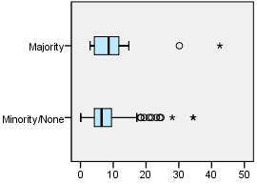

Department = Pilar

Majority overlap with asentamiento, yes/no

Case Processing Summaryª
 | Majority overlap with asentamiento, yes/no | Cases
 | Majority overlap with asentamiento, yes/no | Valid |  | Missing
 | Majority overlap with asentamiento, yes/no | N | Percent | N | Percent
Public primary school | Minority/None | 66 | 100.0% | 0 | 0.0%
Public primary school | Majority | 6 | 100.0% | 0 | 0.0%

Case Processing Summaryª
 | Majority overlap with asentamiento, yes/no | Cases
 | Majority overlap with asentamiento, yes/no | Total
 | Majority overlap with asentamiento, yes/no | N | Percent
Public primary school | Minority/None | 66 | 100.0%
Public primary school | Majority | 6 | 100.0%

a. Department = Pilar

Public primary school

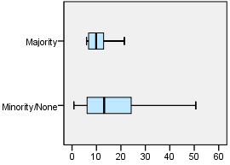

Department = Quilmes

Majority overlap with asentamiento, yes/no

Case Processing Summaryª
 | Majority overlap with asentamiento, yes/no | Cases
 | Majority overlap with asentamiento, yes/no | Valid |  | Missing
 | Majority overlap with asentamiento, yes/no | N | Percent | N | Percent
Public primary school | Minority/None | 76 | 100.0% | 0 | 0.0%
Public primary school | Majority | 16 | 100.0% | 0 | 0.0%

Case Processing Summaryª
 | Majority overlap with asentamiento, yes/no | Cases
 | Majority overlap with asentamiento, yes/no | Total
 | Majority overlap with asentamiento, yes/no | N | Percent
Public primary school | Minority/None | 76 | 100.0%
Public primary school | Majority | 16 | 100.0%

a. Department = Quilmes

Public primary school

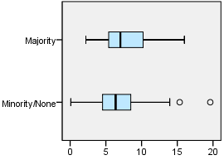

EXAMINE VARIABLES=trvtime_edknd_min BY ASENT_MAJ_YN
/PLOT=BOXPLOT
/STATISTICS=NONE
/NOTOTAL.

Explore

Notes
Output Created |  | 03-APR-2018 18:40:32
Comments
Input | Data | F:\Data_Final\3cases_traveltime_indec.sav
Input | Active Dataset | DataSet1
Input | Filter | <none>
Input | Weight | <none>
Input | Split File | Department
Input | N of Rows in Working Data File | 284
Missing Value Handling | Definition of Missing | User-defined missing values for dependent variables are treated as missing.
Missing Value Handling | Cases Used | Statistics are based on cases with no missing values for any dependent variable or factor used.
Syntax |  | EXAMINE VARIABLES=trvtime_edknd_min BY ASENT_MAJ_YN  /PLOT=BOXPLOT  /STATISTICS=NONE  /NOTOTAL.
Resources | Processor Time | 00:00:00.64
Resources | Elapsed Time | 00:00:00.62

Department = La Matanza

Majority overlap with asentamiento, yes/no

Case Processing Summaryª
 | Majority overlap with asentamiento, yes/no | Cases
 | Majority overlap with asentamiento, yes/no | Valid |  | Missing
 | Majority overlap with asentamiento, yes/no | N | Percent | N | Percent
Public kindergarten | Minority/None | 90 | 100.0% | 0 | 0.0%
Public kindergarten | Majority | 30 | 100.0% | 0 | 0.0%

Case Processing Summaryª
 | Majority overlap with asentamiento, yes/no | Cases
 | Majority overlap with asentamiento, yes/no | Total
 | Majority overlap with asentamiento, yes/no | N | Percent
Public kindergarten | Minority/None | 90 | 100.0%
Public kindergarten | Majority | 30 | 100.0%

a. Department = La Matanza

Public kindergarten

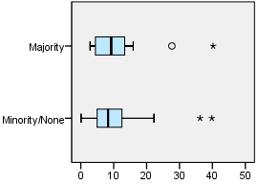

Department = Pilar

Majority overlap with asentamiento, yes/no

Case Processing Summaryª
 | Majority overlap with asentamiento, yes/no | Cases
 | Majority overlap with asentamiento, yes/no | Valid |  | Missing
 | Majority overlap with asentamiento, yes/no | N | Percent | N | Percent
Public kindergarten | Minority/None | 66 | 100.0% | 0 | 0.0%
Public kindergarten | Majority | 6 | 100.0% | 0 | 0.0%

Case Processing Summaryª
 | Majority overlap with asentamiento, yes/no | Cases
 | Majority overlap with asentamiento, yes/no | Total
 | Majority overlap with asentamiento, yes/no | N | Percent
Public kindergarten | Minority/None | 66 | 100.0%
Public kindergarten | Majority | 6 | 100.0%

a. Department = Pilar

Public kindergarten

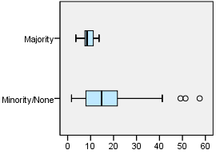

Department = Quilmes

Majority overlap with asentamiento, yes/no

Case Processing Summaryª
 | Majority overlap with asentamiento, yes/no | Cases
 | Majority overlap with asentamiento, yes/no | Valid |  | Missing
 | Majority overlap with asentamiento, yes/no | N | Percent | N | Percent
Public kindergarten | Minority/None | 76 | 100.0% | 0 | 0.0%
Public kindergarten | Majority | 16 | 100.0% | 0 | 0.0%

Case Processing Summaryª
 | Majority overlap with asentamiento, yes/no | Cases
 | Majority overlap with asentamiento, yes/no | Total
 | Majority overlap with asentamiento, yes/no | N | Percent
Public kindergarten | Minority/None | 76 | 100.0%
Public kindergarten | Majority | 16 | 100.0%

a. Department = Quilmes

Public kindergarten

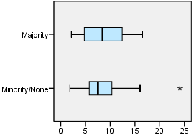

OUTPUT MODIFY
/REPORT PRINTREPORT=NO
/SELECT CHARTS
/DELETEOBJECT DELETE=NO
/OBJECTPROPERTIES VISIBLE=ASIS SIZE=INCHES(2.8,2.0)
/GRAPHS CTEMPLATE="F:\Histogram_MAJvNONMAJ.sgt".

