EXAMINE VARIABLES=trvtime_cbd_bsas BY COVERAGE_TYPE
/PLOT=BOXPLOT
/STATISTICS=NONE
/NOTOTAL.

Explore

Notes
Output Created |  | 03-APR-2018 18:03:27
Comments
Input | Data | F:\Data_Final\3cases_traveltime_indec.sav
Input | Active Dataset | DataSet1
Input | Filter | <none>
Input | Weight | <none>
Input | Split File | <none>
Input | N of Rows in Working Data File | 284
Missing Value Handling | Definition of Missing | User-defined missing values for dependent variables are treated as missing.
Missing Value Handling | Cases Used | Statistics are based on cases with no missing values for any dependent variable or factor used.
Syntax |  | EXAMINE VARIABLES=trvtime_cbd_bsas BY COVERAGE_TYPE  /PLOT=BOXPLOT  /STATISTICS=NONE  /NOTOTAL.
Resources | Processor Time | 00:00:00.33
Resources | Elapsed Time | 00:00:00.23

Overlap with asentamiento, degree

Case Processing Summary
 | Overlap with asentamiento, degree | Cases
 | Overlap with asentamiento, degree | Valid |  | Missing |  | Total
 | Overlap with asentamiento, degree | N | Percent | N | Percent | N
Buenos Aires CBD | MAJ | 50 | 96.2% | 2 | 3.8% | 52
Buenos Aires CBD | MIN | 84 | 93.3% | 6 | 6.7% | 90
Buenos Aires CBD | NONE | 136 | 95.8% | 6 | 4.2% | 142

Case Processing Summary
 | Overlap with asentamiento, degree | Cases
 | Overlap with asentamiento, degree | Total
 | Overlap with asentamiento, degree | Percent
Buenos Aires CBD | MAJ | 100.0%
Buenos Aires CBD | MIN | 100.0%
Buenos Aires CBD | NONE | 100.0%

Buenos Aires CBD

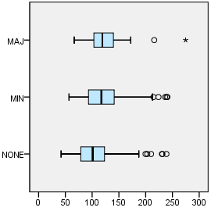

EXAMINE VARIABLES=trvtime_cbd_loc BY COVERAGE_TYPE
/PLOT=BOXPLOT
/STATISTICS=NONE
/NOTOTAL.

Explore

Notes
Output Created |  | 03-APR-2018 18:06:13
Comments
Input | Data | F:\Data_Final\3cases_traveltime_indec.sav
Input | Active Dataset | DataSet1
Input | Filter | <none>
Input | Weight | <none>
Input | Split File | <none>
Input | N of Rows in Working Data File | 284
Missing Value Handling | Definition of Missing | User-defined missing values for dependent variables are treated as missing.
Missing Value Handling | Cases Used | Statistics are based on cases with no missing values for any dependent variable or factor used.
Syntax |  | EXAMINE VARIABLES=trvtime_cbd_loc BY COVERAGE_TYPE  /PLOT=BOXPLOT  /STATISTICS=NONE  /NOTOTAL.
Resources | Processor Time | 00:00:00.34
Resources | Elapsed Time | 00:00:00.22

Overlap with asentamiento, degree

Case Processing Summary
 | Overlap with asentamiento, degree | Cases
 | Overlap with asentamiento, degree | Valid |  | Missing |  | Total
 | Overlap with asentamiento, degree | N | Percent | N | Percent | N
Departmental CBD | MAJ | 50 | 96.2% | 2 | 3.8% | 52
Departmental CBD | MIN | 85 | 94.4% | 5 | 5.6% | 90
Departmental CBD | NONE | 137 | 96.5% | 5 | 3.5% | 142

Case Processing Summary
 | Overlap with asentamiento, degree | Cases
 | Overlap with asentamiento, degree | Total
 | Overlap with asentamiento, degree | Percent
Departmental CBD | MAJ | 100.0%
Departmental CBD | MIN | 100.0%
Departmental CBD | NONE | 100.0%

Departmental CBD

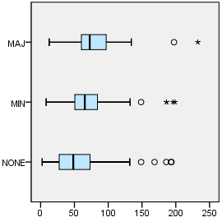

EXAMINE VARIABLES=trvtime_cbd_ngh_min BY COVERAGE_TYPE
/PLOT=BOXPLOT
/STATISTICS=NONE
/NOTOTAL.

Explore

Notes
Output Created |  | 03-APR-2018 18:06:32
Comments
Input | Data | F:\Data_Final\3cases_traveltime_indec.sav
Input | Active Dataset | DataSet1
Input | Filter | <none>
Input | Weight | <none>
Input | Split File | <none>
Input | N of Rows in Working Data File | 284
Missing Value Handling | Definition of Missing | User-defined missing values for dependent variables are treated as missing.
Missing Value Handling | Cases Used | Statistics are based on cases with no missing values for any dependent variable or factor used.
Syntax |  | EXAMINE VARIABLES=trvtime_cbd_ngh_min BY COVERAGE_TYPE  /PLOT=BOXPLOT  /STATISTICS=NONE  /NOTOTAL.
Resources | Processor Time | 00:00:00.28
Resources | Elapsed Time | 00:00:00.23

Overlap with asentamiento, degree

Case Processing Summary
 | Overlap with asentamiento, degree | Cases
 | Overlap with asentamiento, degree | Valid |  | Missing
 | Overlap with asentamiento, degree | N | Percent | N | Percent
Any departmental CBD | MAJ | 50 | 96.2% | 2 | 3.8%
Any departmental CBD | MIN | 85 | 94.4% | 5 | 5.6%
Any departmental CBD | NONE | 137 | 96.5% | 5 | 3.5%

Case Processing Summary
 | Overlap with asentamiento, degree | Cases
 | Overlap with asentamiento, degree | Total
 | Overlap with asentamiento, degree | N | Percent
Any departmental CBD | MAJ | 52 | 100.0%
Any departmental CBD | MIN | 90 | 100.0%
Any departmental CBD | NONE | 142 | 100.0%

Any departmental CBD

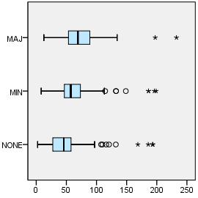

EXAMINE VARIABLES=trvtime_rail_min BY COVERAGE_TYPE
/PLOT=BOXPLOT
/STATISTICS=NONE
/NOTOTAL.

Explore

Notes
Output Created |  | 03-APR-2018 18:06:42
Comments
Input | Data | F:\Data_Final\3cases_traveltime_indec.sav
Input | Active Dataset | DataSet1
Input | Filter | <none>
Input | Weight | <none>
Input | Split File | <none>
Input | N of Rows in Working Data File | 284
Missing Value Handling | Definition of Missing | User-defined missing values for dependent variables are treated as missing.
Missing Value Handling | Cases Used | Statistics are based on cases with no missing values for any dependent variable or factor used.
Syntax |  | EXAMINE VARIABLES=trvtime_rail_min BY COVERAGE_TYPE  /PLOT=BOXPLOT  /STATISTICS=NONE  /NOTOTAL.
Resources | Processor Time | 00:00:00.27
Resources | Elapsed Time | 00:00:00.23

Overlap with asentamiento, degree

Case Processing Summary
 | Overlap with asentamiento, degree | Cases
 | Overlap with asentamiento, degree | Valid |  | Missing |  | Total
 | Overlap with asentamiento, degree | N | Percent | N | Percent | N
Railway station | MAJ | 50 | 96.2% | 2 | 3.8% | 52
Railway station | MIN | 86 | 95.6% | 4 | 4.4% | 90
Railway station | NONE | 136 | 95.8% | 6 | 4.2% | 142

Case Processing Summary
 | Overlap with asentamiento, degree | Cases
 | Overlap with asentamiento, degree | Total
 | Overlap with asentamiento, degree | Percent
Railway station | MAJ | 100.0%
Railway station | MIN | 100.0%
Railway station | NONE | 100.0%

Railway station

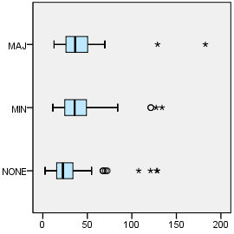

EXAMINE VARIABLES=trvtime_upa_min BY COVERAGE_TYPE
/PLOT=BOXPLOT
/STATISTICS=NONE
/NOTOTAL.

Explore

Notes
Output Created |  | 03-APR-2018 18:06:53
Comments
Input | Data | F:\Data_Final\3cases_traveltime_indec.sav
Input | Active Dataset | DataSet1
Input | Filter | <none>
Input | Weight | <none>
Input | Split File | <none>
Input | N of Rows in Working Data File | 284
Missing Value Handling | Definition of Missing | User-defined missing values for dependent variables are treated as missing.
Missing Value Handling | Cases Used | Statistics are based on cases with no missing values for any dependent variable or factor used.
Syntax |  | EXAMINE VARIABLES=trvtime_upa_min BY COVERAGE_TYPE  /PLOT=BOXPLOT  /STATISTICS=NONE  /NOTOTAL.
Resources | Processor Time | 00:00:00.27
Resources | Elapsed Time | 00:00:00.23

Overlap with asentamiento, degree

Case Processing Summary
 | Overlap with asentamiento, degree | Cases
 | Overlap with asentamiento, degree | Valid |  | Missing |  | Total
 | Overlap with asentamiento, degree | N | Percent | N | Percent | N
Public UPA | MAJ | 50 | 96.2% | 2 | 3.8% | 52
Public UPA | MIN | 84 | 93.3% | 6 | 6.7% | 90
Public UPA | NONE | 136 | 95.8% | 6 | 4.2% | 142

Case Processing Summary
 | Overlap with asentamiento, degree | Cases
 | Overlap with asentamiento, degree | Total
 | Overlap with asentamiento, degree | Percent
Public UPA | MAJ | 100.0%
Public UPA | MIN | 100.0%
Public UPA | NONE | 100.0%

Public UPA

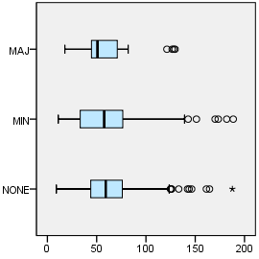

EXAMINE VARIABLES=trvtime_hspt_min BY COVERAGE_TYPE
/PLOT=BOXPLOT
/STATISTICS=NONE
/NOTOTAL.

Explore

Notes
Output Created |  | 03-APR-2018 18:07:11
Comments
Input | Data | F:\Data_Final\3cases_traveltime_indec.sav
Input | Active Dataset | DataSet1
Input | Filter | <none>
Input | Weight | <none>
Input | Split File | <none>
Input | N of Rows in Working Data File | 284
Missing Value Handling | Definition of Missing | User-defined missing values for dependent variables are treated as missing.
Missing Value Handling | Cases Used | Statistics are based on cases with no missing values for any dependent variable or factor used.
Syntax |  | EXAMINE VARIABLES=trvtime_hspt_min BY COVERAGE_TYPE  /PLOT=BOXPLOT  /STATISTICS=NONE  /NOTOTAL.
Resources | Processor Time | 00:00:00.22
Resources | Elapsed Time | 00:00:00.22

Overlap with asentamiento, degree

Case Processing Summary
 | Overlap with asentamiento, degree | Cases
 | Overlap with asentamiento, degree | Valid |  | Missing |  | Total
 | Overlap with asentamiento, degree | N | Percent | N | Percent | N
Public hospital | MAJ | 50 | 96.2% | 2 | 3.8% | 52
Public hospital | MIN | 85 | 94.4% | 5 | 5.6% | 90
Public hospital | NONE | 137 | 96.5% | 5 | 3.5% | 142

Case Processing Summary
 | Overlap with asentamiento, degree | Cases
 | Overlap with asentamiento, degree | Total
 | Overlap with asentamiento, degree | Percent
Public hospital | MAJ | 100.0%
Public hospital | MIN | 100.0%
Public hospital | NONE | 100.0%

Public hospital

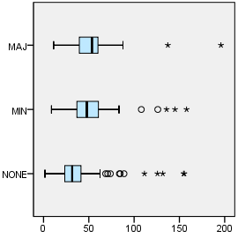

EXAMINE VARIABLES=trvtime_dgntrt_min BY COVERAGE_TYPE
/PLOT=BOXPLOT
/STATISTICS=NONE
/NOTOTAL.

Explore

Notes
Output Created |  | 03-APR-2018 18:07:21
Comments
Input | Data | F:\Data_Final\3cases_traveltime_indec.sav
Input | Active Dataset | DataSet1
Input | Filter | <none>
Input | Weight | <none>
Input | Split File | <none>
Input | N of Rows in Working Data File | 284
Missing Value Handling | Definition of Missing | User-defined missing values for dependent variables are treated as missing.
Missing Value Handling | Cases Used | Statistics are based on cases with no missing values for any dependent variable or factor used.
Syntax |  | EXAMINE VARIABLES=trvtime_dgntrt_min BY COVERAGE_TYPE  /PLOT=BOXPLOT  /STATISTICS=NONE  /NOTOTAL.
Resources | Processor Time | 00:00:00.23
Resources | Elapsed Time | 00:00:00.22

Overlap with asentamiento, degree

Case Processing Summary
 | Overlap with asentamiento, degree | Cases
 | Overlap with asentamiento, degree | Valid |  | Missing
 | Overlap with asentamiento, degree | N | Percent | N | Percent
Public diag./treat. center | MAJ | 52 | 100.0% | 0 | 0.0%
Public diag./treat. center | MIN | 90 | 100.0% | 0 | 0.0%
Public diag./treat. center | NONE | 140 | 98.6% | 2 | 1.4%

Case Processing Summary
 | Overlap with asentamiento, degree | Cases
 | Overlap with asentamiento, degree | Total
 | Overlap with asentamiento, degree | N | Percent
Public diag./treat. center | MAJ | 52 | 100.0%
Public diag./treat. center | MIN | 90 | 100.0%
Public diag./treat. center | NONE | 142 | 100.0%

Public diag./treat. center

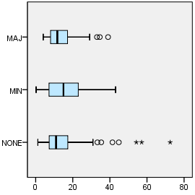

EXAMINE VARIABLES=trvtime_edsec_min BY COVERAGE_TYPE
/PLOT=BOXPLOT
/STATISTICS=NONE
/NOTOTAL.

Explore

Notes
Output Created |  | 03-APR-2018 18:07:28
Comments
Input | Data | F:\Data_Final\3cases_traveltime_indec.sav
Input | Active Dataset | DataSet1
Input | Filter | <none>
Input | Weight | <none>
Input | Split File | <none>
Input | N of Rows in Working Data File | 284
Missing Value Handling | Definition of Missing | User-defined missing values for dependent variables are treated as missing.
Missing Value Handling | Cases Used | Statistics are based on cases with no missing values for any dependent variable or factor used.
Syntax |  | EXAMINE VARIABLES=trvtime_edsec_min BY COVERAGE_TYPE  /PLOT=BOXPLOT  /STATISTICS=NONE  /NOTOTAL.
Resources | Processor Time | 00:00:00.25
Resources | Elapsed Time | 00:00:00.23

Overlap with asentamiento, degree

Case Processing Summary
 | Overlap with asentamiento, degree | Cases
 | Overlap with asentamiento, degree | Valid |  | Missing
 | Overlap with asentamiento, degree | N | Percent | N | Percent
Public secondary school | MAJ | 52 | 100.0% | 0 | 0.0%
Public secondary school | MIN | 90 | 100.0% | 0 | 0.0%
Public secondary school | NONE | 142 | 100.0% | 0 | 0.0%

Case Processing Summary
 | Overlap with asentamiento, degree | Cases
 | Overlap with asentamiento, degree | Total
 | Overlap with asentamiento, degree | N | Percent
Public secondary school | MAJ | 52 | 100.0%
Public secondary school | MIN | 90 | 100.0%
Public secondary school | NONE | 142 | 100.0%

Public secondary school

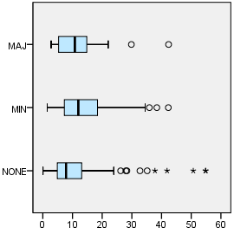

EXAMINE VARIABLES=trvtime_edprm_min BY COVERAGE_TYPE
/PLOT=BOXPLOT
/STATISTICS=NONE
/NOTOTAL.

Explore

Notes
Output Created |  | 03-APR-2018 18:07:44
Comments
Input | Data | F:\Data_Final\3cases_traveltime_indec.sav
Input | Active Dataset | DataSet1
Input | Filter | <none>
Input | Weight | <none>
Input | Split File | <none>
Input | N of Rows in Working Data File | 284
Missing Value Handling | Definition of Missing | User-defined missing values for dependent variables are treated as missing.
Missing Value Handling | Cases Used | Statistics are based on cases with no missing values for any dependent variable or factor used.
Syntax |  | EXAMINE VARIABLES=trvtime_edprm_min BY COVERAGE_TYPE  /PLOT=BOXPLOT  /STATISTICS=NONE  /NOTOTAL.
Resources | Processor Time | 00:00:00.25
Resources | Elapsed Time | 00:00:00.23

Overlap with asentamiento, degree

Case Processing Summary
 | Overlap with asentamiento, degree | Cases
 | Overlap with asentamiento, degree | Valid |  | Missing
 | Overlap with asentamiento, degree | N | Percent | N | Percent
Public primary school | MAJ | 52 | 100.0% | 0 | 0.0%
Public primary school | MIN | 90 | 100.0% | 0 | 0.0%
Public primary school | NONE | 142 | 100.0% | 0 | 0.0%

Case Processing Summary
 | Overlap with asentamiento, degree | Cases
 | Overlap with asentamiento, degree | Total
 | Overlap with asentamiento, degree | N | Percent
Public primary school | MAJ | 52 | 100.0%
Public primary school | MIN | 90 | 100.0%
Public primary school | NONE | 142 | 100.0%

Public primary school

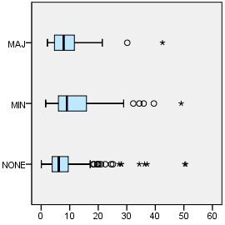

EXAMINE VARIABLES=trvtime_edknd_min BY COVERAGE_TYPE
/PLOT=BOXPLOT
/STATISTICS=NONE
/NOTOTAL.

Explore

Notes
Output Created |  | 03-APR-2018 18:07:57
Comments
Input | Data | F:\Data_Final\3cases_traveltime_indec.sav
Input | Active Dataset | DataSet1
Input | Filter | <none>
Input | Weight | <none>
Input | Split File | <none>
Input | N of Rows in Working Data File | 284
Missing Value Handling | Definition of Missing | User-defined missing values for dependent variables are treated as missing.
Missing Value Handling | Cases Used | Statistics are based on cases with no missing values for any dependent variable or factor used.
Syntax |  | EXAMINE VARIABLES=trvtime_edknd_min BY COVERAGE_TYPE  /PLOT=BOXPLOT  /STATISTICS=NONE  /NOTOTAL.
Resources | Processor Time | 00:00:00.48
Resources | Elapsed Time | 00:00:00.25

Overlap with asentamiento, degree

Case Processing Summary
 | Overlap with asentamiento, degree | Cases
 | Overlap with asentamiento, degree | Valid |  | Missing |  | Total
 | Overlap with asentamiento, degree | N | Percent | N | Percent | N
Public kindergarten | MAJ | 52 | 100.0% | 0 | 0.0% | 52
Public kindergarten | MIN | 90 | 100.0% | 0 | 0.0% | 90
Public kindergarten | NONE | 142 | 100.0% | 0 | 0.0% | 142

Case Processing Summary
 | Overlap with asentamiento, degree | Cases
 | Overlap with asentamiento, degree | Total
 | Overlap with asentamiento, degree | Percent
Public kindergarten | MAJ | 100.0%
Public kindergarten | MIN | 100.0%
Public kindergarten | NONE | 100.0%

Public kindergarten

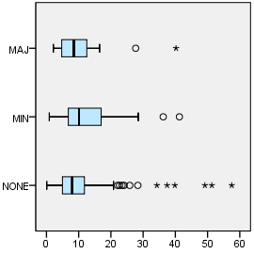

SORT CASES BY DEPTO.
SPLIT FILE SEPARATE BY DEPTO.
EXAMINE VARIABLES=trvtime_cbd_bsas BY COVERAGE_TYPE
/PLOT=BOXPLOT
/STATISTICS=NONE
/NOTOTAL.

Explore

Notes
Output Created |  | 03-APR-2018 18:08:50
Comments
Input | Data | F:\Data_Final\3cases_traveltime_indec.sav
Input | Active Dataset | DataSet1
Input | Filter | <none>
Input | Weight | <none>
Input | Split File | Department
Input | N of Rows in Working Data File | 284
Missing Value Handling | Definition of Missing | User-defined missing values for dependent variables are treated as missing.
Missing Value Handling | Cases Used | Statistics are based on cases with no missing values for any dependent variable or factor used.
Syntax |  | EXAMINE VARIABLES=trvtime_cbd_bsas BY COVERAGE_TYPE  /PLOT=BOXPLOT  /STATISTICS=NONE  /NOTOTAL.
Resources | Processor Time | 00:00:00.83
Resources | Elapsed Time | 00:00:00.64

Department = La Matanza

Overlap with asentamiento, degree

Case Processing Summaryª
 | Overlap with asentamiento, degree | Cases
 | Overlap with asentamiento, degree | Valid |  | Missing |  | Total
 | Overlap with asentamiento, degree | N | Percent | N | Percent | N
Buenos Aires CBD | MAJ | 28 | 93.3% | 2 | 6.7% | 30
Buenos Aires CBD | MIN | 30 | 100.0% | 0 | 0.0% | 30
Buenos Aires CBD | NONE | 60 | 100.0% | 0 | 0.0% | 60

Case Processing Summaryª
 | Overlap with asentamiento, degree | Cases
 | Overlap with asentamiento, degree | Total
 | Overlap with asentamiento, degree | Percent
Buenos Aires CBD | MAJ | 100.0%
Buenos Aires CBD | MIN | 100.0%
Buenos Aires CBD | NONE | 100.0%

a. Department = La Matanza

Buenos Aires CBD

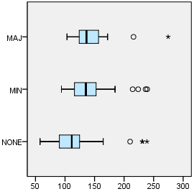

Department = Pilar

Overlap with asentamiento, degree

Case Processing Summaryª
 | Overlap with asentamiento, degree | Cases
 | Overlap with asentamiento, degree | Valid |  | Missing |  | Total
 | Overlap with asentamiento, degree | N | Percent | N | Percent | N
Buenos Aires CBD | MAJ | 6 | 100.0% | 0 | 0.0% | 6
Buenos Aires CBD | MIN | 24 | 80.0% | 6 | 20.0% | 30
Buenos Aires CBD | NONE | 30 | 83.3% | 6 | 16.7% | 36

Case Processing Summaryª
 | Overlap with asentamiento, degree | Cases
 | Overlap with asentamiento, degree | Total
 | Overlap with asentamiento, degree | Percent
Buenos Aires CBD | MAJ | 100.0%
Buenos Aires CBD | MIN | 100.0%
Buenos Aires CBD | NONE | 100.0%

a. Department = Pilar

Buenos Aires CBD

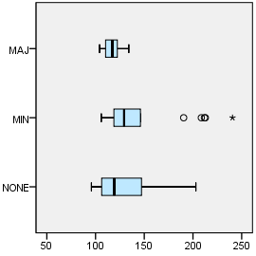

Department = Quilmes

Overlap with asentamiento, degree

Case Processing Summaryª
 | Overlap with asentamiento, degree | Cases
 | Overlap with asentamiento, degree | Valid |  | Missing |  | Total
 | Overlap with asentamiento, degree | N | Percent | N | Percent | N
Buenos Aires CBD | MAJ | 16 | 100.0% | 0 | 0.0% | 16
Buenos Aires CBD | MIN | 30 | 100.0% | 0 | 0.0% | 30
Buenos Aires CBD | NONE | 46 | 100.0% | 0 | 0.0% | 46

Case Processing Summaryª
 | Overlap with asentamiento, degree | Cases
 | Overlap with asentamiento, degree | Total
 | Overlap with asentamiento, degree | Percent
Buenos Aires CBD | MAJ | 100.0%
Buenos Aires CBD | MIN | 100.0%
Buenos Aires CBD | NONE | 100.0%

a. Department = Quilmes

Buenos Aires CBD

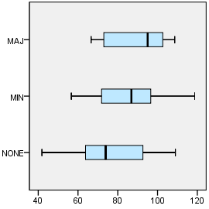

EXAMINE VARIABLES=trvtime_cbd_loc BY COVERAGE_TYPE
/PLOT=BOXPLOT
/STATISTICS=NONE
/NOTOTAL.

Explore

Notes
Output Created |  | 03-APR-2018 18:09:03
Comments
Input | Data | F:\Data_Final\3cases_traveltime_indec.sav
Input | Active Dataset | DataSet1
Input | Filter | <none>
Input | Weight | <none>
Input | Split File | Department
Input | N of Rows in Working Data File | 284
Missing Value Handling | Definition of Missing | User-defined missing values for dependent variables are treated as missing.
Missing Value Handling | Cases Used | Statistics are based on cases with no missing values for any dependent variable or factor used.
Syntax |  | EXAMINE VARIABLES=trvtime_cbd_loc BY COVERAGE_TYPE  /PLOT=BOXPLOT  /STATISTICS=NONE  /NOTOTAL.
Resources | Processor Time | 00:00:00.89
Resources | Elapsed Time | 00:00:00.62

Department = La Matanza

Overlap with asentamiento, degree

Case Processing Summaryª
 | Overlap with asentamiento, degree | Cases
 | Overlap with asentamiento, degree | Valid |  | Missing |  | Total
 | Overlap with asentamiento, degree | N | Percent | N | Percent | N
Departmental CBD | MAJ | 28 | 93.3% | 2 | 6.7% | 30
Departmental CBD | MIN | 30 | 100.0% | 0 | 0.0% | 30
Departmental CBD | NONE | 60 | 100.0% | 0 | 0.0% | 60

Case Processing Summaryª
 | Overlap with asentamiento, degree | Cases
 | Overlap with asentamiento, degree | Total
 | Overlap with asentamiento, degree | Percent
Departmental CBD | MAJ | 100.0%
Departmental CBD | MIN | 100.0%
Departmental CBD | NONE | 100.0%

a. Department = La Matanza

Departmental CBD

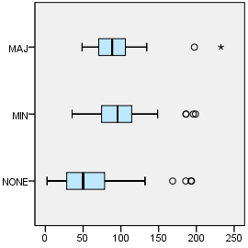

Department = Pilar

Overlap with asentamiento, degree

Case Processing Summaryª
 | Overlap with asentamiento, degree | Cases
 | Overlap with asentamiento, degree | Valid |  | Missing |  | Total
 | Overlap with asentamiento, degree | N | Percent | N | Percent | N
Departmental CBD | MAJ | 6 | 100.0% | 0 | 0.0% | 6
Departmental CBD | MIN | 25 | 83.3% | 5 | 16.7% | 30
Departmental CBD | NONE | 31 | 86.1% | 5 | 13.9% | 36

Case Processing Summaryª
 | Overlap with asentamiento, degree | Cases
 | Overlap with asentamiento, degree | Total
 | Overlap with asentamiento, degree | Percent
Departmental CBD | MAJ | 100.0%
Departmental CBD | MIN | 100.0%
Departmental CBD | NONE | 100.0%

a. Department = Pilar

Departmental CBD

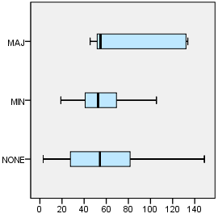

Department = Quilmes

Overlap with asentamiento, degree

Case Processing Summaryª
 | Overlap with asentamiento, degree | Cases
 | Overlap with asentamiento, degree | Valid |  | Missing |  | Total
 | Overlap with asentamiento, degree | N | Percent | N | Percent | N
Departmental CBD | MAJ | 16 | 100.0% | 0 | 0.0% | 16
Departmental CBD | MIN | 30 | 100.0% | 0 | 0.0% | 30
Departmental CBD | NONE | 46 | 100.0% | 0 | 0.0% | 46

Case Processing Summaryª
 | Overlap with asentamiento, degree | Cases
 | Overlap with asentamiento, degree | Total
 | Overlap with asentamiento, degree | Percent
Departmental CBD | MAJ | 100.0%
Departmental CBD | MIN | 100.0%
Departmental CBD | NONE | 100.0%

a. Department = Quilmes

Departmental CBD

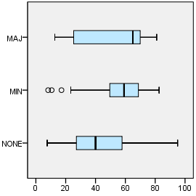

EXAMINE VARIABLES=trvtime_cbd_ngh_min BY COVERAGE_TYPE
/PLOT=BOXPLOT
/STATISTICS=NONE
/NOTOTAL.

Explore

Notes
Output Created |  | 03-APR-2018 18:09:57
Comments
Input | Data | F:\Data_Final\3cases_traveltime_indec.sav
Input | Active Dataset | DataSet1
Input | Filter | <none>
Input | Weight | <none>
Input | Split File | Department
Input | N of Rows in Working Data File | 284
Missing Value Handling | Definition of Missing | User-defined missing values for dependent variables are treated as missing.
Missing Value Handling | Cases Used | Statistics are based on cases with no missing values for any dependent variable or factor used.
Syntax |  | EXAMINE VARIABLES=trvtime_cbd_ngh_min BY COVERAGE_TYPE  /PLOT=BOXPLOT  /STATISTICS=NONE  /NOTOTAL.
Resources | Processor Time | 00:00:00.86
Resources | Elapsed Time | 00:00:00.64

Department = La Matanza

Overlap with asentamiento, degree

Case Processing Summaryª
 | Overlap with asentamiento, degree | Cases
 | Overlap with asentamiento, degree | Valid |  | Missing
 | Overlap with asentamiento, degree | N | Percent | N | Percent
Any departmental CBD | MAJ | 28 | 93.3% | 2 | 6.7%
Any departmental CBD | MIN | 30 | 100.0% | 0 | 0.0%
Any departmental CBD | NONE | 60 | 100.0% | 0 | 0.0%

Case Processing Summaryª
 | Overlap with asentamiento, degree | Cases
 | Overlap with asentamiento, degree | Total
 | Overlap with asentamiento, degree | N | Percent
Any departmental CBD | MAJ | 30 | 100.0%
Any departmental CBD | MIN | 30 | 100.0%
Any departmental CBD | NONE | 60 | 100.0%

a. Department = La Matanza

Any departmental CBD

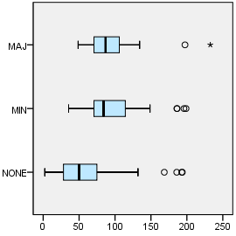

Department = Pilar

Overlap with asentamiento, degree

Case Processing Summaryª
 | Overlap with asentamiento, degree | Cases
 | Overlap with asentamiento, degree | Valid |  | Missing
 | Overlap with asentamiento, degree | N | Percent | N | Percent
Any departmental CBD | MAJ | 6 | 100.0% | 0 | 0.0%
Any departmental CBD | MIN | 25 | 83.3% | 5 | 16.7%
Any departmental CBD | NONE | 31 | 86.1% | 5 | 13.9%

Case Processing Summaryª
 | Overlap with asentamiento, degree | Cases
 | Overlap with asentamiento, degree | Total
 | Overlap with asentamiento, degree | N | Percent
Any departmental CBD | MAJ | 6 | 100.0%
Any departmental CBD | MIN | 30 | 100.0%
Any departmental CBD | NONE | 36 | 100.0%

a. Department = Pilar

Any departmental CBD

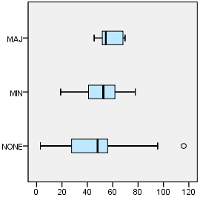

Department = Quilmes

Overlap with asentamiento, degree

Case Processing Summaryª
 | Overlap with asentamiento, degree | Cases
 | Overlap with asentamiento, degree | Valid |  | Missing
 | Overlap with asentamiento, degree | N | Percent | N | Percent
Any departmental CBD | MAJ | 16 | 100.0% | 0 | 0.0%
Any departmental CBD | MIN | 30 | 100.0% | 0 | 0.0%
Any departmental CBD | NONE | 46 | 100.0% | 0 | 0.0%

Case Processing Summaryª
 | Overlap with asentamiento, degree | Cases
 | Overlap with asentamiento, degree | Total
 | Overlap with asentamiento, degree | N | Percent
Any departmental CBD | MAJ | 16 | 100.0%
Any departmental CBD | MIN | 30 | 100.0%
Any departmental CBD | NONE | 46 | 100.0%

a. Department = Quilmes

Any departmental CBD

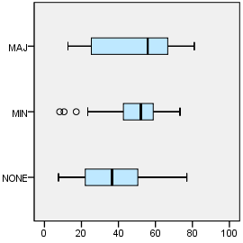

EXAMINE VARIABLES=trvtime_rail_min BY COVERAGE_TYPE
/PLOT=BOXPLOT
/STATISTICS=NONE
/NOTOTAL.

Explore

Notes
Output Created |  | 03-APR-2018 18:10:10
Comments
Input | Data | F:\Data_Final\3cases_traveltime_indec.sav
Input | Active Dataset | DataSet1
Input | Filter | <none>
Input | Weight | <none>
Input | Split File | Department
Input | N of Rows in Working Data File | 284
Missing Value Handling | Definition of Missing | User-defined missing values for dependent variables are treated as missing.
Missing Value Handling | Cases Used | Statistics are based on cases with no missing values for any dependent variable or factor used.
Syntax |  | EXAMINE VARIABLES=trvtime_rail_min BY COVERAGE_TYPE  /PLOT=BOXPLOT  /STATISTICS=NONE  /NOTOTAL.
Resources | Processor Time | 00:00:00.73
Resources | Elapsed Time | 00:00:00.64

Department = La Matanza

Overlap with asentamiento, degree

Case Processing Summaryª
 | Overlap with asentamiento, degree | Cases
 | Overlap with asentamiento, degree | Valid |  | Missing |  | Total
 | Overlap with asentamiento, degree | N | Percent | N | Percent | N
Railway station | MAJ | 28 | 93.3% | 2 | 6.7% | 30
Railway station | MIN | 30 | 100.0% | 0 | 0.0% | 30
Railway station | NONE | 60 | 100.0% | 0 | 0.0% | 60

Case Processing Summaryª
 | Overlap with asentamiento, degree | Cases
 | Overlap with asentamiento, degree | Total
 | Overlap with asentamiento, degree | Percent
Railway station | MAJ | 100.0%
Railway station | MIN | 100.0%
Railway station | NONE | 100.0%

a. Department = La Matanza

Railway station

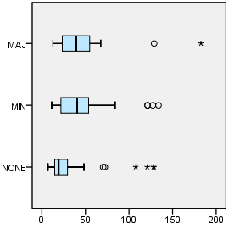

Department = Pilar

Overlap with asentamiento, degree

Case Processing Summaryª
 | Overlap with asentamiento, degree | Cases
 | Overlap with asentamiento, degree | Valid |  | Missing |  | Total
 | Overlap with asentamiento, degree | N | Percent | N | Percent | N
Railway station | MAJ | 6 | 100.0% | 0 | 0.0% | 6
Railway station | MIN | 26 | 86.7% | 4 | 13.3% | 30
Railway station | NONE | 30 | 83.3% | 6 | 16.7% | 36

Case Processing Summaryª
 | Overlap with asentamiento, degree | Cases
 | Overlap with asentamiento, degree | Total
 | Overlap with asentamiento, degree | Percent
Railway station | MAJ | 100.0%
Railway station | MIN | 100.0%
Railway station | NONE | 100.0%

a. Department = Pilar

Railway station

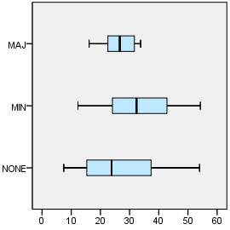

Department = Quilmes

Overlap with asentamiento, degree

Case Processing Summaryª
 | Overlap with asentamiento, degree | Cases
 | Overlap with asentamiento, degree | Valid |  | Missing |  | Total
 | Overlap with asentamiento, degree | N | Percent | N | Percent | N
Railway station | MAJ | 16 | 100.0% | 0 | 0.0% | 16
Railway station | MIN | 30 | 100.0% | 0 | 0.0% | 30
Railway station | NONE | 46 | 100.0% | 0 | 0.0% | 46

Case Processing Summaryª
 | Overlap with asentamiento, degree | Cases
 | Overlap with asentamiento, degree | Total
 | Overlap with asentamiento, degree | Percent
Railway station | MAJ | 100.0%
Railway station | MIN | 100.0%
Railway station | NONE | 100.0%

a. Department = Quilmes

Railway station

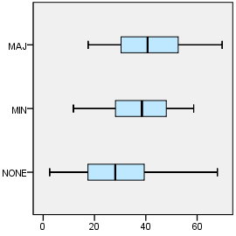

EXAMINE VARIABLES=trvtime_upa_min BY COVERAGE_TYPE
/PLOT=BOXPLOT
/STATISTICS=NONE
/NOTOTAL.

Explore

Notes
Output Created |  | 03-APR-2018 18:10:23
Comments
Input | Data | F:\Data_Final\3cases_traveltime_indec.sav
Input | Active Dataset | DataSet1
Input | Filter | <none>
Input | Weight | <none>
Input | Split File | Department
Input | N of Rows in Working Data File | 284
Missing Value Handling | Definition of Missing | User-defined missing values for dependent variables are treated as missing.
Missing Value Handling | Cases Used | Statistics are based on cases with no missing values for any dependent variable or factor used.
Syntax |  | EXAMINE VARIABLES=trvtime_upa_min BY COVERAGE_TYPE  /PLOT=BOXPLOT  /STATISTICS=NONE  /NOTOTAL.
Resources | Processor Time | 00:00:00.69
Resources | Elapsed Time | 00:00:00.64

Department = La Matanza

Overlap with asentamiento, degree

Case Processing Summaryª
 | Overlap with asentamiento, degree | Cases
 | Overlap with asentamiento, degree | Valid |  | Missing |  | Total
 | Overlap with asentamiento, degree | N | Percent | N | Percent | N
Public UPA | MAJ | 28 | 93.3% | 2 | 6.7% | 30
Public UPA | MIN | 30 | 100.0% | 0 | 0.0% | 30
Public UPA | NONE | 60 | 100.0% | 0 | 0.0% | 60

Case Processing Summaryª
 | Overlap with asentamiento, degree | Cases
 | Overlap with asentamiento, degree | Total
 | Overlap with asentamiento, degree | Percent
Public UPA | MAJ | 100.0%
Public UPA | MIN | 100.0%
Public UPA | NONE | 100.0%

a. Department = La Matanza

Public UPA

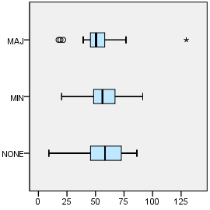

Department = Pilar

Overlap with asentamiento, degree

Case Processing Summaryª
 | Overlap with asentamiento, degree | Cases
 | Overlap with asentamiento, degree | Valid |  | Missing |  | Total
 | Overlap with asentamiento, degree | N | Percent | N | Percent | N
Public UPA | MAJ | 6 | 100.0% | 0 | 0.0% | 6
Public UPA | MIN | 24 | 80.0% | 6 | 20.0% | 30
Public UPA | NONE | 30 | 83.3% | 6 | 16.7% | 36

Case Processing Summaryª
 | Overlap with asentamiento, degree | Cases
 | Overlap with asentamiento, degree | Total
 | Overlap with asentamiento, degree | Percent
Public UPA | MAJ | 100.0%
Public UPA | MIN | 100.0%
Public UPA | NONE | 100.0%

a. Department = Pilar

Public UPA

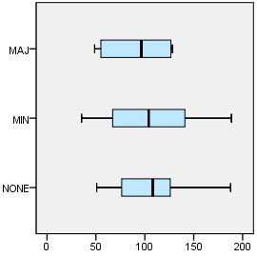

Department = Quilmes

Overlap with asentamiento, degree

Case Processing Summaryª
 | Overlap with asentamiento, degree | Cases
 | Overlap with asentamiento, degree | Valid |  | Missing |  | Total
 | Overlap with asentamiento, degree | N | Percent | N | Percent | N
Public UPA | MAJ | 16 | 100.0% | 0 | 0.0% | 16
Public UPA | MIN | 30 | 100.0% | 0 | 0.0% | 30
Public UPA | NONE | 46 | 100.0% | 0 | 0.0% | 46

Case Processing Summaryª
 | Overlap with asentamiento, degree | Cases
 | Overlap with asentamiento, degree | Total
 | Overlap with asentamiento, degree | Percent
Public UPA | MAJ | 100.0%
Public UPA | MIN | 100.0%
Public UPA | NONE | 100.0%

a. Department = Quilmes

Public UPA

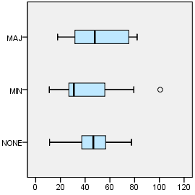

EXAMINE VARIABLES=trvtime_hspt_min BY COVERAGE_TYPE
/PLOT=BOXPLOT
/STATISTICS=NONE
/NOTOTAL.

Explore

Notes
Output Created |  | 03-APR-2018 18:10:35
Comments
Input | Data | F:\Data_Final\3cases_traveltime_indec.sav
Input | Active Dataset | DataSet1
Input | Filter | <none>
Input | Weight | <none>
Input | Split File | Department
Input | N of Rows in Working Data File | 284
Missing Value Handling | Definition of Missing | User-defined missing values for dependent variables are treated as missing.
Missing Value Handling | Cases Used | Statistics are based on cases with no missing values for any dependent variable or factor used.
Syntax |  | EXAMINE VARIABLES=trvtime_hspt_min BY COVERAGE_TYPE  /PLOT=BOXPLOT  /STATISTICS=NONE  /NOTOTAL.
Resources | Processor Time | 00:00:00.66
Resources | Elapsed Time | 00:00:00.62

Department = La Matanza

Overlap with asentamiento, degree

Case Processing Summaryª
 | Overlap with asentamiento, degree | Cases
 | Overlap with asentamiento, degree | Valid |  | Missing |  | Total
 | Overlap with asentamiento, degree | N | Percent | N | Percent | N
Public hospital | MAJ | 28 | 93.3% | 2 | 6.7% | 30
Public hospital | MIN | 30 | 100.0% | 0 | 0.0% | 30
Public hospital | NONE | 60 | 100.0% | 0 | 0.0% | 60

Case Processing Summaryª
 | Overlap with asentamiento, degree | Cases
 | Overlap with asentamiento, degree | Total
 | Overlap with asentamiento, degree | Percent
Public hospital | MAJ | 100.0%
Public hospital | MIN | 100.0%
Public hospital | NONE | 100.0%

a. Department = La Matanza

Public hospital

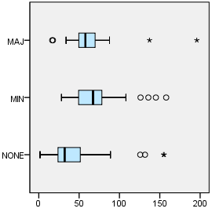

Department = Pilar

Overlap with asentamiento, degree

Case Processing Summaryª
 | Overlap with asentamiento, degree | Cases
 | Overlap with asentamiento, degree | Valid |  | Missing |  | Total
 | Overlap with asentamiento, degree | N | Percent | N | Percent | N
Public hospital | MAJ | 6 | 100.0% | 0 | 0.0% | 6
Public hospital | MIN | 25 | 83.3% | 5 | 16.7% | 30
Public hospital | NONE | 31 | 86.1% | 5 | 13.9% | 36

Case Processing Summaryª
 | Overlap with asentamiento, degree | Cases
 | Overlap with asentamiento, degree | Total
 | Overlap with asentamiento, degree | Percent
Public hospital | MAJ | 100.0%
Public hospital | MIN | 100.0%
Public hospital | NONE | 100.0%

a. Department = Pilar

Public hospital

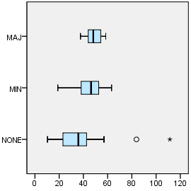

Department = Quilmes

Overlap with asentamiento, degree

Case Processing Summaryª
 | Overlap with asentamiento, degree | Cases
 | Overlap with asentamiento, degree | Valid |  | Missing |  | Total
 | Overlap with asentamiento, degree | N | Percent | N | Percent | N
Public hospital | MAJ | 16 | 100.0% | 0 | 0.0% | 16
Public hospital | MIN | 30 | 100.0% | 0 | 0.0% | 30
Public hospital | NONE | 46 | 100.0% | 0 | 0.0% | 46

Case Processing Summaryª
 | Overlap with asentamiento, degree | Cases
 | Overlap with asentamiento, degree | Total
 | Overlap with asentamiento, degree | Percent
Public hospital | MAJ | 100.0%
Public hospital | MIN | 100.0%
Public hospital | NONE | 100.0%

a. Department = Quilmes

Public hospital

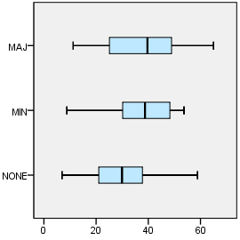

EXAMINE VARIABLES=trvtime_dgntrt_min BY COVERAGE_TYPE
/PLOT=BOXPLOT
/STATISTICS=NONE
/NOTOTAL.

Explore

Notes
Output Created |  | 03-APR-2018 18:10:45
Comments
Input | Data | F:\Data_Final\3cases_traveltime_indec.sav
Input | Active Dataset | DataSet1
Input | Filter | <none>
Input | Weight | <none>
Input | Split File | Department
Input | N of Rows in Working Data File | 284
Missing Value Handling | Definition of Missing | User-defined missing values for dependent variables are treated as missing.
Missing Value Handling | Cases Used | Statistics are based on cases with no missing values for any dependent variable or factor used.
Syntax |  | EXAMINE VARIABLES=trvtime_dgntrt_min BY COVERAGE_TYPE  /PLOT=BOXPLOT  /STATISTICS=NONE  /NOTOTAL.
Resources | Processor Time | 00:00:00.69
Resources | Elapsed Time | 00:00:00.64

Department = La Matanza

Overlap with asentamiento, degree

Case Processing Summaryª
 | Overlap with asentamiento, degree | Cases
 | Overlap with asentamiento, degree | Valid |  | Missing
 | Overlap with asentamiento, degree | N | Percent | N | Percent
Public diag./treat. center | MAJ | 30 | 100.0% | 0 | 0.0%
Public diag./treat. center | MIN | 30 | 100.0% | 0 | 0.0%
Public diag./treat. center | NONE | 60 | 100.0% | 0 | 0.0%

Case Processing Summaryª
 | Overlap with asentamiento, degree | Cases
 | Overlap with asentamiento, degree | Total
 | Overlap with asentamiento, degree | N | Percent
Public diag./treat. center | MAJ | 30 | 100.0%
Public diag./treat. center | MIN | 30 | 100.0%
Public diag./treat. center | NONE | 60 | 100.0%

a. Department = La Matanza

Public diag./treat. center

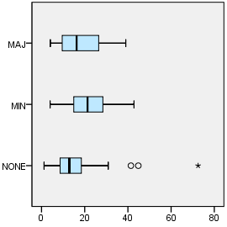

Department = Pilar

Overlap with asentamiento, degree

Case Processing Summaryª
 | Overlap with asentamiento, degree | Cases
 | Overlap with asentamiento, degree | Valid |  | Missing
 | Overlap with asentamiento, degree | N | Percent | N | Percent
Public diag./treat. center | MAJ | 6 | 100.0% | 0 | 0.0%
Public diag./treat. center | MIN | 30 | 100.0% | 0 | 0.0%
Public diag./treat. center | NONE | 34 | 94.4% | 2 | 5.6%

Case Processing Summaryª
 | Overlap with asentamiento, degree | Cases
 | Overlap with asentamiento, degree | Total
 | Overlap with asentamiento, degree | N | Percent
Public diag./treat. center | MAJ | 6 | 100.0%
Public diag./treat. center | MIN | 30 | 100.0%
Public diag./treat. center | NONE | 36 | 100.0%

a. Department = Pilar

Public diag./treat. center

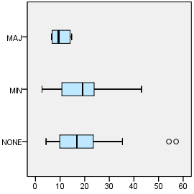

Department = Quilmes

Overlap with asentamiento, degree

Case Processing Summaryª
 | Overlap with asentamiento, degree | Cases
 | Overlap with asentamiento, degree | Valid |  | Missing
 | Overlap with asentamiento, degree | N | Percent | N | Percent
Public diag./treat. center | MAJ | 16 | 100.0% | 0 | 0.0%
Public diag./treat. center | MIN | 30 | 100.0% | 0 | 0.0%
Public diag./treat. center | NONE | 46 | 100.0% | 0 | 0.0%

Case Processing Summaryª
 | Overlap with asentamiento, degree | Cases
 | Overlap with asentamiento, degree | Total
 | Overlap with asentamiento, degree | N | Percent
Public diag./treat. center | MAJ | 16 | 100.0%
Public diag./treat. center | MIN | 30 | 100.0%
Public diag./treat. center | NONE | 46 | 100.0%

a. Department = Quilmes

Public diag./treat. center

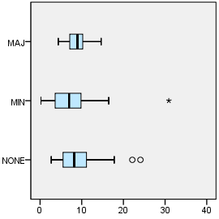

EXAMINE VARIABLES=trvtime_edsec_min BY COVERAGE_TYPE
/PLOT=BOXPLOT
/STATISTICS=NONE
/NOTOTAL.

Explore

Notes
Output Created |  | 03-APR-2018 18:10:53
Comments
Input | Data | F:\Data_Final\3cases_traveltime_indec.sav
Input | Active Dataset | DataSet1
Input | Filter | <none>
Input | Weight | <none>
Input | Split File | Department
Input | N of Rows in Working Data File | 284
Missing Value Handling | Definition of Missing | User-defined missing values for dependent variables are treated as missing.
Missing Value Handling | Cases Used | Statistics are based on cases with no missing values for any dependent variable or factor used.
Syntax |  | EXAMINE VARIABLES=trvtime_edsec_min BY COVERAGE_TYPE  /PLOT=BOXPLOT  /STATISTICS=NONE  /NOTOTAL.
Resources | Processor Time | 00:00:00.80
Resources | Elapsed Time | 00:00:00.62

Department = La Matanza

Overlap with asentamiento, degree

Case Processing Summaryª
 | Overlap with asentamiento, degree | Cases
 | Overlap with asentamiento, degree | Valid |  | Missing
 | Overlap with asentamiento, degree | N | Percent | N | Percent
Public secondary school | MAJ | 30 | 100.0% | 0 | 0.0%
Public secondary school | MIN | 30 | 100.0% | 0 | 0.0%
Public secondary school | NONE | 60 | 100.0% | 0 | 0.0%

Case Processing Summaryª
 | Overlap with asentamiento, degree | Cases
 | Overlap with asentamiento, degree | Total
 | Overlap with asentamiento, degree | N | Percent
Public secondary school | MAJ | 30 | 100.0%
Public secondary school | MIN | 30 | 100.0%
Public secondary school | NONE | 60 | 100.0%

a. Department = La Matanza

Public secondary school

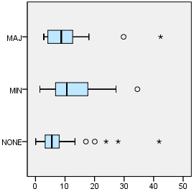

Department = Pilar

Overlap with asentamiento, degree

Case Processing Summaryª
 | Overlap with asentamiento, degree | Cases
 | Overlap with asentamiento, degree | Valid |  | Missing
 | Overlap with asentamiento, degree | N | Percent | N | Percent
Public secondary school | MAJ | 6 | 100.0% | 0 | 0.0%
Public secondary school | MIN | 30 | 100.0% | 0 | 0.0%
Public secondary school | NONE | 36 | 100.0% | 0 | 0.0%

Case Processing Summaryª
 | Overlap with asentamiento, degree | Cases
 | Overlap with asentamiento, degree | Total
 | Overlap with asentamiento, degree | N | Percent
Public secondary school | MAJ | 6 | 100.0%
Public secondary school | MIN | 30 | 100.0%
Public secondary school | NONE | 36 | 100.0%

a. Department = Pilar

Public secondary school

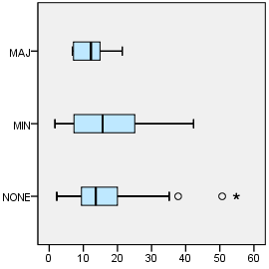

Department = Quilmes

Overlap with asentamiento, degree

Case Processing Summaryª
 | Overlap with asentamiento, degree | Cases
 | Overlap with asentamiento, degree | Valid |  | Missing
 | Overlap with asentamiento, degree | N | Percent | N | Percent
Public secondary school | MAJ | 16 | 100.0% | 0 | 0.0%
Public secondary school | MIN | 30 | 100.0% | 0 | 0.0%
Public secondary school | NONE | 46 | 100.0% | 0 | 0.0%

Case Processing Summaryª
 | Overlap with asentamiento, degree | Cases
 | Overlap with asentamiento, degree | Total
 | Overlap with asentamiento, degree | N | Percent
Public secondary school | MAJ | 16 | 100.0%
Public secondary school | MIN | 30 | 100.0%
Public secondary school | NONE | 46 | 100.0%

a. Department = Quilmes

Public secondary school

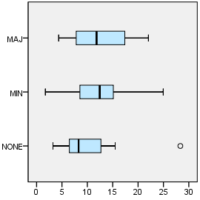

EXAMINE VARIABLES=trvtime_edprm_min BY COVERAGE_TYPE
/PLOT=BOXPLOT
/STATISTICS=NONE
/NOTOTAL.

Explore

Notes
Output Created |  | 03-APR-2018 18:11:02
Comments
Input | Data | F:\Data_Final\3cases_traveltime_indec.sav
Input | Active Dataset | DataSet1
Input | Filter | <none>
Input | Weight | <none>
Input | Split File | Department
Input | N of Rows in Working Data File | 284
Missing Value Handling | Definition of Missing | User-defined missing values for dependent variables are treated as missing.
Missing Value Handling | Cases Used | Statistics are based on cases with no missing values for any dependent variable or factor used.
Syntax |  | EXAMINE VARIABLES=trvtime_edprm_min BY COVERAGE_TYPE  /PLOT=BOXPLOT  /STATISTICS=NONE  /NOTOTAL.
Resources | Processor Time | 00:00:00.56
Resources | Elapsed Time | 00:00:00.58

Department = La Matanza

Overlap with asentamiento, degree

Case Processing Summaryª
 | Overlap with asentamiento, degree | Cases
 | Overlap with asentamiento, degree | Valid |  | Missing
 | Overlap with asentamiento, degree | N | Percent | N | Percent
Public primary school | MAJ | 30 | 100.0% | 0 | 0.0%
Public primary school | MIN | 30 | 100.0% | 0 | 0.0%
Public primary school | NONE | 60 | 100.0% | 0 | 0.0%

Case Processing Summaryª
 | Overlap with asentamiento, degree | Cases
 | Overlap with asentamiento, degree | Total
 | Overlap with asentamiento, degree | N | Percent
Public primary school | MAJ | 30 | 100.0%
Public primary school | MIN | 30 | 100.0%
Public primary school | NONE | 60 | 100.0%

a. Department = La Matanza

Public primary school

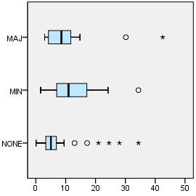

Department = Pilar

Overlap with asentamiento, degree

Case Processing Summaryª
 | Overlap with asentamiento, degree | Cases
 | Overlap with asentamiento, degree | Valid |  | Missing
 | Overlap with asentamiento, degree | N | Percent | N | Percent
Public primary school | MAJ | 6 | 100.0% | 0 | 0.0%
Public primary school | MIN | 30 | 100.0% | 0 | 0.0%
Public primary school | NONE | 36 | 100.0% | 0 | 0.0%

Case Processing Summaryª
 | Overlap with asentamiento, degree | Cases
 | Overlap with asentamiento, degree | Total
 | Overlap with asentamiento, degree | N | Percent
Public primary school | MAJ | 6 | 100.0%
Public primary school | MIN | 30 | 100.0%
Public primary school | NONE | 36 | 100.0%

a. Department = Pilar

Public primary school

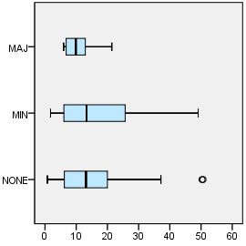

Department = Quilmes

Overlap with asentamiento, degree

Case Processing Summaryª
 | Overlap with asentamiento, degree | Cases
 | Overlap with asentamiento, degree | Valid |  | Missing
 | Overlap with asentamiento, degree | N | Percent | N | Percent
Public primary school | MAJ | 16 | 100.0% | 0 | 0.0%
Public primary school | MIN | 30 | 100.0% | 0 | 0.0%
Public primary school | NONE | 46 | 100.0% | 0 | 0.0%

Case Processing Summaryª
 | Overlap with asentamiento, degree | Cases
 | Overlap with asentamiento, degree | Total
 | Overlap with asentamiento, degree | N | Percent
Public primary school | MAJ | 16 | 100.0%
Public primary school | MIN | 30 | 100.0%
Public primary school | NONE | 46 | 100.0%

a. Department = Quilmes

Public primary school

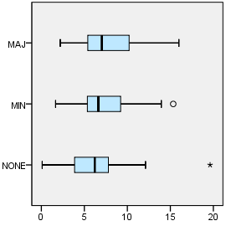

EXAMINE VARIABLES=trvtime_edknd_min BY COVERAGE_TYPE
/PLOT=BOXPLOT
/STATISTICS=NONE
/NOTOTAL.

Explore

Notes
Output Created |  | 03-APR-2018 18:11:12
Comments
Input | Data | F:\Data_Final\3cases_traveltime_indec.sav
Input | Active Dataset | DataSet1
Input | Filter | <none>
Input | Weight | <none>
Input | Split File | Department
Input | N of Rows in Working Data File | 284
Missing Value Handling | Definition of Missing | User-defined missing values for dependent variables are treated as missing.
Missing Value Handling | Cases Used | Statistics are based on cases with no missing values for any dependent variable or factor used.
Syntax |  | EXAMINE VARIABLES=trvtime_edknd_min BY COVERAGE_TYPE  /PLOT=BOXPLOT  /STATISTICS=NONE  /NOTOTAL.
Resources | Processor Time | 00:00:00.69
Resources | Elapsed Time | 00:00:00.64

Department = La Matanza

Overlap with asentamiento, degree

Case Processing Summaryª
 | Overlap with asentamiento, degree | Cases
 | Overlap with asentamiento, degree | Valid |  | Missing |  | Total
 | Overlap with asentamiento, degree | N | Percent | N | Percent | N
Public kindergarten | MAJ | 30 | 100.0% | 0 | 0.0% | 30
Public kindergarten | MIN | 30 | 100.0% | 0 | 0.0% | 30
Public kindergarten | NONE | 60 | 100.0% | 0 | 0.0% | 60

Case Processing Summaryª
 | Overlap with asentamiento, degree | Cases
 | Overlap with asentamiento, degree | Total
 | Overlap with asentamiento, degree | Percent
Public kindergarten | MAJ | 100.0%
Public kindergarten | MIN | 100.0%
Public kindergarten | NONE | 100.0%

a. Department = La Matanza

Public kindergarten

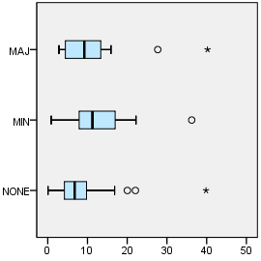

Department = Pilar

Overlap with asentamiento, degree

Case Processing Summaryª
 | Overlap with asentamiento, degree | Cases
 | Overlap with asentamiento, degree | Valid |  | Missing |  | Total
 | Overlap with asentamiento, degree | N | Percent | N | Percent | N
Public kindergarten | MAJ | 6 | 100.0% | 0 | 0.0% | 6
Public kindergarten | MIN | 30 | 100.0% | 0 | 0.0% | 30
Public kindergarten | NONE | 36 | 100.0% | 0 | 0.0% | 36

Case Processing Summaryª
 | Overlap with asentamiento, degree | Cases
 | Overlap with asentamiento, degree | Total
 | Overlap with asentamiento, degree | Percent
Public kindergarten | MAJ | 100.0%
Public kindergarten | MIN | 100.0%
Public kindergarten | NONE | 100.0%

a. Department = Pilar

Public kindergarten

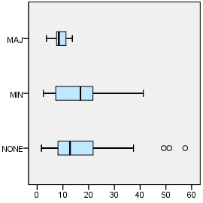

Department = Quilmes

Overlap with asentamiento, degree

Case Processing Summaryª
 | Overlap with asentamiento, degree | Cases
 | Overlap with asentamiento, degree | Valid |  | Missing |  | Total
 | Overlap with asentamiento, degree | N | Percent | N | Percent | N
Public kindergarten | MAJ | 16 | 100.0% | 0 | 0.0% | 16
Public kindergarten | MIN | 30 | 100.0% | 0 | 0.0% | 30
Public kindergarten | NONE | 46 | 100.0% | 0 | 0.0% | 46

Case Processing Summaryª
 | Overlap with asentamiento, degree | Cases
 | Overlap with asentamiento, degree | Total
 | Overlap with asentamiento, degree | Percent
Public kindergarten | MAJ | 100.0%
Public kindergarten | MIN | 100.0%
Public kindergarten | NONE | 100.0%

a. Department = Quilmes

Public kindergarten

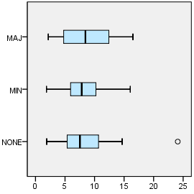

OUTPUT MODIFY
/REPORT PRINTREPORT=NO
/SELECT CHARTS
/DELETEOBJECT DELETE=NO
/OBJECTPROPERTIES VISIBLE=ASIS SIZE=INCHES(2.25,3.0)
/GRAPHS CTEMPLATE="F:\Histogram_MAJvMINvNONE.sgt".
OUTPUT MODIFY
/REPORT PRINTREPORT=NO
/SELECT CHARTS
/DELETEOBJECT DELETE=NO
/OBJECTPROPERTIES VISIBLE=ASIS SIZE=INCHES(2.5,3.5)
/GRAPHS CTEMPLATE="F:\Histogram_MAJvMINvNONE.sgt".

OUTPUT MODIFY
/REPORT PRINTREPORT=NO
/SELECT CHARTS
/DELETEOBJECT DELETE=NO
/OBJECTPROPERTIES VISIBLE=ASIS SIZE=INCHES(2.8,2.8)
/GRAPHS CTEMPLATE="F:\Histogram_MAJvMINvNONE.sgt".

