GET
FILE='F:\Data_Final\3cases_traveltime_indec.sav'.
DATASET NAME DataSet1 WINDOW=FRONT.
EXAMINE VARIABLES=trvtime_cbd_bsas trvtime_cbd_loc trvtime_cbd_ngh_min trvtime_rail_min
trvtime_upa_min trvtime_hspt_min trvtime_dgntrt_min trvtime_edsec_min trvtime_edprm_min
trvtime_edknd_min
/COMPARE VARIABLE
/PLOT=BOXPLOT
/STATISTICS=NONE
/NOTOTAL
/MISSING=LISTWISE.

Explore

Notes
Output Created |  | 03-APR-2018 17:31:44
Comments
Input | Data | F:\Data_Final\3cases_traveltime_indec.sav
Input | Active Dataset | DataSet1
Input | Filter | <none>
Input | Weight | <none>
Input | Split File | <none>
Input | N of Rows in Working Data File | 284
Missing Value Handling | Definition of Missing | User-defined missing values for dependent variables are treated as missing.
Missing Value Handling | Cases Used | Statistics are based on cases with no missing values for any dependent variable or factor used.
Syntax |  | EXAMINE VARIABLES=trvtime_cbd_bsas trvtime_cbd_loc trvtime_cbd_ngh_min trvtime_rail_min  trvtime_upa_min trvtime_hspt_min trvtime_dgntrt_min trvtime_edsec_min trvtime_edprm_min  trvtime_edknd_min  /COMPARE VARIABLE  /PLOT=BOXPLOT  /STATISTICS=NONE  /NOTOTAL  /MISSING=LISTWISE.
Resources | Processor Time | 00:00:02.15
Resources | Elapsed Time | 00:00:01.26

[DataSet1] F:\Data_Final\3cases_traveltime_indec.sav

Case Processing Summary
 | Cases
 | Valid |  | Missing |  | Total
 | N | Percent | N | Percent | N | Percent
Buenos Aires CBD | 270 | 95.1% | 14 | 4.9% | 284 | 100.0%
Departmental CBD | 270 | 95.1% | 14 | 4.9% | 284 | 100.0%
Any departmental CBD | 270 | 95.1% | 14 | 4.9% | 284 | 100.0%
Railway station (min.) | 270 | 95.1% | 14 | 4.9% | 284 | 100.0%
Public UPA (min.) | 270 | 95.1% | 14 | 4.9% | 284 | 100.0%
Public hospital (min.) | 270 | 95.1% | 14 | 4.9% | 284 | 100.0%
Public diag./treat. center (min.) | 270 | 95.1% | 14 | 4.9% | 284 | 100.0%
Public secondary school (min.) | 270 | 95.1% | 14 | 4.9% | 284 | 100.0%
Public primary school (min.) | 270 | 95.1% | 14 | 4.9% | 284 | 100.0%
Public kindergarten (min.) | 270 | 95.1% | 14 | 4.9% | 284 | 100.0%

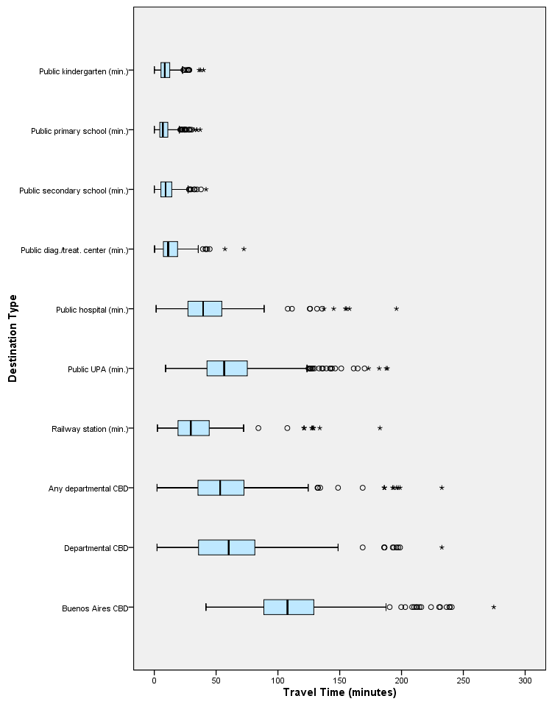

DATASET ACTIVATE DataSet1.

SAVE OUTFILE='F:\Data_Final\3cases_traveltime_indec.sav'
/COMPRESSED.
EXAMINE VARIABLES=trvtime_cbd_bsas trvtime_cbd_loc trvtime_cbd_ngh_min trvtime_rail_min
trvtime_upa_min trvtime_hspt_min trvtime_dgntrt_min trvtime_edsec_min trvtime_edprm_min
trvtime_edknd_min
/COMPARE VARIABLE
/PLOT=BOXPLOT
/STATISTICS=NONE
/NOTOTAL
/MISSING=LISTWISE.

Explore

Notes
Output Created |  | 03-APR-2018 17:33:35
Comments
Input | Data | F:\Data_Final\3cases_traveltime_indec.sav
Input | Active Dataset | DataSet1
Input | Filter | <none>
Input | Weight | <none>
Input | Split File | <none>
Input | N of Rows in Working Data File | 284
Missing Value Handling | Definition of Missing | User-defined missing values for dependent variables are treated as missing.
Missing Value Handling | Cases Used | Statistics are based on cases with no missing values for any dependent variable or factor used.
Syntax |  | EXAMINE VARIABLES=trvtime_cbd_bsas trvtime_cbd_loc trvtime_cbd_ngh_min trvtime_rail_min  trvtime_upa_min trvtime_hspt_min trvtime_dgntrt_min trvtime_edsec_min trvtime_edprm_min  trvtime_edknd_min  /COMPARE VARIABLE  /PLOT=BOXPLOT  /STATISTICS=NONE  /NOTOTAL  /MISSING=LISTWISE.
Resources | Processor Time | 00:00:01.05
Resources | Elapsed Time | 00:00:00.41

Case Processing Summary
 | Cases
 | Valid |  | Missing |  | Total
 | N | Percent | N | Percent | N | Percent
Buenos Aires CBD | 270 | 95.1% | 14 | 4.9% | 284 | 100.0%
Departmental CBD | 270 | 95.1% | 14 | 4.9% | 284 | 100.0%
Any departmental CBD | 270 | 95.1% | 14 | 4.9% | 284 | 100.0%
Railway station | 270 | 95.1% | 14 | 4.9% | 284 | 100.0%
Public UPA | 270 | 95.1% | 14 | 4.9% | 284 | 100.0%
Public hospital | 270 | 95.1% | 14 | 4.9% | 284 | 100.0%
Public diag./treat. center | 270 | 95.1% | 14 | 4.9% | 284 | 100.0%
Public secondary school | 270 | 95.1% | 14 | 4.9% | 284 | 100.0%
Public primary school | 270 | 95.1% | 14 | 4.9% | 284 | 100.0%
Public kindergarten | 270 | 95.1% | 14 | 4.9% | 284 | 100.0%

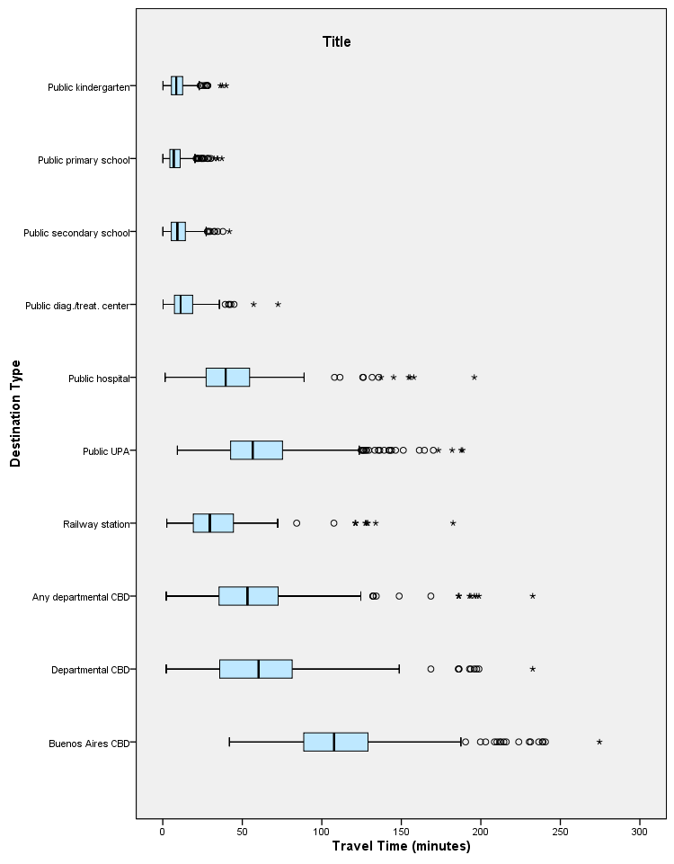

OUTPUT MODIFY
/REPORT PRINTREPORT=NO
/SELECT CHARTS
/DELETEOBJECT DELETE=NO
/OBJECTPROPERTIES VISIBLE=ASIS SIZE=INCHES(7.75,10.0).
SORT CASES BY DEPTO.
SPLIT FILE SEPARATE BY DEPTO.
EXAMINE VARIABLES=trvtime_cbd_bsas trvtime_cbd_loc trvtime_cbd_ngh_min trvtime_rail_min
trvtime_upa_min trvtime_hspt_min trvtime_dgntrt_min trvtime_edsec_min trvtime_edprm_min
trvtime_edknd_min
/COMPARE VARIABLE
/PLOT=BOXPLOT
/STATISTICS=NONE
/NOTOTAL
/MISSING=LISTWISE.

Explore

Notes
Output Created |  | 03-APR-2018 17:39:14
Comments
Input | Data | F:\Data_Final\3cases_traveltime_indec.sav
Input | Active Dataset | DataSet1
Input | Filter | <none>
Input | Weight | <none>
Input | Split File | Department
Input | N of Rows in Working Data File | 284
Missing Value Handling | Definition of Missing | User-defined missing values for dependent variables are treated as missing.
Missing Value Handling | Cases Used | Statistics are based on cases with no missing values for any dependent variable or factor used.
Syntax |  | EXAMINE VARIABLES=trvtime_cbd_bsas trvtime_cbd_loc trvtime_cbd_ngh_min trvtime_rail_min  trvtime_upa_min trvtime_hspt_min trvtime_dgntrt_min trvtime_edsec_min trvtime_edprm_min  trvtime_edknd_min  /COMPARE VARIABLE  /PLOT=BOXPLOT  /STATISTICS=NONE  /NOTOTAL  /MISSING=LISTWISE.
Resources | Processor Time | 00:00:01.56
Resources | Elapsed Time | 00:00:00.80

Department = La Matanza

Case Processing Summaryª
 | Cases
 | Valid |  | Missing |  | Total
 | N | Percent | N | Percent | N | Percent
Buenos Aires CBD | 118 | 98.3% | 2 | 1.7% | 120 | 100.0%
Departmental CBD | 118 | 98.3% | 2 | 1.7% | 120 | 100.0%
Any departmental CBD | 118 | 98.3% | 2 | 1.7% | 120 | 100.0%
Railway station | 118 | 98.3% | 2 | 1.7% | 120 | 100.0%
Public UPA | 118 | 98.3% | 2 | 1.7% | 120 | 100.0%
Public hospital | 118 | 98.3% | 2 | 1.7% | 120 | 100.0%
Public diag./treat. center | 118 | 98.3% | 2 | 1.7% | 120 | 100.0%
Public secondary school | 118 | 98.3% | 2 | 1.7% | 120 | 100.0%
Public primary school | 118 | 98.3% | 2 | 1.7% | 120 | 100.0%
Public kindergarten | 118 | 98.3% | 2 | 1.7% | 120 | 100.0%

a. Department = La Matanza

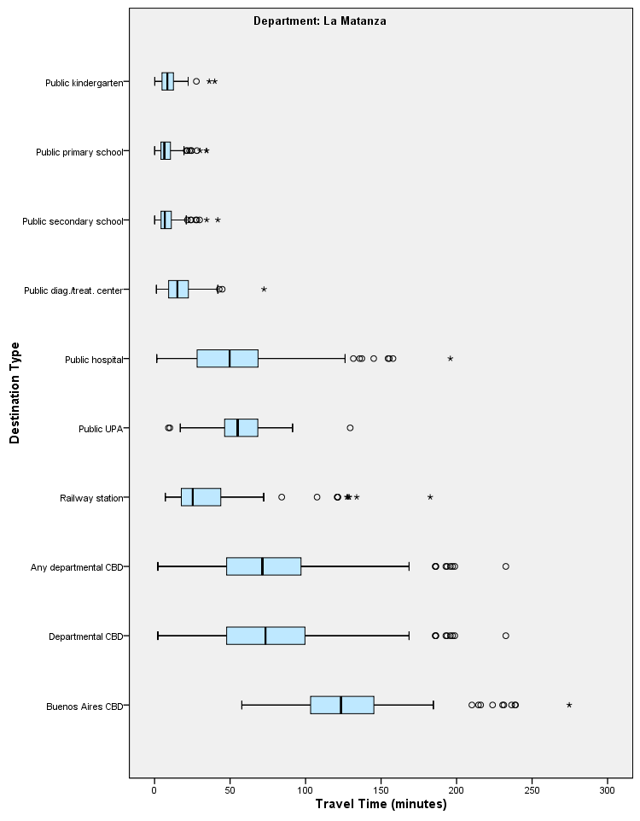

Department = Pilar

Case Processing Summaryª
 | Cases
 | Valid |  | Missing |  | Total
 | N | Percent | N | Percent | N | Percent
Buenos Aires CBD | 60 | 83.3% | 12 | 16.7% | 72 | 100.0%
Departmental CBD | 60 | 83.3% | 12 | 16.7% | 72 | 100.0%
Any departmental CBD | 60 | 83.3% | 12 | 16.7% | 72 | 100.0%
Railway station | 60 | 83.3% | 12 | 16.7% | 72 | 100.0%
Public UPA | 60 | 83.3% | 12 | 16.7% | 72 | 100.0%
Public hospital | 60 | 83.3% | 12 | 16.7% | 72 | 100.0%
Public diag./treat. center | 60 | 83.3% | 12 | 16.7% | 72 | 100.0%
Public secondary school | 60 | 83.3% | 12 | 16.7% | 72 | 100.0%
Public primary school | 60 | 83.3% | 12 | 16.7% | 72 | 100.0%
Public kindergarten | 60 | 83.3% | 12 | 16.7% | 72 | 100.0%

a. Department = Pilar

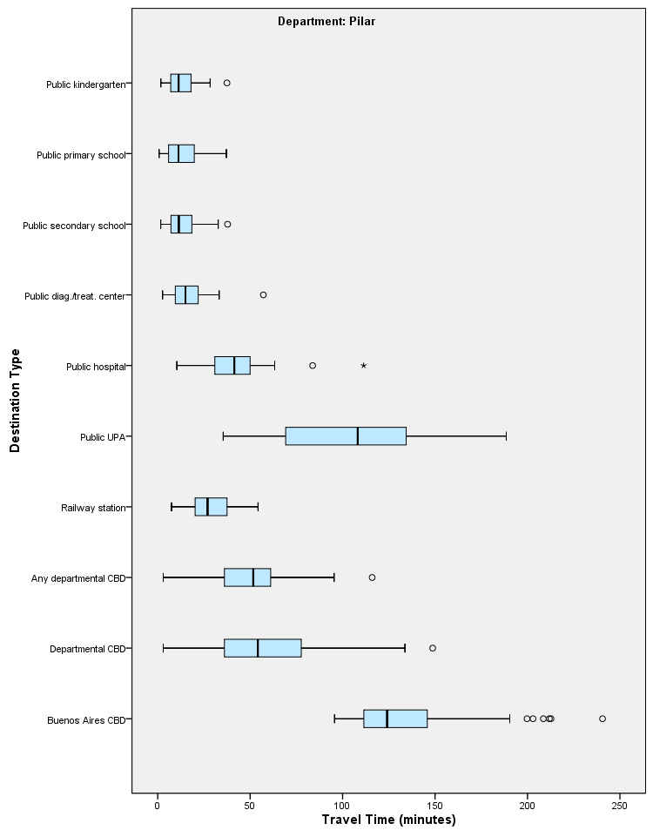

Department = Quilmes

Case Processing Summaryª
 | Cases
 | Valid |  | Missing |  | Total
 | N | Percent | N | Percent | N | Percent
Buenos Aires CBD | 92 | 100.0% | 0 | 0.0% | 92 | 100.0%
Departmental CBD | 92 | 100.0% | 0 | 0.0% | 92 | 100.0%
Any departmental CBD | 92 | 100.0% | 0 | 0.0% | 92 | 100.0%
Railway station | 92 | 100.0% | 0 | 0.0% | 92 | 100.0%
Public UPA | 92 | 100.0% | 0 | 0.0% | 92 | 100.0%
Public hospital | 92 | 100.0% | 0 | 0.0% | 92 | 100.0%
Public diag./treat. center | 92 | 100.0% | 0 | 0.0% | 92 | 100.0%
Public secondary school | 92 | 100.0% | 0 | 0.0% | 92 | 100.0%
Public primary school | 92 | 100.0% | 0 | 0.0% | 92 | 100.0%
Public kindergarten | 92 | 100.0% | 0 | 0.0% | 92 | 100.0%

a. Department = Quilmes

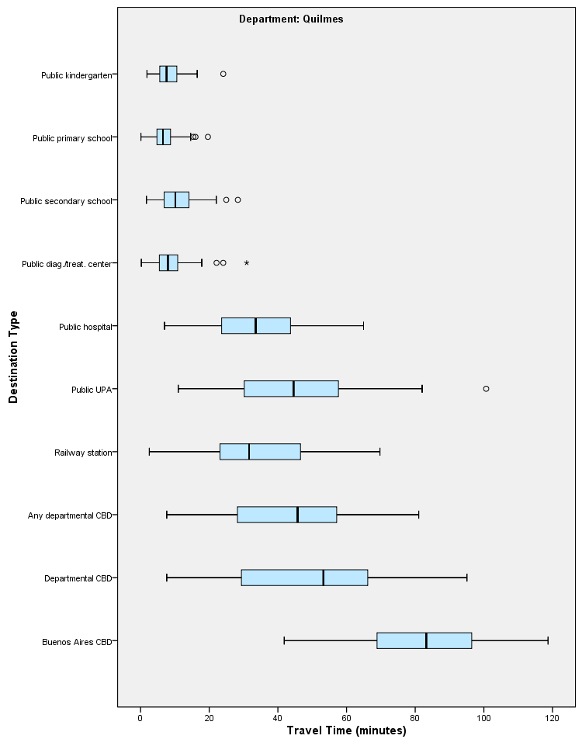

OUTPUT MODIFY
/REPORT PRINTREPORT=NO
/SELECT CHARTS
/DELETEOBJECT DELETE=NO
/OBJECTPROPERTIES VISIBLE=ASIS SIZE=INCHES(7.8,10.0)
/GRAPHS CTEMPLATE="F:\Histogram_All10Types.sgt".

SPLIT FILE OFF.
EXAMINE VARIABLES=z1_tt_cbdbsas z1_tt_cbdloc z1_tt_cbdngh z1_tt_rail z1_tt_upa z1_tt_hspt
z1_tt_dgntrt z1_tt_edsec z1_tt_edprm z1_tt_edknd trvtime_index1_all10
/COMPARE VARIABLE
/PLOT=BOXPLOT
/STATISTICS=NONE
/NOTOTAL
/MISSING=LISTWISE.

Explore

Notes
Output Created |  | 03-APR-2018 17:46:33
Comments
Input | Data | F:\Data_Final\3cases_traveltime_indec.sav
Input | Active Dataset | DataSet1
Input | Filter | <none>
Input | Weight | <none>
Input | Split File | <none>
Input | N of Rows in Working Data File | 284
Missing Value Handling | Definition of Missing | User-defined missing values for dependent variables are treated as missing.
Missing Value Handling | Cases Used | Statistics are based on cases with no missing values for any dependent variable or factor used.
Syntax |  | EXAMINE VARIABLES=z1_tt_cbdbsas z1_tt_cbdloc z1_tt_cbdngh z1_tt_rail z1_tt_upa z1_tt_hspt  z1_tt_dgntrt z1_tt_edsec z1_tt_edprm z1_tt_edknd trvtime_index1_all10  /COMPARE VARIABLE  /PLOT=BOXPLOT  /STATISTICS=NONE  /NOTOTAL  /MISSING=LISTWISE.
Resources | Processor Time | 00:00:00.42
Resources | Elapsed Time | 00:00:00.37

Case Processing Summary
 | Cases
 | Valid |  | Missing |  | Total
 | N | Percent | N | Percent | N | Percent
Travel time to Buenos Aires CBD, scaled local | 270 | 95.1% | 14 | 4.9% | 284 | 100.0%
Travel time to Department CBD, scaled local | 270 | 95.1% | 14 | 4.9% | 284 | 100.0%
Travel time to nearest CBD, scaled local | 270 | 95.1% | 14 | 4.9% | 284 | 100.0%
Travel time to nearest rail station, scaled local | 270 | 95.1% | 14 | 4.9% | 284 | 100.0%
Travel time to nearest UPA, scaled local | 270 | 95.1% | 14 | 4.9% | 284 | 100.0%
Travel time to nearest public hospital, scaled local | 270 | 95.1% | 14 | 4.9% | 284 | 100.0%
Travel time to nearest diagnostic/treatment center, scaled local | 270 | 95.1% | 14 | 4.9% | 284 | 100.0%
Travel time to nearest public secondary school, scaled local | 270 | 95.1% | 14 | 4.9% | 284 | 100.0%
Travel time to nearest public primary school, scaled local | 270 | 95.1% | 14 | 4.9% | 284 | 100.0%
Travel time to nearest public kindergarten, scaled local | 270 | 95.1% | 14 | 4.9% | 284 | 100.0%
Index of locally-scaled travel times, all 10 variables | 270 | 95.1% | 14 | 4.9% | 284 | 100.0%

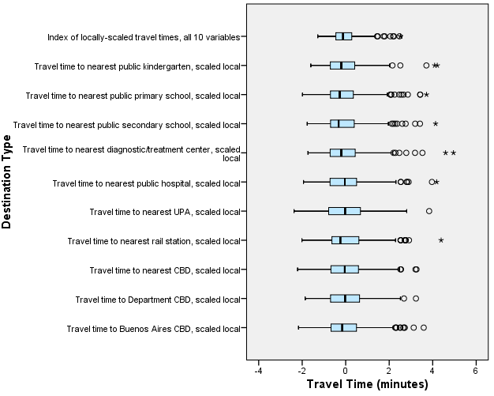

OUTPUT MODIFY NAME=Document1
/REPORT PRINTREPORT=NO
/SELECT CHARTS
/IF COMMANDS=["Explore(4)"] LABELS=[EXACT("Boxplot")] INSTANCES=[1]
/DELETEOBJECT DELETE=NO
/OBJECTPROPERTIES VISIBLE=ASIS
/GRAPHS CTEMPLATE="F:\Histogram_All10Types.sgt".

DATASET ACTIVATE DataSet1.

SAVE OUTFILE='F:\Data_Final\3cases_traveltime_indec.sav'
/COMPRESSED.
EXAMINE VARIABLES=z1_tt_cbdbsas z1_tt_cbdloc z1_tt_cbdngh z1_tt_rail z1_tt_upa z1_tt_hspt
z1_tt_dgntrt z1_tt_edsec z1_tt_edprm z1_tt_edknd trvtime_index1_all10
/COMPARE VARIABLE
/PLOT=BOXPLOT
/STATISTICS=NONE
/NOTOTAL
/MISSING=LISTWISE.

Explore

Notes
Output Created |  | 03-APR-2018 17:53:59
Comments
Input | Data | F:\Data_Final\3cases_traveltime_indec.sav
Input | Active Dataset | DataSet1
Input | Filter | <none>
Input | Weight | <none>
Input | Split File | <none>
Input | N of Rows in Working Data File | 284
Missing Value Handling | Definition of Missing | User-defined missing values for dependent variables are treated as missing.
Missing Value Handling | Cases Used | Statistics are based on cases with no missing values for any dependent variable or factor used.
Syntax |  | EXAMINE VARIABLES=z1_tt_cbdbsas z1_tt_cbdloc z1_tt_cbdngh z1_tt_rail z1_tt_upa z1_tt_hspt  z1_tt_dgntrt z1_tt_edsec z1_tt_edprm z1_tt_edknd trvtime_index1_all10  /COMPARE VARIABLE  /PLOT=BOXPLOT  /STATISTICS=NONE  /NOTOTAL  /MISSING=LISTWISE.
Resources | Processor Time | 00:00:00.44
Resources | Elapsed Time | 00:00:00.39

Case Processing Summary
 | Cases
 | Valid |  | Missing |  | Total
 | N | Percent | N | Percent | N | Percent
Buenos Aires CBD, scaled local | 270 | 95.1% | 14 | 4.9% | 284 | 100.0%
Departmental CBD, scaled local | 270 | 95.1% | 14 | 4.9% | 284 | 100.0%
Any departmental CBD, scaled local | 270 | 95.1% | 14 | 4.9% | 284 | 100.0%
Railway station, scaled local | 270 | 95.1% | 14 | 4.9% | 284 | 100.0%
Public UPA, scaled local | 270 | 95.1% | 14 | 4.9% | 284 | 100.0%
Public hospital, scaled local | 270 | 95.1% | 14 | 4.9% | 284 | 100.0%
Public diag./treat. center, scaled local | 270 | 95.1% | 14 | 4.9% | 284 | 100.0%
Public secondary school, scaled local | 270 | 95.1% | 14 | 4.9% | 284 | 100.0%
Public primary school, scaled local | 270 | 95.1% | 14 | 4.9% | 284 | 100.0%
Public kindergarten, scaled local | 270 | 95.1% | 14 | 4.9% | 284 | 100.0%
Index of locally-scaled travel times, all 10 variables | 270 | 95.1% | 14 | 4.9% | 284 | 100.0%

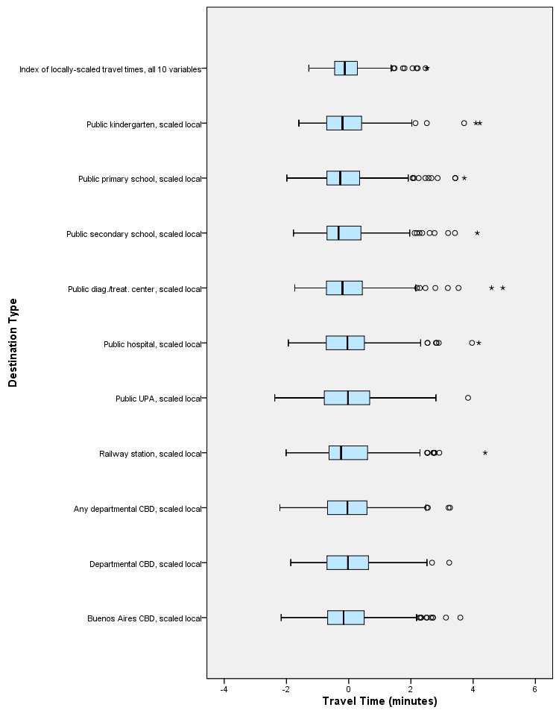

OUTPUT MODIFY NAME=Document1
/REPORT PRINTREPORT=NO
/SELECT CHARTS
/IF COMMANDS=["Explore(5)"] LABELS=[EXACT("Boxplot")] INSTANCES=[1]
/DELETEOBJECT DELETE=NO
/OBJECTPROPERTIES VISIBLE=ASIS
/GRAPHS CTEMPLATE="F:\Histogram_All10Types.sgt".

OUTPUT MODIFY NAME=Document1
/REPORT PRINTREPORT=NO
/SELECT CHARTS
/IF COMMANDS=["Explore(5)"] LABELS=[EXACT("Boxplot")] INSTANCES=[1]
/DELETEOBJECT DELETE=NO
/OBJECTPROPERTIES VISIBLE=ASIS SIZE=INCHES(7.8,10.0)
/GRAPHS CTEMPLATE="F:\Histogram_All10Types.sgt".

