EXAMINE VARIABLES=trvtime_edknd_min BY COVERAGE_TYPE
/PLOT=BOXPLOT
/STATISTICS=NONE
/NOTOTAL.

Explore

Notes
Output Created |  | 03-APR-2018 18:46:46
Comments
Input | Data | F:\Data_Final\3cases_traveltime_indec.sav
Input | Active Dataset | DataSet1
Input | Filter | <none>
Input | Weight | <none>
Input | Split File | <none>
Input | N of Rows in Working Data File | 284
Missing Value Handling | Definition of Missing | User-defined missing values for dependent variables are treated as missing.
Missing Value Handling | Cases Used | Statistics are based on cases with no missing values for any dependent variable or factor used.
Syntax |  | EXAMINE VARIABLES=trvtime_edknd_min BY COVERAGE_TYPE  /PLOT=BOXPLOT  /STATISTICS=NONE  /NOTOTAL.
Resources | Processor Time | 00:00:00.22
Resources | Elapsed Time | 00:00:00.22

Overlap with asentamiento, degree

Case Processing Summary
 | Overlap with asentamiento, degree | Cases
 | Overlap with asentamiento, degree | Valid |  | Missing
 | Overlap with asentamiento, degree | N | Percent | N | Percent
Public kindergarten | MAJ | 52 | 100.0% | 0 | 0.0%
Public kindergarten | MIN | 90 | 100.0% | 0 | 0.0%
Public kindergarten | NONE | 142 | 100.0% | 0 | 0.0%

Case Processing Summary
 | Overlap with asentamiento, degree | Cases
 | Overlap with asentamiento, degree | Total
 | Overlap with asentamiento, degree | N | Percent
Public kindergarten | MAJ | 52 | 100.0%
Public kindergarten | MIN | 90 | 100.0%
Public kindergarten | NONE | 142 | 100.0%

Public kindergarten

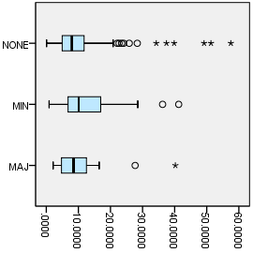

EXAMINE VARIABLES=z1_tt_cbdbsas BY COVERAGE_TYPE
/PLOT=BOXPLOT
/STATISTICS=NONE
/NOTOTAL.

Explore

Notes
Output Created |  | 03-APR-2018 18:47:10
Comments
Input | Data | F:\Data_Final\3cases_traveltime_indec.sav
Input | Active Dataset | DataSet1
Input | Filter | <none>
Input | Weight | <none>
Input | Split File | <none>
Input | N of Rows in Working Data File | 284
Missing Value Handling | Definition of Missing | User-defined missing values for dependent variables are treated as missing.
Missing Value Handling | Cases Used | Statistics are based on cases with no missing values for any dependent variable or factor used.
Syntax |  | EXAMINE VARIABLES=z1_tt_cbdbsas BY COVERAGE_TYPE  /PLOT=BOXPLOT  /STATISTICS=NONE  /NOTOTAL.
Resources | Processor Time | 00:00:00.22
Resources | Elapsed Time | 00:00:00.22

Overlap with asentamiento, degree

Case Processing Summary
 | Overlap with asentamiento, degree | Cases
 | Overlap with asentamiento, degree | Valid |  | Missing
 | Overlap with asentamiento, degree | N | Percent | N | Percent
Buenos Aires CBD, scaled local | MAJ | 50 | 96.2% | 2 | 3.8%
Buenos Aires CBD, scaled local | MIN | 84 | 93.3% | 6 | 6.7%
Buenos Aires CBD, scaled local | NONE | 136 | 95.8% | 6 | 4.2%

Case Processing Summary
 | Overlap with asentamiento, degree | Cases
 | Overlap with asentamiento, degree | Total
 | Overlap with asentamiento, degree | N | Percent
Buenos Aires CBD, scaled local | MAJ | 52 | 100.0%
Buenos Aires CBD, scaled local | MIN | 90 | 100.0%
Buenos Aires CBD, scaled local | NONE | 142 | 100.0%

Buenos Aires CBD, scaled local

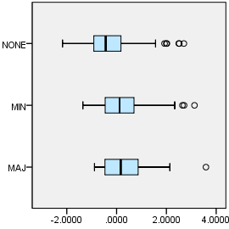

EXAMINE VARIABLES=trvtime_index1_all10 BY COVERAGE_TYPE
/PLOT=BOXPLOT
/STATISTICS=NONE
/NOTOTAL.

Explore

Notes
Output Created |  | 03-APR-2018 18:47:54
Comments
Input | Data | F:\Data_Final\3cases_traveltime_indec.sav
Input | Active Dataset | DataSet1
Input | Filter | <none>
Input | Weight | <none>
Input | Split File | <none>
Input | N of Rows in Working Data File | 284
Missing Value Handling | Definition of Missing | User-defined missing values for dependent variables are treated as missing.
Missing Value Handling | Cases Used | Statistics are based on cases with no missing values for any dependent variable or factor used.
Syntax |  | EXAMINE VARIABLES=trvtime_index1_all10 BY COVERAGE_TYPE  /PLOT=BOXPLOT  /STATISTICS=NONE  /NOTOTAL.
Resources | Processor Time | 00:00:00.20
Resources | Elapsed Time | 00:00:00.22

Overlap with asentamiento, degree

Case Processing Summary
 | Overlap with asentamiento, degree | Cases
 | Overlap with asentamiento, degree | Valid |  | Missing
 | Overlap with asentamiento, degree | N | Percent | N | Percent
Index of locally-scaled travel times, all 10 variables | MAJ | 52 | 100.0% | 0 | 0.0%
Index of locally-scaled travel times, all 10 variables | MIN | 90 | 100.0% | 0 | 0.0%
Index of locally-scaled travel times, all 10 variables | NONE | 142 | 100.0% | 0 | 0.0%

Case Processing Summary
 | Overlap with asentamiento, degree | Cases
 | Overlap with asentamiento, degree | Total
 | Overlap with asentamiento, degree | N | Percent
Index of locally-scaled travel times, all 10 variables | MAJ | 52 | 100.0%
Index of locally-scaled travel times, all 10 variables | MIN | 90 | 100.0%
Index of locally-scaled travel times, all 10 variables | NONE | 142 | 100.0%

Index of locally-scaled travel times, all 10 variables

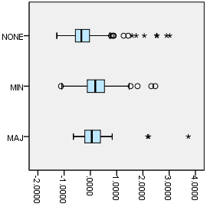

EXAMINE VARIABLES=z1_tt_cbdloc BY COVERAGE_TYPE
/PLOT=BOXPLOT
/STATISTICS=NONE
/NOTOTAL.

Explore

Notes
Output Created |  | 03-APR-2018 18:48:51
Comments
Input | Data | F:\Data_Final\3cases_traveltime_indec.sav
Input | Active Dataset | DataSet1
Input | Filter | <none>
Input | Weight | <none>
Input | Split File | <none>
Input | N of Rows in Working Data File | 284
Missing Value Handling | Definition of Missing | User-defined missing values for dependent variables are treated as missing.
Missing Value Handling | Cases Used | Statistics are based on cases with no missing values for any dependent variable or factor used.
Syntax |  | EXAMINE VARIABLES=z1_tt_cbdloc BY COVERAGE_TYPE  /PLOT=BOXPLOT  /STATISTICS=NONE  /NOTOTAL.
Resources | Processor Time | 00:00:00.23
Resources | Elapsed Time | 00:00:00.22

Overlap with asentamiento, degree

Case Processing Summary
 | Overlap with asentamiento, degree | Cases
 | Overlap with asentamiento, degree | Valid |  | Missing
 | Overlap with asentamiento, degree | N | Percent | N | Percent
Departmental CBD, scaled local | MAJ | 50 | 96.2% | 2 | 3.8%
Departmental CBD, scaled local | MIN | 85 | 94.4% | 5 | 5.6%
Departmental CBD, scaled local | NONE | 137 | 96.5% | 5 | 3.5%

Case Processing Summary
 | Overlap with asentamiento, degree | Cases
 | Overlap with asentamiento, degree | Total
 | Overlap with asentamiento, degree | N | Percent
Departmental CBD, scaled local | MAJ | 52 | 100.0%
Departmental CBD, scaled local | MIN | 90 | 100.0%
Departmental CBD, scaled local | NONE | 142 | 100.0%

Departmental CBD, scaled local

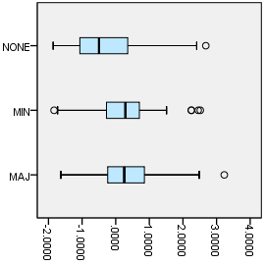

EXAMINE VARIABLES=z1_tt_cbdngh BY COVERAGE_TYPE
/PLOT=BOXPLOT
/STATISTICS=NONE
/NOTOTAL.

Explore

Notes
Output Created |  | 03-APR-2018 18:49:01
Comments
Input | Data | F:\Data_Final\3cases_traveltime_indec.sav
Input | Active Dataset | DataSet1
Input | Filter | <none>
Input | Weight | <none>
Input | Split File | <none>
Input | N of Rows in Working Data File | 284
Missing Value Handling | Definition of Missing | User-defined missing values for dependent variables are treated as missing.
Missing Value Handling | Cases Used | Statistics are based on cases with no missing values for any dependent variable or factor used.
Syntax |  | EXAMINE VARIABLES=z1_tt_cbdngh BY COVERAGE_TYPE  /PLOT=BOXPLOT  /STATISTICS=NONE  /NOTOTAL.
Resources | Processor Time | 00:00:00.27
Resources | Elapsed Time | 00:00:00.22

Overlap with asentamiento, degree

Case Processing Summary
 | Overlap with asentamiento, degree | Cases
 | Overlap with asentamiento, degree | Valid |  | Missing
 | Overlap with asentamiento, degree | N | Percent | N | Percent
Any departmental CBD, scaled local | MAJ | 50 | 96.2% | 2 | 3.8%
Any departmental CBD, scaled local | MIN | 85 | 94.4% | 5 | 5.6%
Any departmental CBD, scaled local | NONE | 137 | 96.5% | 5 | 3.5%

Case Processing Summary
 | Overlap with asentamiento, degree | Cases
 | Overlap with asentamiento, degree | Total
 | Overlap with asentamiento, degree | N | Percent
Any departmental CBD, scaled local | MAJ | 52 | 100.0%
Any departmental CBD, scaled local | MIN | 90 | 100.0%
Any departmental CBD, scaled local | NONE | 142 | 100.0%

Any departmental CBD, scaled local

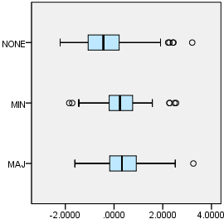

EXAMINE VARIABLES=z1_tt_rail BY COVERAGE_TYPE
/PLOT=BOXPLOT
/STATISTICS=NONE
/NOTOTAL.

Explore

Notes
Output Created |  | 03-APR-2018 18:49:10
Comments
Input | Data | F:\Data_Final\3cases_traveltime_indec.sav
Input | Active Dataset | DataSet1
Input | Filter | <none>
Input | Weight | <none>
Input | Split File | <none>
Input | N of Rows in Working Data File | 284
Missing Value Handling | Definition of Missing | User-defined missing values for dependent variables are treated as missing.
Missing Value Handling | Cases Used | Statistics are based on cases with no missing values for any dependent variable or factor used.
Syntax |  | EXAMINE VARIABLES=z1_tt_rail BY COVERAGE_TYPE  /PLOT=BOXPLOT  /STATISTICS=NONE  /NOTOTAL.
Resources | Processor Time | 00:00:00.22
Resources | Elapsed Time | 00:00:00.22

Overlap with asentamiento, degree

Case Processing Summary
 | Overlap with asentamiento, degree | Cases
 | Overlap with asentamiento, degree | Valid |  | Missing
 | Overlap with asentamiento, degree | N | Percent | N | Percent
Railway station, scaled local | MAJ | 50 | 96.2% | 2 | 3.8%
Railway station, scaled local | MIN | 86 | 95.6% | 4 | 4.4%
Railway station, scaled local | NONE | 136 | 95.8% | 6 | 4.2%

Case Processing Summary
 | Overlap with asentamiento, degree | Cases
 | Overlap with asentamiento, degree | Total
 | Overlap with asentamiento, degree | N | Percent
Railway station, scaled local | MAJ | 52 | 100.0%
Railway station, scaled local | MIN | 90 | 100.0%
Railway station, scaled local | NONE | 142 | 100.0%

Railway station, scaled local

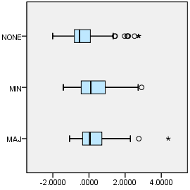

EXAMINE VARIABLES=z1_tt_upa BY COVERAGE_TYPE
/PLOT=BOXPLOT
/STATISTICS=NONE
/NOTOTAL.

Explore

Notes
Output Created |  | 03-APR-2018 18:49:17
Comments
Input | Data | F:\Data_Final\3cases_traveltime_indec.sav
Input | Active Dataset | DataSet1
Input | Filter | <none>
Input | Weight | <none>
Input | Split File | <none>
Input | N of Rows in Working Data File | 284
Missing Value Handling | Definition of Missing | User-defined missing values for dependent variables are treated as missing.
Missing Value Handling | Cases Used | Statistics are based on cases with no missing values for any dependent variable or factor used.
Syntax |  | EXAMINE VARIABLES=z1_tt_upa BY COVERAGE_TYPE  /PLOT=BOXPLOT  /STATISTICS=NONE  /NOTOTAL.
Resources | Processor Time | 00:00:00.20
Resources | Elapsed Time | 00:00:00.22

Overlap with asentamiento, degree

Case Processing Summary
 | Overlap with asentamiento, degree | Cases
 | Overlap with asentamiento, degree | Valid |  | Missing
 | Overlap with asentamiento, degree | N | Percent | N | Percent
Public UPA, scaled local | MAJ | 50 | 96.2% | 2 | 3.8%
Public UPA, scaled local | MIN | 84 | 93.3% | 6 | 6.7%
Public UPA, scaled local | NONE | 136 | 95.8% | 6 | 4.2%

Case Processing Summary
 | Overlap with asentamiento, degree | Cases
 | Overlap with asentamiento, degree | Total
 | Overlap with asentamiento, degree | N | Percent
Public UPA, scaled local | MAJ | 52 | 100.0%
Public UPA, scaled local | MIN | 90 | 100.0%
Public UPA, scaled local | NONE | 142 | 100.0%

Public UPA, scaled local

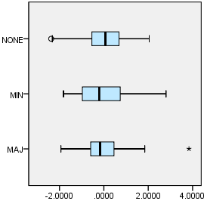

EXAMINE VARIABLES=z1_tt_hspt BY COVERAGE_TYPE
/PLOT=BOXPLOT
/STATISTICS=NONE
/NOTOTAL.

Explore

Notes
Output Created |  | 03-APR-2018 18:49:25
Comments
Input | Data | F:\Data_Final\3cases_traveltime_indec.sav
Input | Active Dataset | DataSet1
Input | Filter | <none>
Input | Weight | <none>
Input | Split File | <none>
Input | N of Rows in Working Data File | 284
Missing Value Handling | Definition of Missing | User-defined missing values for dependent variables are treated as missing.
Missing Value Handling | Cases Used | Statistics are based on cases with no missing values for any dependent variable or factor used.
Syntax |  | EXAMINE VARIABLES=z1_tt_hspt BY COVERAGE_TYPE  /PLOT=BOXPLOT  /STATISTICS=NONE  /NOTOTAL.
Resources | Processor Time | 00:00:00.22
Resources | Elapsed Time | 00:00:00.23

Overlap with asentamiento, degree

Case Processing Summary
 | Overlap with asentamiento, degree | Cases
 | Overlap with asentamiento, degree | Valid |  | Missing
 | Overlap with asentamiento, degree | N | Percent | N | Percent
Public hospital, scaled local | MAJ | 50 | 96.2% | 2 | 3.8%
Public hospital, scaled local | MIN | 85 | 94.4% | 5 | 5.6%
Public hospital, scaled local | NONE | 137 | 96.5% | 5 | 3.5%

Case Processing Summary
 | Overlap with asentamiento, degree | Cases
 | Overlap with asentamiento, degree | Total
 | Overlap with asentamiento, degree | N | Percent
Public hospital, scaled local | MAJ | 52 | 100.0%
Public hospital, scaled local | MIN | 90 | 100.0%
Public hospital, scaled local | NONE | 142 | 100.0%

Public hospital, scaled local

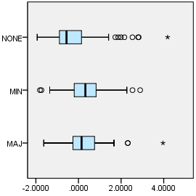

EXAMINE VARIABLES=z1_tt_dgntrt BY COVERAGE_TYPE
/PLOT=BOXPLOT
/STATISTICS=NONE
/NOTOTAL.

Explore

Notes
Output Created |  | 03-APR-2018 18:49:32
Comments
Input | Data | F:\Data_Final\3cases_traveltime_indec.sav
Input | Active Dataset | DataSet1
Input | Filter | <none>
Input | Weight | <none>
Input | Split File | <none>
Input | N of Rows in Working Data File | 284
Missing Value Handling | Definition of Missing | User-defined missing values for dependent variables are treated as missing.
Missing Value Handling | Cases Used | Statistics are based on cases with no missing values for any dependent variable or factor used.
Syntax |  | EXAMINE VARIABLES=z1_tt_dgntrt BY COVERAGE_TYPE  /PLOT=BOXPLOT  /STATISTICS=NONE  /NOTOTAL.
Resources | Processor Time | 00:00:00.20
Resources | Elapsed Time | 00:00:00.22

Overlap with asentamiento, degree

Case Processing Summary
 | Overlap with asentamiento, degree | Cases
 | Overlap with asentamiento, degree | Valid |  | Missing
 | Overlap with asentamiento, degree | N | Percent | N | Percent
Public diag./treat. center, scaled local | MAJ | 52 | 100.0% | 0 | 0.0%
Public diag./treat. center, scaled local | MIN | 90 | 100.0% | 0 | 0.0%
Public diag./treat. center, scaled local | NONE | 140 | 98.6% | 2 | 1.4%

Case Processing Summary
 | Overlap with asentamiento, degree | Cases
 | Overlap with asentamiento, degree | Total
 | Overlap with asentamiento, degree | N | Percent
Public diag./treat. center, scaled local | MAJ | 52 | 100.0%
Public diag./treat. center, scaled local | MIN | 90 | 100.0%
Public diag./treat. center, scaled local | NONE | 142 | 100.0%

Public diag./treat. center, scaled local

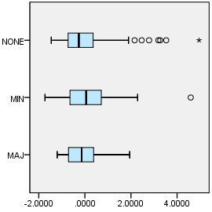

EXAMINE VARIABLES=z1_tt_edsec BY COVERAGE_TYPE
/PLOT=BOXPLOT
/STATISTICS=NONE
/NOTOTAL.

Explore

Notes
Output Created |  | 03-APR-2018 18:49:39
Comments
Input | Data | F:\Data_Final\3cases_traveltime_indec.sav
Input | Active Dataset | DataSet1
Input | Filter | <none>
Input | Weight | <none>
Input | Split File | <none>
Input | N of Rows in Working Data File | 284
Missing Value Handling | Definition of Missing | User-defined missing values for dependent variables are treated as missing.
Missing Value Handling | Cases Used | Statistics are based on cases with no missing values for any dependent variable or factor used.
Syntax |  | EXAMINE VARIABLES=z1_tt_edsec BY COVERAGE_TYPE  /PLOT=BOXPLOT  /STATISTICS=NONE  /NOTOTAL.
Resources | Processor Time | 00:00:00.22
Resources | Elapsed Time | 00:00:00.22

Overlap with asentamiento, degree

Case Processing Summary
 | Overlap with asentamiento, degree | Cases
 | Overlap with asentamiento, degree | Valid |  | Missing
 | Overlap with asentamiento, degree | N | Percent | N | Percent
Public secondary school, scaled local | MAJ | 52 | 100.0% | 0 | 0.0%
Public secondary school, scaled local | MIN | 90 | 100.0% | 0 | 0.0%
Public secondary school, scaled local | NONE | 142 | 100.0% | 0 | 0.0%

Case Processing Summary
 | Overlap with asentamiento, degree | Cases
 | Overlap with asentamiento, degree | Total
 | Overlap with asentamiento, degree | N | Percent
Public secondary school, scaled local | MAJ | 52 | 100.0%
Public secondary school, scaled local | MIN | 90 | 100.0%
Public secondary school, scaled local | NONE | 142 | 100.0%

Public secondary school, scaled local

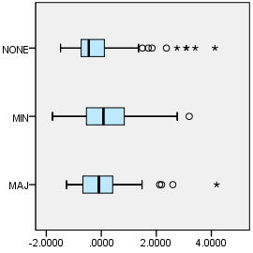

EXAMINE VARIABLES=z1_tt_edknd BY COVERAGE_TYPE
/PLOT=BOXPLOT
/STATISTICS=NONE
/NOTOTAL.

Explore

Notes
Output Created |  | 03-APR-2018 18:49:48
Comments
Input | Data | F:\Data_Final\3cases_traveltime_indec.sav
Input | Active Dataset | DataSet1
Input | Filter | <none>
Input | Weight | <none>
Input | Split File | <none>
Input | N of Rows in Working Data File | 284
Missing Value Handling | Definition of Missing | User-defined missing values for dependent variables are treated as missing.
Missing Value Handling | Cases Used | Statistics are based on cases with no missing values for any dependent variable or factor used.
Syntax |  | EXAMINE VARIABLES=z1_tt_edknd BY COVERAGE_TYPE  /PLOT=BOXPLOT  /STATISTICS=NONE  /NOTOTAL.
Resources | Processor Time | 00:00:00.23
Resources | Elapsed Time | 00:00:00.22

Overlap with asentamiento, degree

Case Processing Summary
 | Overlap with asentamiento, degree | Cases
 | Overlap with asentamiento, degree | Valid |  | Missing
 | Overlap with asentamiento, degree | N | Percent | N | Percent
Public kindergarten, scaled local | MAJ | 52 | 100.0% | 0 | 0.0%
Public kindergarten, scaled local | MIN | 90 | 100.0% | 0 | 0.0%
Public kindergarten, scaled local | NONE | 142 | 100.0% | 0 | 0.0%

Case Processing Summary
 | Overlap with asentamiento, degree | Cases
 | Overlap with asentamiento, degree | Total
 | Overlap with asentamiento, degree | N | Percent
Public kindergarten, scaled local | MAJ | 52 | 100.0%
Public kindergarten, scaled local | MIN | 90 | 100.0%
Public kindergarten, scaled local | NONE | 142 | 100.0%

Public kindergarten, scaled local

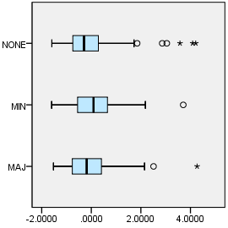

EXAMINE VARIABLES=z1_tt_edprm BY COVERAGE_TYPE
/PLOT=BOXPLOT
/STATISTICS=NONE
/NOTOTAL.

Explore

Notes
Output Created |  | 03-APR-2018 18:50:05
Comments
Input | Data | F:\Data_Final\3cases_traveltime_indec.sav
Input | Active Dataset | DataSet1
Input | Filter | <none>
Input | Weight | <none>
Input | Split File | <none>
Input | N of Rows in Working Data File | 284
Missing Value Handling | Definition of Missing | User-defined missing values for dependent variables are treated as missing.
Missing Value Handling | Cases Used | Statistics are based on cases with no missing values for any dependent variable or factor used.
Syntax |  | EXAMINE VARIABLES=z1_tt_edprm BY COVERAGE_TYPE  /PLOT=BOXPLOT  /STATISTICS=NONE  /NOTOTAL.
Resources | Processor Time | 00:00:00.23
Resources | Elapsed Time | 00:00:00.22

Overlap with asentamiento, degree

Case Processing Summary
 | Overlap with asentamiento, degree | Cases
 | Overlap with asentamiento, degree | Valid |  | Missing
 | Overlap with asentamiento, degree | N | Percent | N | Percent
Public primary school, scaled local | MAJ | 52 | 100.0% | 0 | 0.0%
Public primary school, scaled local | MIN | 90 | 100.0% | 0 | 0.0%
Public primary school, scaled local | NONE | 142 | 100.0% | 0 | 0.0%

Case Processing Summary
 | Overlap with asentamiento, degree | Cases
 | Overlap with asentamiento, degree | Total
 | Overlap with asentamiento, degree | N | Percent
Public primary school, scaled local | MAJ | 52 | 100.0%
Public primary school, scaled local | MIN | 90 | 100.0%
Public primary school, scaled local | NONE | 142 | 100.0%

Public primary school, scaled local

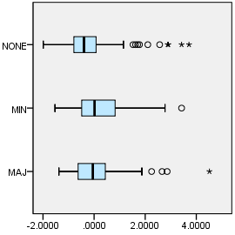

EXAMINE VARIABLES=z1_tt_cbdbsas BY ASENTANY_YN
/PLOT=BOXPLOT
/STATISTICS=NONE
/NOTOTAL.

Explore

Notes
Output Created |  | 03-APR-2018 18:50:19
Comments
Input | Data | F:\Data_Final\3cases_traveltime_indec.sav
Input | Active Dataset | DataSet1
Input | Filter | <none>
Input | Weight | <none>
Input | Split File | <none>
Input | N of Rows in Working Data File | 284
Missing Value Handling | Definition of Missing | User-defined missing values for dependent variables are treated as missing.
Missing Value Handling | Cases Used | Statistics are based on cases with no missing values for any dependent variable or factor used.
Syntax |  | EXAMINE VARIABLES=z1_tt_cbdbsas BY ASENTANY_YN  /PLOT=BOXPLOT  /STATISTICS=NONE  /NOTOTAL.
Resources | Processor Time | 00:00:00.22
Resources | Elapsed Time | 00:00:00.22

Overlap with asentamiento, yes/no

Case Processing Summary
 | Overlap with asentamiento, yes/no | Cases
 | Overlap with asentamiento, yes/no | Valid |  | Missing
 | Overlap with asentamiento, yes/no | N | Percent | N | Percent
Buenos Aires CBD, scaled local | None | 136 | 95.8% | 6 | 4.2%
Buenos Aires CBD, scaled local | Overlap | 134 | 94.4% | 8 | 5.6%

Case Processing Summary
 | Overlap with asentamiento, yes/no | Cases
 | Overlap with asentamiento, yes/no | Total
 | Overlap with asentamiento, yes/no | N | Percent
Buenos Aires CBD, scaled local | None | 142 | 100.0%
Buenos Aires CBD, scaled local | Overlap | 142 | 100.0%

Buenos Aires CBD, scaled local

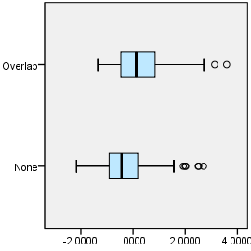

EXAMINE VARIABLES=z1_tt_cbdloc BY ASENTANY_YN
/PLOT=BOXPLOT
/STATISTICS=NONE
/NOTOTAL.

Explore

Notes
Output Created |  | 03-APR-2018 18:50:26
Comments
Input | Data | F:\Data_Final\3cases_traveltime_indec.sav
Input | Active Dataset | DataSet1
Input | Filter | <none>
Input | Weight | <none>
Input | Split File | <none>
Input | N of Rows in Working Data File | 284
Missing Value Handling | Definition of Missing | User-defined missing values for dependent variables are treated as missing.
Missing Value Handling | Cases Used | Statistics are based on cases with no missing values for any dependent variable or factor used.
Syntax |  | EXAMINE VARIABLES=z1_tt_cbdloc BY ASENTANY_YN  /PLOT=BOXPLOT  /STATISTICS=NONE  /NOTOTAL.
Resources | Processor Time | 00:00:00.22
Resources | Elapsed Time | 00:00:00.22

Overlap with asentamiento, yes/no

Case Processing Summary
 | Overlap with asentamiento, yes/no | Cases
 | Overlap with asentamiento, yes/no | Valid |  | Missing
 | Overlap with asentamiento, yes/no | N | Percent | N | Percent
Departmental CBD, scaled local | None | 137 | 96.5% | 5 | 3.5%
Departmental CBD, scaled local | Overlap | 135 | 95.1% | 7 | 4.9%

Case Processing Summary
 | Overlap with asentamiento, yes/no | Cases
 | Overlap with asentamiento, yes/no | Total
 | Overlap with asentamiento, yes/no | N | Percent
Departmental CBD, scaled local | None | 142 | 100.0%
Departmental CBD, scaled local | Overlap | 142 | 100.0%

Departmental CBD, scaled local

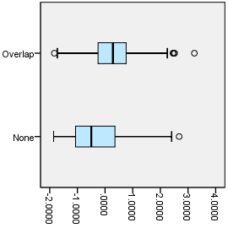

EXAMINE VARIABLES=z1_tt_cbdngh BY ASENTANY_YN
/PLOT=BOXPLOT
/STATISTICS=NONE
/NOTOTAL.

Explore

Notes
Output Created |  | 03-APR-2018 18:50:32
Comments
Input | Data | F:\Data_Final\3cases_traveltime_indec.sav
Input | Active Dataset | DataSet1
Input | Filter | <none>
Input | Weight | <none>
Input | Split File | <none>
Input | N of Rows in Working Data File | 284
Missing Value Handling | Definition of Missing | User-defined missing values for dependent variables are treated as missing.
Missing Value Handling | Cases Used | Statistics are based on cases with no missing values for any dependent variable or factor used.
Syntax |  | EXAMINE VARIABLES=z1_tt_cbdngh BY ASENTANY_YN  /PLOT=BOXPLOT  /STATISTICS=NONE  /NOTOTAL.
Resources | Processor Time | 00:00:00.19
Resources | Elapsed Time | 00:00:00.22

Overlap with asentamiento, yes/no

Case Processing Summary
 | Overlap with asentamiento, yes/no | Cases
 | Overlap with asentamiento, yes/no | Valid |  | Missing
 | Overlap with asentamiento, yes/no | N | Percent | N | Percent
Any departmental CBD, scaled local | None | 137 | 96.5% | 5 | 3.5%
Any departmental CBD, scaled local | Overlap | 135 | 95.1% | 7 | 4.9%

Case Processing Summary
 | Overlap with asentamiento, yes/no | Cases
 | Overlap with asentamiento, yes/no | Total
 | Overlap with asentamiento, yes/no | N | Percent
Any departmental CBD, scaled local | None | 142 | 100.0%
Any departmental CBD, scaled local | Overlap | 142 | 100.0%

Any departmental CBD, scaled local

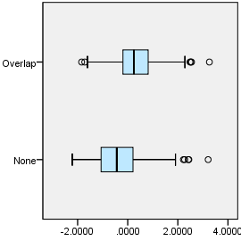

EXAMINE VARIABLES=z1_tt_rail BY ASENTANY_YN
/PLOT=BOXPLOT
/STATISTICS=NONE
/NOTOTAL.

Explore

Notes
Output Created |  | 03-APR-2018 18:50:39
Comments
Input | Data | F:\Data_Final\3cases_traveltime_indec.sav
Input | Active Dataset | DataSet1
Input | Filter | <none>
Input | Weight | <none>
Input | Split File | <none>
Input | N of Rows in Working Data File | 284
Missing Value Handling | Definition of Missing | User-defined missing values for dependent variables are treated as missing.
Missing Value Handling | Cases Used | Statistics are based on cases with no missing values for any dependent variable or factor used.
Syntax |  | EXAMINE VARIABLES=z1_tt_rail BY ASENTANY_YN  /PLOT=BOXPLOT  /STATISTICS=NONE  /NOTOTAL.
Resources | Processor Time | 00:00:00.22
Resources | Elapsed Time | 00:00:00.22

Overlap with asentamiento, yes/no

Case Processing Summary
 | Overlap with asentamiento, yes/no | Cases
 | Overlap with asentamiento, yes/no | Valid |  | Missing
 | Overlap with asentamiento, yes/no | N | Percent | N | Percent
Railway station, scaled local | None | 136 | 95.8% | 6 | 4.2%
Railway station, scaled local | Overlap | 136 | 95.8% | 6 | 4.2%

Case Processing Summary
 | Overlap with asentamiento, yes/no | Cases
 | Overlap with asentamiento, yes/no | Total
 | Overlap with asentamiento, yes/no | N | Percent
Railway station, scaled local | None | 142 | 100.0%
Railway station, scaled local | Overlap | 142 | 100.0%

Railway station, scaled local

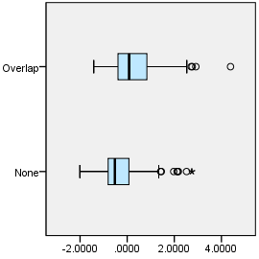

EXAMINE VARIABLES=z1_tt_upa BY ASENTANY_YN
/PLOT=BOXPLOT
/STATISTICS=NONE
/NOTOTAL.

Explore

Notes
Output Created |  | 03-APR-2018 18:50:46
Comments
Input | Data | F:\Data_Final\3cases_traveltime_indec.sav
Input | Active Dataset | DataSet1
Input | Filter | <none>
Input | Weight | <none>
Input | Split File | <none>
Input | N of Rows in Working Data File | 284
Missing Value Handling | Definition of Missing | User-defined missing values for dependent variables are treated as missing.
Missing Value Handling | Cases Used | Statistics are based on cases with no missing values for any dependent variable or factor used.
Syntax |  | EXAMINE VARIABLES=z1_tt_upa BY ASENTANY_YN  /PLOT=BOXPLOT  /STATISTICS=NONE  /NOTOTAL.
Resources | Processor Time | 00:00:00.23
Resources | Elapsed Time | 00:00:00.22

Overlap with asentamiento, yes/no

Case Processing Summary
 | Overlap with asentamiento, yes/no | Cases
 | Overlap with asentamiento, yes/no | Valid |  | Missing
 | Overlap with asentamiento, yes/no | N | Percent | N | Percent
Public UPA, scaled local | None | 136 | 95.8% | 6 | 4.2%
Public UPA, scaled local | Overlap | 134 | 94.4% | 8 | 5.6%

Case Processing Summary
 | Overlap with asentamiento, yes/no | Cases
 | Overlap with asentamiento, yes/no | Total
 | Overlap with asentamiento, yes/no | N | Percent
Public UPA, scaled local | None | 142 | 100.0%
Public UPA, scaled local | Overlap | 142 | 100.0%

Public UPA, scaled local

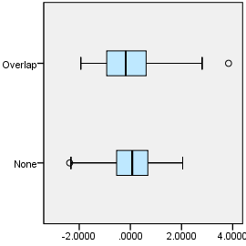

EXAMINE VARIABLES=z1_tt_hspt BY ASENTANY_YN
/PLOT=BOXPLOT
/STATISTICS=NONE
/NOTOTAL.

Explore

Notes
Output Created |  | 03-APR-2018 18:50:53
Comments
Input | Data | F:\Data_Final\3cases_traveltime_indec.sav
Input | Active Dataset | DataSet1
Input | Filter | <none>
Input | Weight | <none>
Input | Split File | <none>
Input | N of Rows in Working Data File | 284
Missing Value Handling | Definition of Missing | User-defined missing values for dependent variables are treated as missing.
Missing Value Handling | Cases Used | Statistics are based on cases with no missing values for any dependent variable or factor used.
Syntax |  | EXAMINE VARIABLES=z1_tt_hspt BY ASENTANY_YN  /PLOT=BOXPLOT  /STATISTICS=NONE  /NOTOTAL.
Resources | Processor Time | 00:00:00.23
Resources | Elapsed Time | 00:00:00.23

Overlap with asentamiento, yes/no

Case Processing Summary
 | Overlap with asentamiento, yes/no | Cases
 | Overlap with asentamiento, yes/no | Valid |  | Missing
 | Overlap with asentamiento, yes/no | N | Percent | N | Percent
Public hospital, scaled local | None | 137 | 96.5% | 5 | 3.5%
Public hospital, scaled local | Overlap | 135 | 95.1% | 7 | 4.9%

Case Processing Summary
 | Overlap with asentamiento, yes/no | Cases
 | Overlap with asentamiento, yes/no | Total
 | Overlap with asentamiento, yes/no | N | Percent
Public hospital, scaled local | None | 142 | 100.0%
Public hospital, scaled local | Overlap | 142 | 100.0%

Public hospital, scaled local

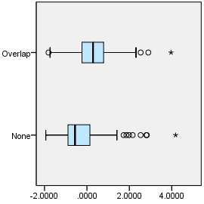

EXAMINE VARIABLES=z1_tt_dgntrt BY ASENTANY_YN
/PLOT=BOXPLOT
/STATISTICS=NONE
/NOTOTAL.

Explore

Notes
Output Created |  | 03-APR-2018 18:51:00
Comments
Input | Data | F:\Data_Final\3cases_traveltime_indec.sav
Input | Active Dataset | DataSet1
Input | Filter | <none>
Input | Weight | <none>
Input | Split File | <none>
Input | N of Rows in Working Data File | 284
Missing Value Handling | Definition of Missing | User-defined missing values for dependent variables are treated as missing.
Missing Value Handling | Cases Used | Statistics are based on cases with no missing values for any dependent variable or factor used.
Syntax |  | EXAMINE VARIABLES=z1_tt_dgntrt BY ASENTANY_YN  /PLOT=BOXPLOT  /STATISTICS=NONE  /NOTOTAL.
Resources | Processor Time | 00:00:00.22
Resources | Elapsed Time | 00:00:00.22

Overlap with asentamiento, yes/no

Case Processing Summary
 | Overlap with asentamiento, yes/no | Cases
 | Overlap with asentamiento, yes/no | Valid |  | Missing
 | Overlap with asentamiento, yes/no | N | Percent | N | Percent
Public diag./treat. center, scaled local | None | 140 | 98.6% | 2 | 1.4%
Public diag./treat. center, scaled local | Overlap | 142 | 100.0% | 0 | 0.0%

Case Processing Summary
 | Overlap with asentamiento, yes/no | Cases
 | Overlap with asentamiento, yes/no | Total
 | Overlap with asentamiento, yes/no | N | Percent
Public diag./treat. center, scaled local | None | 142 | 100.0%
Public diag./treat. center, scaled local | Overlap | 142 | 100.0%

Public diag./treat. center, scaled local

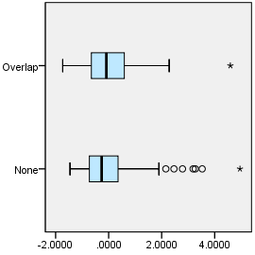

EXAMINE VARIABLES=z1_tt_edsec BY ASENTANY_YN
/PLOT=BOXPLOT
/STATISTICS=NONE
/NOTOTAL.

Explore

Notes
Output Created |  | 03-APR-2018 18:51:13
Comments
Input | Data | F:\Data_Final\3cases_traveltime_indec.sav
Input | Active Dataset | DataSet1
Input | Filter | <none>
Input | Weight | <none>
Input | Split File | <none>
Input | N of Rows in Working Data File | 284
Missing Value Handling | Definition of Missing | User-defined missing values for dependent variables are treated as missing.
Missing Value Handling | Cases Used | Statistics are based on cases with no missing values for any dependent variable or factor used.
Syntax |  | EXAMINE VARIABLES=z1_tt_edsec BY ASENTANY_YN  /PLOT=BOXPLOT  /STATISTICS=NONE  /NOTOTAL.
Resources | Processor Time | 00:00:00.22
Resources | Elapsed Time | 00:00:00.22

Overlap with asentamiento, yes/no

Case Processing Summary
 | Overlap with asentamiento, yes/no | Cases
 | Overlap with asentamiento, yes/no | Valid |  | Missing
 | Overlap with asentamiento, yes/no | N | Percent | N | Percent
Public secondary school, scaled local | None | 142 | 100.0% | 0 | 0.0%
Public secondary school, scaled local | Overlap | 142 | 100.0% | 0 | 0.0%

Case Processing Summary
 | Overlap with asentamiento, yes/no | Cases
 | Overlap with asentamiento, yes/no | Total
 | Overlap with asentamiento, yes/no | N | Percent
Public secondary school, scaled local | None | 142 | 100.0%
Public secondary school, scaled local | Overlap | 142 | 100.0%

Public secondary school, scaled local

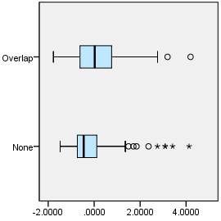

EXAMINE VARIABLES=z1_tt_edknd BY ASENTANY_YN
/PLOT=BOXPLOT
/STATISTICS=NONE
/NOTOTAL.

Explore

Notes
Output Created |  | 03-APR-2018 18:51:20
Comments
Input | Data | F:\Data_Final\3cases_traveltime_indec.sav
Input | Active Dataset | DataSet1
Input | Filter | <none>
Input | Weight | <none>
Input | Split File | <none>
Input | N of Rows in Working Data File | 284
Missing Value Handling | Definition of Missing | User-defined missing values for dependent variables are treated as missing.
Missing Value Handling | Cases Used | Statistics are based on cases with no missing values for any dependent variable or factor used.
Syntax |  | EXAMINE VARIABLES=z1_tt_edknd BY ASENTANY_YN  /PLOT=BOXPLOT  /STATISTICS=NONE  /NOTOTAL.
Resources | Processor Time | 00:00:00.22
Resources | Elapsed Time | 00:00:00.22

Overlap with asentamiento, yes/no

Case Processing Summary
 | Overlap with asentamiento, yes/no | Cases
 | Overlap with asentamiento, yes/no | Valid |  | Missing
 | Overlap with asentamiento, yes/no | N | Percent | N | Percent
Public kindergarten, scaled local | None | 142 | 100.0% | 0 | 0.0%
Public kindergarten, scaled local | Overlap | 142 | 100.0% | 0 | 0.0%

Case Processing Summary
 | Overlap with asentamiento, yes/no | Cases
 | Overlap with asentamiento, yes/no | Total
 | Overlap with asentamiento, yes/no | N | Percent
Public kindergarten, scaled local | None | 142 | 100.0%
Public kindergarten, scaled local | Overlap | 142 | 100.0%

Public kindergarten, scaled local

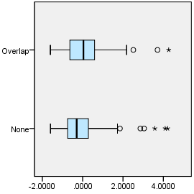

EXAMINE VARIABLES=z1_tt_edprm BY ASENTANY_YN
/PLOT=BOXPLOT
/STATISTICS=NONE
/NOTOTAL.

Explore

Notes
Output Created |  | 03-APR-2018 18:51:28
Comments
Input | Data | F:\Data_Final\3cases_traveltime_indec.sav
Input | Active Dataset | DataSet1
Input | Filter | <none>
Input | Weight | <none>
Input | Split File | <none>
Input | N of Rows in Working Data File | 284
Missing Value Handling | Definition of Missing | User-defined missing values for dependent variables are treated as missing.
Missing Value Handling | Cases Used | Statistics are based on cases with no missing values for any dependent variable or factor used.
Syntax |  | EXAMINE VARIABLES=z1_tt_edprm BY ASENTANY_YN  /PLOT=BOXPLOT  /STATISTICS=NONE  /NOTOTAL.
Resources | Processor Time | 00:00:00.20
Resources | Elapsed Time | 00:00:00.22

Overlap with asentamiento, yes/no

Case Processing Summary
 | Overlap with asentamiento, yes/no | Cases
 | Overlap with asentamiento, yes/no | Valid |  | Missing
 | Overlap with asentamiento, yes/no | N | Percent | N | Percent
Public primary school, scaled local | None | 142 | 100.0% | 0 | 0.0%
Public primary school, scaled local | Overlap | 142 | 100.0% | 0 | 0.0%

Case Processing Summary
 | Overlap with asentamiento, yes/no | Cases
 | Overlap with asentamiento, yes/no | Total
 | Overlap with asentamiento, yes/no | N | Percent
Public primary school, scaled local | None | 142 | 100.0%
Public primary school, scaled local | Overlap | 142 | 100.0%

Public primary school, scaled local

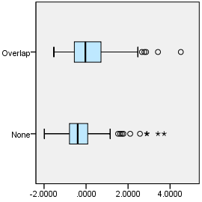

EXAMINE VARIABLES=trvtime_index1_all10 BY ASENTANY_YN
/PLOT=BOXPLOT
/STATISTICS=NONE
/NOTOTAL.

Explore

Notes
Output Created |  | 03-APR-2018 18:51:35
Comments
Input | Data | F:\Data_Final\3cases_traveltime_indec.sav
Input | Active Dataset | DataSet1
Input | Filter | <none>
Input | Weight | <none>
Input | Split File | <none>
Input | N of Rows in Working Data File | 284
Missing Value Handling | Definition of Missing | User-defined missing values for dependent variables are treated as missing.
Missing Value Handling | Cases Used | Statistics are based on cases with no missing values for any dependent variable or factor used.
Syntax |  | EXAMINE VARIABLES=trvtime_index1_all10 BY ASENTANY_YN  /PLOT=BOXPLOT  /STATISTICS=NONE  /NOTOTAL.
Resources | Processor Time | 00:00:00.20
Resources | Elapsed Time | 00:00:00.22

Overlap with asentamiento, yes/no

Case Processing Summary
 | Overlap with asentamiento, yes/no | Cases
 | Overlap with asentamiento, yes/no | Valid |  | Missing
 | Overlap with asentamiento, yes/no | N | Percent | N | Percent
Index of locally-scaled travel times, all 10 variables | None | 142 | 100.0% | 0 | 0.0%
Index of locally-scaled travel times, all 10 variables | Overlap | 142 | 100.0% | 0 | 0.0%

Case Processing Summary
 | Overlap with asentamiento, yes/no | Cases
 | Overlap with asentamiento, yes/no | Total
 | Overlap with asentamiento, yes/no | N | Percent
Index of locally-scaled travel times, all 10 variables | None | 142 | 100.0%
Index of locally-scaled travel times, all 10 variables | Overlap | 142 | 100.0%

Index of locally-scaled travel times, all 10 variables

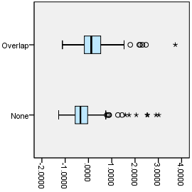

EXAMINE VARIABLES=z1_tt_cbdbsas BY ASENT_MAJ_YN
/PLOT=BOXPLOT
/STATISTICS=NONE
/NOTOTAL.

Explore

Notes
Output Created |  | 03-APR-2018 18:51:44
Comments
Input | Data | F:\Data_Final\3cases_traveltime_indec.sav
Input | Active Dataset | DataSet1
Input | Filter | <none>
Input | Weight | <none>
Input | Split File | <none>
Input | N of Rows in Working Data File | 284
Missing Value Handling | Definition of Missing | User-defined missing values for dependent variables are treated as missing.
Missing Value Handling | Cases Used | Statistics are based on cases with no missing values for any dependent variable or factor used.
Syntax |  | EXAMINE VARIABLES=z1_tt_cbdbsas BY ASENT_MAJ_YN  /PLOT=BOXPLOT  /STATISTICS=NONE  /NOTOTAL.
Resources | Processor Time | 00:00:00.22
Resources | Elapsed Time | 00:00:00.22

Majority overlap with asentamiento, yes/no

Case Processing Summary
 | Majority overlap with asentamiento, yes/no | Cases
 | Majority overlap with asentamiento, yes/no | Valid |  | Missing
 | Majority overlap with asentamiento, yes/no | N | Percent | N | Percent
Buenos Aires CBD, scaled local | Minority/None | 220 | 94.8% | 12 | 5.2%
Buenos Aires CBD, scaled local | Majority | 50 | 96.2% | 2 | 3.8%

Case Processing Summary
 | Majority overlap with asentamiento, yes/no | Cases
 | Majority overlap with asentamiento, yes/no | Total
 | Majority overlap with asentamiento, yes/no | N | Percent
Buenos Aires CBD, scaled local | Minority/None | 232 | 100.0%
Buenos Aires CBD, scaled local | Majority | 52 | 100.0%

Buenos Aires CBD, scaled local

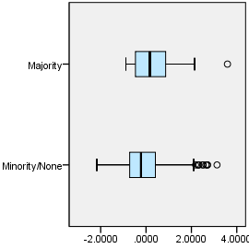

EXAMINE VARIABLES=z1_tt_cbdloc BY ASENT_MAJ_YN
/PLOT=BOXPLOT
/STATISTICS=NONE
/NOTOTAL.

Explore

Notes
Output Created |  | 03-APR-2018 18:51:51
Comments
Input | Data | F:\Data_Final\3cases_traveltime_indec.sav
Input | Active Dataset | DataSet1
Input | Filter | <none>
Input | Weight | <none>
Input | Split File | <none>
Input | N of Rows in Working Data File | 284
Missing Value Handling | Definition of Missing | User-defined missing values for dependent variables are treated as missing.
Missing Value Handling | Cases Used | Statistics are based on cases with no missing values for any dependent variable or factor used.
Syntax |  | EXAMINE VARIABLES=z1_tt_cbdloc BY ASENT_MAJ_YN  /PLOT=BOXPLOT  /STATISTICS=NONE  /NOTOTAL.
Resources | Processor Time | 00:00:00.20
Resources | Elapsed Time | 00:00:00.22

Majority overlap with asentamiento, yes/no

Case Processing Summary
 | Majority overlap with asentamiento, yes/no | Cases
 | Majority overlap with asentamiento, yes/no | Valid |  | Missing
 | Majority overlap with asentamiento, yes/no | N | Percent | N | Percent
Departmental CBD, scaled local | Minority/None | 222 | 95.7% | 10 | 4.3%
Departmental CBD, scaled local | Majority | 50 | 96.2% | 2 | 3.8%

Case Processing Summary
 | Majority overlap with asentamiento, yes/no | Cases
 | Majority overlap with asentamiento, yes/no | Total
 | Majority overlap with asentamiento, yes/no | N | Percent
Departmental CBD, scaled local | Minority/None | 232 | 100.0%
Departmental CBD, scaled local | Majority | 52 | 100.0%

Departmental CBD, scaled local

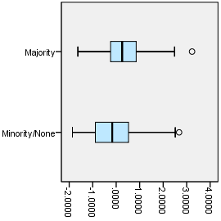

EXAMINE VARIABLES=z1_tt_cbdngh BY ASENT_MAJ_YN
/PLOT=BOXPLOT
/STATISTICS=NONE
/NOTOTAL.

Explore

Notes
Output Created |  | 03-APR-2018 18:51:57
Comments
Input | Data | F:\Data_Final\3cases_traveltime_indec.sav
Input | Active Dataset | DataSet1
Input | Filter | <none>
Input | Weight | <none>
Input | Split File | <none>
Input | N of Rows in Working Data File | 284
Missing Value Handling | Definition of Missing | User-defined missing values for dependent variables are treated as missing.
Missing Value Handling | Cases Used | Statistics are based on cases with no missing values for any dependent variable or factor used.
Syntax |  | EXAMINE VARIABLES=z1_tt_cbdngh BY ASENT_MAJ_YN  /PLOT=BOXPLOT  /STATISTICS=NONE  /NOTOTAL.
Resources | Processor Time | 00:00:00.23
Resources | Elapsed Time | 00:00:00.22

Majority overlap with asentamiento, yes/no

Case Processing Summary
 | Majority overlap with asentamiento, yes/no | Cases
 | Majority overlap with asentamiento, yes/no | Valid |  | Missing
 | Majority overlap with asentamiento, yes/no | N | Percent | N | Percent
Any departmental CBD, scaled local | Minority/None | 222 | 95.7% | 10 | 4.3%
Any departmental CBD, scaled local | Majority | 50 | 96.2% | 2 | 3.8%

Case Processing Summary
 | Majority overlap with asentamiento, yes/no | Cases
 | Majority overlap with asentamiento, yes/no | Total
 | Majority overlap with asentamiento, yes/no | N | Percent
Any departmental CBD, scaled local | Minority/None | 232 | 100.0%
Any departmental CBD, scaled local | Majority | 52 | 100.0%

Any departmental CBD, scaled local

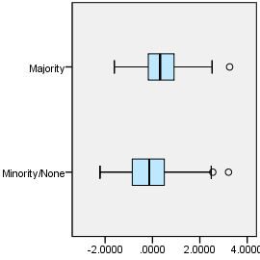

EXAMINE VARIABLES=z1_tt_rail BY ASENT_MAJ_YN
/PLOT=BOXPLOT
/STATISTICS=NONE
/NOTOTAL.

Explore

Notes
Output Created |  | 03-APR-2018 18:52:05
Comments
Input | Data | F:\Data_Final\3cases_traveltime_indec.sav
Input | Active Dataset | DataSet1
Input | Filter | <none>
Input | Weight | <none>
Input | Split File | <none>
Input | N of Rows in Working Data File | 284
Missing Value Handling | Definition of Missing | User-defined missing values for dependent variables are treated as missing.
Missing Value Handling | Cases Used | Statistics are based on cases with no missing values for any dependent variable or factor used.
Syntax |  | EXAMINE VARIABLES=z1_tt_rail BY ASENT_MAJ_YN  /PLOT=BOXPLOT  /STATISTICS=NONE  /NOTOTAL.
Resources | Processor Time | 00:00:00.22
Resources | Elapsed Time | 00:00:00.22

Majority overlap with asentamiento, yes/no

Case Processing Summary
 | Majority overlap with asentamiento, yes/no | Cases
 | Majority overlap with asentamiento, yes/no | Valid |  | Missing
 | Majority overlap with asentamiento, yes/no | N | Percent | N | Percent
Railway station, scaled local | Minority/None | 222 | 95.7% | 10 | 4.3%
Railway station, scaled local | Majority | 50 | 96.2% | 2 | 3.8%

Case Processing Summary
 | Majority overlap with asentamiento, yes/no | Cases
 | Majority overlap with asentamiento, yes/no | Total
 | Majority overlap with asentamiento, yes/no | N | Percent
Railway station, scaled local | Minority/None | 232 | 100.0%
Railway station, scaled local | Majority | 52 | 100.0%

Railway station, scaled local

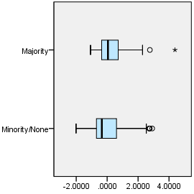

EXAMINE VARIABLES=z1_tt_upa BY ASENT_MAJ_YN
/PLOT=BOXPLOT
/STATISTICS=NONE
/NOTOTAL.

Explore

Notes
Output Created |  | 03-APR-2018 18:52:11
Comments
Input | Data | F:\Data_Final\3cases_traveltime_indec.sav
Input | Active Dataset | DataSet1
Input | Filter | <none>
Input | Weight | <none>
Input | Split File | <none>
Input | N of Rows in Working Data File | 284
Missing Value Handling | Definition of Missing | User-defined missing values for dependent variables are treated as missing.
Missing Value Handling | Cases Used | Statistics are based on cases with no missing values for any dependent variable or factor used.
Syntax |  | EXAMINE VARIABLES=z1_tt_upa BY ASENT_MAJ_YN  /PLOT=BOXPLOT  /STATISTICS=NONE  /NOTOTAL.
Resources | Processor Time | 00:00:00.22
Resources | Elapsed Time | 00:00:00.22

Majority overlap with asentamiento, yes/no

Case Processing Summary
 | Majority overlap with asentamiento, yes/no | Cases
 | Majority overlap with asentamiento, yes/no | Valid |  | Missing
 | Majority overlap with asentamiento, yes/no | N | Percent | N | Percent
Public UPA, scaled local | Minority/None | 220 | 94.8% | 12 | 5.2%
Public UPA, scaled local | Majority | 50 | 96.2% | 2 | 3.8%

Case Processing Summary
 | Majority overlap with asentamiento, yes/no | Cases
 | Majority overlap with asentamiento, yes/no | Total
 | Majority overlap with asentamiento, yes/no | N | Percent
Public UPA, scaled local | Minority/None | 232 | 100.0%
Public UPA, scaled local | Majority | 52 | 100.0%

Public UPA, scaled local

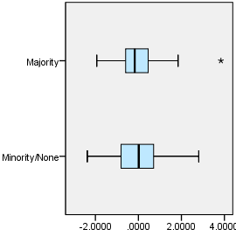

EXAMINE VARIABLES=z1_tt_hspt BY ASENT_MAJ_YN
/PLOT=BOXPLOT
/STATISTICS=NONE
/NOTOTAL.

Explore

Notes
Output Created |  | 03-APR-2018 18:52:17
Comments
Input | Data | F:\Data_Final\3cases_traveltime_indec.sav
Input | Active Dataset | DataSet1
Input | Filter | <none>
Input | Weight | <none>
Input | Split File | <none>
Input | N of Rows in Working Data File | 284
Missing Value Handling | Definition of Missing | User-defined missing values for dependent variables are treated as missing.
Missing Value Handling | Cases Used | Statistics are based on cases with no missing values for any dependent variable or factor used.
Syntax |  | EXAMINE VARIABLES=z1_tt_hspt BY ASENT_MAJ_YN  /PLOT=BOXPLOT  /STATISTICS=NONE  /NOTOTAL.
Resources | Processor Time | 00:00:00.23
Resources | Elapsed Time | 00:00:00.22

Majority overlap with asentamiento, yes/no

Case Processing Summary
 | Majority overlap with asentamiento, yes/no | Cases
 | Majority overlap with asentamiento, yes/no | Valid |  | Missing
 | Majority overlap with asentamiento, yes/no | N | Percent | N | Percent
Public hospital, scaled local | Minority/None | 222 | 95.7% | 10 | 4.3%
Public hospital, scaled local | Majority | 50 | 96.2% | 2 | 3.8%

Case Processing Summary
 | Majority overlap with asentamiento, yes/no | Cases
 | Majority overlap with asentamiento, yes/no | Total
 | Majority overlap with asentamiento, yes/no | N | Percent
Public hospital, scaled local | Minority/None | 232 | 100.0%
Public hospital, scaled local | Majority | 52 | 100.0%

Public hospital, scaled local

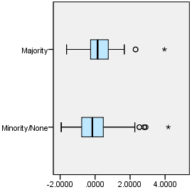

EXAMINE VARIABLES=z1_tt_dgntrt BY ASENT_MAJ_YN
/PLOT=BOXPLOT
/STATISTICS=NONE
/NOTOTAL.

Explore

Notes
Output Created |  | 03-APR-2018 18:52:24
Comments
Input | Data | F:\Data_Final\3cases_traveltime_indec.sav
Input | Active Dataset | DataSet1
Input | Filter | <none>
Input | Weight | <none>
Input | Split File | <none>
Input | N of Rows in Working Data File | 284
Missing Value Handling | Definition of Missing | User-defined missing values for dependent variables are treated as missing.
Missing Value Handling | Cases Used | Statistics are based on cases with no missing values for any dependent variable or factor used.
Syntax |  | EXAMINE VARIABLES=z1_tt_dgntrt BY ASENT_MAJ_YN  /PLOT=BOXPLOT  /STATISTICS=NONE  /NOTOTAL.
Resources | Processor Time | 00:00:00.23
Resources | Elapsed Time | 00:00:00.22

Majority overlap with asentamiento, yes/no

Case Processing Summary
 | Majority overlap with asentamiento, yes/no | Cases
 | Majority overlap with asentamiento, yes/no | Valid |  | Missing
 | Majority overlap with asentamiento, yes/no | N | Percent | N | Percent
Public diag./treat. center, scaled local | Minority/None | 230 | 99.1% | 2 | 0.9%
Public diag./treat. center, scaled local | Majority | 52 | 100.0% | 0 | 0.0%

Case Processing Summary
 | Majority overlap with asentamiento, yes/no | Cases
 | Majority overlap with asentamiento, yes/no | Total
 | Majority overlap with asentamiento, yes/no | N | Percent
Public diag./treat. center, scaled local | Minority/None | 232 | 100.0%
Public diag./treat. center, scaled local | Majority | 52 | 100.0%

Public diag./treat. center, scaled local

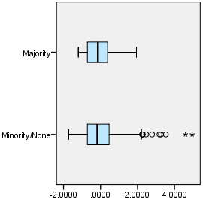

EXAMINE VARIABLES=z1_tt_edsec BY ASENT_MAJ_YN
/PLOT=BOXPLOT
/STATISTICS=NONE
/NOTOTAL.

Explore

Notes
Output Created |  | 03-APR-2018 18:52:30
Comments
Input | Data | F:\Data_Final\3cases_traveltime_indec.sav
Input | Active Dataset | DataSet1
Input | Filter | <none>
Input | Weight | <none>
Input | Split File | <none>
Input | N of Rows in Working Data File | 284
Missing Value Handling | Definition of Missing | User-defined missing values for dependent variables are treated as missing.
Missing Value Handling | Cases Used | Statistics are based on cases with no missing values for any dependent variable or factor used.
Syntax |  | EXAMINE VARIABLES=z1_tt_edsec BY ASENT_MAJ_YN  /PLOT=BOXPLOT  /STATISTICS=NONE  /NOTOTAL.
Resources | Processor Time | 00:00:00.23
Resources | Elapsed Time | 00:00:00.23

Majority overlap with asentamiento, yes/no

Case Processing Summary
 | Majority overlap with asentamiento, yes/no | Cases
 | Majority overlap with asentamiento, yes/no | Valid |  | Missing
 | Majority overlap with asentamiento, yes/no | N | Percent | N | Percent
Public secondary school, scaled local | Minority/None | 232 | 100.0% | 0 | 0.0%
Public secondary school, scaled local | Majority | 52 | 100.0% | 0 | 0.0%

Case Processing Summary
 | Majority overlap with asentamiento, yes/no | Cases
 | Majority overlap with asentamiento, yes/no | Total
 | Majority overlap with asentamiento, yes/no | N | Percent
Public secondary school, scaled local | Minority/None | 232 | 100.0%
Public secondary school, scaled local | Majority | 52 | 100.0%

Public secondary school, scaled local

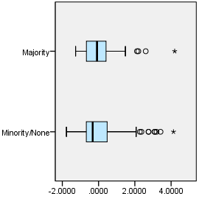

EXAMINE VARIABLES=z1_tt_edknd BY ASENT_MAJ_YN
/PLOT=BOXPLOT
/STATISTICS=NONE
/NOTOTAL.

Explore

Notes
Output Created |  | 03-APR-2018 18:52:36
Comments
Input | Data | F:\Data_Final\3cases_traveltime_indec.sav
Input | Active Dataset | DataSet1
Input | Filter | <none>
Input | Weight | <none>
Input | Split File | <none>
Input | N of Rows in Working Data File | 284
Missing Value Handling | Definition of Missing | User-defined missing values for dependent variables are treated as missing.
Missing Value Handling | Cases Used | Statistics are based on cases with no missing values for any dependent variable or factor used.
Syntax |  | EXAMINE VARIABLES=z1_tt_edknd BY ASENT_MAJ_YN  /PLOT=BOXPLOT  /STATISTICS=NONE  /NOTOTAL.
Resources | Processor Time | 00:00:00.23
Resources | Elapsed Time | 00:00:00.23

Majority overlap with asentamiento, yes/no

Case Processing Summary
 | Majority overlap with asentamiento, yes/no | Cases
 | Majority overlap with asentamiento, yes/no | Valid |  | Missing
 | Majority overlap with asentamiento, yes/no | N | Percent | N | Percent
Public kindergarten, scaled local | Minority/None | 232 | 100.0% | 0 | 0.0%
Public kindergarten, scaled local | Majority | 52 | 100.0% | 0 | 0.0%

Case Processing Summary
 | Majority overlap with asentamiento, yes/no | Cases
 | Majority overlap with asentamiento, yes/no | Total
 | Majority overlap with asentamiento, yes/no | N | Percent
Public kindergarten, scaled local | Minority/None | 232 | 100.0%
Public kindergarten, scaled local | Majority | 52 | 100.0%

Public kindergarten, scaled local

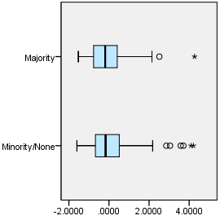

EXAMINE VARIABLES=z1_tt_edprm BY ASENT_MAJ_YN
/PLOT=BOXPLOT
/STATISTICS=NONE
/NOTOTAL.

Explore

Notes
Output Created |  | 03-APR-2018 18:52:43
Comments
Input | Data | F:\Data_Final\3cases_traveltime_indec.sav
Input | Active Dataset | DataSet1
Input | Filter | <none>
Input | Weight | <none>
Input | Split File | <none>
Input | N of Rows in Working Data File | 284
Missing Value Handling | Definition of Missing | User-defined missing values for dependent variables are treated as missing.
Missing Value Handling | Cases Used | Statistics are based on cases with no missing values for any dependent variable or factor used.
Syntax |  | EXAMINE VARIABLES=z1_tt_edprm BY ASENT_MAJ_YN  /PLOT=BOXPLOT  /STATISTICS=NONE  /NOTOTAL.
Resources | Processor Time | 00:00:00.23
Resources | Elapsed Time | 00:00:00.22

Majority overlap with asentamiento, yes/no

Case Processing Summary
 | Majority overlap with asentamiento, yes/no | Cases
 | Majority overlap with asentamiento, yes/no | Valid |  | Missing
 | Majority overlap with asentamiento, yes/no | N | Percent | N | Percent
Public primary school, scaled local | Minority/None | 232 | 100.0% | 0 | 0.0%
Public primary school, scaled local | Majority | 52 | 100.0% | 0 | 0.0%

Case Processing Summary
 | Majority overlap with asentamiento, yes/no | Cases
 | Majority overlap with asentamiento, yes/no | Total
 | Majority overlap with asentamiento, yes/no | N | Percent
Public primary school, scaled local | Minority/None | 232 | 100.0%
Public primary school, scaled local | Majority | 52 | 100.0%

Public primary school, scaled local

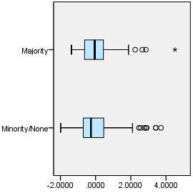

EXAMINE VARIABLES=trvtime_index1_all10 BY ASENT_MAJ_YN
/PLOT=BOXPLOT
/STATISTICS=NONE
/NOTOTAL.

Explore

Notes
Output Created |  | 03-APR-2018 18:53:04
Comments
Input | Data | F:\Data_Final\3cases_traveltime_indec.sav
Input | Active Dataset | DataSet1
Input | Filter | <none>
Input | Weight | <none>
Input | Split File | <none>
Input | N of Rows in Working Data File | 284
Missing Value Handling | Definition of Missing | User-defined missing values for dependent variables are treated as missing.
Missing Value Handling | Cases Used | Statistics are based on cases with no missing values for any dependent variable or factor used.
Syntax |  | EXAMINE VARIABLES=trvtime_index1_all10 BY ASENT_MAJ_YN  /PLOT=BOXPLOT  /STATISTICS=NONE  /NOTOTAL.
Resources | Processor Time | 00:00:00.22
Resources | Elapsed Time | 00:00:00.22

Majority overlap with asentamiento, yes/no

Case Processing Summary
 | Majority overlap with asentamiento, yes/no | Cases
 | Majority overlap with asentamiento, yes/no | Valid |  | Missing
 | Majority overlap with asentamiento, yes/no | N | Percent | N | Percent
Index of locally-scaled travel times, all 10 variables | Minority/None | 232 | 100.0% | 0 | 0.0%
Index of locally-scaled travel times, all 10 variables | Majority | 52 | 100.0% | 0 | 0.0%

Case Processing Summary
 | Majority overlap with asentamiento, yes/no | Cases
 | Majority overlap with asentamiento, yes/no | Total
 | Majority overlap with asentamiento, yes/no | N | Percent
Index of locally-scaled travel times, all 10 variables | Minority/None | 232 | 100.0%
Index of locally-scaled travel times, all 10 variables | Majority | 52 | 100.0%

Index of locally-scaled travel times, all 10 variables

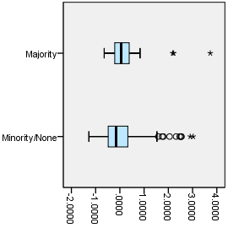

OUTPUT MODIFY
/REPORT PRINTREPORT=NO
/SELECT CHARTS
/DELETEOBJECT DELETE=NO
/OBJECTPROPERTIES VISIBLE=ASIS SIZE=INCHES(2.8,2.8)
/GRAPHS CTEMPLATE="F:\Histogram_Z.sgt".

