SPLIT FILE OFF.
EXAMINE VARIABLES=trvtime_cbd_bsas BY ASENTANY_YN
/PLOT=BOXPLOT
/STATISTICS=NONE
/NOTOTAL.

Explore

Notes
Output Created |  | 03-APR-2018 18:19:26
Comments
Input | Data | F:\Data_Final\3cases_traveltime_indec.sav
Input | Active Dataset | DataSet1
Input | Filter | <none>
Input | Weight | <none>
Input | Split File | <none>
Input | N of Rows in Working Data File | 284
Missing Value Handling | Definition of Missing | User-defined missing values for dependent variables are treated as missing.
Missing Value Handling | Cases Used | Statistics are based on cases with no missing values for any dependent variable or factor used.
Syntax |  | EXAMINE VARIABLES=trvtime_cbd_bsas BY ASENTANY_YN  /PLOT=BOXPLOT  /STATISTICS=NONE  /NOTOTAL.
Resources | Processor Time | 00:00:00.22
Resources | Elapsed Time | 00:00:00.22

Overlap with asentamiento, yes/no

Case Processing Summary
 | Overlap with asentamiento, yes/no | Cases
 | Overlap with asentamiento, yes/no | Valid |  | Missing |  | Total
 | Overlap with asentamiento, yes/no | N | Percent | N | Percent | N
Buenos Aires CBD | None | 136 | 95.8% | 6 | 4.2% | 142
Buenos Aires CBD | Overlap | 134 | 94.4% | 8 | 5.6% | 142

Case Processing Summary
 | Overlap with asentamiento, yes/no | Cases
 | Overlap with asentamiento, yes/no | Total
 | Overlap with asentamiento, yes/no | Percent
Buenos Aires CBD | None | 100.0%
Buenos Aires CBD | Overlap | 100.0%

Buenos Aires CBD

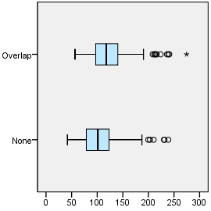

EXAMINE VARIABLES=trvtime_cbd_loc BY ASENTANY_YN
/PLOT=BOXPLOT
/STATISTICS=NONE
/NOTOTAL.

Explore

Notes
Output Created |  | 03-APR-2018 18:20:13
Comments
Input | Data | F:\Data_Final\3cases_traveltime_indec.sav
Input | Active Dataset | DataSet1
Input | Filter | <none>
Input | Weight | <none>
Input | Split File | <none>
Input | N of Rows in Working Data File | 284
Missing Value Handling | Definition of Missing | User-defined missing values for dependent variables are treated as missing.
Missing Value Handling | Cases Used | Statistics are based on cases with no missing values for any dependent variable or factor used.
Syntax |  | EXAMINE VARIABLES=trvtime_cbd_loc BY ASENTANY_YN  /PLOT=BOXPLOT  /STATISTICS=NONE  /NOTOTAL.
Resources | Processor Time | 00:00:00.25
Resources | Elapsed Time | 00:00:00.23

Overlap with asentamiento, yes/no

Case Processing Summary
 | Overlap with asentamiento, yes/no | Cases
 | Overlap with asentamiento, yes/no | Valid |  | Missing |  | Total
 | Overlap with asentamiento, yes/no | N | Percent | N | Percent | N
Departmental CBD | None | 137 | 96.5% | 5 | 3.5% | 142
Departmental CBD | Overlap | 135 | 95.1% | 7 | 4.9% | 142

Case Processing Summary
 | Overlap with asentamiento, yes/no | Cases
 | Overlap with asentamiento, yes/no | Total
 | Overlap with asentamiento, yes/no | Percent
Departmental CBD | None | 100.0%
Departmental CBD | Overlap | 100.0%

Departmental CBD

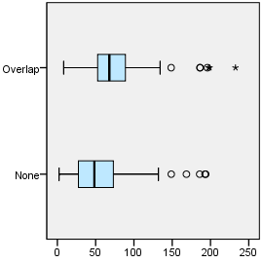

EXAMINE VARIABLES=trvtime_cbd_ngh_min BY ASENTANY_YN
/PLOT=BOXPLOT
/STATISTICS=NONE
/NOTOTAL.

Explore

Notes
Output Created |  | 03-APR-2018 18:20:38
Comments
Input | Data | F:\Data_Final\3cases_traveltime_indec.sav
Input | Active Dataset | DataSet1
Input | Filter | <none>
Input | Weight | <none>
Input | Split File | <none>
Input | N of Rows in Working Data File | 284
Missing Value Handling | Definition of Missing | User-defined missing values for dependent variables are treated as missing.
Missing Value Handling | Cases Used | Statistics are based on cases with no missing values for any dependent variable or factor used.
Syntax |  | EXAMINE VARIABLES=trvtime_cbd_ngh_min BY ASENTANY_YN  /PLOT=BOXPLOT  /STATISTICS=NONE  /NOTOTAL.
Resources | Processor Time | 00:00:00.23
Resources | Elapsed Time | 00:00:00.22

Overlap with asentamiento, yes/no

Case Processing Summary
 | Overlap with asentamiento, yes/no | Cases
 | Overlap with asentamiento, yes/no | Valid |  | Missing
 | Overlap with asentamiento, yes/no | N | Percent | N | Percent
Any departmental CBD | None | 137 | 96.5% | 5 | 3.5%
Any departmental CBD | Overlap | 135 | 95.1% | 7 | 4.9%

Case Processing Summary
 | Overlap with asentamiento, yes/no | Cases
 | Overlap with asentamiento, yes/no | Total
 | Overlap with asentamiento, yes/no | N | Percent
Any departmental CBD | None | 142 | 100.0%
Any departmental CBD | Overlap | 142 | 100.0%

Any departmental CBD

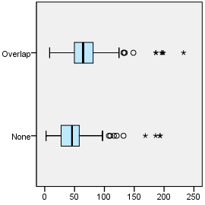

EXAMINE VARIABLES=trvtime_rail_min BY ASENTANY_YN
/PLOT=BOXPLOT
/STATISTICS=NONE
/NOTOTAL.

Explore

Notes
Output Created |  | 03-APR-2018 18:20:49
Comments
Input | Data | F:\Data_Final\3cases_traveltime_indec.sav
Input | Active Dataset | DataSet1
Input | Filter | <none>
Input | Weight | <none>
Input | Split File | <none>
Input | N of Rows in Working Data File | 284
Missing Value Handling | Definition of Missing | User-defined missing values for dependent variables are treated as missing.
Missing Value Handling | Cases Used | Statistics are based on cases with no missing values for any dependent variable or factor used.
Syntax |  | EXAMINE VARIABLES=trvtime_rail_min BY ASENTANY_YN  /PLOT=BOXPLOT  /STATISTICS=NONE  /NOTOTAL.
Resources | Processor Time | 00:00:00.22
Resources | Elapsed Time | 00:00:00.22

Overlap with asentamiento, yes/no

Case Processing Summary
 | Overlap with asentamiento, yes/no | Cases
 | Overlap with asentamiento, yes/no | Valid |  | Missing |  | Total
 | Overlap with asentamiento, yes/no | N | Percent | N | Percent | N
Railway station | None | 136 | 95.8% | 6 | 4.2% | 142
Railway station | Overlap | 136 | 95.8% | 6 | 4.2% | 142

Case Processing Summary
 | Overlap with asentamiento, yes/no | Cases
 | Overlap with asentamiento, yes/no | Total
 | Overlap with asentamiento, yes/no | Percent
Railway station | None | 100.0%
Railway station | Overlap | 100.0%

Railway station

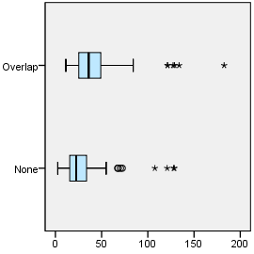

EXAMINE VARIABLES=trvtime_upa_min BY ASENTANY_YN
/PLOT=BOXPLOT
/STATISTICS=NONE
/NOTOTAL.

Explore

Notes
Output Created |  | 03-APR-2018 18:21:04
Comments
Input | Data | F:\Data_Final\3cases_traveltime_indec.sav
Input | Active Dataset | DataSet1
Input | Filter | <none>
Input | Weight | <none>
Input | Split File | <none>
Input | N of Rows in Working Data File | 284
Missing Value Handling | Definition of Missing | User-defined missing values for dependent variables are treated as missing.
Missing Value Handling | Cases Used | Statistics are based on cases with no missing values for any dependent variable or factor used.
Syntax |  | EXAMINE VARIABLES=trvtime_upa_min BY ASENTANY_YN  /PLOT=BOXPLOT  /STATISTICS=NONE  /NOTOTAL.
Resources | Processor Time | 00:00:00.25
Resources | Elapsed Time | 00:00:00.22

Overlap with asentamiento, yes/no

Case Processing Summary
 | Overlap with asentamiento, yes/no | Cases
 | Overlap with asentamiento, yes/no | Valid |  | Missing |  | Total
 | Overlap with asentamiento, yes/no | N | Percent | N | Percent | N
Public UPA | None | 136 | 95.8% | 6 | 4.2% | 142
Public UPA | Overlap | 134 | 94.4% | 8 | 5.6% | 142

Case Processing Summary
 | Overlap with asentamiento, yes/no | Cases
 | Overlap with asentamiento, yes/no | Total
 | Overlap with asentamiento, yes/no | Percent
Public UPA | None | 100.0%
Public UPA | Overlap | 100.0%

Public UPA

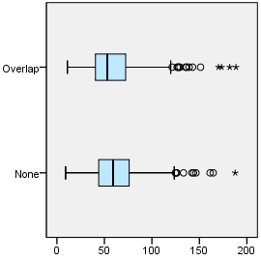

EXAMINE VARIABLES=trvtime_hspt_min BY ASENTANY_YN
/PLOT=BOXPLOT
/STATISTICS=NONE
/NOTOTAL.

Explore

Notes
Output Created |  | 03-APR-2018 18:21:19
Comments
Input | Data | F:\Data_Final\3cases_traveltime_indec.sav
Input | Active Dataset | DataSet1
Input | Filter | <none>
Input | Weight | <none>
Input | Split File | <none>
Input | N of Rows in Working Data File | 284
Missing Value Handling | Definition of Missing | User-defined missing values for dependent variables are treated as missing.
Missing Value Handling | Cases Used | Statistics are based on cases with no missing values for any dependent variable or factor used.
Syntax |  | EXAMINE VARIABLES=trvtime_hspt_min BY ASENTANY_YN  /PLOT=BOXPLOT  /STATISTICS=NONE  /NOTOTAL.
Resources | Processor Time | 00:00:00.23
Resources | Elapsed Time | 00:00:00.20

Overlap with asentamiento, yes/no

Case Processing Summary
 | Overlap with asentamiento, yes/no | Cases
 | Overlap with asentamiento, yes/no | Valid |  | Missing |  | Total
 | Overlap with asentamiento, yes/no | N | Percent | N | Percent | N
Public hospital | None | 137 | 96.5% | 5 | 3.5% | 142
Public hospital | Overlap | 135 | 95.1% | 7 | 4.9% | 142

Case Processing Summary
 | Overlap with asentamiento, yes/no | Cases
 | Overlap with asentamiento, yes/no | Total
 | Overlap with asentamiento, yes/no | Percent
Public hospital | None | 100.0%
Public hospital | Overlap | 100.0%

Public hospital

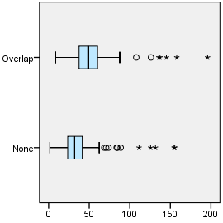

EXAMINE VARIABLES=trvtime_dgntrt_min BY ASENTANY_YN
/PLOT=BOXPLOT
/STATISTICS=NONE
/NOTOTAL.

Explore

Notes
Output Created |  | 03-APR-2018 18:21:27
Comments
Input | Data | F:\Data_Final\3cases_traveltime_indec.sav
Input | Active Dataset | DataSet1
Input | Filter | <none>
Input | Weight | <none>
Input | Split File | <none>
Input | N of Rows in Working Data File | 284
Missing Value Handling | Definition of Missing | User-defined missing values for dependent variables are treated as missing.
Missing Value Handling | Cases Used | Statistics are based on cases with no missing values for any dependent variable or factor used.
Syntax |  | EXAMINE VARIABLES=trvtime_dgntrt_min BY ASENTANY_YN  /PLOT=BOXPLOT  /STATISTICS=NONE  /NOTOTAL.
Resources | Processor Time | 00:00:00.22
Resources | Elapsed Time | 00:00:00.20

Overlap with asentamiento, yes/no

Case Processing Summary
 | Overlap with asentamiento, yes/no | Cases
 | Overlap with asentamiento, yes/no | Valid |  | Missing
 | Overlap with asentamiento, yes/no | N | Percent | N | Percent
Public diag./treat. center | None | 140 | 98.6% | 2 | 1.4%
Public diag./treat. center | Overlap | 142 | 100.0% | 0 | 0.0%

Case Processing Summary
 | Overlap with asentamiento, yes/no | Cases
 | Overlap with asentamiento, yes/no | Total
 | Overlap with asentamiento, yes/no | N | Percent
Public diag./treat. center | None | 142 | 100.0%
Public diag./treat. center | Overlap | 142 | 100.0%

Public diag./treat. center

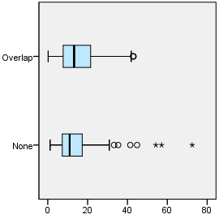

EXAMINE VARIABLES=trvtime_edsec_min BY ASENTANY_YN
/PLOT=BOXPLOT
/STATISTICS=NONE
/NOTOTAL.

Explore

Notes
Output Created |  | 03-APR-2018 18:21:36
Comments
Input | Data | F:\Data_Final\3cases_traveltime_indec.sav
Input | Active Dataset | DataSet1
Input | Filter | <none>
Input | Weight | <none>
Input | Split File | <none>
Input | N of Rows in Working Data File | 284
Missing Value Handling | Definition of Missing | User-defined missing values for dependent variables are treated as missing.
Missing Value Handling | Cases Used | Statistics are based on cases with no missing values for any dependent variable or factor used.
Syntax |  | EXAMINE VARIABLES=trvtime_edsec_min BY ASENTANY_YN  /PLOT=BOXPLOT  /STATISTICS=NONE  /NOTOTAL.
Resources | Processor Time | 00:00:00.23
Resources | Elapsed Time | 00:00:00.22

Overlap with asentamiento, yes/no

Case Processing Summary
 | Overlap with asentamiento, yes/no | Cases
 | Overlap with asentamiento, yes/no | Valid |  | Missing
 | Overlap with asentamiento, yes/no | N | Percent | N | Percent
Public secondary school | None | 142 | 100.0% | 0 | 0.0%
Public secondary school | Overlap | 142 | 100.0% | 0 | 0.0%

Case Processing Summary
 | Overlap with asentamiento, yes/no | Cases
 | Overlap with asentamiento, yes/no | Total
 | Overlap with asentamiento, yes/no | N | Percent
Public secondary school | None | 142 | 100.0%
Public secondary school | Overlap | 142 | 100.0%

Public secondary school

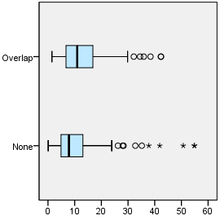

EXAMINE VARIABLES=trvtime_edprm_min BY ASENTANY_YN
/PLOT=BOXPLOT
/STATISTICS=NONE
/NOTOTAL.

Explore

Notes
Output Created |  | 03-APR-2018 18:21:43
Comments
Input | Data | F:\Data_Final\3cases_traveltime_indec.sav
Input | Active Dataset | DataSet1
Input | Filter | <none>
Input | Weight | <none>
Input | Split File | <none>
Input | N of Rows in Working Data File | 284
Missing Value Handling | Definition of Missing | User-defined missing values for dependent variables are treated as missing.
Missing Value Handling | Cases Used | Statistics are based on cases with no missing values for any dependent variable or factor used.
Syntax |  | EXAMINE VARIABLES=trvtime_edprm_min BY ASENTANY_YN  /PLOT=BOXPLOT  /STATISTICS=NONE  /NOTOTAL.
Resources | Processor Time | 00:00:00.22
Resources | Elapsed Time | 00:00:00.22

Overlap with asentamiento, yes/no

Case Processing Summary
 | Overlap with asentamiento, yes/no | Cases
 | Overlap with asentamiento, yes/no | Valid |  | Missing
 | Overlap with asentamiento, yes/no | N | Percent | N | Percent
Public primary school | None | 142 | 100.0% | 0 | 0.0%
Public primary school | Overlap | 142 | 100.0% | 0 | 0.0%

Case Processing Summary
 | Overlap with asentamiento, yes/no | Cases
 | Overlap with asentamiento, yes/no | Total
 | Overlap with asentamiento, yes/no | N | Percent
Public primary school | None | 142 | 100.0%
Public primary school | Overlap | 142 | 100.0%

Public primary school

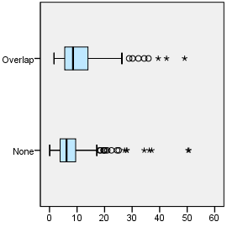

EXAMINE VARIABLES=trvtime_edknd_min BY ASENTANY_YN
/PLOT=BOXPLOT
/STATISTICS=NONE
/NOTOTAL.

Explore

Notes
Output Created |  | 03-APR-2018 18:21:51
Comments
Input | Data | F:\Data_Final\3cases_traveltime_indec.sav
Input | Active Dataset | DataSet1
Input | Filter | <none>
Input | Weight | <none>
Input | Split File | <none>
Input | N of Rows in Working Data File | 284
Missing Value Handling | Definition of Missing | User-defined missing values for dependent variables are treated as missing.
Missing Value Handling | Cases Used | Statistics are based on cases with no missing values for any dependent variable or factor used.
Syntax |  | EXAMINE VARIABLES=trvtime_edknd_min BY ASENTANY_YN  /PLOT=BOXPLOT  /STATISTICS=NONE  /NOTOTAL.
Resources | Processor Time | 00:00:00.20
Resources | Elapsed Time | 00:00:00.22

Overlap with asentamiento, yes/no

Case Processing Summary
 | Overlap with asentamiento, yes/no | Cases
 | Overlap with asentamiento, yes/no | Valid |  | Missing
 | Overlap with asentamiento, yes/no | N | Percent | N | Percent
Public kindergarten | None | 142 | 100.0% | 0 | 0.0%
Public kindergarten | Overlap | 142 | 100.0% | 0 | 0.0%

Case Processing Summary
 | Overlap with asentamiento, yes/no | Cases
 | Overlap with asentamiento, yes/no | Total
 | Overlap with asentamiento, yes/no | N | Percent
Public kindergarten | None | 142 | 100.0%
Public kindergarten | Overlap | 142 | 100.0%

Public kindergarten

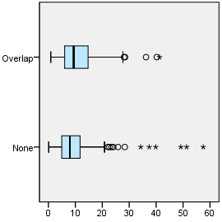

SORT CASES BY DEPTO.
SPLIT FILE SEPARATE BY DEPTO.
EXAMINE VARIABLES=trvtime_cbd_bsas BY ASENTANY_YN
/PLOT=BOXPLOT
/STATISTICS=NONE
/NOTOTAL.

Explore

Notes
Output Created |  | 03-APR-2018 18:22:20
Comments
Input | Data | F:\Data_Final\3cases_traveltime_indec.sav
Input | Active Dataset | DataSet1
Input | Filter | <none>
Input | Weight | <none>
Input | Split File | Department
Input | N of Rows in Working Data File | 284
Missing Value Handling | Definition of Missing | User-defined missing values for dependent variables are treated as missing.
Missing Value Handling | Cases Used | Statistics are based on cases with no missing values for any dependent variable or factor used.
Syntax |  | EXAMINE VARIABLES=trvtime_cbd_bsas BY ASENTANY_YN  /PLOT=BOXPLOT  /STATISTICS=NONE  /NOTOTAL.
Resources | Processor Time | 00:00:00.69
Resources | Elapsed Time | 00:00:00.62

Department = La Matanza

Overlap with asentamiento, yes/no

Case Processing Summaryª
 | Overlap with asentamiento, yes/no | Cases
 | Overlap with asentamiento, yes/no | Valid |  | Missing |  | Total
 | Overlap with asentamiento, yes/no | N | Percent | N | Percent | N
Buenos Aires CBD | None | 60 | 100.0% | 0 | 0.0% | 60
Buenos Aires CBD | Overlap | 58 | 96.7% | 2 | 3.3% | 60

Case Processing Summaryª
 | Overlap with asentamiento, yes/no | Cases
 | Overlap with asentamiento, yes/no | Total
 | Overlap with asentamiento, yes/no | Percent
Buenos Aires CBD | None | 100.0%
Buenos Aires CBD | Overlap | 100.0%

a. Department = La Matanza

Buenos Aires CBD

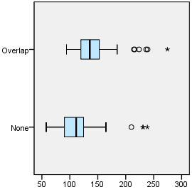

Department = Pilar

Overlap with asentamiento, yes/no

Case Processing Summaryª
 | Overlap with asentamiento, yes/no | Cases
 | Overlap with asentamiento, yes/no | Valid |  | Missing |  | Total
 | Overlap with asentamiento, yes/no | N | Percent | N | Percent | N
Buenos Aires CBD | None | 30 | 83.3% | 6 | 16.7% | 36
Buenos Aires CBD | Overlap | 30 | 83.3% | 6 | 16.7% | 36

Case Processing Summaryª
 | Overlap with asentamiento, yes/no | Cases
 | Overlap with asentamiento, yes/no | Total
 | Overlap with asentamiento, yes/no | Percent
Buenos Aires CBD | None | 100.0%
Buenos Aires CBD | Overlap | 100.0%

a. Department = Pilar

Buenos Aires CBD

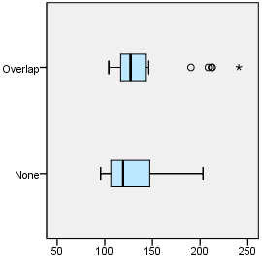

Department = Quilmes

Overlap with asentamiento, yes/no

Case Processing Summaryª
 | Overlap with asentamiento, yes/no | Cases
 | Overlap with asentamiento, yes/no | Valid |  | Missing |  | Total
 | Overlap with asentamiento, yes/no | N | Percent | N | Percent | N
Buenos Aires CBD | None | 46 | 100.0% | 0 | 0.0% | 46
Buenos Aires CBD | Overlap | 46 | 100.0% | 0 | 0.0% | 46

Case Processing Summaryª
 | Overlap with asentamiento, yes/no | Cases
 | Overlap with asentamiento, yes/no | Total
 | Overlap with asentamiento, yes/no | Percent
Buenos Aires CBD | None | 100.0%
Buenos Aires CBD | Overlap | 100.0%

a. Department = Quilmes

Buenos Aires CBD

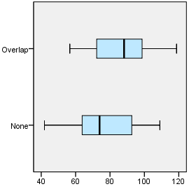

EXAMINE VARIABLES=trvtime_cbd_loc BY ASENTANY_YN
/PLOT=BOXPLOT
/STATISTICS=NONE
/NOTOTAL.

Explore

Notes
Output Created |  | 03-APR-2018 18:22:38
Comments
Input | Data | F:\Data_Final\3cases_traveltime_indec.sav
Input | Active Dataset | DataSet1
Input | Filter | <none>
Input | Weight | <none>
Input | Split File | Department
Input | N of Rows in Working Data File | 284
Missing Value Handling | Definition of Missing | User-defined missing values for dependent variables are treated as missing.
Missing Value Handling | Cases Used | Statistics are based on cases with no missing values for any dependent variable or factor used.
Syntax |  | EXAMINE VARIABLES=trvtime_cbd_loc BY ASENTANY_YN  /PLOT=BOXPLOT  /STATISTICS=NONE  /NOTOTAL.
Resources | Processor Time | 00:00:00.61
Resources | Elapsed Time | 00:00:00.58

Department = La Matanza

Overlap with asentamiento, yes/no

Case Processing Summaryª
 | Overlap with asentamiento, yes/no | Cases
 | Overlap with asentamiento, yes/no | Valid |  | Missing |  | Total
 | Overlap with asentamiento, yes/no | N | Percent | N | Percent | N
Departmental CBD | None | 60 | 100.0% | 0 | 0.0% | 60
Departmental CBD | Overlap | 58 | 96.7% | 2 | 3.3% | 60

Case Processing Summaryª
 | Overlap with asentamiento, yes/no | Cases
 | Overlap with asentamiento, yes/no | Total
 | Overlap with asentamiento, yes/no | Percent
Departmental CBD | None | 100.0%
Departmental CBD | Overlap | 100.0%

a. Department = La Matanza

Departmental CBD

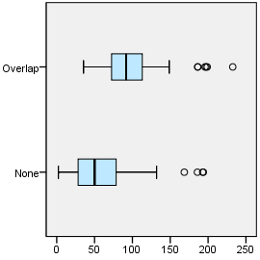

Department = Pilar

Overlap with asentamiento, yes/no

Case Processing Summaryª
 | Overlap with asentamiento, yes/no | Cases
 | Overlap with asentamiento, yes/no | Valid |  | Missing |  | Total
 | Overlap with asentamiento, yes/no | N | Percent | N | Percent | N
Departmental CBD | None | 31 | 86.1% | 5 | 13.9% | 36
Departmental CBD | Overlap | 31 | 86.1% | 5 | 13.9% | 36

Case Processing Summaryª
 | Overlap with asentamiento, yes/no | Cases
 | Overlap with asentamiento, yes/no | Total
 | Overlap with asentamiento, yes/no | Percent
Departmental CBD | None | 100.0%
Departmental CBD | Overlap | 100.0%

a. Department = Pilar

Departmental CBD

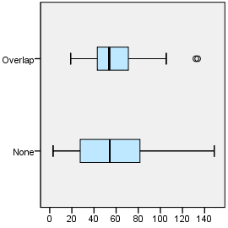

Department = Quilmes

Overlap with asentamiento, yes/no

Case Processing Summaryª
 | Overlap with asentamiento, yes/no | Cases
 | Overlap with asentamiento, yes/no | Valid |  | Missing |  | Total
 | Overlap with asentamiento, yes/no | N | Percent | N | Percent | N
Departmental CBD | None | 46 | 100.0% | 0 | 0.0% | 46
Departmental CBD | Overlap | 46 | 100.0% | 0 | 0.0% | 46

Case Processing Summaryª
 | Overlap with asentamiento, yes/no | Cases
 | Overlap with asentamiento, yes/no | Total
 | Overlap with asentamiento, yes/no | Percent
Departmental CBD | None | 100.0%
Departmental CBD | Overlap | 100.0%

a. Department = Quilmes

Departmental CBD

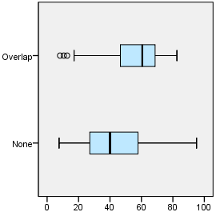

EXAMINE VARIABLES=trvtime_cbd_ngh_min BY ASENTANY_YN
/PLOT=BOXPLOT
/STATISTICS=NONE
/NOTOTAL.

Explore

Notes
Output Created |  | 03-APR-2018 18:22:47
Comments
Input | Data | F:\Data_Final\3cases_traveltime_indec.sav
Input | Active Dataset | DataSet1
Input | Filter | <none>
Input | Weight | <none>
Input | Split File | Department
Input | N of Rows in Working Data File | 284
Missing Value Handling | Definition of Missing | User-defined missing values for dependent variables are treated as missing.
Missing Value Handling | Cases Used | Statistics are based on cases with no missing values for any dependent variable or factor used.
Syntax |  | EXAMINE VARIABLES=trvtime_cbd_ngh_min BY ASENTANY_YN  /PLOT=BOXPLOT  /STATISTICS=NONE  /NOTOTAL.
Resources | Processor Time | 00:00:00.66
Resources | Elapsed Time | 00:00:00.62

Department = La Matanza

Overlap with asentamiento, yes/no

Case Processing Summaryª
 | Overlap with asentamiento, yes/no | Cases
 | Overlap with asentamiento, yes/no | Valid |  | Missing
 | Overlap with asentamiento, yes/no | N | Percent | N | Percent
Any departmental CBD | None | 60 | 100.0% | 0 | 0.0%
Any departmental CBD | Overlap | 58 | 96.7% | 2 | 3.3%

Case Processing Summaryª
 | Overlap with asentamiento, yes/no | Cases
 | Overlap with asentamiento, yes/no | Total
 | Overlap with asentamiento, yes/no | N | Percent
Any departmental CBD | None | 60 | 100.0%
Any departmental CBD | Overlap | 60 | 100.0%

a. Department = La Matanza

Any departmental CBD

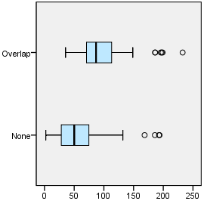

Department = Pilar

Overlap with asentamiento, yes/no

Case Processing Summaryª
 | Overlap with asentamiento, yes/no | Cases
 | Overlap with asentamiento, yes/no | Valid |  | Missing
 | Overlap with asentamiento, yes/no | N | Percent | N | Percent
Any departmental CBD | None | 31 | 86.1% | 5 | 13.9%
Any departmental CBD | Overlap | 31 | 86.1% | 5 | 13.9%

Case Processing Summaryª
 | Overlap with asentamiento, yes/no | Cases
 | Overlap with asentamiento, yes/no | Total
 | Overlap with asentamiento, yes/no | N | Percent
Any departmental CBD | None | 36 | 100.0%
Any departmental CBD | Overlap | 36 | 100.0%

a. Department = Pilar

Any departmental CBD

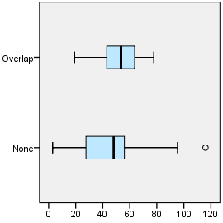

Department = Quilmes

Overlap with asentamiento, yes/no

Case Processing Summaryª
 | Overlap with asentamiento, yes/no | Cases
 | Overlap with asentamiento, yes/no | Valid |  | Missing
 | Overlap with asentamiento, yes/no | N | Percent | N | Percent
Any departmental CBD | None | 46 | 100.0% | 0 | 0.0%
Any departmental CBD | Overlap | 46 | 100.0% | 0 | 0.0%

Case Processing Summaryª
 | Overlap with asentamiento, yes/no | Cases
 | Overlap with asentamiento, yes/no | Total
 | Overlap with asentamiento, yes/no | N | Percent
Any departmental CBD | None | 46 | 100.0%
Any departmental CBD | Overlap | 46 | 100.0%

a. Department = Quilmes

Any departmental CBD

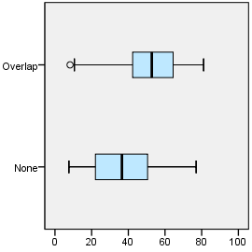

EXAMINE VARIABLES=trvtime_rail_min BY ASENTANY_YN
/PLOT=BOXPLOT
/STATISTICS=NONE
/NOTOTAL.

Explore

Notes
Output Created |  | 03-APR-2018 18:22:56
Comments
Input | Data | F:\Data_Final\3cases_traveltime_indec.sav
Input | Active Dataset | DataSet1
Input | Filter | <none>
Input | Weight | <none>
Input | Split File | Department
Input | N of Rows in Working Data File | 284
Missing Value Handling | Definition of Missing | User-defined missing values for dependent variables are treated as missing.
Missing Value Handling | Cases Used | Statistics are based on cases with no missing values for any dependent variable or factor used.
Syntax |  | EXAMINE VARIABLES=trvtime_rail_min BY ASENTANY_YN  /PLOT=BOXPLOT  /STATISTICS=NONE  /NOTOTAL.
Resources | Processor Time | 00:00:00.66
Resources | Elapsed Time | 00:00:00.62

Department = La Matanza

Overlap with asentamiento, yes/no

Case Processing Summaryª
 | Overlap with asentamiento, yes/no | Cases
 | Overlap with asentamiento, yes/no | Valid |  | Missing |  | Total
 | Overlap with asentamiento, yes/no | N | Percent | N | Percent | N
Railway station | None | 60 | 100.0% | 0 | 0.0% | 60
Railway station | Overlap | 58 | 96.7% | 2 | 3.3% | 60

Case Processing Summaryª
 | Overlap with asentamiento, yes/no | Cases
 | Overlap with asentamiento, yes/no | Total
 | Overlap with asentamiento, yes/no | Percent
Railway station | None | 100.0%
Railway station | Overlap | 100.0%

a. Department = La Matanza

Railway station

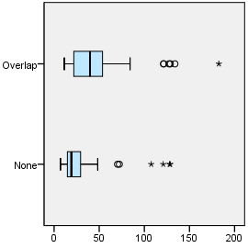

Department = Pilar

Overlap with asentamiento, yes/no

Case Processing Summaryª
 | Overlap with asentamiento, yes/no | Cases
 | Overlap with asentamiento, yes/no | Valid |  | Missing |  | Total
 | Overlap with asentamiento, yes/no | N | Percent | N | Percent | N
Railway station | None | 30 | 83.3% | 6 | 16.7% | 36
Railway station | Overlap | 32 | 88.9% | 4 | 11.1% | 36

Case Processing Summaryª
 | Overlap with asentamiento, yes/no | Cases
 | Overlap with asentamiento, yes/no | Total
 | Overlap with asentamiento, yes/no | Percent
Railway station | None | 100.0%
Railway station | Overlap | 100.0%

a. Department = Pilar

Railway station

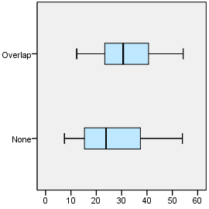

Department = Quilmes

Overlap with asentamiento, yes/no

Case Processing Summaryª
 | Overlap with asentamiento, yes/no | Cases
 | Overlap with asentamiento, yes/no | Valid |  | Missing |  | Total
 | Overlap with asentamiento, yes/no | N | Percent | N | Percent | N
Railway station | None | 46 | 100.0% | 0 | 0.0% | 46
Railway station | Overlap | 46 | 100.0% | 0 | 0.0% | 46

Case Processing Summaryª
 | Overlap with asentamiento, yes/no | Cases
 | Overlap with asentamiento, yes/no | Total
 | Overlap with asentamiento, yes/no | Percent
Railway station | None | 100.0%
Railway station | Overlap | 100.0%

a. Department = Quilmes

Railway station

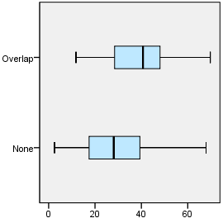

EXAMINE VARIABLES=trvtime_upa_min BY ASENTANY_YN
/PLOT=BOXPLOT
/STATISTICS=NONE
/NOTOTAL.

Explore

Notes
Output Created |  | 03-APR-2018 18:23:08
Comments
Input | Data | F:\Data_Final\3cases_traveltime_indec.sav
Input | Active Dataset | DataSet1
Input | Filter | <none>
Input | Weight | <none>
Input | Split File | Department
Input | N of Rows in Working Data File | 284
Missing Value Handling | Definition of Missing | User-defined missing values for dependent variables are treated as missing.
Missing Value Handling | Cases Used | Statistics are based on cases with no missing values for any dependent variable or factor used.
Syntax |  | EXAMINE VARIABLES=trvtime_upa_min BY ASENTANY_YN  /PLOT=BOXPLOT  /STATISTICS=NONE  /NOTOTAL.
Resources | Processor Time | 00:00:00.62
Resources | Elapsed Time | 00:00:00.62

Department = La Matanza

Overlap with asentamiento, yes/no

Case Processing Summaryª
 | Overlap with asentamiento, yes/no | Cases
 | Overlap with asentamiento, yes/no | Valid |  | Missing |  | Total
 | Overlap with asentamiento, yes/no | N | Percent | N | Percent | N
Public UPA | None | 60 | 100.0% | 0 | 0.0% | 60
Public UPA | Overlap | 58 | 96.7% | 2 | 3.3% | 60

Case Processing Summaryª
 | Overlap with asentamiento, yes/no | Cases
 | Overlap with asentamiento, yes/no | Total
 | Overlap with asentamiento, yes/no | Percent
Public UPA | None | 100.0%
Public UPA | Overlap | 100.0%

a. Department = La Matanza

Public UPA

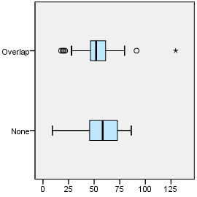

Department = Pilar

Overlap with asentamiento, yes/no

Case Processing Summaryª
 | Overlap with asentamiento, yes/no | Cases
 | Overlap with asentamiento, yes/no | Valid |  | Missing |  | Total
 | Overlap with asentamiento, yes/no | N | Percent | N | Percent | N
Public UPA | None | 30 | 83.3% | 6 | 16.7% | 36
Public UPA | Overlap | 30 | 83.3% | 6 | 16.7% | 36

Case Processing Summaryª
 | Overlap with asentamiento, yes/no | Cases
 | Overlap with asentamiento, yes/no | Total
 | Overlap with asentamiento, yes/no | Percent
Public UPA | None | 100.0%
Public UPA | Overlap | 100.0%

a. Department = Pilar

Public UPA

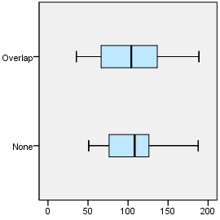

Department = Quilmes

Overlap with asentamiento, yes/no

Case Processing Summaryª
 | Overlap with asentamiento, yes/no | Cases
 | Overlap with asentamiento, yes/no | Valid |  | Missing |  | Total
 | Overlap with asentamiento, yes/no | N | Percent | N | Percent | N
Public UPA | None | 46 | 100.0% | 0 | 0.0% | 46
Public UPA | Overlap | 46 | 100.0% | 0 | 0.0% | 46

Case Processing Summaryª
 | Overlap with asentamiento, yes/no | Cases
 | Overlap with asentamiento, yes/no | Total
 | Overlap with asentamiento, yes/no | Percent
Public UPA | None | 100.0%
Public UPA | Overlap | 100.0%

a. Department = Quilmes

Public UPA

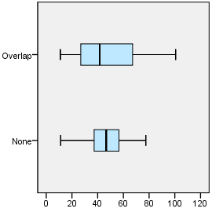

EXAMINE VARIABLES=trvtime_hspt_min BY ASENTANY_YN
/PLOT=BOXPLOT
/STATISTICS=NONE
/NOTOTAL.

Explore

Notes
Output Created |  | 03-APR-2018 18:23:16
Comments
Input | Data | F:\Data_Final\3cases_traveltime_indec.sav
Input | Active Dataset | DataSet1
Input | Filter | <none>
Input | Weight | <none>
Input | Split File | Department
Input | N of Rows in Working Data File | 284
Missing Value Handling | Definition of Missing | User-defined missing values for dependent variables are treated as missing.
Missing Value Handling | Cases Used | Statistics are based on cases with no missing values for any dependent variable or factor used.
Syntax |  | EXAMINE VARIABLES=trvtime_hspt_min BY ASENTANY_YN  /PLOT=BOXPLOT  /STATISTICS=NONE  /NOTOTAL.
Resources | Processor Time | 00:00:00.58
Resources | Elapsed Time | 00:00:00.58

Department = La Matanza

Overlap with asentamiento, yes/no

Case Processing Summaryª
 | Overlap with asentamiento, yes/no | Cases
 | Overlap with asentamiento, yes/no | Valid |  | Missing |  | Total
 | Overlap with asentamiento, yes/no | N | Percent | N | Percent | N
Public hospital | None | 60 | 100.0% | 0 | 0.0% | 60
Public hospital | Overlap | 58 | 96.7% | 2 | 3.3% | 60

Case Processing Summaryª
 | Overlap with asentamiento, yes/no | Cases
 | Overlap with asentamiento, yes/no | Total
 | Overlap with asentamiento, yes/no | Percent
Public hospital | None | 100.0%
Public hospital | Overlap | 100.0%

a. Department = La Matanza

Public hospital

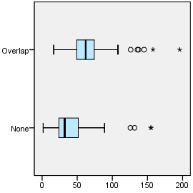

Department = Pilar

Overlap with asentamiento, yes/no

Case Processing Summaryª
 | Overlap with asentamiento, yes/no | Cases
 | Overlap with asentamiento, yes/no | Valid |  | Missing |  | Total
 | Overlap with asentamiento, yes/no | N | Percent | N | Percent | N
Public hospital | None | 31 | 86.1% | 5 | 13.9% | 36
Public hospital | Overlap | 31 | 86.1% | 5 | 13.9% | 36

Case Processing Summaryª
 | Overlap with asentamiento, yes/no | Cases
 | Overlap with asentamiento, yes/no | Total
 | Overlap with asentamiento, yes/no | Percent
Public hospital | None | 100.0%
Public hospital | Overlap | 100.0%

a. Department = Pilar

Public hospital

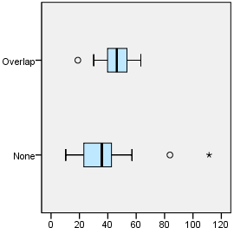

Department = Quilmes

Overlap with asentamiento, yes/no

Case Processing Summaryª
 | Overlap with asentamiento, yes/no | Cases
 | Overlap with asentamiento, yes/no | Valid |  | Missing |  | Total
 | Overlap with asentamiento, yes/no | N | Percent | N | Percent | N
Public hospital | None | 46 | 100.0% | 0 | 0.0% | 46
Public hospital | Overlap | 46 | 100.0% | 0 | 0.0% | 46

Case Processing Summaryª
 | Overlap with asentamiento, yes/no | Cases
 | Overlap with asentamiento, yes/no | Total
 | Overlap with asentamiento, yes/no | Percent
Public hospital | None | 100.0%
Public hospital | Overlap | 100.0%

a. Department = Quilmes

Public hospital

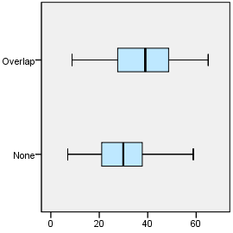

EXAMINE VARIABLES=trvtime_dgntrt_min BY ASENTANY_YN
/PLOT=BOXPLOT
/STATISTICS=NONE
/NOTOTAL.

Explore

Notes
Output Created |  | 03-APR-2018 18:23:24
Comments
Input | Data | F:\Data_Final\3cases_traveltime_indec.sav
Input | Active Dataset | DataSet1
Input | Filter | <none>
Input | Weight | <none>
Input | Split File | Department
Input | N of Rows in Working Data File | 284
Missing Value Handling | Definition of Missing | User-defined missing values for dependent variables are treated as missing.
Missing Value Handling | Cases Used | Statistics are based on cases with no missing values for any dependent variable or factor used.
Syntax |  | EXAMINE VARIABLES=trvtime_dgntrt_min BY ASENTANY_YN  /PLOT=BOXPLOT  /STATISTICS=NONE  /NOTOTAL.
Resources | Processor Time | 00:00:00.66
Resources | Elapsed Time | 00:00:00.62

Department = La Matanza

Overlap with asentamiento, yes/no

Case Processing Summaryª
 | Overlap with asentamiento, yes/no | Cases
 | Overlap with asentamiento, yes/no | Valid |  | Missing
 | Overlap with asentamiento, yes/no | N | Percent | N | Percent
Public diag./treat. center | None | 60 | 100.0% | 0 | 0.0%
Public diag./treat. center | Overlap | 60 | 100.0% | 0 | 0.0%

Case Processing Summaryª
 | Overlap with asentamiento, yes/no | Cases
 | Overlap with asentamiento, yes/no | Total
 | Overlap with asentamiento, yes/no | N | Percent
Public diag./treat. center | None | 60 | 100.0%
Public diag./treat. center | Overlap | 60 | 100.0%

a. Department = La Matanza

Public diag./treat. center

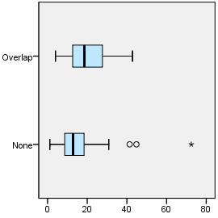

Department = Pilar

Overlap with asentamiento, yes/no

Case Processing Summaryª
 | Overlap with asentamiento, yes/no | Cases
 | Overlap with asentamiento, yes/no | Valid |  | Missing
 | Overlap with asentamiento, yes/no | N | Percent | N | Percent
Public diag./treat. center | None | 34 | 94.4% | 2 | 5.6%
Public diag./treat. center | Overlap | 36 | 100.0% | 0 | 0.0%

Case Processing Summaryª
 | Overlap with asentamiento, yes/no | Cases
 | Overlap with asentamiento, yes/no | Total
 | Overlap with asentamiento, yes/no | N | Percent
Public diag./treat. center | None | 36 | 100.0%
Public diag./treat. center | Overlap | 36 | 100.0%

a. Department = Pilar

Public diag./treat. center

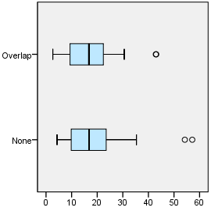

Department = Quilmes

Overlap with asentamiento, yes/no

Case Processing Summaryª
 | Overlap with asentamiento, yes/no | Cases
 | Overlap with asentamiento, yes/no | Valid |  | Missing
 | Overlap with asentamiento, yes/no | N | Percent | N | Percent
Public diag./treat. center | None | 46 | 100.0% | 0 | 0.0%
Public diag./treat. center | Overlap | 46 | 100.0% | 0 | 0.0%

Case Processing Summaryª
 | Overlap with asentamiento, yes/no | Cases
 | Overlap with asentamiento, yes/no | Total
 | Overlap with asentamiento, yes/no | N | Percent
Public diag./treat. center | None | 46 | 100.0%
Public diag./treat. center | Overlap | 46 | 100.0%

a. Department = Quilmes

Public diag./treat. center

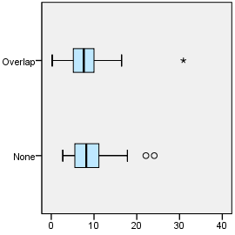

EXAMINE VARIABLES=trvtime_edsec_min BY ASENTANY_YN
/PLOT=BOXPLOT
/STATISTICS=NONE
/NOTOTAL.

Explore

Notes
Output Created |  | 03-APR-2018 18:23:33
Comments
Input | Data | F:\Data_Final\3cases_traveltime_indec.sav
Input | Active Dataset | DataSet1
Input | Filter | <none>
Input | Weight | <none>
Input | Split File | Department
Input | N of Rows in Working Data File | 284
Missing Value Handling | Definition of Missing | User-defined missing values for dependent variables are treated as missing.
Missing Value Handling | Cases Used | Statistics are based on cases with no missing values for any dependent variable or factor used.
Syntax |  | EXAMINE VARIABLES=trvtime_edsec_min BY ASENTANY_YN  /PLOT=BOXPLOT  /STATISTICS=NONE  /NOTOTAL.
Resources | Processor Time | 00:00:00.64
Resources | Elapsed Time | 00:00:00.61

Department = La Matanza

Overlap with asentamiento, yes/no

Case Processing Summaryª
 | Overlap with asentamiento, yes/no | Cases
 | Overlap with asentamiento, yes/no | Valid |  | Missing
 | Overlap with asentamiento, yes/no | N | Percent | N | Percent
Public secondary school | None | 60 | 100.0% | 0 | 0.0%
Public secondary school | Overlap | 60 | 100.0% | 0 | 0.0%

Case Processing Summaryª
 | Overlap with asentamiento, yes/no | Cases
 | Overlap with asentamiento, yes/no | Total
 | Overlap with asentamiento, yes/no | N | Percent
Public secondary school | None | 60 | 100.0%
Public secondary school | Overlap | 60 | 100.0%

a. Department = La Matanza

Public secondary school

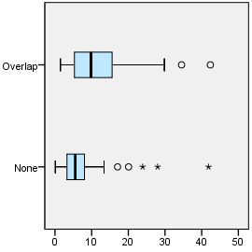

Department = Pilar

Overlap with asentamiento, yes/no

Case Processing Summaryª
 | Overlap with asentamiento, yes/no | Cases
 | Overlap with asentamiento, yes/no | Valid |  | Missing
 | Overlap with asentamiento, yes/no | N | Percent | N | Percent
Public secondary school | None | 36 | 100.0% | 0 | 0.0%
Public secondary school | Overlap | 36 | 100.0% | 0 | 0.0%

Case Processing Summaryª
 | Overlap with asentamiento, yes/no | Cases
 | Overlap with asentamiento, yes/no | Total
 | Overlap with asentamiento, yes/no | N | Percent
Public secondary school | None | 36 | 100.0%
Public secondary school | Overlap | 36 | 100.0%

a. Department = Pilar

Public secondary school

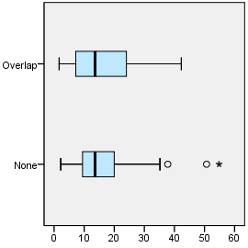

Department = Quilmes

Overlap with asentamiento, yes/no

Case Processing Summaryª
 | Overlap with asentamiento, yes/no | Cases
 | Overlap with asentamiento, yes/no | Valid |  | Missing
 | Overlap with asentamiento, yes/no | N | Percent | N | Percent
Public secondary school | None | 46 | 100.0% | 0 | 0.0%
Public secondary school | Overlap | 46 | 100.0% | 0 | 0.0%

Case Processing Summaryª
 | Overlap with asentamiento, yes/no | Cases
 | Overlap with asentamiento, yes/no | Total
 | Overlap with asentamiento, yes/no | N | Percent
Public secondary school | None | 46 | 100.0%
Public secondary school | Overlap | 46 | 100.0%

a. Department = Quilmes

Public secondary school

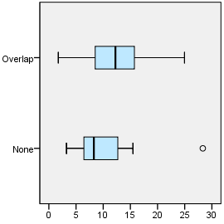

EXAMINE VARIABLES=trvtime_edprm_min BY ASENTANY_YN
/PLOT=BOXPLOT
/STATISTICS=NONE
/NOTOTAL.

Explore

Notes
Output Created |  | 03-APR-2018 18:23:43
Comments
Input | Data | F:\Data_Final\3cases_traveltime_indec.sav
Input | Active Dataset | DataSet1
Input | Filter | <none>
Input | Weight | <none>
Input | Split File | Department
Input | N of Rows in Working Data File | 284
Missing Value Handling | Definition of Missing | User-defined missing values for dependent variables are treated as missing.
Missing Value Handling | Cases Used | Statistics are based on cases with no missing values for any dependent variable or factor used.
Syntax |  | EXAMINE VARIABLES=trvtime_edprm_min BY ASENTANY_YN  /PLOT=BOXPLOT  /STATISTICS=NONE  /NOTOTAL.
Resources | Processor Time | 00:00:00.61
Resources | Elapsed Time | 00:00:00.61

Department = La Matanza

Overlap with asentamiento, yes/no

Case Processing Summaryª
 | Overlap with asentamiento, yes/no | Cases
 | Overlap with asentamiento, yes/no | Valid |  | Missing
 | Overlap with asentamiento, yes/no | N | Percent | N | Percent
Public primary school | None | 60 | 100.0% | 0 | 0.0%
Public primary school | Overlap | 60 | 100.0% | 0 | 0.0%

Case Processing Summaryª
 | Overlap with asentamiento, yes/no | Cases
 | Overlap with asentamiento, yes/no | Total
 | Overlap with asentamiento, yes/no | N | Percent
Public primary school | None | 60 | 100.0%
Public primary school | Overlap | 60 | 100.0%

a. Department = La Matanza

Public primary school

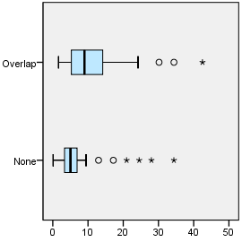

Department = Pilar

Overlap with asentamiento, yes/no

Case Processing Summaryª
 | Overlap with asentamiento, yes/no | Cases
 | Overlap with asentamiento, yes/no | Valid |  | Missing
 | Overlap with asentamiento, yes/no | N | Percent | N | Percent
Public primary school | None | 36 | 100.0% | 0 | 0.0%
Public primary school | Overlap | 36 | 100.0% | 0 | 0.0%

Case Processing Summaryª
 | Overlap with asentamiento, yes/no | Cases
 | Overlap with asentamiento, yes/no | Total
 | Overlap with asentamiento, yes/no | N | Percent
Public primary school | None | 36 | 100.0%
Public primary school | Overlap | 36 | 100.0%

a. Department = Pilar

Public primary school

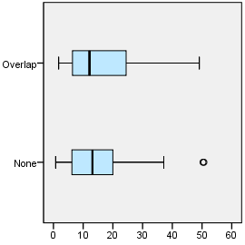

Department = Quilmes

Overlap with asentamiento, yes/no

Case Processing Summaryª
 | Overlap with asentamiento, yes/no | Cases
 | Overlap with asentamiento, yes/no | Valid |  | Missing
 | Overlap with asentamiento, yes/no | N | Percent | N | Percent
Public primary school | None | 46 | 100.0% | 0 | 0.0%
Public primary school | Overlap | 46 | 100.0% | 0 | 0.0%

Case Processing Summaryª
 | Overlap with asentamiento, yes/no | Cases
 | Overlap with asentamiento, yes/no | Total
 | Overlap with asentamiento, yes/no | N | Percent
Public primary school | None | 46 | 100.0%
Public primary school | Overlap | 46 | 100.0%

a. Department = Quilmes

Public primary school

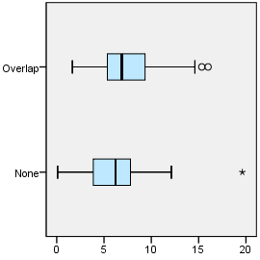

EXAMINE VARIABLES=trvtime_edknd_min BY ASENTANY_YN
/PLOT=BOXPLOT
/STATISTICS=NONE
/NOTOTAL.

Explore

Notes
Output Created |  | 03-APR-2018 18:23:56
Comments
Input | Data | F:\Data_Final\3cases_traveltime_indec.sav
Input | Active Dataset | DataSet1
Input | Filter | <none>
Input | Weight | <none>
Input | Split File | Department
Input | N of Rows in Working Data File | 284
Missing Value Handling | Definition of Missing | User-defined missing values for dependent variables are treated as missing.
Missing Value Handling | Cases Used | Statistics are based on cases with no missing values for any dependent variable or factor used.
Syntax |  | EXAMINE VARIABLES=trvtime_edknd_min BY ASENTANY_YN  /PLOT=BOXPLOT  /STATISTICS=NONE  /NOTOTAL.
Resources | Processor Time | 00:00:00.55
Resources | Elapsed Time | 00:00:00.56

Department = La Matanza

Overlap with asentamiento, yes/no

Case Processing Summaryª
 | Overlap with asentamiento, yes/no | Cases
 | Overlap with asentamiento, yes/no | Valid |  | Missing
 | Overlap with asentamiento, yes/no | N | Percent | N | Percent
Public kindergarten | None | 60 | 100.0% | 0 | 0.0%
Public kindergarten | Overlap | 60 | 100.0% | 0 | 0.0%

Case Processing Summaryª
 | Overlap with asentamiento, yes/no | Cases
 | Overlap with asentamiento, yes/no | Total
 | Overlap with asentamiento, yes/no | N | Percent
Public kindergarten | None | 60 | 100.0%
Public kindergarten | Overlap | 60 | 100.0%

a. Department = La Matanza

Public kindergarten

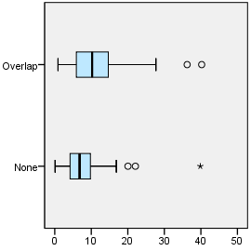

Department = Pilar

Overlap with asentamiento, yes/no

Case Processing Summaryª
 | Overlap with asentamiento, yes/no | Cases
 | Overlap with asentamiento, yes/no | Valid |  | Missing
 | Overlap with asentamiento, yes/no | N | Percent | N | Percent
Public kindergarten | None | 36 | 100.0% | 0 | 0.0%
Public kindergarten | Overlap | 36 | 100.0% | 0 | 0.0%

Case Processing Summaryª
 | Overlap with asentamiento, yes/no | Cases
 | Overlap with asentamiento, yes/no | Total
 | Overlap with asentamiento, yes/no | N | Percent
Public kindergarten | None | 36 | 100.0%
Public kindergarten | Overlap | 36 | 100.0%

a. Department = Pilar

Public kindergarten

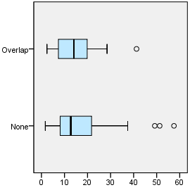

Department = Quilmes

Overlap with asentamiento, yes/no

Case Processing Summaryª
 | Overlap with asentamiento, yes/no | Cases
 | Overlap with asentamiento, yes/no | Valid |  | Missing
 | Overlap with asentamiento, yes/no | N | Percent | N | Percent
Public kindergarten | None | 46 | 100.0% | 0 | 0.0%
Public kindergarten | Overlap | 46 | 100.0% | 0 | 0.0%

Case Processing Summaryª
 | Overlap with asentamiento, yes/no | Cases
 | Overlap with asentamiento, yes/no | Total
 | Overlap with asentamiento, yes/no | N | Percent
Public kindergarten | None | 46 | 100.0%
Public kindergarten | Overlap | 46 | 100.0%

a. Department = Quilmes

Public kindergarten

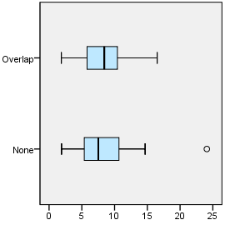

OUTPUT MODIFY
/REPORT PRINTREPORT=NO
/SELECT CHARTS
/DELETEOBJECT DELETE=NO
/OBJECTPROPERTIES VISIBLE=ASIS SIZE=INCHES(2.75,3.0)
/GRAPHS CTEMPLATE="F:\Histogram_ANYvNONE.sgt".

OUTPUT MODIFY
/REPORT PRINTREPORT=NO
/SELECT CHARTS
/DELETEOBJECT DELETE=NO
/OBJECTPROPERTIES VISIBLE=ASIS SIZE=INCHES(2.8,2.0)
/GRAPHS CTEMPLATE="F:\Histogram_ANYvNONE.sgt".

OUTPUT MODIFY
/REPORT PRINTREPORT=NO
/SELECT CHARTS
/DELETEOBJECT DELETE=NO
/OBJECTPROPERTIES VISIBLE=ASIS SIZE=INCHES(2.8,2.0)
/GRAPHS CTEMPLATE="F:\Histogram_ANYvNONE.sgt".

