GET
FILE='F:\Data_Final\3cases_traveltime_indec.sav'.
DATASET NAME DataSet1 WINDOW=FRONT.
GRAPH
/HISTOGRAM(NORMAL)=trvtime_cbd_bsas.

Graph

Notes
Output Created |  | 14-MAR-2018 20:03:47
Comments
Input | Data | F:\Data_Final\3cases_traveltime_indec.sav
Input | Active Dataset | DataSet1
Input | Filter | <none>
Input | Weight | <none>
Input | Split File | <none>
Input | N of Rows in Working Data File | 284
Syntax |  | GRAPH  /HISTOGRAM(NORMAL)=trvtime_cbd_bsas.
Resources | Processor Time | 00:00:02.11
Resources | Elapsed Time | 00:00:00.94

[DataSet1] F:\Data_Final\3cases_traveltime_indec.sav

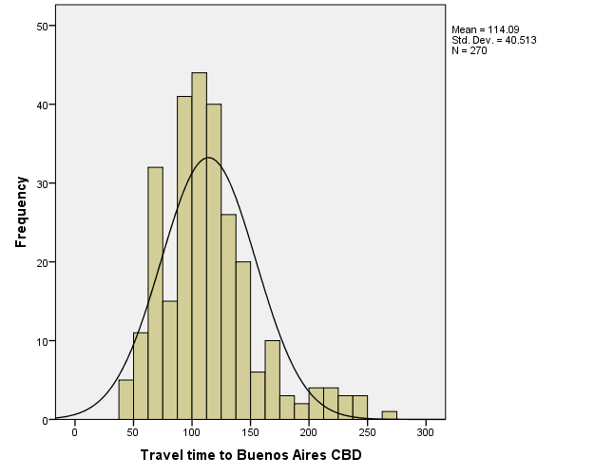

GRAPH
/HISTOGRAM(NORMAL)=trvtime_cbd_loc.

Graph

Notes
Output Created |  | 14-MAR-2018 20:04:54
Comments
Input | Data | F:\Data_Final\3cases_traveltime_indec.sav
Input | Active Dataset | DataSet1
Input | Filter | <none>
Input | Weight | <none>
Input | Split File | <none>
Input | N of Rows in Working Data File | 284
Syntax |  | GRAPH  /HISTOGRAM(NORMAL)=trvtime_cbd_loc.
Resources | Processor Time | 00:00:00.73
Resources | Elapsed Time | 00:00:00.25

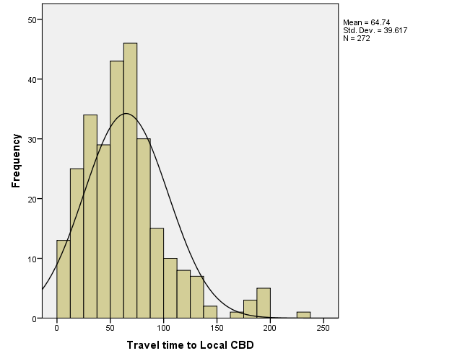

GRAPH
/HISTOGRAM(NORMAL)=trvtime_cbd_ngh_min.

Graph

Notes
Output Created |  | 14-MAR-2018 20:05:06
Comments
Input | Data | F:\Data_Final\3cases_traveltime_indec.sav
Input | Active Dataset | DataSet1
Input | Filter | <none>
Input | Weight | <none>
Input | Split File | <none>
Input | N of Rows in Working Data File | 284
Syntax |  | GRAPH  /HISTOGRAM(NORMAL)=trvtime_cbd_ngh_min.
Resources | Processor Time | 00:00:00.44
Resources | Elapsed Time | 00:00:00.27

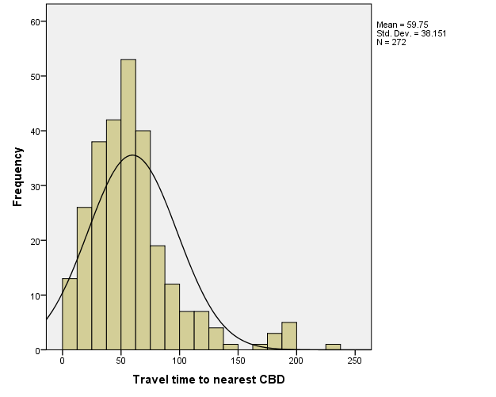

GRAPH
/HISTOGRAM(NORMAL)=trvtime_rail_min.

Graph

Notes
Output Created |  | 14-MAR-2018 20:05:22
Comments
Input | Data | F:\Data_Final\3cases_traveltime_indec.sav
Input | Active Dataset | DataSet1
Input | Filter | <none>
Input | Weight | <none>
Input | Split File | <none>
Input | N of Rows in Working Data File | 284
Syntax |  | GRAPH  /HISTOGRAM(NORMAL)=trvtime_rail_min.
Resources | Processor Time | 00:00:00.39
Resources | Elapsed Time | 00:00:00.25

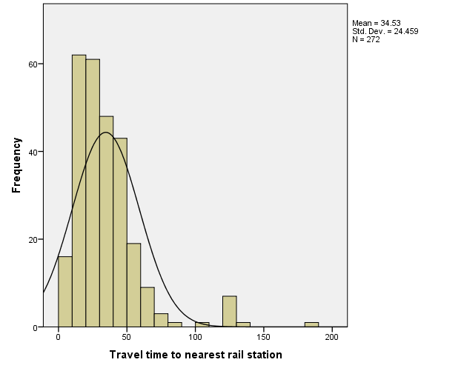

GRAPH
/HISTOGRAM(NORMAL)=trvtime_upa_min.

Graph

Notes
Output Created |  | 14-MAR-2018 20:05:32
Comments
Input | Data | F:\Data_Final\3cases_traveltime_indec.sav
Input | Active Dataset | DataSet1
Input | Filter | <none>
Input | Weight | <none>
Input | Split File | <none>
Input | N of Rows in Working Data File | 284
Syntax |  | GRAPH  /HISTOGRAM(NORMAL)=trvtime_upa_min.
Resources | Processor Time | 00:00:00.52
Resources | Elapsed Time | 00:00:00.25

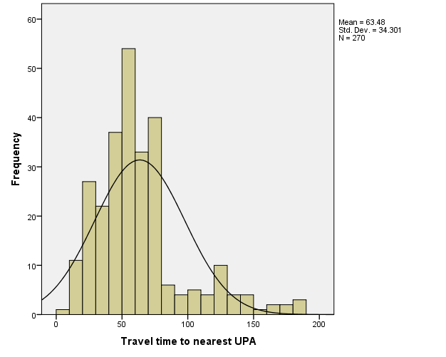

GRAPH
/HISTOGRAM(NORMAL)=trvtime_hspt_min.

Graph

Notes
Output Created |  | 14-MAR-2018 20:05:41
Comments
Input | Data | F:\Data_Final\3cases_traveltime_indec.sav
Input | Active Dataset | DataSet1
Input | Filter | <none>
Input | Weight | <none>
Input | Split File | <none>
Input | N of Rows in Working Data File | 284
Syntax |  | GRAPH  /HISTOGRAM(NORMAL)=trvtime_hspt_min.
Resources | Processor Time | 00:00:00.42
Resources | Elapsed Time | 00:00:00.27

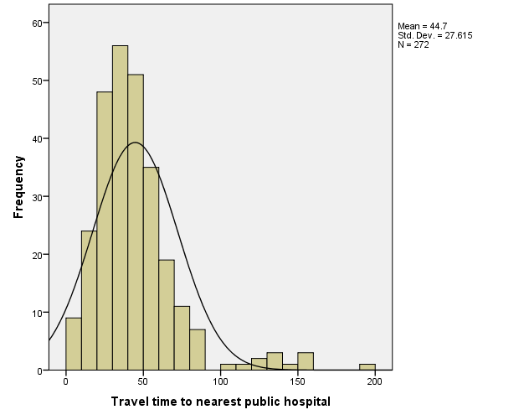

GRAPH
/HISTOGRAM(NORMAL)=trvtime_dgntrt_min.

Graph

Notes
Output Created |  | 14-MAR-2018 20:05:49
Comments
Input | Data | F:\Data_Final\3cases_traveltime_indec.sav
Input | Active Dataset | DataSet1
Input | Filter | <none>
Input | Weight | <none>
Input | Split File | <none>
Input | N of Rows in Working Data File | 284
Syntax |  | GRAPH  /HISTOGRAM(NORMAL)=trvtime_dgntrt_min.
Resources | Processor Time | 00:00:00.27
Resources | Elapsed Time | 00:00:00.23

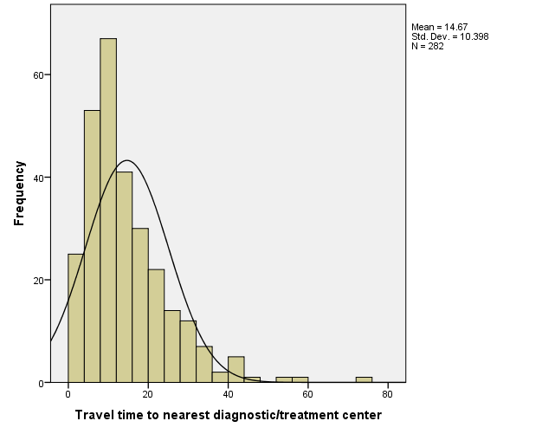

GRAPH
/HISTOGRAM(NORMAL)=trvtime_edknd_min.

Graph

Notes
Output Created |  | 14-MAR-2018 20:06:00
Comments
Input | Data | F:\Data_Final\3cases_traveltime_indec.sav
Input | Active Dataset | DataSet1
Input | Filter | <none>
Input | Weight | <none>
Input | Split File | <none>
Input | N of Rows in Working Data File | 284
Syntax |  | GRAPH  /HISTOGRAM(NORMAL)=trvtime_edknd_min.
Resources | Processor Time | 00:00:00.42
Resources | Elapsed Time | 00:00:00.23

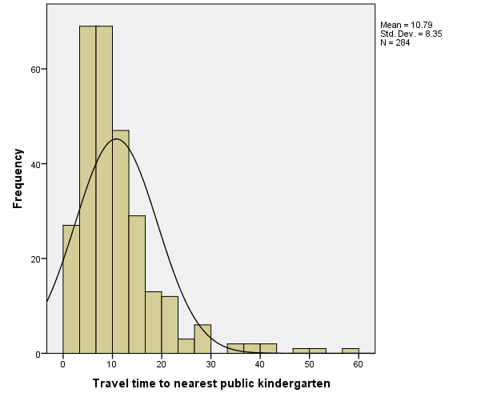

GRAPH
/HISTOGRAM(NORMAL)=trvtime_edprm_min.

Graph

Notes
Output Created |  | 14-MAR-2018 20:06:11
Comments
Input | Data | F:\Data_Final\3cases_traveltime_indec.sav
Input | Active Dataset | DataSet1
Input | Filter | <none>
Input | Weight | <none>
Input | Split File | <none>
Input | N of Rows in Working Data File | 284
Syntax |  | GRAPH  /HISTOGRAM(NORMAL)=trvtime_edprm_min.
Resources | Processor Time | 00:00:00.31
Resources | Elapsed Time | 00:00:00.23

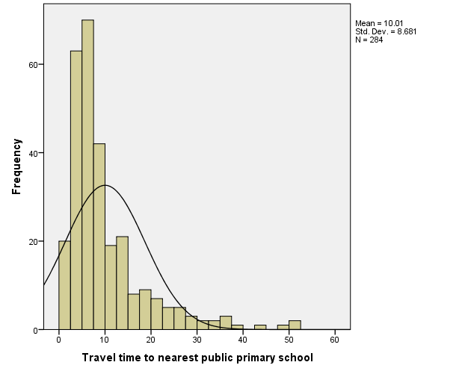

GRAPH
/HISTOGRAM(NORMAL)=trvtime_edsec_min.

Graph

Notes
Output Created |  | 14-MAR-2018 20:06:21
Comments
Input | Data | F:\Data_Final\3cases_traveltime_indec.sav
Input | Active Dataset | DataSet1
Input | Filter | <none>
Input | Weight | <none>
Input | Split File | <none>
Input | N of Rows in Working Data File | 284
Syntax |  | GRAPH  /HISTOGRAM(NORMAL)=trvtime_edsec_min.
Resources | Processor Time | 00:00:00.30
Resources | Elapsed Time | 00:00:00.23

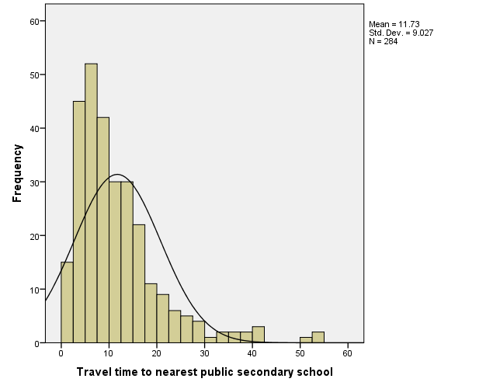

GRAPH
/HISTOGRAM(NORMAL)=trvtime_edsec_min
/PANEL ROWVAR=COVERAGE_LEVEL ROWOP=CROSS.

Graph

Notes
Output Created |  | 14-MAR-2018 20:09:14
Comments
Input | Data | F:\Data_Final\3cases_traveltime_indec.sav
Input | Active Dataset | DataSet1
Input | Filter | <none>
Input | Weight | <none>
Input | Split File | <none>
Input | N of Rows in Working Data File | 284
Syntax |  | GRAPH  /HISTOGRAM(NORMAL)=trvtime_edsec_min  /PANEL ROWVAR=COVERAGE_LEVEL ROWOP=CROSS.
Resources | Processor Time | 00:00:00.30
Resources | Elapsed Time | 00:00:00.25

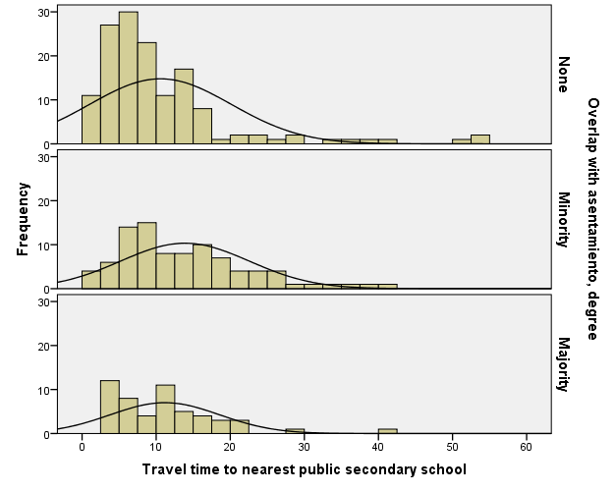

DATASET ACTIVATE DataSet1.

SAVE OUTFILE='F:\Data_Final\3cases_traveltime_indec.sav'
/COMPRESSED.
GRAPH
/HISTOGRAM(NORMAL)=trvtime_edprm_min
/PANEL ROWVAR=COVERAGE_LEVEL ROWOP=CROSS.

Graph

Notes
Output Created |  | 14-MAR-2018 20:10:02
Comments
Input | Data | F:\Data_Final\3cases_traveltime_indec.sav
Input | Active Dataset | DataSet1
Input | Filter | <none>
Input | Weight | <none>
Input | Split File | <none>
Input | N of Rows in Working Data File | 284
Syntax |  | GRAPH  /HISTOGRAM(NORMAL)=trvtime_edprm_min  /PANEL ROWVAR=COVERAGE_LEVEL ROWOP=CROSS.
Resources | Processor Time | 00:00:00.33
Resources | Elapsed Time | 00:00:00.25

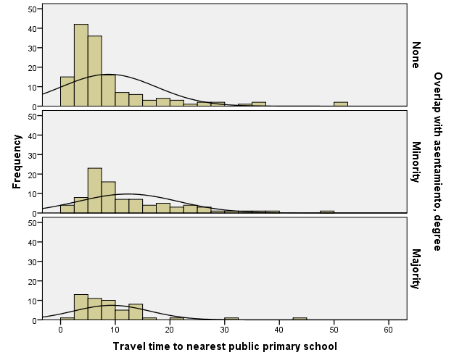

DATASET ACTIVATE DataSet1.

SAVE OUTFILE='F:\Data_Final\3cases_traveltime_indec.sav'
/COMPRESSED.
GRAPH
/HISTOGRAM(NORMAL)=trvtime_edknd_min
/PANEL ROWVAR=COVERAGE_LEVEL ROWOP=CROSS.

Graph

Notes
Output Created |  | 14-MAR-2018 20:10:57
Comments
Input | Data | F:\Data_Final\3cases_traveltime_indec.sav
Input | Active Dataset | DataSet1
Input | Filter | <none>
Input | Weight | <none>
Input | Split File | <none>
Input | N of Rows in Working Data File | 284
Syntax |  | GRAPH  /HISTOGRAM(NORMAL)=trvtime_edknd_min  /PANEL ROWVAR=COVERAGE_LEVEL ROWOP=CROSS.
Resources | Processor Time | 00:00:00.33
Resources | Elapsed Time | 00:00:00.23

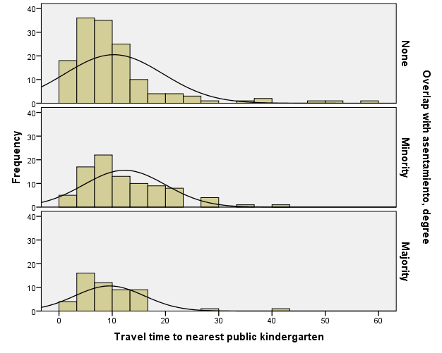

GRAPH
/HISTOGRAM(NORMAL)=trvtime_cbd_bsas
/PANEL ROWVAR=COVERAGE_LEVEL ROWOP=CROSS.

Graph

Notes
Output Created |  | 14-MAR-2018 20:11:23
Comments
Input | Data | F:\Data_Final\3cases_traveltime_indec.sav
Input | Active Dataset | DataSet1
Input | Filter | <none>
Input | Weight | <none>
Input | Split File | <none>
Input | N of Rows in Working Data File | 284
Syntax |  | GRAPH  /HISTOGRAM(NORMAL)=trvtime_cbd_bsas  /PANEL ROWVAR=COVERAGE_LEVEL ROWOP=CROSS.
Resources | Processor Time | 00:00:00.28
Resources | Elapsed Time | 00:00:00.23

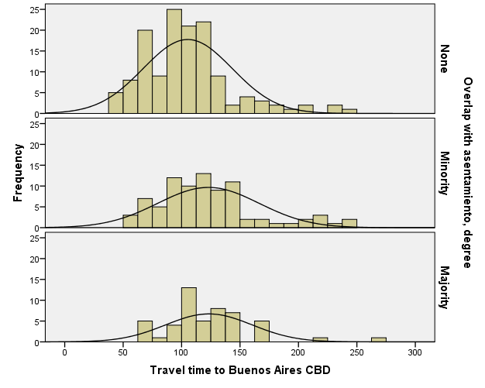

GRAPH
/HISTOGRAM(NORMAL)=trvtime_cbd_loc
/PANEL ROWVAR=COVERAGE_LEVEL ROWOP=CROSS.

Graph

Notes
Output Created |  | 14-MAR-2018 20:11:34
Comments
Input | Data | F:\Data_Final\3cases_traveltime_indec.sav
Input | Active Dataset | DataSet1
Input | Filter | <none>
Input | Weight | <none>
Input | Split File | <none>
Input | N of Rows in Working Data File | 284
Syntax |  | GRAPH  /HISTOGRAM(NORMAL)=trvtime_cbd_loc  /PANEL ROWVAR=COVERAGE_LEVEL ROWOP=CROSS.
Resources | Processor Time | 00:00:00.31
Resources | Elapsed Time | 00:00:00.23

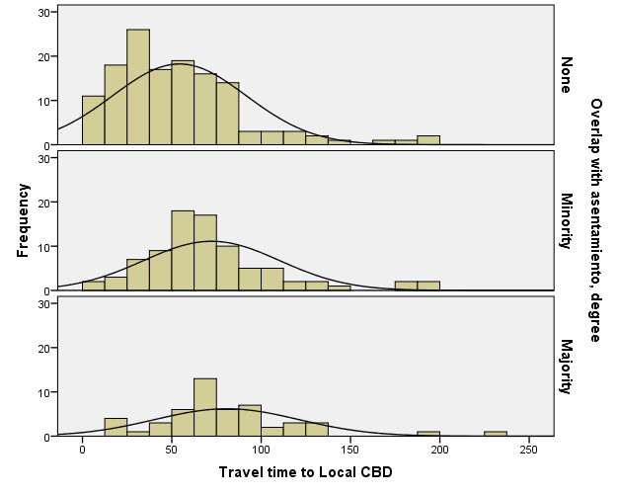

GRAPH
/HISTOGRAM(NORMAL)=trvtime_cbd_ngh_min
/PANEL ROWVAR=COVERAGE_LEVEL ROWOP=CROSS.

Graph

Notes
Output Created |  | 14-MAR-2018 20:11:46
Comments
Input | Data | F:\Data_Final\3cases_traveltime_indec.sav
Input | Active Dataset | DataSet1
Input | Filter | <none>
Input | Weight | <none>
Input | Split File | <none>
Input | N of Rows in Working Data File | 284
Syntax |  | GRAPH  /HISTOGRAM(NORMAL)=trvtime_cbd_ngh_min  /PANEL ROWVAR=COVERAGE_LEVEL ROWOP=CROSS.
Resources | Processor Time | 00:00:00.33
Resources | Elapsed Time | 00:00:00.23

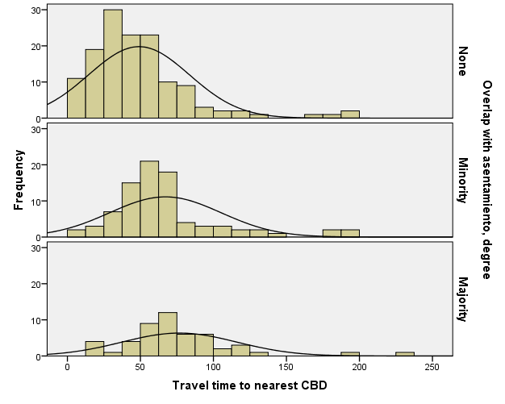

GRAPH
/HISTOGRAM(NORMAL)=trvtime_rail_min
/PANEL ROWVAR=COVERAGE_LEVEL ROWOP=CROSS.

Graph

Notes
Output Created |  | 14-MAR-2018 20:12:03
Comments
Input | Data | F:\Data_Final\3cases_traveltime_indec.sav
Input | Active Dataset | DataSet1
Input | Filter | <none>
Input | Weight | <none>
Input | Split File | <none>
Input | N of Rows in Working Data File | 284
Syntax |  | GRAPH  /HISTOGRAM(NORMAL)=trvtime_rail_min  /PANEL ROWVAR=COVERAGE_LEVEL ROWOP=CROSS.
Resources | Processor Time | 00:00:00.22
Resources | Elapsed Time | 00:00:00.22

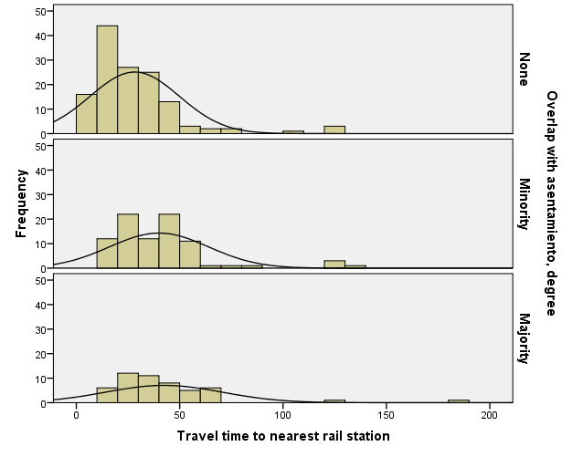

GRAPH
/HISTOGRAM(NORMAL)=trvtime_upa_min
/PANEL ROWVAR=COVERAGE_LEVEL ROWOP=CROSS.

Graph

Notes
Output Created |  | 14-MAR-2018 20:12:12
Comments
Input | Data | F:\Data_Final\3cases_traveltime_indec.sav
Input | Active Dataset | DataSet1
Input | Filter | <none>
Input | Weight | <none>
Input | Split File | <none>
Input | N of Rows in Working Data File | 284
Syntax |  | GRAPH  /HISTOGRAM(NORMAL)=trvtime_upa_min  /PANEL ROWVAR=COVERAGE_LEVEL ROWOP=CROSS.
Resources | Processor Time | 00:00:00.27
Resources | Elapsed Time | 00:00:00.23

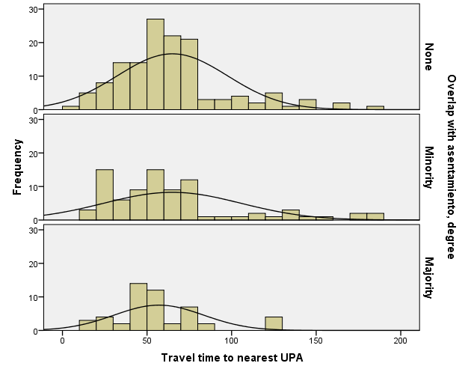

GRAPH
/HISTOGRAM(NORMAL)=trvtime_hspt_min
/PANEL ROWVAR=COVERAGE_LEVEL ROWOP=CROSS.

Graph

Notes
Output Created |  | 14-MAR-2018 20:12:22
Comments
Input | Data | F:\Data_Final\3cases_traveltime_indec.sav
Input | Active Dataset | DataSet1
Input | Filter | <none>
Input | Weight | <none>
Input | Split File | <none>
Input | N of Rows in Working Data File | 284
Syntax |  | GRAPH  /HISTOGRAM(NORMAL)=trvtime_hspt_min  /PANEL ROWVAR=COVERAGE_LEVEL ROWOP=CROSS.
Resources | Processor Time | 00:00:00.25
Resources | Elapsed Time | 00:00:00.23

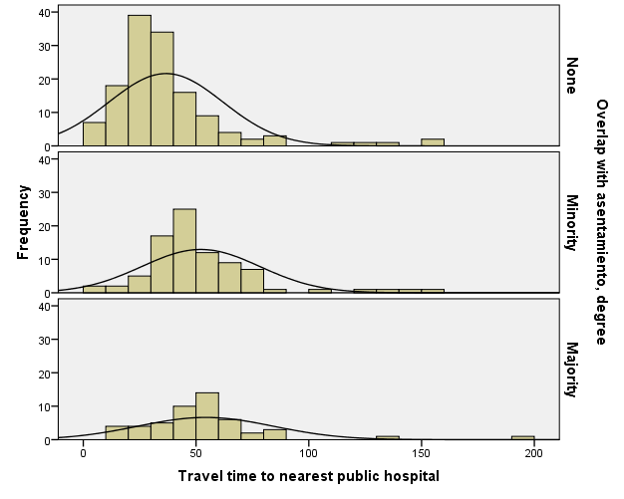

GRAPH
/HISTOGRAM(NORMAL)=trvtime_dgntrt_min
/PANEL ROWVAR=COVERAGE_LEVEL ROWOP=CROSS.

Graph

Notes
Output Created |  | 14-MAR-2018 20:12:32
Comments
Input | Data | F:\Data_Final\3cases_traveltime_indec.sav
Input | Active Dataset | DataSet1
Input | Filter | <none>
Input | Weight | <none>
Input | Split File | <none>
Input | N of Rows in Working Data File | 284
Syntax |  | GRAPH  /HISTOGRAM(NORMAL)=trvtime_dgntrt_min  /PANEL ROWVAR=COVERAGE_LEVEL ROWOP=CROSS.
Resources | Processor Time | 00:00:00.39
Resources | Elapsed Time | 00:00:00.25

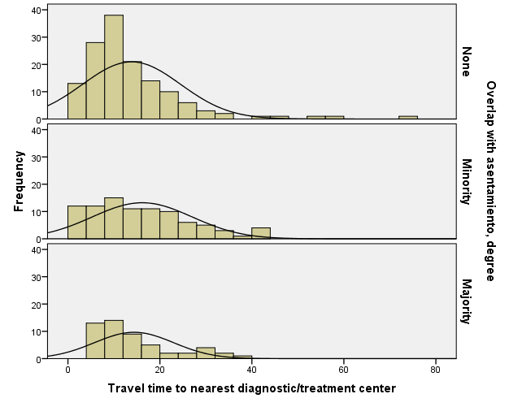

GRAPH
/HISTOGRAM(NORMAL)=trvtime_cbd_bsas
/PANEL ROWVAR=ASENTANY_YN ROWOP=CROSS.

Graph

Notes
Output Created |  | 14-MAR-2018 20:13:03
Comments
Input | Data | F:\Data_Final\3cases_traveltime_indec.sav
Input | Active Dataset | DataSet1
Input | Filter | <none>
Input | Weight | <none>
Input | Split File | <none>
Input | N of Rows in Working Data File | 284
Syntax |  | GRAPH  /HISTOGRAM(NORMAL)=trvtime_cbd_bsas  /PANEL ROWVAR=ASENTANY_YN ROWOP=CROSS.
Resources | Processor Time | 00:00:00.22
Resources | Elapsed Time | 00:00:00.22

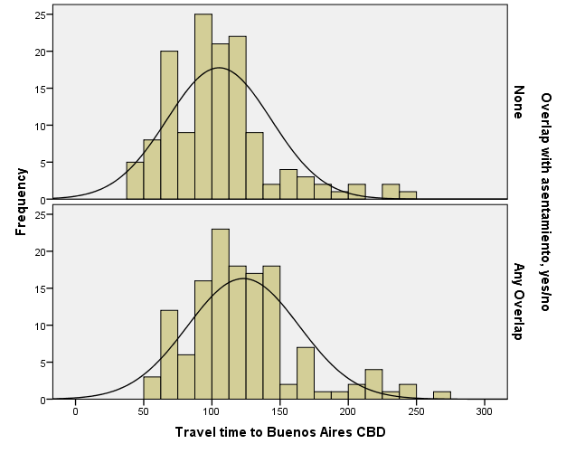

GRAPH
/HISTOGRAM(NORMAL)=trvtime_cbd_bsas
/PANEL ROWVAR=ASENTANY_YN ROWOP=CROSS.

Graph

Notes
Output Created |  | 14-MAR-2018 20:13:36
Comments
Input | Data | F:\Data_Final\3cases_traveltime_indec.sav
Input | Active Dataset | DataSet1
Input | Filter | <none>
Input | Weight | <none>
Input | Split File | <none>
Input | N of Rows in Working Data File | 284
Syntax |  | GRAPH  /HISTOGRAM(NORMAL)=trvtime_cbd_bsas  /PANEL ROWVAR=ASENTANY_YN ROWOP=CROSS.
Resources | Processor Time | 00:00:00.34
Resources | Elapsed Time | 00:00:00.22

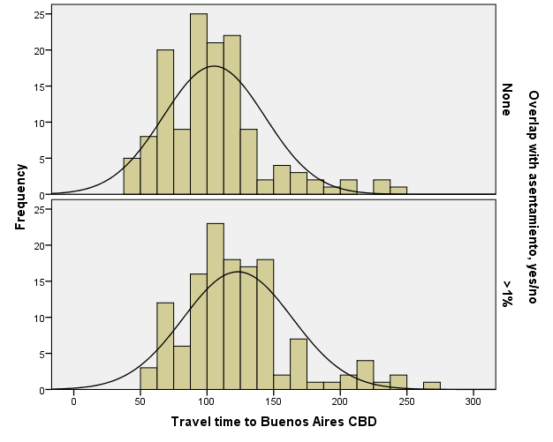

GRAPH
/HISTOGRAM(NORMAL)=trvtime_cbd_bsas
/PANEL ROWVAR=ASENTANY_YN ROWOP=CROSS.

Graph

Notes
Output Created |  | 14-MAR-2018 20:14:05
Comments
Input | Data | F:\Data_Final\3cases_traveltime_indec.sav
Input | Active Dataset | DataSet1
Input | Filter | <none>
Input | Weight | <none>
Input | Split File | <none>
Input | N of Rows in Working Data File | 284
Syntax |  | GRAPH  /HISTOGRAM(NORMAL)=trvtime_cbd_bsas  /PANEL ROWVAR=ASENTANY_YN ROWOP=CROSS.
Resources | Processor Time | 00:00:00.34
Resources | Elapsed Time | 00:00:00.23

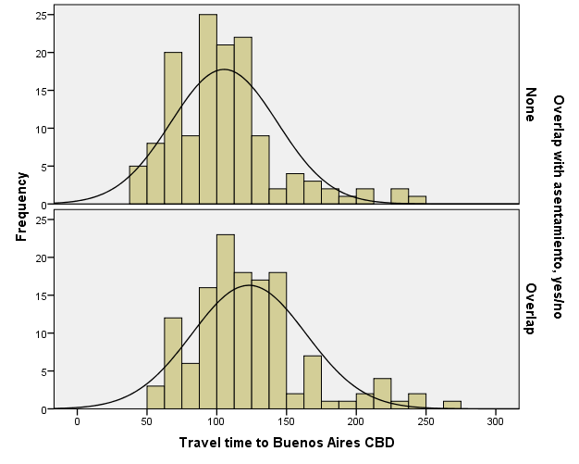

GRAPH
/HISTOGRAM(NORMAL)=trvtime_cbd_loc
/PANEL ROWVAR=ASENTANY_YN ROWOP=CROSS.

Graph

Notes
Output Created |  | 14-MAR-2018 20:14:13
Comments
Input | Data | F:\Data_Final\3cases_traveltime_indec.sav
Input | Active Dataset | DataSet1
Input | Filter | <none>
Input | Weight | <none>
Input | Split File | <none>
Input | N of Rows in Working Data File | 284
Syntax |  | GRAPH  /HISTOGRAM(NORMAL)=trvtime_cbd_loc  /PANEL ROWVAR=ASENTANY_YN ROWOP=CROSS.
Resources | Processor Time | 00:00:00.23
Resources | Elapsed Time | 00:00:00.23

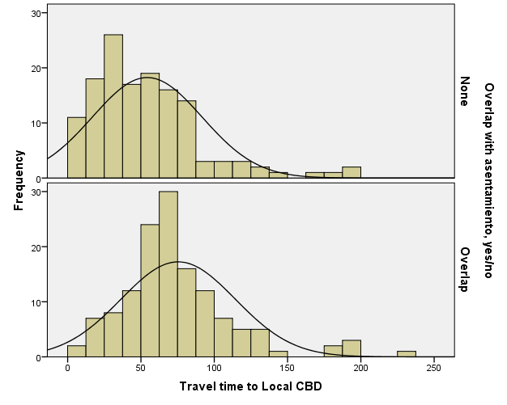

GRAPH
/HISTOGRAM(NORMAL)=trvtime_cbd_ngh_min
/PANEL ROWVAR=ASENTANY_YN ROWOP=CROSS.

Graph

Notes
Output Created |  | 14-MAR-2018 20:14:22
Comments
Input | Data | F:\Data_Final\3cases_traveltime_indec.sav
Input | Active Dataset | DataSet1
Input | Filter | <none>
Input | Weight | <none>
Input | Split File | <none>
Input | N of Rows in Working Data File | 284
Syntax |  | GRAPH  /HISTOGRAM(NORMAL)=trvtime_cbd_ngh_min  /PANEL ROWVAR=ASENTANY_YN ROWOP=CROSS.
Resources | Processor Time | 00:00:00.22
Resources | Elapsed Time | 00:00:00.22

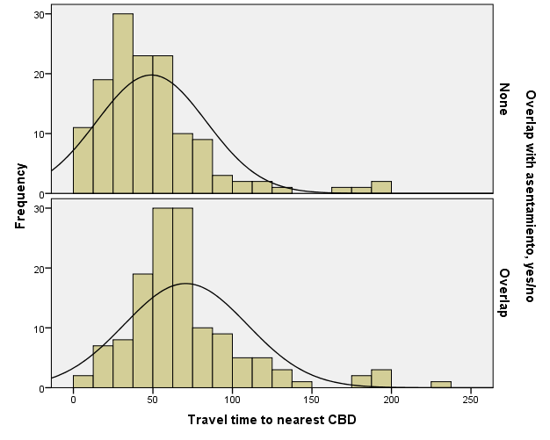

GRAPH
/HISTOGRAM(NORMAL)=trvtime_rail_min
/PANEL ROWVAR=ASENTANY_YN ROWOP=CROSS.

Graph

Notes
Output Created |  | 14-MAR-2018 20:14:33
Comments
Input | Data | F:\Data_Final\3cases_traveltime_indec.sav
Input | Active Dataset | DataSet1
Input | Filter | <none>
Input | Weight | <none>
Input | Split File | <none>
Input | N of Rows in Working Data File | 284
Syntax |  | GRAPH  /HISTOGRAM(NORMAL)=trvtime_rail_min  /PANEL ROWVAR=ASENTANY_YN ROWOP=CROSS.
Resources | Processor Time | 00:00:00.44
Resources | Elapsed Time | 00:00:00.23

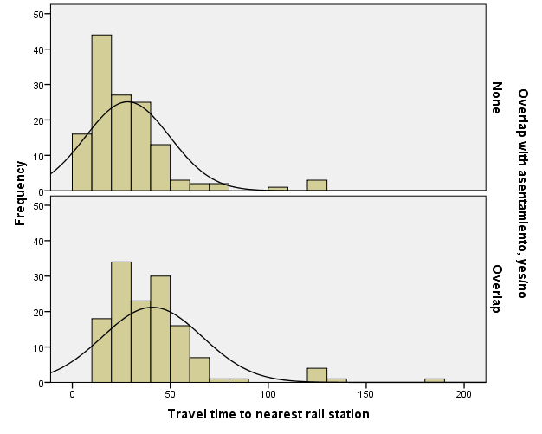

GRAPH
/HISTOGRAM(NORMAL)=trvtime_upa_min
/PANEL ROWVAR=ASENTANY_YN ROWOP=CROSS.

Graph

Notes
Output Created |  | 14-MAR-2018 20:14:45
Comments
Input | Data | F:\Data_Final\3cases_traveltime_indec.sav
Input | Active Dataset | DataSet1
Input | Filter | <none>
Input | Weight | <none>
Input | Split File | <none>
Input | N of Rows in Working Data File | 284
Syntax |  | GRAPH  /HISTOGRAM(NORMAL)=trvtime_upa_min  /PANEL ROWVAR=ASENTANY_YN ROWOP=CROSS.
Resources | Processor Time | 00:00:00.23
Resources | Elapsed Time | 00:00:00.22

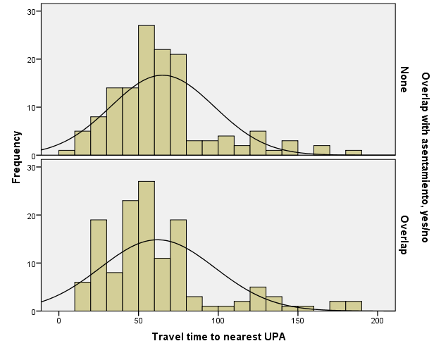

GRAPH
/HISTOGRAM(NORMAL)=trvtime_hspt_min
/PANEL ROWVAR=ASENTANY_YN ROWOP=CROSS.

Graph

Notes
Output Created |  | 14-MAR-2018 20:15:02
Comments
Input | Data | F:\Data_Final\3cases_traveltime_indec.sav
Input | Active Dataset | DataSet1
Input | Filter | <none>
Input | Weight | <none>
Input | Split File | <none>
Input | N of Rows in Working Data File | 284
Syntax |  | GRAPH  /HISTOGRAM(NORMAL)=trvtime_hspt_min  /PANEL ROWVAR=ASENTANY_YN ROWOP=CROSS.
Resources | Processor Time | 00:00:00.28
Resources | Elapsed Time | 00:00:00.23

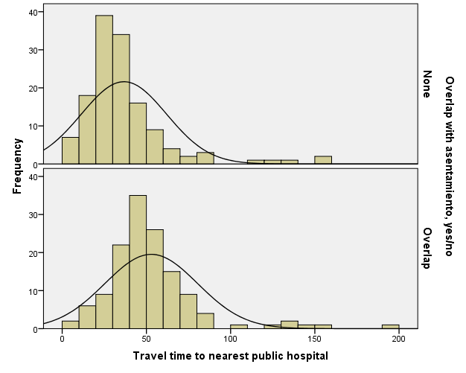

GRAPH
/HISTOGRAM(NORMAL)=trvtime_dgntrt_min
/PANEL ROWVAR=ASENTANY_YN ROWOP=CROSS.

Graph

Notes
Output Created |  | 14-MAR-2018 20:15:09
Comments
Input | Data | F:\Data_Final\3cases_traveltime_indec.sav
Input | Active Dataset | DataSet1
Input | Filter | <none>
Input | Weight | <none>
Input | Split File | <none>
Input | N of Rows in Working Data File | 284
Syntax |  | GRAPH  /HISTOGRAM(NORMAL)=trvtime_dgntrt_min  /PANEL ROWVAR=ASENTANY_YN ROWOP=CROSS.
Resources | Processor Time | 00:00:00.27
Resources | Elapsed Time | 00:00:00.23

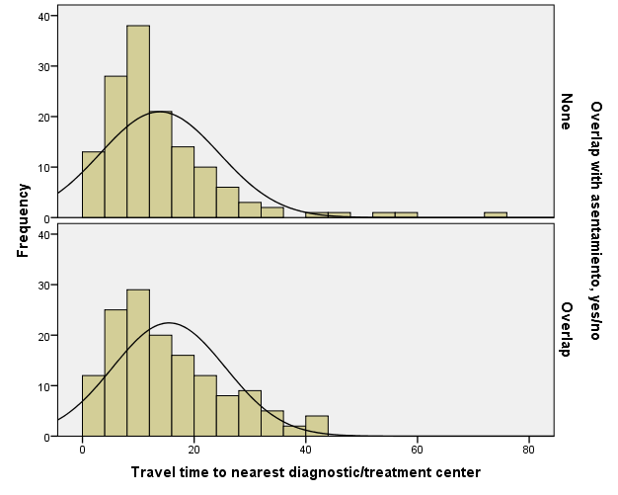

GRAPH
/HISTOGRAM(NORMAL)=trvtime_edknd_min
/PANEL ROWVAR=ASENTANY_YN ROWOP=CROSS.

Graph

Notes
Output Created |  | 14-MAR-2018 20:15:17
Comments
Input | Data | F:\Data_Final\3cases_traveltime_indec.sav
Input | Active Dataset | DataSet1
Input | Filter | <none>
Input | Weight | <none>
Input | Split File | <none>
Input | N of Rows in Working Data File | 284
Syntax |  | GRAPH  /HISTOGRAM(NORMAL)=trvtime_edknd_min  /PANEL ROWVAR=ASENTANY_YN ROWOP=CROSS.
Resources | Processor Time | 00:00:00.23
Resources | Elapsed Time | 00:00:00.23

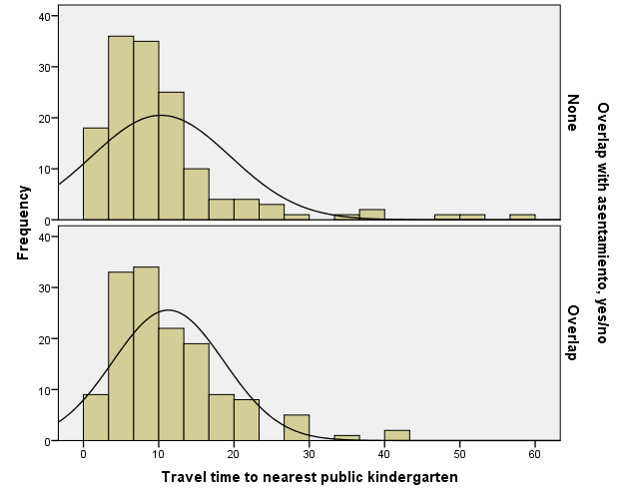

GRAPH
/HISTOGRAM(NORMAL)=trvtime_edprm_min
/PANEL ROWVAR=ASENTANY_YN ROWOP=CROSS.

Graph

Notes
Output Created |  | 14-MAR-2018 20:15:34
Comments
Input | Data | F:\Data_Final\3cases_traveltime_indec.sav
Input | Active Dataset | DataSet1
Input | Filter | <none>
Input | Weight | <none>
Input | Split File | <none>
Input | N of Rows in Working Data File | 284
Syntax |  | GRAPH  /HISTOGRAM(NORMAL)=trvtime_edprm_min  /PANEL ROWVAR=ASENTANY_YN ROWOP=CROSS.
Resources | Processor Time | 00:00:00.23
Resources | Elapsed Time | 00:00:00.23

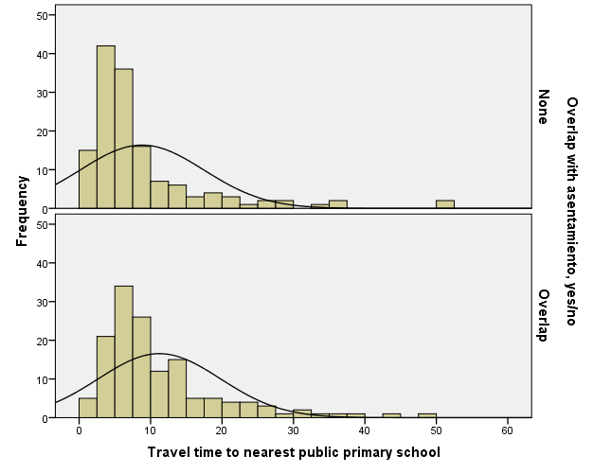

GRAPH
/HISTOGRAM(NORMAL)=trvtime_edsec_min
/PANEL ROWVAR=ASENTANY_YN ROWOP=CROSS.

Graph

Notes
Output Created |  | 14-MAR-2018 20:15:42
Comments
Input | Data | F:\Data_Final\3cases_traveltime_indec.sav
Input | Active Dataset | DataSet1
Input | Filter | <none>
Input | Weight | <none>
Input | Split File | <none>
Input | N of Rows in Working Data File | 284
Syntax |  | GRAPH  /HISTOGRAM(NORMAL)=trvtime_edsec_min  /PANEL ROWVAR=ASENTANY_YN ROWOP=CROSS.
Resources | Processor Time | 00:00:00.25
Resources | Elapsed Time | 00:00:00.22

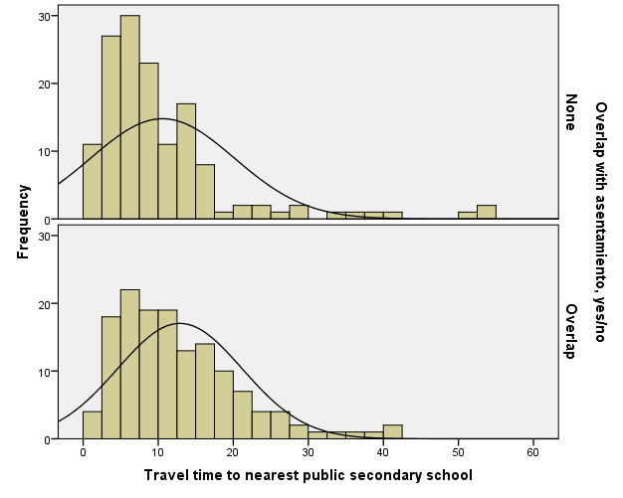

GRAPH
/HISTOGRAM(NORMAL)=trvtime_cbd_bsas
/PANEL ROWVAR=DEPTO ROWOP=CROSS.

Graph

Notes
Output Created |  | 14-MAR-2018 20:15:58
Comments
Input | Data | F:\Data_Final\3cases_traveltime_indec.sav
Input | Active Dataset | DataSet1
Input | Filter | <none>
Input | Weight | <none>
Input | Split File | <none>
Input | N of Rows in Working Data File | 284
Syntax |  | GRAPH  /HISTOGRAM(NORMAL)=trvtime_cbd_bsas  /PANEL ROWVAR=DEPTO ROWOP=CROSS.
Resources | Processor Time | 00:00:00.25
Resources | Elapsed Time | 00:00:00.22

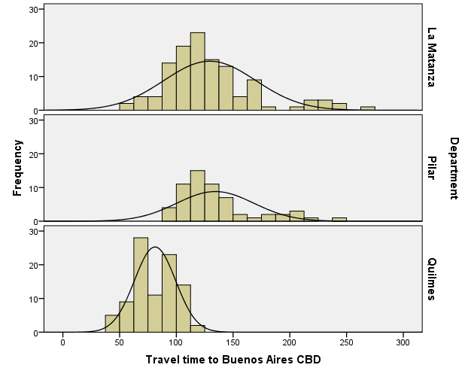

GRAPH
/HISTOGRAM(NORMAL)=trvtime_cbd_loc
/PANEL ROWVAR=DEPTO ROWOP=CROSS.

Graph

Notes
Output Created |  | 14-MAR-2018 20:16:16
Comments
Input | Data | F:\Data_Final\3cases_traveltime_indec.sav
Input | Active Dataset | DataSet1
Input | Filter | <none>
Input | Weight | <none>
Input | Split File | <none>
Input | N of Rows in Working Data File | 284
Syntax |  | GRAPH  /HISTOGRAM(NORMAL)=trvtime_cbd_loc  /PANEL ROWVAR=DEPTO ROWOP=CROSS.
Resources | Processor Time | 00:00:00.27
Resources | Elapsed Time | 00:00:00.23

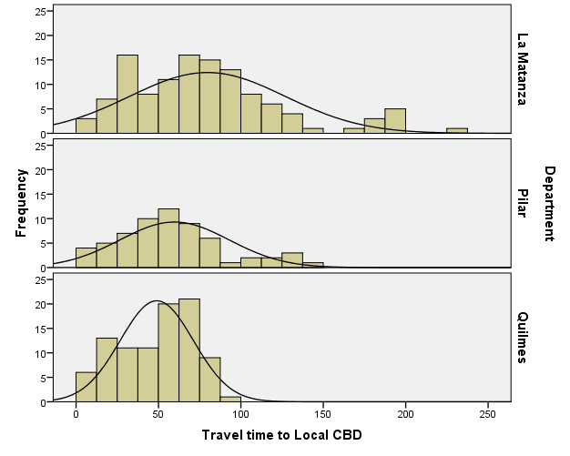

GRAPH
/HISTOGRAM(NORMAL)=trvtime_cbd_ngh_min
/PANEL ROWVAR=DEPTO ROWOP=CROSS.

Graph

Notes
Output Created |  | 14-MAR-2018 20:16:25
Comments
Input | Data | F:\Data_Final\3cases_traveltime_indec.sav
Input | Active Dataset | DataSet1
Input | Filter | <none>
Input | Weight | <none>
Input | Split File | <none>
Input | N of Rows in Working Data File | 284
Syntax |  | GRAPH  /HISTOGRAM(NORMAL)=trvtime_cbd_ngh_min  /PANEL ROWVAR=DEPTO ROWOP=CROSS.
Resources | Processor Time | 00:00:00.25
Resources | Elapsed Time | 00:00:00.23

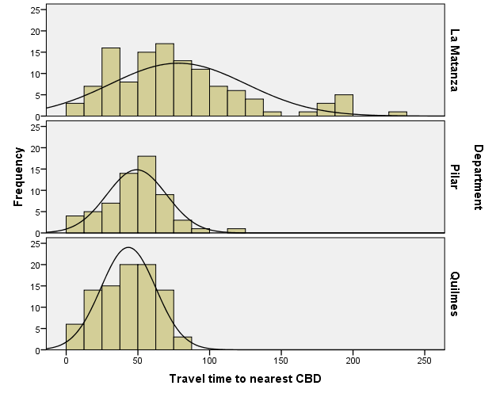

GRAPH
/HISTOGRAM(NORMAL)=trvtime_rail_min
/PANEL ROWVAR=DEPTO ROWOP=CROSS.

Graph

Notes
Output Created |  | 14-MAR-2018 20:16:37
Comments
Input | Data | F:\Data_Final\3cases_traveltime_indec.sav
Input | Active Dataset | DataSet1
Input | Filter | <none>
Input | Weight | <none>
Input | Split File | <none>
Input | N of Rows in Working Data File | 284
Syntax |  | GRAPH  /HISTOGRAM(NORMAL)=trvtime_rail_min  /PANEL ROWVAR=DEPTO ROWOP=CROSS.
Resources | Processor Time | 00:00:00.25
Resources | Elapsed Time | 00:00:00.23

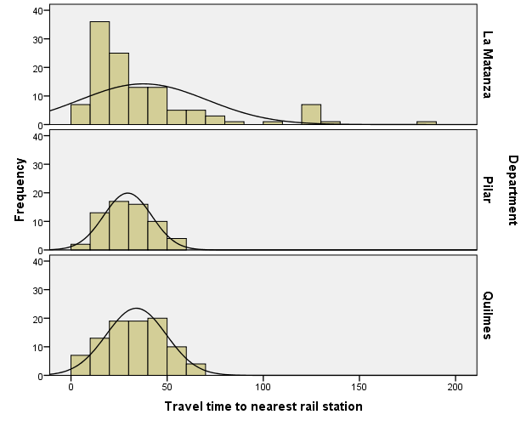

GRAPH
/HISTOGRAM(NORMAL)=trvtime_upa_min
/PANEL ROWVAR=DEPTO ROWOP=CROSS.

Graph

Notes
Output Created |  | 14-MAR-2018 20:16:50
Comments
Input | Data | F:\Data_Final\3cases_traveltime_indec.sav
Input | Active Dataset | DataSet1
Input | Filter | <none>
Input | Weight | <none>
Input | Split File | <none>
Input | N of Rows in Working Data File | 284
Syntax |  | GRAPH  /HISTOGRAM(NORMAL)=trvtime_upa_min  /PANEL ROWVAR=DEPTO ROWOP=CROSS.
Resources | Processor Time | 00:00:00.28
Resources | Elapsed Time | 00:00:00.23

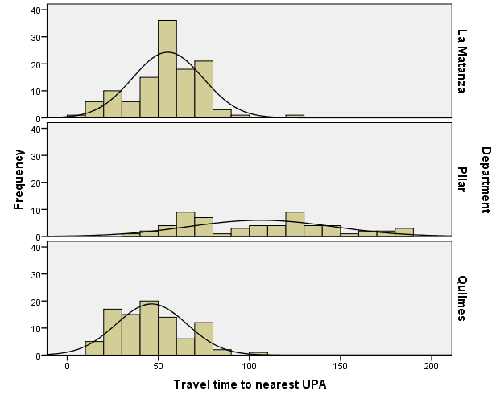

GRAPH
/HISTOGRAM(NORMAL)=trvtime_hspt_min
/PANEL ROWVAR=DEPTO ROWOP=CROSS.

Graph

Notes
Output Created |  | 14-MAR-2018 20:17:02
Comments
Input | Data | F:\Data_Final\3cases_traveltime_indec.sav
Input | Active Dataset | DataSet1
Input | Filter | <none>
Input | Weight | <none>
Input | Split File | <none>
Input | N of Rows in Working Data File | 284
Syntax |  | GRAPH  /HISTOGRAM(NORMAL)=trvtime_hspt_min  /PANEL ROWVAR=DEPTO ROWOP=CROSS.
Resources | Processor Time | 00:00:00.22
Resources | Elapsed Time | 00:00:00.22

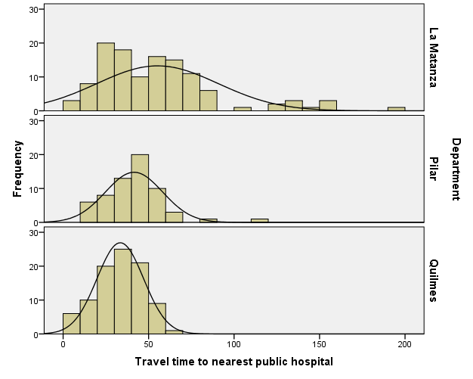

GRAPH
/HISTOGRAM(NORMAL)=trvtime_dgntrt_min
/PANEL ROWVAR=DEPTO ROWOP=CROSS.

Graph

Notes
Output Created |  | 14-MAR-2018 20:17:09
Comments
Input | Data | F:\Data_Final\3cases_traveltime_indec.sav
Input | Active Dataset | DataSet1
Input | Filter | <none>
Input | Weight | <none>
Input | Split File | <none>
Input | N of Rows in Working Data File | 284
Syntax |  | GRAPH  /HISTOGRAM(NORMAL)=trvtime_dgntrt_min  /PANEL ROWVAR=DEPTO ROWOP=CROSS.
Resources | Processor Time | 00:00:00.23
Resources | Elapsed Time | 00:00:00.23

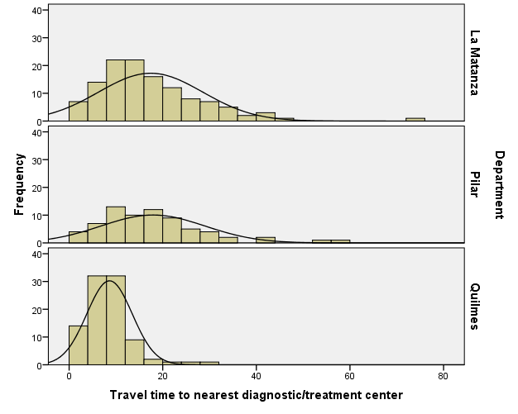

GRAPH
/HISTOGRAM(NORMAL)=trvtime_edknd_min
/PANEL ROWVAR=DEPTO ROWOP=CROSS.

Graph

Notes
Output Created |  | 14-MAR-2018 20:17:20
Comments
Input | Data | F:\Data_Final\3cases_traveltime_indec.sav
Input | Active Dataset | DataSet1
Input | Filter | <none>
Input | Weight | <none>
Input | Split File | <none>
Input | N of Rows in Working Data File | 284
Syntax |  | GRAPH  /HISTOGRAM(NORMAL)=trvtime_edknd_min  /PANEL ROWVAR=DEPTO ROWOP=CROSS.
Resources | Processor Time | 00:00:00.23
Resources | Elapsed Time | 00:00:00.23

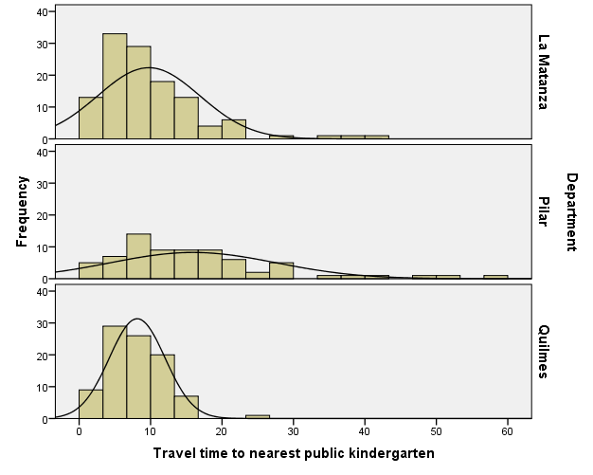

GRAPH
/HISTOGRAM(NORMAL)=trvtime_edprm_min
/PANEL ROWVAR=DEPTO ROWOP=CROSS.

Graph

Notes
Output Created |  | 14-MAR-2018 20:17:28
Comments
Input | Data | F:\Data_Final\3cases_traveltime_indec.sav
Input | Active Dataset | DataSet1
Input | Filter | <none>
Input | Weight | <none>
Input | Split File | <none>
Input | N of Rows in Working Data File | 284
Syntax |  | GRAPH  /HISTOGRAM(NORMAL)=trvtime_edprm_min  /PANEL ROWVAR=DEPTO ROWOP=CROSS.
Resources | Processor Time | 00:00:00.25
Resources | Elapsed Time | 00:00:00.23

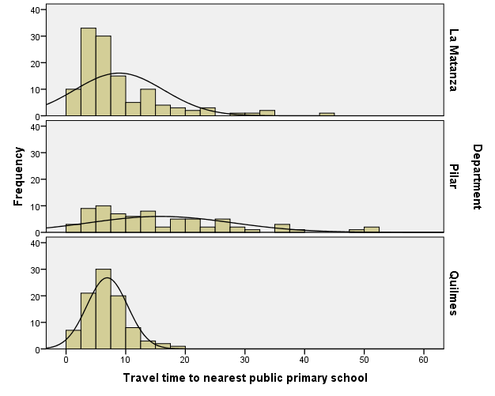

GRAPH
/HISTOGRAM(NORMAL)=trvtime_edsec_min
/PANEL ROWVAR=DEPTO ROWOP=CROSS.

Graph

Notes
Output Created |  | 14-MAR-2018 20:17:38
Comments
Input | Data | F:\Data_Final\3cases_traveltime_indec.sav
Input | Active Dataset | DataSet1
Input | Filter | <none>
Input | Weight | <none>
Input | Split File | <none>
Input | N of Rows in Working Data File | 284
Syntax |  | GRAPH  /HISTOGRAM(NORMAL)=trvtime_edsec_min  /PANEL ROWVAR=DEPTO ROWOP=CROSS.
Resources | Processor Time | 00:00:00.23
Resources | Elapsed Time | 00:00:00.22

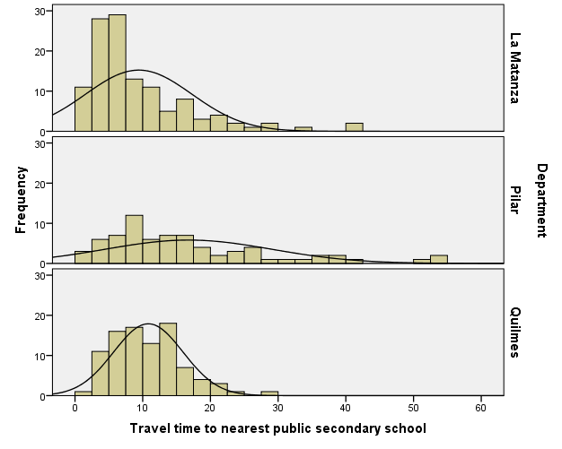

GRAPH
/HISTOGRAM(NORMAL)=trvtime_cbd_bsas
/PANEL COLVAR=DEPTO COLOP=CROSS ROWVAR=COVERAGE_LEVEL ROWOP=CROSS.

Graph

Notes
Output Created |  | 14-MAR-2018 20:18:09
Comments
Input | Data | F:\Data_Final\3cases_traveltime_indec.sav
Input | Active Dataset | DataSet1
Input | Filter | <none>
Input | Weight | <none>
Input | Split File | <none>
Input | N of Rows in Working Data File | 284
Syntax |  | GRAPH  /HISTOGRAM(NORMAL)=trvtime_cbd_bsas  /PANEL COLVAR=DEPTO COLOP=CROSS ROWVAR=COVERAGE_LEVEL ROWOP=CROSS.
Resources | Processor Time | 00:00:00.39
Resources | Elapsed Time | 00:00:00.23

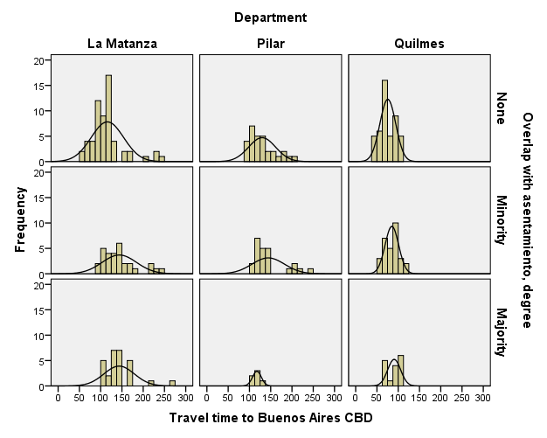

GRAPH
/HISTOGRAM(NORMAL)=trvtime_cbd_loc
/PANEL COLVAR=DEPTO COLOP=CROSS ROWVAR=COVERAGE_LEVEL ROWOP=CROSS.

Graph

Notes
Output Created |  | 14-MAR-2018 20:18:31
Comments
Input | Data | F:\Data_Final\3cases_traveltime_indec.sav
Input | Active Dataset | DataSet1
Input | Filter | <none>
Input | Weight | <none>
Input | Split File | <none>
Input | N of Rows in Working Data File | 284
Syntax |  | GRAPH  /HISTOGRAM(NORMAL)=trvtime_cbd_loc  /PANEL COLVAR=DEPTO COLOP=CROSS ROWVAR=COVERAGE_LEVEL ROWOP=CROSS.
Resources | Processor Time | 00:00:00.23
Resources | Elapsed Time | 00:00:00.23

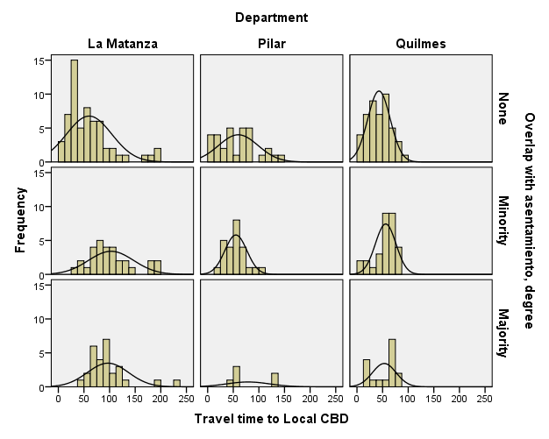

GRAPH
/HISTOGRAM(NORMAL)=trvtime_cbd_ngh_min
/PANEL COLVAR=DEPTO COLOP=CROSS ROWVAR=COVERAGE_LEVEL ROWOP=CROSS.

Graph

Notes
Output Created |  | 14-MAR-2018 20:18:48
Comments
Input | Data | F:\Data_Final\3cases_traveltime_indec.sav
Input | Active Dataset | DataSet1
Input | Filter | <none>
Input | Weight | <none>
Input | Split File | <none>
Input | N of Rows in Working Data File | 284
Syntax |  | GRAPH  /HISTOGRAM(NORMAL)=trvtime_cbd_ngh_min  /PANEL COLVAR=DEPTO COLOP=CROSS ROWVAR=COVERAGE_LEVEL ROWOP=CROSS.
Resources | Processor Time | 00:00:00.25
Resources | Elapsed Time | 00:00:00.25

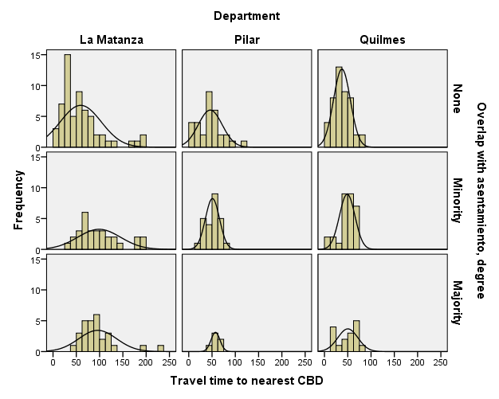

GRAPH
/HISTOGRAM(NORMAL)=trvtime_rail_min
/PANEL COLVAR=DEPTO COLOP=CROSS ROWVAR=COVERAGE_LEVEL ROWOP=CROSS.

Graph

Notes
Output Created |  | 14-MAR-2018 20:18:59
Comments
Input | Data | F:\Data_Final\3cases_traveltime_indec.sav
Input | Active Dataset | DataSet1
Input | Filter | <none>
Input | Weight | <none>
Input | Split File | <none>
Input | N of Rows in Working Data File | 284
Syntax |  | GRAPH  /HISTOGRAM(NORMAL)=trvtime_rail_min  /PANEL COLVAR=DEPTO COLOP=CROSS ROWVAR=COVERAGE_LEVEL ROWOP=CROSS.
Resources | Processor Time | 00:00:00.28
Resources | Elapsed Time | 00:00:00.23

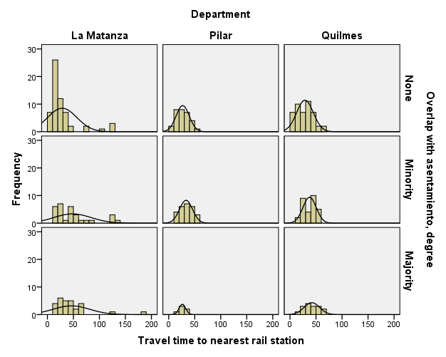

GRAPH
/HISTOGRAM(NORMAL)=trvtime_upa_min
/PANEL COLVAR=DEPTO COLOP=CROSS ROWVAR=COVERAGE_LEVEL ROWOP=CROSS.

Graph

Notes
Output Created |  | 14-MAR-2018 20:19:06
Comments
Input | Data | F:\Data_Final\3cases_traveltime_indec.sav
Input | Active Dataset | DataSet1
Input | Filter | <none>
Input | Weight | <none>
Input | Split File | <none>
Input | N of Rows in Working Data File | 284
Syntax |  | GRAPH  /HISTOGRAM(NORMAL)=trvtime_upa_min  /PANEL COLVAR=DEPTO COLOP=CROSS ROWVAR=COVERAGE_LEVEL ROWOP=CROSS.
Resources | Processor Time | 00:00:00.30
Resources | Elapsed Time | 00:00:00.23

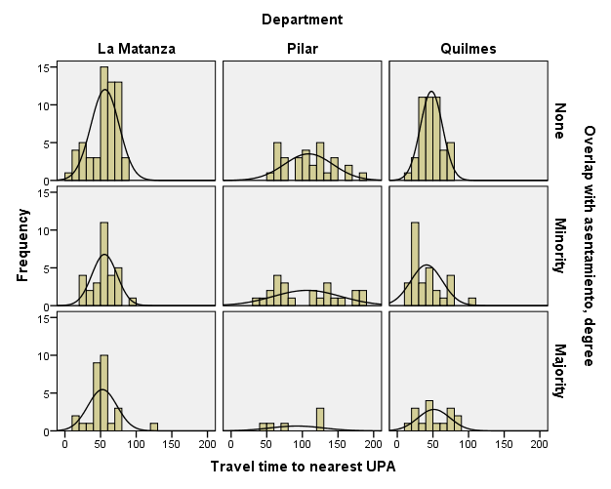

GRAPH
/HISTOGRAM(NORMAL)=trvtime_hspt_min
/PANEL COLVAR=DEPTO COLOP=CROSS ROWVAR=COVERAGE_LEVEL ROWOP=CROSS.

Graph

Notes
Output Created |  | 14-MAR-2018 20:19:34
Comments
Input | Data | F:\Data_Final\3cases_traveltime_indec.sav
Input | Active Dataset | DataSet1
Input | Filter | <none>
Input | Weight | <none>
Input | Split File | <none>
Input | N of Rows in Working Data File | 284
Syntax |  | GRAPH  /HISTOGRAM(NORMAL)=trvtime_hspt_min  /PANEL COLVAR=DEPTO COLOP=CROSS ROWVAR=COVERAGE_LEVEL ROWOP=CROSS.
Resources | Processor Time | 00:00:00.28
Resources | Elapsed Time | 00:00:00.23

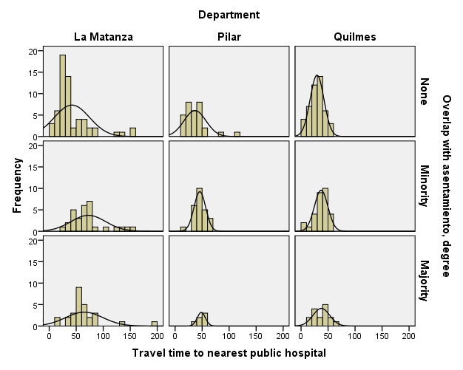

GRAPH
/HISTOGRAM(NORMAL)=trvtime_dgntrt_min
/PANEL COLVAR=DEPTO COLOP=CROSS ROWVAR=COVERAGE_LEVEL ROWOP=CROSS.

Graph

Notes
Output Created |  | 14-MAR-2018 20:19:41
Comments
Input | Data | F:\Data_Final\3cases_traveltime_indec.sav
Input | Active Dataset | DataSet1
Input | Filter | <none>
Input | Weight | <none>
Input | Split File | <none>
Input | N of Rows in Working Data File | 284
Syntax |  | GRAPH  /HISTOGRAM(NORMAL)=trvtime_dgntrt_min  /PANEL COLVAR=DEPTO COLOP=CROSS ROWVAR=COVERAGE_LEVEL ROWOP=CROSS.
Resources | Processor Time | 00:00:00.27
Resources | Elapsed Time | 00:00:00.23

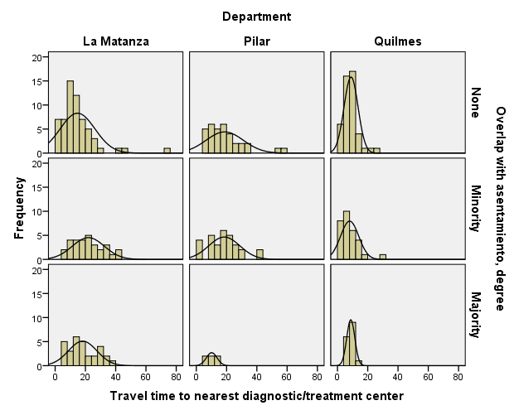

GRAPH
/HISTOGRAM(NORMAL)=trvtime_edknd_min
/PANEL COLVAR=DEPTO COLOP=CROSS ROWVAR=COVERAGE_LEVEL ROWOP=CROSS.

Graph

Notes
Output Created |  | 14-MAR-2018 20:19:49
Comments
Input | Data | F:\Data_Final\3cases_traveltime_indec.sav
Input | Active Dataset | DataSet1
Input | Filter | <none>
Input | Weight | <none>
Input | Split File | <none>
Input | N of Rows in Working Data File | 284
Syntax |  | GRAPH  /HISTOGRAM(NORMAL)=trvtime_edknd_min  /PANEL COLVAR=DEPTO COLOP=CROSS ROWVAR=COVERAGE_LEVEL ROWOP=CROSS.
Resources | Processor Time | 00:00:00.27
Resources | Elapsed Time | 00:00:00.23

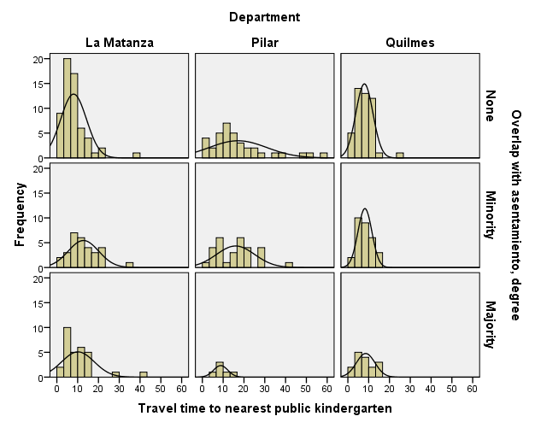

GRAPH
/HISTOGRAM(NORMAL)=trvtime_edprm_min
/PANEL COLVAR=DEPTO COLOP=CROSS ROWVAR=COVERAGE_LEVEL ROWOP=CROSS.

Graph

Notes
Output Created |  | 14-MAR-2018 20:19:56
Comments
Input | Data | F:\Data_Final\3cases_traveltime_indec.sav
Input | Active Dataset | DataSet1
Input | Filter | <none>
Input | Weight | <none>
Input | Split File | <none>
Input | N of Rows in Working Data File | 284
Syntax |  | GRAPH  /HISTOGRAM(NORMAL)=trvtime_edprm_min  /PANEL COLVAR=DEPTO COLOP=CROSS ROWVAR=COVERAGE_LEVEL ROWOP=CROSS.
Resources | Processor Time | 00:00:00.25
Resources | Elapsed Time | 00:00:00.23

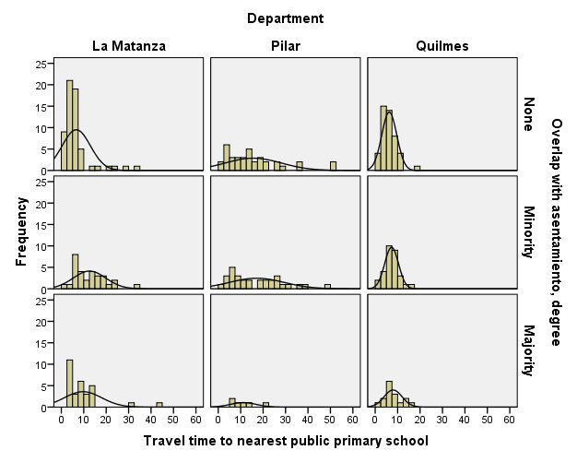

GRAPH
/HISTOGRAM(NORMAL)=trvtime_edsec_min
/PANEL COLVAR=DEPTO COLOP=CROSS ROWVAR=COVERAGE_LEVEL ROWOP=CROSS.

Graph

Notes
Output Created |  | 14-MAR-2018 20:20:03
Comments
Input | Data | F:\Data_Final\3cases_traveltime_indec.sav
Input | Active Dataset | DataSet1
Input | Filter | <none>
Input | Weight | <none>
Input | Split File | <none>
Input | N of Rows in Working Data File | 284
Syntax |  | GRAPH  /HISTOGRAM(NORMAL)=trvtime_edsec_min  /PANEL COLVAR=DEPTO COLOP=CROSS ROWVAR=COVERAGE_LEVEL ROWOP=CROSS.
Resources | Processor Time | 00:00:00.25
Resources | Elapsed Time | 00:00:00.23

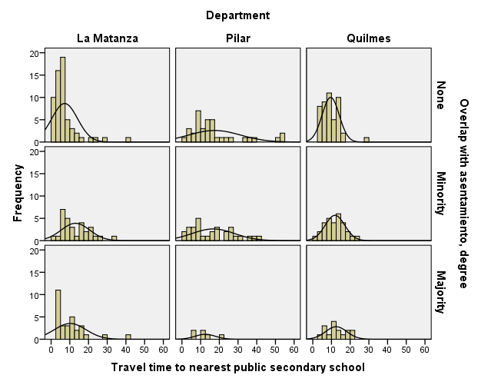

GRAPH
/HISTOGRAM(NORMAL)=trvtime_cbd_bsas
/PANEL COLVAR=DEPTO COLOP=CROSS ROWVAR=ASENTANY_YN ROWOP=CROSS.

Graph

Notes
Output Created |  | 14-MAR-2018 20:20:27
Comments
Input | Data | F:\Data_Final\3cases_traveltime_indec.sav
Input | Active Dataset | DataSet1
Input | Filter | <none>
Input | Weight | <none>
Input | Split File | <none>
Input | N of Rows in Working Data File | 284
Syntax |  | GRAPH  /HISTOGRAM(NORMAL)=trvtime_cbd_bsas  /PANEL COLVAR=DEPTO COLOP=CROSS ROWVAR=ASENTANY_YN ROWOP=CROSS.
Resources | Processor Time | 00:00:00.22
Resources | Elapsed Time | 00:00:00.23

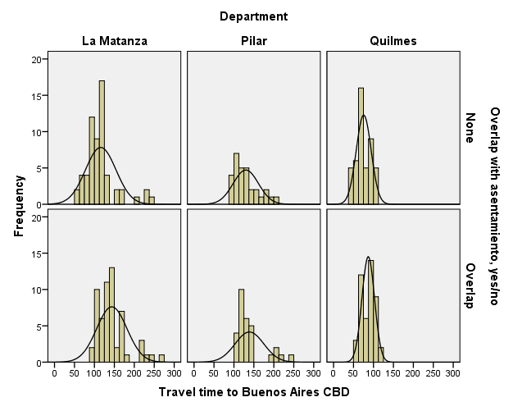

GRAPH
/HISTOGRAM(NORMAL)=trvtime_cbd_loc
/PANEL COLVAR=DEPTO COLOP=CROSS ROWVAR=ASENTANY_YN ROWOP=CROSS.

Graph

Notes
Output Created |  | 14-MAR-2018 20:20:41
Comments
Input | Data | F:\Data_Final\3cases_traveltime_indec.sav
Input | Active Dataset | DataSet1
Input | Filter | <none>
Input | Weight | <none>
Input | Split File | <none>
Input | N of Rows in Working Data File | 284
Syntax |  | GRAPH  /HISTOGRAM(NORMAL)=trvtime_cbd_loc  /PANEL COLVAR=DEPTO COLOP=CROSS ROWVAR=ASENTANY_YN ROWOP=CROSS.
Resources | Processor Time | 00:00:00.22
Resources | Elapsed Time | 00:00:00.23

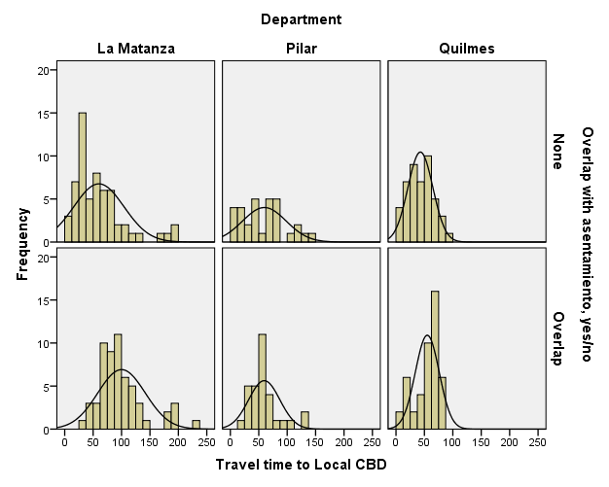

GRAPH
/HISTOGRAM(NORMAL)=trvtime_cbd_ngh_min
/PANEL COLVAR=DEPTO COLOP=CROSS ROWVAR=ASENTANY_YN ROWOP=CROSS.

Graph

Notes
Output Created |  | 14-MAR-2018 20:20:49
Comments
Input | Data | F:\Data_Final\3cases_traveltime_indec.sav
Input | Active Dataset | DataSet1
Input | Filter | <none>
Input | Weight | <none>
Input | Split File | <none>
Input | N of Rows in Working Data File | 284
Syntax |  | GRAPH  /HISTOGRAM(NORMAL)=trvtime_cbd_ngh_min  /PANEL COLVAR=DEPTO COLOP=CROSS ROWVAR=ASENTANY_YN ROWOP=CROSS.
Resources | Processor Time | 00:00:00.22
Resources | Elapsed Time | 00:00:00.23

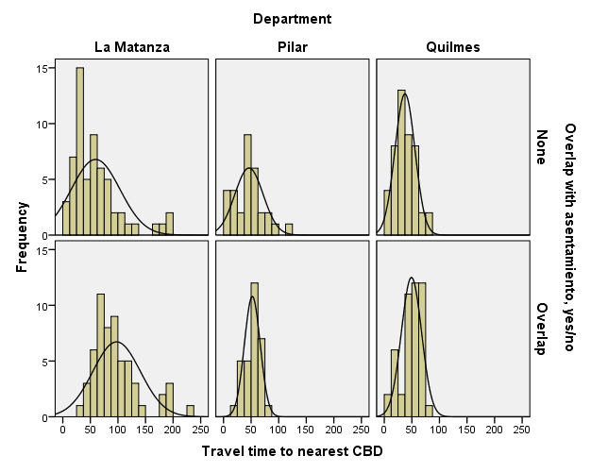

GRAPH
/HISTOGRAM(NORMAL)=trvtime_rail_min
/PANEL COLVAR=DEPTO COLOP=CROSS ROWVAR=ASENTANY_YN ROWOP=CROSS.

Graph

Notes
Output Created |  | 14-MAR-2018 20:22:12
Comments
Input | Data | F:\Data_Final\3cases_traveltime_indec.sav
Input | Active Dataset | DataSet1
Input | Filter | <none>
Input | Weight | <none>
Input | Split File | <none>
Input | N of Rows in Working Data File | 284
Syntax |  | GRAPH  /HISTOGRAM(NORMAL)=trvtime_rail_min  /PANEL COLVAR=DEPTO COLOP=CROSS ROWVAR=ASENTANY_YN ROWOP=CROSS.
Resources | Processor Time | 00:00:00.27
Resources | Elapsed Time | 00:00:00.23

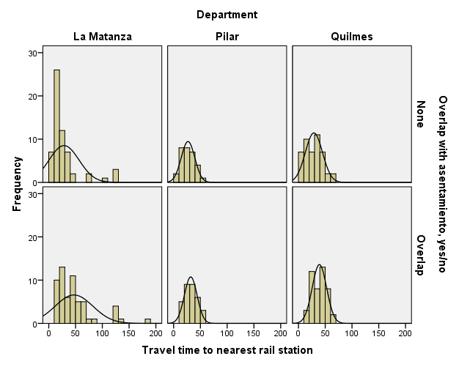

GRAPH
/HISTOGRAM(NORMAL)=trvtime_upa_min
/PANEL COLVAR=DEPTO COLOP=CROSS ROWVAR=ASENTANY_YN ROWOP=CROSS.

Graph

Notes
Output Created |  | 14-MAR-2018 20:22:20
Comments
Input | Data | F:\Data_Final\3cases_traveltime_indec.sav
Input | Active Dataset | DataSet1
Input | Filter | <none>
Input | Weight | <none>
Input | Split File | <none>
Input | N of Rows in Working Data File | 284
Syntax |  | GRAPH  /HISTOGRAM(NORMAL)=trvtime_upa_min  /PANEL COLVAR=DEPTO COLOP=CROSS ROWVAR=ASENTANY_YN ROWOP=CROSS.
Resources | Processor Time | 00:00:00.25
Resources | Elapsed Time | 00:00:00.23

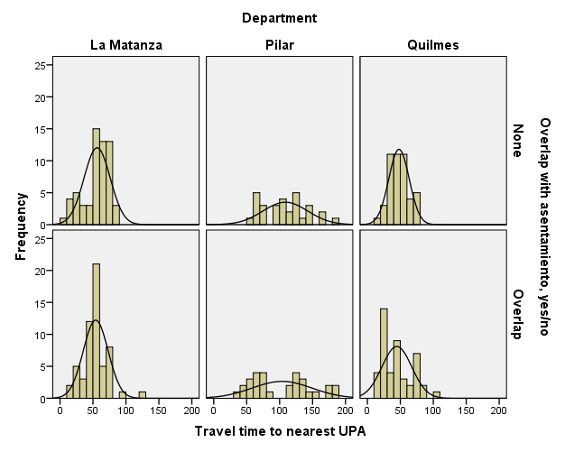

GRAPH
/HISTOGRAM(NORMAL)=trvtime_hspt_min
/PANEL COLVAR=DEPTO COLOP=CROSS ROWVAR=ASENTANY_YN ROWOP=CROSS.

Graph

Notes
Output Created |  | 14-MAR-2018 20:22:28
Comments
Input | Data | F:\Data_Final\3cases_traveltime_indec.sav
Input | Active Dataset | DataSet1
Input | Filter | <none>
Input | Weight | <none>
Input | Split File | <none>
Input | N of Rows in Working Data File | 284
Syntax |  | GRAPH  /HISTOGRAM(NORMAL)=trvtime_hspt_min  /PANEL COLVAR=DEPTO COLOP=CROSS ROWVAR=ASENTANY_YN ROWOP=CROSS.
Resources | Processor Time | 00:00:00.23
Resources | Elapsed Time | 00:00:00.23

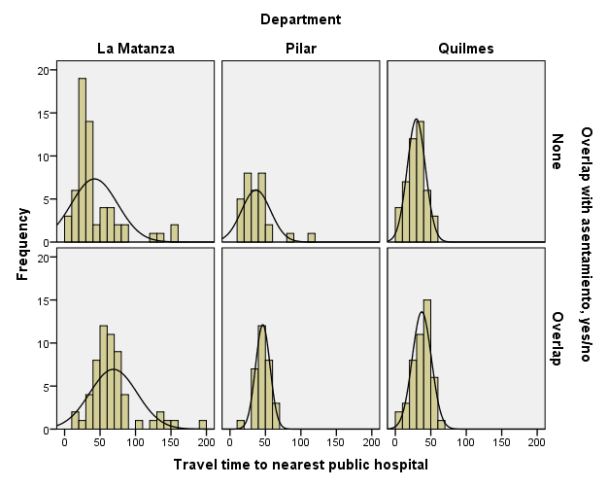

GRAPH
/HISTOGRAM(NORMAL)=trvtime_dgntrt_min
/PANEL COLVAR=DEPTO COLOP=CROSS ROWVAR=ASENTANY_YN ROWOP=CROSS.

Graph

Notes
Output Created |  | 14-MAR-2018 20:22:36
Comments
Input | Data | F:\Data_Final\3cases_traveltime_indec.sav
Input | Active Dataset | DataSet1
Input | Filter | <none>
Input | Weight | <none>
Input | Split File | <none>
Input | N of Rows in Working Data File | 284
Syntax |  | GRAPH  /HISTOGRAM(NORMAL)=trvtime_dgntrt_min  /PANEL COLVAR=DEPTO COLOP=CROSS ROWVAR=ASENTANY_YN ROWOP=CROSS.
Resources | Processor Time | 00:00:00.28
Resources | Elapsed Time | 00:00:00.23

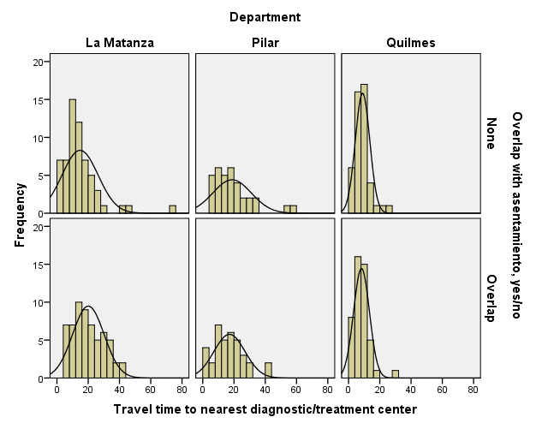

GRAPH
/HISTOGRAM(NORMAL)=trvtime_edknd_min
/PANEL COLVAR=DEPTO COLOP=CROSS ROWVAR=ASENTANY_YN ROWOP=CROSS.

Graph

Notes
Output Created |  | 14-MAR-2018 20:22:45
Comments
Input | Data | F:\Data_Final\3cases_traveltime_indec.sav
Input | Active Dataset | DataSet1
Input | Filter | <none>
Input | Weight | <none>
Input | Split File | <none>
Input | N of Rows in Working Data File | 284
Syntax |  | GRAPH  /HISTOGRAM(NORMAL)=trvtime_edknd_min  /PANEL COLVAR=DEPTO COLOP=CROSS ROWVAR=ASENTANY_YN ROWOP=CROSS.
Resources | Processor Time | 00:00:00.23
Resources | Elapsed Time | 00:00:00.23

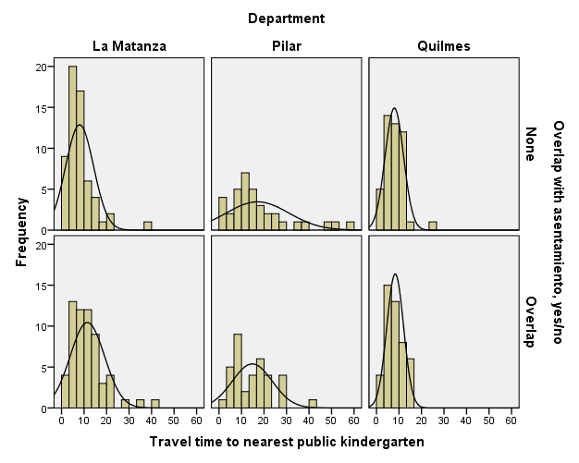

GRAPH
/HISTOGRAM(NORMAL)=trvtime_edprm_min
/PANEL COLVAR=DEPTO COLOP=CROSS ROWVAR=ASENTANY_YN ROWOP=CROSS.

Graph

Notes
Output Created |  | 14-MAR-2018 20:23:00
Comments
Input | Data | F:\Data_Final\3cases_traveltime_indec.sav
Input | Active Dataset | DataSet1
Input | Filter | <none>
Input | Weight | <none>
Input | Split File | <none>
Input | N of Rows in Working Data File | 284
Syntax |  | GRAPH  /HISTOGRAM(NORMAL)=trvtime_edprm_min  /PANEL COLVAR=DEPTO COLOP=CROSS ROWVAR=ASENTANY_YN ROWOP=CROSS.
Resources | Processor Time | 00:00:00.23
Resources | Elapsed Time | 00:00:00.25

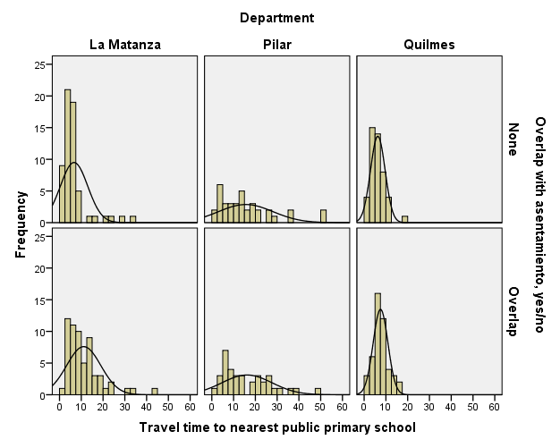

GRAPH
/HISTOGRAM(NORMAL)=trvtime_edsec_min
/PANEL COLVAR=DEPTO COLOP=CROSS ROWVAR=ASENTANY_YN ROWOP=CROSS.

Graph

Notes
Output Created |  | 14-MAR-2018 20:23:12
Comments
Input | Data | F:\Data_Final\3cases_traveltime_indec.sav
Input | Active Dataset | DataSet1
Input | Filter | <none>
Input | Weight | <none>
Input | Split File | <none>
Input | N of Rows in Working Data File | 284
Syntax |  | GRAPH  /HISTOGRAM(NORMAL)=trvtime_edsec_min  /PANEL COLVAR=DEPTO COLOP=CROSS ROWVAR=ASENTANY_YN ROWOP=CROSS.
Resources | Processor Time | 00:00:00.25
Resources | Elapsed Time | 00:00:00.23

