**Code and Results**

> # Load libraries, set wd, and load/attach data

> library(MASS)

> setwd("C:\\Users\\Kyle\\Dropbox\\CS\\CS3654\\R\\Inclass9")

> load("fdata.rdata")

> # Create/attach training and test subset as demonstrated in text

> final$gp <- runif(dim(final)[1])

> test <- subset(final, final$gp <= 0.1)

> train <- subset(final, final$gp > 0.1)

> attach(train)

> # Remove columns used for creating subsets

> train["gp"] <- NULL

> test["gp"] <- NULL

> # Fit linear regression with all features

> fit <- lm(ssc ~ age + gender + location + ethnicity + coder + som1 + som2 + som3 + som4

+ + som5 + som6 + som7 + som8 + som9 + som10 + som11 + som12 + som13 + som14)

> summary(fit)

> step <- stepAIC(fit, direction = "both")

> step

> step$anova

Stepwise Model Path

Analysis of Deviance Table

Initial Model:

ssc ~ age + gender + location + ethnicity + coder + som1 + som2 +

som3 + som4 + som5 + som6 + som7 + som8 + som9 + som10 +

som11 + som12 + som13 + som14

Final Model:

ssc ~ age + location + ethnicity + coder + som1 + som2 + som3 +

som4 + som5 + som9 + som10 + som11 + som12 + som13 + som14

Step Df Deviance Resid. Df Resid. Dev AIC

1 265 539.3376 237.9931

2 - som8 1 0.2053721 266 539.5429 236.1054

3 - som6 1 0.2107394 267 539.7537 234.2206

4 - som7 1 0.2348345 268 539.9885 232.3489

5 - gender 1 0.8016397 269 540.7902 230.7865

> rm(step)

> rm(fit)

> # Build model with only retained variables

> fit1 <- lm( ssc ~ age + location + ethnicity + coder + som1 + som2 + som3 +

+ som4 + som5 + som10 + som11 + som12 + som13 + som14)

> summary(fit1)

> # Remove training set (no longer needed)

> detach(train)

> rm(train)

> # Now predict using the test set

> test$ssc_pred <- predict(fit1, newdata = test)

> rm(fit1)

> #See how predicted ssc compares to actual ssc values

> library(ggplot2)

> ggplot(data = test, aes(x = ssc_pred, y = ssc)) +

+ geom_point(color = "red") +

+ geom_line(aes(x = ssc, y = ssc), color = "blue")

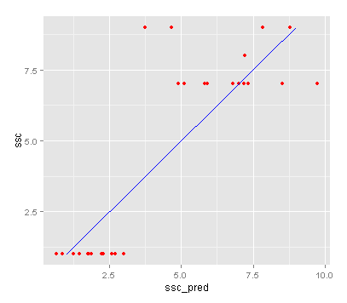

**Interpretation**

The actual SSC scores versus the predicted scores in this case are relatively inaccurate. While the relationship between the two is linear with a slope of near 1, we can see from looking at the plot that there are many outliers, and that a given SSC score can lead to a prediction within +/- 5 of the actual score. As a result, I would say that this is not an accurate model for predicting SSC scores.