Kyle Stanford
Parallel Systems CS380P
Dr. Lin
07 October 2026
LAB 2 REPORT
This lab asked me to solve k-means four ways, once on the CPU and three times on the GPU. All four share one argument parser, one input reader, one copy of the kmeans_rand seeding routine and one clock, so the numbers below differ only in how an iteration is computed. One binary picks the implementation with --alg. I ran each configuration five times and kept the fastest run.
Implementation
The sequential version is plain Lloyd's. The basic CUDA version runs one thread per point, has each thread scan all k centroids for the nearest, and then atomically adds the point into a global sum buffer. The shared memory version does the same work but it stages the centroids and a per block sum and count buffer in shared memory, which cuts the global atomics from one per point per dimension to one per block per entry. The Thrust version is a group by aggregate: sort the point indices by label, next expand to one key per point per dimension, then reduce_by_key for the sums and a second one for the counts. All four match the published answers inside 1e-4 and converge in the same iteration counts, 18, 15 and 14 on the three inputs.
One measurement decision matters for everything below. The first CUDA call in a process builds the device context, which costs about 290 milliseconds here, and I pay that before the clock starts. Everything else is inside the timed region: allocation, every copy, every kernel, and the convergence test. Before I moved it out, every GPU run reported about 300 milliseconds total whether the input had 2048 points or 65536, because the startup cost swamped the real work.
Hardware
Everything was measured on Codio but there are a few details that matter for the estimate below. The GPU is one Tesla T4 with 40 SMs and 1024 resident threads per SM, so 40960 thread contexts. The CPU is an Intel Xeon Platinum 8259CL at 3.10 GHz. The toolkit is CUDA 10.1, which defaults to sm_30, so the build has to name an architecture explicitly because atomicAdd on double needs 6.0. The GPU is shared with the other tenants, which is why I reported the best of five runs rather than an average.
Which is fastest, which is slowest, and did it match
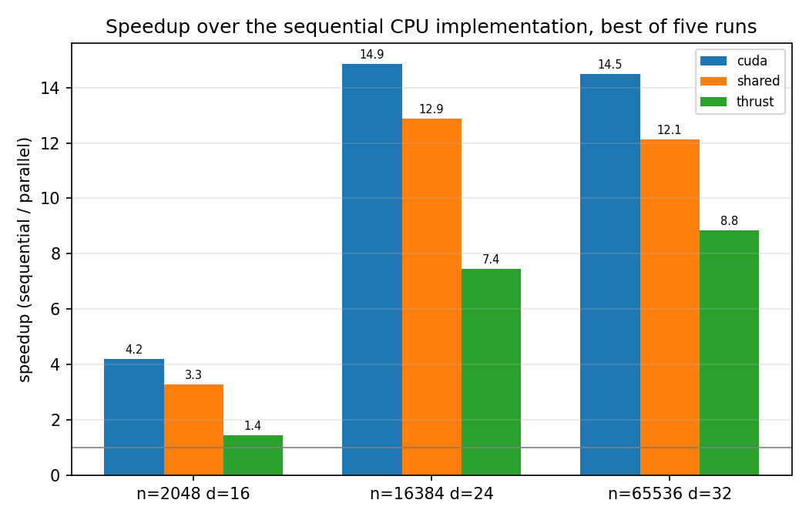
Speedup is sequential time divided by parallel time, so the higher the better. Basic CUDA is fastest on every input at 4.2, 14.9 and 14.5 times sequential. Shared memory follows at 3.3, 12.9 and 12.1, and Thrust is last at 1.4, 7.4 and 8.8.
Thrust being slowest is what I expected, and section 3.4 says as much. The hand written kernels read each point once per iteration. Thrust sorts 65536 indices, gets two million keys and two million doubles, reduces them, and does all of it again on the next iteration, moving about four times the bytes for the same answer. It does scale up better than the other two though, climbing from 1.4 to 8.8 as the input grows, because that fixed per iteration cost doesn’t care much about n and the largest input amortizes it.

Basic CUDA beating shared memory is not what I expected. Reducing global memory traffic is the whole point of section 3.3, and the shared version does cut the global atomics on the largest input from about 2.16 million per iteration to about 135 thousand. It loses anyway by 10 to 20 percent. My reading is that the atomics were never the bottleneck, so that saving buys nothing while the extra work isthere, since the block still has to zero the accumulator, copy the centroids in, cross two barriers, and flush k times d atomics at the end.
I got this wrong in the other direction too. I tried dropping the centroid staging on the theory that the L1 cache was already broadcasting them, and it came out 40 percent slower on the largest input, because the kernel streams 16 MB of points through that same cache every iteration and evicts the centroids continuously. Both mistakes were reasoning about a bottleneck I had not measured.
For the best case estimate, my kernel launches one thread per point, so 65536 threads on the largest input, against 40960 resident contexts. Almost the whole problem is in flight at once and taken literally that predicts a speedup of 40960 over a single CPU thread. That number is useless because a GPU thread context is not a CPU core. Narrowing it to hardware that can actually retire double precision work, 80 FP64 lanes at 1.59 GHz against one core at 3.10 GHz is about 41 core equivalents. That still assumes the CPU issues a multiply add every cycle, which it does not, because the inner loop is latency bound on its accumulator. Working backwards from the measurement it manages one every 3.2 cycles, which pushes the ceiling to about 130.
So my prediction is 41 to 130 depending on how much credit the CPU gets, and I measured 14.5 on that input, roughly a third of the generous end. I did not profile the gap, so this part is speculation, but the likeliest cause is my point layout. Points are stored point major, so
consecutive threads read addresses 256 bytes apart at d=32 and a warp reading a single dimension touches 32 separate cache lines. Storing points dimension major would make those reads contiguous. I left the layout alone so that the three GPU versions differ only in their use of shared memory, but it is the first thing I would change given more time.
End to end runtime and data transfer
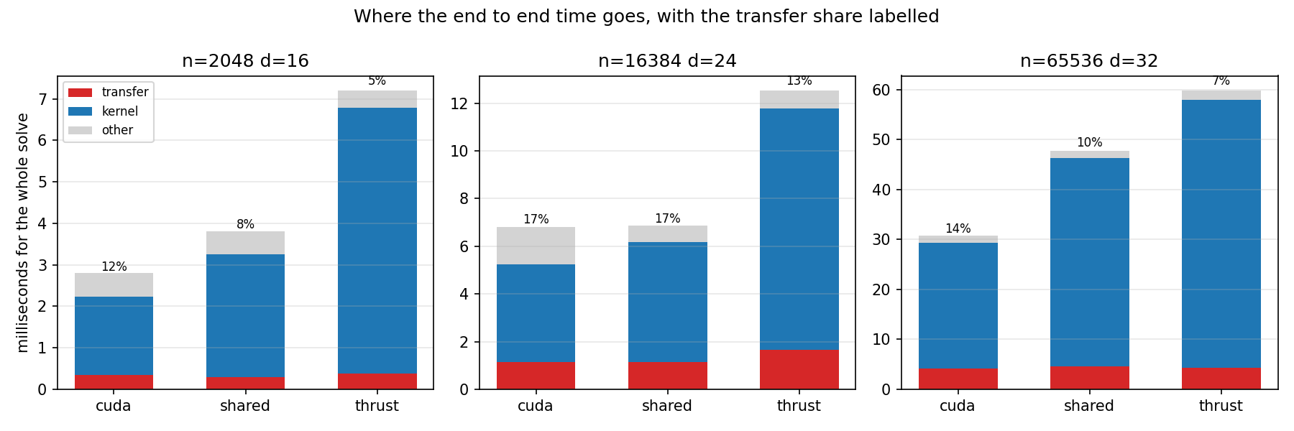
Measured with CUDA events around every copy, transfer is 12 to 17 percent of end to end runtime for basic CUDA, 8 to 17 percent for shared memory, and 5 to 13 percent for Thrust. On the largest input basic CUDA spends 4.22 of 30.79 milliseconds in transfer, or 13.7 percent. These rows are single runs rather than best of five, so treat them as approximate.
Nearly all of that is one copy. The point array is 16.78 MB and goes up once before the loop. The per iteration traffic is only the k by d centroid buffer coming back for the convergence test, which is 4 KB, and the labels come back once at the end at 262 KB. So about 98 percent of the bytes crossing the bus are the initial upload, and the percentage would fall further on an input that needed more iterations. Transfer is therefore not what limits me. If the kernels took no time at all, the largest input would still finish in about 5.7 milliseconds, which would be 85 times sequential rather than 14.5. The limit is inside the kernel.
Time Spent
I spent approximately 15 hours on this lab.

